Teodora Papazova
2114277
Digital skills and research methods
BMSW4003
Lecturer: Joy Botu

Research-Investigating the use of Telemonitoring in hospitals for heart failure in UK

Table of contes

1.Abstract……………………………………………...3

2.Introduction……………………...……………….….3

3.Rationale……………………………………….…….3

4.Research Objectives………………………….….…...4

5.Research Methodology………………………... ….…4

6.Literature review ……………………...…....…4,5,6,7,8

7.Analysis and Discussion ……………………………...8

8.Secondary Data Analysis …………………….….…....8

9.Conclusion and Recommendation…….……….………9

10.Reference………………………………………...10,11

Investigating the use of Telemonitoring in hospitals for heart failure in UK

Prepared by Teodora Papazova-2114277

1.Abstract
Heart failure (HF) is a primary cause of illness and death. Several ways are available to remotely monitor patients' health. Although studies have shown that remote monitoring may reduce Heart Failure patience hospitalizations and death, the outcomes of clinical trials to date have been limited by the investigation of diverse patient demographics, the use of different monitoring technologies, and the use of different endpoints

2.Introduction
This secondary research report is made to investigate the use of technology in hospitals for monitoring heart failure (HF) patience in UK, how they are used to detect and treat heart failure. Readmission rates and death can be reduced using heart failure disease management programs. We examine present home monitoring techniques, pertinent studies, and possible directions for telemedicine in this review. (Dierckx et al. 2014)

3.Rational
The purpose of this research is to find out what is the difference for heart failure patients, using telemonitoring at home or the usual care, and how they are helping to detect and monitoring heart failure in UK. Heart failure is when the heart is unable to adequately pump blood throughout the body (NHS 2019). Conditions which can lead to heart failure are-Coronary heart disease, Hight blood pressure, Cardiomyopathy, Arrhythmias, Atrial fibrillation, Heart attack, Genetic heart disease. Common treatments for HF-medicine, devices implanted in the chest, bypass operation, heart transplant.

4.Research object
Secondary research method been used for this paper. The information is collected from different trusted journals, who show what is the outcome of their research.

5.Research methodology
The data for this research was collected to show what technology is used for monitoring Heart Failure.
One of the methods used for monitoring Heart Failure is telemonitoring. Telemonitoring allows a doctor and nurses to track, record patients at home on a regular basis. This allows patients with heart failure to be closely monitored, potentially lowering the rate of death and the rate of hospitalization. (Louis et al.,2003)

6.Literature review
There is an increase interest in the potential for telemonitoring to support the home-based management of patients with chronic heart failure. However, little is known about the views of patients and professionals on the use of telemonitoring in this context. A chronic heart failure telemonitoring service was set-up by NHS Lothian, Scotland, to evaluate the intervention.
Telemonitoring equipment is used to record the blood pressure, heart rate, and oxygen saturation (Figure 1). All of the readings from the equipment are encrypted and sent to a base station in each of the hospitals through a dedicated telephone. A heart failure nurse analyses the transmitted data daily Monday through Friday. (Dar et al., 2009a)
One on the negatives for telemonitoring is because there are no face-to-face interactions with patients, healthcare providers must rely on photographs, graphs, and other representations to speak for the patient. Telemedicine means that patients may no longer rely on their physician's personal relationships, which are typically long-standing and well-established. Patients are required to make their bodies available to healthcare providers they have never met in person. In the case of telemonitoring devices, this omission of healthcare is actual. (Oudshoon,2008)

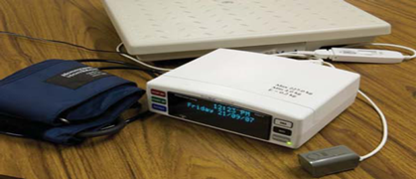

Figure 1: Home telemonitoring equipment
Some of the research for telemonitoring Heart Failure (HF) suggest that one of the best technologies to monitoring heart failure patience is Telemonitoring (TM). Telemonitoring helps for early diagnosis of deterioration and lowers readmission rates and in one research for Telemonitoring (TM), when they are monitoring of weight and symptoms in patients with heart failure, shows a significant reduction in death at 6 months in one large, randomized control research; however, there was no difference in readmission rates. One clinical study comparing video-consultation as part of a home health care programs for individuals, found that the cost of hospital treatment was reduced during using telemonitoring. On the other hand, there was no difference show on this clinical study in the results between the TM group and the conventional care group in one randomized trial. (Louise et al.,2003).
Only 20% of heart failure patients released from hospital in the United Kingdom receive any kind of expert follow-up. Telehealth holds the promise of bringing specialized care in patients' home. While this novel technology has shown promise, much of the data for it is application in the therapy of heart failure comes from observational studies of very young patients with severe heart failure. Furthermore, even though this category of patients is prevalent and has a risk of readmission like those with systolic heart failure, the two biggest randomized studies to report in full excluded individuals with a line.
In another research, which has been done Between June 2006 and August 2007, 456 patients were screened for eligibility, with 182 (40%) agreeing to participate in the trial and being randomly assigned to Telemonitoring (TM) or usual specialist care (UC) in a 1:1 ratio. (Dar et al.,2009) (Figure 2)
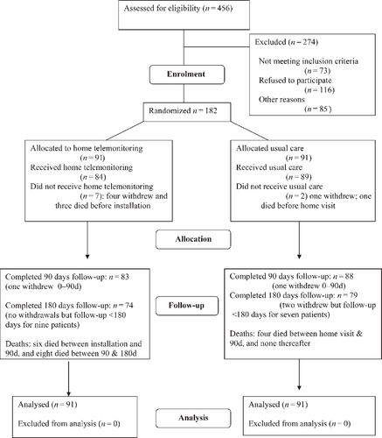
Figure 2: HOME-HF Study are depicted in this figure. Patients who died but might have been followed up for that time period are included in the completed category.

With telemonitoring, we saw in this research a decrease in the frequency of secondary care outpatient visits. (Figure 3)

 | UC | TM
People | 733 | 622
Emergency room visit | 32 | 20
Primary care visit | 403 | 421

Table
Figure 3

Another study shows similar rate for patience (Figure 4)

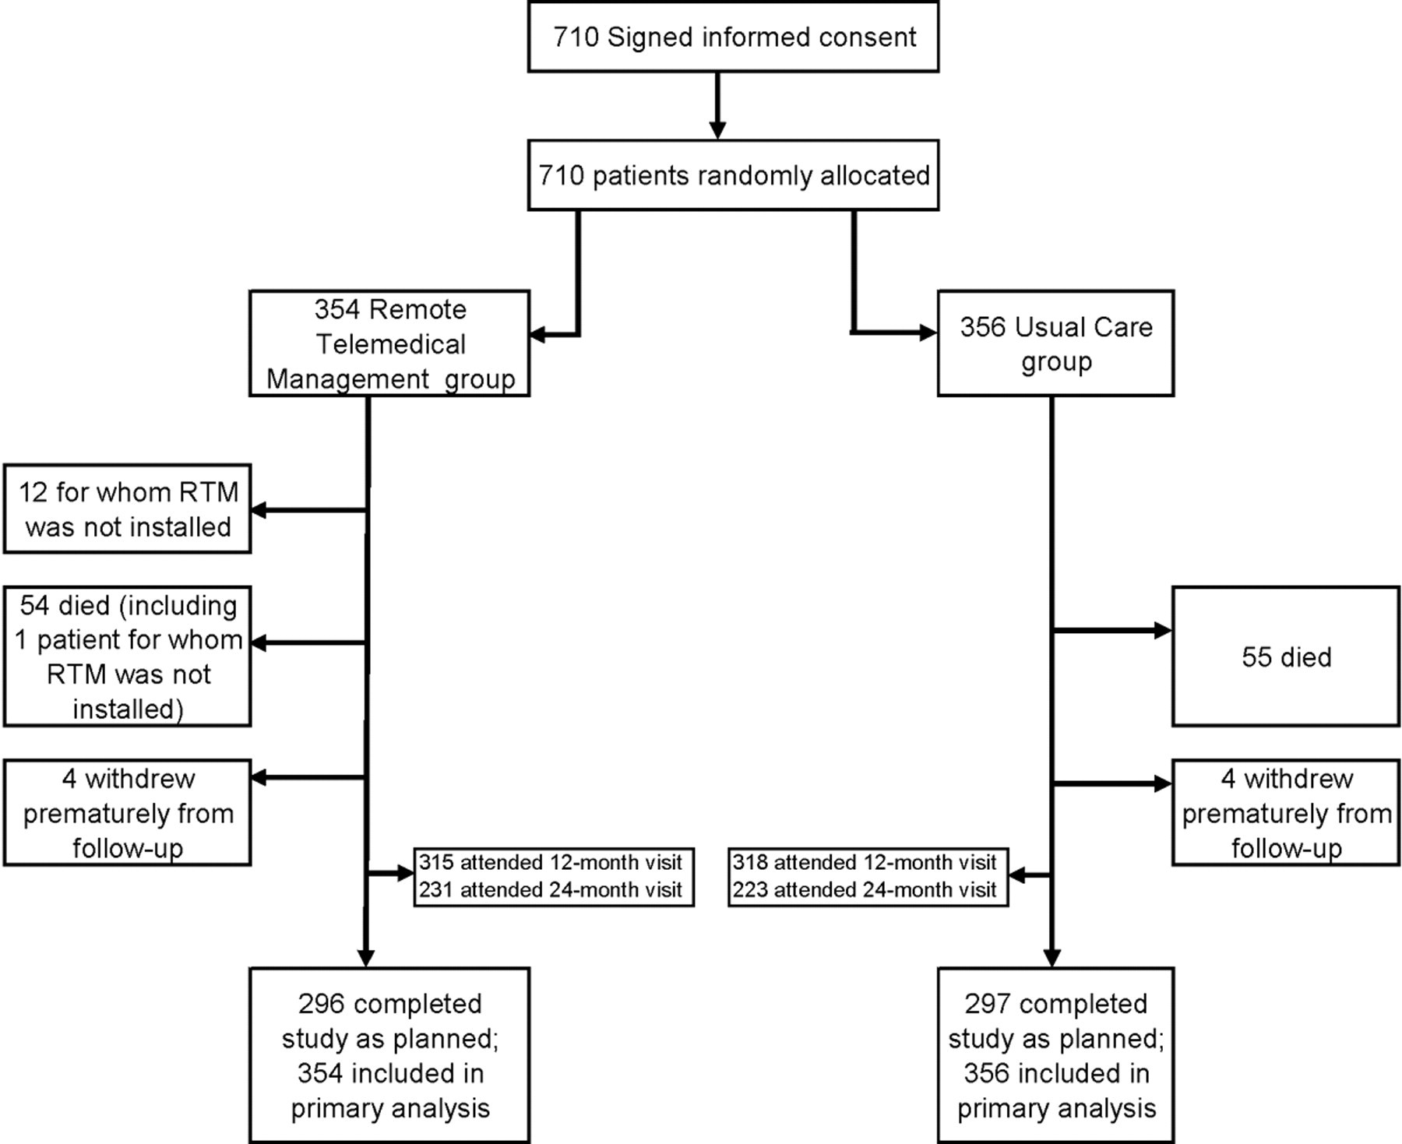

Figure 4
This study finds that, there was no reduction in the hospital readmission or mortality rate.

In another research make to determine the impact of home-based telehealth treatments on secondary healthcare utilization and death, setting in 179 general practices in England (Steventon et al.,2012) used 3230 people recruited from practices between May 2008 and November 2009, shows the differences. They included 1584 control patients and 1570 intervention patients in the analyses (98% of those recruited). In comparison to controls, intervention patients were considerably less likely to die within 12 months. The intervention and control groups similarly had minimal variations in the mean number of emergency admissions per person (crude rate 0.54 v 0.68; difference 0.14) In general, the differences in hospital visit groups were not significant. This research paper shows according to their findings, telemonitoring assisted patients in avoiding the need for emergency hospital treatment. The mechanism behind this is yet unknown. Telemonitoring might help patients better control their diseases, reducing the number of acute exacerbations that necessitate emergency hospitalizations. People's perceptions of when they need extra help, as well as physicians' judgments about whether to refer or admit patients, might be influenced by telehealth. Further research will be conducted to learn more about the processes via which telehealth can reduce admission rates. (Steventon et al.,2012)

7.Analysis and Discussion

All data information was reread again, as well as information about the telemonitoring services' performance. In all studies, the collected information shows that home Telemonitoring and usual care have the similar outcomes from secondary care based. They all failed to prove that TM can allow early detection and reduction in hospitalization with TM. The studies report reduction in mortality rate for the patience with heart failure problems. The data from all the trials reveals that home telemonitoring and usual care had similar results to secondary care. They all failed to show that TM can help with early diagnosis and hospitalization reduction. According to the studies, patients with heart failure had a lower death rate. They also demonstrate that TM may be beneficial for older patients who want to improve their health at home. TM holds the promise of bringing specialized care closer to patients' homes. Given the variety of patients involved and the sort of technology used, it's not unexpected that the influence of telemonitoring on patient outcome is quite variable. According to a recent review, there is minimal influence on overall hospitalization, but there is a reduction in mortality and the possibility of fewer heart failure admissions. (Dar et al.,2009b) Overall, patients were empowered by the ability to have and know all the information. They suddenly have access to information about their health that was previously only available to healthcare practitioners and was usually not shared with them. (Hanley et al.,2018).

8. Secondary Data Analysis

Hospitals and specialist for heart failure find the use of Telemonitoring useful in some cases, although not necessarily in terms of the system's financial efficiency. (Koehler et al.,2011)

9.Conclusion and Recommendation

In this secondary research we find information about how Telemonitoring is used during treatments and after care for patients with heart failure, how it helps and improve the after-care system. All of the research shows that is not a really big difference between the telemonitoring and the usual after care for the patience. Telemonitoring can really help for early diagnosis of deterioration and to lowers readmission rates for after care patience. In most instances, cost-effectiveness studies show that TM was the best option, but there is a lot of doubt about how well the treatments were described and how accurate the costs were estimated. (Thokala et al.,2013) However, its impact on a vast path has yet to be determined. A major focus is developing measures to prevent readmissions of people with heart failure.

10.Reference

1.Dar, O., Riley, J., Chapman, C., Dubrey, S.W., Morris, S., Rosen, S.D., Roughton, M. and Cowie, M.R. (2009a). A randomized trial of home telemonitoring in a typical elderly heart failure population in North West London: results of the Home-HF study. European Journal of Heart Failure, 11(3), pp.319–325.
2.Dar, O., Riley, J., Chapman, C., Dubrey, S.W., Morris, S., Rosen, S.D., Roughton, M. and Cowie, M.R. (2009b). A randomized trial of home telemonitoring in a typical elderly heart failure population in North West London: results of the Home-HF study. European Journal of Heart Failure, 11(3), pp.319–325.
3.Dierckx, R., Pellicori, P., Cleland, J.G.F. and Clark, A.L. (2014). Telemonitoring in heart failure: Big Brother watching over you. Heart Failure Reviews, 20(1), pp.107–116.
4.Hanley, J., Pinnock, H., Paterson, M. and McKinstry, B. (2018). Implementing telemonitoring in primary care: learning from a large qualitative dataset gathered during a series of studies. BMC Family Practice, 19(1).
5.Koehler, F., Winkler, S., Schieber, M., Sechtem, U., Stangl, K., Böhm, M., Boll, H., Baumann, G., Honold, M., Koehler, K., Gelbrich, G., Kirwan, B.-A. and Anker, S.D. (2011). Impact of Remote Telemedical Management on Mortality and Hospitalizations in Ambulatory Patients With Chronic Heart Failure. Circulation, 123(17), pp.1873–1880.
6.Louis, A.A., Turner, T., Gretton, M., Baksh, A. and Cleland, J.G.F. (2003a). A systematic review of telemonitoring for the management of heart failure. European Journal of Heart Failure, 5(5), pp.583–590.
7.Louis, A.A., Turner, T., Gretton, M., Baksh, A. and Cleland, J.G.F. (2003b). A systematic review of telemonitoring for the management of heart failure. European Journal of Heart Failure, 5(5), pp.583–590.
8.NHS (2019). Overview - Heart failure. [online] NHS. Available at: https://www.nhs.uk/conditions/heart-failure/ [Accessed: 5 Dec. 2021].
9.Oudshoorn, N. (2008). Diagnosis at a distance: the invisible work of patients and healthcare professionals in cardiac telemonitoring technology. Sociology of Health & Illness, 30(2), pp.272–288.
10.Steventon, A., Bardsley, M., Billings, J., Dixon, J., Doll, H., Hirani, S., Cartwright, M., Rixon, L., Knapp, M., Henderson, C., Rogers, A., Fitzpatrick, R., Hendy, J. and Newman, S. (2012). Effect of telehealth on use of secondary care and mortality: findings from the Whole System Demonstrator cluster randomised trial. BMJ, 344(jun21 3), pp.e3874–e3874.
11.Thokala, P., Baalbaki, H., Brennan, A., Pandor, A., Stevens, J.W., Gomersall, T., Wang, J., Bakhai, A., Al-Mohammad, A., Cleland, J., Cowie, M.R. and Wong, R. (2013). Telemonitoring after discharge from hospital with heart failure: cost-effectiveness modelling of alternative service designs. BMJ Open, 3(9), p.e003250.

