A critical analysis of external factors impacting high street retailer in the UK

Table of Contents
INTRODUCTION 3
FINDINGS 3
SWOT Analysis 4
Pestle analysis 7
CONCLUSION 8
RECOMMENDATION 9
REFERENCES 10

List of Figure
Figure 1 Tesco 3
Figure 2 SWOT Analysis 4
Figure 3 Pestle analysis 7

List of Table
Table 1 Pestle analysis 8

INTRODUCTION
Tesco is a major UK retailer with more than 3,400 shops exposed to numerous external forces that influence its activities. The development of online shopping, economic issues, such as inflation is 8.7% in 2025, and the twist in attitudes of the consumers, including the movement toward healthy and sustainable products are transforming the retail business (Bank of England, 2025). This report uses SWOT and PESTLE analysis to critically examine these forces to determine how Tesco can change and adapt to these forces and continue dominating the market.

FINDINGS
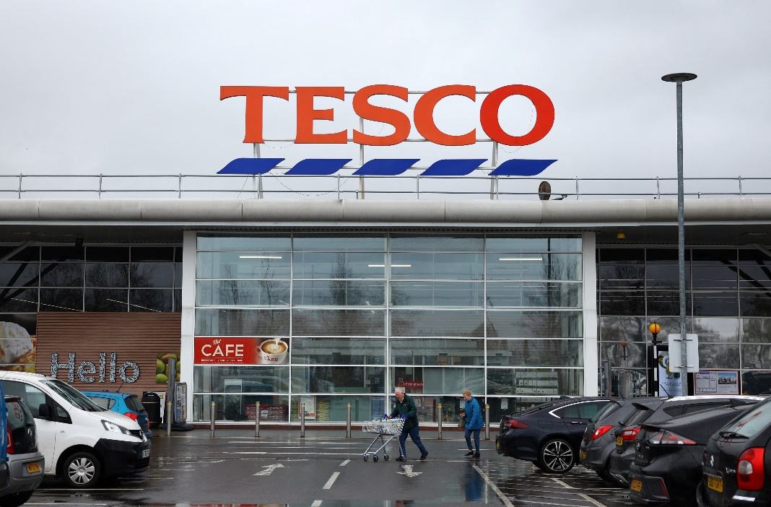
Figure 1 Tesco
Source- Reuters (2024)

SWOT Analysis
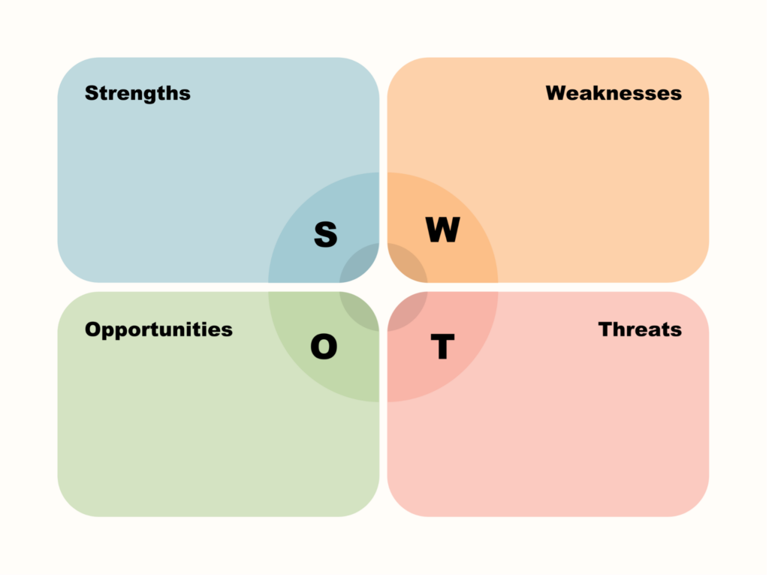
Figure 2 SWOT Analysis
Source- BNI

Strengths:
- Market Leadership: Tesco is among leading retailers in the UK operating more than 3400 stores consisting of hypermarkets, supermarkets, and convenience stores. As of 2024, it leads the way in 27.4 percent market share against other industry players in the UK such as Sainsbury (15.2) and Asda (14.8) (Kantar, 2024). Such a huge presence is a strong factor of gaining recognition as a consumer and brand loyalty by Tesco.
- Speciality products: Tesco has diversified its product offerings also; besides groceries it now has lines of clothing (F&F), bank and insurance (Fatricia, 2017). This diversification has enabled Tesco to reach wider group of customers that has facilitated its revenue generation.
- Technological Integration: Tesco has been a huge spender in the field of technology, more in e-commerce and supply chain management. In 2023, the online level of sales constituted 30.6 percent of the total turnover (Tesco Annual Report, 2023).
- Artificial intelligence: Artificial intelligence (AI) and analytics of big data in terms of handling the inventory and setting up the environment of individual shop experiences have given way to competition both online and in brick-and-mortar stores (Woohyoung et al., 2020).
Weaknesses:
- The UK Dependency: Tesco has been setting up business in countries overseas leaving its dependency on the UK that is more than 80 percent of its total income (Aiello et al., 2020). This case makes Tesco be at risk when it faces economic crisis and changes in the UK market. This is especially dangerous when the mood of consumers changes; like what may happen with the current cost-of-living crisis.
- Increasing Cost in Supply Chain: Tesco, similar to other retailers, has been experiencing heightened interruptions of supply chains and a significant cost hike especially in the wake of Brexit. Complicated importation process into the UK of goods form the EU has resulted to an increase in the costs of other imported goods especially, fresh foods.
- Price Competition: Low prices offered by the discount stores such as Aldi and Lidl have raised competition on Tesco and forced it to reduce prices especially in the grocery business. The next year, Aldi is the fastest-growing supermarket in the UK with a 10.2 percent market share (Kantar, 2024). This pressure of the discounted retailers is affecting the status of Tesco in sustaining high profit margins.
Opportunities:
- Growth on the digital platform: The further rise of online shopping presents a very important avenue where Tesco may increase its market share even more (Kim et al., 2019). The emphasis that Tesco has placed over enhancing its online operations such as delivery service in its grocery operations is set to be used in generating proceeds further. It is estimated to increase the online grocery market of 8.5 percent per year within five years (Statista, 2025).
- Sustainability and Ethical Shopping: The increase in consumer demands on sustainability provides a chance to Tesco in exploring more on eco-friendly shopping. These consumer trends harmonize with the company aiming to cut down on plastic wrapping and make more plant-based food available. In 2022, Tesco also began selling carbon neutral products, one reason being a rising populous of eco-friendly consumers.
- Internationalization: Tesco is also deriving international growth opportunities and especially in Asia where retailing is getting progressively advanced. Non-food products such as clothing and banking may also be an avenue to gain more sources of revenue when expanded.
Threats:
- Increased Inflation and Cost-of-Living Emergency: A UK inflation rate of 8.7 percent in 2025 along with an increase in energy prices and a failure to offer increasing wages is tightening the budgets of households. This movement has led to cheaper brands consumption favouring the discount chains such as Aldi and Lidl. Following this, Tesco has had to change or rather re-strategize its pricing policy in order to remain competitive.
- Brexit and Regulatory Risk- These issues affect the output of the ES stipulated by Brexit that may continue to affect the supply chain and the labour force. The cost of imports has increased particularly on fresh produce and there are fears of a shortage of work force in areas of logistics (Rosnizam et al., 2020). The difficulties may present problems of price hikes and supply shortages, which may affect the ability of Tesco to meet demand.
- Rivalry: Tesco is subjected to an intense rivalry not only among the traditional grocery stores but also among online agencies such as Amazon which has been powerfully encroaching into the market by getting into the grocer industry.

Pestle analysis
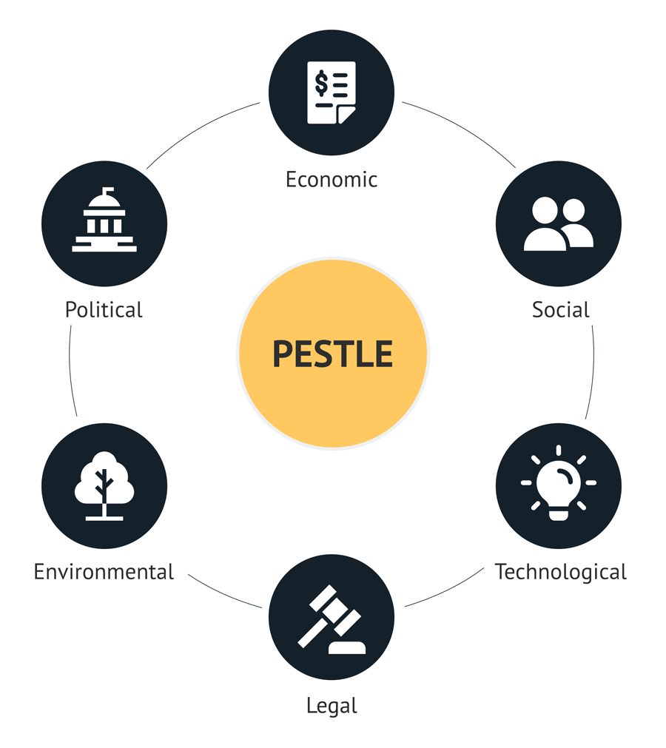
Figure 3 Pestle analysis
Source- Consulterce

Factor | Impact on Tesco with Critical Data/Statistics
Political | Brexit has disrupted Tesco’s supply chain, leading to higher import costs, particularly for fresh food, and workforce shortages. In 2024, Tesco experienced a 5.2% rise in operating costs due to food price inflation (Tesco Annual Report, 2024). Additionally, labour shortages in key sectors like logistics have raised hiring costs, impacting operational efficiency (Ghrmay, 2017).
Economic | Tesco is facing economic challenges, including an 8.7% inflation rate in 2025 (Bank of England, 2025). Consumers are increasingly price-sensitive due to the cost-of-living crisis, shifting towards discount retailers like Aldi and Lidl. To stay competitive, Tesco has adjusted its pricing strategies and focused on value products. In response to these trends, Tesco’s online sales accounted for 30.6% of total revenue in 2023 (Tesco PLC, 2023).
Social | Consumer preferences are shifting towards healthier, sustainable, and ethically sourced products. In 2023, 57% of UK consumers preferred brands with strong environmental commitments (YouGov, 2023). Tesco has adapted by expanding its plant-based and eco-friendly product offerings and improving packaging sustainability, aligning with the growing demand for ethically produced goods (Tian, 2021).
Technological | Tesco has embraced digital transformation, investing in e-commerce and AI. In 2023, online sales made up 30.6% of its total revenue. AI is used for inventory management, while automation in warehouses improves operational efficiency (Phadermrod et al., 2016). Tesco also partnered with Google to enhance personalized shopping experiences, demonstrating its commitment to leveraging technology to maintain competitiveness.
Legal | Tesco must comply with evolving food labelling and environmental laws. Stricter food labelling regulations, effective from 2025, require transparency on allergens and nutritional content (Casañ et al., 2021). Additionally, the company must adhere to anti-competition laws and environmental regulations to avoid legal risks (Akman, 2020).
Environmental | Tesco is committed to sustainability, aiming to become net-zero by 2050. It plans to eliminate 1 billion pieces of plastic from its shelves by 2025 (Tesco PLC, 2023). These efforts align with consumer demand for sustainable practices and reinforce Tesco's environmental responsibility.
Table 1 Pestle analysis

CONCLUSION
The external factors that affect the success of Tesco include economic inflation, Brexit, and shifts in consumer preference. The company currently holds a strong market position and does well in terms of technological innovation, which is its competitive advantage, though discounted retailers and the increase in the costs of operations present a big challenge to the company. Tesco needs to use its opportunities in online services and sustainability to remain competitive and not fall behind in a market that is ever-changing and highly competitive.

RECOMMENDATION
To ensure continued success in a rapidly evolving retail landscape, Tesco should focus on the following key strategies:
Enhance Online and Delivery Services:
The trend of online shopping is also increasing whereby Tesco online revenue contributes to 30.6 percent of total revenue in 2023 (Tesco PLC, 2023). In order to ride on this trend, Tesco ought to invest more in its e-commerce platform, which can be improved through its user experience and increased delivery services. Tesco has an opportunity of taking a larger part of the market in online grocery shopping which is projected to grow by 8.5 percent in the next five years (Statista, 2025) by optimising the efficiency of its online services and its ability to accommodate the fact that online grocery shopping uses up more capacity than traditional gardening produce, and the trend lines in the market mean that Tesco is nearly guaranteed to have to accommodate this online shopping interest in the future.
Strengthen Sustainability Initiatives:
Since consumers are increasingly prioritizing sustainability, it is praiseworthy that Tesco aims to reach net-zero by 2050 and remove 1 billion pieces of plastic shelved by 2025 (Tesco PLC, 2023). Nevertheless, the company ought to speed up sustainability processes including making investments into sustainable sources, decreasing carbon emissions more, and offering more green products (Dalirazar and Sabzi, 2020). The transparency of labelling and marketing of products and services to consumers must be evident since Tesco must be in tandem with rising consumer demands and green-conscious brands and products.
Adapt Pricing Strategies to Economic Challenges:
As inflation rates stay at 8.7%, and the cost-of-living crisis tightens consumer budgets, Tesco should keep iterating on its pricing strategy to stay competitive. This involves provision of more value-added products, promotions and discounts; mostly on necessities (Anwar et al., 2021). Tesco also needs to consider combining with discount retailers or some discount of its own to attract customers who are price conscious without compromising its profitability

REFERENCES
Aiello, L., Quercia, D., Schifanella, R. and Del Prete, L. (2020). Tesco Grocery 1.0, a Large-Scale Dataset of Grocery Purchases in London. Scientific Data, 7. Available at: https://doi.org/10.1038/s41597-020-0397-7.
Akman, M. (2020). Defense Management and PESTLE Analysis. 93-102. Available at: https://doi.org/10.33674/3201910.
Anwar, M., Gill, A., Fitzgibbon, A. and Gull, I. (2021). PESTLE+ Risk Analysis Model to Assess Pandemic Preparedness of Digital Ecosystems. Security and Privacy, 5. Available at: https://doi.org/10.1002/spy2.187.
Bank of England. (2025). Bank Rate maintained at 4.25% – June 2025. Available at: https://www.bankofengland.co.uk (Accessed: 3 July 2025).
Bank of England. (2025). Unexpected curves – remarks by Alan Taylor. Available at: https://www.bankofengland.co.uk (Accessed: 3 July 2025).
BNI. (n.d.). 3 Easy Steps to Conduct a SWOT Analysis. Available at: https://www.bni.com/the-latest/blog-news/3-easy-steps-to-conduct-a-swot-analysis/ (Accessed: 3 July 2025).
Casañ, M., Alier, M. and Llorens, A. (2021). A Collaborative Learning Activity to Analyze the Sustainability of an Innovation Using PESTLE. Sustainability. Available at: https://doi.org/10.3390/su13168756.
Consulterce. (n.d.). PESTLE Analysis. Available at: https://consulterce.com/pestle-analysis/ (Accessed: 3 July 2025).
Dalirazar, S. and Sabzi, Z. (2020). Strategic Analysis of Barriers and Solutions to Development of Sustainable Buildings Using PESTLE Technique. International Journal of Construction Management, 23, 167-181. Available at: https://doi.org/10.1080/15623599.2020.1854931.
Fatricia, R. (2017). Strategic Analysis of Tesco Supermarket. Jurnal Manajemen Terapan dan Keuangan. Available at: https://doi.org/10.22437/jmk.v6i2.4046.
Ghrmay, T. (2017). Tesco: Losing Ground in the UK - Case Analysis. European Journal of Business and Management, 9, 109-117.
Kantar. (2024). UK Grocery Market Share. Available at: https://www.kantar.com (Accessed: 3 July 2025).
Kim, W., Hallsworth, A. and Kim, H. (2019). On Being Local and Being Successful in Korea: Tesco and E‐mart. Area, 51, 461-469. Available at: https://doi.org/10.1111/AREA.12442.
Phadermrod, B., Crowder, R. and Wills, G. (2016). Importance-Performance Analysis Based SWOT Analysis. International Journal of Information Management, 44, 194-203. Available at: https://doi.org/10.1016/j.ijinfomgt.2016.03.009.
Reuters. (2024). Tesco loses appeal it infringed Lidl’s trademark with discount scheme logo. Available at: https://www.reuters.com/business/retail-consumer/tesco-loses-appeal-it-infringed-lidls-trademark-with-discount-scheme-logo-2024-03-19/ (Accessed: 3 July 2025).
Reuters. (2025). UK inflation jumps higher than expected to 3.5% in April. Available at: https://www.reuters.com (Accessed: 3 July 2025).
Rosnizam, M., Kee, D., Akhir, M., Shahqira, M., Yusoff, M., Budiman, R. and Alajmi, A. (2020). Market Opportunities and Challenges: A Case Study of Tesco. JCDA, 3, 18-27. Available at: https://doi.org/10.32535/jcda.v3i2.807.
Statista. (2025). UK online grocery market growth forecast. Available at: https://commonslibrary.parliament.uk (Accessed: 3 July 2025).
Tesco PLC. (2023). Annual Report and Financial Statements 2023. Available at: https://www.tescoplc.com (Accessed: 3 July 2025).
Tesco PLC. (2023). Packaging and Plastics. Available at: https://www.tescoplc.com (Accessed: 3 July 2025).
Tian, Q. (2021). Analysis on the Business Strategy of Tesco in the Chinese Market. 2. Available at: https://doi.org/10.32629/MEMF.V2I1.280.
Woohyoung, K., Kim, H. and Hwang, J. (2020). Transnational Corporation’s Failure in China: Focus on Tesco. Sustainability. Available at: https://doi.org/10.3390/su12177170.
YouGov. (2023). British attitudes towards sustainability in 2024: Key insights from YouGov data. Available at: https://business.yougov.com (Accessed: 3 July 2025).

