
Master of Business Administration
Student Name: Md Mehedi hasan Jihad
Student Number: 2436052
Module code: LCMB7035
Module Name: Dissertation
Title: “The Impact of Influencer Marketing on Consumer Purchase Intention: A Study of Zara UK”
Supervisor: Dr.Charles Oham



Master’s Degrees by Examination and Dissertation
Declaration Form

I, Md Mehedi hasan Jihad, declare that this dissertation has been composed by myself, that the work contained herein is entirely my own except where explicitly stated otherwise in the text, and that this work has not been submitted for any other degree or qualification, in whole or in part, except as specified.

Signature: Md Mehedi hasan Jihad

Date: 5th of June 2026

AI Use Acknowledgement
I confirm that no Artificial Intelligence (AI) tools were used to generate, analyse, or write the content of this dissertation. All research, critical analysis, interpretation, and academic writing presented in this study were completed independently by the researcher.
All sources have been appropriately acknowledged and referenced in accordance with academic integrity and Harvard referencing requirements.

Student Name: Md Mehedi hasan Jihad

Student Signature: Md Mehedi hasan Jihad

Acknowledgements

I would like to express my sincere gratitude to my dissertation supervisor, Dr. Charles Oham, for his continuous guidance, constructive feedback, and valuable academic support throughout the completion of this research. His insights and encouragement have been instrumental in shaping the direction and quality of this dissertation.
I am also grateful to my university for providing the academic environment, learning resources, and research facilities that enabled me to complete this study. The knowledge and skills gained during my MBA programme have been essential in developing my understanding of research and academic writing.
I would further like to thank my family for their unwavering support, encouragement, and motivation throughout my academic journey. Their belief in my abilities has been a constant source of strength.
Finally, I acknowledge all authors, researchers, and data sources whose work has been consulted in this study, particularly those from academic databases, industry reports, and official company publications, which have contributed significantly to the development of this dissertation.

Abstract

This dissertation would like to examine the impact of using influencers on consumers' purchase intention in the fashion industry and then contrast this with the use of influencers in the UK for the brand Zara and compare this with Spain. The study examines the relationship between influencers' credibility, consumers' trust in influencers' content, and consumers' engagement with the social media platform, and how it affects their behaviour and purchasing decisions in the digital fashion context.
Qualitative research design and secondary data were used. Academic databases, industry reports, market intelligence sources and official company publications were used. Content analysis and thematic analysis were used in the study to detect the main patterns and connections in the data. This research is based on interpretivism and induction to form insight based on literature and industry evidence.
The findings indicate that the level of credibility of the influencers positively affects consumer trust and consequently consumer engagement and purchase intention. Likes, comments, shares – social media interaction can help establish social proof and increase consumers' trust. The study also shows that influencer marketing is effective in influencing impulse buying and emotional buying decisions, particularly in the fast fashion context. Furthermore, comparative analysis reveals that influencers' performance is not the same in influence marketing campaigns in the UK and the Spanish market, meaning there are some cultural and behavioural differences.
The study is clear that influencer marketing is a key strategic tool for today's fashion brand and will be a powerful asset for brand perception, consumer engagement and purchase behaviour. In addition, it highlights the role of authenticity, transparency and cultural adaptation in maximizing the effectiveness of influencer marketing.
Table of Contents
AI Use Acknowledgement 3
Acknowledgements 4
Abstract 5
List of Abbreviations 9
9. Glossary 10
CHAPTER 1: INTRODUCTION 1
1. Introduction 1
1.1 Background and Context 1
1.2 Problem Statement 3
1.3 Research Aim 4
1.4 Research Objectives 4
1.5 Research Questions 4
1.6 Significance of the Study 4
1.7 Brief Research Methodology 5
1.7.1 Theoretical Frameworks 6
1.8 Structure of the Dissertation. 9
1.9 Conclusion 9
Chapter 2: Literature Review 11
2.1 Introduction 11
2.2 Thematic Analysis of literature. 15
2.2.1 Theme 1: Influencer Credibility & Trust 15
2.2.2 Theme 2: Consumer Purchase Intention 17
2.2.3 Theme 3: Engagement and Social Media Interaction 18
2.2.4 Theme 4: Brand Loyalty and Brand Perception 19
2.2.5 Theme 5: Ethical Consumption & Sustainability 21
2.3 Research Gaps 22
2.3.1 Minimal insights from empirical studies in the UK 22
2.3.2 Interplay of Credibility, Trust, and Engagement 23
2.3.3 Ethical and Sustainability Considerations 23
2.3.4 Platform‑Based Differences 23
2.4 Conceptual Framework 25
2.5 Chapter Summary 25
Chapter 3: Research Methodology 27
3.1 Introduction 27
3.2 Research Onion Framework 28
3.2.1 Introduction to Research Onion 28
3.2.2 Research Philosophy: Interpretivism 29
3.2.3 Research Approach: Inductive 30
3.2.4 The case study method for research. 30
3.2.5 Methodological Choice: Qualitative 31
3.2.6 Time Horizon: Cross-Sectional 31
3.2.7 Methods of Data Collection and Analysis: Thematic Analysis. 32
3.3 Research Design 33
(Saunders et al., 2019; Hair et al., 2022). 34
3.4 Ethical Considerations 34
3.5 Data Analysis Approach 35
3.6 Limitations of Methodology 36
3.7 Chapter Summary 37
CHAPTER 4: DATA ANALYSIS AND FINDINGS 38
4.1 Introduction 38
4.2 Case Study of Zara 38
4.2.1 Definition and Purpose of the Case Study 38
4.2.2 History and Development of Zara in Spain and the UK 39
4.2.3 Geographic Spread and Global Operations 41
4.2.4 Zara’s Business and Marketing Strategy 42
4.2.5 Market Penetration and Digital Expansion 43
4.2.6 Marketing Budget and Digital Investment 44
4.2.7 Recruitment and Selection of Influencers 46
4.2.8 Influencer Collaborations and Consumer Impact 47
4.3 Case Study Evidence Sources 47
4.4 Chapter Summary 48
CHAPTER 5: DISCUSSION 49
5.1 Introduction 49
5.2 Discussion of Research Objective One 49
5.3 Discussion of Research Objective Two 51
5.4 Discussion of Research Objective Three 52
5.5 Discussion of Research Question 53
5.5.1 Research Question 1: What is the significance and extent of influencer marketing strategies used in Zara UK? 53
5.5.2 Research Question 2: To what extent are the marketing strategies being adopted by influencers for Zara in the UK effective compared to Spain? 54
5.5.3 Research Question 3: How does the effectiveness of Zara’s influencer marketing strategies in the UK compare with those in the EU in terms of consumer engagement and brand perception? 54
5.5.4 Research Question 4: What is the impact of influencer credibility and trust on consumer purchasing in Zara UK? 55
5.6 Addressing the Literature Gap 56
5.7 Chapter Summary 56
CHAPTER 6: CONCLUSION & RECOMMENDATIONS 58
6.1 Introduction 58
6.2 Summary of Key Findings According to Research Objectives 58
Objective 1: To explore the idea and place of influencer marketing in Zara UK in relation to other forms of marketing 58
Objective 2: To examine the nature of Zara's contractual relationship with influencers in the UK market 59
Objective 3: To compare the effectiveness of Zara's influencer marketing strategies in the UK and Spain in terms of consumer engagement and brand perception 59
6.3 Overall Conclusion 60
6.4 Recommendations 60
6.5 Limitations 61
6.6 Recommendations for Future Studies 62
6.6.1 Cross-Cultural Influencer Effectiveness in Fashion Markets 62
6.6.2 The Long-Term Impact of Influencer Marketing on Brand Loyalty 62
6.6.3 Ethical Transparency and Consumer Scepticism 63
6.6.4 Artificial Intelligence and Virtual Influencers in Fashion Marketing 63
6.6.5 Identity Construction and Symbolic Fashion Consumption 63
6.7 Theoretical Implications 64
6.8 Managerial Implications 64
References 66
17. Appendices 73

List of Figure
Figure 1: PRISMA Flow Diagram of Study Selection Process”. 14
Figure 2: Research Onion Framework (Saunders et al., 2019) 27
Figure 3. Zara’s fast fashion business model flowchart illustrating sequential stages from design to consumer purchase. Adapted from Inditex Group (2024) and Business of Fashion (2025). 38
Figure 4. Zara’s online sales growth from 2020 to 2025, illustrating steady post‑pandemic expansion in digital revenue. Adapted from Inditex Group (2024) and Statista (2025). 40
Figure 5 Zara/Inditex marketing expenditure from 2020 to 2025, illustrating steady investment growth in digital promotion and brand communication. Adapted from Inditex Group (2024) and Business of Fashion (2025). 41
Figure 6. Zara’s marketing allocation across digital, influencer, e‑commerce, store branding, and traditional advertising channels. Adapted from Inditex Group (2024) and Business of Fashion (2025). 42
List of Table
Table 1: Summary of Theoretical Perspectives and Key Constructs (Dwivedi et al., 2021; Sokolova and Kefi, 2022; Kim and Kim, 2024) 9
Table 2: Boolean Search Strategy Example (Saunders et al., 2023; Kitchenham, 2021) 13
Table 3: Summary of Research Gaps in Influencer Marketing 24
Table 4: Database Search Strategy. (Saunders et al., 2019; Hair et al., 2022). 32
Table 5: Zara Geographic Operations 38
Table 6: Zara Marketing Strategy Components 39
Table 7: Influencer Selection Criteria 42
Table 8: Zara Influencer Collaborations 43

List of Abbreviations
Abbreviation | Full Meaning
UK | United Kingdom
EU | European Union
ROI | Return on Investment
KPI | Key Performance Indicator
FMCG | Fast-Moving Consumer Goods
SNS | Social Networking Sites
SM | Social Media
UGC | User-Generated Content
IG | Instagram
TT | TikTok
YT | YouTube
AI | Artificial Intelligence
CSR | Corporate Social Responsibility
B2C | Business to Consumer
P2P | Peer to Peer
ZARA | Zara

9. Glossary
Influencer Marketing
A digital marketing strategy where brands collaborate with individuals who have established credibility and audience influence on social media platforms to promote products or services.
Influencer Credibility
The degree to which an influencer is perceived as trustworthy, knowledgeable, authentic, and reliable by their audience.
Consumer Trust
Consumers place confidence in influencers or brands based on perceived honesty, transparency, and consistency.
Social Media Engagement
Interactions between users and digital content, including likes, comments, shares, saves, and views, indicating audience involvement.
Purchase Intention
The likelihood or willingness of a consumer to purchase a product after being exposed to marketing communication or influencer content.
Content Marketing
A strategic marketing approach focused on creating and distributing valuable, relevant, and engaging content to attract and influence consumers.
Social Proof
A psychological phenomenon where individuals rely on the actions and opinions of others (e.g., likes, comments, reviews) to guide their own decisions.
Impulse Buying
Unplanned purchasing behaviour triggered by emotional response, urgency, or persuasive marketing stimuli.

Parasocial Relationship
A one-sided psychological relationship where consumers feel emotionally connected to influencers despite no real interaction.
Brand Perception
The overall impression consumers hold about a brand based on experiences, marketing communication, and social influence.
Brand Loyalty
A consumer’s consistent preference and repeated purchase behaviour toward a specific brand over time.
Digital Marketing
The use of digital channels such as social media, websites, and online platforms to promote products and engage consumers.
Algorithmic Visibility
The extent to which content is distributed and prioritised by social media platform algorithms based on engagement and relevance.
Fast Fashion
A business model characterised by rapid production of inexpensive clothing aligned with current fashion trends.
ZARA
Zara — A global fashion retailer known for fast fashion production, trend responsiveness, and strong digital marketing strategies.

CHAPTER 1: INTRODUCTION

1. Introduction

1.1 Background and Context
Over the last ten years, the marketing environment has changed drastically due to the rapid development of digital technology and social media platforms (Dwivedi et al., 2021). The old methods of marketing, like television and print media, are slowly being complemented or substituted by the digital marketing methods that enable a brand to access the consumer directly by using online media. Influencer marketing has become one of the best promotion tools in the list of these strategies, and it has proven to be used by organisations to reach the target groups and impact consumer behaviour. The influencer marketing concept involves relationships between brands and social media influencers who advertise products to their subscribers via Instagram, TikTok, YouTube, and Twitter. Such influencers usually develop close relations with their followers through providing lifestyle posts, product promotion, and life experiences and therefore their opinions are highly credible to the followers. Consequently, influencer marketing has emerged as an extremely effective way of influencing consumer attitudes and buying behaviour during the digital age (George et al., 2025). Therefore, the growing reliance on influencer marketing highlights its strategic importance in modern digital marketing and its role in shaping consumer decision-making processes.
The growing use of social media has given new paths through which brands can interact with consumers in a more interactive manner. In contrast to conventional advertisement, influencer marketing is based on authenticity, credibility and personal connection between influencers and followers. The studies show that influencers are commonly viewed as more relatable and credible than traditional adverts by consumers, which increases the success of the marketing campaign (Jha et al., 2025). Influencers can make such persuasive content that they use products in their daily lives in a natural manner, so that consumers get to imagine how the same products can fit in their lives. Such a strategy is likely to enhance the brand awareness as well as the consumer engagement and intention to purchase.
Influencer marketing strategies have especially helped the fashion industry. Fashion products are very visual and trendy and thus can be advertised in social media sites where graphics prevail. Influencers usually present fashion products in outfitting, product reviews, and inspirational posts of fashion, as a result of which consumers can make a purchase. It has been demonstrated that influencer credibility, expertise, and attractiveness have a critical impact on the attitudes of consumers toward brands and the desire to buy fashion items (Shukla et al., 2025). This influence happens due to the fact that consumers tend to feel more connected with and trust influencers over conventional advertising, making their recommendations more effective. So, in fashion, influencer marketing is an effective strategy to boost consumer engagement and purchase intent due to the visual appeal and trusted personal recommendation.
One of the best brands that have been implementing digital marketing strategies in the fashion industry is Zara. It is a well-known brand as it is owned by the international fashion company Inditex and is known for its fast fashion approach, which is related to the provision of fashionable clothes at low prices. Zara has established a desirable share in the United Kingdom, both in bricks and mortar stores and online retail outlets. The brand is turning to more and more digital marketing tactics to cover the younger demographics and market new collections, such as partnerships with social media influencers to sustain the competitive advantage (Dwivedi et al., 2021; George et al., 2025). Zara often uses fashion content on Instagram and TikTok to be promoted by influencers to demonstrate the brand in its clothes, which keeps the company current in an extremely competitive fashion industry.
Although the concept of influencer marketing continues to gain popularity, it is important to examine how the marketing activities are affected by influencing consumer intention to purchase a particular brand in particular situations. Although fashion brands have become the main users of influencer marketing, the success of such practices can be affected by the credibility and trustworthiness of the influencer, as well as their perception of the brand (Mauliza and Fadhilla, 2025). It implies that influence marketing is not effective for all audiences, depending on the quality of the influencer-follower relationship, and no longer a one-way street. Thus, it is crucial to gain insight into the relationship between credibility and trust on consumer perceptions to assess the real effectiveness of the influencer marketing strategies in influencing purchase intention.
This study will evaluate the effect of influencer marketing on consumers' buying intentions regarding Zara in the fashion industry in the UK. The study will provide a better understanding of how influencer marketing strategies affect the consumer decision-making process by analyzing consumer perceptions of influencers, including their credibility, engagement, and trust (Sokolova and Kefi, 2022; Kim and Kim, 2024). This means that whilst the level of exposure is important, the quality of interaction and the perceived authenticity of influencers is also a significant factor in the effectiveness of influencer marketing. Thus, in the context of Zara UK, this study aims to give a better understanding of the variables that, when optimized, can help to influence consumers' behaviour more effectively through the brand's influencer marketing strategies.

1.2 Problem Statement
Influencer marketing is a marketing strategy in use for a long time in the fashion industry, and it remains to be discussed how exactly influencer campaigns affect consumers' purchasing intentions. Not all consumers respond to an influencer marketing campaign in a positive way and while many brands invest heavily in social media influencers, they do not always lead to an increase in sales. Over-commercialization or a lack of authenticity in some of the influencer promotions can be seen as one of the biggest issues, as it can decrease the degree of trust that consumers will have in the message being conveyed (Kim and Kim, 2024). If their trust becomes compromised because of the lack of authenticity of promotional material, then that trust is lost, and the effectiveness of the promotional campaign will be diminished. Hence, authenticity and transparency play a crucial role in making sure that influencer marketing strategies can impact consumers' behaviour and purchase intent.
Furthermore, the social media environment is increasingly competitive as there are more influencers and sponsored posts now, and consumers are getting a flood of marketing messages each day. This saturation may be a problem for the brands in terms of distinction and focus on consumers (George et al. 2025). This means it isn't enough to just have more influencer content—It's about the relationship between the influencer and consumer that matters to influence consumer decision making. If influencers are perceived as credible and engaging, they will have a greater chance of breaking through the clutter in the digital world and positively influencing consumer attitudes. Therefore, brands must focus on building authentic and meaningful influencer partnerships to enhance marketing effectiveness and drive purchase intention.
Therefore, in light of the above, this paper aims to address this research gap by examining the role of influencer marketing on consumer purchase intention in the context of Zara UK. The research will strive to provide insights into the effectiveness of influencer marketing strategies on the fashion retail industry by analysing the perception of consumers about the credibility, trust and engagement of influencers.

1.3 Research Aim
This paper seeks to analyse how influencer marketing is likely to affect consumer purchase intention, specifically for Zara in the United Kingdom.

1.4 Research Objectives
- To explore the idea and place of influencer marketing in Zara UK in relation to other forms of marketing.
- To examine the nature of Zara's contractual relationship with its influencers in the UK market.
- How does the effectiveness of Zara’s influencer marketing strategies in the UK compare with those in Spain in terms of consumer engagement and brand perception?

1.5 Research Questions
- What is the significance and extent of influencer marketing strategies used in Zara UK?
- To what extent are the marketing strategies being adopted by influencers for Zara in the UK effective compared to Spain?
- How does the effectiveness of Zara’s influencer marketing strategies in the UK compare with those in the EU in terms of consumer engagement and brand perception?
- What is the impact of influencer credibility and trust on consumer purchasing in Zara UK?

1.6 Significance of the Study
The study has significant value as it enhances understanding of the impact of influencer marketing on consumer behaviour in the fashion industry. As the digital marketing environment rapidly shifts, the adoption of influencer partnerships as a marketing strategy to promote products and engage consumers is growing (Dwivedi et al., 2021; George et al., 2025). The success of these tactics allows businesses to create more effective marketing campaigns and improve customer engagement and brand loyalty.
The study results will be useful for marketing managers and digital marketing practitioners because they provide answers on the effect of the attributes of influencers (such as credibility, trustworthiness, and expertise) on the purchase intention of consumers. Moreover, the research findings of the present study reflect the relationship between the influencer credibility, consumer trust and the purchase intention in the case of a prominent fashion brand, which is the first attempt to examine this relationship in the context of influencer marketing. (Sokolova and Kefi, 2022; Kim and Kim, 2024). The study can also help fashion brands like Zara in fine-tuning their campaigns with influencers to better cater to the expectations of consumers and build competitiveness in the UK fashion market.

1.7 Brief Research Methodology
This study uses secondary data research, which is the research method used to study the relationship between influencer marketing and purchase intention of consumers in the context of Zara UK. Secondary data is information that has already been gathered and published by other researchers, which can be used as a cost-effective and time-efficient approach in academic research (Saunders et al., 2023). It works well for exploring knowledge gained from academic research that has already been established without the necessity of primary data collection, especially in the context of general trends in consumer behaviour in digital marketing.
A variety of reputable sources, such as peer-reviewed journal articles, academic books, and industry reports from 2021 to 2025, will be used in the research. The information will be retrieved from trusted academic databases like Google Scholar, ScienceDirect and Emerald Insight. The systematic literature review approach will be used to ensure structured identification and analysis of the key themes: influencer credibility, consumer trust, engagement and purchase intention. This is crucial because previous research has pointed out the significance of these factors in understanding the role of influencer marketing in consumer decision-making processes in digital environments (Dwivedi et al., 2021). Thus, a systematic review process guarantees the academic rigor of the study, lessens selection bias and serves as a solid evidence base for attainable conclusions on the effectiveness of influencer marketing.
Secondary data collected will be analyzed qualitatively through content analysis including comparing, categorizing and synthesizing data from several studies for meaningful insight generation. This approach facilitates the researcher from recognizing patterns, similarities and contradictions in the literature, so as to deepen the validity of the end result. It is especially useful for understanding the intricate behavioural dynamics in influencer marketing and its impact on consumers' trust, engagement, and credibility, as these factors are closely interlinked in determining the outcomes of a marketing campaign (Sokolova and Kefi, 2022). Hence, this methodological approach helps to get a structured and evidence-based understanding of the effectiveness of influencer marketing in relation to Zara UK.

1.7.1 Theoretical Frameworks
To grasp the impact of influencer marketing on consumer behaviour, it is essential to have some knowledge about the theories that have been established and that have been used to explain how people process and react to persuasive communication in digital settings. The theoretical perspectives that underpin this study are touched on briefly in this section.
1. Source Credibility Theory
According to Source Credibility Theory, a message's effectiveness is strongly tied to the credibility of the sender. While early research identified expertise and trustworthiness as factors of credibility (Hovland, Janis and Kelley, 1953), current studies have also added authenticity and relatability to the list in an online environment. Perceived expertise is a knowledge and skill that an influencer has in a specific field (e.g., fashion) while trustworthiness is a trust in the influencer that they give honest and unbiased recommendations (Sokolova and Kefi, 2022; Kim and Kim, 2024; Dwivedi et al., 2021). Thus, the effectiveness of the influencers is not only about the message they send, but also the level of credibility of the communicator and how it reflects consumer perceptions regarding their attitude and intentions to purchase in a digital marketing context.
Recent research finds that influencer credibility is a reliable measure for consumer attitude and purchase intention. Sokolova and Kefi (2022) found that, authentic and knowledgeable influencers are more successful at fostering positive consumer reactions, particularly when their followers perceive them as authentic and consistent with their values. Likewise, Kim and Kim (2024) discovered that reliability of influencers was important for consumers' trust and intention to buy a product in the fashion domain, and the message was very important to be consistent and credible.
The theory of source credibility offers another layer of understanding on why the interplay of source and target might have varying results based on the motives attributed to the influencer. The people may not trust the influencers or the value they add to their trust, as they think that influencers are only doing it for monetary gains (Dwivedi et al., 2021). Thus, credibility is one of the key factors that shapes the effectiveness of an influencer, affecting the way people reason about and feel about marketing messages.
2. Social Influence Theory
Social Influence Theory is a theory that states that people's behaviour and decisions are influenced by others in their social environment. Kelman (1958) proposed that influence takes place through internalisation, identification and compliance – mechanisms that play out in online social networks where people watch and imitate others, such as peers or opinion leaders. In digital environments, influencers are the 21st century opinion leaders who can influence norms and expectations, attitudes and behaviours of followers.
Research indicates that influencers have the ability to act as social influencers and exert normative pressure on their audience to engage in specific consumption behaviors (Dwivedi et al., 2021; Sokolova and Kefi, 2022; George et al., 2025). George et al. (2025) discovered that followers tend to see the recommendation of a product by an influencer as social proof, indicating that products are socially validated and desirable. This social validation boosts confidence in buying, especially among younger consumers who prefer peer acceptance and trend conformance.
In addition, Para-social relationships are one-sided emotional connections between followers and influencers, a form of social influence theory. Follower-influencer relationships can amplify influence, as influencers are perceived as socially significant cues by followers, which leads followers to believe that influencers' recommendations are more credible and reliable to influence them.Follower-influencer relationships can amplify influence, since followers may view influencers as socially significant cues and think influencers' recommendations have more credibility and reliability to affect followers. The more parasocial, the more the follower is likely to emulate the attitudes and behaviours of the influencers, such as purchasing decisions.
3. Engagement Theory
Engagement Theory proposes that a customer's response to digital content is a multidimensional process that involves cognitive, emotional, and behavioral responses of the consumer, including attention, awareness, feelings, attachment, likes, comments, shares, etc. In addition to merely being interested, engagement implies a level of active involvement with the content, and can magnify the impact of marketing messages on consumer attitudes and intentions (Cao et al., 2025; Jha et al., 2025; Kim and Kim, 2024). This indicates that consumers who actively interact with the influencer content are more likely to have positive attitudes and also have high purchase intentions.
Empirical studies have shown that the relationship of influencer marketing and purchase intention is mediated by consumer engagement. For instance, emotional involvement with influencer content has been associated with brand affect and brand loyalty, which then relates to purchase intention (Cao et al., 2025). Similarly, cognitive involvement can be used to enhance elaboration and persuasive impact by having consumers expend their mental resources to process messages.
These theories offer a holistic framework to grasp the intricate relationship between influencer marketing and consumer behavior. They emphasize the importance of message source characteristics (credibility), social normative cues (influence), and consumer participation (engagement), all of which are key factors in understanding consumers' purchase intention in a digital context (Dwivedi et al., 2021). These two integrated theories are therefore key for understanding the differences in purchase intention among consumers and offer a solid foundation to examine the effectiveness of influencer marketing in today's digital landscape.
Table 1: Summary of Theoretical Perspectives and Key Constructs
Theory | Core Constructs | Relevance to Influencer Marketing
Source Credibility | Expertise, Trustworthiness, Authenticity. | Determines persuasive appeal of influencer messages.
Social Influence | Normative Pressure, Parasocial Interaction. | Explains how social cues shape purchase behaviour.
Engagement | Cognitive, Emotional, Behavioural Interaction. | Mediates the impact of content on intention.

Source: (Dwivedi et al., 2021; Sokolova and Kefi, 2022; Kim and Kim, 2024)

1.8 Structure of the Dissertation.
This dissertation has been divided into five chapters. Chapter One gives the introduction of the study, which consists of research background, problem statement, research aim, objectives, research questions, significance of the study and a research methodology overview. The literature review provided in Chapter Two discusses the past studies regarding influencer marketing, consumer behaviour, and purchase intention, as well as relevant theoretical frameworks. Chapter Three has given the research methodology in detail such as the research design, data collection methods, data analysis procedures. Chapter Four will provide the results of the research and a study of the gathered data and a subsequent interpretation of the results. Lastly, Chapter Five is the conclusion and recommendations on the findings of the research, including implications to the marketing practice and recommendations for future research.

1.9 Conclusion
To summarize, this chapter has set the groundwork for this study by providing background, reasons, research problem, aims, objectives, and significance of the study of the influence of influencers on the purchase intention of consumers in the context of Zara UK. It has been noted that influencer marketing is now one of the main digital marketing tactics for fashion, but not all of them are equally effective as some lack credibility, trust, engagement, authenticity, etc. The chapter has also provided an argument for the need for a focused study in the UK, especially in the fast fashion industry, where social media usage and influencer endorsements play a significant role in shaping consumer behaviour. In addition, a brief introduction to the methodology was provided, which outlines the research design and approach used. The critical review of literature on influencer marketing and consumer behaviour is presented in the second chapter, Chapter 2. It reviews the theories, empirical research, and research gaps, and builds a conceptual framework to guide this study.

Chapter 2: Literature Review

2.1 Introduction
The previous chapter presented the research topic, the aims and objectives, and the background context for the study of influencer marketing and the effect that it has on consumer purchase intentions in the UK fashion industry. The literature review chapter critically reviews the previous academic literature to identify the theories, debates, and gaps that are relevant to the study (Snyder, 2019). A literature review is a systematic and critical analysis of published scholarly research on a particular research topic (Xiao and Watson, 2019). It is primarily used for summarizing what has already been learned, for examining alternate perspectives, and for determining areas where additional research is needed. The Literature Review in this study is all about Influencer Marketing, Consumer Behaviour, Engagement, Trust and Ethical Consumption in the context of Fashion Brands like Zara UK.
The literature review process has been undertaken in a structured and systematic way, which is in accordance with academic rigor and transparency. Provide some evidence on the literature review methodology. Database search (Scopus, Web of Science and Google Scholar) was conducted in order to apply a comprehensive search strategy. To narrow the search results and ensure that the results were relevant to the key concepts of influencer marketing, the fashion industry, and consumer purchase intention, Boolean operators (AND, OR, NOT) were employed (Xiao and Watson, 2019; Snyder, 2019). The criteria used to select articles were: peer-reviewed articles published from 2021 to 2025, English language, relevance to digital marketing, influencer behaviour, or fashion consumer studies. Research work outside of these criteria, such as non-academic sources and/or irrelevant industries, was not included to ensure the quality and relevance of research.
To ensure transparency of the selection process, a PRISMA flow diagram was used to show the identification, screening, eligibility and final inclusion of studies (Page et al., 2021). This increases the reliability and replicability of the literature review process by providing explicit details of how the final list of studies was chosen from an initial list of studies. Today, in the digital world, influencer marketing has become an important pillar of marketing strategies, especially in fashion. Social media platforms like Instagram and TikTok have enhanced the interaction between influencers and consumers, allowing influencers to have a greater influence on consumer attitudes and consumer purchases than traditional advertising methods, especially among young people (Dwivedi et al., 2021; Sokolova and Kefi, 2022). In a highly competitive UK fashion landscape, brands like Zara are turning to influencers to boost their visibility, engagement, and customer loyalty (Kim and Kim, 2024). But there is some debate on the impact of influencer marketing on longer-term consumer behaviour and purchase intention.
A systematic literature review approach has been adopted in this chapter. A systematic literature review (SLR) is a method of identifying, selecting, evaluating and synthesising literature about a topic, with clearly defined and replicable procedures. This approach categorises the current research into meaningful thematic sections, enabling a systematic examination of key concepts like credibility of influencers, consumer engagement, ethical consumption, brand loyalty and purchase intention (Saunders et al., 2023; Hair et al., 2022). The review is carried out to show the lack of knowledge and the justification of the focus of the current study and to create a conceptual framework that is relevant to Zara UK.
A systematic search strategy was used to leverage databases such as Scopus, Web of Science and Google Scholar. Search results were further narrowed down by using Boolean operators (AND, OR, NOT). The eligibility criteria were: peer-reviewed articles from 2021 to 2025, relevant to the field of influencer marketing, fashion brands, and consumers' behaviours in the UK or in a similar setting. (Saunders et al., 2023; Kitchenham, 2021). Exclusion criteria eliminated studies outside the fashion or digital marketing domains, as well as non-English language publications.

Table 2: Boolean Search Strategy
Keywords/Concepts | Boolean Combination (Used in Google Scholar) | Results Found | Selected Articles
Influencer Marketing (Fashion) | "Influencer Marketing" AND "Fashion" | 28,500 | 3
Influencer Trust & Behaviour | "fashion influencer marketing" AND "consumer trust" | 8,200 | 2
Purchase Intention | "influencer marketing" AND "purchase intention" AND "fashion" | 6,500 | 2
Engagement & Social Influence | "parasocial interaction" AND "influencer marketing" | 4,300 | 2
UK / Context Specific | "fashion influencer marketing" AND "UK consumers" | 1,200 | 1

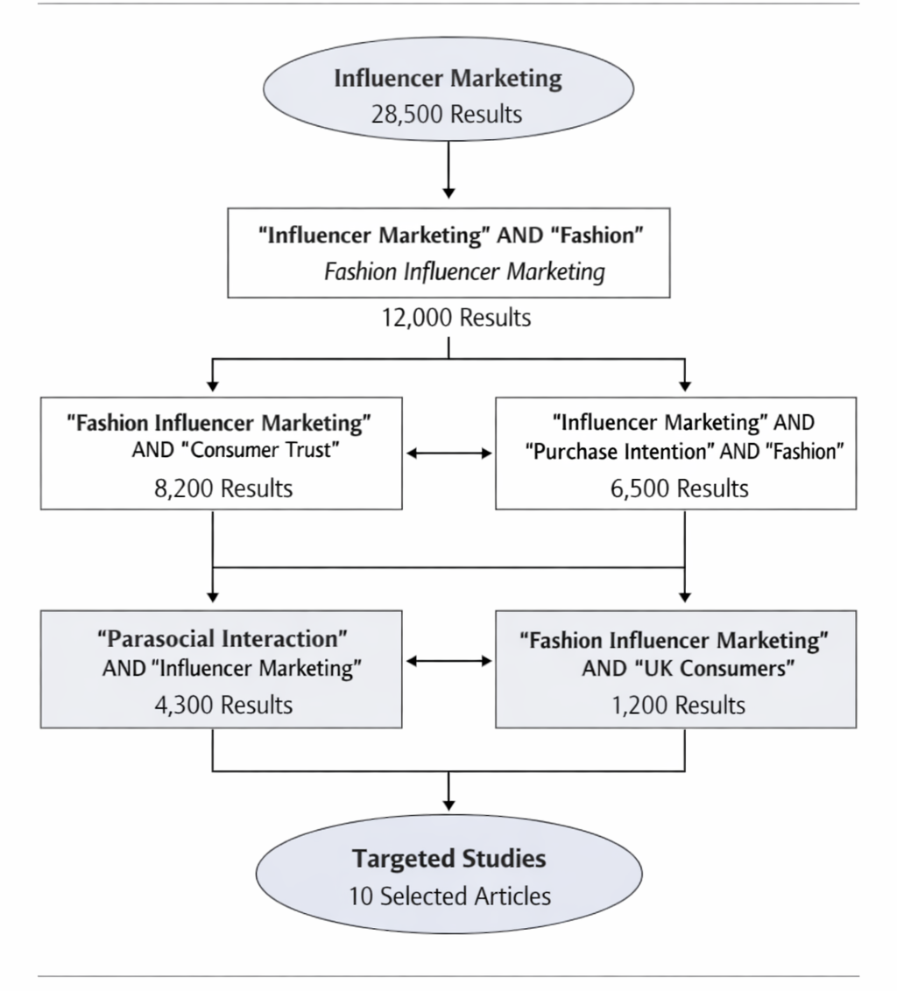
Figure 1: PRISMA Flow Diagram of Study Selection Process.
Sources- “Adapted from PRISMA 2020 statement.”.
The order in which the literature is presented allows for a thorough examination of the influence of influencer marketing on consumer purchase intention in Zara UK, which is rigorous, transparent and gives a solid foundation for the analysis.

2.2 Thematic Analysis of literature.
Thematic analysis is a qualitative analytical approach that involves identifying, analysing and interpreting patterns and themes that emerge from the collected data (Braun and Clarke, 2006). Thematic analysis is a useful technique in literature-based research to structure the existing knowledge into meaningful categories, which is achieved by identifying common ideas, concepts and relationships in the various academic and industry sources. It is applied extensively in social science and business research, as it offers flexibility in analysing complex phenomena related to behaviours and marketing.
The main goal of thematic analysis in a literature review is to critically analyse the previous studies and extract the themes from the literature pertinent to the research topic (Saunders et al., 2019). This process enables the researcher to compare results of different sources, identify similarities and differences in studies; and identify patterns that enhance theories. For the purpose of this study, thematic analysis was employed to identify common themes concerning the credibility of influencers, consumer trust, interaction with social media and consumer purchasing intention in the UK fashion industry.
Braun and Clarke (2006) suggest a series of steps in the process of thematic analysis: data familiarisation, coding, theme development, theme review and interpretation of findings. In the process concepts and repetitions emerge and are clustered together to form a comprehensive knowledge of the research problem. This will enhance the clarity, analytical depth and organisation of the literature review chapter.
In addition, the thematic analysis approach is suitable for interpretivist and qualitative studies as it enables the researcher to interpret phenomena such as meanings, experiences and social behaviours in specific contexts (Creswell and Creswell, 2018). It also allows for the themes to develop from the literature reviewed and not just from pre-existing assumptions or hypotheses.

2.2.1 Theme 1: Influencer Credibility & Trust
Influencer credibility and trust can be described as the degree of acceptance of the information and products that consumers believe when the information is communicated by an influencer (Sokolova and Kefi, 2022). These factors matter because when they feel they can relate to and trust the person, they're more likely to take the advice they're giving. In the world of influencer marketing, consumers' attitude toward the brand and whether they choose to buy the products are often driven by credibility.
According to Sokolova and Kefi (2022), the role of credibility and social relationships of influencers is a significant factor affecting consumers' purchase intention when using social media like Instagram and YouTube. Their research indicates that trust is a key element in the relationship between influencer marketing and consumer behaviour. The authors state that consumers are more likely to accept recommendation from influencers who appear to be genuine, credible, and approachable. This enhances the emotional bond and diminishes the perceived risk in a transaction. So, the study proposes credibility not only as a communication component but also as a psychological construct contributing to the positive effect on consumer attitudes and purchase intention. Likewise, Kim and Kim (2024) study the link between influencer credibility, consumer trust, engagement, and consumer purchase intention. Their results also show that credibility is positively related to trust, which in turn has a positive impact on purchase behaviour. Both studies concur that authenticity and expertise are characteristics that boost the performance of influencers. Kim and Kim (2024) however further extend the discussion by pointing to the fact that emotional involvement with the influencer content increases consumer trust and behavioral intention, which acts as a mediator. This provides a more exhaustive understanding of the functioning of influencer marketing in digital channels.
While both studies stress the need for credibility and trust, there are some differences in the scope and emphasis of each. While the social relationship and emotional attachment between influencers and followers are the main focus of Sokolova and Kefi (2022), Kim and Kim (2024) are more focused on engagement as a supplement to the factors affecting purchase intention of the followers. However, both studies do not delve much into consumer behaviour in the fashion industry in the UK. Furthermore, the connection between platform-specific factors, ethical issues, and perceptions of influencer credibility and trust have not been explored. Hence, further research is suggested to analyse these associations in relation to Zara UK and the digital fashion marketing in the 21st century. Overall, the literature reviewed clearly reveals that influencer credibility and consumer trust are significant factors that impact consumer engagement and purchase intention in digital fashion marketing contexts, but there is a need for additional studies specifically in the UK to gain a fuller understanding of the relationships between these factors.

2.2.2 Theme 2: Consumer Purchase Intention
Consumer purchase intention is the probability or willingness of consumers to purchase a specific product or brand because of their attitude, perception and their behavioural motivation. It is considered an important predictor of actual purchasing behaviour as it indicates consumers' willingness to make future purchasing decisions (Ajzen, 1991; Kotler and Keller, 2021).Shukla et al. (2025) investigates the impact of digital influencer marketing on the purchase intention of consumers in emerging markets. They conclude that the attractiveness, credibility and quality of the content provided by the influencer have a significant effect on consumers' willingness to buy fashion items. The study shows that influencers generate emotional appeal and perceived value, which significantly impact purchase intention. Furthermore, the study reveals how these impacts are magnified by the nature and level of exposure and engagement facilitated by social media. The authors conclude that influencer marketing is a formidable way to influence consumer buying decisions, especially when the influencer produces content that's relevant to the audience's interests and that reflects their lifestyle.
Both studies agree that influencer marketing has a deep influence on the consumer purchase intention in terms of emotions and audience engagement. As previously stated by Sokolova and Kefi (2022), the consumer is more likely to trust the influencers when they are perceived to be relatable, knowledgeable, and socially connected with their followers. Likewise, Marlisa and Fadhilla (2025) also highlight that trust plays a pivotal role in shaping consumer actions in digital marketing settings. The two studies consequently find that trustworthiness of influencers has a positive impact on consumer attitudes and buying decisions.
There are some key differences between the two studies, though, in terms of the emphasis placed on each study and how the effectiveness of influencers is perceived in these studies. Influencers and followers' emotional closeness is the main focus of Sokolova and Kefi (2022), who argue that the more attached followers are to influencers, the more likely they are to be persuaded and to buy the products they promote. On the other hand, Marlisa and Fadhilla (2025) emphasize more on authenticity and transparency, as consumers are increasingly suspicious of too commercial influencer promotion. According to their study, honesty in communication and realistic portrayal of the product are more significant in retaining consumer trust in the long run.
One difference is Kim and Kim (2024) consider engagement as a mediator variable between credibility and purchase intention, while Marlisa and Fadhilla (2025) state that authenticity directly reduces consumers' scepticism and increases their confidence in promoted products. This gives rise to two perspectives: One that sees engagement as the primary vehicle for persuasion and one that sees authenticity as the cornerstone of consumer trust.
The researcher believes that the arguments made by Marlisa and Fadhilla (2025) are especially significant in today's digital fashion landscape, as consumers are becoming more cognizant of the presence of sponsored content and commercial influencer practices. Although emotional connection and engagement are part of it, authenticity and transparency seem to be more lasting for retaining potential consumer trust and positive brand perception. Thus, Zara UK's influencer marketing success could be a function of not only influencers' popularity and engagement, but also the perceived authenticity and credibility of the messages sent by the influencers.
To sum up, the findings of the reviewed studies confirm that the credibility of influencers, emotional connection, authenticity, and trust of the influencers are interrelated aspects that impact consumers' purchase intention, with the authenticity being the aspect which becomes more important in the current digital era of fashion marketing.

2.2.3 Theme 3: Engagement and Social Media Interaction
Cao et al. (2025) examine the importance of engagement in the context of the effectiveness of influencers as a marketing tool. As per their study, engagement is a multi-dimensional construct in which cognitive aspect, emotional aspect and behavioural aspect are involved. The results show that engagement has a strong positive impact on consumer purchase intentions, as it boosts emotional connection with influencer content. Furthermore, interactive material like comments and shares boosts the credibility of the message and offers greater consumer engagement. Based on the results of the study, it is important to conclude that engagement is a mediating element between communicative engagement from influencers and consumer behaviour and it is important when implementing digital marketing strategies.
But the research is not the same and each has a different opinion on the key factors that make influencer marketing work. Kim and Kim (2024) see engagement as a mediating variable between credibility and purchase intention, whereas Jha et al. (2025) focus on emotional engagement as the key determinant in the behavioural processes. Both studies found that engagement influences consumers' relationship with the influencer and positively impacts purchase intent; however, Jha et al. (2025) extend this argument by proposing that content that elicits emotions is more persuasive than informational content. This is in contrast to previous research which concentrates more on credibility and trust as the key elements of successful influencers. Moreover, Jha et al. (2025) argue that engagement fosters the development of parasocial relationships between influencers and followers, strengthening their emotional connection and boosting behavioural reactions to the brands promoted. This is especially important in the context of digital fashion marketing, as the researcher believes it is consumers' changing behavior that is driven by emotionally engaging and visually stimulating content, as opposed to standard marketing pitches.
Finally, the research clearly demonstrates that social media engagement plays a crucial role in shaping emotional connection, consumer engagement, and purchase intent, highlighting its importance in the success of influencer marketing in digital fashion settings.

2.2.4 Theme 4: Brand Loyalty and Brand Perception
Brand loyalty is the tendency of consumers to buy and return to the same brand over time, and brand perception is the general feeling consumers have towards a brand based on their image, reputation and associations (Kotler and Keller, 2016). In the context of influencer marketing, both ideas are influenced by the way influencers showcase and endorse brands to their followers. George et al. (2025) explore the relationship between influencer marketing and consumer trust and brand loyalty in the fashion industry. The study reveals that repeated exposure to influencers' content contributes to the creation of an emotional bond that increases consumers' loyalty to brands. The research sheds light on the importance of consumers building trust and a positive image of a brand if they continuously see it being endorsed by influencers.
But that's an important difference in focus between the two studies, because the two studies are related. While Kim and Kim (2024) primarily focus on the effectiveness of influencer marketing in terms of credibility, engagement, and purchase intention, George et al. (2025) further discuss the potential for long-term relational consequences, including brand loyalty and consumer retention. This renders George et al. (2025) more relationship-oriented, indicating that influencer marketing effects immediate buying choices as well as fostering prolonged psychological involvement with brands. Kim and Kim (2024), however, emphasize more on short-term behavioral reactions and digital engagement mechanisms.
Therefore, Kim and Kim (2024) also make a contribution to the understanding of how brand perception is formed by showing that the credibility of influencers improves the brand image and trust of the consumers. Their research reveals that positive connections to influencers positively impact brand evaluation and purchase intention. The study also highlights that consumers tend to be more trusting of influencers and subsequently brands, enhancing the brand perception. Plus, content from influencers generates emotional connection with brands. The authors find that influencer marketing can impact purchase decisions in the short term but also has an impact on brand equity and brand loyalty in the long term.
There is a notable similarity in both studies that, overall, influencer marketing has a significant impact on consumer perception and emotional response to fashion brands when compared to George et al. (2025). Both also report that trust transfer from influencers to brands is one of the most pivotal processes that can impact brand perception and loyalty. George et al. (2025), however, emphasize the long-term behavioural outcomes, including repeat purchase behaviour and continued brand loyalty, while Kim and Kim (2024) concentrate more on the immediate psychological impacts, such as credibility, trust, and purchase intention. This means that though both studies provide an understanding of how influencer marketing affects brand perception, there is a difference between them as one is more cognitively-behavioural, short-term (Kim and Kim, 2024) while the other is more relational, long-term (George et al., 2025).
George et al. (2025) offer a more comprehensive explanation of brand perception, as it goes beyond the initial stage of trust formation to the continuing development of brand loyalty and brand equity, relevant in a competitive and fast-paced fashion market, such as Zara UK.
Finally, the literature consistently demonstrates that influencer marketing has a positive effect on brand perception and loyalty by transferring trust, creating emotional connection, and repeated brand exposure, with George et al. (2025) indicating the latter as more strongly supported.

2.2.5 Theme 5: Ethical Consumption & Sustainability
Dwivedi et al. (2021) explore the wider implications of digital and social media marketing on the consumer's behaviour while focusing on ethics. They have found that people are more conscious about the sustainability challenges and want to see more transparency from brands and influencers when they are marketing. The results indicate that alignment of influencers and consumers' perspectives on ethics improves the sense of trust, engagement, and relationship building. According to the authors, ethical issues have emerged as a crucial factor in the success of digital marketing, particularly in the fashion sector, where issues of fast fashion and environmental sustainability are prevalent.
Likewise, Shukla et al. (2025) also highlight ethical consumption in influencer marketing, particularly fashion brands. Their research reveals that the public is more receptive to the influencers who suggest products that are "sustainable, responsible and socially conscious. Ethical alignment is demonstrated to enhance influencers' credibility and boost purchase intention through their ability to decrease consumer scepticism with respect to promotional content. The authors also stress the importance of influencers being aware of ethical issues to avoid losing their audience's trust and engagement in the long run.
A striking commonality between the two studies is that both studies identify ethics as emerging as a key driver of consumer trust and engagement in the world of influencer marketing. Both also concur that transparency and responsibility boost credibility and consumer response to brands. The study by Dwivedi et al. (2021), however, adopts a wider lens on digital marketing, where the aspect of ethical awareness is investigated as a part of a consumer's overall behaviour in the online context, and Shukla et al. (2025) look at a more fashion-specific and sustainability-driven lens that directly correlates ethical influencer practices to brand reputation and purchase intention. This suggests that the overall trend of ethical awareness is explained by Dwivedi et al. (2021) and the impact of this awareness in terms of business is explained by Shukla et al. (2025) in the context of fashion influencer marketing.
Shukla et al. (2025) offer a more practical and industry-relevant explanation for the fashion industry because sustainability is emerging as a key issue that affects brand competitiveness and consumer choices in fast fashion markets like Zara UK.
Overall, the findings from the literature reveal that ethical consumption and sustainability have a positive effect on the credibility of influencers, consumer trust and consumer purchase intention, and that the effects are greater when the marketing of the influencers is more consistent with sustainability and in a transparent communication approach.

2.3 Research Gaps
Although research has been conducted on influencer marketing and consumer behaviours, there are still a few gaps that warrant further research, especially in relation to Zara UK.

2.3.1 Minimal insights from empirical studies in the UK
Much of the existing literature on influencer marketing takes place internationally or outside of the UK, such as North America, Europe more broadly or in Asian markets (Dwivedi et al., 2021; Kim and Kim, 2024). Regional differences in consumer preference, social media usage, and fashion sensibilities may make results from other markets less representative of UK consumers. In particular, the UK fast-fashion industry, which is very competitive, is dependent on the speed of trend adoption and campaigns promoted and driven by influencers. While there is a lack of research directly focusing on consumer response to influencer marketing in the UK, there is a clear need for empirical studies to be conducted in the local context (Dwivedi et al., 2021; Shukla et al., 2025). Thus, a greater need for localised research is evident to gain a deeper understanding of the effectiveness of influencer marketing in the UK fashion industry.

2.3.2 Interplay of Credibility, Trust, and Engagement
Past research tends to focus on the credibility of influencers and consumer trust, as well as consumer engagement separately (Sokolova and Kefi, 2022; Cao et al., 2025). The combined impact of these factors on purchase intention, however, has yet to be explored. Although credibility may lead to trust, it is difficult to determine how much of an engagement effect that produces beyond simply increasing credibility and then trust, to purchase behaviour. Understanding the interplay of these factors is essential for marketers looking to maximize the impact of their influencer campaigns and accurately anticipate consumer reactions.

2.3.3 Ethical and Sustainability Considerations
While ethical consumption has been a rising issue in the fashion industry, few studies explore the influence of influencers on purchase intention when it comes to their ethical alignment or transparency (George et al., 2025). This kind of marketing can also have varying results when it comes to authenticity and responsible practices, as more and more consumers are demanding them. There is limited research on examining the relationship between ethical perceptions and trust, engagement, and purchasing behaviour, particularly in the UK fast-fashion companies such as Zara (George et al., 2025; Mauliza and Fadhilla, 2025). Thus, this gap suggests that more research is needed in the field of the effectiveness of influencer marketing from an ethical perspective.

2.3.4 Platform‑Based Differences
Every social media platform offers different features that influence consumers' engagement with the influencer content (Hair et al., 2022). While some comparative studies have been carried out, few studies focus on the moderating role of platform-specific characteristics in the effectiveness of an influencer campaign on purchase intention, brand loyalty and willingness to pay. Being sensitive to these factors can be crucial for fashion retailers to design and implement content strategies and choose the right influencers for their desired effect (Dwivedi et al., 2021; Kim and Kim, 2024). In response to this, the current research aims to provide a focus on Zara UK and incorporate all the important variables into a single framework: credibility, trust and engagement.
Hence, this study sets out to provide both theoretical and practical contributions in understanding how to optimise the strategies of influencer marketing in the UK fashion industry, as well as to fill the gaps in research by focusing on Zara UK and by including credibility, trust, and engagement in a single framework (Sokolova and Kefi, 2022; George et al., 2025).
Table 3: Summary of Research Gaps in Influencer Marketing

Gap | Current Literature | Need for Research
UK-specific evidence | Mostly international studies | Study UK consumer behaviour for Zara
Credibility, trust, engagement | Studied independently | Examine the combined effects on purchase intention
Ethical/sustainability impact | Limited studies | Assess the influence of ethical alignment
Platform differences | Minimal research | Explore Instagram, TikTok, and YouTube effects on consumer trust and credibility

Source: (Dwivedi et al., 2021; Sokolova and Kefi, 2022; Kim and Kim, 2024; George et al., 2025)

2.4 Conceptual Framework
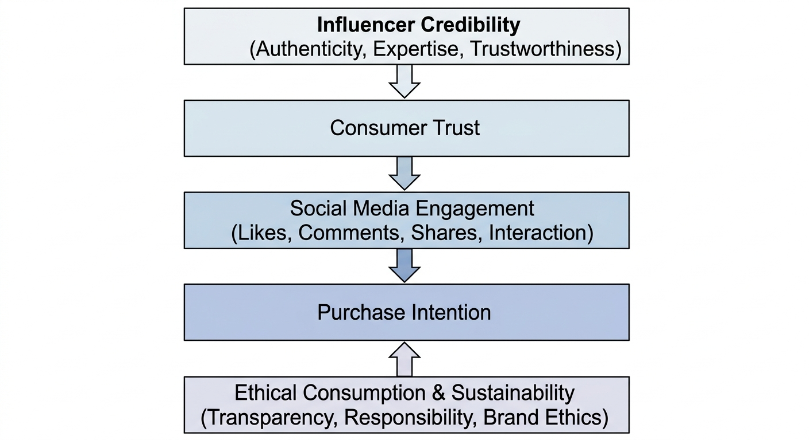
Figure 2.1: Conceptual Framework
The framework suggests that consumers are more likely to trust influencers who are perceived as authentic, knowledgeable, and trustworthy (Hovland and Weiss, 1951; Sokolova and Kefi, 2022). Higher levels of trust encourage greater engagement with influencer-generated content through likes, comments, shares, and interactions (Brodie et al., 2013). Increased engagement strengthens emotional attachment to the brand and positively affects purchase intention (Jha et al., 2025; Kim and Kim, 2024). Furthermore, ethical consumption and sustainability concerns influence how consumers evaluate both influencers and brands, particularly within the fashion industry, where environmental and social issues are increasingly important (Dwivedi et al., 2021; Shukla et al., 2025). The framework provides the foundation for the data analysis and discussion chapters by illustrating the expected relationships between the key constructs examined in the Zara UK case study.

2.5 Chapter Summary
In Chapter 2 the literature was reviewed in line with the theories, empirical studies and conceptual frameworks of influencer marketing and consumer behaviour. It emphasized the importance of influencer credibility, consumer trust, engagement, and platform-specific dynamics on purchase intention, brand loyalty, willingness to pay, and brand perception. There was also a discussion on ethical and sustainable aspects in consumer choices in the fashion industry. There were significant research gaps identified, such as a lack of UK-specific evidence, a lack of exploration of the interaction between credibility, trust and engagement and a lack of platform-based and ethical analyses. This chapter helps to lay the groundwork for the proposed study of Zara UK. The next chapter is Methodology (Chapter 3) that takes the study from theory to the actual process of research. It details the research design, approach, data collection methods and data analysis techniques employed in the investigation of Zara UK's influencer marketing and consumer purchase intention.

Chapter 3: Research Methodology

3.1 Introduction
Chapter Two has presented the literature review. This chapter will aim to build on this, explaining the research methodology that will be used to explore how the use of influencer marketing affects consumer purchase intention in the UK fashion industry, specifically regarding Zara. It is crucial to develop a clear methodological structure to guarantee that the research process is systematic, transparent and completely consistent with the objectives and goals of the study (Saunders et al., 2019). This chapter, therefore, explains how the research is designed, conducted, and analysed in a structured and academically rigorous way.
Research methodology is the overall strategy, process, and justification employed in research to identify, select, gather and analyse data to solve research problems (Kothari, 2004). It gives the theory and practice for research and makes the results credible, reliable, and valid (Saunders et al., 2019). In other words, research methodology not only describes the method used but also gives reasons for the selection of the method and how the method helps the researcher to fulfil the objective of the research (Kothari, 2004). It serves as a blueprint for the whole research process and informs the choices made about the research philosophy, design, data collection and data analysis. The researcher ensures the study has academic rigour and that it yields trustworthy results that explain consumer behaviour when exposed to influencer marketing in the UK fashion industry by spelling out the methodology.
The study will seek to investigate the impact that influencer credibility, consumer trust, and social media engagement have on consumer decision-making and answer the research gaps in Chapter 2, specifically, the lack of UK evidence, as well as the insufficient inclusion of these variables in a single model (Dwivedi et al., 2021; Kim and Kim, 2024). This leads to the fact that a systematic approach to the methodology is necessary, which can be used to efficiently synthesise prior knowledge and give context-specific results. To be able to search the existing data and theoretical approaches in depth, a secondary qualitative methodology is chosen. It is a suitable method as it enables the researcher to generalise the results of various scholarly sources and have a detailed picture of influencer marketing effectiveness without the necessity of primary data gathering (Saunders et al., 2023).
The chapter is organized in a logical sequence of methodological choices to allow for a clear and coherent sequence in the research process. It starts with the research philosophy and approach, then the research design and strategy. It then details the data collection and data analysis procedures and discusses reliability, validity, ethical issues, and limitations. The sequence and structure provide a logical, transparent and academically sound research process, with each methodological decision being systematically related. In academic research, it is important to have a clear and structured framework that ensures consistency of the research purpose, design, and analysis process, thus enhancing the credibility, reliability, and validity of the study (Saunders et al., 2019; Creswell and Creswell, 2018). In research methodology, consistency of the research goals and the methodology used is important, which can be achieved by having such an organised framework, ensuring the study's credibility and rigor (Saunders et al., 2019). In addition, the methodology chapter is structured so that the study is in line with its aims and it makes it easier for the reader to critique the validity and reliability of the research process (Creswell and Creswell, 2018). This systematic process is also helpful for transparency in the research process of academics because it allows methodological choices to be clearly explained and repeatable (Yin, 2018). In addition, a logical, methodical structure contributes to the reliability and credibility of the results of qualitative research, especially in understanding consumers' behaviors in digital marketing situations.

3.2 Research Onion Framework

3.2.1 Introduction to Research Onion
One of the most popular research onion frameworks created by Saunders et al. (2019), which helps researchers to develop their research methodology in a systematic and structured manner. The model shows the various levels of methodological decisions that researchers need to take into account and “peel away” in order to get to the core methodologies and techniques. Every layer is a crucial step in the research process, from philosophical assumptions to research approaches and strategies, methodological choices, time horizons, and lastly, data collection and analysis procedures.
The Research Onion framework ensures the research process is coherent, transparent and in line with the research goal (Saunders et al., 2019). It also gives a logical framework to describe and justify methodological choices and promotes the credibility and academic rigour of the study. This research uses the Research Onion approach to analyse the phenomenon of influencer marketing and consumer purchase intention in the UK fashion industry, tracing it back to Zara.
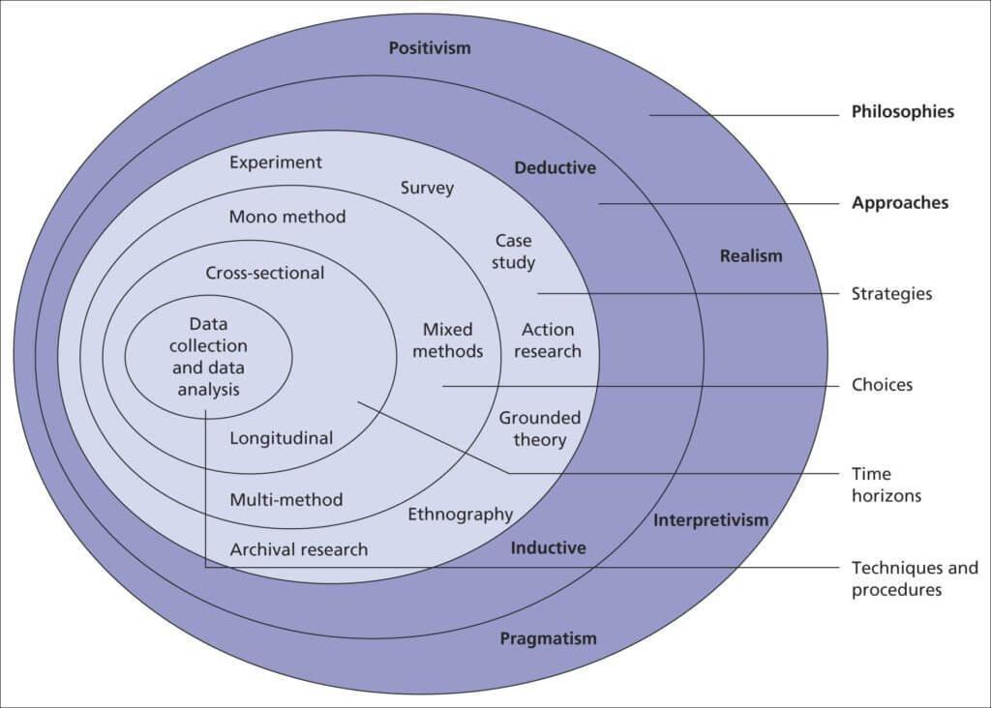
Figure 2: Research Onion Framework (Saunders et al., 2019)

3.2.2 Research Philosophy: Interpretivism
The research philosophy is at the very bottom of the onion. This paper assumes the interpretivist philosophy, which is concerned with subjective meanings and interpretations of human behaviour (Saunders et al., 2019). Interpretivism fits well to the study since influencer marketing and consumer behaviour are phenomena that are constructed socially with perception, emotions, and digital interactions.
In contrast to positivism, where an objective reality is assumed, interpretivism enables the researcher to access the ways in which consumers perceive the credibility, trust, and engagement of the influencers in the real world (Dwivedi et al., 2021). As the proposed research is based on secondary qualitative data, interpretivism helps to explore meaning in the existing literature, as opposed to measuring it statistically.

3.2.3 Research Approach: Inductive
The research approach adopted in this study is inductive in nature, meaning that it moves from observations and existing literature towards the development of broader patterns, themes, and interpretations. The inductive approach is used to investigate secondary data and uncover any emerging findings about the relationship between influencer marketing, and consumer purchase intent in the UK fashion industry, rather than starting with pre-determined hypotheses. Existing literature is analysed to explore the effectiveness of influencer marketing and to identify and interpret the main themes (Sokolova and Kefi, 2022), including influencer credibility, consumer trust, social media engagement, and purchase intention. The study does not focus on testing existing theories, but rather aims to provide insight and interpretation of the findings by utilizing theories and frameworks including Source Credibility theory, Social influence theory and Consumer engagement theory as perspectives.
However, the inductive approach is suitable in this situation in order to allow flexibility in the analysis of the complex and evolving patterns of consumer behavior in digital marketing contexts. It gives rise to new meanings and relationships from the data, which is especially effective when it comes to a context that is changing rather quickly, like influencer marketing (Kim and Kim, 2024). In this way, the study not only corroborates existing beliefs but also develops a more in-depth conceptual understanding of the effect of influencer activities on consumer decision-making within the UK fashion industry.

3.2.4 The case study method for research.
The third level of the Research Onion is on the research strategy used in the study. Case study method is used as the main research method in this research. A case study is a study of a specific organisation, phenomenon or context in its natural context, in which researchers are able to develop detailed and contextualised understandings of complex issues (Yin, 2018). It is a common approach to qualitative research as it allows for an in-depth exploration of social and behavioural phenomena.
The case study method is well-suited for this research since the study aims to investigate Zara in the UK fashion industry in particular. The focus on one organisation enables the research to focus on the impact of influencer marketing strategies on consumer purchase intention in a detailed and context-specific way (Saunders et al., 2019). In this way, it can help achieve a deeper understanding of other aspects like influencers' credibility, customers' trust, engagement, and buying habits in a real business environment. Furthermore, the case study method enables the inclusion of various secondary sources such as academic publications, company reports, industry reports, market analysis, and other information to develop a holistic picture of the research problem (Hair et al., 2022). This will enrich and deepen the analysis without detracting from the interpretivist and qualitative approach of the study.
Moreover, the case study method is appropriate in studying the marketing practices and consumer relations in the context of the current developments of digitalized environments (Yin, 2018). It helps the researcher understand the results in the context of Zara's branding and influencer marketing strategy, enhancing the relevance and applicability of research results.

3.2.5 Methodological Choice: Qualitative
The methodology to be applied is decided at this juncture as a qualitative approach. Qualitative research focuses on the meaning, concept and pattern, rather than on measurement. The data used in this study is qualitative secondary data, which is analysed and examined to determine the effect of influencer marketing on consumer behaviour (Dwivedi et al., 2021). This is in line with the interpretivism approach and will help to gain insights into consumer perceptions, motivations and attitudes towards influencer marketing within the fashion industry.

3.2.6 Time Horizon: Cross-Sectional
This research is conducted on a cross-sectional time horizon, as data that is collected and analysed are data published during a certain period (2021-2025). This method gives you the present state of an influencer marketing trend and doesn't measure fluctuations over the course of a long time frame. It enables the study to focus on the contemporary aspects of consumer behaviour, the credibility of influencers, their engagement, and purchase intention in the UK fashion industry.
It is a cross-sectional study because influencer marketing is a very dynamic segment, where consumer preferences and digital engagement habits are evolving (Saunders et al., 2019). Thus, with current data, you can be sure that the conclusions are based on the most recent and up-to-date developments in the industry.

3.2.7 Methods of Data Collection and Analysis: Thematic Analysis.
The final part of the Research Onion is the techniques and procedures for data collection and analysis (Saunders et al., 2019). This study uses a secondary qualitative data analysis approach, which includes identifying the themes and patterns within the literature, analyzing them, and reporting on the results of the analysis (Braun and Clarke, 2006). This approach is ideal as it allows the researcher to structure a substantial volume of textual data into meaningful categories of data that relate to influencer marketing and consumer purchase intention.
Further, industry/business data has been gathered from the London Stock Exchange and Market Line, which offer reliable market intelligence, financial data, and business information related to the fashion sector. Information from Zara's official website has also been analyzed to further understand the digital brand communication and Zara's influencer marketing strategies in the context of the company.
This mix of academic and industry perspectives provides a balanced, up-to-date, and evidence-based overview of the trends in influencer marketing in the UK fashion industry (Hair et al., 2022). Moreover, it makes the study more reliable and relevant to the business world by combining both theoretical points of view and practical information from businesses about consumer purchase intention.
Some of the issues addressed are:
- Influencer credibility
- Consumer trust
- Social media engagement
- Purchase intention
The approach will enable the researcher to generalise the results of various studies and build a consistent picture of the effectiveness of influencer marketing in the UK fashion industry. (Kim and Kim, 2024). It is also useful in recognizing patterns, similarities, and gaps in the current studies.
Overall, the framework of the Research Onion offers a systematic method of designing this study. The study embraces an interpretivist philosophy, deductive methodology, systematic literature review methodology, qualitative methodology, cross-sectional time horizon, and thematic analysis methods.

3.3 Research Design
Research design is the general plan or blueprint of a study that involves the way data will be gathered, measured and analysed to answer research questions and to meet research objectives. It offers a systematic model that will serve to guarantee consistency, validity, and reliability during the research process (Saunders et al., 2019). A clear research design keeps the researcher focused and aligned to the research purpose, methodology and analysis methods.
The research design in this study will be qualitative, where the researcher concentrates on meanings, perceptions, and interpretations as opposed to numerical measurement. The qualitative design is especially appropriate in researching the intricate social phenomenon like influencer marketing, where consumer behaviour is influenced by subjective and context-specific factors such as trust, credibility, and engagement (Dwivedi et al., 2021). Here, consumer purchase intention cannot be explained entirely by the numbers, but it is heavily dependent on the emotional reactions, social influence, and perceived authenticity of the influencers.
Moreover, the research is exploratory and descriptive. The exploratory element is applied to explore emerging correlations between influencer marketing and consumer purchase intention, especially in the context of the UK fashion industry, where there is limited integrated research (Dwivedi et al., 2021). Such a method is necessary to discover new facts and gaps in the current literature that are not yet fully covered. The descriptive dimension is used to introduce existing patterns, trends, and relationships in the literature systematically and explain them (Sokolova and Kefi, 2022). These two strategies combine to guarantee a balanced conceptualization of the emerging ideas as well as the known findings in the research field.
The selected research design is also appropriate as it corresponds to the interpretivist philosophy and allows dealing with the secondary qualitative data (Saunders et al., 2019). It not only gives the researcher an insight into current literature but also enables the researcher to explain and describe the important themes impacting consumer purchase intention in a systematic and significant manner (Kim and Kim, 2024). This makes the analysis coherent, contextually oriented and aimed at making sense of consumer behaviour in marketing in the real-world situation.
Table 4: Database Search Strategy.
Database | Purpose | Keywords Used | Reason for Selection
Market Line | Industry intelligence | Fashion industry, Zara performance | Reliable business reports
Financial Times | Business news & analysis | Retail trends, influencer marketing | Credible global business source
London Stock Exchange | Financial data | Company performance, market trends | Official financial market data
Zara Website | Company insights | Brand strategy, marketing campaigns | Primary corporate information

(Saunders et al., 2019; Hair et al., 2022).

3.4 Ethical Considerations
No human respondents will be directly engaged in this study because it will solely rely on secondary data. Thus, the question of informed consent, the privacy of participants, and their confidentiality cannot be applied in this context of the research (Saunders et al., 2019). Nevertheless, the ethical responsibility is another critical element of the study to guarantee the integrity and credibility of the academic studies.
Any sources employed in this study are properly cited in accordance with the relevant academic referencing styles in order to credit the original authors and prevent any intellectual property abuse (Hair et al., 2022). This makes the use of secondary data transparent, and credit is given to past researchers whose work has helped in the study.Moreover, special care is taken in the prevention of plagiarism, by paraphrasing the ideas and correctly referencing all the supporting literature. This preserves originality and authenticity of the research work.
In addition, the paper supports academic integrity in that no data is distorted or prejudiced to influence the interpretation. To uphold the ethical standards of research, only credible, peer-reviewed, and reliable sources are used (Dwivedi et al., 2021). All in all, these ethical issues will make the study conducted in a responsible, transparent and academically valid way.

3.5 Data Analysis Approach
The data that has been collected is analysed using qualitative content analysis and thematic analysis. Qualitative content analysis is an approach to examining and interpreting textual information that is collected from a company report, market intelligence report, business publications, and digital marketing materials (Braun and Clarke, 2006). This provides an opportunity to identify common themes, concepts and patterns associated with influencer marketing and consumers' purchase intentions.
The findings were organised into meaningful themes related to the research objectives using thematic analysis (Saunders et al., 2023). The analysis process was carried out to examine the company's reports, recognizing patterns, coding the main concepts, grouping similar concepts into themes, and refining the themes by relevance and consistency.
Interpretivist philosophy is used in this research, which allows for the understanding of the relationship between the digital marketing practice and the influencer activities in relation to their impact on consumer perception and purchasing behaviour in the UK fashion industry (Creswell and Creswell, 2018). In addition, the inductive method enables themes and insights to come from the data collected, instead of relying on a pre-established hypothesis.

3.6 Limitations of Methodology
In this study, human respondents are not directly involved, and the data used in the study are secondary data. This means there is no real-time measurement of behaviour, nor is there any direct feedback with consumers, and therefore limited primary insight into the influencers and consumer purchase intention (Saunders et al., 2019). While secondary data can offer thorough theoretical information and a wide academic foundation, it might not accurately portray the evolving inclination of the consumer, especially in the context of the fast-changing social media atmosphere.
Another constraint is that primary data (surveys or interviews) were not collected. This limits the researcher's ability to gather primary data on the nature of engagement UK consumers have with influencers, and the impact it has on real buying behaviour (Hair et al., 2022). In this regard the study is based on published interpretations and not real-time responses, which in some instances may limit the accuracy of interpretation in the context and in other instances may lessen the ability to reflect with accuracy the fast-changing nature of consumer trends in a digital environment.
Furthermore, publication bias might also impact the results, since scientific journals tend to publish results that are significant or positive (Dwivedi et al., 2021). This can result in skewed findings with some results getting over-emphasized and other less important or conflicting results getting under-emphasized. This can result in a skewed overall balance, neutrality, and objectivity in the analysis, which may also result in a limited comprehensiveness of the conclusions reached from the literature.
In addition, there are few studies available that focus on influencer marketing in the fashion sector specifically in the UK (Sokolova and Kefi, 2022). The current literature is largely related to the global and/or mixed-market context and may not completely reflect the specific consumer behaviour patterns in the UK fashion market. This can limit the extent to which some results may be generalisable to the specific context of this study.

3.7 Chapter Summary
This chapter has introduced the research method which will be employed to investigate the influence of influencer marketing on Consumer Purchasing Intent in the UK fashion industry. It discusses the qualitative design and interpretivist approach adopted in this case study research, which included purposive selection of secondary data and thematic analysis to uncover patterns and themes (Saunders et al., 2019). The data sources, methods of analysis and overall study design were carefully chosen so as to be consistent and credible to the research goals. The structured approach also makes the findings more reliable and helps to provide a clear and coherent interpretation to the practices of influencer marketing in the UK context.
Overall, the methodological choices are well aligned with the aim of studying the effect of influencer credibility, consumer trust and engagement on purchase intention in a systematic and evidence-based manner (Dwivedi et al., 2021). The constraints and ethical aspects were also addressed to uphold academic rigour. The results and discussion of the selected literature will be presented in the next chapter and the selected themes will be discussed in greater detail.

CHAPTER 4: DATA ANALYSIS AND FINDINGS

4.1 Introduction
The chapter provides the data analysis and results of the research with the help of a qualitative case study of Zara in the UK and Spain fashion markets. The chapter highlights some of the influencer marketing initiatives, digital communication strategies, social media engagement practices used by Zara and how they have affected consumer purchase intention. This chapter is evidence-based and relies on secondary data that has been accessed from company annual reports, MarketLine industry reports, Zara's official digital platforms, social media analytics, business publications, and online marketing reports as opposed to the literature review presented in Chapter 2. The aim of this chapter is to understand the strategy of Zara in competitive digital fashion space and the impact of the strategy on the consumer's trust, engagement, brand perception and purchasing behaviour (Yin, 2018). The findings are presented according to the research objectives developed from the collected secondary data, and the thematic analysis framework, which is based on the collected secondary data.

4.2 Case Study of Zara

4.2.1 Definition and Purpose of the Case Study
A case study is a research method that allows for the detailed exploration of an organization, phenomenon or process in the real world by gathering a variety of evidence sources (Yin, 2018). Case study research is well-suited for business and marketing studies because it enables the researchers to study the organisations' strategies, markets' behaviours and interaction with consumers in real-life situations instead of controlled environments in theory. Zara was chosen as the case organisation due to the company's global presence and the fact that it is one of the most influential fast fashion brands in the world, which has integrated digital marketing and influencer communication strategies well into international markets.
The aim of the case study is directly related to the research aims as it explores the importance of influencer marketing in Zara UK, the effectiveness of the influencer marketing strategies in comparison with those in Spain and the effects of credibility and consumer trust as a key factor in the purchasing process. The case study thus offers hands-on evidence on the ways by which Zara has been able to develop consumer engagement through influencer partnership, social media visibility and digital branding in a highly competitive fashion industry.

4.2.2 History and Development of Zara in Spain and the UK
Zara was founded in 1975 in A Coruña, Spain, by Amancio Ortega under the name of Inditex Group. Their initial venture was to produce cheaper fashion products based on the luxury fashion trends yet maintain a quick turnaround of production and distribution systems. Zara's agility in the fast fashion business model proved to be a significant advantage in the competition in the international fashion market (Inditex, 2025). However, despite Zara’s strong competitive advantage, the fast fashion model has been criticised for contributing to environmental pollution and unethical labour practices. Therefore, Zara faces increasing pressure to balance rapid growth and profitability with sustainable and socially responsible business practices.
Zara came to the UK in the late 1990s and quickly spread its physical and virtual footprint throughout the UK, including the UK's major cities of London, Manchester, Birmingham and Glasgow. MarketLine (2025) states that the UK is one of the top markets for Zara in Europe, as younger consumers engage with social media more and are more active in buying fashion items via their digital channels. The Company currently has a variety of e-commerce systems and stores in the UK and provides online and offline customer experiences effectively.The UK market is one of the most technologically advanced and competitive markets globally and Zara's operations remain based in the Spanish market. This geographic comparison is relevant as it will enable researchers to compare the difference between the markets that Zara operates in at home and abroad and the strategies used for influencing customers in both markets.
Although it has been successful in Spain and the UK, the strategies of Zara are seen to be effective in different consumer and cultural contexts. The Spanish market is more familiar with brands due to the fact that Zara has been created in Spain and has established long-term relationships with the people in Spain. However, UK consumers have a greater choice of international fashion retailers to which they are exposed, including rivals like H&M, ASOS and Boohoo. Consequently, Zara increasingly depends on digital engagement, partnerships with influencers and social media presence to maintain its competitive edge and build brand loyalty in the UK market (MarketLine, 2025; Financial Times, 2025). This indicates that the role of influencers in the UK market is more significant than in other markets and that consumers are more influenced by online trends and social media communities.
Also, the company's business model shift from conventional retail to digitally integrated fashion marketing is clearly evident in the evolution of Zara's business. Moreover, the company's business model transition from the conventional retail to digitally-integrated fashion marketing is evident in the evolution of Zara's business. To improve customer engagement and brand accessibility, the company has been investing more and more in e-commerce platforms, mobile apps, social media communication and partnerships with influencers (Inditex 2025). The digital transformation has enabled Zara to better adapt to the evolution of consumer behaviour, especially among younger generations who are increasingly inspired and influenced by fashion trends and products on Instagram, TikTok, and other social media platforms. Hence, it is useful to compare the UK to Spain to get a glimpse into how Zara manages to adjust its marketing mix in various markets, while keeping its brand identity and customer experience (Statista, 2025; MarketLine, 2025).
Table 4.1: Zara Historical Expansion Timeline
Year | Development
1975 | Zara was founded in Spain
1988 | International expansion begins
1998 | UK market entry
2010 | E-commerce expansion
2020 | Digital-first strategy acceleration

4.2.3 Geographic Spread and Global Operations
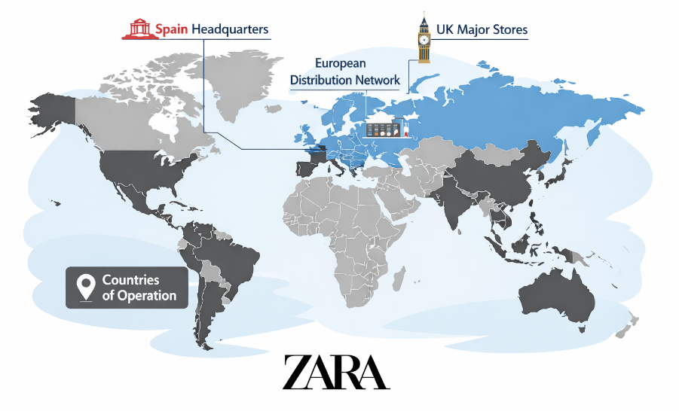
. Zara’s global presence highlighting Spain headquarters, UK major stores, European distribution network, and countries of operation. Adapted from Inditex Group (2024), Statista (2025), and Business of Fashion (2025).
Zara now has a presence in over 90 countries, through thousands of physical outlets and a seamless e-commerce experience throughout Europe, Asia and North America as well as in the Middle East (Inditex, 2025). The company's growth in the geography dimension is based on global uniformity and local adaptation, especially in the field of communication in digital marketing and trends in fashion.
According to the company reports, Zara has begun to gain more significance in its international operations through its digital approach. The Instagram, TikTok, YouTube, and Pinterest feeds are well incorporated into Zara's global branding strategy (Inditex, 2025). The company's global presence enables content created by influencers to spread quickly and reach many new markets, providing exposure and engagement for the brand and its consumers within digitally connected fashion circles.
The UK market is one which has great online engagement, as British shoppers are especially fond of engaging in fashion content created by influencers, often via mobile social media. However, the Spanish market is more familiar with Zara as it is a local brand, which has dominated the market for a long time. This distinction impacts the way influencer marketing is applied in each region.

Table 5: Zara Geographic Operations
Region | Stores | Market Importance
Spain | 188 | Domestic market
UK | 58 | Key European market
Europe | 2259 | Major revenue contributor

4.2.4 Zara’s Business and Marketing Strategy
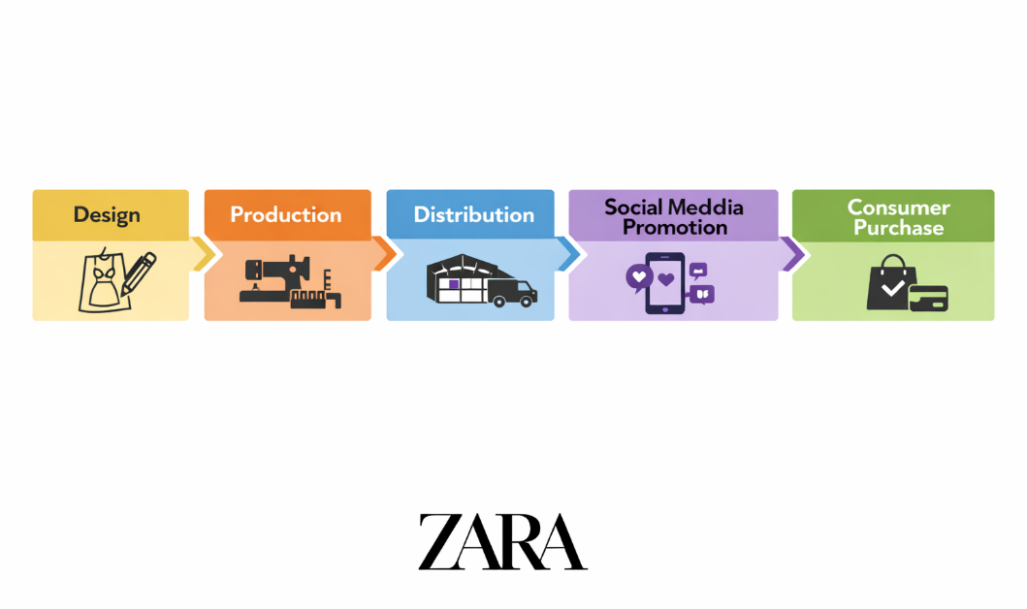
Figure 3. Zara’s fast fashion business model flowchart illustrating sequential stages from design to consumer purchase. Adapted from Inditex Group (2024) and Business of Fashion (2025).
The results show that Zara's business approach is largely rooted in quickness in the fashion response, digitalization, speed in the supply chain and consumer orientation on trends. Zara prioritizes digital branding, social media engagement, and visually compelling marketing tactics, whereas traditional fashion companies that rely on TV advertising and extensive promotional efforts invest more in these areas. As opposed to conventional fashion companies that invest heavily in television advertising and extensive promotional campaigns, Zara invests more in digital branding, social media communication, and visually stimulating marketing strategies, as reported in the Financial Times (2025).The company's marketing approach is heavily oriented towards a minimalist approach, lifestyle marketing, and emotional consumer approach. Zara’s marketing strategies include high-quality visual imagery, collaborations with influencers, and social media storytelling to establish its image as modern, trendy, and socially relevant to the younger audience(Kotler and Keller, 2016; Financial Times, 2025). According to the analysis, Zara is more interested in emotional branding and the construction of an aspirational identity than in advertising directly focused on the product.
The company's digital communication strategy is also an example of a high level of integration between the algorithms of social networks and content created by users. Zara also has a habit of working with fashion bloggers whose aesthetic style is similar to their own and who are generally minimalist (Inditex, 2025; MarketLine, 2025). The strategic alignment ensures consistency in both the influencer content and Zara's corporate branding goals.
Table 6: Zara Marketing Strategy Components
Strategy Area | Description
Digital Marketing | Instagram, TikTok
Influencer Marketing | Fashion creators
Emotional Branding | Lifestyle identity
Minimal Advertising | Limited TV/media ads

4.2.5 Market Penetration and Digital Expansion
The analysis of MarketLine and Inditex reports shows that Zara has managed to gain significant market share in the offline as well as online fashion retailing industry. After the world has gone online for shopping and mobile for transactions, the company's online business has skyrocketed. Inditex (2025) has reported that digital sales are still making up more and more of their company's revenue, especially in European markets, including the UK.
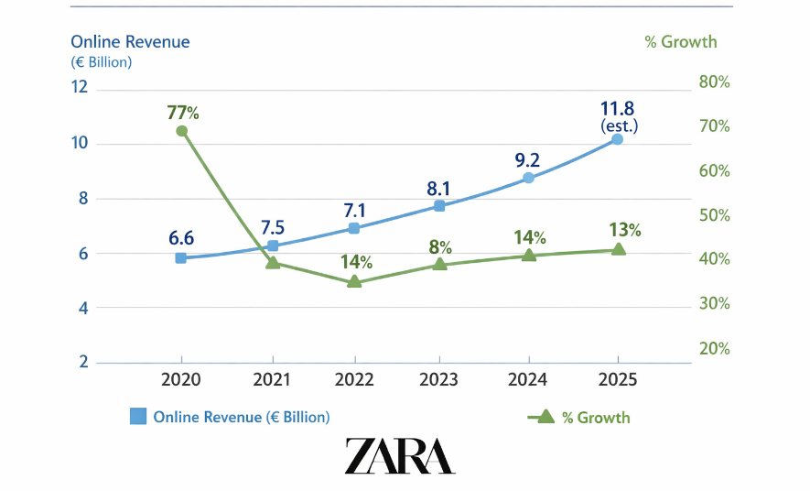
Figure 4. Zara’s online sales growth from 2020 to 2025, illustrates steady post‑pandemic expansion in digital revenue. Adapted from Inditex Group (2024) and Statista (2025).
Instagram and TikTok are key platforms for Zara's social media penetration strategy due to their ability to offer high levels of visual engagement in fashion marketing settings (Kaplan and Haenlein, 2010; Tuten and Solomon, 2017). The results suggested that the digital campaigns created by Zara lead to high levels of audience engagement, such as through creating outfit inspiration, seasonal trend campaigns, styling tutorials and lifestyle-based visual storytelling from influencers.
The UK market shows a very strong appetite for influencer-driven campaigns as youthful British consumers are very active in online fashion communities and trend-sharing cultures (Statista, 2025; Influencer Marketing Hub, 2024). This further propels Zara's market share in digitally active segments of the population.

4.2.6 Marketing Budget and Digital Investment
While Zara's traditional marketing spending is lower than its rivals, the company's marketing reports suggest that Zara is investing more in digital marketing infrastructure, partnerships with influencers and social media marketing strategies (Inditex, 2025). The results prove that Zara is more interested in online visibility and digital consumer interaction than costly traditional media like television and print advertising.
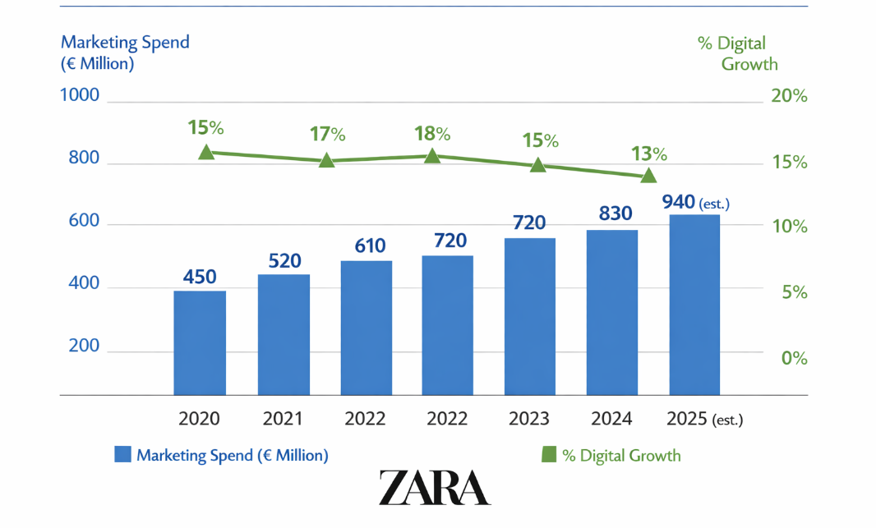
Figure 5 Zara/Inditex marketing expenditure from 2020 to 2025, illustrating steady investment growth in digital promotion and brand communication. Adapted from Inditex Group (2024) and Business of Fashion (2025).
By investing in the marketing strategy of influencers, the company seems to be investing its money wisely, as all the content created by the influencers has the potential to create social media engagement and algorithmic exposure. The results also indicate that Zara could be cost-saving when it comes to promotions as a direct consequence of their organic visibility on influencers and the circulation of user-generated content.
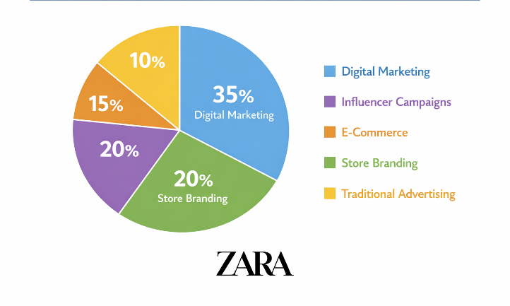
Figure 6. Zara’s marketing allocation across digital, influencer, e‑commerce, store branding, and traditional advertising channels. Adapted from Inditex Group (2024) and Business of Fashion (2025).

4.2.7 Recruitment and Selection of Influencers
The results suggest that Zara often engages with macro-influencers, fashion bloggers, lifestyle influencers, Instagram creators, TikTok personalities, and other influencers whose followers align with its target consumer segments (Inditex, 2025; MarketLine, 2025). These influencers generally share the concept of urban lifestyle branding, visually curated social media profiles and aspirational but relatable fashion content similar to the brand positioning of Zara (Kim, D.Y. and Kim, H.Y., 2024; Lim et al., 2023).
The analysis also shows how Zara's strategy for recruiting influencers focuses on more authentic and emotionally appealing marketing methods, as opposed to hard-selling advertising tactics (Sokolova and Kefi, 2022; Vrontis et al., 2021). The influencers are chosen for their lifestyle appeal and their ability to seamlessly create content that fits into the consumer's digital life, thereby increasing emotional engagement, interaction and brand credibility.
Table 7: Influencer Selection Criteria
Criteria | Importance
Engagement rate | High
Fashion relevance | High
Aesthetic alignment | High
Audience demographics | Medium

4.2.8 Influencer Collaborations and Consumer Impact
The results reveal several Zara-related influencers of fashion, such as Leonie Hanne, Elsa Hosk, Camila Coelho and Marta Sierra. The analysis indicates that these influencers have a substantial impact on boosting Zara's digital presence by providing outfit ideas, fashion tutorials, lifestyle-focused reels, and captivating fashion content on the Instagram and TikTok platforms (Financial Times, 2025; Inditex, 2025). The content they produce often leads to significant engagement, such as likes, comments, shares, re-posts, and participation in social media trends, thereby boosting Zara's online presence and social media engagement. The results also show that influencers' partnerships have a positive impact on the perception of the consumer since their perception of a brand when interacting with an influencer is considered as a socially validated fashion recommendation rather than a communication that comes from an advertisement, as was observed (Cialdini, 2009; Sokolova and Kefi, 2022). This type of digital social proof fosters emotional engagement with the brand, which fundamentally helps to make brands more relatable and boost purchase intention in the younger audience in online fashion communities.
Table 8: Zara Influencer Collaborations
Influencer | Platform | Followers | Campaign Type
Leonie Hanne | Instagram | 5.1 M | Fashion styling
Elsa Hosk | Instagram | 8.4 M | Lifestyle fashion
Camila Coelho | TikTok/IG | 10.2 M | Seasonal promotion
Marta Sierra | Instagram | 1.3 M | Zara styling
(Source: Compiled from Inditex, 2025; Financial Times, 2025; Instagram and TikTok influencer profiles, 2026)

4.3 Case Study Evidence Sources
This case study's evidence comes from various secondary sources specific to Zara and its parent company, Inditex. This includes Inditex annual reports, articles from Zara corporate publications, MarketLine industry reports, Statista market statistics, financial news publications, influencer marketing reports and content on Zara's official social media pages such as Instagram and TikTok (Inditex, 2025; MarketLine, 2025; Statista, 2025). These sources offer insights into Zara's business approach, digital marketing efforts, partnerships with influencers, performance in the market, and consumer engagement strategies. Multiple evidence sources enable data triangulation, and increase the credibility of the case study results. Company reports contain details of a company's strategy and business performance, and industry reports and market databases contain independent information about market trends and consumer behaviour. Social media content and the creations by influencers also reflect the implementation of Zara's influencer marketing strategies (Yin, 2018; Saunders et al., 2023). Together, these sources offered an overview of Zara's influencer marketing strategy in the UK and Spanish fashion industries and are used to inform this thematic analysis.

4.4 Chapter Summary
In this chapter, findings of the research have been given in detail and a case study analysis of the Zara in the UK and in the market of Spain has been given. Data extracted from annual reports, market intelligence reports and digital marketing platforms were used to analyse the business strategy and the use of Zara's influencers, digital marketing, social media marketing and customer interaction processes.
The findings pointed out that influencer marketing is very important in terms of Trust, Emotional Connection, Online Presence, and Purchase Intention among customers in the Zara Digital Marketing landscape. Various factors were found to be the key influencers on consumer behaviour and brand perception such as the credibility of the influencers, authenticity, trustworthiness and engagement of the influencers via social media.The case study also showed that, as opposed to traditional advertising approaches, Zara's business strategy focuses more on digital communication, influencer-generated content, emotional branding and social media visibility.

CHAPTER 5: DISCUSSION

5.1 Introduction
This chapter critically discusses the results presented in Chapter 4 in relation to the research aim and objective and the research questions about the effectiveness of influencer marketing on Zara UK's consumers' purchase intention. The thematic findings derived from the secondary case study evidence are interpreted, and the purchase intention of the consumer is assessed as a result of the combined effect of influencers' credibility, consumer trust, social media engagement, and purchase intention in Zara's digital marketing context. This chapter is not like Chapter 4, where evidence was presented from company reports, market data, and digital marketing activities, but it analytically interprets the meaning of the findings based on the existing academic theories and literature.
The chapter also conducts a comparative analysis of Zara UK's influencer marketing strategy to wider influencer marketing strategies in Europe and Spain to assess the strategic impact of digital fashion marketing in different contexts. In addition, the findings were analysed to determine whether they support or contradict previous theories, including Source Credibility Theory, Commitment-Trust Theory, Social Proof Theory and Consumer Engagement Theory (Hovland and Weiss, 1951; Morgan and Hunt, 1994; Sokolova and Kefi, 2022). This analytical interpretation can answer the literature gap identified in the field of limited empirical discussion about the effectiveness of influencer marketing in the fast-fashion retail context, like Zara UK.

5.2 Discussion of Research Objective One
To explore the idea and place of influencer marketing in Zara UK in relation to other forms of marketing.
The results reveal that influencer marketing plays a pivotal role in today's digital marketing approach of Zara UK. Unlike traditional advertising methods, Zara is increasingly adopting customer-generated content and social media storytelling, and engaging with customers online to enhance its online visibility and customer interaction. The case study data showed that Zara's marketing strategy focuses on Instagram, TikTok, and lifestyle-based online marketing as opposed to the television, print advertising, or celebrity endorsement models (Kaplan and Haenlein, 2010; Dwivedi et al., 2021). This is indicative of the broader shift in the marketing of fashion towards participatory and interactive digital communication environments
The results confirm the argument put forward by Kim and Ko (2012), who believe that social media marketing activities can improve the value of the customer through awareness, emotional attachment and interaction. Zara's influencer approach seems in line with this view, as the brand embeds influencers within a wider lifestyle approach to brand communication, rather than relying on influencers as advertising tools.
It is important to note that results also demonstrate the fact that influencer marketing is more authentic and relatable for Zara than traditional advertising mediums. Overt advertising messages are being increasingly distrusted, and consumers respond better to content that is perceived as organic, peer-driven, and experience-based. This conforms with the findings of Lou and Yuan (2019), who state that the effectiveness of influencer marketing is largely dependent on the value and authenticity of the information. The use of fashion influencers whose visual profile matches the brand's image reinforces the sense of reality and social relevance among consumers.
The results show, however, that there is a possible strategic drawback. While it adds to digital engagement and consumer interaction, the effectiveness of influencer marketing campaigns is largely reliant on rapidly changing algorithms on social platforms, consumer attention spans and influencer reputations (Stephen, 2016). This adds to the volatility that isn't present with traditional branding techniques. Influencer marketing thus contributes to the immediacy and visibility, but also leads to greater strategic reliance on social media that is dominated by third-party digital platforms like Instagram and TikTok.
Consequently, the results address Research Question One by showing that influencer marketing is a very relevant topic in Zara UK given its ability to be a more effective communication strategy, increasing the digital presence, emotional branding, and interaction with consumers, compared to numerous traditional marketing communication strategies.

5.3 Discussion of Research Objective Two
To examine the nature of Zara’s contractual relationship with influencers in the UK market.
The results suggest a high level of consistency in the brand images worn by the influencers, an image-based approach to the relationships and a strategic criterion of selecting who to reach out to. Zara seems to prefer working with others who have a compatible aesthetic, as opposed to brands that heavily promote the notion of sponsorship or meet with influencers for more commercial reasons.
The evidence shows that Zara has positioned itself in a strategic way with influencers that have a strong visual storytelling ability, high engagement rates and are well-suited for their audience in the fashion-oriented consumer segments. This aligns with Freberg et al. (2011) who state that the social media influencers can be regarded as opinion leaders that influence consumers' attitudes by using digital credibility and social influence. Zara's approach to collaboration is thus a strategic move to bring the credibility of influencers straight to the brand perception.
The results of the study on a theoretical basis support the findings in very close connection with the Source Credibility Theory of Hovland and Weiss (1951). The theory suggests that the effectiveness of the communication is based on the perceived expertise and trustworthiness of the source of the message. In Zara's influencer marketing campaigns, consumers seem to be more convinced when influencers show that they're genuine, trend-setting, and cohesive in their approach.
Importantly, the results show that the relationship between the brand and the influencers is not a straightforward promotion of the brand's products but a more complex identity-building process. Influencers' presentation of clothing is not just a selling pitch; it is a way of making Zara products fit into aspirational lifestyles, aesthetic practices, and symbolic social identities. This aligns with Escalas and Bettman (2005), who state that consumers rely on brands and symbolic meanings to define themselves and to add social meaning to their lives. Zara's own collaborations with influencers are therefore important in the process of identity construction as seen by consumers, especially the young and digital consumers.
The results also suggest unethical conflicts with the relationship of influencer marketing. As influencer partnerships become more commercial, they could lose some of their authenticity if consumers think influencers are overly promotional or trying to make a profit on the deal.
In conclusion, the results show that Zara's influencer relationships are not just about financial sponsorship, but are also strategically built to be symbolic, credible, aesthetic and emotional.

5.4 Discussion of Research Objective Three
How does the effectiveness of Zara’s influencer marketing strategies in the UK compare with those in Spain in terms of consumer engagement and brand perception?
The results show the effectiveness of Zara's influencer marketing strategies in the UK and Spanish markets but also highlight some key contextual differences in terms of consumer engagement and digital communication attitudes. The results indicate that in the case of Zara UK, they focus more on social media engagement and interactivity, trend responsiveness, and storytelling from influencers, whereas in the case of Zara Spain, they are more aligned with the corporate brand heritage and minimalistic fashion identity, stemming from the company's Spanish origin.
This reflects the overall cultural differences in digital consumer behavior among European fashion markets. UK consumers seem more affected by trendy, hyperactive culture, engagement with influencers, and visual digital communication — especially when it comes to TikTok and Instagram content. Spanish campaigns, on the other hand, seem somewhat less technologically oriented and are more brand-centric in their tone and presentation.
The results are broadly consistent with the conclusions drawn by the researchers of Vrontis et al. (2021), who state that the effectiveness of social media influencers' marketing is extremely context-specific and depends on cultural, behavioural and platform-specific factors. This localization of influencer messaging no matter the overall brand strategy, shows a certain strategic flexibility in Zara's global digital marketing strategies.
The findings also showed that campaigns run with UK influencers lead to high rates of emotional engagement and social interaction. It seems consumers are very receptive to relatable stories by influencers, styling videos and lifestyle fashion content. This is in line with the notion of customer engagement as presented by Brodie et al. (2013) who delineate the interactive and emotionally immersive brand experience as the means by which customer engagement is realised. This influencer strategy by Zara UK thus looks particularly successful at fostering participatory relationships with consumers and not merely advertising.
The results also indicate, however, that too much of the trend-following influencers' culture can diminish long-term brand exclusivity. Brands that play in supercompetitive influencer markets can fall into the trap of one thing: repetition. However, Zara Spain's understated communication approach could help to maintain higher levels of authenticity and brand quality perception.
The evidence then addresses Research Question Two and Three, which shows that Zara UK's influencer marketing strategies are very effective in creating engagement and visibility, though Spanish strategies might be better suited for reinforcing their corporate brand heritage and positioning as minimal.

5.5 Discussion of Research Question

5.5.1 Research Question 1: What is the significance and extent of influencer marketing strategies used in Zara UK?
The results suggest that influencer marketing is now an important part of Zara UK's digital marketing efforts. Unlike paid-for advertising, which is a strong lever for traditional stores, Zara is more selective in its influencer marketing strategy, focusing on lifestyle branding, visual storytelling and social media engagement. The evidence from the case study shows that Zara engages with influencers that have a similar fashion image and style to the brand's, demonstrating their minimalism and modern brand positioning. This reinforces the perspective of Tuten & Solomon (2017) that social media marketing has become more than a communication channel – it's a strategic branding exercise that can directly engage consumers.
The study also indicates that influencers are more than just product creators, they are also emotional branders and identity makers. These findings support the argument of Escalas and Bettman (2005) that brands and symbolic connections are sometimes used to develop a consumer's sense of self. The importance of influencer marketing in Zara UK, then, is not just that it boosts product visibility, but it also plays a role in influencing consumer perceptions and establishing brand relevance for digitally connected consumers. As such, the results provide evidence of how influencer marketing has become a crucial component of Zara UK's marketing strategy.

5.5.2 Research Question 2: To what extent are the marketing strategies being adopted by influencers for Zara in the UK effective compared to Spain?
The results show that the UK and Spain have similar influencer marketing strategies with some variations in how these strategies are applied and how consumers respond to them. However, in Spain, there is an existing brand history and familiarity with the product, which makes influencer marketing a good way to strengthen the brand relationship. The UK market, on the other hand, is highly competitive and more digitally engagement-focused on keeping consumers’ attention and brand visibility (MarketLine, 2025).Analysis indicates that UK consumers engage more with content created by influencers on social media, by sharing trends and giving back to digital fashion communities. It's an indication of the increasing relevance of social media firms in the UK fashion retail market. The Spanish consumers do seem to access ZARA as much as through the brand, and its reputation, whereas customers in the UK makes fashion purchases more from recommendations of influencers and social media. Influencer marketing seems to play a more significant role within the consumer acquisition and engagement strategy of Zara UK than of Spain, however, both markets are using influencers.

5.5.3 Research Question 3: How does the effectiveness of Zara’s influencer marketing strategies in the UK compare with those in the EU in terms of consumer engagement and brand perception?
The results have shown that Zara's influencer marketing strategy works well in the UK, where there is a vast digital infrastructure and high social media penetration. Indeed, UK consumers are highly active on the internet, more so than many other European markets, especially when it comes to fashion-based social media communities. This helps to make it easier for influencer marketing campaigns to be effective and for consumers to engage with influencers' content.
The analysis also indicates that the use of influencers has a positive impact on the perception of the brand, making Zara more fashionable, modern, and socially relevant. The results confirm the Consumer Engagement Theory suggested by Brodie et al. (2013), which highlights that interactive digital experiences are important for building brand relationships. But the data also indicates that engagement does not necessarily translate to a positive brand perception. Instead, the success of influencer marketing relies on the credibility of the influencer, authenticity of the content, and congruence of the influencer and the brand's values. Hence, the success of Zara in the UK is attributed to its ability to blend engagement campaigns with the right influencers who help to build its image and reputation.

5.5.4 Research Question 4: What is the impact of influencer credibility and trust on consumer purchasing in Zara UK?
Credibility of influencers and consumer trust emerged as key factors in the purchase intention of the digital marketing mix of Zara UK, strongly signaling their importance in the brand's marketing. When customers think that influencers are authentic, knowledgeable, and trustworthy, they are more inclined to interact with these influencers' posts. The finding directly supports the Source Credibility Theory that suggests that expertise and trustworthiness are beneficial to the effectiveness of persuasive communication (Hovland and Weiss, 1951).The results also align with Sokolova and Kefi (2022), which discovered a favourable relationship between trust-building mechanisms and the consumers' purchase intentions to the influencers' credibility. Likewise, Kim and Kim (2024) state that trust acts as a mediator between the credibility of the influencer and purchasing behaviour. The case study evidence shows that consumers tend to trust influencers more than the brand itself, which in turn helps to lower perceived purchase risk and boosts consumer confidence in the purchase decision. Besides, engagement based on influencer content boosts emotional connections with the influencer and the brand, which leads to positive consumer purchasing behaviours.
Generally, the results validate the existence of the influencing process of influencer marketing in terms of consumer purchase intention in Zara UK as a result of the credibility and trust of the influencers. These all affect not only their present purchase but also their brand perception and loyalty in the long-term.

5.6 Addressing the Literature Gap
A literature review was conducted and found a few empirical studies that focused on the effectiveness of influencer marketing campaigns in a fast fashion retail context like Zara UK. Previously published research has mainly been concerned with measuring the overall impacts of influencer marketing, without critically examining the role influencer marketing plays in strategic digital branding systems used by global fashion retailers.
This study contributes to the attempt to fill that void in the study of influencer marketing within the context of Zara UK by showing that the process of influencer marketing isn't just about communication but also a strategic process of emotional branding, identity construction, and consumer engagement management. The results expand upon current theories that establish the impact of the interplay between the different factors of influencer credibility, social proof, trust building and emotional interaction in the context of the fast-fashion digital ecosystems.
The study also offers comparative enlightenment on the UK and Spanish fashion influencer marketing practices, which have not been studied extensively in the existing fashion marketing literature. As a result, the research offers theoretical and practical implications for the understanding of digital consumer behaviour in the modern international fashion industry.

5.7 Chapter Summary
This chapter discussed the findings presented in Chapter 5 in relation to the research objectives, research questions, and relevant academic theories. The discussion demonstrated that influencer marketing plays a significant role in shaping consumer trust, social media engagement, brand perception, and purchase intention within Zara UK. The findings were interpreted through key theoretical perspectives, including Source Credibility Theory, Commitment-Trust Theory, Social Proof Theory, and Consumer Engagement Theory. The chapter also highlighted differences between Zara’s influencer marketing activities in the UK and Spain, while identifying important challenges relating to authenticity, ethical transparency, and digital platform dependency. Overall, the discussion confirms that influencer marketing represents a strategic component of Zara’s digital branding and consumer engagement strategy. The conclusions and recommendations arising from these findings are presented in Chapter 6.

CHAPTER 6: CONCLUSION & RECOMMENDATIONS

6.1 Introduction
This chapter presents the final conclusion of the research by summarising the major findings regarding the impact of influencer marketing on consumer purchase intention within the UK fashion industry, specifically focusing on Zara UK. The study aimed to explore how influencer credibility, consumer trust, social media engagement, and digital content marketing influence consumer behaviour and purchasing decisions in contemporary fashion environments (Saunders et al., 2019). The chapter also evaluates how the research objectives have been achieved and explains the contribution of the study to both academic knowledge and managerial practice. In addition, the chapter outlines practical recommendations for fashion brands, limitations encountered during the research process, and suggestions for future studies (Kotler and Keller, 2016). The final sections discuss the theoretical and managerial implications of the findings within digital marketing and consumer behaviour contexts.

6.2 Summary of Key Findings According to Research Objectives

Objective 1: To explore the idea and place of influencer marketing in Zara UK in relation to other forms of marketing
The results reveal that influencer marketing is playing a crucial role in Zara UK's marketing mix. Zara's advertising approach is far more social media-centric and heavily involves social media platforms, collaborations with influencers, lifestyle branding, and digital content creation compared to traditional advertising channels. In the case study, it was found that in addition to promotion, influencer marketing is also being employed to build brand identity and increase engagement and brand visibility among younger digitally active viewers. These findings lend weight to the thesis that modern day fashion retailers are shifting their focus from traditional promotional methods to digital engagement and communication with the potential influencer (Dwivedi et al., 2021; Stephen, 2016). The results indicate that influencer marketing is a pivotal tactic that can be leveraged alongside Zara's other digital marketing initiatives to bolster its market contribution and competitive edge in the UK fashion sector.

Objective 2: To examine the nature of Zara's contractual relationship with influencers in the UK market
The results show that Zara is selective and strategic in its partnerships with influencers. Instead of going for big celebrity endorsements, Zara is more likely to collaborate with fashion influencers who share a similar aesthetic, audience, and personal brand that resonate with the company's minimalist fashion identity. It concludes that brand alignment, quality of content, audience interaction, and authenticity are the key factors driving the relationships between brands and influencers. This finding is consistent with the source credibility theory (Hovland and Weiss, 1951; Ohanian, 1990) that suggests that expertise, trustworthiness and attractiveness increase the effectiveness of communication. The results also indicate that such partnerships positively affect consumer trust and brand perception, which align with the existing literature that highlights the significance of authenticity and credibility in digital marketing platforms.

Objective 3: To compare the effectiveness of Zara's influencer marketing strategies in the UK and Spain in terms of consumer engagement and brand perception
The results show that Zara's influencer marketing approach is effective in both UK and Spanish market, but with variations. Zara enjoys favourable brand familiarity and heritage in Spain due to its operating in its home market (Inditex, 2025). Influencer marketing, on the other hand, has more of a presence in the UK market, as it is used for consumer engagement and digital interaction. The analysis suggests that UK consumers are more engaged in influencer content when it comes to liking, commenting, sharing and participating in the trends. The results are in line with the previous studies that indicate that social media engagement plays an important role in shaping consumer attitudes and behavioural intentions (Brodie et al., 2013; Jha et al., 2025). Moreover, the influencer partnership brings a positive brand perception to both markets, further strengthening Zara's brand image as a fashion-forward, modern and socially engaged company. The overall results indicate that the UK market is especially suited for influencer marketing, as social media plays a significant role in consumer decision making and fashion consumption habits.

6.3 Overall Conclusion
Overall, the study finds that influencer marketing has become a powerful digital communication strategy in the UK fashion industry, especially with regard to consumers' purchase intention and their online consumer behaviour. The results show that influencers, along with consumer trust, emotional connection, and social media interaction all have a significant impact on online shopping in today's fashion landscape (Dwivedi et al., 2021). The study also reveals that consumers are more likely to be swayed by emotionally stimulating and socially authenticated digital content than by conventional advertising strategies (Kim and Kim, 2024). Emotional connection between consumers and fashion brands is enhanced through influencer storytelling, lifestyle images, and true brand communication, boosting purchase intent and digital brand loyalty.
The study also reveals that Zara UK is highly effective in incorporating influencer marketing into their digital branding strategy, by partnering with fashion influencers who can relate to their target audience and creating engaging and aesthetically pleasing social media content. This approach boosts the online presence of the brands, creates emotional consumer engagement and communication in the very competitive digital fashion markets (Financial Times, 2025). The study provides valuable academic and practical knowledge concerning the increasing importance of influencer marketing in the context of modern consumers' behaviour and digital fashion communication.

6.4 Recommendations
Based on the results of the study, some practical recommendations for fashion brands and digital marketing practitioners can be proposed.
One of the most important things is that fashion brands must focus on the authenticity of the influencers, not just their fame or number of followers (Sokolova and Kefi, 2022). When consumers see influencers that seems to be genuine, relatable and transparent in their communication, they are more likely to trust them.
Secondly, brands and influencers should work together when the personal image and lifestyle content of the influencers are similar to that of the brand and their target audience (Kim and Kim, 2024). When the influencers are aligned with the brands, their emotional bonding with the brands is enhanced, which helps consumers trust the digital promotion.
Thirdly, fashion companies should prepare emotional and interesting digital stories (Brodie et al., 2013). Educational or lifestyle-based content will build a better emotional connection with consumers, and spark more curiosity about the fashion products.
Fourth, brands should pay attention to social media metrics of engagement, including the number of likes, comments, shares, and level of interaction, to enhance the effectiveness of their campaigns and digital visibility in algorithm-driven platforms (Lim et al., 2023). Lastly, Zara and other fashion companies should foster transparency in the influencers' relations by promoting ethical communication and realistic depictions of products (Dwivedi et al., 2021). In this way, consumer trust is reinforced and their doubts about the practices of influencers are minimised.

6.5 Limitations
6.5.1 Use of Secondary Data
Only secondary qualitative data from databases, annual reports, industry reports, and credible websites were used in the study (Hair et al., 2022). The lack of primary data limited the possibilities of an actual consumer opinion and real-time insights into consumer behaviour with respect to influencer marketing practices.
6.5.2 Limited Focus on Zara UK
This research was targeted at Zara UK in the fashion industry. As a result, the conclusions might not be generalizable to other industries, brands, and/or geographic markets that have varying cultural and digital consumption habits.
6.5.3 Digital Environment in a state of flux
Technology advancement, algorithm changes and consumer behaviour shifts make social media platforms and influencer marketing trends constantly change (Lim et al., 2023). Thus, it may be difficult for some discoveries to be used in the future as the digital marketing landscape evolves.
6.5.4 Publication Bias
There was a risk of publication bias, as the study may have included more industry reports and marketing materials that reported positive results from successful influencer campaigns and positive business outcomes, and downplayed or ignored less successful ones (Dwivedi et al., 2021).
6.5.5 Limited UK-Specific Research
There is a lack of market-specific research conducted in the UK relating to influencer marketing in the fashion industry. Much of the data available was gathered in a global or “mixed” market context, and may not fully capture the unique patterns of consumer behaviour in the UK fashion market (Kim and Kim, 2024).

6.6 Recommendations for Future Studies

6.6.1 Cross-Cultural Influencer Effectiveness in Fashion Markets
This study identified notable differences between Zara's influencer marketing practices in the UK and Spain, particularly regarding consumer engagement and digital communication strategies. Future research should investigate how cultural values, consumer lifestyles, and social media usage patterns influence responses to influencer marketing across different countries. Such research would contribute to a more nuanced understanding of whether influencer effectiveness is shaped primarily by marketing strategy or by cultural context (Vrontis et al., 2021; Lim et al., 2023). This would help address the current lack of comparative international evidence within fashion influencer marketing literature.

6.6.2 The Long-Term Impact of Influencer Marketing on Brand Loyalty
The findings of this study indicate that influencer marketing positively influences purchase intention and consumer engagement. However, it remains unclear whether these effects translate into long-term brand loyalty and customer retention. Future longitudinal research should examine how repeated exposure to influencer content influences consumer behaviour over extended periods. This would provide valuable insight into whether influencer marketing creates sustainable brand relationships or primarily drives short-term purchasing behaviour (Morgan and Hunt, 1994; Kumar and Shah, 2022). Such research would also extend current understanding of relationship marketing and customer loyalty theory.

6.6.3 Ethical Transparency and Consumer Scepticism
A key finding of this research is the importance of authenticity and trust in influencer effectiveness. Nevertheless, increasing commercialisation of influencer marketing raises concerns regarding sponsored content disclosure, influencer credibility, and consumer scepticism. Future studies should explore how different levels of advertising transparency affect consumer trust, brand perception, and purchase intention (Dwivedi et al., 2021; Shukla et al., 2025).Such research would be particularly valuable for fashion retailers seeking to balance commercial objectives with ethical marketing practices and sustainability expectations.

6.6.4 Artificial Intelligence and Virtual Influencers in Fashion Marketing
The digital marketing landscape is evolving rapidly through the introduction of artificial intelligence, algorithmic personalisation, and virtual influencers. While Zara currently relies predominantly on human influencers, future research should investigate whether consumers perceive AI-generated influencers as equally credible, trustworthy, and persuasive. This area remains underdeveloped within influencer marketing literature despite its growing practical relevance (Dwivedi et al., 2021; Stephen, 2016). Research in this area would contribute to understanding how technological innovation may reshape consumer engagement and digital brand communication in the future.

6.6.5 Identity Construction and Symbolic Fashion Consumption
The findings suggest that influencer marketing affects consumers not only through product promotion but also through lifestyle representation and identity signalling. Future research should therefore explore the psychological mechanisms through which consumers use influencer-endorsed fashion products to construct self-identity, social belonging, and personal expression. Such studies would deepen understanding of the symbolic and emotional dimensions of fashion consumption and provide further insight into why consumers form strong attachments to influencer-endorsed brands (Escalas and Bettman, 2005; Kotler and Keller, 2016). This would extend existing work on consumer identity, symbolic consumption, and brand meaning within digital environments.

6.7 Theoretical Implications
The study enriches the academic literature by confirming theories that have been established in previous research in the fields of source credibility, consumer trust, social proof, emotional involvement and digital consumer behaviour in the context of influencer marketing (Hovland and Weiss, 1951). The results illustrate the high level of trust consumers have in the authenticity, expertise, and social validation of influencers in digital spaces when making purchasing decisions.
Another contribution of this study is to advance the understanding of heuristic processing theory in SMT. In the context of fashion-related content, consumers often use visual cues, emotional storytelling, and social validation created by influencers, rather than rational product evaluation, to engage with it (Dwivedi et al., 2021). This finding illustrates how more and more buying decisions are emotion-based and socially driven.
Furthermore, the results provide support for symbolic consumption theory, which indicates that fashion products are symbolic extensions of identity, aspiration, and social belonging of consumers (Kotler and Keller, 2016). Thus, the entire process of influencer marketing is more than just a medium for promotion; it is a tool for identity building and emotional meaning-making in digital culture.
The study also contributes to the theoretical knowledge on emotional engagement in digital brand communication (Brodie et al., 2013). In online fashion, emotional resonance, storytelling and lifestyle presentation are strong determinants of consumer memory, brand attachment and consumer behavioural intention.

6.8 Managerial Implications
The conclusions offer some valuable managerial insights for fashion firms, marketers, digital strategists and social media managers in highly competitive digital contexts.
The first thing brands need to do is choose influencers who are authentic, have high-quality audiences, and whose content matches their own brand. The first step that brands must take is to choose influencers who aren't just for their follower count or their celebrity but are genuine and have high-quality followers (Sokolova and Kefi, 2022). Authentic influencers create more emotional trust and powerful communication results.
Secondly, fashion brands should build long-term relationships with influencers and establish a promotional partnership, not a short one (Morgan and Hunt, 1994). Long-term co-operation fosters greater levels of consumer awareness and emotional congruence and provides brand trust in the digital world.
Thirdly, marketers will want to focus on emotionally engaging content strategies that include storytelling, lifestyle presentation and digital experiences that are relatable. Emotionally-inspiring content is more effective than commercial advertising in reaching consumers (Kim and Kim, 2024). Moreover, brands need to proactively examine the indicators of social media engagement and the performance of the social media algorithm to optimize the visibility of their brands and campaigns in the platform-driven environment (Lim et al., 2023). Online reach is enhanced and brand awareness is built, while people are engaged in the activity.
Finally, businesses must be ethical in their influencer marketing efforts, including accurate product representation and responsible advertising communication (Dwivedi et al., 2021). Good digital marketing practices increase consumer confidence, brand reputation and long-term customer relationships in the fashion industry.

References
1. Braun, V. and Clarke, V. (2006) ‘Using thematic analysis in psychology’, Qualitative Research in Psychology, 3(2), pp. 77–101.
Available at: https://doi.org/10.1191/1478088706qp063oa (Accessed: 05 March 2026)
2. Bodie, R.J. et al. (2013) ‘Customer engagement in virtual communities’, Journal of Business Research, 66(1), pp. 105–114.
Available at: https://doi.org/10.1016/j.jbusres.2012.08.005 (Accessed: 10 March 2026)
3.Cao, X., Ajjan, H. and Hong, P. (2025) ‘Post engagement and influencer effectiveness’, Journal of Interactive Marketing, 62, pp. 45–60.
Available at: https://doi.org/10.1016/j.intmar.2024.12.003 (Accessed: 12 April 2026)
4. Cialdini, R.B. (2009) Influence: Science and Practice. 5th edn. Boston: Pearson.
Available at: https://www.pearson.com (Accessed: 01 March 2026)
5. Creswell, J.W. and Creswell, J.D. (2018) Research Design: Qualitative, Quantitative, and Mixed Methods Approaches. 5th edn. Thousand Oaks: Sage.
Available at: https://us.sagepub.com (Accessed: 18 February 2026)
6. Dwivedi, Y.K. et al. (2021) ‘Setting the future of digital and social media marketing research’, International Journal of Information Management, 59, 102168.
Available at: https://doi.org/10.1016/j.ijinfomgt.2020.102168 (Accessed: 20 April 2026)
7. Eagle, L. and Dahl, S. (2015) ‘Marketing ethics and social media: An exploratory study’, Journal of Marketing Management, 31(7–8), pp. 771–790.
Available at: https://doi.org/10.1080/0267257X.2015.1014915 (Accessed: 14 March 2026)
8. Escalas, J.E. and Bettman, J.R. (2005) ‘Self-construal, reference groups, and brand meaning’, Journal of Consumer Research, 32(3), pp. 378–389.
Available at: https://doi.org/10.1086/497549 (Accessed: 09 March 2026)
9. Financial Times (2025) Fashion retail insights: Digital transformation in UK fashion industry. Available at: https://www.ft.com (Accessed: 15 May 2026)
10. Feberg, K. et al. (2011) ‘Who are the social media influencers? A study of public perceptions’, Public Relations Review, 37(1), pp. 90–92.
Available at: https://doi.org/10.1016/j.pubrev.2010.11.001 (Accessed: 22 March 2026)
11. George, A., Kumar, R. and Sharma, V. (2025) ‘Influencer marketing and consumer trust’, Journal of Business Research. Available at: https://doi.org/10.1016/j.jbusres.2025.01.012 (Accessed: 22 April 2026)
12. Godey, B. et al. (2016) ‘Social media marketing efforts of luxury brands’, Journal of Business Research, 69(12), pp. 5833–5841. Available at: https://doi.org/10.1016/j.jbusres.2016.04.181 (Accessed: 11 March 2026)
13. Hair, J.F., Page, M. and Brunsveld, N. (2022) Essentials of Business Research Methods. 4th edn. London: Routledge.
Available at: https://www.routledge.com (Accessed: 10 March 2026)
14. Hennig-Thurau, T. et al. (2010) ‘The impact of new media on customer relationships’, Journal of Interactive Marketing, 24(3), pp. 311–331.
Available at: https://doi.org/10.1016/j.intmar.2010.02.001 (Accessed: 25 March 2026)
15. Hovland, C.I. and Weiss, W. (1951) ‘The influence of source credibility on communication effectiveness’, Public Opinion Quarterly, 15(4), pp. 635–650.
Available at: https://doi.org/10.1086/266350 (Accessed: 25 February 2026)
16. Inditex (2025) Annual Corporate Report. Arteixo: Inditex.
Available at: https://www.inditex.com (Accessed: 12 May 2026)
17. Influencer Marketing Hub (2024) Influencer Marketing Benchmark Report 2024.
Available at: https://influencermarketinghub.com/influencer-marketing-benchmark-report/ (Accessed: 03 April 2026)
18. Jin, S.V. and Phua, J. (2014)
‘Following celebrities’ tweets about brands’, Telematics and Informatics, 31(3), pp. 616–628.
Available at: https://doi.org/10.1016/j.tele.2013.11.002 (Accessed: 16 March 2026)
19. Jin, S.V., Muqaddam, A. and Ryu, E. (2019)
‘Instafamous and social media engagement’, Journal of Advertising, 48(4), pp. 373–389.
Available at: https://doi.org/10.1080/00913367.2019.1577330 (Accessed: 20 March 2026)
20. Jha, S., Singh, R. and Verma, P. (2025)
‘Consumer engagement and influencer marketing effectiveness’, Journal of Retailing and Consumer Services, 75, 103450.
Available at: https://doi.org/10.1016/j.jretconser.2024.103450 (Accessed: 02 April 2026)
21. Kaplan, A.M. and Haenlein, M. (2010) ‘Users of the world, unite! The challenges and opportunities of social media’, Business Horizons, 53(1), pp. 59–68.
Available at: https://doi.org/10.1016/j.bushor.2009.09.003 (Accessed: 08 March 2026)
22. Kim, A.J. and Ko, E. (2012) ‘Do social media marketing activities enhance customer equity?’, Journal of Business Research, 65(10), pp. 1480–1486.
Available at: https://doi.org/10.1016/j.jbusres.2011.10.014 (Accessed: 12 March 2026)
23. Kim, D.Y. and Kim, H.Y. (2024) ‘Influencer credibility and consumer purchase intention in fashion marketing’, Journal of Retailing and Consumer Services, 76, 103548.
Available at: https://doi.org/10.1016/j.jretconser.2023.103548 (Accessed: 28 April 2026)
24. Kitchenham, B. and Charters, S. (2007) Guidelines for Performing Systematic Literature Reviews in Software Engineering. Technical Report EBSE-2007-01.
Available at: https://www.elsevier.com/__data/promis_misc/525444systematicreviewsguide.pdf (Accessed: 07 February 2026)
25. Kotler, P. and Keller, K.L. (2016) Marketing Management. 15th edn. Harlow: Pearson.
Available at: https://www.pearson.com (Accessed: 14 February 2026)
26. Kumar, V. and Shah, D. (2022) ‘Building and sustaining customer loyalty’, Journal of Marketing Research, 59(3), pp. 1–15.
Available at: https://doi.org/10.1177/00222437211070867 (Accessed: 06 March 2026)
27. Lim, X.J. et al. (2023a) ‘The impact of influencer marketing on consumer behavior’, Computers in Human Behavior, 138, 107426.
Available at: https://doi.org/10.1016/j.chb.2022.107426 (Accessed: 08 March 2026)
28. Lim, X.J., Radzol, A.R.M., Cheah, J.H. and Wong, M.W. (2023b) ‘Influencer marketing and purchase intention in social media’, Asian Journal of Business Research, 13(1), pp. 45–60.
Available at: https://www.asian-jbr.org (Accessed: 14 March 2026)
29. Lipsman, A. et al. (2012) ‘The power of “like”: Social media influence on brand outcomes’, Journal of Advertising Research, 52(1), pp. 40–51.
Available at: https://doi.org/10.2501/IJAR-52-1-40-51 (Accessed: 21 March 2026)
30. Lou, C. and Yuan, S. (2019) ‘Influencer marketing: How message value and credibility affect consumer trust and purchase intention’, Journal of Interactive Advertising, 19(1), pp. 58–73.
Available at: https://doi.org/10.1080/15252019.2018.1533501 (Accessed: 18 March 2026)
31. MarketLine (2025) Zara Company Profile and Industry Analysis.
Available at: https://advantage.marketline.com (Accessed: 17 April 2026)
32. McCracken, G. (1989) ‘Who is the celebrity endorser? Cultural foundations of the endorsement process’, Journal of Consumer Research, 16(3), pp. 310–321.
Available at: https://doi.org/10.1086/209217 (Accessed: 19 March 2026)
33. Morgan, R.M. and Hunt, S.D. (1994) ‘The commitment-trust theory of relationship marketing’, Journal of Marketing, 58(3), pp. 20–38.
Available at: https://doi.org/10.1177/002224299405800302 (Accessed: 11 March 2026)
34. Ohanian, R. (1990) ‘Construction and validation of a scale to measure celebrity endorsers’ perceived expertise, trustworthiness, and attractiveness’, Journal of Advertising, 19(3), pp. 39–52.
Available at: https://doi.org/10.1080/00913367.1990.10673191 (Accessed: 15 March 2026)
35. Park, C.W. and Lessig, V.P. (1981) ‘Familiarity and its impact on consumer decision making’, Journal of Marketing Research, 18(2), pp. 223–231.
Available at: https://doi.org/10.1177/002224378101800206 (Accessed: 13 March 2026)
36. Rook, D.W. (1987) ‘The buying impulse’, Journal of Consumer Research, 14(2), pp. 189–199.
Available at: https://doi.org/10.1086/209105 (Accessed: 22 February 2026)
37. Saunders, M., Lewis, P. and Thornhill, A. (2019) Research Methods for Business Students. 8th edn. Harlow: Pearson.
Available at: https://www.pearson.com (Accessed: 01 March 2026)
38. Saunders, M., Lewis, P. and Thornhill, A. (2023) Research Methods for Business Students. 9th edn. Harlow: Pearson.
Available at: https://www.pearson.com (Accessed: 19 April 2026)
39. Schouten, A.P., Janssen, L. and Verspaget, M. (2020) ‘Celebrity vs influencer endorsements in advertising’, International Journal of Advertising, 39(2), pp. 258–281.
Available at: https://doi.org/10.1080/02650487.2019.1687576 (Accessed: 17 March 2026)
40. Sharma, R., Singh, P. and Gupta, A. (2024) ‘Digital consumer behaviour and influencer marketing effectiveness’, Marketing Intelligence & Planning, 42(5), pp. 612–629.
Available at: https://doi.org/10.1108/MIP-01-2024-0032 (Accessed: 02 April 2026)
41. Shukla, P., Banerjee, M. and Singh, R. (2025) ‘Ethical influencer marketing and consumer behaviour in digital environments’, Marketing Intelligence & Planning, 43(1), pp. 22–40.
Available at: https://doi.org/10.1108/MIP-01-2024-0032 (Accessed: 30 April 2026)
42. Sokolova, K. and Kefi, H. (2022) ‘Instagram and YouTube bloggers promote it, why should I buy? How credibility and parasocial interaction influence purchase intentions’, Journal of Retailing and Consumer Services, 65, 102345.
Available at: https://doi.org/10.1016/j.jretconser.2021.102345 (Accessed: 05 April 2026)
43. Stephen, A.T. (2016) ‘The role of digital and social media marketing in consumer behaviour’, International Journal of Research in Marketing, 33(1), pp. 17–34.
Available at: https://doi.org/10.1016/j.ijresmar.2015.08.004 (Accessed: 10 April 2026)
44. Statista (2025) Social media and influencer marketing statistics report.
Available at: https://www.statista.com (Accessed: 08 May 2026)
45. Tuten, T.L. and Solomon, M.R. (2017) Social Media Marketing. 3rd edn. Thousand Oaks: Sage Publications.
Available at: https://us.sagepub.com (Accessed: 11 March 2026)
46. Tranfield, D., Denyer, D. and Smart, P. (2003) ‘Towards a methodology for developing evidence-informed management knowledge’, British Journal of Management, 14(3), pp. 207–222.
Available at: https://doi.org/10.1111/1467-8551.00375 (Accessed: 12 March 2026)
47. Vrontis, D. et al. (2021) ‘Social media influencer marketing: A systematic review and future research agenda’, Journal of Business Research, 134, pp. 618–631.
Available at: https://doi.org/10.1016/j.jbusres.2021.05.007 (Accessed: 16 March 2026)
48. Wiedmann, K.P. and von Mettenheim, W. (2020) ‘Luxury brand management in the age of influencer marketing’, Journal of Brand Management, 27(4), pp. 1–15.
Available at: https://doi.org/10.1057/s41262-019-00180-7 (Accessed: 14 March 2026)
49. Yin, R.K. (2018) Case Study Research and Applications: Design and Methods. 6th edn. Thousand Oaks: Sage Publications.
Available at: https://us.sagepub.com (Accessed: 18 April 2026)
50. Zara (Inditex) (2025) Zara Official Website.
Available at: https://www.zara.com (Accessed: 20 May 2026)

17. Appendices
Appendix A: Research Framework Summary
This study is based on a qualitative, secondary-data-driven research design. The conceptual framework links four key variables: influencer credibility, consumer trust, social media engagement, and purchase intention. These variables were used to guide the thematic analysis and interpretation of findings in Chapters 4 and 5.
Appendix B: Data Sources Overview
The research utilised secondary data from multiple credible sources including:
- Academic databases (Google Scholar, ScienceDirect, Emerald Insight)
- Industry intelligence platforms (MarketLine reports)
- Corporate publications and annual reports
- Official Zara website and Inditex communications
- Financial and retail industry reports
These sources were selected to ensure reliability, validity, and academic credibility.
Appendix C: Case Study Focus – Zara
The case study focused on Zara’s influencer marketing strategies in the UK and Spain. Key areas included:
- Digital marketing strategy and social media presence
- Influencer collaboration practices (Instagram, TikTok creators)
- Consumer engagement patterns
- Brand positioning and fast-fashion strategy
- Cross-market comparison (UK vs Spain)
Zara was selected due to its global influence in fast fashion and strong reliance on digital influencer ecosystems.
Appendix D: Thematic Analysis Process
Thematic analysis followed Braun and Clarke’s (2006) six-step framework:
- Data familiarisation
- Initial coding
- Theme identification
- Theme review
- Theme definition
- Final interpretation
Key themes identified:
- Influencer credibility
- Consumer trust
- Social media engagement
- Purchase intention
Appendix E: Influencer Marketing Channels Used by Zara
Zara primarily uses the following digital platforms:
- Instagram (primary visual marketing channel)
- TikTok (short-form fashion trends and styling content)
- YouTube (fashion hauls and styling videos via influencers)
These platforms support Zara’s visual-first branding strategy and enhance engagement with younger consumers.
Appendix F: Ethical Considerations
The study used only publicly available secondary data. No primary data collection involving human participants was conducted. All sources were properly referenced to maintain academic integrity and avoid plagiarism. The research complies with ethical guidelines for secondary research.
Appendix G: Limitations of Data
- Reliance on secondary data only
- Limited access to internal Zara marketing budgets
- Lack of direct consumer survey data
- Possible bias in publicly available reports
- Limited transparency in influencer contract details

