
Student Name :- Smit Thomas Macwan
Student ID :- 2245268
Programme :- Master of Business Administration
Module :- International Marketing
Module Code :- LCMB7006
Lecturer Name :- Tushara Balendran
Submitted On : 20th December 2023

International Marketing of Starbucks

Table of Contents
1).Introduction 6
2).Overview of Starbucks 8
3).Mission and vision of the company 8
3.1).Vision: 9
3.2)Mission: 9
3.3)Alignment with International Markets 10
4).PESTEL analysis of UK and Australia 10
4.1)Similarities between UK and Australia PESTEL analysis 12
4.2)Differences between UK and Australia PESTEL analysis 13
5).Hofstede model analysis of UK and Australia 13
5.2.Similarities between UK and Australia Hofstede Cultural Dimensions Model 15
5.3.Differences between UK and Australia Hofstede Cultural Dimensions Model 16
5.4.Advantages and disadvantages of Hofstede model for both countries UK and Australia 17
UK 17
Advantages: 17
Disadvantages 17
Australia: 17
Advantages: 17
Disadvantages: 17
5.5Manifestation of Advantages/Disadvantages Due to Cultural Nuances for UK and Australia 18
6).Porter’s 5 force analysis of UK and Australia 19
6.1.Similarities between UK and Australia porter’s 5 force analysis 21
6.2.Differences between UK and Australia porter’s 5 force analysis 21
7).SWOT Analysis for the Company in UK and Australia 22
7.1.Similarities between the SWOT analysis of the UK and Australia: 24
7.2.Differences between UK and Australia SWOT Analysis: 25
8).Starbucks Segmentation, Targeting, and Positioning: 25
8.1.Similarities in STP Analysis between the UK and Australia: 29
8.2.Differences in STP Analysis between the UK and Australia: 29
8.3.Alignment with Consumer Behaviour 29
9).Marketing mix elements for Starbucks 29
Differences: 33
Similarities: 34
10).Directional development strategy 34
UK: 34
Australia: 34
11).BCG matrix analysis of UK and Australia 35
11.1.Overall Implications of Strategy 36
12).Recommendation for Starbucks in UK and Australia 36
13).Recommendation for Starbucks in UK and Australia 38
13.1TOWS analysis for Starbucks……………………………………………………………38
Recommendations for Starbucks in the UK: 38
Recommendations for Starbucks in Australia: 38
14).Future strategies 39
Future Strategy for Starbucks in the UK: 39
Future Strategy for Starbucks in Australia: 39
15Conclusion 40
Key findings 40
Critical analysis 40
Conclusion 40
References 41

1).Introduction

Source: Starbucks Rebrand | Taylor Donato
Starbucks, a group of coffee shops around the world, has to deal with the complicated issues of cultural variety and globalization in the ever-changing world of international marketing. Starbucks is known for being an expert in coffee, and it has become a sign of global coffee culture by changing its business practices to fit local tastes. Let's take a closer look at how Starbucks approaches international marketing in the UK and Australia. In the changing face of global markets, Starbucks' strategic entry into the UK and Australia is important. With strong economies and wide ranges of consumers, these two countries are important places for international growth. Starbucks knows that it needs to change how it does business in each country because each market is different.
UK: The UK offers Starbucks an entry point into a market that values both modern and traditional styles because of its rich global culture and deep historical roots. Starbucks can use its global fame to weave its brand story into the fabric of British society, which values tradition and workmanship.
Australia: Australia, which is known for its easy going and casual way of life, offers Starbucks a unique set of chances. Australia's marketing plan probably focuses on making Starbucks a place where people can relax and hang out with friends, which fits with what Australian customers want. In line with the culture of the area, the coffee shop may market itself as a spot for friends to get together and relax.
Thus, Starbucks' entry into these areas is part of a strategic initiative to connect with customers from a wide range of ethnic backgrounds. This is more than just expanding into new areas; it's a planned move to make Starbucks' coffee culture fit the needs of each market, getting the spirit of the brand in both Britain, which is very traditional, and Australia, which is more laid-back. This global growth is expected to not only increase Starbucks' market share but also weave its brand story into the complex web of coffee drinking around the world.

2).Overview of Starbucks
Starbucks is a massive international coffee chain that is present in more than 80 countries and has come to represent the worldwide coffee culture. Starbucks, which was founded in Seattle, Washington, in 1971, has revolutionized the coffee experience and become a sensation in society. In addition to its distinctive coffee blends, the firm provides a wide range of drinks, pastries, and snacks, all of which contribute to the cozy ambiance found in its retail locations. Starbucks' dedication to using coffee beans from ethical sources, encouraging environmental sustainability, and helping coffee farmers throughout the world via programs like the Coffee and Farmer Equity (C.A.F.E.) Practices are the cornerstones of its success. Starbucks has gained the trust of a discerning customer base because to its socially conscious business practices.
Every Starbucks location is designed to offer a welcoming and community-focused environment, so the experience goes beyond just a cup. The recognizable green logo transcends national boundaries and cultural variances as a representation of excellence and reliability. Starbucks has embraced digital improvements with an emphasis on innovation, launching reward programs, smartphone ordering, and a smooth customer experience. Beyond just coffee, the brand represents a way of life and a dedication to promoting constructive social change. Essentially, Starbucks has successfully infused itself into the hearts of millions of people, making a lasting impression on the world of coffee.

3).Mission and vision of the company

3.1).Vision:
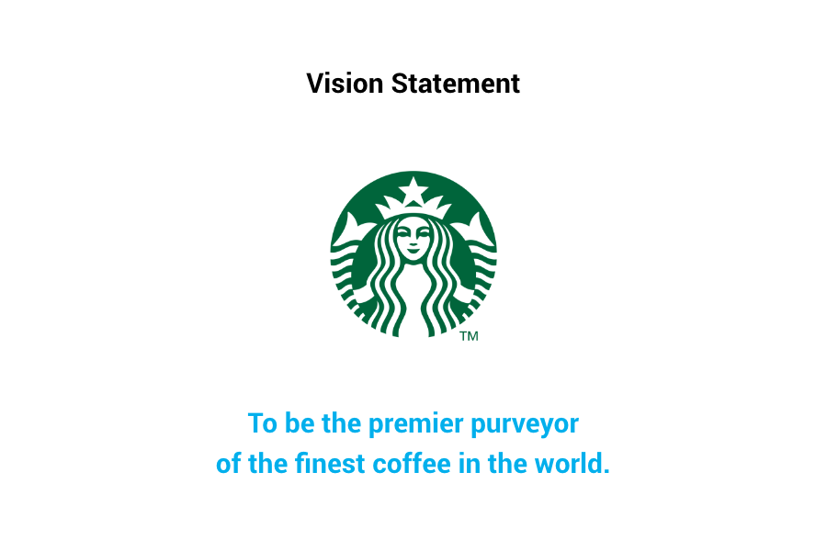
Source:- api-stg.3m.com
Starbucks aspires to a global coffeehouse experience that is inclusive and inspires inspirational moments. In order to make everyone feel respected, accepted, and a part of the world's coffee culture, the firm aspires to be a beacon of warmth and community.

3.2)Mission:

Source: Our Mission (starbucks.com)
Starbucks is committed to providing the best coffee experiences possible, one cup, one person, and one community at a time, in order to fire the human spirit. Starbucks strives to uplift and nourish the human spirit while accepting diversity, having a beneficial influence on both local communities and the environment. This is achieved via the ethical sourcing of coffee beans and a dedication to environmental stewardship.

3.3)Alignment with International Markets
Starbucks customizes its goods to each region's own cultural peculiarities in order to fit with global markets. Starbucks crafts an experience that is inclusive and culturally relevant by fusing its worldwide coffee expertise with a thorough awareness of local tastes. Establishing ethical sourcing and sustainability standards further solidifies the company's leadership in the global coffee industry. These commitments also coincide with the rising demand for socially responsible activities globally.

4).PESTEL analysis of UK and Australia
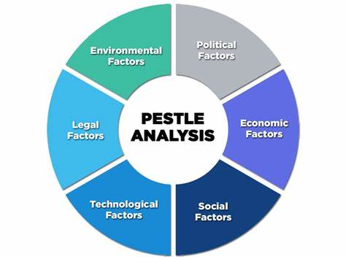
Source:- Pestle Analysis: A Mechanism for Analysis of Businesses - Enterslice
1). Political
- UK :- Businesses benefit from the political stability and well-established legal framework of the United Kingdom. Brexit, for example, has created uncertainty that has an impact on regulatory environments and commercial relations.
- AUSTRALIA :- Australia's business climate is good due in part to its political stability. Economic conditions are greatly influenced by government actions, including trade agreements and immigration regulations.
2). Economic :-
- UK:- Although the UK's economy is strong and varied, issues like unemployment and inflation still exist. The effects of Brexit and changes in the world economy have left the economic scene ever-changing.
- AUSTRALIA:- Australia's resource-rich economy has shown resilient despite being subject to changes in the price of commodities globally. Economic issues that affect corporate operations include inflation and unemployment (Khushman, 2019).
3). Social:-
- UK:- Businesses are impacted by shifting customer preferences, cultural developments, and changing demographics. Concerns about diversity, sustainability, and health and wellbeing have grown in importance and are influencing customer preferences and corporate tactics (Sisson & Bowen, 2017).
- AUSTRALIA:- Consumer behavior is impacted by shifting demographics, a multicultural culture, and an increasing emphasis on sustainability and health. Companies need to adjust to a wide range of society norms and consumer preferences.
4). Technological :-
- UK:- : Leading the way in technical innovation, the UK is advancing several different industries. Businesses can benefit from the quick speed of technological development, but they also need to adapt in order to remain competitive.
- AUSTRALIA:- Australia welcomes technical developments and encourages industry-wide innovation. Businesses face both possibilities and problems in keeping up with the rapid advancement of technology and meeting the evolving demands of their customers.
5). Environmental:-
- UK :- Growing public consciousness about environmental problems has resulted in more stringent laws and demands from consumers for sustainable practices. Eco-friendly solutions and alignment with green efforts are vital for businesses operating in the UK.
- AUSTRALIA:- Australia must deal with environmental issues including conservation initiatives and climate change. Companies are under growing pressure to implement environmentally friendly operations as a result of legislative changes and customer concerns.
6). Legal:-
- UK:- Although the legal system in the UK offers a stable business climate, continuing Brexit-related reforms might make things more complicated. For companies doing business in the UK, compliance with rules, legislation pertaining to intellectual property, and compliance standards is essential.
- AUSTRALIA:- The legal system in Australia offers stability, but it is essential to comply with all applicable rules and standards, especially those pertaining to the environment and the workplace. Legal standards must be followed by businesses in order to operate smoothly in the Australian market.

4.1)Similarities between UK and Australia PESTEL analysis
Australia and the United Kingdom (UK) have significant PESTEL analysis parallels. Stable governments are politically advantageous to both countries as they create an atmosphere that is favourable for corporate activities. In terms of the economy, they struggle with issues like inflation, unemployment, and swings in the world economy. Both nations are also greatly impacted by outside variables like trade dynamics. Social factors such as shifting demographics and a diversified culture influence consumer choices and behavior, underscoring the need of cultural landscape adaptation. Australia and the UK are at the forefront of technology innovation; therefore, firms must remain flexible in the face of quickening technological change. Sustainable development and conservation initiatives are examples of environmental issues that are mutually important and influence corporate strategy. Although the legal systems of both countries are solid, companies nonetheless have to deal with changing laws, such those resulting from Brexit in the UK and continuous legal changes in Australia. These similarities demonstrate how intertwined the world's markets are and how comparable external influences must be taken into account by companies when developing their strategic plans.

4.2)Differences between UK and Australia PESTEL analysis
Although the PESTEL analysis of Australia and the United Kingdom (UK) show certain parallels, their business environments are also distinguished by important distinctions. Australia is not confronted with the same political challenges as the UK due to Brexit, which has caused uncertainty in trade relations and regulatory frameworks. Australia's resource-rich economy is impacted by the price of commodities globally, but the UK's economic dynamics are more closely linked to its financial and services industries. Social and cultural subtleties vary per nation, influencing consumer tastes and market needs in distinct ways. Both countries value innovation in technology, although their areas of concentration may vary, indicating different sector strengths. Australia faces distinct environmental difficulties, such as climate change and conservation, whereas the UK could place a different emphasis on environmental goals (Honack & Waikar, 2019). Although both countries have sound legal systems, there are significant distinctions in their business environments due to unique laws and ongoing legal developments, such as the UK's Brexit-related adjustments and Australia's legal reforms.

5).Hofstede model analysis of UK and Australia
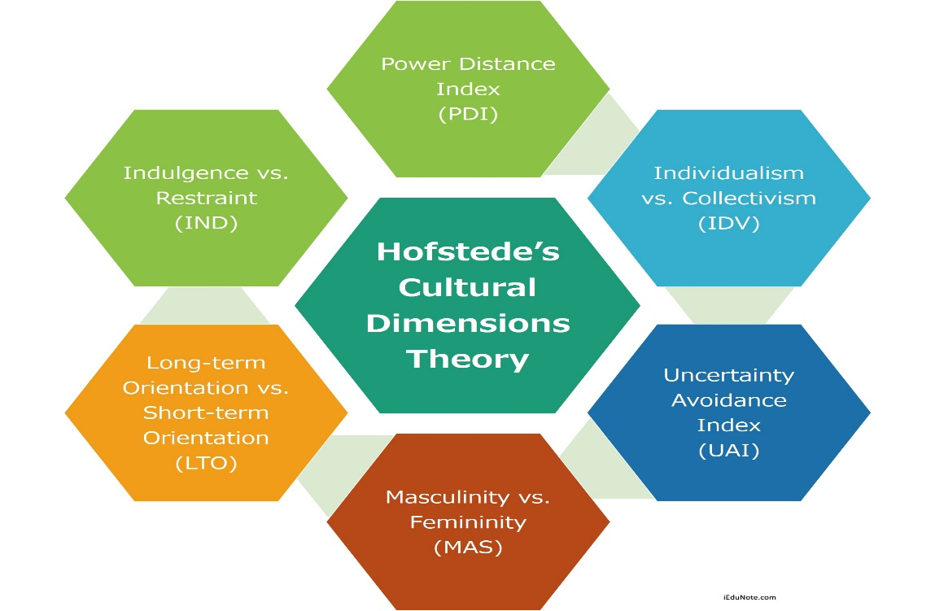
Source:- 6-dimensions-hofstedes-cultural-dimensions-

1). Power Distance (PD): -
- UK:- The power distance score of the UK is quite low. This points to a culture that favours equality and has a tendency to divide authority more fairly. In general, open communication and consultation are expected, and hierarchy is minimized.
- Australia:- Australia's power distance score is often poor. Decentralized decision-making is preferred, and equality is prioritized, much as in the UK. In general, free communication and a more egalitarian view of power are valued by Australians.
2). Individualism vs. Collectivism (IDV):-
- UK:- The UK has a high individuality rating. Self-expression, personal independence, and individual liberties are valued in British culture. It is required of people to look after their close family as well as themselves (Campbell & Helleloid, 2016).
- Australia:- Similar to the UK, Australia has a high individuality score. Australians place a high value on individual liberty, independence, and self-expression. People are expected by society to look after themselves and their close family members.
3). Masculinity vs. Femininity (MAS): -
- UK:- Many people believe that society in the UK is a little bit more macho. Success, accomplishment, and financial gains are prioritized. This dimension is not as prominent as it is in some other civilizations, though.
- Australia:- Australia is frequently seen as having a somewhat macho culture. Achievements in business, ambition, and success are valued, but not as much as in societies that lean heavily toward masculinity (Sholihah et al., 2016).
4). Uncertainty Avoidance (UA): -
- UK:- The UK's score on uncertainty avoidance is rather low. This points to a culture that is more adaptable, inventive, and willing to take chances. People are generally at ease with uncertainty.
- Australia:- Australia's uncertainty avoidance score is often lower. Australians are often more accepting to change, creativity, and taking chances. There exists a cultural ease with vagueness and a flexible attitude toward unpredictability
5). Long-Term Orientation vs. Short-Term Normative Orientation (LTO): -
- UK:- The UK tends to have a short-term normative orientation. This suggests that customs and social conventions are prioritized above serious future planning.
- Australia:- Australia tends to be oriented on short-term norms. Though history is valued, pragmatism and resolving urgent issues may take precedence over serious consideration of long-term planning.
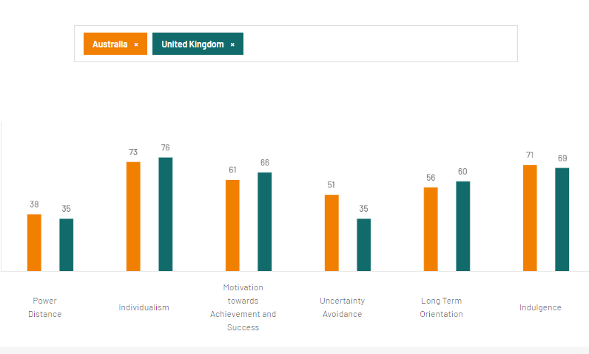
Source: Country comparison tool (hofstede-insights.com)

5.2.Similarities between UK and Australia Hofstede Cultural Dimensions Model
The United Kingdom (UK) and Australia have several striking parallels that are highlighted by the Hofstede Cultural Dimensions Model, highlighting common cultural traits. The low Power Distance orientation of both nations highlights a desire for egalitarianism and decentralized decision-making. When it comes to individuality vs collectivism, Australia and the UK both rank well because they place a high value on individual liberty and autonomy. This cultural characteristic emphasizes the notion that people should look after themselves and their close family members. Furthermore, both countries tend to favor short-term normative orientations, placing more emphasis on customs and social norms than comprehensive long-term planning. Their comparatively low Uncertainty Avoidance ratings demonstrate their acceptance of risk and uncertainty, which encourages creativity and openness to change. These common cultural characteristics lay the groundwork for mutual understanding between Australia and the UK, revealing attitudes and practices while promoting productive cross-cultural exchanges across a range of fields.

5.3.Differences between UK and Australia Hofstede Cultural Dimensions Model
The Hofstede Cultural Dimensions Model shows several similarities between the UK and Australia, but it also shows some significant distinctions that are indicative of their own cultural subtleties. Their approaches to masculinity and femininity differ significantly. Both nations are seen as relatively masculine, although in comparison to Australia, the UK tends to place a little more value on success, ambition, and financial accomplishments (Zhang, 2023). Furthermore, with regards to Long-Term vs. Short-Term Normative Orientation, Australia displays a similar inclination but with a pragmatic approach that emphasizes addressing immediate concerns, while the UK leans more towards a short-term normative orientation, valuing tradition and societal norms. These differences draw attention to minute differences in cultural values that influence how people and organizations from each nation may see authority, individuality, and striking a balance between immediate gratification and long-term planning. It is essential to comprehend these distinctions in order to promote productive cross-cultural exchanges and cooperation between Australia and the UK.

5.4.Advantages and disadvantages of Hofstede model for both countries UK and Australia

UK

Advantages:
Businesses and people may navigate the cultural environment with the help of the Hofstede Model, which offers insightful information about the cultural aspects of the United Kingdom. Its methodical approach facilitates the recognition and comprehension of cultural quirks including the prioritization of individuality, low power distance, and a tendency toward short-term normative orientation (Carter et al., 2023x). This information is essential for managing a team, conducting business internationally, and communicating effectively. Additionally, the approach makes it easier to identify possible cultural obstacles, which helps companies create cross-cultural engagement tactics that work.

Disadvantages
The Hofstede Model is not without limits, though. It could oversimplify how complicated a culture is, as cultural norms and behaviors can change depending on the situation. Furthermore, it's possible that the model fails to account for how cultural dynamics change over time. For example, the variety and multiculturalism of the UK might not be well reflected. For a more thorough understanding, it is necessary to complement the model—which is a useful place to start—with additional cultural frameworks.

Australia:

Advantages:
The Hofstede Model has substantial benefits for Australia in terms of comprehending cultural aspects. It successfully conveys important characteristics including strong individualism, short-term normative orientation, and minimal power distance. Businesses who work in or with Australia will find this information to be quite helpful as it may provide guidance on topics like corporate culture, team dynamics, and negotiating tactics. The concept promotes constructive cross-cultural interactions by supporting the recognition and acceptance of Australian cultural values.

Disadvantages:
However, the Hofstede Model still has some problems. It could oversimplify the rich cultural fabric of Australia by failing to take into consideration regional or indigenous cultural variances with it (Nemmaniwar, 2022). Furthermore, because the model is static, it could not account for continuous cultural modifications and alterations. Like any cultural framework, the Hofstede Model should be supplemented with contextual knowledge and firsthand observations from everyday life, rather than being used as a true portrayal of Australian culture in its entirety.

5.5Manifestation of Advantages/Disadvantages Due to Cultural Nuances for UK and Australia
For the United Kingdom (UK) and Australia, the Hofstede Model's advantages and disadvantages are expressed differently due to the distinctive cultural quirks that are particular to each nation. The Hofstede Model's advantages for the UK are clear in its capacity to draw attention to the nation's inclination toward high individuality and low power distance. This knowledge may help organizations navigate the cultural terrain of Britain by fostering productive team relationships and communication techniques. Nevertheless, the simplifying of the model could not adequately capture the subtleties of diversity in the UK, which could result in misunderstandings of cultural dynamics. A deeper knowledge beyond the model's components is essential for successful cross-cultural relationships in a heterogeneous culture such as the UK.
In a similar, Australia's model does a good job of capturing important cultural aspects, helping companies to comprehend traits like individualism and a short-term normative orientation. The model's portrayal of the indigenous and regional variety with in Australia, however, may reveal some of its shortcomings. Particularly indigenous cultures might have unique cultural characteristics that the model is unable to adequately capture. Consequently, even if the Hofstede Model offers a helpful framework, a comprehensive comprehension of cultural subtleties in the UK and Australia necessitates a sophisticated and situation-specific strategy that goes beyond the model's parameters.

6).Porter’s 5 force analysis of UK and Australia

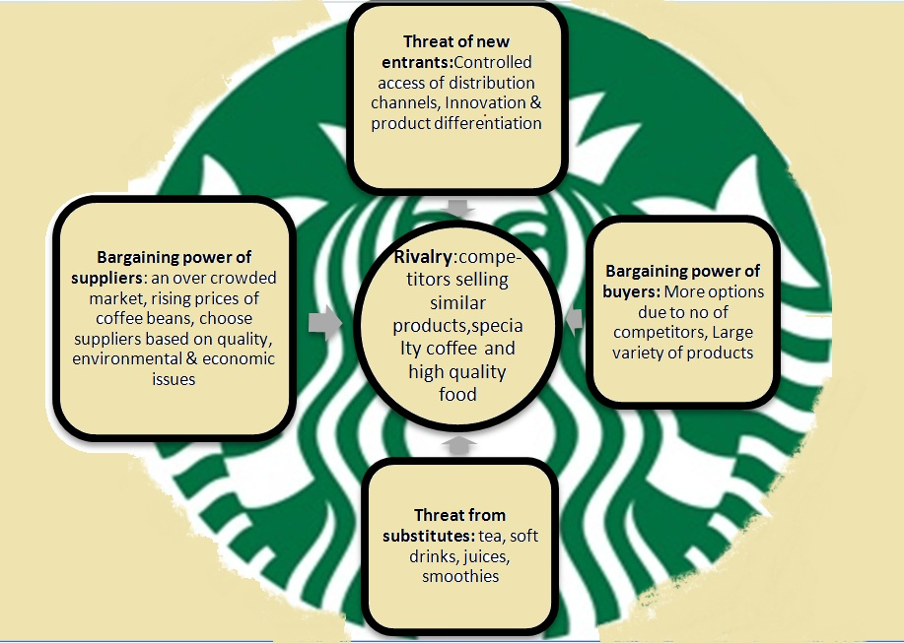
Source:- The competitive environment of Starbucks: Porter’s five forces
An examination of Starbucks' Porter's Five Forces in the UK and Australia sheds light on the competitive landscape and state of the markets in these areas.
1. New Entrants' Threat:
- UK: The UK's coffee market is extremely crowded, with many domestic and foreign rivals. Because of the high capital needs, enduring brand loyalty, and well-established distribution networks, the threat of new competitors is minimal.
- Australia: Like the UK, Australia has a thriving local and international coffee industry with a long history. Coffee shop ownership and operation requires a large initial investment, which serves as a barrier and lessens the danger of new competitors.
2. Buyers' Bargaining Power:
- UK: In the UK coffee market, buyers' negotiating strength is mediocre. Although there are other possibilities, Starbucks' well-known brand and devoted following somewhat offset this.
- Australia: Similar modest negotiating power exists for Australian consumers. The market's emphasis on quality and innovation, together with the availability of a variety of coffee options, provide consumers options; nonetheless, Starbucks' strong brand helps them stick around.
3. Suppliers' Bargaining Power:
- UK: Coffee suppliers may have a moderate amount of negotiation leverage in the UK. Starbucks may have considerable negotiating influence due to its widespread presence and purchasing power.
- Australia: Similarly, coffee bean suppliers have a considerable amount of negotiating leverage in Australia. The significance of high-quality coffee is counterbalanced by Starbucks' worldwide reach and buying power.
4. Threat of Substitute Products:
- UK: In the UK, the danger of replacements is moderate, with a variety of options including tea, specialty drinks, and other beverages. Nonetheless, there is some protection due to the robust coffee culture.
- Australia: Although Australians have a wide variety of beverage tastes, the danger of alternatives is lessened by the country's long-standing coffee culture. Starbucks has a competitive edge thanks to its capacity to provide a distinctive coffee experience.
5. Competitive Rivalry:
- UK: The UK coffee market is characterized by fierce rivalry. Starbucks is in competition with both regional and international chains. High levels of rivalry spur innovation and high standards of quality.
- Australia: Australia has a fiercely competitive market, with both domestic and foreign businesses fighting for market dominance. Starbucks has competition from well-established firms, which fuels intense competitiveness.

6.1.Similarities between UK and Australia porter’s 5 force analysis
There are a lot of similarities between Starbucks' Porter's Five Forces analysis for the UK and Australia. The high capital needs and strong brand loyalty in both industries indicate modest threats from new competitors. Given the variety of alternatives available, buyers in both locations have a modest amount of negotiating power (Bryson & Atwal, 2019). Because of Starbucks' significant worldwide purchasing power, suppliers have a moderate amount of negotiation strength. The robust coffee cultures in both nations lessen the danger of replacements. Lastly, both industries are characterized by intense competition that is fueled by the existence of several local and international competitors, highlighting the necessity of innovation and high standards of quality.

6.2.Differences between UK and Australia porter’s 5 force analysis
Starbucks' Porter's Five Forces study finds subtle variations between the marketplaces in the UK and Australia. There are differences even if both nations have little buyer bargaining power and minimal risks from new competitors. Competitive competition is heightened in the UK due to market saturation, but Australia's rivalry is shaped by a developing coffee culture. In both locations, suppliers have a moderate amount of negotiating leverage. Because of the wide range of beverage tastes in the UK, the threat of alternatives is somewhat greater. These variations show how Starbucks must modify its tactics to successfully negotiate the varied competitive environments in the UK and Australia.

7).SWOT Analysis for the Company in UK and Australia
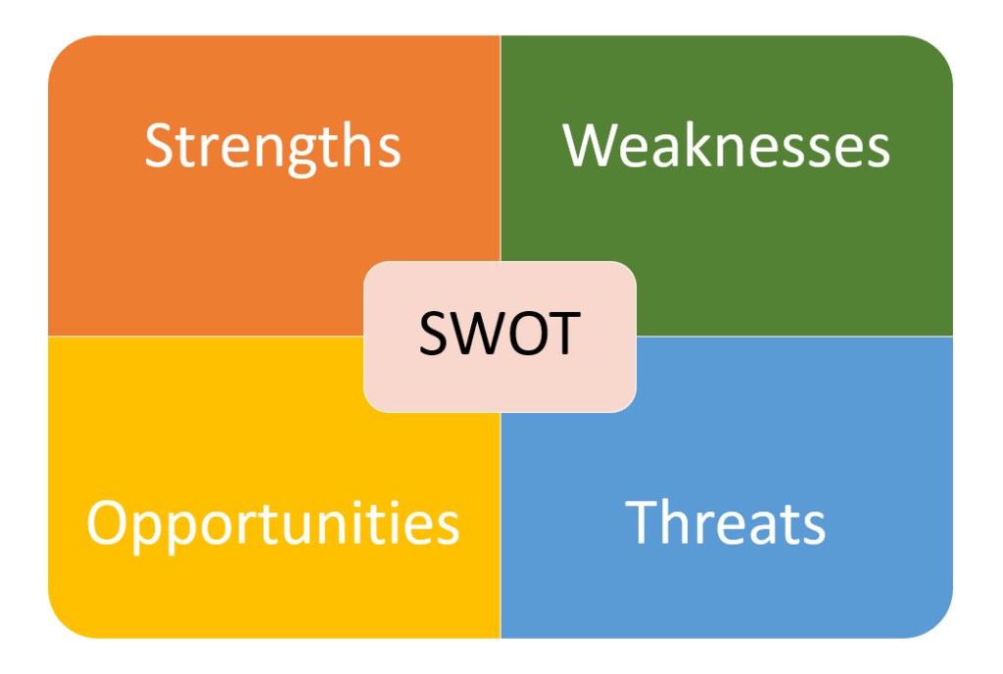
Source:- SWOT Analysis - Tallyfy
UK | Australia
1). Strength:  - Starbucks enjoys a solid international reputation for high-quality coffee and a varied menu, which helps the company in the UK.  - The vast network of strategically placed stores creates a significant market presence.  - Consumers who are socially concerned are drawn to the company's dedication to sustainability and ethical sourcing.  - Starbucks has used creative measures to improve customer experience and loyalty, such as smartphone ordering and loyalty programs. | 1).Strength  - Starbucks enjoys widespread brand awareness worldwide and provides a wide selection of high-quality coffee items in Australia.  - Sustainable business methods and ethical sourcing are principles that the firm shares with Australian consumers that care about the environment.  - Starbucks offers a great customer experience in part because of its well-located stores and attractive designs. Customer involvement is improved with the adoption of cutting-edge technologies like loyalty programs and mobile ordering.
2). Weakness  - The UK coffee market is very competitive, which makes distinctiveness necessary. Price-conscious clients can be turned off by the premium pricing (Chuang, 2019).  - Weaknesses that require addressed include inconsistent consumer experiences across sites and possible oversaturation in urban regions. Agility is required to adjust to changing customer tastes and local competitors. | 2). Weakness  - Starbucks faces difficulties in the coffee business in Australia due to intense competition, which calls for constant differentiation tactics.  - In a market where consumers are sensitive to price, the brand's attractiveness may be limited by its premium cost.  - It can be difficult to strike a balance between catering to different local tastes and preferences and upholding a consistent corporate image. Certain local rivals may cast a shadow over brand recognition in certain areas.
3). Opportunities:  - In the UK, Starbucks has the chance to adapt to evolving consumer tastes and preferences by adding healthier choices to its menu.  - Partnerships and collaborations with regional companies can expand market reach. Gaining traction with the expanding market for plant-based and sustainable products will help you stay in line with current trends. | 3). Opportunities  - In Australia, there is a chance to expand the menu to accommodate changing customer tastes, such offering more plant-based and healthier alternatives.  - Partnerships or joint ventures with neighbourhood companies can help Starbucks become more visible in the marketplace.  - Making the most of the growing market for eco-friendly goods and taking part in community-oriented projects is in line with the preferences of Australian consumers.
4). Threats:  - Consumer spending is impacted by economic uncertainty, which pose a danger to the UK market. There's a danger because there is fierce rivalry from both new and existing coffee chains.  - Unfavorable press, particularly with moral dilemmas or subpar products, can damage a brand's reputation (Musonera, 2021). Starbucks may face dangers in the UK from external sources like geopolitical events and changes in regulations. | 4). Threats:  - Australia's economic ups and downs threaten consumer spending habits, which affects the purchasing of premium coffee.  - Ongoing strategic initiatives are necessary due to intense competition from new coffee chains and well-known local brands. Starbucks' reputation might be harmed by unfavourable press or problems including moral dilemmas.  - Unexpected occurrences or changes in legislation are examples of external variables that might bring uncertainty and difficulties to the Australian market.

7.1.Similarities between the SWOT analysis of the UK and Australia:
Starbucks has comparable advantages in the UK and Australia, such as its well-known worldwide brand and dedication to ethical sourcing. The necessity for constant adaptation to shifting customer tastes and the difficulties posed by intense competition in their particular coffee markets are among their shortcomings (Yunus et al.,, 2022). Threats include unstable economies, fierce competition, and even damaging media coverage that might damage a brand's reputation. Opportunities include growing the menu and meeting sustainability trends in both markets.

7.2.Differences between UK and Australia SWOT Analysis:
There are clear distinctions between Starbucks' potential and disadvantages in Australia and the UK. Potential oversaturation in cities and uneven consumer experiences are identified problems in the UK. Opportunities include addressing shifting tastes and working with regional brands. On the other hand, local brands may overwhelm national brands in Australia, raising worries about how to strike a balance between catering to a variety of preferences and being consistent. Participating in community-focused activities is one of the opportunities found in Australia. Notwithstanding these variations, Starbucks must be flexible in order to adapt to changing consumer expectations and competitive environments in both areas.

8).Starbucks Segmentation, Targeting, and Positioning:
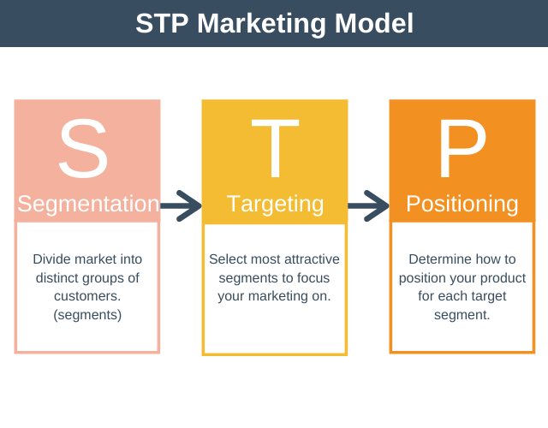Source:- STP Marketing Model - Segmenting, Targeting, Positioning (expertprogrammanagement.com)

1). Segmentation:-
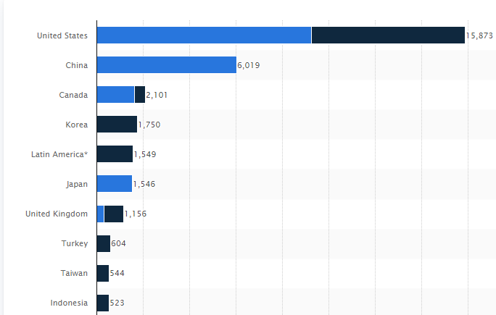
countries with the largest number of Starbucks stores worldwide as of October 2022 :- Countries with the most Starbucks' worldwide 2022 | Statista
- Demographic Segmentation:- While the second target group is made up of 18 to 24 year olds from wealthy homes, the primary group is made up of persons with high earnings between the ages of 25 and 40. According to Fromm (2014), the bulk of clientele are Generation Y (born between 1977 and 2000).

- Psychographic segmentation:- indicates that customers belong to the upper-middle class and generally have college education (Rafii, 2013)
- VALS Segmentation:- VALS is a psychographic consumer segmentation system held by Strategic Business Insights that is based on the following eight consumer segments: innovators, thinkers, achievers, experiencers, believers, strivers, creators, and survivors."
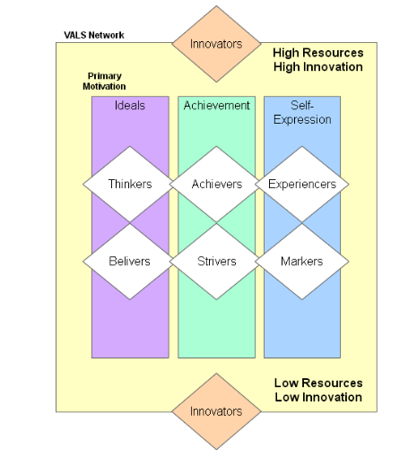

Source:- NOTES MAGIC: Market Segmentation
Starbucks uses VALS segmentation to categorize prospective consumers according to a range of criteria, such as interests, consumption patterns, viewpoints on social problems, buying behaviors, and personality features. VALS segmentations are beneficial because persons within the same demographic might have a wide range of psychographic features depending on their individual experiences and upbringing.
2). Targeting:- Starbucks attempts to appeal to a broader audience, but it also has particular customer criteria, such as younger age groups or higher income levels. This places them in between mass and sector marketing.(Haskova,2015)
3). Positioning:- Positioning is critical for defining and altering the product's concrete features as well as its intangible perceptions, as observed by Blankson and Kalafatis (2007) in the Journal of Services Marketing, although it has received little attention from marketers. Customers at Starbucks buy an expensive, high-quality product (tangible), but they also get a personalized in-store experience enhanced by trained employees, such as having their name written on the plastic cup their beverage will be served in (intangible); this helps Starbucks achieve premium brand status.( Haskova,2015)
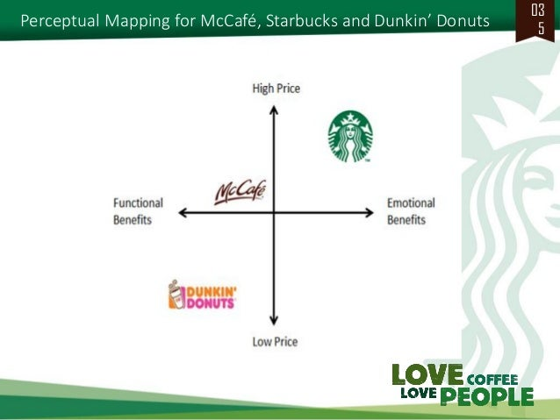
Source:- Case Study: Starbucks | PPT (slideshare.net)

8.1.Similarities in STP Analysis between the UK and Australia:
Starbucks uses comparable Segmentation, Targeting, and Positioning (STP) techniques in the UK and Australia to successfully navigate their respective marketplaces. Targeting metropolitan regions with a high degree of customer diversity, the segmentation tactics take multiculturalism into consideration. Both marketplaces are demographically targeted, with an emphasis on age and income brackets to draw customers prepared to shell out more for superior coffee experiences. Starbucks' strategy in both nations centres on providing a high-end lifestyle option while prioritizing sustainability, ethical sourcing, and quality (Sakal, 2018). Loyalty programs and digital efforts are being utilized in both areas to interact with tech-savvy customers.

8.2.Differences in STP Analysis between the UK and Australia:
Notwithstanding these parallels, Starbucks' STP initiatives in Australia and the UK differ slightly. Starbucks may have difficulties due to oversaturation in metropolitan locations in the UK, which would require more specialized adjustments in order to preserve consistency. In the meanwhile, Australia emphasizes the delicate balancing act of maintaining a consistent corporate image while appealing to a wide range of tastes (Khushman, 2019). Furthermore, Starbucks may have to deal with the local brand taking precedence in Australia, necessitating the use of distinctive positioning techniques. These variations highlight how Starbucks must modify its STP tactics to fit the unique competitive and cultural environments of every nation.

8.3.Alignment with Consumer Behaviour
Starbucks' STP strategies in both the UK and Australia align seamlessly with consumer behaviour. Recognizing the variety of consumer requirements and the multiculturalism that permeates these countries, Starbucks uses customized segmentation. Starbucks' premium lifestyle positioning, which prioritizes quality and sustainability, aligns with the ideals of the affluent and socially concerned consumers in both areas. The brand's dedication to technology advancements, loyalty schemes, and community involvement serves to further solidify its compatibility with the tech-savvy and socially conscious customer habits prevalent in Australia and the UK.

9).Marketing mix elements for Starbucks

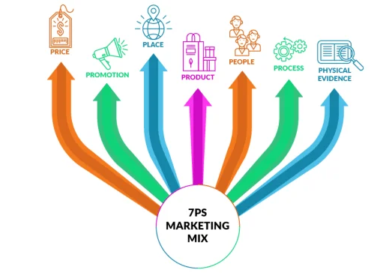
Source:- (lionspiritmedia.co.uk)

1). Product:- At the core of Starbucks' success has been its dedication to providing excellent products. Starbucks has dependably produced exceptional coffee products, from its early days of procuring coffee beans to its current global presence. Starbucks' ability to adapt to shifting consumer demands is seen in its transition from selling coffee beans to ready-made beverages. The distinctive Siren mermaid logo has gone through various variations, yet it remains an indelible element of the brand's identity, instantly recognized to customers. Starbucks' product diversification approach includes a variety of coffee items, such as freshly brewed coffee in its cafés, ready-made drinks, and coffee beans sold in supermarkets.(Wily Mohammad, Syifa Izzati Zahira)


Source:- AI Global Media Ltd

2).Price:- At the core of Starbucks' success has been its dedication to providing excellent products. Starbucks has dependably produced exceptional coffee products, from its early days of procuring coffee beans to its current global presence. Starbucks' ability to adapt to shifting consumer demands is seen in its transition from selling coffee beans to ready-made beverages. The distinctive Siren mermaid logo has gone through various variations, yet it remains an indelible element of the brand's identity, instantly recognized to customers. Starbucks' product diversification approach includes a variety of coffee items, such as freshly brewed coffee in its cafés, ready-made drinks, and coffee beans sold in supermarkets.
3). Place:- Starbucks' smart placement strategy is evident in its worldwide reach. The corporation deliberately locations its stores near tourist attractions, universities, and commercial centers to ensure a consistent flow of foot traffic. Starbucks Margonda, Indonesia, for example, is ideally located near major colleges, allowing it to tap into the strong student community. This strategy not only increases exposure but also appeals to a wide range of client categories. Furthermore, Starbucks uses a partnership approach to increase its reach, enabling licensed partners to build locations alongside those directly controlled by the business.

10).Market Entry Methods of Starbucks
Choosing the proper entry strategy is one of the most crucial first stages in a company's expansion into a new market. There are numerous strategies to penetrate an emerging market, as illustrated below.
- Licensing, 2. Franchising, 3. Joint venture, 4. Strategic alliance

Advantages of Joint venture market entry method

1).Risk sharing:- The sharing of risks is one of the benefits of Starbucks' joint venture model. Starbucks lowers the operational and financial risks associated with its international business partnerships.
2). Cost Cutting :- Starbucks may share resources and expenses thanks to joint ventures. This includes infrastructure sharing and operating costs, which would be far greater if Starbucks opted to expand on its own.

3). Access to New Markets and Distribution Networks:- Starbucks was able to access distribution networks and new markets through partnerships and strategic alliances that would have been difficult to establish on its own.
Disadvantages of Joint venture market entry method

1). Cultural Differences:- Understanding and integrating with other cultures was one of the more notable difficulties Starbucks had during its joint ventures.
2). Profit Sharing:- Profits must be divided among participants in joint enterprises, which can lead to arguments and disputes.

3). Management Difficulties:- Due to partner variations in decision-making processes, corporate cultures, and operational styles, joint ventures may face managerial challenges.

4). Promotion:- Starbucks' advertising activities are demonstrated by the Starbucks Rewards program. This loyalty program encourages repeat commerce by awarding stars for each transaction. These stars may be redeemed for a variety of appealing incentives, ranging from drink toppings to free coffee bean items. Starbucks' Rewards program not only encourages customer loyalty but also collects significant data on consumer preferences, allowing for targeted marketing initiatives.
5). People:- Starbucks has further cemented its image by investing in its employees, who guarantee constant quality of service and create favorable customer encounters.
6). Process:- Adjustments made to the coffee production process, like the removal of automatic cappuccino makers and the return of in-house grinding machines, highlight Starbucks' dedication to improving the customer experience by highlighting the close relationship to the coffee-making process. Starbucks embraces technology by providing a specialized smartphone app for ordering and payment, as well as cooperating with online food delivery services to broaden its reach.
7). Physical Evidence:- This refers to the tangible cues or artifacts that consumers may view and utilize to form opinions about the service. Facilities, machinery, and other obvious components are included in the actual surroundings.

Differences:
- Product: Local changes were made in both areas to fit culture needs.
- Price: Price changes were made to match the standards of the Australian market.
- Place: Different placement tactics are needed to reach the most people in each country.
- Promotion: made promotional actions that fit in with culture events in the area.
- People:-Cultural difference might reflect in customer services.
- Process:- local regulation, sourcing and supply chain difference.
- Physical evidence:- Interior design affects.

Similarities:
- Product: The main products they sell are similar, with a focus on coffee and a variety of drinks.
- Price: In both areas, Starbucks goods are priced higher than they should be.
- Place: A common approach is to set up shop in cities and other places with a lot of foot traffic.
- Promotion: Focused on internet marketing, social media, and reward programmes at the same time.
- People:- Follow similar training program and service standards.
- Process:- Operational process might be same.
- Physical evidence:- Location, Architecture and interior design more prefer.

Directional development strategy

UK:
Starbucks can use a directional growth plan in the UK by increasing its presence in cities. Focused growth in cities, shopping areas, and transportation hubs will take advantage of the strong coffee culture while setting the company apart from rivals (Li, 2022). The goal is to make Starbucks even more popular as an easy and high-quality coffee option for people who live in cities.

Australia:
For Australia, Starbucks can take a directional approach to growth by embracing the country's variety. To connect with people in different parts of Australia, you need to make sure that your products and marketing tactics are tailored to their unique likes and cultural aspects (Lemus et al., 2015). This approach takes into account how big the Australian market is by making it easier for people from different groups to connect with and understand the brand.

11).BCG matrix analysis of UK and Australia
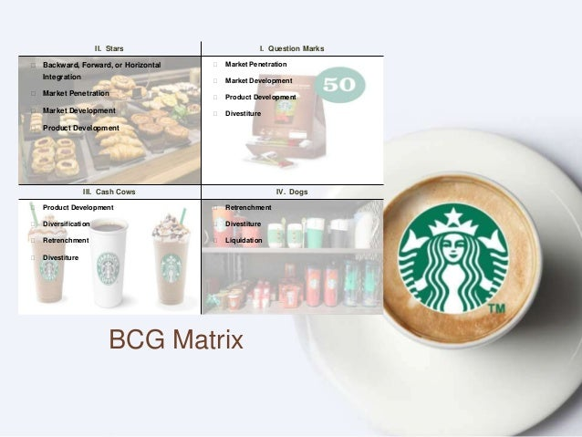
Source:- BCG Matrix | PPT (slideshare.net)
BCG Matrix | Starbucks in the UK | Starbucks in Australia
Stars | Signature Coffees, Specialty Blends | Established presence in key urban areas
Cash Cows | Core Coffee Beverages, Seasonal Favorites | Well-established market with high revenue
Question Marks | New Product Launches, Local Adaptations | Regional Expansion Initiatives
Dogs | Underperforming Stores, Products with Declining Sales | Stores with Limited Footfall, Low Performing Products

1). Stars:- Products and services with a larger market share and growth rate are grouped together in the star quadrant of the Starbucks BCG matrix growth-share matrix study. They provide a substantial contribution to the coffeehouse brand's income, profitability, and sales.(Shaw,2023)
2). Cash Cows:- The goods and services that fall into the cash cow quadrant in the Starbucks BCG matrix growth-share matrix study are those with a larger market share and a slower growth rate. They provide a substantial contribution to the coffeehouse brand's income, profitability, and sales. .(Shaw,2023)
3). Question Marks:- Products and services with a greater growth rate but a smaller market share are outlined in the question mark quadrant of the Starbucks BCG matrix growth-share matrix study. They have the potential to add to the coffeehouse brand's income, profitability, and sales if the firm focuses on its weaknesses. .(Shaw,2023)
4). Dogs:- These goods and services, which have a smaller market share and slower growth rate, are included in the dog quadrant of the Starbucks BCG matrix growth-share matrix study. They do not contribute to the income, profitability, or sale of the coffeehouse brand; instead, they absorb a large portion of the company's capital resources. .(Shaw,2023)

11.1.Overall Implications of Strategy
The BCG matrix shows how Starbucks' business plans in the UK and Australia will be affected. Stars, like signature coffees and important urban presences, deserve more money. Cash cows, or goods that bring in steady income from core sales, should be kept. For growth, question marks like new launches and regional extensions need to be carefully thought out and backed by money. Dogs mean that shops and goods aren't doing well and may need to be reevaluated or sold off. The matrix helps Starbucks make the best use of its resources so that it can keep growing, stay ahead of the competition, and make money in both countries.

12).Recommendation for Starbucks in UK and Australia

12.1.TOWS Analysis for Starbucks
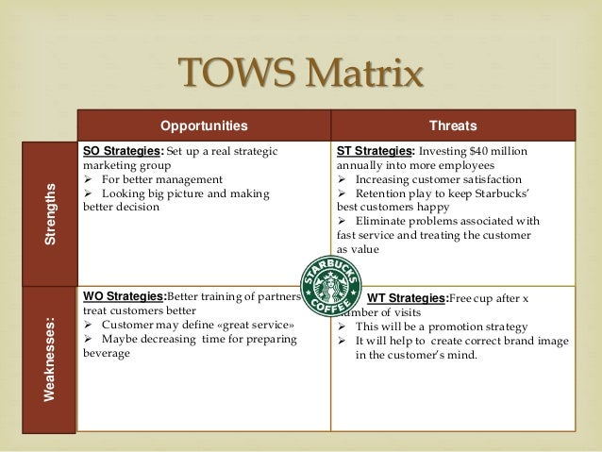
Source:- Starbucks:Delivering Customer Service | PPT (slideshare.net)
Weaknesses to Threats :- The weakness to threats also known as “Mini – Mini strategy”.
Weaknesses to Opportunities :- The weakness to opportunity is also known as “Mini – Maxi strategy”.
Strengths to Threats :- The Strengths to Threats also known as “ Maxi-Mini Strategies”.
Strengths to Opportunities :- The Strengths to opportunities also known as “ Maxi-Maxi Strategies”.

Starbucks should use “Mini – Mini” strategy in the UK. Starbucks should release a range of low cost of product to minimize the cost challenging from competitive brands like Prett and costa.
Starbucks should use “Maxi – Maxi” strategy in Australia. Starbucks should market the brand in less penetrated area and Use the global brand image to extend presence in emerging economies.

13).Recommendation for Starbucks in UK and Australia

Recommendations for Starbucks in the UK:
1. Increase Urban Presence: To take advantage of the UK's strong coffee culture, increase Starbucks' presence in key urban areas, focused on shopping streets and transport hubs.
2. New Products: Make new products that are inspired by the area to appeal to a wide range of tastes and interests, while still keeping a balance between global consistency and local relevance.
3. Digital Engagement: Use digital marketing and reward programmes even more to get tech-savvy customers interested, which will help you keep customers and make them loyal to your brand.
4. Environmental Sustainability: To keep up with the UK's growing focus on eco-friendly shopping, make environmental sustainability programmes stronger.

Recommendations for Starbucks in Australia:
1. Regional Customization: Make sure that your products and marketing plans are tailored to the different regions of Australia, taking into account and enjoying the unique tastes and cultural aspects of each area.
2. Community Engagement: Support projects and partnerships that focus on the community to match with Australian values. This will make the brand more recognisable and increase customer loyalty.
3. Strategic Expansion: To reach more customers, strategically grow in areas with untapped potential, making sure to balance your approach to urban and neighbourhood markets.
4. Digital Presence: To appeal to the tech-savvy Australian market, build a strong online presence with a focus on social media, mobile apps, and online shopping.

14).Future strategies

Future Strategy for Starbucks in the UK:
To keep doing well in the UK, Starbucks should focus on digital innovation, like making it easier to order on your phone, and personalised reward programmes. Focusing on sustainability and ethical sources is in line with how customer ideals are changing. For future growth, it will be important to make sure that marketing plans fit the needs of local communities and that businesses stay flexible enough to adapt to changing customer trends.

Future Strategy for Starbucks in Australia:
In Australia, Starbucks should focus on regional customising, making changes to their menu to suit different tastes, and getting more involved in the community (Liu et al., 2022). Its market position will be strengthened by strategic growth into new areas and a strong focus on digital projects. The brand will be even more popular in Australia if it stays committed to sustainability and eco-friendly practises.

Conclusion

Key findings
it's a tough job for Starbucks to make sure that its world brand fits in with the different cultures of the UK and Australia. Starbucks can connect with a wide range of customer behaviours by segmenting, focusing, and placing its products. The BCG matrix shows growth possibilities and helps decide how to use resources. Customised suggestions stress how important it is for digital innovation, regional customization, and community involvement. Starbucks' success in these markets depends on how well it can balance global uniformity with local relevance. This way, it can give customers in the UK and Australia a quality and long-lasting coffee experience that adapts to their changing tastes and values.

Critical analysis
Starbucks is very good at segmenting, targeting, and positioning, and that it adapts its tactics to the different cultures of the UK and Australia. The BCG matrix shows how important it is to keep up with and invest in goods that work well while also looking for ways to grow wisely. For future success, recommendations stress how important it is to use digital innovation, make things fit the needs of each area, and get involved in the community. The challenge for the global brand is to make sure that its personality fits with the complex tastes and beliefs of people in these different markets. This is done by providing a high-quality, long-lasting coffee experience that fits with how the UK and Australia's surroundings are changing.

15).Conclusion
In conclusion, Starbucks shows strategy flexibility by adapting its global brand to the way markets work in the UK and Australia. For long-term growth in these different markets, the suggestions stress how important it is to adjust to local differences and put money into digital innovations.

References
Bryson, D., & Atwal, G. (2019). Brand hate: the case of Starbucks in France. British Food Journal, 121(1), 172-182. https://www.emerald.com/insight/content/doi/10.1108/BFJ-03-2018-0194/full/html?casa_token=tLQJS3-Zl0oAAAAA:tpafTgeXNvYdDKrUr7BKnOXD9L7vl8Sh5ztUCvC38wNYrbE7a1T1WAVyAHmhA-3WRu20AZYHd5SsO39WRXoogFtNi67fK4aiytUT9HGtLSrHZKMx1A
Campbell, K., & Helleloid, D. (2016). Starbucks: Social responsibility and tax avoidance. Journal of Accounting Education, 37, 38-60. https://commons.und.edu/cgi/viewcontent.cgi?article=1000&context=man-fac
Carter, D. B., Warren, R., & Steinhoff, A. (2023). The anatomy of tragedy: Starbucks as a politics of displacement. Accounting, Auditing & Accountability Journal, 36(1), 146-176. https://www.emerald.com/insight/content/doi/10.1108/AAAJ-08-2015-2169/full/html?casa_token=QKTgMLeFSYEAAAAA:_rQtYPwY2UYHDnC42sOKu_SQhLFsDsVr-GxRJ7RMPKP5hhOtNyi2dxFL3xm8cMS1nP6NS3Fid64zbWAS3-UhSMXkS6sQxv4a9kRp_fSbsVnwywBCDQ
chuang
Chuang, H. J. (2019). Starbucks in the World. HOLISTICA–Journal of Business and Public Administration, 10(3), 99-110. https://sciendo.com/pdf/10.2478/hjbpa-2019-0031
Ferreira, J. (2017). Café nation? Exploring the growth of the UK café industry. Area, 49(1), 69-76. https://pureportal.coventry.ac.uk/files/13831138/Cafe_nation_FINAL.pdf
Honack, R., & Waikar, S. (2017). Growing big while staying small: Starbucks harvests international growth. Kellogg School of Management Cases, 1-22. https://www.emerald.com/insight/content/doi/10.1108/case.kellogg.2016.000142/full/html
Khushman, A. (2019). An Evaluation of Entrepreneurial Activities and Growth Strategies–The Case of Starbucks Coffee House. Available at SSRN 3594916. https://www.researchgate.net/profile/Amer-Khushman/publication/341950363_An_Evaluation_of_Entrepreneurial_Activities_and_Growth_Strategies_-_The_Case_of_Starbucks_Coffee_House/links/63c04c644c7e7c4e5122fe38/An-Evaluation-of-Entrepreneurial-Activities-and-Growth-Strategies-The-Case-of-Starbucks-Coffee-House.pdf
Khushman, A. (2019). An Evaluation of Entrepreneurial Activities and Growth Strategies–The Case of Starbucks Coffee House. Available at SSRN 3594916. https://www.researchgate.net/profile/Amer-Khushman/publication/341950363_An_Evaluation_of_Entrepreneurial_Activities_and_Growth_Strategies_-_The_Case_of_Starbucks_Coffee_House/links/63c04c644c7e7c4e5122fe38/An-Evaluation-of-Entrepreneurial-Activities-and-Growth-Strategies-The-Case-of-Starbucks-Coffee-House.pdf
Lemus, E., von Feigenblatt, O. F., Orta, M., & Rivero, O. (2015). Starbucks Corporation: Leading Innovation in the 21st Century. Journal of Alternative Perspectives in the Social Sciences, 7(1), 23-38. https://www.researchgate.net/profile/Orlando-Rivero/publication/326412206_Starbucks_Corporation_Leading_Innovation_in_the_21st_Century/links/5b4fd702aca27217ffa2026c/Starbucks-Corporation-Leading-Innovation-in-the-21st-Century.pdf
Li, X. (2022). The discursive construction of corporate identity in the corporate social responsibility reports: A case study of Starbucks. Frontiers in Psychology, 13, 940541. https://www.frontiersin.org/articles/10.3389/fpsyg.2022.940541/full
Liu, X., Tang, Y., & Wang, Y. (2022, April). Consumer Satisfaction for Starbucks. In 2022 7th International Conference on Social Sciences and Economic Development (ICSSED 2022) (pp. 1475-1482). Atlantis Press. https://www.atlantis-press.com/article/125973685.pdf
Musonera, E. (2021). Strategic marketing case analysis: Starbucks. Journal of Business and Social Science Review, 2(11), 12-22. https://jbssrnet.com/wp-content/uploads/2021/12/2.pdf
Nemmaniwar, P. (2022). Case Study on Starbucks. Available at SSRN 4301032. https://www.zbw.eu/econis-archiv/bitstream/11159/606786/1/EBP091234719_0.pdf
Sakal, D. V. (2018). Company analysis of Starbucks Corporation. https://finance.hr/wp-content/uploads/2018/12/Starbucks-Company-Analysis.pdf
Sholihah, P. I., Ali, M., Ahmed, K., & Prabandari, S. P. (2016). The Strategy of Starbucks and it's Effectiveness on its Operations in China, a SWOT Analysis. Asian Journal of Business and Management, 4(5). https://www.researchgate.net/profile/Mohammad-Ali-105/publication/328569449_The_Strategy_of_Starbucks_and_it's_Effectiveness_on_its_Operations_in_China_a_SWOT_Analysis/links/5bd5ab0c299bf1124fa7b34a/The-Strategy-of-Starbucks-and-its-Effectiveness-on-its-Operations-in-China-a-SWOT-Analysis.pdf
Sisson, D. C., & Bowen, S. A. (2017). Reputation management and authenticity: A case study of Starbucks’ UK tax crisis and “# SpreadTheCheer” campaign. Journal of Communication Management, 21(3), 287-302. https://www.emerald.com/insight/content/doi/10.1108/JCOM-06-2016-0043/full/html?casa_token=Z8wYitBwo-UAAAAA:NBfWvYDXkmMWMYT9zyUsOIQ2KVt8UgwAwxsetqQh5pEil7TqTqSsNk0ZQQyzWjB42tjcPx3l8O0NQfc1iiVggniv-bpv8I516WLA5fVmRRV4c1_cMQ
Virgin, M. (2016). Cheers! Starbucks Strategy in Italy and the Global Market (Doctoral dissertation, University of Oregon). http://scholarsbank.uoregon.edu/xmlui/bitstream/handle/1794/20382/Final%20Thesis-Virgin.pdf?sequence=1&isAllowed=y
Yunus, M. H., Renaldi, R., Munawir, M., & Asaff, R. (2022). Factor Supporting Companies Performing Transfer Pricing. Jurnal Akuntansi, 26(1), 76-91. https://ecojoin.org/index.php/EJA/article/download/818/799
Zhang, X. (2023). Starbucks’ Global Journey: Internationalization, Challenges, and Brand Positioning. Journal of World Economy, 2(3), 45-47. https://www.pioneerpublisher.com/jwe/article/download/445/398
Mohammad, W. and Zahira, S.I. (2023). Analyzing Starbucks’ 7Ps Marketing Mix Strategy in the Global Coffee Industry. Yumeka: Journal of Digital Business and Economics, [online] 1(1), pp.1–6. Available at: https://journal.chishikinh.my.id/index.php/yumeka/article/view/16/46 [Accessed 20 Dec. 2023].
jointventurestrategy (2023). Starbucks joint Venture Strategy | jointventurestrategy.com. [online] Available at: https://jointventurestrategy.com/starbucks-joint-venture-strategy/ [Accessed 20 Dec. 2023].
Shaw, A.A. (2023). BCG Matrix of Starbucks. [online] Strategic Analysis Hub. Available at: https://strategicanalysishub.com/bcg-matrix-of-starbucks/ [Accessed 20 Dec. 2023].
‌ Haskova, K. (2015b). Starbucks Marketing Analysis. [online] ResearchGate. Available at: https://www.researchgate.net/publication/284112548_Starbucks_Marketing_Analysis [Accessed 20 Dec. 2023].

