MONOTYPE printing: searching for image using weaves, lace and texture

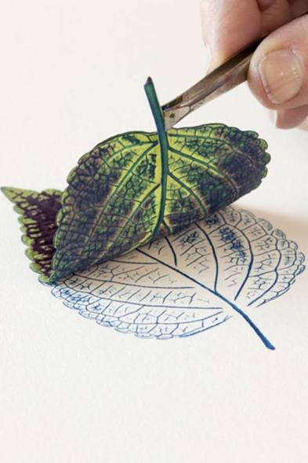
Ink up objects to use for direct printing (Monotype), using these colours from the Farrow and Ball colour palette.

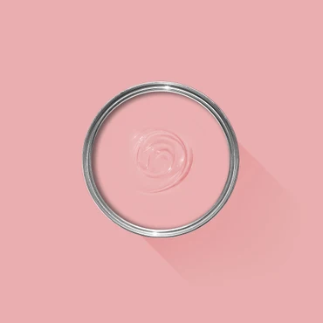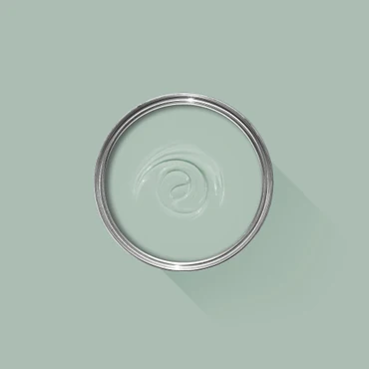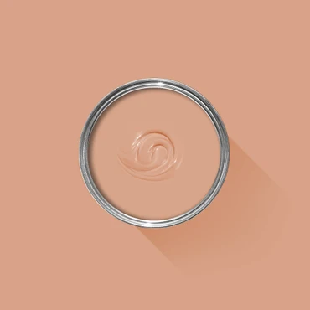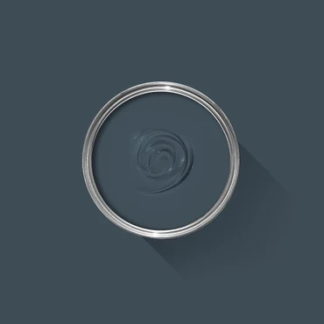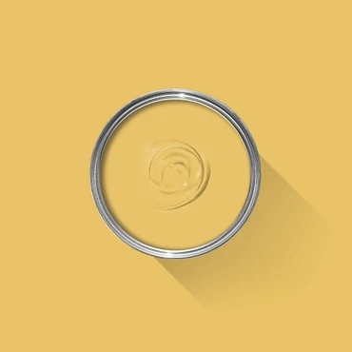
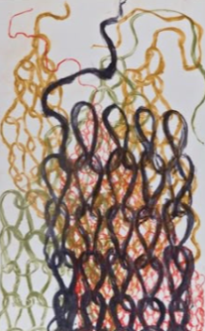
You are searching for interesting textures that can support the image making module, rather than designs and perfect outcomes.
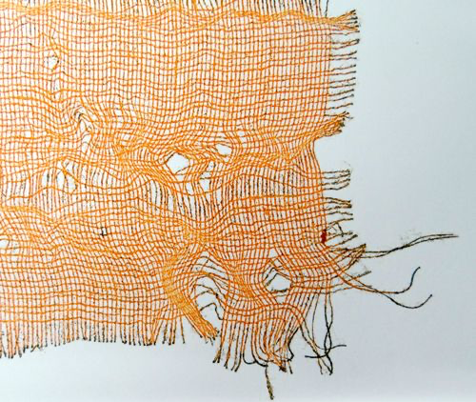

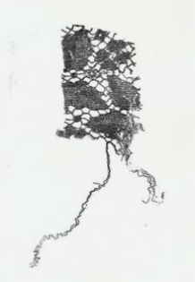
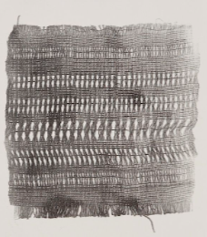
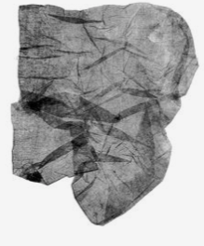
Print makers for research and referencing
- im_printed (Instagram)
- printmakerscouncil (Instagram)
- johnbloorprintmaker (Instagram)
- kateheiss (Instagram)
- linolord press (Instagram)
- angie lewin (Instagram)
- stjudes (Instagram)
- mark_hearld (Instagram)

