1
MARIA GIUSEPPINA REGGIANI
Student number: 2020973
Lecturer: LLOYD BEHARRY.

EFFECTIVE TEAM WORKING AND COMMUNICATION

TABLE OF CONTENTS:
Table of contents ………………………………………..………………………………………………………………………………………………1
1. Introduction 2

2. Models of communication- case studies
- Shannon and Weaver model………………………………………………………………………………………………………….3
- Sharamm’s model.………………………………………………………………………………………………………………………..4
- Berlo’s model………………………………………………………………………………………………………………………………5-6

3. Elements of communication- case studies
- Verbal-written………………………………………………………………………………………………………………………………..7
- Non-verbal…………………………………………………………………………………………………………………………..…………8
- Listening………………………………………………………………………………………………………………………………….……..9
4. Conclusion …………………………………………………………………………………………………………………………………..…..10
Reference List ……………………………………………………………………………….………………………………………………...11

2

- INTRODUCTION

In this report I will illustrate the three models of communication, the elements of communication studied describing them with case studies and my experience at work, demonstrating how communication could be affected.
- In 1948, Claude Shannon devised the first significant communication model, published by Bell Laboratories with an introduction by Warren Weaver.

3
DESCRIPTION:

- THE MODELS OF COMMUNICATION:
- 2.1 Shannon-Weaver Mathematical Model, 1949
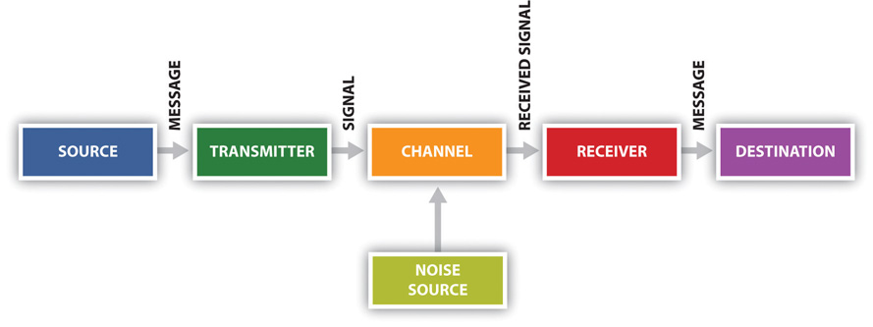 www.thinglink.com
Shannon and Weaver model of communication is composed of five stages: Information source produces a message, this is then encoded into signals by a transmitter, which also sends the message through Channel is the medium through which the message is sent to the receiver, which then the signal reconstructed by the message have a destination. According to Shannon and Weaver noise could affect the message. (Chris,2021)
In the case study Maria and Pedro, I can say that…
Pedro didn’t understand what Maria was saying for the noise where he was working. He understood to meet in the kitchen, but she asked to buy a chicken. This misunderstanding was caused by the noise.
Another example is at my workplace…
I have worked in a hotel. Clients that have effectuated a prenotation with a message, before arriving phone the hotel, asked to them their surname (information for receptionist) for search their prenotation to identify the confirmation and the channel used.
The receptionist while searching the confirmation through the device (software), find (noise- telephonically physical), that change the clarity of the message understanding a different surname. (Mobile phones.) The prenotation confirmed its different, and the client doesn’t find what he thought had prenoted.

4
- 2.2 Schramm’s Model of communication, 1954
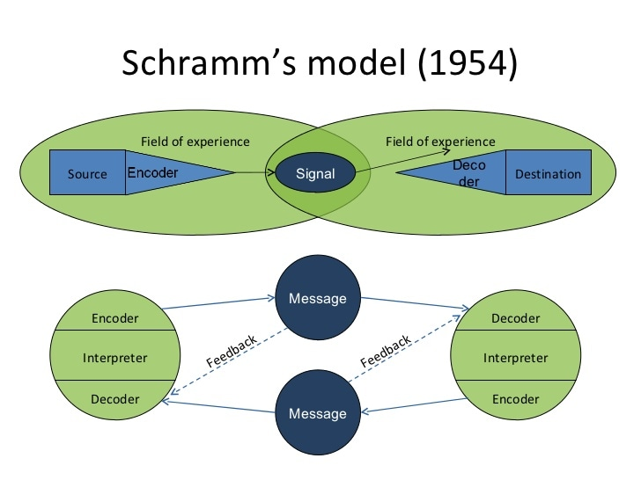 www.thinglink.com
Wilber Schramm proposed it in 1954 but have origins in the Shannon-weaver model.
Coding plays an important role; it starts the communication process by turning ideas into content. When the information reaches the recipient, their responsibility is to understand what the speaker intends to convey. The sender sends the message.
It talks about sending a message: SMCR the receiver must send a message back to the sender providing feedback for the message to be complete.
The encoder turns the message to be sent into codes. The decoder, gets the message which has been sent by the encoder and converts it. The message may be interpreted in a different way if there is noise, from how the sender wishes. (Juneja, P., 2021)
In the case of Maria and Pedro… Pedro should have contacted Maria saying that was too much noise, asking her what she meant.

My experience:
Schramm’s Model: Sports Direct. The sales office of the company put an (announcement) message of the items discounted and new arrivals, on the company website where Information’s decoded and interpreted are sent to clients with a message. One Client interested about a clothes product, phone the store saying:
“You will close today after 10?”
Present communication noise, the worker understands “It’s available today this clothes n°10?” and says, “yes we are available,” When the customers arrive find the store at the closing time. Gets hungry saying, “You told me that the store would have been open now.” (feedback)-- would have been given by the worker when was speaking, at the end of the call for clarification saying: “what are you searching its available.” The client should have clearly repeated the question.
5

- 2.3 Berlo’s Model of communication
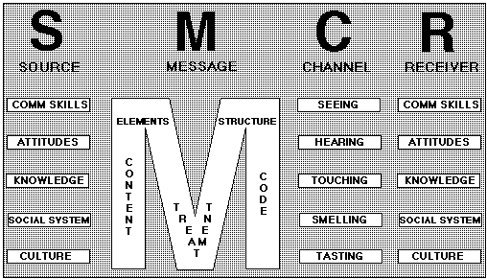www.managementstudyguide.com
It’s A Linear model
Berlo's communication model takes the emotional aspect of information. Runs on the SMCR model. Interference could be caused by a set of different things.
In the model:
- Source: transfer information to the receiver.
- Message: package, form of the message.
- Channel: medium through which information flows.
- Receiver: receive the message. (Juneja, P., 2021)

Case study:
One day the professor’s house was on fire. He went to the near village to ask help in a complicated language, but he wasn’t understood by the people, so they didn’t do anything. If he used a different language, they would understand him. The structure of the content was composed in a professional way.

6
My experience:
Berlo’s Model: Starbucks.
Client wants to buy, the message it’s the order. The channel used with verbal, devices. Baristas analyse the request.
Noise: by the customers seated.
Customer: good communication skills explaining with a good attitude ordering what he knows, could learn history of company even if are presents cultural differences in both parts.

- We obtain a message, includes ex: what is going to say or the gesture: if a customer doesn’t know what to order. Treatment: message sent. Know how to structure the message. Code: how we communicate.
Channels: hear requests, seeing making appealing the pastries, touching make the drink, smelling the coffee, tasting when selling product must respect the company guidelines.
Barista: should have simple communication skills. Attitude: patience with new customers, explaining with knowledge.

7
- THE ELEMENTS OF COMMUNICATION:
- 3.1 Verbal – written
Where information is transmitted through spoken language, or written words. The sender expresses his thoughts in words, with presentations or dialogues. The effectiveness of oral communication depends on the tone/clarity of the speaker, body language. Feedback is immediate. The sender should always check that the message is understood as expected also must listen. (Name, 2021)

Max and Tamara…
Verbal element. Max was feeling under pressure doing all the sectors of his work, causing on him stress. He couldn’t organise his time and work. Tamara his client asked him to plan her parent’s anniversary, but something went wrong.
It could have been prevented by Max, telling Tamara to phone him in another moment.
Tamara should not ruin his career.

My experience at Starbucks:
- With manager:
we should have to reach the target for show to the company. Had an impact on my communication whit her, I was feeling stressful, couldn’t concentrate on what I was doing, having bad communication with the staff and costumers. Because of this I wasn’t understanding the customer request, I was more concentrated on being faster.

- With stuff:
At the beginning was important when I was learning the bar, the till and how to put the pastries in the right way. I was using it as much as I could for have new skills. When staying at the bar communication was very important even for write the order.
3) With clients:
I had possibility to have contacts with different clients. I was affected by using my language skills.
8
- 3.2 Nonverbal
Process of sending, receiving messages with body language to convey information: eye contact, facial expressions, gestures, analysis of body movements or the use of language to convey information through writing text, speech, or sign language. Valuable information, it expresses an intention about a certain situation.
Types of examples:
- body movements
- Personal appearance
- physical environment
We must be sensitive when responding to nonverbal communication. (Nordquist, 2021)

Mark and Alana …
Nonverbal element of communication. Mark was very excited about talking with Alana that when he saw her, started to feel many bad sensations, but Alana was a good person. He took advantage telling her his thought about his work with arrogance (posture).
In Mark’s position I would talk about my thoughts, never being unrespectful.

My experience:
Nonverbal communication:
- Manager was showing me the type of clients that were entering in the store and that I should serve them at the table.

- Stuff, I was occupied to help the first barista. When I was new when I was serving to the till I was flanked by a barista and was indicating me where I should find what to charge, affected by how I would serve customers.

- Clients, written maybe indicating the drink on the wall.
9
- 3.3 Listening
Listening is the key to accurately understanding what another person is saying. Barriers when listening; noise that could interfere the message. Listener must ensure to limit distractions to avoid failing to focus on the massage. (Fryer, 2009). The listener must have a reflective technique. (Wheeless, et. al, 1997)
Listening styles and categories:
People oriented listeners: want to provide concern in other’s interest.
Action- oriented listeners: interested in concise communication.
Content- oriented listeners: before giving feedback, they value the information in a carefully way.
Time oriented listeners: short communication. (Nelson and Heeney ,1984)
(Maund and Andrew, 2017)
Stages: Receiving, understanding, remembering, evaluating, responding, feedback. (Wrench, 2017)
My experience of listening communication:
- When I was trying to talk whit the manager, she wasn’t paying attention on my words. Affected me because I would never have a reference point.

- Of the stuff that sometimes I wasn’t understanding their words.

- About customers that could be affected by their attitude.

10
- CONCLUSION

In the three models the principal person is who create the message to send, must be clear. The secondary is the receiver.
The noise factor it’s present in all of them and could cause a discomfort: on the Maria and Pedro’s case, could think that Maria would have talked about an important issue. In the case of the professor the village they could have felt whit a low communication.

All the three elements of communication are important when we are discussing whit someone, we must put them on practice. We must pay attention on the steps for don’t lose and forget important case, be able to understand the interlocutor ex: his anxiety, trying to avoid the negative ones putting on top the ones having a good impact.
Seven percent of all communication is verbal, through spoken or written words (tone and peach). Non-verbal communication: body language, proximity, facial expressions, eye contact and touch. Active Listening - paying attention and not doing other things, assuming what the other person is going to say. Empathetic listening – trying to put yourself in the speaker’s shoes.

11
REFERENCE LIST:

- Chris Drew, P., 2021. Shannon Weaver Model of Communication - 7 Key Concepts (2021). [online] Helpful Professor. Available at: <https://helpfulprofessor.com/shannon-weaver-model/> [Accessed 23 June 2021].
- Juneja, P., 2021. Berlo's Model of Communication. [online] Managementstudyguide.com. Available at: <https://www.managementstudyguide.com/berlo-model-of-communication.htm> [Accessed 2 July 2021].
- Kobiruzzaman, M., 2021. Communication Elements 9 Elements of Communication Process. [online] Newsmoor.com. Available at: <https://newsmoor.com/communication-elements-9-components-of-basic-communication-process/#:~:text=Therefore%2C%20elements%20of%20communication%20are%20essential%20and%20interconnected,components%20for%20effective%20communication%20between%20sender%20and%20receiver.> [Accessed 3 July 2021].
- Maund and Andrew, 2017. UWTSD Moodle 2020/21:Log in. [online] Moodle.uwtsd.ac.uk. Available at: <https://moodle.uwtsd.ac.uk/pluginfile.php/363317/mod_resource/content/1/Certificate%20in%20higher%20Education%20Skills%20for%20the%20Workplace%20Student%20Yearbook%20-%20Chapter%205%20Listening.pdf> [Accessed 15 August 2021].
- Name, n., 2021. What is Verbal Communication? definition and meaning - Business Jargons. [online] Business Jargons. Available at: <https://businessjargons.com/verbal-communication.html#:~:text=Definition%3A%20The%20Verbal%20Communication%20is%20a%20type%20of,the%20form%20of%20speeches%2C%20discussions%2C%20presentations%2C%20and%20conversations.> [Accessed 2 July 2021].
- Nordquist, R., 2021. What Is Nonverbal Communication? [online] ThoughtCo. Available at: <https://www.thoughtco.com/what-is-nonverbal-communication-1691351> [Accessed 2 July 2021].
- Wrench, J., 2017. The Importance of Listening in Effective Communication. [online] Brewminate. Available at: <https://brewminate.com/the-importance-of-listening-in-effective-communication/> [Accessed 3 July 2021].

