Name: Edwina Kadie Kamara
ID: 2336793
Lectura: Christopher
Module ID: Assessment Component 1 BMHP5015
Module: Changemakers: Building your Personal Brand for Sustainable Employment

Introduction
In today’s energetic and unpredictable labour market, I learned that the ability to cultivate a strong and authentic personal brand is essential for long‑term career sustainability. Out-dated career pathways are gradually giving way to portfolio careers, gig work and continuous upskilling, which places greater emphasis on how individuals communicate their values, purpose and professional identity. It comes to my understanding, changemaker is someone who proactively drives positive change, demonstrating leadership, innovation and a commitment to social impact. Developing this mindset begins with effective brainstorming, a key process for generating ideas, exploring passions and identifying unique strengths. The Changemaker programme underlines that every individual has the capacity to shape their professional narrative. Engaging in thoughtful brainstorming enabled me to clarify my goals, reflect on my skills and values, and develop strategies for sustainable career success. By exploring different pathways and opportunities, I discovered how to align my passions with labour‑market needs, creating a compelling narrative that resonates with employers and communities alike. Building a personal brand is not about self‑promotion; it is about developing a meaningful, value‑driven identity that supports adaptability and long‑term employability in a rapidly changing world.

Task 1 Unit 1: Brand You
Unit 1, Brand You, showed me that personal branding develops through self‑awareness, ambition, and reflective planning. Brainstorming helped me clarify my strengths, motivations, and long‑term direction. Osborn (2012) describes brainstorming as a method that encourages divergent thinking, allowing individuals to generate ideas freely before evaluating or refining them. Engaging in this process enabled me to map out my values. I learned that ambition shapes how I imagine my future self and guides purposeful career choices (Johnson, 2015). Understanding boundaryless careers highlighted the need for flexibility and mobility across roles and sectors (Arthur, 2005). A central theme in the unit was the idea that ambition is critical. Ambition, as discussed in the lectures, is not limited to personal desire; it is a reflective process that shapes how individuals envision their future selves. Johnson (2015) argues that ambition becomes meaningful when it aligns with intrinsic motivation and long‑term purpose. Reflecting on what drives me helped me recognise that my ambition is rooted in contributing to social impact, continuous learning, and developing a career that remains adaptable in a rapidly changing world. The unit also emphasised the importance of recognising what drives you, highlighting intrinsic motivation as a foundation for meaningful and sustainable career development (Ryan and Deci, 2020). It also introduced the concept of the boundaryless career, which challenged traditional ideas of stable, linear employment. Arthur (2005) explains that boundaryless careers involve mobility across organisations, sectors, and even countries, requiring individuals to cultivate flexible, transferable skills. This idea helped me understand that my personal brand must be adaptable and future‑focused. Closely linked to this is the development of boundaryless skills competencies such as digital literacy, communication, and problem‑solving that remain valuable across diverse contexts. Recognising the importance of these skills strengthened my awareness of how I must prepare for a career that may evolve beyond conventional boundaries. Also explored the gig economy, defined as short‑term, technology‑mediated work arrangements. Understanding the gig economy helped me appreciate how modern careers increasingly rely on flexibility, self‑management, and entrepreneurial thinking. This reinforced the importance of building a personal brand that communicates reliability, adaptability, and a strong sense of professional identity. Learning about the gig economy reinforced the importance of building a resilient, self‑managed personal brand (Everett, 2016).
Overall, Unit 1 helped me understand that personal branding is an active, reflective process shaped by ambition, self‑awareness, and the ability to navigate boundaryless career landscapes. Brainstorming played a crucial role in helping me clarify what drives me and how I can position myself confidently within the modern world of work. Ibarra (2015) argues that ambition shapes how individuals construct their “possible selves,” influencing the choices they make and the opportunities they pursue.
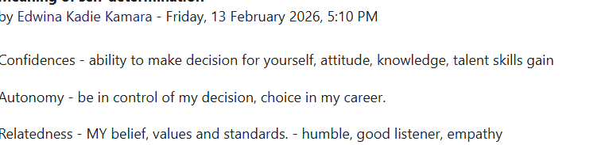
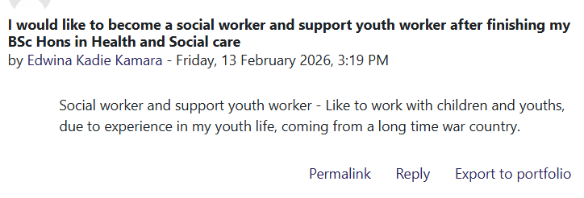

Task 2 – Reflection on Unit 2: It’s a Small World (400 Words)
Unit 2, It’s a Small World, expanded my understanding of how globalisation shapes health and social care, and how my own ambition and motivations influence the way I respond to global challenges. The unit highlighted that health and social care systems do not operate in isolation; instead, they are deeply connected through global workforce mobility, international policy frameworks, and shared public health priorities. This helped me recognise that my professional development is also part of a wider global landscape. One of the key topics explored was global health inequalities, which emphasised how social, economic, and political factors create uneven health outcomes across countries. The World Health Organization (2021) stresses that structural determinants such as poverty and access to healthcare drive these disparities. Understanding this strengthened my awareness of the need for culturally responsive practice, especially in diverse UK communities shaped by global migration. The unit also examined global labour markets, linking directly to my ambition and what drives me. Dodson (2024) argues that modern workers must develop boundaryless skills adaptable competencies that can transfer across roles, sectors, and even countries. This concept helped me understand that ambition is not only about personal goals but also about preparing to navigate a globalised workforce. Similarly, Houston (2019) highlights how globalisation reshapes professional identity, requiring practitioners to remain flexible, reflective, and open to continuous learning. Another important topic was the rise of the gig economy, defined as short‑term, technology‑mediated work arrangements (Everett, 2016). Although often discussed in relation to business, the gig economy also influences health and social care through agency work, international recruitment, and flexible staffing models. This broadened my awareness of how global economic trends affect local service delivery and employment patterns. Brand You, showed me that personal branding develops through self‑awareness, ambition, and reflective planning. Brainstorming helped me clarify my strengths, motivations, and long‑term direction. I learned that ambition shapes how I imagine my future self and guides purposeful career choices (Johnson, 2015). Understanding boundaryless careers highlighted the need for flexibility and mobility across roles and sectors (Arthur, 2005). This connected to developing boundaryless skills, which support adaptability in modern labour markets. Learning about the gig economy reinforced the importance of building a resilient, self‑managed personal brand (Everett, 2016). The unit’s activities also connected to the idea of the boundaryless career. Inkson and Arthur (2001) describe this as a career path that extends beyond organisational and geographical boundaries. Reflecting on this helped me recognise that my ambition and what drives me particularly my desire to contribute to global wellbeing align with a career that may involve cross‑sector collaboration, international learning, and digital mobility. Overall, Unit 2 strengthened my understanding of how global forces shape both health and social care practice and my own career development. I now recognise that being an effective practitioner requires global awareness, adaptability, and the ambition to develop boundaryless skills that support sustainable professional growth.
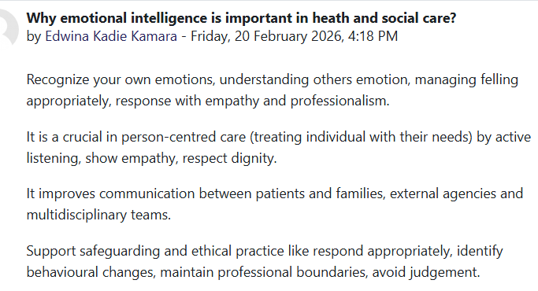
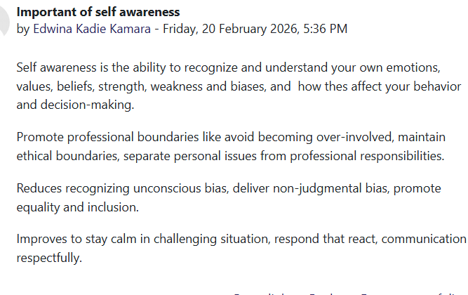
Task 3 – Reflection on Unit 3: Opportunity Knocks
Unit 3, Opportunity Knocks, strengthened my understanding of how opportunities emerge and how I can actively recognise and use them to support my personal and professional development. The unit emphasised that opportunities are not purely accidental; instead, they often arise when individuals adopt proactive behaviours, remain open to new experiences, and position themselves in environments where growth is possible. This perspective encouraged me to take greater ownership of my career journey. A key topic in the unit was creating my own luck. I learned that luck is often the result of deliberate actions such as networking, seeking feedback, and engaging in continuous learning. Krumboltz’s (2009) Planned Happenstance Theory supports this idea by suggesting that individuals can generate positive career events by staying curious, acting, and embracing uncertainty. Through the online activities, I recognised that I create my own luck when I volunteer for new tasks, connect with others, and remain open to unexpected opportunities. This helped me understand that opportunity is something I can influence rather than something I must wait for.
The unit also explored identifying career opportunities, which required me to reflect on my strengths, values, and long‑term ambitions. I learned to analyse opportunities not only in formal job roles but also in informal learning spaces, mentorship, and digital platforms such as Me.com. Inkson and Arthur’s (2001) concept of the boundaryless career helped me appreciate that modern careers are fluid and shaped by networks, transferable skills, and cross‑sector mobility. This encouraged me to broaden my thinking and recognise opportunities beyond traditional pathways.
Another important theme was recognising open doors moments of change or transition that can lead to growth. The unit taught me to view these moments as potential opportunities rather than barriers. This aligns with Dweck’s (2017) growth mindset theory, which highlights that individuals who embrace learning and adaptability are more likely to take advantage of emerging opportunities. By applying this mindset, I now see how unexpected situations such as organisational changes or new responsibilities can become stepping stones in my development.
This unit showed me that personal branding relies on ambition, self‑awareness and reflective tools like brainstorming. Understanding boundaryless careers and the gig economy highlighted the need for adaptable, transferable skills in modern work. These ideas strengthened my awareness of how to shape a flexible, future‑focused professional identity (Arthur, 2005; Johnson, 2015; Everett, 2016).
Overall, Unit 3 helped me understand that opportunities are often present but require awareness, confidence, and action. I now feel more equipped to recognise open doors, create my own luck, and pursue opportunities that align with my personal and professional goals.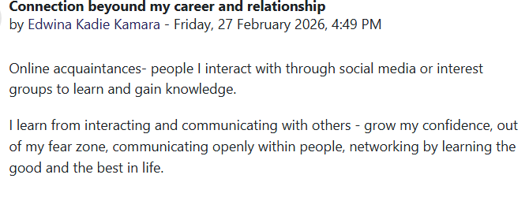
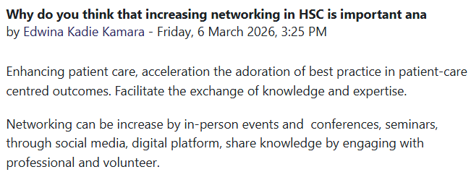
Task 4 – Reflection on Unit 4: The Pursuit of Happiness and Conclusion
Unit 4, The Pursuit of Happiness, deepened my understanding of how wellbeing, purpose and personal fulfilment influence both professional identity and long‑term career satisfaction. The unit encouraged me to reflect on what happiness means in the context of health and social care, where emotional resilience, compassion and personal motivation play a central role. I learned that happiness is not simply an emotional state but a combination of meaning, engagement and personal growth. Seligman’s (2011) model helped me recognise that positive emotion, relationships and accomplishment are essential components of sustainable wellbeing, particularly in demanding care environments. A key insight from the unit was the importance of envisioning my future self. Reflecting on “Future Me” helped me identify the type of practitioner I want to become and the values that will guide my decisions. This aligns with Oysermans’ (2015) theory of possible selves, which suggests that imagining future identities motivates present‑day actions. Through the activities, I recognised that cultivating passion and perseverance qualities associated with long‑term success requires consistent self‑reflection and a willingness to adapt. The unit also highlighted the role of passion and perseverance, often described as “grit”. Duckworth (2016) argues that grit is a stronger predictor of achievement than talent alone. This helped me understand that pursuing happiness in my career involves commitment, resilience and the ability to stay motivated even when challenges arise. In health and social care, where emotional labour is significant, perseverance supports both professional effectiveness and personal wellbeing. The online activities reinforced these ideas by prompting me to evaluate what brings me fulfilment, how I respond to setbacks and how I can maintain motivation over time. These reflections strengthened my awareness that happiness is closely linked to purpose, and that purpose is essential for sustaining a meaningful career in care. Overall, Unit 4 helped me understand that happiness, purpose and perseverance are central to building a sustainable and fulfilling career in health and social care. Across the module, I developed greater self‑awareness, reflective skills and confidence in shaping my professional identity. These insights will support my future practice by helping me stay motivated, resilient and committed to delivering compassionate, person‑centred care.
Conclusion
Across Units 1–4, this module has significantly strengthened my self‑awareness, professional identity and understanding of how to navigate a rapidly changing health and social care environment. Unit 1 helped me recognise that personal branding is an intentional process shaped by ambition, reflective practice and the development of boundaryless skills. Through brainstorming and self‑evaluation, I gained clarity about what motivates me and how to position myself confidently within modern, flexible career pathways. Unit 2 expanded my awareness of global connections, showing how international policies, global inequalities and workforce mobility influence local practice. This deepened my understanding of cultural competence and highlighted the importance of adaptability in delivering effective, person‑centred care. Unit 3 strengthened my ability to recognise and act on opportunities. Learning about creating my own luck, identifying career openings and developing resilience helped me understand how proactive behaviour supports long‑term professional growth. I now see challenges as potential openings rather than barriers. Finally, Unit 4 emphasised the importance of happiness, purpose and perseverance in sustaining a meaningful career. Reflecting on my future self-helped me understand how wellbeing and motivation influence my ability to thrive in demanding care settings. Overall, the knowledge and skills gained across all units will support my future practice by enhancing my confidence, adaptability and commitment to compassionate, reflective and resilient care.
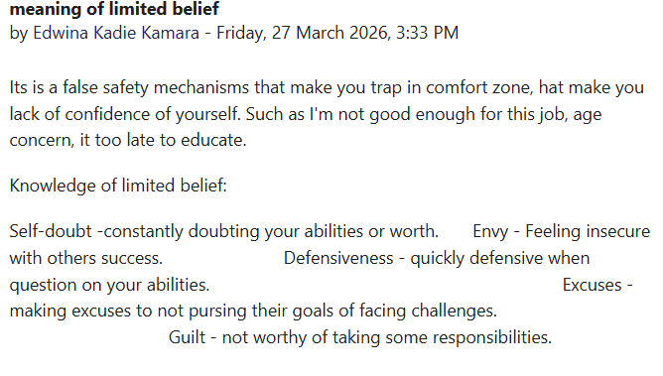
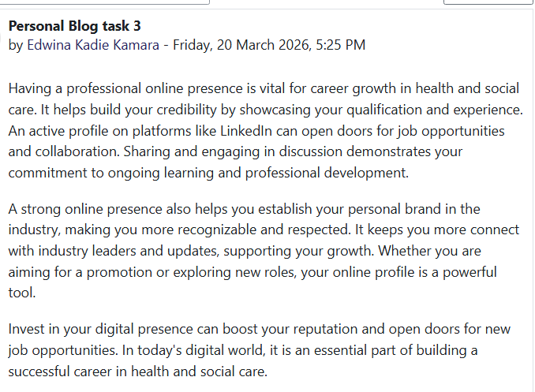

References
Arthur, M.B. (2005) Boundaryless Careers: A New Employment Principle for a New Organisational Era. Oxford: Oxford University Press.
Arthur, M.B., Khapova, S.N., Wilderom, C.P. (2005) Career success in a boundaryless career world. Journal of Organization Behaviour: The International Journal of Industrial, Occupational and Organizational Psychology and Behaviour. 26(2), pp.177-202.
Duckworth, A. (2016) Grit: The Power of Passion and Perseverance. New York: Scribner.
Dweck, C. (2017) Mindset: Changing the Way You Think to Fulfil Your Potential. London: Robinson.
Dodson, J. (2024) What Ambition Is and How to Maintain a Healthy Sense of It. Available at: https://www.betterhelp.com/advice/ambition/what-does-ambition-mean-an-overview/ (Accessed: 09 April 2026).
Dodson, J. (2024) Global Skills for a Changing Workforce. London: Routledge.
Everett, C. (2016) ‘The gig economy’, HR Magazine, 61(3), p.12.
Houston, (2019) What is Goal Setting and How to Do it Well URL Available at: https://positivepsychology.com/goal-setting/ (Accessed: 09 April 2026).
Houston, S. (2019) Globalisation and Professional Practice. London: Palgrave.
Ibarra, H. (2015) Act Like a Leader, Think Like a Leader. Boston: Harvard Business Review Press.
IInkson, K. and Arthur, M.B. (2001) ‘How to be a successful career capitalist’, Organizational Dynamics, 30(1), pp. 48–61. https://psycnet.apa.org/record/2001-18805-004 (Accessed: 09 April 2026).
Johnson, D.R. (2015) Ambition and Personal Development in Modern Careers. London: Sage.
Johnson, D.R. (2015) Emotional intelligence as a crucial component to medical education. International journal of medicine education. 6, p.176
Krumboltz, J.D. (2009) ‘The happenstance learning theory’, Journal of Career Assessment, 17(2), pp. 135–154.
Osborn, A. (2012) Applied Imagination: Principles and Procedures of Creative Problem-Solving. New York: Scribner.
Oyserman, D. (2015) Pathways to Success Through Identity‑Based Motivation. Oxford: Oxford University Press.
Ryan, R.M. and Deci, E.L. (2020) Self‑Determination Theory: Basic Psychological Needs in Motivation, Development, and Wellness. New York: Guilford Press.
Seligman, M. (2011) Flourish: A Visionary New Understanding of Happiness and Well‑Being. New York: Free Press.
World Health Organization (2021) World Health Statistics 2021. Geneva: WHO.

