General discussion on approaching an answer to the Assignment 1. 09-03-21
Assignment 1
Construct three critical reports mirroring the process of generating a research proposal.
The reports will link together therefore you need not repeat things said in report 1 in report 2 etc. Simply say “As argued above….”. If you are following a writer’s arguments do use their name again e.g. As argued in section 1, using Varoufakis (2020) a more equal society might be a better way to solve general problems of poverty, global warming and diplomatic crisis, yet those who own resources are unlikely to give them up. My research will target interviewing rich resource owners to test their willingness to share.
Varoufakis, Y. (2020) Another Now. Dispatches from an Alternative Present, London, Penguin/Random House.
General comments:
- Whether this is your first, 3rd or final assignment, Caroline and Steve will mark it positively. That is we will look for good ideas, arguments, signs of research and use of evidence and reward it with grades.
(The alternative negative marking starts with 100% and then takes marks off for poor work…. this we do not do).
- There is NO single answer to the questions set. Your answer will be individual to you. However there are common ways to review, evaluate and “sift” ideas, theories and ways to research. These we will be looking for.

- The whole assignment seeks to get you to rehearse the things you need to do anyways, when preparing for your ultimate research, thesis writing and presentation of the document. Therefore it is possible to make mistakes. This will be especially valuable if you recognise mistakes, know why they are the wrong thing to do and make preparation to avoid these in the future.

- In the sense that these are “blogs”, they can resemble small reflections on your learning journey. Like any journey we can sometimes get lost or experiment with new ways to get to our destination. Should you lose your way, it is Caroline and Steve’s job to help you back on the road that will get you to where you want to be.

- The other thing to appreciate is that the process you are undertaking is a circle or cycle. You may start with some ideas, investigate them, design a research project, undertake it, but then come back to the same questions…you may even go on a new cycle. This assignment hopes that you will start this circle journey. At the end of the assignment and the taught modules we hope you will be stringer and more confident. Then you start the full research process and write your dissertation!

Play to your strengths. If you like certain things or have achieved good results in study or work, use some of these past studies or experiences to reflect on how you might develop a research project.

The process of this assignment reflects Maxwell’s chapters:
Joseph A. Maxwell (2012) Qualitative Research Design: An Interactive Approach: (Applied Social Research Methods), London, SAGE.

Maxwell’s chapter headings are:
- A Model for Qualitative research design.

- Goals: Why are you doing this study?

- Conceptual Framework: What do you think is going on?

- Research Questions: What do you want to understand?

- Methods: What will you actually do?

- Validity: How might you be wrong?

- Research Proposals: Presenting and justifying a qualitative research study.

His chapters 2 to 6 might be particularly relevant to the process you are undertaking in this assignment.
Chapter 1 would be relevant if you plan qualitative data collection.
Chapter 7 would be relevant for your final research proposal but could be useful for this assignment for the section 3 and presentation.
There are many other texts and articles that offer the same approach. Do reference them.

Another free source: This is a nice chapter on getting yourself ready for doctoral research:
Source: https://in.sagepub.com/sites/default/files/upm-assets/58917_book_item_58917.pdf
See the Research Circle/Cycle, quoted in most research methods books and articles:
You might keep thinking about the circle at each stage of the assignment to see how your ideas are progressing. How do they fit in?
Fig. 1 The Basic Circle of investigation
Source: Jonathan A. Long (2007) Researching Leisure, Sport, and Tourism, London, SAGE.

(Long (2007) labels this diagram (Figure 15.1: A cycle of generating and testing theory.)

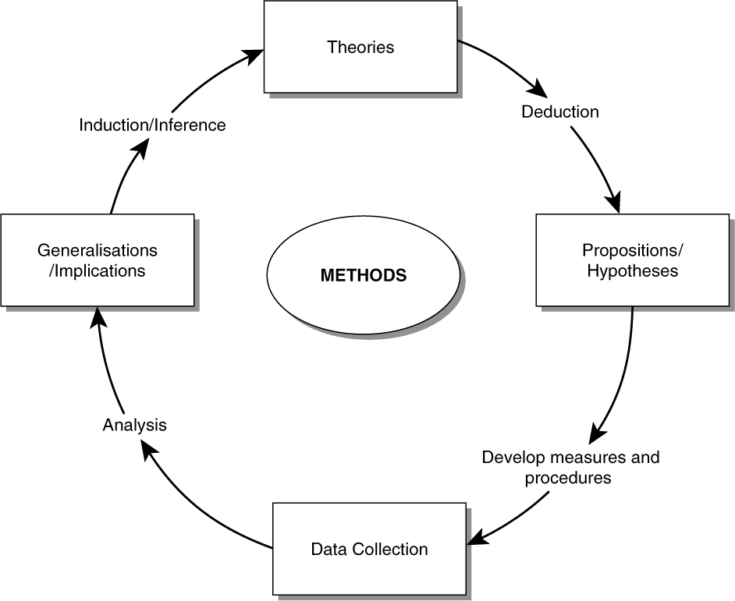

Fig 2: A more detailed and applied Circle/Cycle of research activity.
Source: https://conceptdraw.com/a2019c3/p1/preview/640/pict--circle-diagram-research-cycle-circle-diagram

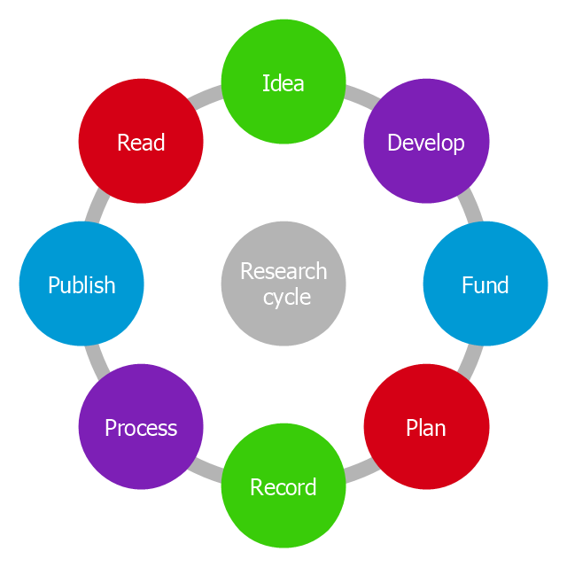

The normal process for academic researchers is to have a publishing goal at the end. This can also be seen in business research methods for companies.
This sharing of ideas and research is part of being in the “academic community”. This community may not be perfect, especially if you have made an important breakthrough and are looking to exploit this or go for a Nobel Prize!!! See the Coronavirus vaccine development arguments.
It raises issues for you, since it might influence what you research and how you do it.
For example:
- In your applied research are you looking at commercially sensitive data that a company wants to keep confidential/secret?
- Are you in employment and planning to research things linked to the company?
- Are you being sponsored by a company or receiving any help with data collection?
- Is your research being commissioned by a company, government or any organisation?
- You may simply be interested in sharing your work in a conference paper, industry magazine, online research depository or in your personal profile e.g. on LinkedIn. BE CAREFUL.

Advice for the assignment.

- Read the question and any advice that is offered.
This may seem obvious, but many students do not. This includes how the assignment is graded and what must be included e.g. a BIBLIOGRAPHY.

- Look at the word count and plan your answer.
If you find that your reports are not equal in length think about tactically moving words around or losing words in the text.

- Using appendices. If you do this, number them and do refer to them in your reports. This is often good if you have much descriptive text. Make sure the real report has analysis and evaluation in it, with evidence to back up what you are saying.

- Perhaps move some material from section 2 to section 1. Be careful (see instruction number 1 above.

- Going over by more than 10% will incur penalties. The word count is also there to protect you.

- Assignment 1, section 1: Getting ideas.
    - Investigate ideas for a viable research proposal.
This report will contain:
- A personal evaluation of your past educational studies and training experiences. These will conclude with knowledge and skill areas of strength and needs for further study and training.
- A list of sources consulted to define areas of interest to your future research. There must be a wide range of sources. However, these must include several articles from respected refereed journals. All sources must be evaluated for validity and reliability for their contribution to your foundation for future research.
- Include a discussion on the validity and reliability of different sources.
- An evaluation of the currency and applicability of concepts and themes interrogated.
- It is likely that your initial search could be wide ranging, but as your analysis deepens you will identify areas of particular interest to focus your future investigations.
You can have as many ideas as you like from whatever sources you like. The main task for this section is to see how you reduce the number of ideas and decide which one(s) to follow up.
See past lecture on this with the resources uploaded. I shared this picture of a brainstorm I did with a class a couple of years ago on how to get ideas. Please see my document on the possible positive and negatives of each.
Document: Getting ideas for research projects: Positives and Negatives of different ways. Updated after lecture on 16-02-21.
You do not need to do them all but maybe choose 5 or 6 to analyse.
Fig 3: Steve’s brainstorm with class.

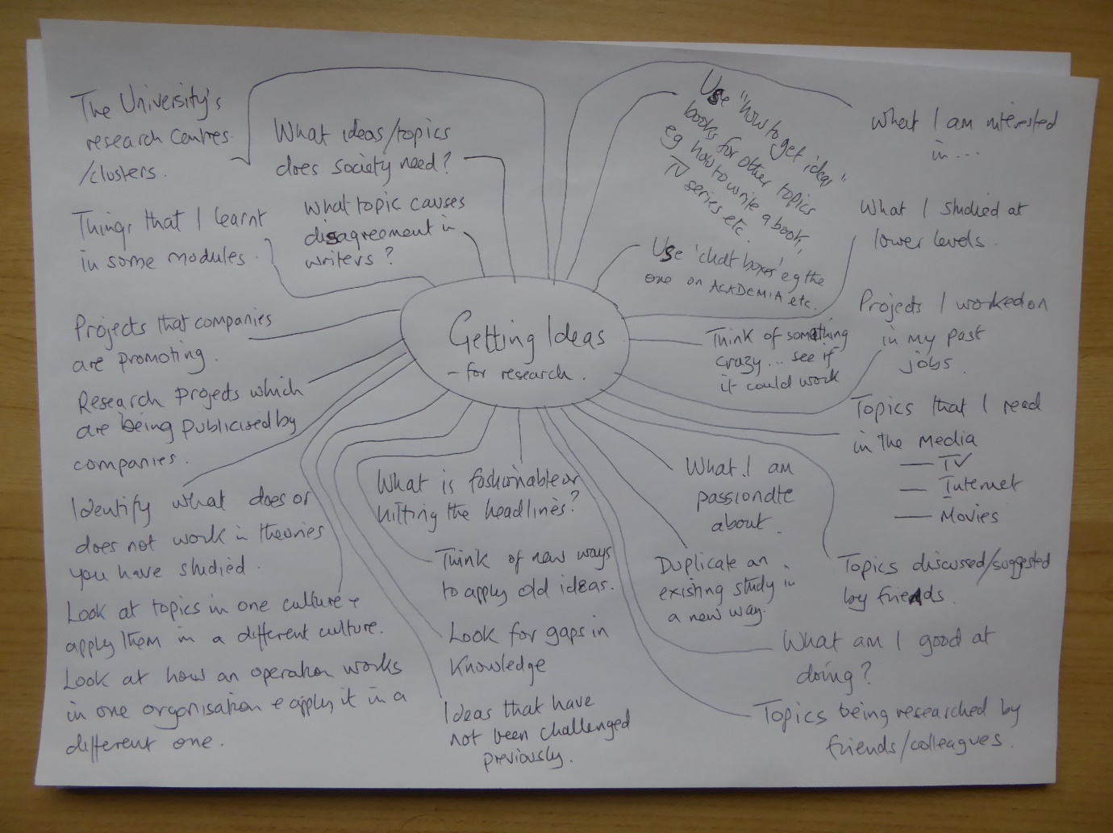

The craziest or silliest source could give some good ideas. The good ideas will be good because they will allow you to have SMART objectives:
Objectives are 'SMART' if they are specific, measurable, achievable, (sometimes agreed), realistic (or relevant) and time-bound, (or timely).
https://www.managers.org.uk/wp-content/uploads/2020/03/CHK-231-Setting_Smart_Objectives.pdf

Fig 4 Empty Beer can on eBay.
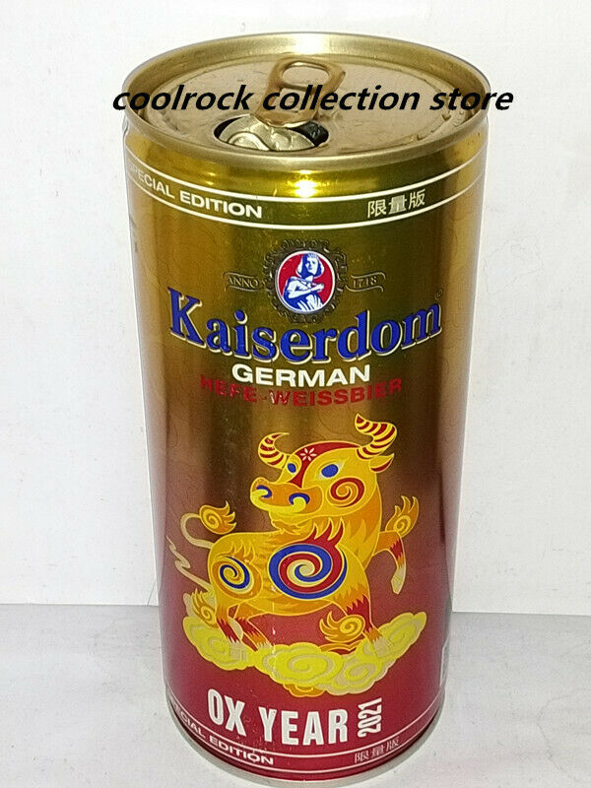

https://www.ebay.com/itm/2021-China-Kaiserdom-German-beer-OX-YEAR-can-1L-1000ml-empty-for-collectible-/174557899448 Selling for $15.00, an empty can!!!!
How could this become an academic study?
Anything can be if it has sufficient academic backing, depth of analysis and has good methods for data collection and evaluation.
See my quick analysis of 6 possible research ideas.
Document: Getting ideas and analysis of their strength for future research.
- Do find other sources for your favourites.
- Do try to reference backup academic literature to show that you can see there are theoires that you will be able to reference.
- Make sure that you reference these academic articles to show your early research of the literature.
- Do try to anticipate problems (and maybe how to get over them) if you chose a topic for future research.
- Do try to use the Words VALIDITY, RELIABILTY, CURRENCY, APPLICATION OF CONCEPTS, ……

- Assignment 1 section 2.

    - Evaluate a core theory and its application to several possible lines of investigation.

- Choose a general theory and its possible applicability to applied research.
- It is recommended that you include a concept mapping diagram and discussion to inform the reader of the development of your theme.
- Evaluate its strengths and weaknesses to a possible focus for your future research.
- Consider applications in several environments, such as different organisational forms, different cultures, different regional/national environments.
- Discuss possible objections to some applications from an ethical, availability of data, research risk and personal capacity to deliver.
- Identify sources of support that might be employed in your research planning. Integrate evaluation of possible bias and access problems that you would have to overcome.
At every stage you can quote research methods books and articles for why you are choosing to review and apply certain theories and topics.

Fig 5. Making use of literature
Source: Long, J.A. (2007) Researching Leisure, Sport, and Tourism, London, SAGE.

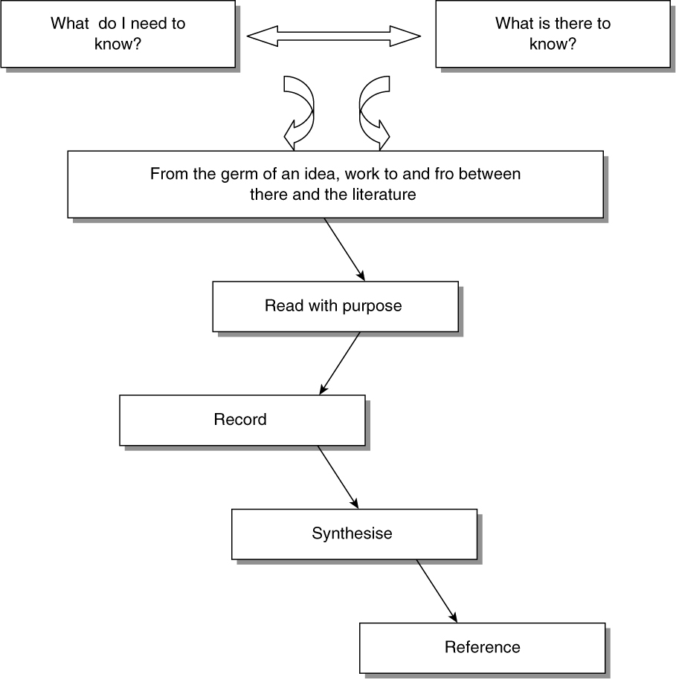

Evaluate a core theory.

My chosen theory will be the Family Life Cycle (FLC).
Despite criticisms that it is outdated, like several others I believe it can be updated for modern and international conditions.

I will review the origins and updates of the FLC, including its applications away from the originals in family theory in Sociology and Marketing targeting in business, to health, education and population management.
The focus will be essential to make a workable project therefore I choose to specialise in singles (old and young). This will narrow the discussions to allow depth of analysis.
I will also incorporate theories of generations, since younger singles are likely to be Millennials (Gen-Z) and older singles (Baby Boomers).

I will focus my spending pattern research on service demand especially leisure and tourism, transportation, personal services (insurance, banking, health etc) and use of technology.

There are many challenges to this core theory. Various writers offer alternative perspectives to explain patterns and planning of spending.
Anti FLC Influential Variables
- Income- class structures, Working class, Middle class,
- Family history- conventional v unconventional (who defines normal?), family responsibilities,
- Religion, lifestyle choices, social environment- Muslim, Christian, Hindu, Buddhist, Confucian, Taoist, Environmentalist, Feminist, and many other interpretations
- Education experiences- high school graduates, university graduates,
- Other formative experiences- military service, international travel,
- Sex/Gender- Male v Female v Other?
- Work position (may be linked to Income/class)- manual, professional, managerial, self-employed, entrepreneur, positions.
- Family concept adopted- planned family or family history.
- Market development and opportunities- housing, leisure, family support, travel/transport,
There are also challenges to the Generations approach.
- Some do not want to be located in a “generation”. Others do not see it as relevant to them. Resistance will be a problem for data collection.
- Different generations often share many things. “Silver Surfers” in the Baby Boom generation may look like Gen -Z. Poor, uneducated young people may not know anything about new technology, even if their peers in other rich countries are the i-Generation.
- The FLC might be a threat to the Gneeration approach since once the young Gen-Zs have children they will look very much like Gen-Y. When they retire and their children leave home, they may even look like “Baby Boomers “today.
- Income, class, education, cultures, lifestyle may override Generations descriptions.
- International comparisons will be inappropriate since some cultures do not reflect the generations influences, or some regions may evolve the generations characteristics more slowly. For example today’s Gen-Z young people in Japan, may resemble a future generation in Yemen in 10 years’ time. Today’s young people in Yemen have more important things to worry about. Cross cultural and regional comparative analysis will be full of problems.

- Assignment 1 section 3.

    - Identify one possible research theme and a discussion of research methods to achieve stated objectives.
Select an area of specialism for possible research.
- Analyse quantitative, qualitative or mixed method approaches to research your chosen theme. Define advantages and disadvantages of each approach.
- Discuss the challenges to reliability and validity of different data collection approaches, linked to your applied theme.
- Evolve a more defined research proposal with a valid methodology to achieve stated objectives. Locate your chosen method in the spectrum of possible methodologies.
- Analyse likely sources that will be used in your research, including the use of non-refereed sources.
- Identify risk factors, including research ethics risks, in pursuing your research and the chosen methodology planned.

Fig. 6. Procedure of Systematic Literature Analyses. Source: Own elaboration based on Martin and Assenov (2012), Welty Peachey et al. (2019), and Thees et al. 2020 in

Herbold V, Thees H, Philipp J. The Host Community and Its Role in Sports Tourism—Exploring an Emerging Research Field. Sustainability. 2020; 12(24):10488. https://doi.org/10.3390/su122410488

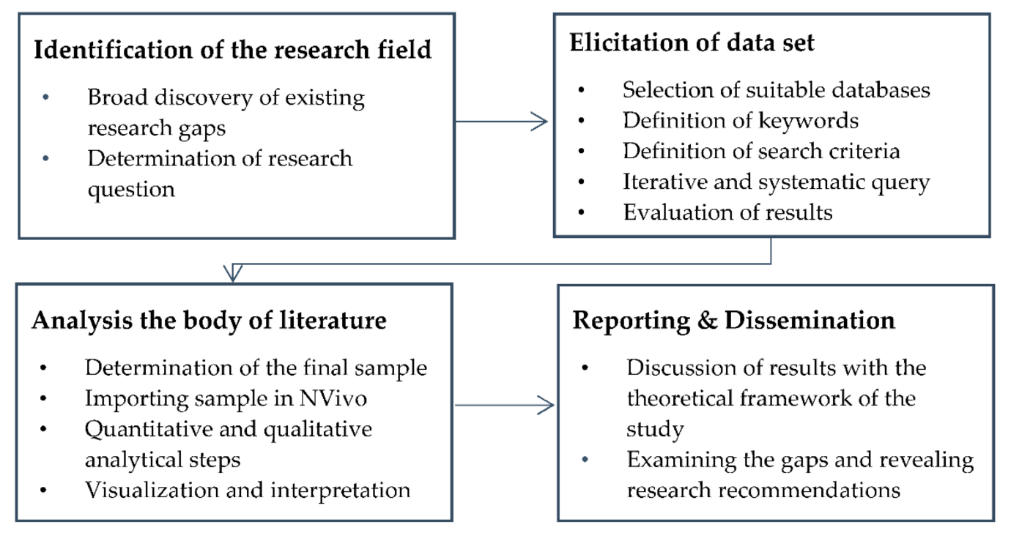

Fig 7: The Research Tradition.

Durdella, N. (2019). Qualitative dissertation methodology: A Guide for Research Design and Methods. London, SAGE Publications, Inc https://www.doi.org/10.4135/9781506345147

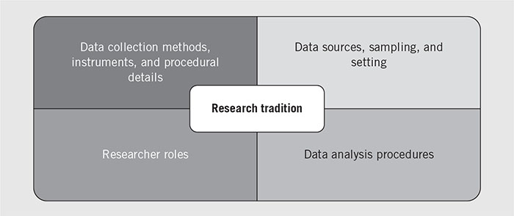

Evaluate a theme within the core theory.

Develop a theme from the general theory:
‘Compare different generations from a FLC perspective”.
An evaluation of the spending patterns of current young and older singles, to make predictions about current singles and their behaviours in 30 years’ time.
- Determine the existing spending patterns in one country.
- Compare and contrast these spending patterns (quality and quantity)
- Predict existing Gen- Z and what they might be doing in 30 years. https://www.pewresearch.org/fact-tank/2019/01/17/where-millennials-end-and-generation-z-begins/
The oldest Millennials, the i-Generation are in their early 20s. They are digital citizens. Will this change how they will be living compared with current older singles, likely aged 55-85, the ‘baby boomers’?
Special reference to leisure, entertainment, tourism, hospitality and personal services. I may need to reduce this list to one or two service industries.
I would like to make cross cultural comparisons, but I feel that this might reduce focus on existing singles and predictions in one culture.

I like the idea of qualitative research which I am fairly new to. I especially like Maxwell (1998) and his updates where he recommends interactive methods to elicit deeper understanding of respondents.
This method will not easily test a hypothesis. However working hypothesises are:
- Young singles are very different to older singles in their demand for services. This is shown by different quantities of different services and different qualities of the same services.

- Today’s young singles are likely to be very different in their consumption of services in 30 years’ time, related to their comfort using digital technologies and the likely evolution of service provision.

- The FLC will need significant modification to incorporate changes in lifestyle, regulations and resource access. Such modifications may threaten the very use of the FLC concept.
Methodology
Qualitative.
The main method will be a content analysis of marketing campaigns targeting young and old singles. A review of organisations who target these groups for membership, selling of related products and education/training of the two groups.
In parallel interview questions will be derived from factors identified int eh literature and industrial practice to review differences and similarities in the spending patterns of existing older and younger singles. Younger singles will be invited to share their plans, ambitions and hopes for career development, family development and wider cultural sensitivities in spending and its impacts for the future.
Data Analysis
A thematic approach using software to help compute the data will allow logical progression through the dissertation.
Ethical Risk Analysis
Risk assessment for interview groups younger and older singles on buying patterns.

Grading:
- Likelihood of occurrence. 1-5 (1-least likely...5 highly likely)
- Degree of harm if factor occurred. 1-5 (1-negligible harm…5 catastrophic harm)

 | Evaluation | a | b. | c.
 | Risk factor. | Likelihood of occurrence. | Degree of harm if factor occurred. | Total  a x b = c
 | Participant extreme emotional disagreement in discussion | 1 | 1 | 1
 | Participants naming individuals in the discussion | 2 | 2 | 4
 | Participants lack honesty about behaviour | 2 | 1 | 2
 | Participants confess to illegal behaviour | 1 | 1 | 1
 | Insulting attitude to researcher by participants | 1 | 1 | 1
 | University reputation issues should findings when published be seen to be unsupportive or unethical. | 2 | 3 | 6
 | Release of confidential participant data from researcher’s files. | 1 | 2 | 2
 | Total | Possible score- c x no. factors. | Actual score = | 17/175

Likelihood of achieving objectives.
- It may be too ambitious to combine the FLC with the Generations research.
- Predicting behaviours in 30 years’ time may be too far ahead. Perhaps modify to predicting the next stage of their move along the cycle.
- Maybe targeting two types of singles may be too difficult.
- The social attitudes to race, sexuality, environmental concern, use of technology, family responsibilities etc may be very different, however some issues are very sensitive, including possible illegal behaviours (drug use) or irresponsible behaviours (neglecting families). Sensitivities will make questionnaires and interviews data less valid and reliable.
- Cultural sensitivities could also impact on the researcher, leading to bias in analysis and selection of questions to use.
Conclusion: Researcher may need training in data collection and analysis.

Bibliography (includes things quoted or used)

Alasuutari, P., Bickman, L. & Brannen, J. (eds.) (2008) The SAGE Handbook of Social Research Methods, London, SAGE. DOI: https://dx.doi.org/10.4135/9781446212165

Amirtha, R., Sivakumar, V. J. and Yujong Hwang (2021) Influence of Perceived Risk Dimensions on e-Shopping Behavioural Intention among Women-A Family Life Cycle Stage Perspective. Journal of Theoretical & Applied Electronic Commerce Research. Vol. 16 Issue 3, p320-355.

Andersen, Torben M; Bhattacharya Joydeep.(2021) Why mandate young borrowers to contribute to their retirement accounts? Economic Theory; Feb., p115-149.

Branson, J.S., Branson, A. , Pozniak, K., Tookes, J. & Schmidt, M. (2019) The Role of Family During Older Adults' Living Transitions: Implications for Helping Professionals and Family Counselors. Family Journal. Vol. 27 Issue 1, p75-83.

Creswell, J.W. and Creswell, J.D. (2018) Research Design: Qualitative, Quantitative, and Mixed Methods Approaches, London, SAGE.
De Melo, A.T. and Alarcão, M. (2014) Beyond the family life cycle: Understanding family development in the twenty-first century through complexity theories,
Family Science, Volume 5, Issue 1 Pages 52-59

Flick, U. (ed.) (2014) The SAGE Handbook of Qualitative Data Analysis, London, SAGE. DOI: https://dx.doi.org/10.4135/9781446282243

Garcia Preto, N.G. and Carter, B. (2015) The Expanding Family Life Cycle: Individual, Family, and Social Perspectives, London, Pearson.
Gallego-Martelo, S.M., Ceballos, L. M. & Mejia-Gil, M.C. (2020) Leisure lifestyles of childless couples vs. full nest. Estudios de Administración. ene-jun2020, Vol. 27 Issue 1, p49-68.

Herbold V, Thees H, Philipp J. The Host Community and Its Role in Sports Tourism—Exploring an Emerging Research Field. Sustainability. 2020; 12(24):10488. https://doi.org/10.3390/su122410488

James, E.A. & Slater, T. (2014) Writing your Doctoral Dissertation or Thesis Faster: A Proven Map to Success, London, SAGE. DOI: https://dx.doi.org/10.4135/9781506374727
Kaland, O.J. (2021) “We Have Many Options, But They are All Bad Options!”: Aspirations Among Internal Migrant Youths in Shanghai, China, The European Journal of Development Research; Vol. 33, Iss. 1, p35-53.

Long, J. A. (2007). Ways of seeing, ways of thinking. In Researching leisure, sport, and tourism (pp. 191-201). SAGE Publications, Ltd, https://www.doi.org/10.4135/9780857024619
Maxwell, J. A. (1998). Designing a qualitative study. In L. Bickman & D. J. Rog (Eds.), Handbook of applied social research methods (p. 69–100). Sage Publications, Inc.

Maxwell, J. A. (2012) A Realist Approach for Qualitative Research, London, SAGE.

Meng, Y., Yang, B., Li, S. & Feldman, M.W. (2021) Marriage, Health, and Old-Age Support: Risk to Rural Involuntary Bachelors' Family Development in Contemporary China. Asian Bioethics Review. Vol. 13 Issue 1, p77-89. 13p.

Peace Health (2021) Family Life Cycle, https://www.peacehealth.org/medical-topics/id/ty6171 (Accessed 02-02-21)

Shannon, Randall, S., Sthienrapapayut, T., Moschis, G.P., Teichert, T. and Balikcioglu, B. (2020) Family life cycle and the life course paradigm: A four-country comparative study of consumer expenditures. 家庭生命周期及生命历程范式：四国消费支出比较研究., Journal of Global Scholars of Marketing Science. Jan2020, Vol. 30 Issue 1, p34-44.

Thibodeau, J. & Bouchard, G. (2020) Attachment and Satisfaction at the Empty-Nest Stage: An Actor–Partner Interdependence Model. Journal of Adult Development. Vol. 27 Issue 3, p212-223.

Tobias, L., & Wallenius, J. (2021) Having It All? Employment, Earnings, and Children, The Scandinavian Journal of Economics; Oxford Vol. 123, Iss. 1, p353-381.
Varoufakis, Y. (2020) Another Now. Dispatches from an Alternative Present, London, Penguin/Random House.
Walters, T. (2016) Researching tourism, leisure and hospitality for your dissertation, Annals of Leisure Research, 19:2, 256-257, DOI: 10.1080/11745398.2015.1068188

Maxwell, J. A. (1998). Designing a qualitative study. In L. Bickman & D. J. Rog (Eds.), Handbook of applied social research methods (p. 69–100). Sage Publications, Inc.
See PDF

Abstract
Presents a new model of research design, representing the logic and process of qualitative research. Calling it an "interactive" model of research design, the author outlines 5 key components in the model: purposes, conceptual context, research questions, methods, and validity. Although these components are not unique to qualitative research design, the author contends that what is unique are the relationships among the components. Qualitative design is consequently flexible, due to the simultaneous nature of many of the research activities. Despite this flexibility, the author demonstrates, it is important for the researcher to have an underlying scheme that provides some guidance for a coherent research study. (PsycINFO Database Record (c) 2019 APA, all rights reserved)

