

Assessment Component 1 – Academic Report

Student name:​ Krisztina Szegvari

Student ID: 1908223

Module name: ​ Living with Care: The Older Person

Module code: BMHP6009

Lecturer name: Edward Goka ​

Date: 10. 01. 2022

Table of contens:

Introduction..........................................................................................................................3
Discussion............................................................................................................................3
Analysis...............................................................................................................................10
Evaluation............................................................................................................................11
Recommendations..............................................................................................................13
Conclusion..........................................................................................................................13
References List...................................................................................................................14

Assessment Component 1 – Academic Report

- Introduction:

In this academic report, I will show what life for older people here in the UK is, what care they receive, what help they can get, what tools or programs could be put in place to tackle the problem of privacy, how technology can be used in caring for lonely older people, how loneliness and isolation affect older people life. We will then look at the legislation and policies that can help reduce this situation. We will then examine the future of caring for the elderly and what changes could be made to address the problem that has arisen. My goal is to give recommendations and solutions to this situation. Then after comparing it with another country to see what the situation of the elderly there is, help, support, technology and in all other areas my choice will be Hungary. In the end, I will compare the data collected from the two countries and look at both the differences and the similarities.

2.0 Discussion:

There are two definitions of old age. The last stage of an individual’s life process, an age group or generation that forms part of the oldest members of the population. The social aspects of old age are influenced not by the physical effects of ageing, the experience of a given generation, and the relationship of common values with the particular organization of society in which it exists. Old age is called the last stage of normal life in humans. The definitions of old age are inconsistent in terms of biology or demography or employment and retirement as well as sociology. Old age is often defined as 60 or 65 years of age(Coll, 2019).

Loneliness is a distressing experience that will occur when a person perceives a social relationship to be less than desired, quantitatively and especially qualitatively. While the general formulation of loneliness describes a state of loneliness, because of loneliness, people feel empty, lonely, and undesirable. Loneliness can be voluntary or necessary. Depending on the situation and situations(Bandari et al., 2019).

Elderly person in United Kingdom:
In England, from 2020, older people will be able to retire at the age of 66 at the earliest, with both men and women of the same age. It is well known that the population is ageing rapidly. Longevity is a success story, and it has played an important role in the health and care system, but it is also a significant part of changing your health and care needs. In all regions of England, the population over the age of 65 is growing faster than the younger age groups.
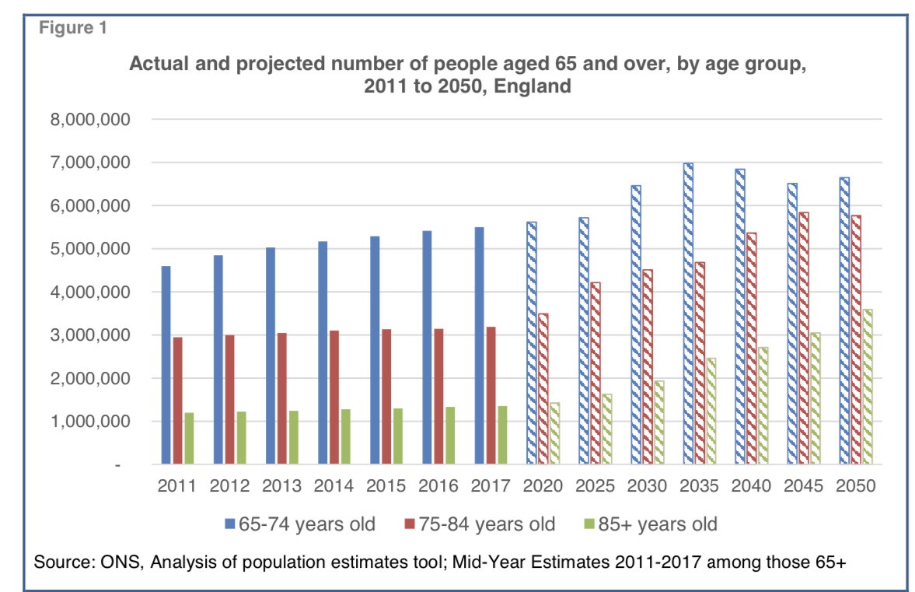
Source: file:///home/chronos/u-8738d80dce2cad35b2fc6f65e9974919b76185f6/MyFiles/Downloads/age_uk_briefing_state_of_health_and_care_of_older_people_july2019.pdf

NHS England is working together to support people for good ageing. They do everything they can to improve their well-being. The basic goal for them is to support the elderly. For the longest time in their health and independence and to receive high-quality care. The current policy to provide care for the elderly includes the principles of independence, participation, care for self-fulfilment and the right to dignity. The policy of caring for the elderly, the balance of current work or private life, what type of care you need is a care arrangement. For older people, it is important to treat them properly, regardless of race, religion, nation, age, disability, marital status or source of payment.

Older people are exposed to their loneliness much more often, and this can have health effects. The most vulnerable people are over 75 years old. They can be lonely for a variety of reasons, they can no longer be old and weakened, they can no longer be the centres of their family, they have left their jobs, their spouses or friends have died, their relationship or their illness. This can even lead to depression. The impact of loneliness is really important as seniors do not ask for help with too much pride.

Anyone can be lonely at any age. There is a lot of half of the programs that make seniors feel important to be part of society again. Invite them to a tea to re-socialize. Charities, gatherings. Find them on the phone to keep in touch. If the person is old, teach by using a computer to keep in touch with family or friends via video. Also can also go to libraries with the company. These are all if you are in-home care. If they are in a nursing home or residential home, there are various activity programs, gardening programs, making objects, music programs, exercises, day centre, family visits(Feng and Mlinac, 2016).

Future technology is available in limited care for the elderly and the demand is quite divisive. Robots vacuum cleaners, portable walking aids, or robots that can replace human nurses use smartphones in care to edit the care plan. The development of technology is handled, connected to scales, blood pressure measurements, sugar meters. Shopping online from home is more comfortable. Online exercises and online appointments. Online banking. Technology contributes to patient-centred care, facilitating communication between providers and patients.

The cost of care in England is an average weekly cost of £ 700 in a residential home but prices for a nursing home are around £ 880. How much they have to pay as a patient depends on your financial situation and for wealth or property. If they pay all the costs for yourself then you are financing if the state is state-subsidized. Then examine the financial situation of housing value, retirement and other benefits.People working with the elderly do not have to be professionals. In many cases, they are just taught and can work without any qualifications. They do not need to have any experience, only training need to be involved. Also moving and handling, fire, infection control, dementia care, health care, hoist, life support, risk assessment, safeguarding, dignity care, diabetes care(Romeo et al., 2016).
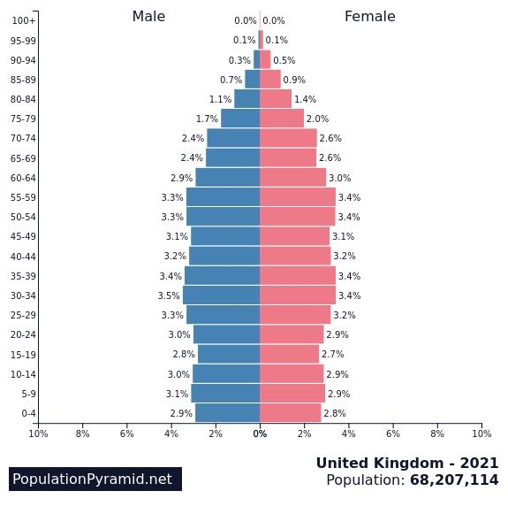

Source: https://www.populationpyramid.net/united-kingdom/2021/

This demographic pyramid shows that the increase in the age of 50-54 and 55-59 is at the same level, which is between 3.3-3.4%. The majority are elderly people. The majority of the population is ageing in the country with little birth rate gold at 2.8-2.9%.

Elderly person in Hungary:

People who have 20 years of employment can retire in this country. Women can retire at the age of 64.5 and half and men at the age of 65. The average age in Hungary is 65-75 years. The elderly are in a very difficult situation in this country because they often live in a poor living environment and have poor financial conditions. In the same way, they receive various grants and aids. But very often the main problem is not getting the right support and help on time. Elderly care needs, respect, dignity, privacy. A nursing or residential home can accommodate a person who needs more than 4 hours of help a day. Although the Hungarian health care system treats the elderly as well as the young, they receive the same attention and service, they do not differentiate them(Hajdú and Lajkó, 2018).
The loneliness of old people for them to leave work and the other is due to deteriorating health. Here, the disease of their age is the social loneliness of the elderly. Depression and high blood pressure can also be a problem here. Since most of them are either alone, their partner is divorced or dead. This is how you isolate yourself from the company. For this, social events, travel, community groups are recommended(Kovács, 2020).
The technology in elderly care is defined and limited here. For them, the care plans, different data, medication history are online. But on the other hand, the daily documentation is still written by hand. Appointments are by phone call. It is very difficult for the elderly to accept change and learn new things, a lot of the elderly cannot use smart phones and the internet either. In the future, there are smaller goals for care so that documentation and administration can go faster with different machines and phones She is provided with 24-hour supervision, doctors, nurses and other things she needs are included in the price, but if you want to buy anything extra you have to fund for yourself. A person who has reached the age of 18 can work with the elderly. Need a degree if you do not have any skills you can not work from home. Basic qualification in social care and nursing sector, 2 years of studying. Although they need to attend further training, they need to complete training if there are changes in the home(Gyarmati, 2019).

Funding for care for the elderly depends on the pension, the property, the help of family members and what kind of benefits the state provides to the elderly. Home fees vary. A boarding service for the elderly at home for 1 day costs 9392 HUF. A personal seat of 1,500,000 HUF is called an entry fee. They can bring your own bed, items, clothes, tv. She is provided with 24-hour supervision, doctors, nurses and other things she needs are included in the price, but if you want to buy anything extra you have to fund for yourself. A person who has reached the age of 18 can work with the elderly. Need a degree if you do not have any skills you can not work from home. Basic qualification in social care and nursing sector, 2 years of studying. Although they need to attend further training, they need to complete training if there are changes in the home(Gyarmati, 2019).

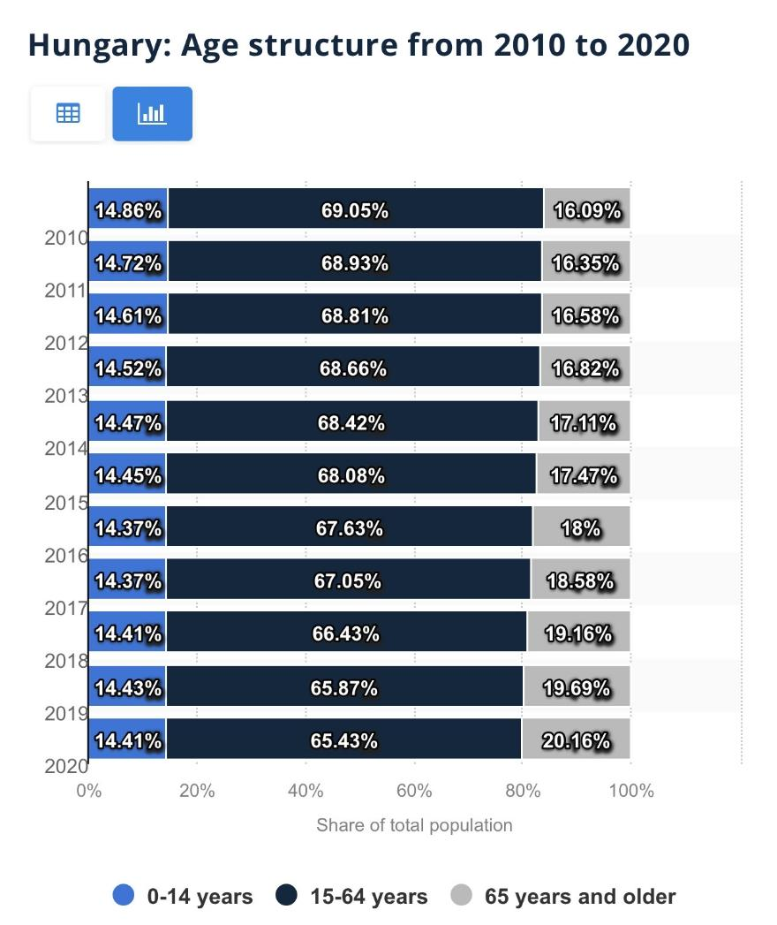
This age structure diagram perfectly shows that the number of elderly people in Hungary is growing year by year. That population is 20.16% already in old age are over 65 years of age.

Source: https://www.statista.com/statistics/332546/age-structure-in-hungary/

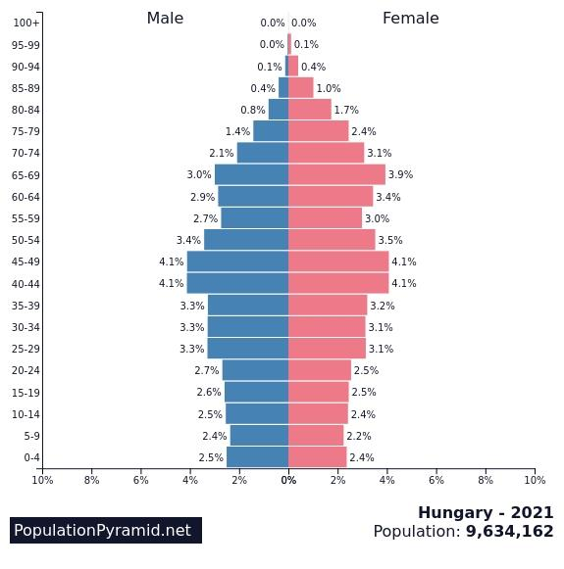

Source: https://www.populationpyramid.net/hungary/2021/

In Hungary, the age of 40-44 and 45-49 are at the same level, the middle age group is in a much larger majority in this country. Birth is the lowest rate, 0-4 years old, as salaries and jobs are lower. The age of 65-69, which is also lower than the retirement age compared to the middle age group, is a less ageing country as the average age is low.

Different:

In Hungary, older people receive less support from health organizations than in England. The life expectancy of the elderly is lower in Hungary than in England, and the age is much higher. The staff member must have a degree, not be employed without a degree, but turn to England yes, teach the employee no qualifications required. Documentation of everyday things is done on paper in Hungary, while in England in digital form, it is faster and more reasonable. They can retire in Hungary after 20 years of employment, it does not matter if they are only 65 years old in England.

Similarities:

Both countries have the same current policy providing care rules. The same programs are recommended for seniors to help the side of solitude. It is almost the same age as his retirement. The cost of care is the same, the property, pension, family is charged for the fee. The workers must be 18 years old.

3.0 Analysis:

In both countries, it is difficult to be elderly because in both places the retirement age is quite old. The UK population is ageing more and more in recent years. This is mainly due to the improvement in life expectancy and the decrease in crop yields. Society in England is getting older. People have lived here for much longer than in Hungary. The increase in the number of older people, especially if not accompanied by an improvement in health, is putting increasing pressure on the state as a relatively smaller working-age population supports growth in health, social and pension spending. There are many types of organizations in England that support and help older people to prevent the risk of isolation. There are various volunteers and support groups. The charities that help them socialize so that they are not isolated in solitude in their homes alone. There is similar help in Hungary so that the elderly do not feel alone.
In England they have two important law ,The Care Act 2014 sets out the legal framework for the provision of care and support services in England. The decline in loneliness and isolation. Action against loneliness is needed to take steps to address isolation. Importantly, this law promotes support and well-being for the elderly. To receive proper care for the elderly. Defines protection and abuse against physical and mental good existence, human dignity, the individual contributes to society.
Equality Act and Age Discrimination Act The law of equality that protects people from discrimination, personal characteristics, age and discrimination. Causes can be age, race, sex, no change, faith or religion, disability, pregnancy or maternity. No one may be treated in a different way or placed in a privileged position because of his or her age.
In Hungary they has two important laws as well, which help and support the elderly person. Human rights are rights and freedoms that all people have the same rights from birth. These include fundamental civil and political rights, such as the right to life or liberty, freedom of opinion and expression, equality before the law, and economic, social and cultural rights, such as the right to participate freely in cultural life, food, education and right to work.
The 1993 year Act 3 On Social Administration and Benefits, the person claiming the benefit or another person may undertake to pay the same personal compensation fee as the compensation fee established by decree. In addition, it is possible to pay the difference and part of the difference between the personal reimbursement fee received by the recipient and the reimbursement fee set by the maintainer.
1712/2014. (XII. 5.) Government Decree. decision on the Council of the Elderly, it is about the well being and safety of the elderly.

4.0 Evaluation:

In England, solving loneliness has different objectives to help people. To talk about loneliness and to dare to ask for help. Another is to take solitude into account in political decision-making and the implementation of societal organizations and to support organizations that connect people. Improving the evidence base for privacy, a compelling reason to act so that everyone has the information they need to make informed decisions in difficult times. In another country, it tries to make seniors aware by advertising and flyers that they are not afraid to ask for help, they get free home help to feel safe.

As the retirement age for the elderly is raised year after year in both countries, it causes many problems. They work a lot even over the age of 65 in addition to retirement because they have little pay or pension. In the future, taking care to replace or make it easier with robots and more modern things will take away people's job opportunities.

Theories of ageing:

- Modernization Theory:

The situation of the elderly is declining more and more as society is beginning to modernize. As society, prosperity and industrialization develop more and more, the elderly become more and more marginalized(Morgan and Kunkel, 2011).

- Social Breakdown -Reconstruction Theory:

During ageing, a negative psychological function develops. Which causes negative views about the service about dissatisfaction with the elderly. As the age, retirement is negatively affected by being deprived of your daily routines. Changing views on proper social security and the elderly is really important(Hendricks, 2020).

- Continuity Theory:

Older people are addicted to habits. They are used to the same routines and habits throughout their lives. The theory of activity is that during the reduction of social relationships, several types of mental illness can develop(Wang, 2012).

- Activity Theory:

In many cases, it is difficult for the elderly to accept physical change. They do not take into account that there are limitations that hinder their daily activities. It is important that they have some substitute activity after retirement if they have lived an active life. To prevent other mental illnesses(Barja, 2019).

- Disengagement Theory:

The elderly are gradually withdrawing into society as they age. Interest in society is declining, and the need for emotional relationships is declining. In many cases, social withdrawal increases dissatisfaction with life(Asiamah, 2017).

5.0 Recommendations:

In my opinion, it is important for both countries to avoid the loneliness of the elderly, but they need to develop in this. As the elderly no longer work, it is much more difficult to avoid loneliness as they no longer feel they are important members of society. Countries need to come up with more programs, groups and activities to reintegrate them into society, after which they will feel important again. The more volunteers who give them tasks they are able to do because their daily routine was their work so they can feel like they belong to a group again. I think it would be important to raise the amount of the pension in both places and lower the retirement age. Technology is also important in caring for the elderly to avoid loneliness as it is easier for me to stay in touch with family and friends, smartphone or computer with video calls, or online exercise, online shopping, or anything that makes it easier for them to stay in touch. They feel less lonely. It would be useful for both countries to teach older people how to use technology and show them the benefits.

6.0 Conclusion:

The collected data and read after books and articles, journals I analysed them. There is much more support for older people in England, both in terms of alleviating loneliness and caring, than in the country of their choice. Technology is much better developed in England it is much better used for the elderly than in communication and care assistance than in Hungary. There is also a big difference between the two countries in care and health care. The demographic pyramid shows that there are far more elderly people in England than in Hungary. Loneliness can be voluntary or developed due to a situation. Loneliness can develop into a mental illness and then a physical illness. Loneliness can develop at any age, regardless of gender or age. This is a global problem all over the world, it would be important to solve this problem not only in these two countries. Many countries around the world struggle with privacy and how to solve it. Because in so many countries where poverty is so more elderly and less birth gold, people do not dare to start a family without a normal financial background. All of these affect populations around the world.

7.0 References List:

Asiamah, N., 2017. Social engagement and physical activity: Commentary on why the activity and disengagement theories of ageing may both be valid. [online] 4(1). Available at: <https://www.tandfonline.com/doi/full/10.1080/2331205X.2017.1289664> [Accessed 5 December 2021].

Bandari, R., Khankeh, H., Shahboulaghi, F., Ebadi, A., Keshtkar, A. and Montazeri, A., 2019. Defining loneliness in older adults: protocol for a systematic review. Systematic Reviews, 8(1).

Barja, G., 2019. Towards a unified mechanistic theory of aging. [online] 124. Available at: <https://www.sciencedirect.com/science/article/abs/pii/S0531556519301731> [Accessed 5 December 2021].

Coll, P., 2019. Healthy Aging: A Complete Guide to Clinical Management.

Feng, M. and Mlinac, M., 2016. Assessment of Activities of Daily Living, Self-Care, and Independence, [online] 31(6), pp.506–516. Available at: <https://academic.oup.com/acn/article/31/6/506/1727834?login=true> [Accessed 5 December 2021].

Gyarmati, A., 2019. Ageing and Care for the Elderly in Hungary. [ebook] Available at: <https://library.fes.de/pdf-files/bueros/budapest/15482.pdf> [Accessed 5 December 2021].

Hajdú, J. and Lajkó, D., 2018. Long Term Care in Hungary. Long-Term Care in Europe, pp.177-228.

Hendricks, J., 2020. Structure and Identity— Mind the Gap: Toward a Personal Resource Model of Successful Aging. pp.https://www.taylorfrancis.com/chapters/edit/10.4324/9781315230849-6/structure-identity%E2%80%94-mind-gap-toward-personal-resource-model-successful-aging-jon-hendricks.

Kovács, E., 2020. LIVING LONGER, WORKING SMARTER, AGEING WELL. [ebook] Budapest. Available at: <https://www.researchgate.net/profile/Peter-Vekas/publication/344429575_Living_Longer_Working_Smarter_Ageing_Well_-_2/links/5feb6f7d92851c13fed36812/Living-Longer-Working-Smarter-Ageing-Well-2.pdf#page=116> [Accessed 5 December 2021].

Morgan, L. and Kunkel, S. (2011) Aging, Society, and the Life Course, Fourth Edition. New York: Springer Publishing Company Inc.

Romeo, R., Knapp, M., Salverda, S., Orrell, M., Fossey, J. and Ballard, C., 2016. The cost of care homes for people with dementia in England: a modelling approach. International Journal of Geriatric Psychiatry, 32(12), pp.1466-1475.

Tornstam, L. (1994). Gerotranscendence - a Theoretical and Empirical Exploration. Westport: Greenwood

Wang, M. (ed.) (2012) The Oxford Handbook of Retirement. Oxford: Oxford University Press.

