
Skills for the Workplace
Module Assignment Submission
Student Name: | Sam Lloyd
Student Number: | 2012879
Module No: | BMSK4008
Module Title: | Remote Managing

Statement of Confirmation of Authenticity
By the act of making this submission, the student declares that this is the work of the student named above. The work has not, in whole or in part, been knowingly presented elsewhere for assessment, or where assessment has been built on a previous assessment, this has been identified. Where materials have been used from other sources it has been properly acknowledged. If this statement is untrue, the student acknowledges that an assessment offence has been committed.
Attention is drawn to the plagiarism and unfair practice policies of both the University and of ILM.
Permission for ILM to use this script
ILM uses learners’ submissions – on an anonymous basis – for assessment standardisation. By submitting, both the centre and the learner agree that ILM may use this script on condition that identifying information is removed. However, if you are unwilling to allow ILM use this script, please refuse by ticking the box: □

Table of Contents
Introduction to Remote Managing 3
Section 1: Managing 4
1.1 What is a manager? 4
1.2 What do they Manage? 4
1.3 Remote Managing 5
Section 2: What are the obstacles with remote managing? 6
2.1 Remotely managing people. 6
2.2 Technology and remote managing 6
2.3 Can remote managing function as in-house managing? 7
Section 3: Benefits of remote managing 7
3.1 Covid-19 and its effects on managing a business. 7
3.2 Staying connected 8
3.3 Working away from the office 8
Section 4: Remote managing in an industry; security 10
4.1 How does security industry use remote managing? 10
4.2 Is remote managing effective in the security industry? 10
4.3 Data of management communication 11
Conclusion 12
References 13
Appendix 1 14
Appendix 2 15

Introduction to Remote Managing

In March 2020, the UK government initiated the “work from home, where possible” initiative, to combat the rise in COVID-19 (coronavirus) cases, (Office for national statistics , 2020). This was implemented to ensure social distancing rules were met, which led to the increase in the number of people working remotely, due to the advancement in technology this meant that managers could keep track on employee, business output from the safety of their own home. Before COVID-19 some employees were already telecommuting (also known as teleworking), where necessary, to save money on travel expenses.
The difference between teleworking and working remotely is as follows; teleworking would be where an employee would work away from an office environment most of the week with face-to-face updates with management weekly to ensure deadlines were being met, (Fortier, 2021). Working remotely would mean that an employee would work full time from home, which would mean managers would need to manage remotely to ensure the employee was meeting the standards of their job roles.
“Remote work suggests that the employee is just that—remotely located. It is not a technical definition, but it does imply that the employee is too far away from the company to come into the office. They may “work remotely” on a temporary basis, such as while traveling, or they might be a permanent remote worker.” (Marzullo, 2019)
Remote managing is required by a business where face-to-face interactions are not possible, not only of employees but of expenses, profit and loss, ordering, customer communication, productivity surveys and many other factors. A manager needs to remotely oversee all functions of the business, technology can help with this, from zoom meetings, Microsoft teams, messaging applications, and other forms of interfacing. A manager needs to create timetables or time periods where a form of interfacing can occur with employees, customers or other managers. They need to be able to find ways remotely to ensure the business is being conducted efficiently, with the needs of the business is being met.

Section 1: Managing

1.1 What is a manager?

A manager is a person who supervises the productivity of a business, of a group of people and ensures that the business is working at its full efficiency. According to YEC (young entrepreneur council) there are certain qualities that should be possessed by a good manager, accountability, character, cultural affinity, prioritization, warmth, patience, honesty, decisiveness, empathy, positive attitude, competence, flexibility (Market Business News , 2020). A manager needs to be approachable by employees, to make them feel comfortable to allow for better communication, a higher work quality from the employees.

1.2 What do they Manage?

Managers are required to maintain several things, as follows.
- Employees
Managers need to get to know employees, have face to face interactions, and communication to ensure that an employee can perform to the best of their abilities and finding ways to which they can improve.
- Profit/ loss reports
Managers need to keep track on changes in profit and outline where any losses are being made.
- Customer satisfaction/ feedback
Managers can have direct or indirect communication from with the customers, to gather information where improvements may be needed, or find out where the business is doing well, from here they can set up a plan for improvement.
- Time management
The manager finds time to have communication with the employees and other managers to ensure all needs are being met. This can be done by organising weekly meetings, training days, team building activities, or events that increase productivity.
A manager works all these areas, to ensure the business is efficient, developing a product, making the product or providing a service, ensuring all employees are trained correctly, are sure of their position and any changes that can be made to ensure they too are working efficiently. They must cover a lot of areas, with the right attitude and temperament. A manager must prioritize between high priority projects and low priority projects ensuring that they are meeting their time limits, (Drucker, 1963)

1.3 Remote Managing

Remote managing is doing the roles of a manager under the same time restraints, but from a remote location where there are less face-to-face interactions with employees and customers. A manager will complete all roles and responsibilities but away from an office setting, by finding ways of staying connected with employees, watching for all changes in the business efficiency, and planning ways to stay connected, but also find personal time away from work.
A good remote manager as well as having the roles previously stated also must develop other techniques to manage efficiently when away from an office or site. They must be able to set projects and trust in the team they have developed to carry out the project, trust is important within a team and when managing remotely because there may be issues with connecting, they must be confident that their team or employees are doing the roles handed to them. Remote managers also to have to ensure that they have provided the right training, support and equipment so that their employees can carry out a task or project. Virtual inspiration, this could be in the form of a daily joint call with all members of the team, a message to encourage the team or keep them updated with what needs to be do that day whilst inspiring confidence. This ensures that they are keeping in contact with their team, also they can provide regular one-to-one virtual meetings or calls with employees to check in and see how they are doing. Put feedback and comments in a correct format, with via group bulletin board, messaging service or personal one to one calendar updates. Help support wellbeing of their team as working from home or away from the office can make employees feel disconnected from work or from a work social life, a good mental wellbeing is good for productivity. It is important for a manager when working remotely to also provide positive feedback and praise when an employee is working well, contact needs to be supportive and encouraging, not just contacting to criticize or express negative feelings. It is important that a manager continues to support the team, a team will work better when they feel connected, praised and understood. (CIPD, 2021)

Section 2: What are the obstacles with remote managing?

2.1 Remotely managing people.

When managing people in an office, its easier to find them and initiate contact, communicating on a face-to-face interaction. In an office environment there is less distraction from external noises, issues, technology, family, friends etc. they follow the office rules, keeping themselves concentrated on work. Remote managing is different because an employee could be working from home, or another remote location, where there are issues of them becoming distracted, or procrastinating. For an example scenario: a manager having an online meeting with an employee, (using one of the many different forums Zoom, Microsoft Teams, Skype, etc.), whilst talking with the employee children begin screaming in the background of the employee’s home, music is being played loud, a dog is barking. All these become distractions and time is lost in the meeting whilst the employee deals with the distraction, to then continue the meeting. As a manager it is important to be understanding of these distractions, however when trying to stick to a time schedule, meetings becoming delayed and interrupted it becomes more difficult to ensure that progress in work is continued.
Another issue is hiring new members of staff, the hiring process is incredibility difficult remotely, although achievable, however because it is very impersonal not meeting the new employees or getting to know new employees personally can be an issue. A new employee may also not fully understand their job role or have a clear explanation to their job role, and it becomes exceedingly difficult as a manager to be able to explain their roles and responsibilities remotely out of office. According to a news article written by Mark C. Perna, 2021, (Perna, 2021), new employees are “flying under the radar” where they are not being recognised by other members of employment in the same company and are not getting the interactions, they would usually get in an office environment. New employees are feeling disconnected from co-workers and company values, they do not feel as though that have been introduced to the company fully and would state they are doing “fine” however feeling less inclined to interact with others.

2.2 Technology and remote managing

Technology plays a large part in remote managing; numerous forms of devices can be used to open channels of communication within a business. Unfortunately, technology is not always perfect, or people do not have access to the technology needed to complete a task remotely.
Cyber security is another especially important issue, how can a business ensure that remote managing is safe, how can they ensure that customer information is not being hacked and leaked. As stated by an article in Secure remote management 1995, “One would like to have a more intrusive management capability but in a large distributed system one must have confidence that management activities cannot be subverted, whether by accident or by malicious intent” (Bhatti, et al., 1995). It is important as a manager to make sure remote managing systems and the programmes used to remotely manage a team cannot be accessed by an outside source, anything that can influence the business, the employee and the customers. Leading to the loss of personal information, unfinished or failed product that could influence the customers negatively away from the business, losing information about upcoming or unfinished products that can be then used by rival companies.

2.3 Can remote managing function as in-house managing?

Remote managing can also be a challenging because as well as maintaining their own motivation for work, a manager must maintain others motivation without having a face-to- face interaction, or where an employee may be less available then in a work environment. A personal comment from a column in The Guardian, newspaper written by Gene Marks 2020, where he stated his view to remote working, “But you know what? I miss an office. My company suffers from not having one. We have no culture. We rarely see each other as a group. We are not really a team and lack bonding or social connections. We miss out on extemporaneously sharing ideas. Our innovation suffers. As a result, the value of my business suffers.” (Marks, 2020)

Section 3: Benefits of remote managing

3.1 Covid-19 and its effects on managing a business.

Remote managing has become particularly important during the pandemic, it allows for the hiring process to continue also and open job opportunities for those who have lost employment from businesses that are unable to reopen, pubs, clubs, movie theatres, restaurants, etc. and provide online training in new skills, so that new employees and current employees develop new skills to increase their employability.
Managers can fulfil their roles to employees, being flexible (more flexible than before with multiple options to connect and communicate and with more people at once), they can be supportive, they have more opportunities to develop an understanding with employees by developing trust ensuring work gets done or if an employee is struggling, they are supportive in finding solution. Remote managing is safer during a pandemic, but also helps all employees develop skills and confidence so when they can return to an office situation, in building situation, when possible, these new skills can be used and translated to boost productivity.

3.2 Staying connected

There are multiple ways for a manager to stay connected to their team, they can use different channel of communication, from virtual meeting where they can see their team or employees face to face, to simple a messaging service. Many companies offer new technologies and applications that allow people to stay connected; Facebook Messenger; WhatsApp; text messaging; iMessage; skype; Microsoft teams; Gmail; email; Zoom; phone calls; Facetime; etc. Companies can also use personal messaging boards to connect, either from a workplace homepage or organisation message board.
Remote managers were able to stay in contact with their team in this way, this benefited managers and employees, with everyone more connected they could create a social workspace and continue to build work bonds that they were usually have in office. Before the pandemic employees working away from the office were able to stay connected to the team whilst working away or off-site, this connectivity keeps the team together, and updated on any changes to a task or project, or update on an emergency.

3.3 Working away from the office

A benefit to remote managing is that because it is away from an office environment, it can be done anywhere that is comfortable, where work can be done. This can be at home, where it is comfortable, it is a space created by a person to live in, with comforts such as food, work can be done from a comfortable seat, sat on the bed, relaxing in a recliner, not an office chair at a desk. If there are too many distractions at home, then instead it can be conducted in a comfortable setting.
According to the research of Job van der Voort, 2020, “71% of UK tech employees would move to a different country and 8% would move to a different region if they were able to work remotely and retain the same job and remuneration.” (Voort, 2020). Remote working allows a freedom to work where a person feels more comfortable, where they can perform their best outside of an on-site or office environment. In many cases it for employees it is more beneficial to work remotely for health reasons, where they would suffer from anxiety, stress, other mental health issues from the pressures of working in an office environment, so instead they need to work in an outside environment without the change in profession, in these cases their productivity has increased. Where even moving to another country but working and staying in contact with the same team, managing the same team, has become more beneficial for the business. The graph below shows the percentage of people already working from home before the COVID-19 pandemic from January to December 2019.

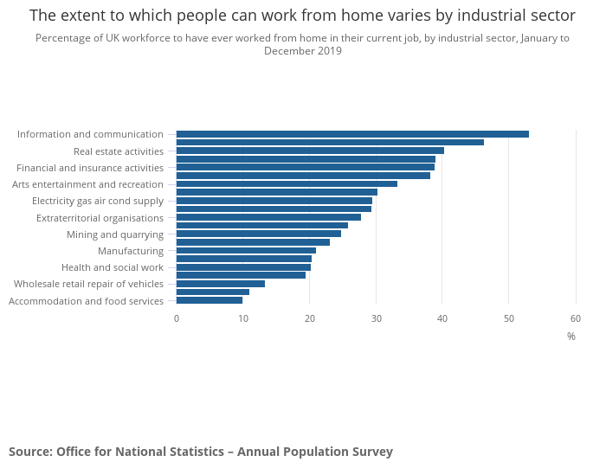
From the graph above the workforce in the information and communication sector lead the highest percentage of people working from home at over 50%, whilst those who are unable to work from home as easily such as accommodation and food service industry have a lower percentage of workforce working from home at less then 10%. Depending on the work sector, depends on how the work can be conducted from home, those that find it easy to conduct their job remote tend to do so. (Office for national statistics , 2020) (Appendices 2).

Section 4: Remote managing in an industry; security

4.1 How does security industry use remote managing?

Due to a security company working across many different sites, at all hours, over a large area, managing is mainly only done remotely with the manager themselves going to a site when is necessary, usually in an emergency for during and issue with the site and how is has been conducting.
The security team is managed across sites with direct communication to a home office, from here if a team member has an issue, it can be reported to the manager or to local authorities if a situation has become out of hand. Managers can communicate with the team directly usually through a messaging, voice messaging service or calling a team member directly.
All reports are written down by hand, recorded and collected from sites on a daily or weekly basis, with all sites being video and/ audio recorded, due to protection of individuals on specific sites, video calling services cannot be used to have face-to-face remote team meetings with the manager. Due to intensity of the work, over 24-hour period check-ins are consistently made with the management and other member of staff with wellness updates via mobile messaging. After At every 12-hour period there is a switch over, any changes at each site are written and recorded with time dates and stamps and expressed with face-to-face interactions between team members. Besides this one face-to-face interaction, all other interactions are conducted remotely via a form of messaging or call service.

4.2 Is remote managing effective in the security industry?

In this form of service industry, remote managing is effective, although it is difficult to have full contact will a manager and report any personal issues or sickness. The management will only be part of the team when there is an issue. However, the management shows trust in the team to let the team members organise the site between themselves, this creates an extraordinarily strong team bond, which is needed when dealing daily with dangerous situations or individuals.
When remotely communicating with management it is very rarely to congratulate a team member for hard work, but more to reprimand or ask a member of staff to take more overtime and do not ask or care for the well-being of an individual within the team. Employees are made to feel either part of the team or letting the team down. When a message from the manager even saying well done for today would be much more appreciated, which is very rarely if ever.
A more effective way of remote managing would be to separate the management team into two managers, one to keep contact with daytime staff and one to keep contact with night-time staff, a lot of the time the same member of staff is switching between nights and days and becoming exhausted, whilst the manager is busy at another site over the day and is not noticing who is working the days and nights, until a team member is becoming unwell.

4.3 Data of management communication

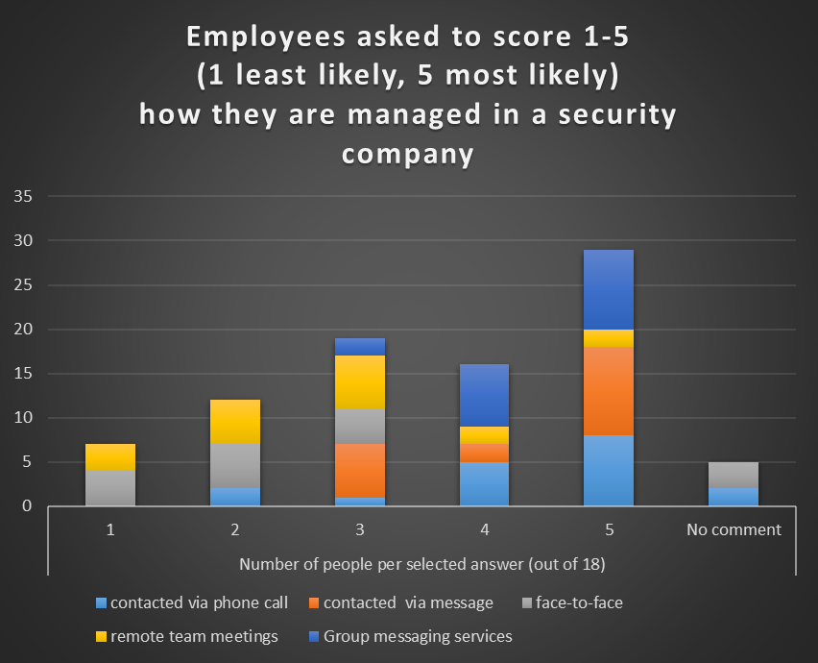
A survey was taken of from a security site of 18 team members, each team member was asked a series of questions of how they are contacted by management, they then gave a score from 1-5 for each question, 1 being least likely and 5 being most likely. From the data seen above members of staff said that they were most likely to be contacted via message, phone call or in group messaging services. With the least likely options being face-to-face or in remote team meetings such as video meetings or phone call meetings.
This evidence shows that most of the members of staff are managed remotely having little or no face-to-face interaction with their manager, when asked their opinion they felt trusted but as though they were very disconnected from their managers and from the company itself, being trained mostly with online courses, or shown a site and role by another member of the team and not by a member of the management team.
From my own personal reflection working in this industry, I have found that although I do like to be able to my own pace and make my own decisions, feeling very trusted, I would like great communication with the management, especially in terms of them getting to know the team, knowing who works more shifts, how is more flexible and offer a way of making work a little more manageable for those individuals.

Conclusion

In conclusion to remote managing, it is seen most of all that it is the managers responsibility to essentially care for the team, find out when the team is breaking down or failing, but also to praise and support the team when it is doing well. To understand each individual person in that team, old members and new and ensure their wellbeing so that they can work more efficiently. With technology, remote managing will continue to advance in ways to connect each other where necessary, however people still require personal communication, and some form of face-to-face interactions, taking feedback wherever possible to keep building and keep improving on this.

References
Bhatti, S. N., Knight, G., Gurle, D. & Rodier, P., 1995. Secure remote management. In: T. I. F. f. I. Processing, ed. Integrated Network Management IV. First ed. Boston, MA: Springer, pp. 156-169.
CIPD, 2021. Getting the most from remote working. [Online]
Available at: https://www.cipd.co.uk/knowledge/fundamentals/relations/flexible-working/remote-working-top-tips
[Accessed 24 03 2021].
Drucker, P. F., 1963. Managing for business effectiveness. Managing for business effectiveness, 41(3), pp. 53-60.
Fortier, B., 2021. An Introduction to Telework. [Online]
Available at: https://www.monster.ca/career-advice/article/an-introduction-to-telework-canada#:~:text=Telework%2C%20also%20known%20as%20telecommuting,the%20growth%20of%20information%20technology.
[Accessed 20 03 2021].
LLywodraeth Cymru, 2020. Stay Home, Stay Safe – Minister for North Wales. [Online]
Available at: https://gov.wales/stay-home-stay-safe-minister-north-wales
[Accessed 24 03 2021].
Market Business News , 2020. What is a manager? Definition and meaning. [Online]
Available at: https://marketbusinessnews.com/financial-glossary/manager-definition-meaning/
[Accessed 20 03 2021].
Marks, G., 2020. We're not all going to be working from home, nor should we. Here's why. [Online]
Available at: https://amp.theguardian.com/business/2020/jun/11/were-not-all-going-to-be-working-from-home-nor-should-we-heres-why
[Accessed 24 03 2021].
Marzullo, D., 2019. What’s the Difference Between Remote Work and Telecommuting?. [Online]
Available at: https://www.zenefits.com/workest/difference-remote-work-telecommuting/#:~:text=Remote%20work%20and%20telecommuting%20are,is%20just%20that%E2%80%94remotely%20located.&text=Telecommuting%2C%20also%20called%20telework%2C%20can,site%20some%20of%20the%20time.
[Accessed 20 03 2021].
Ministry of Housing, Communities and Local Government, 2020. Guidance: Further businesses and premises, London: Ministry of Housing, Communities and Local Government.
Office for national statistics , 2020. Coronavirus (COVID-19) roundup, 23 to 27 March 2020. [Online]
Available at: https://www.ons.gov.uk/peoplepopulationandcommunity/healthandsocialcare/conditionsanddiseases/articles/coronaviruscovid19roundup23to27march2020/2020-03-27
[Accessed 20 03 2021].
Perna, M. C., 2021. Employees Hired Remotely In 2020 Say They’re Doing Fine. The Data Says Not Really. [Online]
Available at: https://www.forbes.com/sites/markcperna/2021/02/16/employees-hired-remotely-in-2020-say-theyre-doing-fine-the-data-says-not-really/?sh=5102bb5b6ebd
[Accessed 24 03 2021].
Voort, J. v. d., 2020. Remote work trends in 2021. [Online]
Available at: https://www.fenews.co.uk/fevoices/58714-remote-work-trends-in-2021
[Accessed 24 03 2021].

Appendix 1

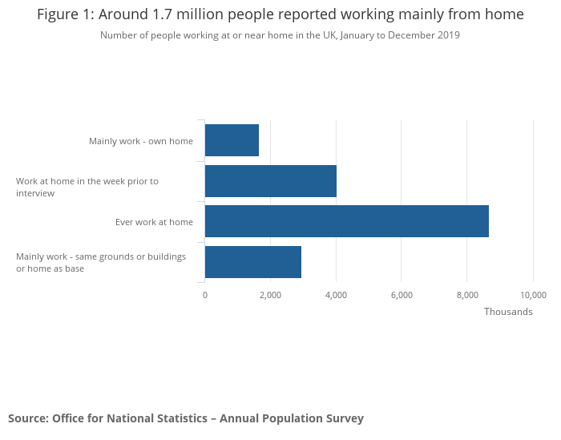

Appendix 2

Table 1: Homeworking by minor occupation group, UK
 | Level (000's) | Percentage
 | Employed | Own Home | Same grounds  or buildings, or  home as base | Separate from  home | Work at home in  the week prior  to interview | Ever work  at home
111 Chief Executives  and Senior Officials | 114 | 8.9 | 16.8 | 74.3 | 39.5 | 69.2
247 Media Professionals | 187 | 20.5 | 11.4 | 68.2 | 30.7 | 58.1
341 Artistic, Literary and  Media Occupations | 454 | 23.7 | 29.0 | 47.2 | 37.2 | 57.8
231 Teaching and Educational  Professionals | 1,607 | 3.8 | 5.9 | 90.3 | 19.0 | 57.8
118 Health and Social Services  Managers and Directors | 107 | 2.5 | 8.0 | 89.1 | 23.1 | 57.0
113 Functional Managers and  Directors | 1,196 | 13.2 | 13.5 | 73.2 | 33.1 | 56.1
241 Legal Professionals | 213 | 5.4 | 7.1 | 87.4 | 25.2 | 55.7
213 IT and Telecommunications  Professionals | 1,065 | 11.4 | 9.0 | 79.3 | 33.8 | 55.0
242 Business, Research and  Administrative Professionals | 841 | 8.0 | 10.7 | 81.3 | 31.8 | 54.8
215 Research and Development  Managers | 55 | 2.7 | 6.0 | 91.0 | 19.2 | 54.8
Source: | Office for National Statistics – Annual Population Survey

