
Skills for the Workplace
Module Assignment Submission
Student Name: | Helen Grandin
Student Number: | 1708671
Module No: | BMSK4004
Module Title: | Problem Solving and Decision Making

Statement of Confirmation of Authenticity
By the act of making this submission, the student declares that this is the work of the student named above. The work has not, in whole or in part, been knowingly presented elsewhere for assessment, or where assessment has been built on a previous assessment, this has been identified. Where materials have been used from other sources it has been properly acknowledged. If this statement is untrue, the student acknowledges that an assessment offence has been committed.
Attention is drawn to the plagiarism and unfair practice policies of UWTSD.

Table of Contents
Define a complex problem in the workplace, including its scope and impact 3
Analyse information on the identified problem, to help inform the decision making process 5
Mind Mapping 6
6
6
6
6
Fishbone Diagram (Ishikawa) 7
Propose a range of alternative solutions to the problem 8
Using a decision making technique, evaluate a range of solutions to identify the most appropriate option 10
Develop a detailed plan for implementing the solution 15
Communicate the plan to relevant stakeholders 17
Assess appropriate monitoring and review techniques to ensure successful implementation of solution 19
References 20
Appendix 1. 21
Appendix 2 22

Define a complex problem in the workplace, including its scope and impact

What making a problem complex is it is not clear what is the cause, it can have many elements making if difficult to analyse.
Problems can be basic, complicated or complex, have varying levels of risk, can be a one off or ongoing for a short, medium or long period of time and can be caused by several factors for example, a person, financial situation or a technical issue.
In an article by Michael Cooper (2014) he stated that Albert Einstein once said, “If I were given one hour to save the world, I would spend 59 minutes defining the problem and one minute resolving it”, It comes across very exaggerated however it strongly emphasises the importance of defining a problem correctly and ultimately saving time, money and resources.
Establishing the causes of the problem. Kepner and Tregoe, (2013) identified a decision-making process which became a well-established framework for problem solving through using a scientific approach to help identify the problem. This is called the K-T process and consists of five steps.
- Define the problem.
- Describe the problem.
- Establish possible causes.
- Test the most probable cause.
- Verify the true cause.
The complex problem within the workplace I will be focusing on specifically is when people are arriving for work late. It is only a small team of 10 working in pairs dealing with specific areas of inbound calls and have been trained in that area only, the shift starts at 8.15am to be set up ready to start taking calls from 8.30am. There are 4 out of the 10 who are friends and share the same house, continuously arriving late, this has been monitored over the last 14 days and 11 of those days there has been 1 or more staff members late, this is now starting to affect the team, customers and the company.
It has indicated that customers calls are not being answered on time, meaning customers are holding for longer than they should which is not promoting effective customer service making the customers feel unhappy and wanting to seek an alternate supplier. We have seen an increase in incentive offers for the purpose of retaining unhappy customers due to long wait times on the telephones. If left to continue company costs for unworked hours paid to the staff along with the increase in incentive offers to retain customers, overtime will result in profit loss and a bad reputation. Also, the rest of the team are becoming increasingly frustrated by the lack of commitment and disruption the individuals in question are causing by their continued lateness.
Due to this already effecting the company and team moral diminishing it is imperative the problem is addressed immediately.
The department manager will oversee the situation but will be relying on his team leaders to obtain information and a true sense of feeling from their team to ensure the perspective is as wide as possible and enough information has been gathered to be able to make an informative decision on how to solve the problem.
Morgan, (2017) states “if the real objective is not clarified at the beginning of the process, then it’s unlikely that the problem will be solved”. Therefore, it would be imperative that the problem is identified correctly for the problem to be solved quickly, effectively, and fairly.

Analyse information on the identified problem, to help inform the decision making process

There are many ways we can analyse information to assist finding the reason for a problem. This can be done by using tools and techniques such as:

The 5 Whys.
The 5 Whys technique was invented in the 1930’s by the founder of the Toyota motor company Sakichi Toyoda. The philosophy behind it is “go and see”, meaning getting out there and seeing what’s going on for yourself so then the decisions are made with a better understanding. It started becoming more popular in the 1970’s and Toyota still use this technique today. It is a simple technique which enables us to reach the root cause of the problem.

- Why were there so many incentives offers used? Because the customer was unhappy.
- Why was the customer unhappy? Because they were on hold for more than 30 minutes.
- Why were they on hold for more than 30 minutes? Because there was only one person in that department.
- Why was there only one person in that department? Because the other person was late for work.
- Why was that person late for work?
Although this may not work on some complex problems as it is aimed at pursuing usually one line of enquiry and a complex if likely to have more than one, it is still an analysis to be considered before exploring more in-depth methods of analysis. However, it can be used to follow more than one line of enquiry if there is more than one answer to the why’s. In that case it would be more productive creating a mind map.

Mind Mapping

Mind Mapping is used to develop ideas to better understand the information by breaking them down to help understand the concept, giving an expansive visual to support the thinking process. Having the reason anchored in the centre of the mind map encourages people to stay focused on the topic. Just like a tree, the branches grow as the ideas develop all connected to the same root, hence the saying ‘root cause’. It is a valuable tool and skill to have, unlocking your brainpower enabling synergetic thinking which means ‘whole - brain’ thinking to gather ideas on how the problem can be solved. Brainstorming with your management team enables you to get different perspectives, putting forward ideas that you yourself may not have thought of or considered as a possible solution. Tony Buzan (2013) stated “we need to use our intelligence to process the information. Using imagination and association helps produce multiple ideas that can be fully assessed and analysed”.

Introduce Clocking in Cards
Offer Training
Terminate Employment

Informal Chat
Offer Support
Persistent Lateness
Lateness

Formal Meeting
Offer Incentives/On-time Bonus
Team Meeting

Fishbone Diagram (Ishikawa)

Identifying the underlying issues can be done using a Fishbone Diagram known as Ishikawa. Ishikawa’s fishbone diagram dates back as far as the 1920’s but became more heard of in the 1960s, created by Kaoru Ishikawa a Japanese organisational theorist, scientist and a professor in the engineering faculty at the University of Tokyo. It is used to visualise potential causes of a problem. It is also known as a Cause and Effect Analysis.
“Think of at least four factors which influence your problem. See if a shift in one of these causes can give you a different effect to explore.” (Ishikawa. K 1985).
Ishikawa is a favoured method for root cause analysis, used to determine reasons behind problems, combined with brainstorming and mind mapping it allows an insight into probable causes to a problem rather than focusing on just one obvious reason. It is created by following four steps.

- Identification and agreement on the problem. Write the problem in a box to the righthand side, this will be the head of the fish and a horizonal line for the spine.

- Brainstorm potential causes.

- Identify possible causes. Draw vertical lines off the spine for each potential cause for more complex problems smaller lines can be added off the vertical lines to identify causes of causes.

- Analyse your diagram. Your diagram should now indicate all possible causes to the problem and now be further investigated to find the root cause.

Propose a range of alternative solutions to the problem

There could be multiple solutions to any one problem. By obtaining ideas from others like stakeholders can be very valuable as they can see problems from a completely different perspective. Also combining different parts of solutions can give a better chance of finding the right solution.
Using the information gathered regarding the problem the decision has been made to hold informal chats with the individuals in question in the attempt to establish the reason for the continued lateness. During these chats which will be with the team leader and department manager, notes will be taken, conducted with empathy and without judgement. Depending on the reason provided a decision will be made at the end of the meeting on how we will proceed. If the employee is lacking in motivation, incentives, training and support could be offered to help increase motivation. It could be that they have been having transport issues, creating a car-pooling arrangement with other members of the team could help alleviate this, if the issue is due to unforeseen circumstances for example weather, public transport issue or car breakdown we are very limited as to finding a solution as they are unexpected problems. If the problem is medical or home related help and support would be offered. The problem could be related to poor management whether it be the team leader is not doing their job as effectively as they should, have little control over their team and ultimately the team taking advantage of this. In this case the focus would move to the team leader and finding out what they are lacking or need for them to be able to run their team effectively with training, moving to another role which better suits them or simply making them aware that the running of their team needs to improve. The other outcome from the informal chats could be that the job is not for them, and they don’t want to be there, in this case it would be the sensible option to give them a months’ notice to give them time to find alternative employment and provide a reference.
Following the informal chats if the problem has still not been resolved the other option would be to introduce clocking in cards for the whole team. This will enable the situation to be monitored more closely and employees only being paid for the hours they work. This will incur costs to the company initially but over a period of time those costs can be regained by the elimination of employees being paid for unworked hours, which may only be half an hour 3 times a week but over months/years and several employees doing the same it works out to be a substantial amount. The introduction of the cards would also involve training for some employees so they know how the new system works, to be on hand to solve issues that may occur with the system and to be able to provide assistance to anyone having problems using the new system. This training would be provided within the company with no need for an outside educator to attend meaning there will little or no cost to the company.
When making the decision on which resolution to take we need to be aware of any barriers or obstacles that could interfere with the process. As there is always more than one solution to any problem it is vital that every proposed solution is thoroughly analysed to ensure these barriers and obstacles are foreseen before the resolution has been put into place. Another way we can ensure the resolution information is viable is to use SMART Objectives, first developed by George T. Doran (1981), it is anacronym which consists of five steps and ensures that the information is realistic and appropriate.
Each element of the criteria is important, you will only get the right outcome if all elements are adhered to.
- Specific – well-defined and clear.
- Measurable – include measurable indicators to track progress.
- Attainable – realistic and achievable within the resources, time, money, experience, etc. you have.
- Relevant – align with your other goals.
- Timely – has a finishing date.
(Tosi et al., 1970)

Using a decision making technique, evaluate a range of solutions to identify the most appropriate option

I have chosen to use Grid Analysis the help me work out the importance of the solutions gathered during the brainstorming process creating the mind map.

FACTORS | COST | TIME | TEAM MORAL
IMPORTANCE | 3 | 4 | 5 | TOTAL
Clocking in cards | 4 | 3 | 5 | 12
Training | 5 | 4 | 5 | 14
Incentives | 3 | 4 | 1 | 8
Support | 5 | 5 | 2 | 12
Informal Chat | 5 | 5 | 5 | 15
Team Meeting | 5 | 3 | 1 | 9

By using grid analysis, it allowed me to categorise the solutions and their importance giving a clearer indication of what solution is more likely to work and solve the problem.
Firstly, looking at the factors and giving them an importance level of between 1 and 5, with 5 being very important down to 1 being not so important, when giving the level for cost the levelling value is switched with 5 meaning best value for money and 1 meaning high cost. It is not inevitable that the solution with the highest number is the best solution, these figures can change by using an additional formula.
For example:
Clocking in cards gave us a score of 12, by using the additional formula it would give a score of 49.
By multiplying the factors importance score with the solution score for each section can change the final solution scoring.
Cost score – 12 (3 x 4)
Time score – 12 (4 x 3)
Team moral score – 25 (5 x 5)

Implementing this across the whole grid the scores would be:
Before additional formula After additional formula
- Informal Chat (15) 1. Informal chat (60)
- Training (14) 2. Training (56)
- Clocking in cards (12) 3. Incentives (50)
- Support (12) 4. Clocking in cards (49)
- Team meeting (9) 5. Support (45)
- Incentives (8) 6. Team meeting (32)
You can see the last four have changed where they place, and we need to take this into consideration when choosing the best solution.
Choosing the best solution does not mean simply choosing the one with the highest score. A combination of solutions could be the answer. For example, start with having informal chats with the individuals in question, see if there is an underlying issue as to why the lateness is happening and reoccurring, and if there is anything you can do to assist them with resolving their issue. Exploring options that will have little or no cost to the company as a first step would be beneficial, rather than just opting for a costly and time-consuming option. It is possible the problem could be solved with just having an informal chat. Keep the options open and always have a plan B, C and maybe D.

Creating a Gantt Chart to plan out when specific tasks will take place, by giving a week-by-week indication of what will be taking place in that week to enable everybody to stay on track. It is clear, simple, and easy to understand. Henry Laurence Gantt's (1861-1919) most popular legacy to management was the Gantt Chart. (Peterson, 1993). He invented the chart in the 1910s as a visual representation to show the time progression throughout the project’s phases, recording what has been done and balancing it with what still needs to be done.
The Gantt Chart I have created applies to myself as a Team Leader. It clearly shows what my duties are for each week. This could be coupled with an action plan giving more specific detail as to exactly what each week will entail, giving myself goals allowing me to prioritise each task with other daily tasks, as our usual work schedule has not been designed to allow for these extra tasks, but resolving the problem falls in the urgent and important category so this needs to be prioritised.

To allow the solution of clocking in cards to work a Cost Benefit Analysis needs to be drawn up, to determine whether the solution is viable and the cost of implementing it will recover the costs of the purchase of the machine and cards and alleviate the costs to the company due to the overpaid hours to the employees. Its is important the set-up cost can be recovered so the company does not find themselves losing further money and the problem remaining unsolved.
To create this firstly we gather the information for the cost of introducing a clocking in system, taking into consideration the cost and maintenance of the machine, this will be worked out over a five-year period. Secondly working out the benefits of the introduction of a clocking in system by costing up the amount of money paid out for unworked hours. And finally working out the annual benefit minus the annual cost for each year giving us the overall benefit figure of the implementation.
Gathering as much information as possible on the proposed solution is vital to ensure it is viable and worth the time, effort, and money of the company. Implementing as solution without thorough investigation can mean the wrong solution being introduced and costing the company considerably.

Develop a detailed plan for implementing the solution

By creating an Action Plan for the implementation of the clocking cards gives a clear description of what needs to be done in preparation for the go live date, by who and what their duties include to ensure a smooth transition. And monitoring how the first week went, if there were any problems and what can be done to resolve them. Feedback from the team on how they are finding the transition. And reporting back to the Department Manager. This is to ensure that the whole department are fully aware of their responsibilities and the problem has been successfully resolved.

Action Plan
Reason: Implementation of clocking in cards.
Go Live date: 29th August 2022.
Task: | Criteria: | By When: | Responsibility of: | Completed on:
Ordering and Instillation | Ordering of machine and clocking cards.  Booking machine installation.  Ensure machines are installed and working. Arrange Team Leader training. | 15/08/2022 | Department Manager | 12/08/2022
Liaise with Department Manager and Team Members | Arrange and oversee teams machine training. Distribution of cards and syncing to machine. | 26/08/2022 | Team Leader | 26/08/2022
Monitor | Monitor and oversee week 1 of clocking in. Informal chats with team members.  Do a report of your findings and forward to Department Manager. | 05/09/2022 | Team Leader | 02/05/2022
In my action plan I have delegated duties to certain members of staff, so it is clear what they need to do, enabling prioritisation and deadlines for tasks to be completed with clear goals and steps to be followed. There are great benefits for using an action plan. In 1926 at the age of 20, Benjamin Franklin an American inventor, scientist and political philosopher wrote his life goals in a chart which consisted of his goals and days of the week, each goal he allocated a week he used it as his life plan.

Communicate the plan to relevant stakeholders

Being aware of who your stakeholders are is very important. They need to be involved or aware of the running of the business to some extent whether it is to let them know of any changes, plans or problems or whether they need to be physically involved, identifying who they are and their level of contribution to the business is crucial, and that communication is maintained.
Stakeholders can be:
- Employees and their families.
- Directors.
- Customers.
- Suppliers.
- Creditors.
Stakeholders’ needs are prioritised into four categories.
- Manage Closely.
- Keep Satisfied.
- Keep Informed.
- Monitor.

Stakeholder theory has grown considerably since Robert Edward Freeman coupled together a stakeholder framework in his work around Strategic Management called A Stakeholder Approach. He used a variety of studies to develop his stakeholder approach. he used corporate planning, systems theory and Corporate Social Responsibility known as CSR.
Freeman referred to a stakeholder as “any group or individual who can affect or is affected by the achievement of the organization’s objectives” (Freeman 1984, p. 46).
The stakeholder model was developed by Ronald K. Mitchell, Bradley R. Agle and Donna J. Wood in 1997 and had seven segments, see appendix 1. It was later narrowed down to just four. See appendix 2.
By following the stakeholder model it allows us to categorise stakeholders into the correct area making it easier to distribute the relevant information to the right people. By categorising the stakeholders also makes it easier to delagate the work to the appropriate staff for informantion distribution. For example, stakeholders in the mange closely category require a more personal touch and more information than stakeholders in keep satisfied, informed and monitor categories, the keep satisfied category would require less information than the monitor closely category but more than the keep informed and monitor categories.

Assess appropriate monitoring and review techniques to ensure successful implementation of solution

Start Date: 01/08/2022 Team Leader: Helen Grandin Review Meeting: 29/08/22
Employee  Name &  Department | Week  Date | Number of Days  Worked | Number of late clock in’s | Improvement/  No Change/ Decline | Checked By
Georgina  Ward  Inbound  Customer Service | w/c  01/08/22 | 5 | 2 | n/a | Helen Grandin
Georgina  Ward  Inbound  Customer Service | w/c  08/08/22 | 5 | 1 | Improvement | Helen Grandin
Georgina  Ward  Inbound  Customer Service | w/c  15/08/22 | 5 | 0 | Improvement | Helen Grandin
Georgina  Ward  Inbound  Customer Service | w/c  22/08/22 | 6 | 0 | Improvement | Helen Grandin

Team Leader notes: Georgina had a total of 3 late clock in’s; however, this was due to a public transport strike and had to use another method of transport.
The monitoring and review technique I have chosen is a Personal Development Plan for each team member. In the plan the area of focus will be centred around the number of late clock ins, and if there has been an improvement or decline in the time they are arriving for work. This will initially be for four-week period after the introduction of the cards with a review meeting at the end of the four-week period. It will be then that the findings will be disgusted with the employee to clarify the reasons behind their late arrivals, if the reasons are satisfactory and proven no further action will be taken. If the reasons are not satisfactory and proven, then the employee will be given a verbal warning and the monitoring extended for another four-week period. Notes will be added to the plan at every review explaining what was disgusted and the outcome of that review. If the reviews continue to have a negative outcome, then written and final warnings will be given in accordance with company policy.
Personal Development Plans are a way of looking after and monitor your employees for several reasons. They can be used to keep a check on training, individual goals, improvement, development, reaching their potential, strengths, weaknesses, and recognised threats and opportunities. By monitoring these it allows us as team leaders to intervene and provide help and support.
In this case of the problem of lateness by certain employees, the decision to have a PDP for each employee within the department was made so not to single out individuals.

References

5 Whys. Getting to the Root of Problem. Quicklyhttps://www.mindtools.com/pages/article/newTMC_5W.htm.
Buzan, T., Griffiths, C., & Harrison, J. (2014). Mind maps for business (2nd ed.). Pearson Education Limited.
Cooper, M. (2014). Defining Problems: The Most Important Business Skill You've Never Been Taught. https://www.entrepreneur.com/article/237668.
Freeman, R. E., (1984). Strategic management: a stakeholder approach. Pitman, Boston, MA.
Mitchell, R. K., Agle, B. R., & Wood, D. J. (1997). Toward a Theory of Stakeholder Identification and Salience: Defining the Principle of Who and What Really Counts. The Academy of Management Review, 22(4).
Morgan, P. (2017). Business student’s guide to study and employability. London: Sage Publications Ltd.
Nancy R. Tague,N., R., (2004) The Quality Toolbox, 2nd edition, ASQ Quality Press, pages 255–257.
Osborn, A.F. (1963) Applied imagination: Principles and procedures of creative problem solving (3rdEdition). New York, NY: Charles Scribner’s Sons.
Peterson, P. (1993). THE FOLLOWERS OF HENRY L. GANTT (1861-1919). Academy Of Management Proceedings, 1993(1), 174-178. https://doi.org/10.5465/ambpp.1993.10315773.
Pmcenteradim. (2017). Importance of communicating with project stakeholders. https://pmcenter.bellevue.edu/2017/09/16/importance-of-communicating-with-project-stakeholders/
Proctor,T,. (2005) Essentials of Marketing Research, ,4th edition, Financial Times/ Prentice Hall.
Tosi, H. L., Rizzo, J. R., & Carroll, S. J. (1970). Setting Goals in Management by Objectives. California Management Review, 12(4), 70–78. https://doi.org/10.2307/41164307.
Vliet, V. (2022). Kaoru Ishikawa. toolshero. Retrieved 2 August 2022, from https://www.toolshero.com/toolsheroes/kaoru-ishikawa/.

Appendix 1.

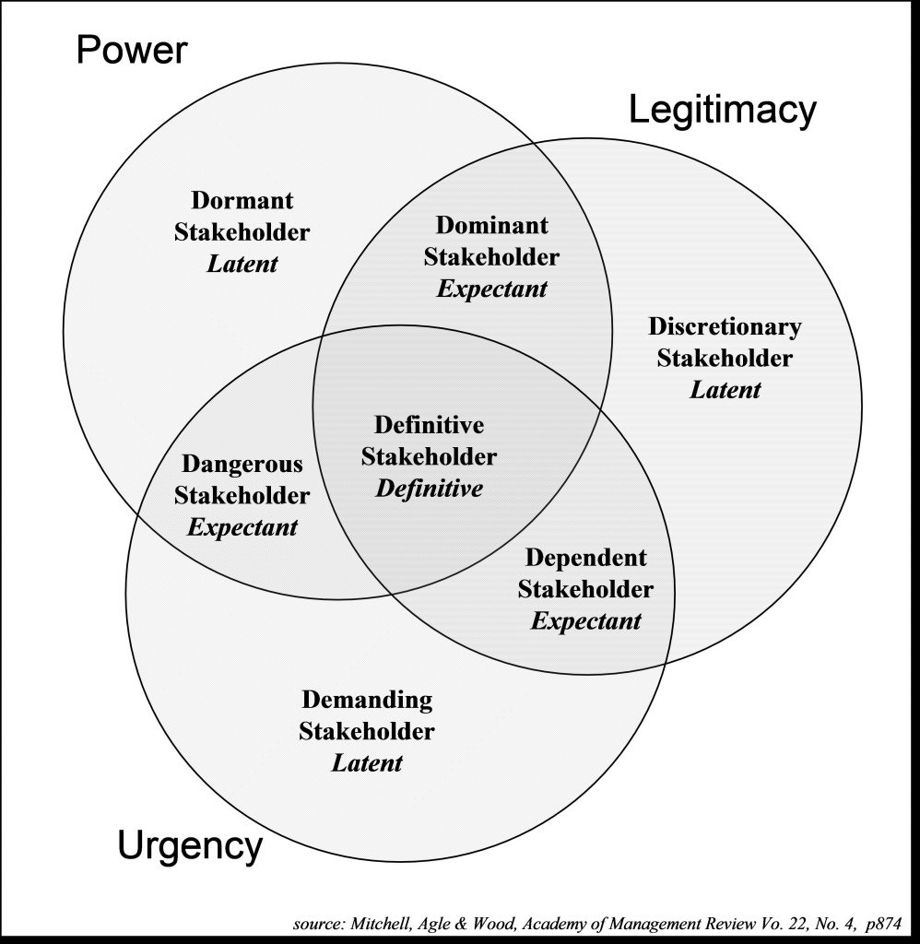

Appendix 2



