Student name: Serena Bailey
Student number: 2025320
Lecture name: Robert Nartowski
BMHP5014_BIRM
Changemakers: creativity and value creation

Contents
Pitch – women who suffer postnatal depression. 3
LET’S KICK POSTNATAL DEPRESSION OUT THE WINDOW AND SUPPORT A MOM TODAY! 3
Why is it personal to me? 4
Why I think my idea will good. 5
funding 6
Reference’s 8

ARTEFACT TASK 3.

Pitch – women who suffer postnatal depression.

LET’S KICK POSTNATAL DEPRESSION OUT THE WINDOW AND SUPPORT A MOM TODAY!
Postnatal depression is a common issue among new parents, and it happens to 1 in 10 mothers of young babies according to the NHS (2022). When doing research about support systems it seems that there is not many that are face to face groups and most of it seems to be online. Well, my business would like to change that. Women suffering from postnatal depression need guidance to help the recovery process. “Untreated maternal depression has potentially serious consequences for a woman’s overall well-being, her functioning as a mother, the family’s functioning, and her child’s development” (Schultz et al., 2013). We don’t want women to go untreated and let them get worse when we will offer a variety of workshops for mother and baby, meeting people in the same situation as them. I want mothers to be able to talk to one another give advice and know they will not be judged and most importantly have voice.
My company STM (Support the moms) developing and would like to be able to grow and become bigger and better! We are here for all mothers to help you on your journey to recover from PND. There will be:
- Face to face meetings
- Mother and baby workshops
- Meeting other mothers struggling like you
- Trips
- 1:1 advisor to help with anything you Want
- Home visits
- Family days out
- Counselling
- Mentoring
This is what makes us different from the other support services that deal with postnatal depression, because a lot of the companies don’t organise events and trips to help a mother. If you chose to fund our company, you will see a drastic change in the percentage of women suffering long term.

Why is it personal to me?
This is very personal to me and is why I chose to build a business within the mental health sector for women. As when I became a first-time mom at 18 my feelings and emotions after having my little girl made me go into serious postnatal depression, I felt lonely, had feelings of guilt and was always avoiding people, I barley left my house. So, I want women to know that they are not alone. When I needed help the doctors wanted to put me on antidepressants. Sometimes I felt like medication isn’t always the way forward and just made me feel worse and ashamed as medication does not cure you from suffering with your mental health. I want all mothers out there suffering to know the bullet points listed above can benefit them too in more ways than one.
I felt ashamed and wished that there was support groups for mothers with postnatal depression sector local and meeting women like me to know I’m not the only one going through it and we could of all helped each other through the process because it can be really hard, even the little things like talking to family its such a hard thing to do because unless you have experienced these emotions no one will fully understand. If I would have seen a support system/group like this I would loved to try it out and I personally feel like it can really make a difference to mothers. Communicating is crucial and I wouldn’t want any to suffer in silence like I did. So stop and think for one mother recovering is one less mother to worry about. No mother should feel ashamed and uncomfortable to talk about PND I want every mother to have a voice and not feel judged and know that you will be heard by us. This was meant to be the happiest moment of my life, yet I felt hopeless. I hate the fact that mothers out there are still struggling how I did. I want to make a change! I was always aiming for best to try and achieve the unachievable and it drained me. I would always be smiling pretending everything was okay but inside I was falling apart. But the truth of the matter is as a mother we are still learning every day, even now my daughters 3 and I’m still learning. Being a mother is the best gift ever, but we must give ourselves a break and stop judging ourselves because it’s hard, but together we can make it work.
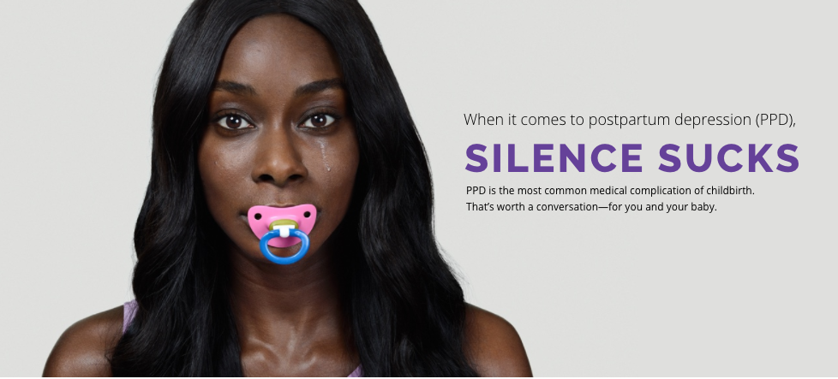

Why I think my idea will good.
I feel like my idea (supporting mothers with PND) will be great for women to join because its more than just taking medication and counselling to solve it, as a team we can get you there to feeling comfortable in yourself again and being happy through resources and activities to make women aware. Flyers with our business information could be given to pregnant women when attending there first scan so they have awareness of postnatal depression and know what steps they can take if they feel like they are struggling with it, also to know it’s completely normal. Most of all we will offer workshops, classes, etc. which I don’t really see much of this for mothers dealing with PND it gives them a chance to change the way they are feeling and build their confidence back up.
We need to get rid of the stigma of mothers feeling scared to ask for help because people don’t talk about it or come forward with what they are struggling with whether it be something big or small every single person is different and need to understand it’s okay and it will get better eventually. If we don’t get help we can make it worse and it wont go away by ignoring it. It can be a lot of pressure having a new born “the happiest time of your life but your not happy” that is postnatal depression. This where we come in to help mothers through: online, face-to-face, mother groups and mother and baby groups. Whatever you feel most comfortable doing we will support you along the way to getting better. My hope is that we destigmatise and normalise postnatal depression in mothers, so new mothers don’t feel like they must hide.

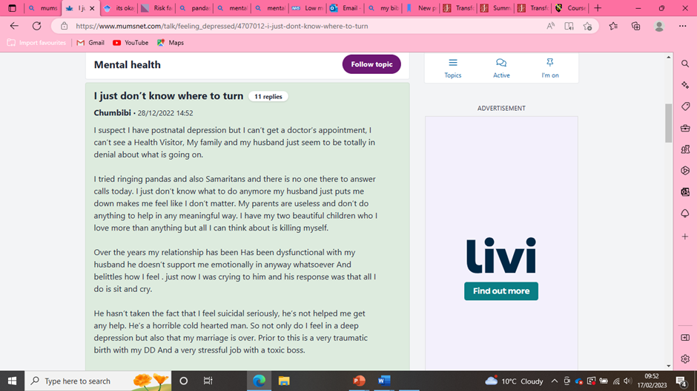 (www.mumsnet.com, n.d.)
Existing support networks have failed due to research and supporting evidence I found from a online forum for mothers in need of support, so we (Support the moms) are trying fill the gaps within the support network sector. Women who join our support group and system will not feel isolated oh having supress the way she feels.
See this short clip below to understand a bit more on postnatal depression. https://www.jstor.org/stable/10.7249/j.ctt2jc9b3

funding
I would like to obtain a grant to help to scale my business. I have been doing some research and have found that the princes trust can help with funding for businesses, they have worked with thousands of people to start out a business and I feel like with the funding we could receive off them would benefit the company to become excellent. (Princes-trust.org.uk, 2019)We’ve helped over 90,000 young people to start their own business – and you could be next. We work with 18 to 30-year-olds living in the UK to turn big ideas into a reality. Furthermore, by joining each innovation with the support of princes trust it could offer endless opportunities for those who currently or have experienced postnatal depression by providing a purpose and guidance.

ARTEFACT TASK 5

Poster
Below visual of a combination of research for postnatal depression design poster, giving awareness to mothers or anyone who wants to gain some sort of understanding.

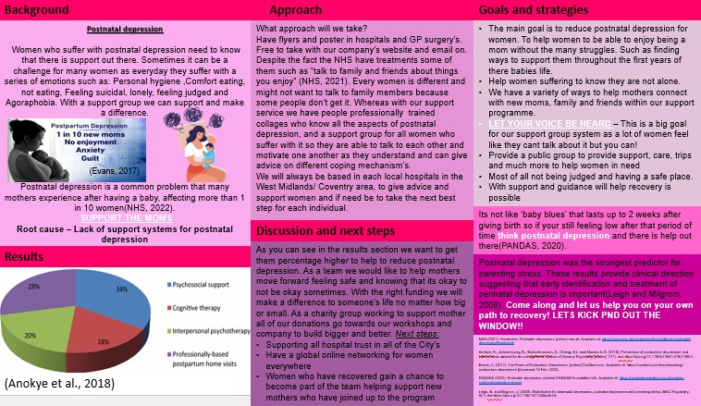


“Every mother counts!”
Support the moms the light is at the end of the tunnel, and we will get you there no matter how long or short it may take.
Contact details:
website: www.supportthemoms.co.uk
Phone details: 0121 345 769
Email: support.the.moms@gmail.com

Reference’s

Schultz, D. (Dana J.., Schultz, D. and Schultz, D. (Dana J.. (2013) Transforming systems for parental depression and early childhood developmental delays findings and lessons learned from the Helping Families Raise Healthy Children initiative. Santa Monica, CA: RAND Corporation.(Available at: UWTSD library)
Princes-trust.org.uk. (2019). Support for starting a business | The Prince’s Trust. [online] Available at: https://www.princes-trust.org.uk/help-for-young-people/support-starting-business.
What is postnatal depression? (Accessed date:16th February 2023) Available at: YouTube: https://www.youtube.com/watch?v=nfh-XIP2dR0
NHS (2021). Treatment - Postnatal depression. [online] nhs.uk. Available at: https://www.nhs.uk/mental-health/conditions/post-natal-depression/treatment/.
www.mumsnet.com. (n.d.). (2022) I just don’t know where to turn - Mumsnet. [online] Available at: https://www.mumsnet.com/talk/feeling_depressed/4707012-i-just-dont-know-where-to-turn [Accessed 17 Feb. 2023].

