19/01/2023
MA Confirmative Praxis Report
MA Contemporary Dialogues: Surface Pattern Design
The Fictioning
By Sophie Jones
2006943
Word Count: 5485

Table of Contents
Note To Reader 2
Introduction 3
Chapter One: Relationship with Nature 6
Section One: Biophilia 6
Section Two: Constance Spry 16
Section Three: Conclusion for Chapter One 20
Chapter Two: The ‘Fictioning’ Theory 21
Section One: Surrealism 21
Section Two: The Metaverse 24
Section Three: The Fictioning Theory 29
Conclusion 34
Bibliography 36
Table of Figures 38

Note To Reader

This report contains both academic writing that has stemmed from research and non-academic written responses which are required for the research of this praxis. The non-academic narrative is stylised outside of academic norm for reflective and critical purposes.

The visual and academic exploration of this praxis can be viewed at:
https://sophiejconfirmativepraixs.blogspot.com

Introduction
The body of this report explores the notion of ‘Fictioning’ which is; “the blurring of the reality/fiction boundary, but also, more generally, the material instantiation- or performance- or fictions within the real that then gives them a certain traction on the latter.” (O’Sullivan, 2017, p. 292)

In Simon O’Sullivans’ Mythopoesis or Fiction as Mode of Existence, O’Sullivan expresses interests in developing fiction as an actuality and suggests ideologies behind ‘invented life’. My praxis has stemmed from an interest and exploration on how the COVID-19 pandemic has created a need to explore fictional spaces as a means of escapism. My thought process throughout my praxis blends well with the theory of ‘fictioning’ by blurring actual and temporary spaces within interior design. As a response to the pandemic, I have created projected imagery which explores how virtual and augmented reality can change an interior space, in order to create a divide between the home and work.

I have also merged the concept of ‘fictioning’ with biophilia. As, within my praxis, I have ‘invented life’ (O’Sullivan, 2017, p. 292) by creating and hypothesising hybridised florals to accentuate the divide between reality and fiction. However, I have selected to explore this notion with nature given that biophilia encompasses the “The belief that contact with nature is somehow good or beneficial” (Ulrich, 1993, p. 73), which contributes to my research of finding ways to cope within the same four walls that people found themselves in during Covid.

The means for this report is to understand the development of my research and thought processes throughout my work. There is not necessarily an ending or conclusion to my research and praxis, however an exploration of what could be with paradoxical ideas blurred with ideas from the norm. To understand my praxis, you must understand the influence behind my work, and the medium in which is it used to be presented.

The influence in questioning being the impact that the Covid-19 virus caused mentally and physically around the world “and as of 20 May 2020, it has infected 4,806,299 people, and caused 318,599 deaths.” (Ciotti, et al., 2020, p. 366). Throughout the pandemic, the message ‘Stay Home’ was repeatedly reinforced, herein lies the inspiration for my Praxis as our homes no longer resembled the place people could escape to but became places people wanted to escape from and our connection with nature became dulled. Therefore, the exploration of biophilia within my work is so imperative to this investigation towards a resolution in this creative process.

The choice of medium within my creative practice is well suited to the aspects of temporality and blurring the borders between fiction and actuality. I have purposely chosen the use of projectors and virtual reality as a visual medium to portray a fictional entity existing in correlation with a real physical space and due to its ability to be changed/removed/installed instantly. The work enhances the existence of the ‘fictioning’ theory, whilst also being imaginative with the coining of new ‘life forms. My praxis sees an innovative concept of creating ephemeral designs for interior design without the negative environmental impact.

Chapter One: Relationship with Nature

Section One: Biophilia
The main body of my praxis has revolved around our innate relationship with nature and how this has evolved during the COVID-19 pandemic. The most significant research has been influenced by Biophilia. Biophilia theory stipulates that “nature fosters psychological wellbeing, reduces the stress of urban living, and promotes physical health” (Ulrich, 1993, p. 73). The notion that biophilia helps improve a persons mental health is also supported by Riaza, Gregora and Lin (2018) whom state that “exposure to natural elements that helped early humans to survive leads to positive emotions.” (Riaza, Gregora, & Lin, 2018, p. 199). It is through my research of biophilia that I created 14 ‘patterns’ or distinctive floral features of biophilic design that frame how nature should be incorporated into “cities and indoor environments” (Grinde & Patil, 2009, p. 2332).
The 14 patterns are segregated into three sub-contexts: Nature in Space; Natural Analoques and Nature of the Space (as per figure 1). This is in line with my research in which having nature within “living spaces can presumably induce positively valued changes” (Grinde & Patil, 2009, p. 2333). The nature of my work primarily reflects patterns within the Nature in Space context, however my praxis does carry characteristics of all three contexts.
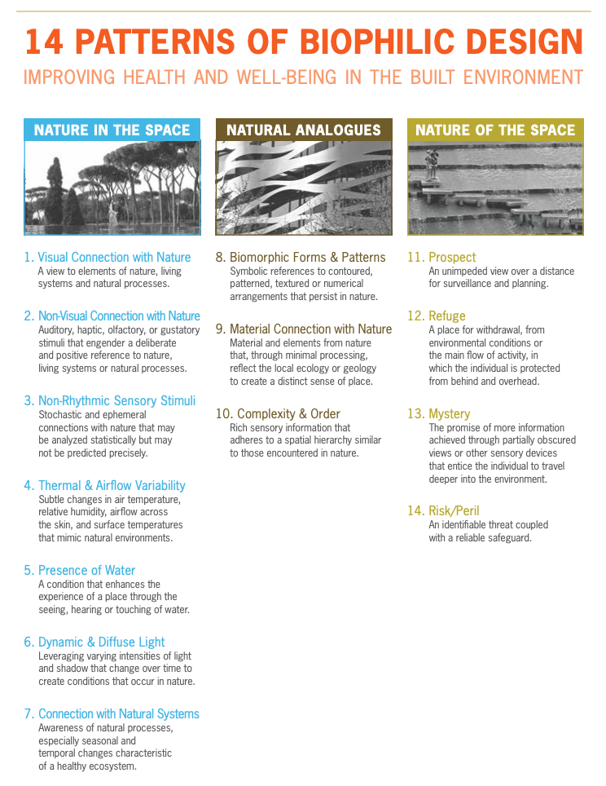
Figure 1 14 Patterns of Biophilic Design (Browning, Ryan, & Clancy, 2015, p. 12)

The framework is designed to aide biophilia within an urban setting. My praxis revolves around creating visual designs that hold futuristic characteristics such as being digitally projected or visualised within virtual or augmented reality. While also ensuring that I created materials that were supported by academic literature. Figure 1 demonstrates that a good biophilic design embodies the ‘mind-body system as indicators of health and well-being” (Browning, Ryan, & Clancy, 2015, p. 13). In order for, humans to have a good balance between their mind and body nature is a vital source of this, as an “environment devoid of nature” (Grinde & Patil, 2009, p. 2332) has a negative effect on the person. Furthermore as mentioned above a vital part of my research and praxis was to research ways to counter-act the impact that COVID-19 had on peoples mental health through incorporating biophilic pattern design inside the home.
Everett Conklin’s significance of understanding biophilia within interiors stems from Conklin being one of the primary sources to highlight biophilia within interior design. Conklin popularised the use of plants and nature within interiors in the 60’s and 70’s, and “stated that there is a ‘primal association’ with plants and flowers, that they aren’t luxuries but requirements of our biological heritage, that we need them in order to be happy.” (Zazzera, 2015). The ‘need’ for nature in this instance seems to be an emotional need, rather than a physiological or cognitive need. Ulrich (1993) stipulates that they believe biophilia “contributed to fitness or chances of survival” (Ulrich, 1993, p. 74). While this source is outdated there are elements which are supported in recent academic research and thus it is still a valuable source. Grinde and Patil (2009) overlap with my argument of the need of nature and the purpose of biophilia through stating that biophilia induces positive changes both “in cognition and emotion” (Grinde & Patil, 2009, p. 2333) That being said, my argument stems from my praxis which has drawn on emotional wellbeing during the pandemic and looks to understand how being surrounded by nature or natural imagery can improve emotional wellbeing during this time.

The “need” for nature is also imperative to acknowledge that we need nature and the eco-system in order to survive, therefore acknowledging that in order to survive, we need to be happy. Grinde and Patil (2009) similarly convey the message that it is our need for survival that makes our relationship with nature so innate and intricate. Through stating that "Plants were of crucial importance for survival during most of our evolutionary history; as a food resource, for shelter, and as an indicator of water. On a purely theoretical ground, one would expect the presence of plants, as an integral part of the human EEA, to have had an impact on the evolution of the brain. We are presumably adapted to live in a green environment." (Grinde & Patil, 2009, p. 2333). Further demonstrating the importance of plant life on the development of our brains which enable us to be a happy and functional member of society. It also explains why as humans were go to “considerable lengths to maintain contact with nature” (Ulrich, 1993, p. 73), thus explaining why we are becoming increasingly focused on bettering our environment and world.

“We are linked to nature physically, cognitively and emotionally” (Bochart, 2022). From this and the above academic literature, It is apparent that the relationship we have with nature is not strictly emotional, it is so much more than placing plants in rooms and buildings to make us feel better. Biophilia also consists of the environment, air quality, lighting, access to nature and much more. The introduction of biophilic design within interiors has created space that has benefited from positive physiological and psychological attributes and, in turn, creates a space where productivity and harmony are seen to increase, as opposed to spaces that lack any connectivity with nature. "Adding elements of Nature to living spaces can presumably induce positively valued changes in cognition and emotion, which again may impact on stress level, health and well-being." (Grinde & Patil, 2009, p. 2333)
Something that impacts us positively as humans is imperative to how our lives develop. The importance of evoking more positive emotions within ourselves soared during the pandemic as it became necessary to find new ways to take care of our own wellbeing whilst having to isolate from the world. "Living spaces" (Grinde & Patil, 2009, p. 2333) could possibly refer to the homes that became our entire world during that time, therefore it is important to understand how introducing nature elements into our spaces has become even more relevant in recent years than it ever has been. The ‘living spaces’ acts as a canvas in the instance of my praxis. I felt that it was important to develop the idea of biophilia alongside developing designs for interiors as this would create a correlation between interior architecture and exterior nature. Its juxtaposition is highly welcomed by interior designers alike who use biophilic design to inspire modern designs.
I have had to consider the opposing theory to biophilia- ‘Biophobia’- as a threat to my research and praxis. The theory of Biophobia “…suggests that exposure to natural elements that endangered early humans’ survival leads to negative emotions.” (Riaza, Gregora, & Lin, 2018, p. 199). This argument is grounded in the fact that past experiences in evolution have caused humans to have certain negative associations with nature; such as hearing a hissing noise and that noise evoking a negative emotional response to the imagery of a snake.
A reason that this research is so crucial to my praxis is because it places biophilia and biophobia in the digital world and views nature in a comparatively different way to the way it would be portrayed in interior design. It also gives me scope to review whether biophilic and biophobic associations are primarily aesthetic, and whether the imagery of nature is what we base our emotional responses on. Figure one explores the results of Riaza, Grefora and Lin (2018) whom formed their argument based of an experiment they conducted which compared peoples emotional response of either valance or arousal to the following stimuli: a snake that represented the biophobic website design; a small mammal that represented the biophilia website; and a neutral image in order to keep the experiment fair and reliable. It is also important to mention that those images that cause a valance response is due to the way the image “enhances our creativity” (Browning, Ryan, & Clancy, 2015, p. 4), and those images that caused an arousal response are due to the “fascination and fear” (Browning, Ryan, & Clancy, 2015, p. 4), that they provoke. Which is why biophilia and biphobia are of particular interest to me as they can have a massive impact on a persons attitude.
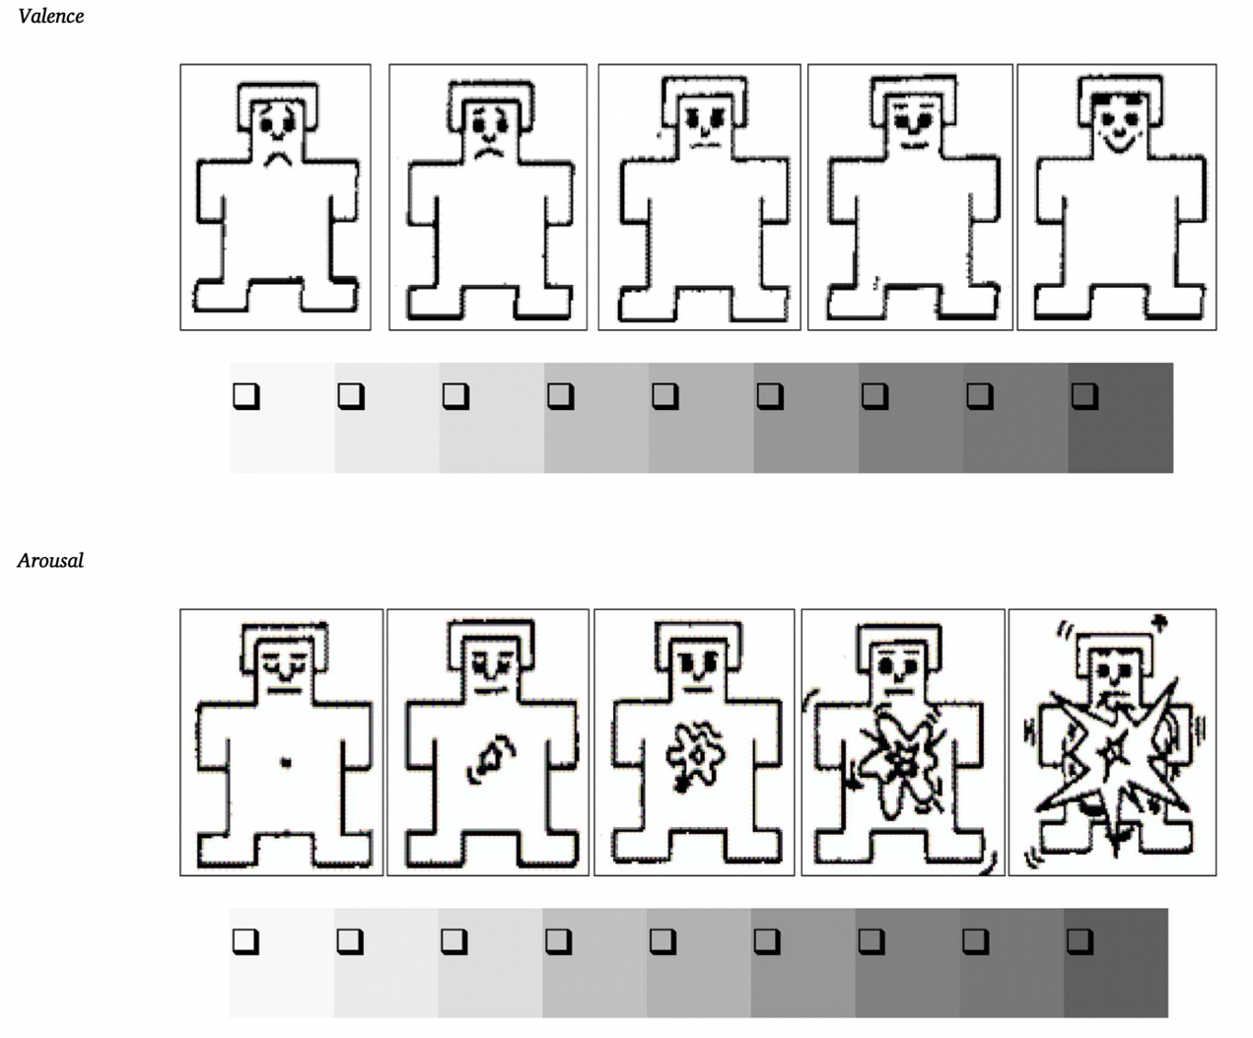
Figure 2: shows the self-assessment manikin that was given to participants in the experiment (Riaza, Gregora, & Lin, 2018, p. 211)

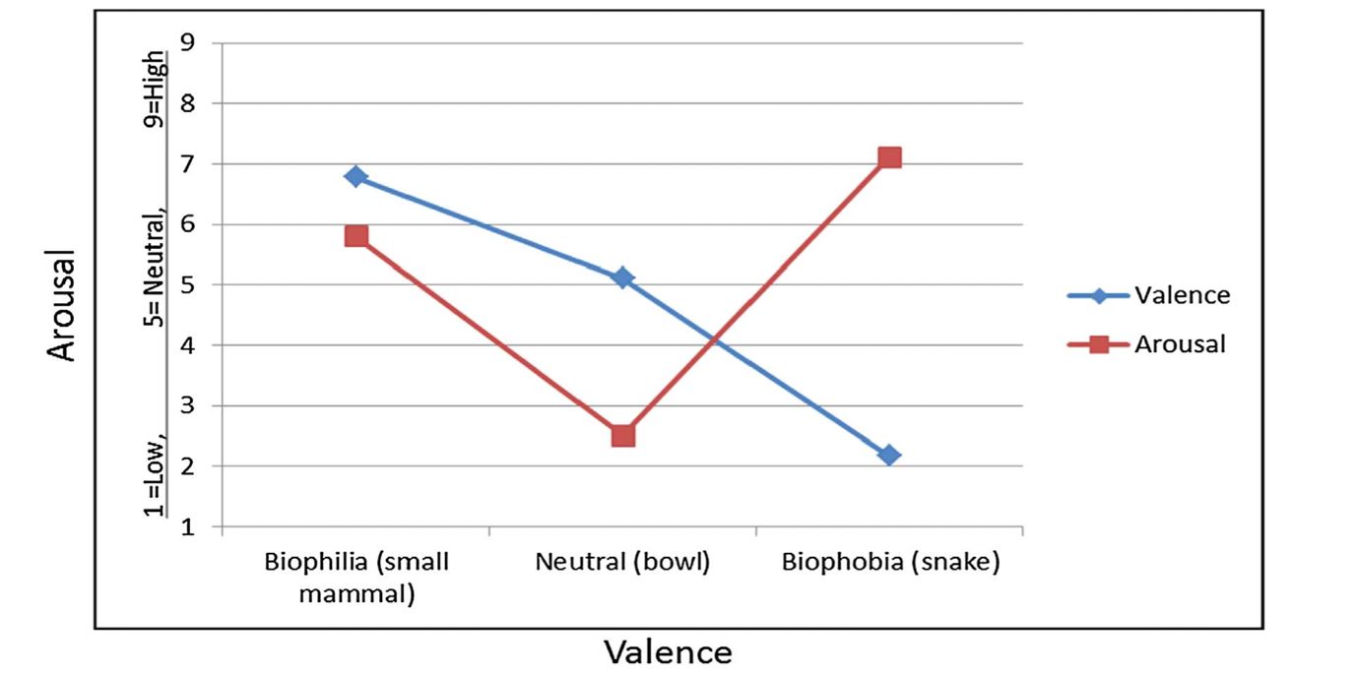
Figure 3 shows the correlation between biophilia, biophobia and the emotional responses (Riaza, Gregora, & Lin, 2018, p. 205)

Figures two and three show the significant correlation that biophilia has with the emotion ‘valance’ and the correlation that biophobia has with arousal. The primary conclusion I took from this research is that our emotional responses towards natural resources depend highly on the aesthetics of the image that we are facing. “Participant 1 in the biophobia (i.e., snake) condition said: “The picture of the snake scared me. I won’t visit this website again.” Participant 97 in the biophilia (i.e., small mammal) condition said: “I would like to use this type of website again. I actually want to go to a park now to see the lovely animal”. “ (Riaza, Gregora, & Lin, 2018, p. 205). The image that is portrayed to the participant actually acts as a deciding factor, as well as emotional responses being evoked in these circumstances. My praxis of hybridised flora was carefully considered after the context of this experiment. The aesthetic imagery became an important part of how I grouped flowers and created these hybrids in order to create something that was physically appeasing, yet still revealed and quirky and surrealist response to my own written brief.
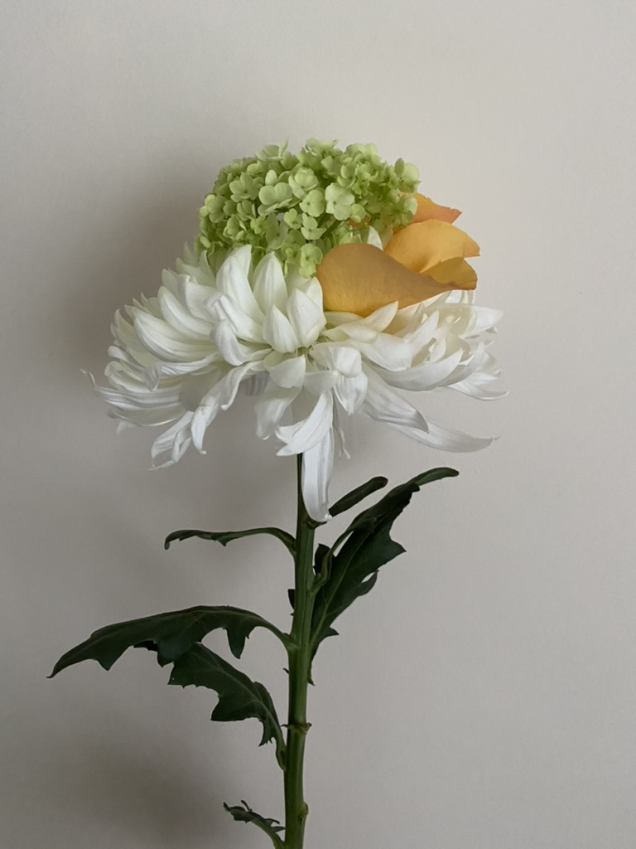
Figure 4 Figure Three: Image of one of my hybrid florals (Jones, 2022)
Figure four showcases one of the first hybrid floras that I had created for this series of work. While hybrid flowers create to my mind a more aesthetic visual image, I am weary that this then constitutes as a manmade environmental stimuli and some people have phobias of “nature formed of two of five coherent types” (Lundberg, 2014, p. 176) these types of fears of nature fall under biphobia. Moreover, it could be argued that my hybrid flowers do not fall under the term of nature, due to them being man-made, however Browning, Ryan and Clancy (2015) explore how this sentiment I outdated due to the fact that “nearly everything on earth has been” impacted by humans (Browning, Ryan, & Clancy, 2015, p. 8), thus it is from this research that I created hybrid flowers that entailed “living and non-living components” (Browning, Ryan, & Clancy, 2015, p. 8) in order to also ensure my work did not have a negative impact on the environment- through the removal of healthy flowers, instead I used flowers that were on the verge of rotting and sort out ways that they could have additional uses.

Section Two: Constance Spry
Constance Spry, the innovative and career driven woman who established herself as the leading ‘floral decorator’” (Richardson, 2016, p. 74) for her unusual flower designs including introducing vegetables and herbs into her magnificent bouquets. I have adapted this through creating bouquets as per Figure 1 with elements of both floral and plant life, through combing different flowers with an unusual pairing such as leaves (bristly oxtongue) from a weed. I have created a “multi-sensory” (Browning, Ryan, & Clancy, 2015, p. 9) stimuli which embodies elements of Constance Spry and her passion for pushing the artistic boundary.
“Spry believed in the power of flowers to raise the spirits at the bleakest times.” (Richardson, 2016, p. 76). Not only did Spry become infamous for her innovative floral designs, but she also recognised the psychological impact that being surrounded by nature evoked, prior to biophilia being introduced formally to the public. That being said the work of Spry is supported by the patterns of biophilia, specifically biomorphic forms & patterns which embodies “contoured, patterned, textured or numerical arrangements” (Browning, Ryan, & Clancy, 2015, p. 10). Which is the same element under which I feel I have embedded within my hybrid flowers as evident in Figure 1- to name just one example.
It was important to Spry that people were “original if you want to be and don't if you don't want to be.” Quoted by Constance Spry, cited by London Flower School (LFS, 2022). Spry’s attitude towards being innovative and revolutionary has inspired the eccentricity behind my hybrid floras. ‘Being original’ is something that I struggled with in terms of my work prior to completing my praxis and I forced myself to leave my comfort zone of digitally drawn florals. I have always been inspired by natural forms and so I did not want to stem away from that necessarily, yet I had the urge to develop something that furthered the existence of flowers in nature. Spry’s work helped me understand floristry and flowers do not have to be mundane bouquets that decorate the home. They can be so much more and inhibit more than just an aesthetically pleasing appeal.
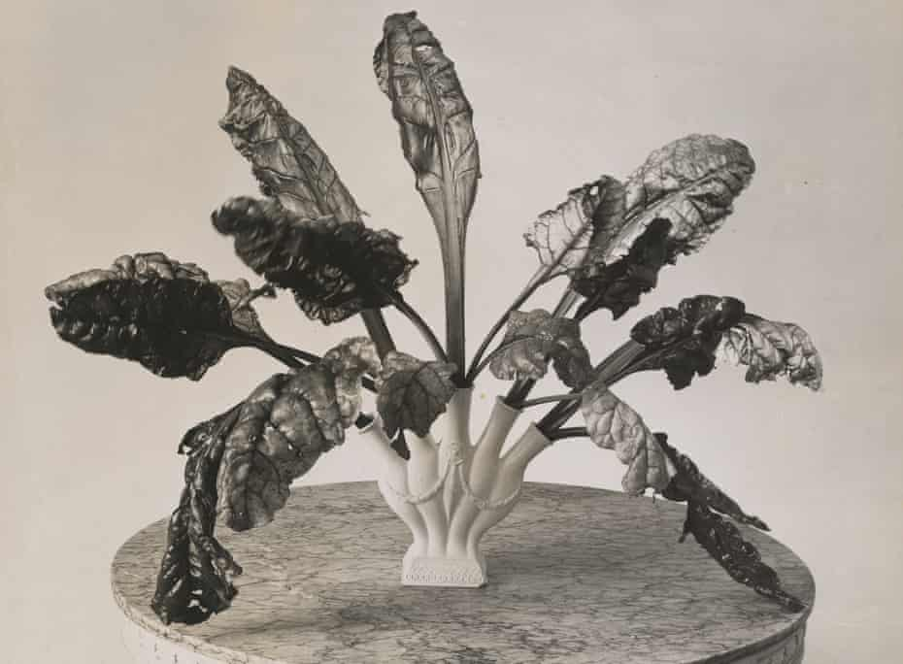
Figure 5 Constance Spry’s signature chard leaves, c1935. Photograph: Reginald Malby/RHS Lindley Collections

The authenticity of Spry’s admiration of natural forms is emphasised in her signature Chard Leaves. Figure five shows chard leaves freely flowing and falling from individual stems in a vase, creating movement in her still imagery. This is also supported by the patterns of biophilia, specifically visual connections with nature in which Spry image contains “living systems and natural process” (Browning, Ryan, & Clancy, 2015, p. 9). In this Spry creates a paradox between the norm and the imaginative by using vegetable leaves as floral arrangements. Yet because the chard leaves are so different to the norm, they create a striking visual narrative that evokes conversations around the controversial contrast. I have attempted to use this notion of movement and going against the norm within my work. Figure 1 (above) and figure 6 (below) are examples of this.

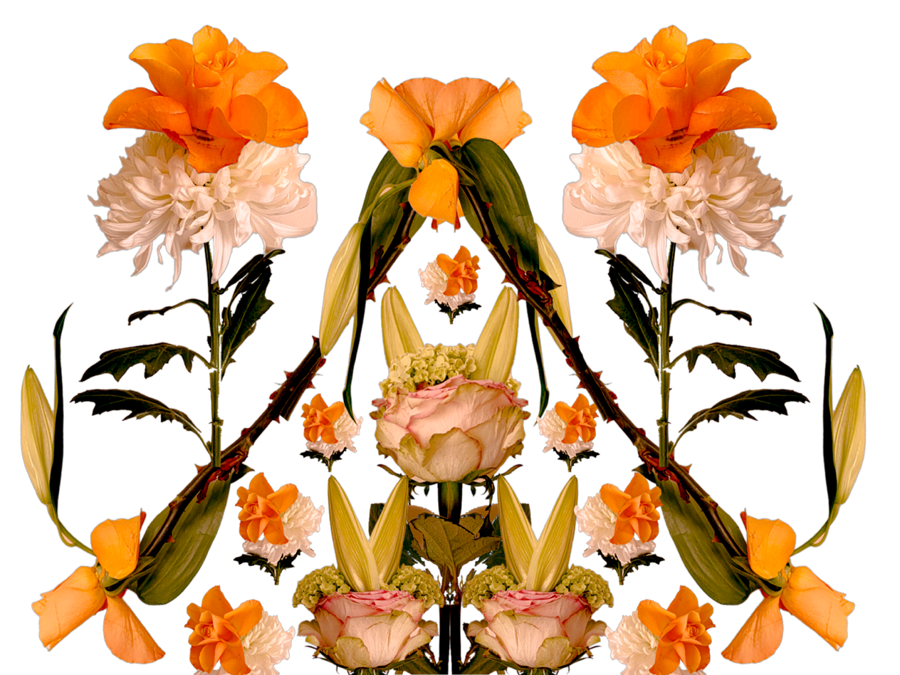
Figure 6 My floral arrangements (Jones, 2022)

In Figure 6, I have adapted my work to suit modern design and created digital ‘bouquets’ that have a sense of symmetry, yet also, more importantly, convey a sense of movement within a still image. This is achieved through having multi-directional floral arrangements which is a striking arrangement due to not only encompassing different “patterned, textured or numerical arrangements” (Browning, Ryan, & Clancy, 2015, p. 10) but also because it goes against the norm of a traditional bouquet. I have contested that design of modern floral bouquets by highlighting that natural-forms are exactly that- they are natural forms that grow and fall in different directions that can be affected by the environment that they grow within. Unlike Spry’s work, I have focused on maintaining colourful combinations to emphasise the realistic colours of the flowers, thus I have created a “more natural environments” (Grinde & Patil, 2009, p. 2333), even though they have been redesigned into the hybrid forms because I have not strayed away from the vibrant colours within nature. Furthermore, working digitally allows me to be more experimental with how I structure and position each ‘bouquet’, which enabled me to think about where each ‘bouquet’ should be located in order to embody a sense of movement within my work.

Section Three: Conclusion for Chapter One
In chapter one, I explored the theory of biophilia and our affiliation with natural forms. I was able to take inspiration from the work of Constance Spry, through thinking of how still images can capture movements but also be visual aesthetic even if typical abnormal items are used, as seen in Figure 5. The theory of biophilia is imperative to the journey of my work, as it helps explain the reasoning behind creating floral imagery for interiors and how these images can impact a person’s valance or arousal.

Chapter Two: The ‘Fictioning’ Theory
This chapter explores the part of my praxis that inspired the idea behind the hybrid florals. Within this body of research, I have acknowledged the likes of Surrealism and the Fictioning theory that contributed to having a big impact on my designs.

Section One: Surrealism

Prior to exploring ‘fictioning’ I first need to explore Surrealism, this is because Surrealism became important at a time when people needed to escape the unprecedented times people encountered post World War One.
‘Sur-realism’ meaning, in addition to in this case reality. The idea of which was first popularised by Andre Breton and his ‘Surrealist Manifesto’, where he stated that it was a “fusion of elements of fantasy with elements of the modern world to form a kind of superior reality.” (Breton, 1969, p. 66). Thus, suggesting the concept of surrealism is a convergence of mentality and physicality. He also suggests that “we have proscribed every way of seeking the truth which does not conform with convention.” (Breton, 1969, p. 66). This suggests societies needs to conform to what is reality and what is not. This ultimately makes us question the very existence of everything we know and see, as Walter Benjamin describes, Surrealism adds to what we can see and how the vision is revolutionary (Benjamin, 1993, p.108). A place of real and true surrealism. This is known as the “iceberg principle” which was coined by Ernest Hemmingway in his writing style. But it can be applied to surrealism because it is “A psychological concept that holds that, similar to the iceberg being 90% beneath the surface of the water, innate human desire is similarly hidden in the subconscious.” (Doyle, 2016, p. 49) This indicates that most of reality is undiscovered, meaning surrealism perfectly demonstrates thoughts of the subconscious mind.
During Covid, people encountered periods of isolation, self-suffering and drastic mental-health related issues as the result of the Covid-19 Pandemic. Being deprived of basic necessities has revealed a new stark reality. Surrealism came to my mind primarily as it expresses the want for this fantasy world that was physically real less two years ago.
Salvador Dali's work became a way for him and those who connected to his work to escape the realities of the Franco dictatorship. could be argued as being a response to the dictatorship of Franco's Spain, escaping the very military style of life at the time. Dalí's major contribution to the Surrealist movement was what he called the "paranoiac-critical method," a mental exercise of accessing the subconscious to enhance artistic creativity. Dalí would use the method to create a reality from his dreams and subconscious thoughts, thus mentally changing reality to what he wanted it to be and not necessarily what it was. For Dalí, it became a way of life.
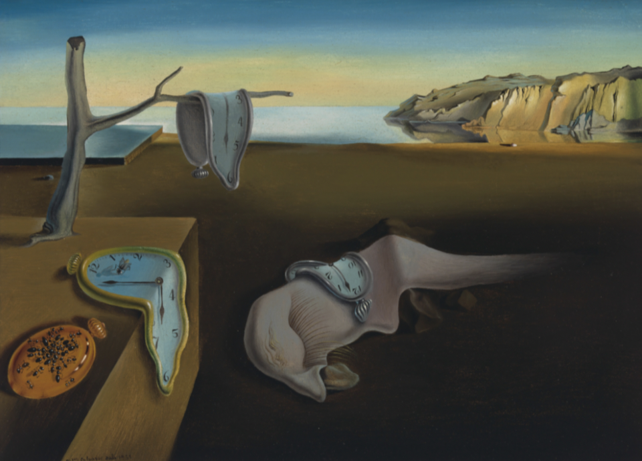
Figure 7 Salvador Dali’s The Persistence of Memory 1931

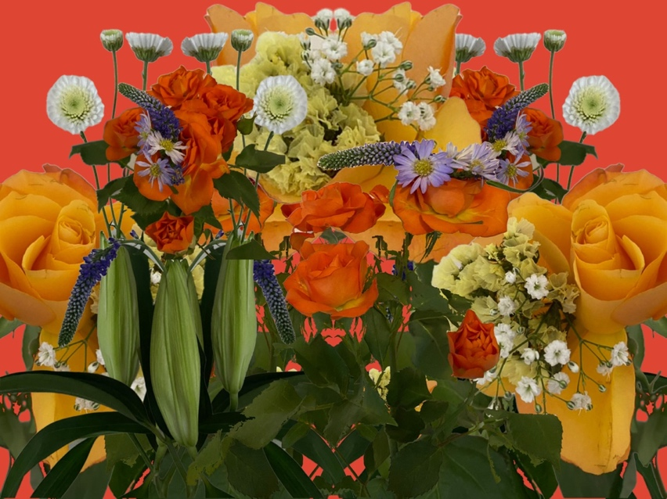
Figure 8 The Surrealist Bouquet (Jones, 2022)

Figure Eight depicts an illustration of one of the ‘bouquets’ I had constructed digitally as a part of my development and praxis. The chaos of the bouquet contradicts the expected ‘planned’ bouquet, which would have otherwise been gathered according to colour, style, size and height. Whilst I have described this bouquet as being chaotic, it still accentuates the beauty of the hybrid florals in a very structured and symmetrical way. As opposed to the likes of surrealism depicted by Dali, I wanted to portray surrealist artwork in a much more positive and bright way. Whilst it is not strictly surrealist, my work highlights the influences brought on by my interest in surrealism, in order to bring the movement into contemporary art and as a way of expressing escapist art in times that have been dark and bitter for the most of us. I still felt as though it was necessary to not overcomplicate the images of the hybrid florals so that the consumer would understand the images being portrayed and I wanted to capture that essence of escapist biophilia within design.

Section Two: The Metaverse
“The word Metaverse is a closed compound word with two components: Meta (Greek prefix meaning post, after or beyond) and universe” (Mystakidis , 2022, p. 486)

In Figures 9 and 10, I have combined ‘fictioning theory’ with using metaverse techniques. Thus, I also believe it is important to explore why the metaverse was imperative to the research and body of my praxis.

The metaverse enables people to have multisensory interactions with their environment through use of “virtual reality (VR) and augmented reality (AR)” (Mystakidis , 2022, p. 486). My final body of work (Figure 11) ensues a production of a series of animated patterns that project the surrealist idea of the hybrid flora using VR environment media. The animation of the individual motifs within the pattern design is what creates “…another layer that can’t be experienced in the physical environment.” (Dickinson, 2022, p. 2), encompassing a multisensory experience through movement.
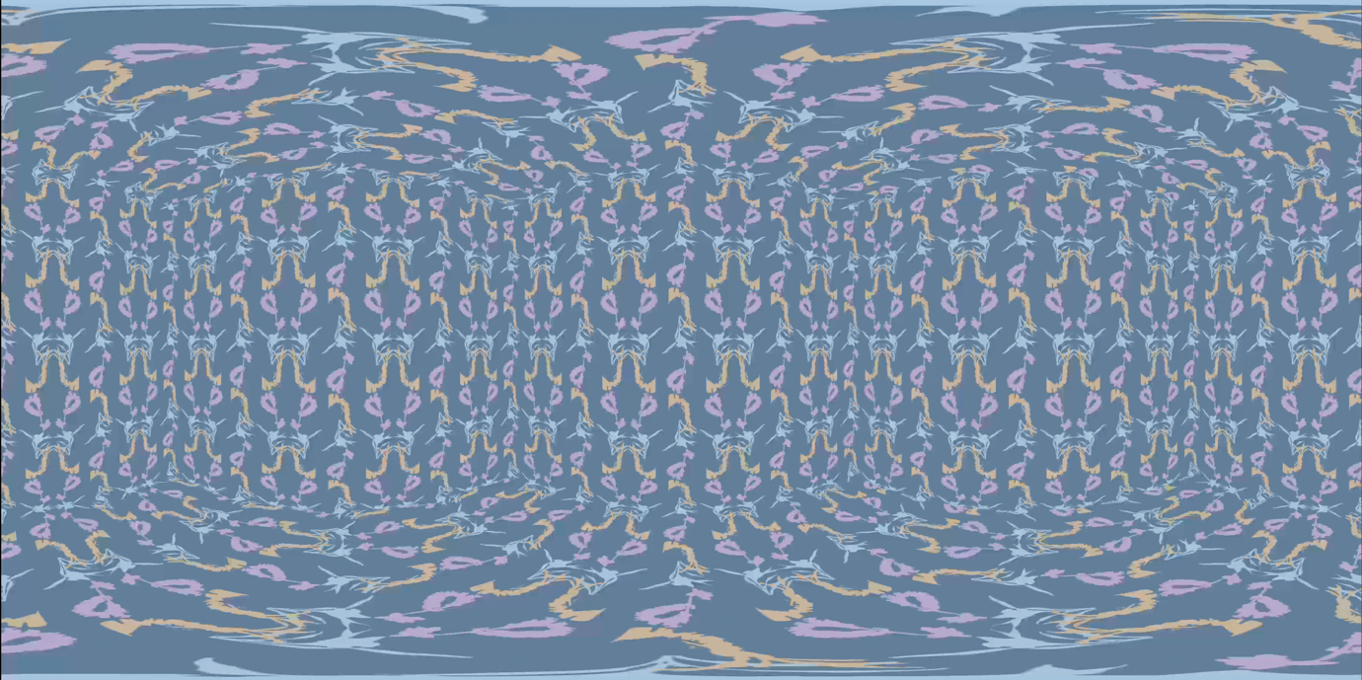
Figure 9 shows still image of animated pattern in VR environment. (Jones, 2022)

“The use of virtual modelling, animation, projection and the laser-cutting of hard materials enabled explorations between the virtual and the physical,
investigating ways to generate and present pattern in two-, three- and
four-dimensions.” (McLeod, 2014, p. 113) The expansion of the metaverse has created a pathway to further the exploration of pattern design in this instance. Natalie McLeod creates traditional textile pattern within digital media, as this “provides an alternative platform…encouraging exploration of movement, scale, space and interactivity.” (Braddock-Clarke, 2012, p. 2) McLeod’s Biohazard, as seen in figure 10, explores traditional textile pattern practice through the use of digital media, that projects as animated wallpaper. Her work encompasses the ever-evolving textile and print industry and can be compared to ‘mixed reality’- a virtual world overlaid on the physical world. (Braddock-Clarke, 2012, p. 2)
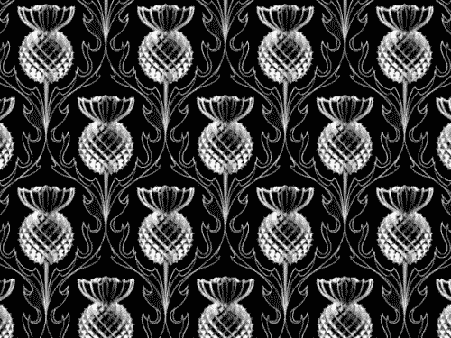
Figure 10 shows 'Biohazard' by Natalie McLeod
This style of exploration has been evidenced through my own body of work, referring to the aforementioned multisensory environments that are displayed within the Metaverse.
The metaverse is substantially more than just using a VR headset and playing a game, it is also experienced when people interact with “projected digital data” (Mystakidis , 2022, p. 487). Given that the Metaverse does not have to be fully digital environment, in enables the metaverse to provide a range of different uses within the home environment. This negates the proposition that the metaverse presents the virtual world as a “virtual environment, which can be experienced by numerous participants at once, who are represented within the space by avatars.” (Nevelsteen, 2017, p. 3)

Not only does the metaverse provide the user with a more lived experience but it can also enable the user through having a “partially synthetic digital environment constructed by technology” (Mystakidis , 2022, p. 487), meaning that people are able to choose the correct wall paper, wall colour and/ or furniture to fit the space without having to leave their home through projecting different prints onto their own walls. This comes as “Without limitations in physical design or time constraints, designers can put their energies into a new dimension.” (Dickinson, 2022) This will change the way people can shop for their home as people will be able to better visualise the wallpaper, for example, as the metaverse uses a “3D environment as it medium for communication and interaction.” (Izani, Mustaffa, Razak, & Alkhalidi, 2023, p. 135).

The use of the metaverse alongside the design field has become more prominent more recently and this is evident in the way fashion companies including Nike “has started a collaboration with Roblox” (Izani, Mustaffa, Razak, & Alkhalidi, 2023, p. 139). Furthermore, the use of the metaverse helps companies to better understand the “needs of consumers” (Izani, Mustaffa, Razak, & Alkhalidi, 2023, p. 139), once consumer needs have been identified companies are able to better appeal to their target audience especially because media has revolutionised “every aspect of the path to purchase” (Alexander, 2014, p. 31) .

Section Three: The Fictioning Theory
The ‘fictioning’ theory (O’Sullivan, 2017, p. 292) is imperative to understanding how my praxis evolved from biophilic design into hybridised biophilia, a much more complex way of exploring biophilic design as a way of escapism.
‘Fictioning’ is “the blurring of the reality/fiction boundary” (O’Sullivan, 2017, p. 292). I have explored and utilised this theory in addition to use of metaverse techniques to support the hypothetical ‘digital hybrid floral wallpaper’ that I have proposed for this praxis. My work symbolises fictional organisms existing within real spaces, in real time. The theory suggests that two incomparable things can co-exist in a bizarre paradoxical juxtaposition. It may be as simple as “juxtapose the fictional world… with the physical world” (Benford, et al., 2006, p. 427) through using a projector to bring this hypothesis to life. In other words using the metaverse to enable me to blur the boundaries between reality and desired reality in the case of my hypothetical digital hybrid floral wallpaper.

Brian Catling is a multi-talented individual, who is best known for their work in the arts and in particular, the literary arts. The most recent novel that has stemmed from Catling is The Vorrh (2016). The Vorrh is a fantasy, or a work of magic realism. Realistic details can be seen alongside objects and forces drawn from myth and imagination. The forest seems to exist somewhere all across North Africa, stretching down along the eastern coast, yet also near the Mediterranean. As with, say, the works of Tim Powers, this novel works fantastic elements realities of mundane life. It also reads like surrealist art and fiction, with genuinely strange scenes and ideas: a cyclops going to a carnival, after being taught from mysterious crates by helpful puppets. “Guattari develops the concept of ‘fabulous images’ for those descriptions that cross over from fiction to life, ultimately ‘producing another real, correlative to another subjectivity’” (O’Sullivan, 2017, p. 299)

“‘Fabulous images’ operate as connectors between regimes, bridges between
the different levels of life, both real and imaginary.” (O’Sullivan, 2017, p. 299)

The Vorrh (Catling 2016) shatters the ideology of there being coherent space-time within the novel. “The Vorrh meets the criteria of what Patricia Garcia calls the Fantastic of Space, with reference to a ‘literary phenomenon where the normal laws of physical space that rule our extratextual experience are not respected. “ (Fodor, 2019, p. 39)

I highlighted my research on Catling’s The Vorrh as it resonates with my exploration throughout my praxis, as it redefines how the relationship of space and time corresponds with one another. Placing ‘imaginary’ or fictional beings in very real spaces/places- whether that be physical spaces or political/sexual/societal places- allows the idea of the imagined becoming real within this paradoxical idea of blurring fiction and reality.

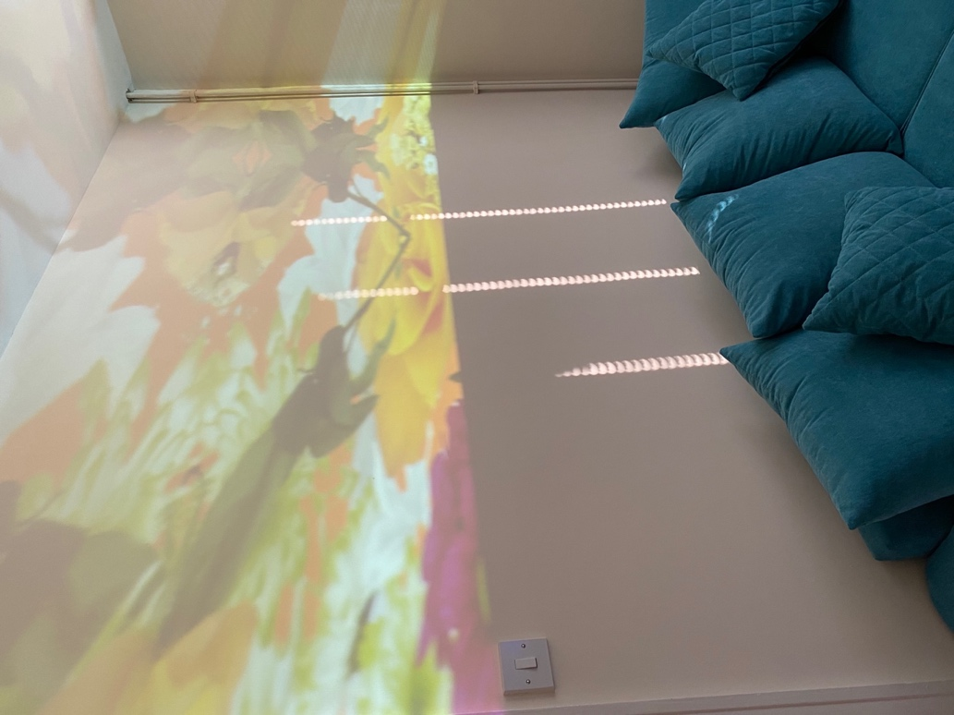

Figure 11 Blurring fiction with reality (projected imagery within my home) (Jones, 2022)

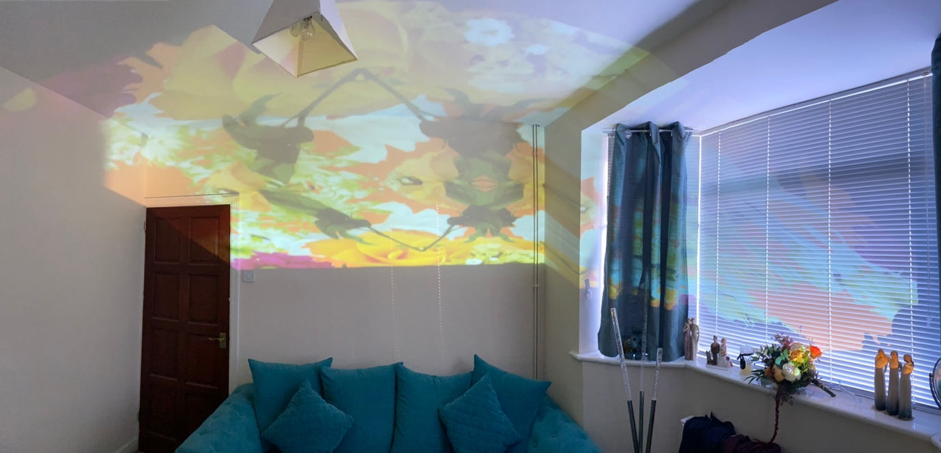
Figure 12 Blurring of fiction and reality continued. (Jones, 2022)
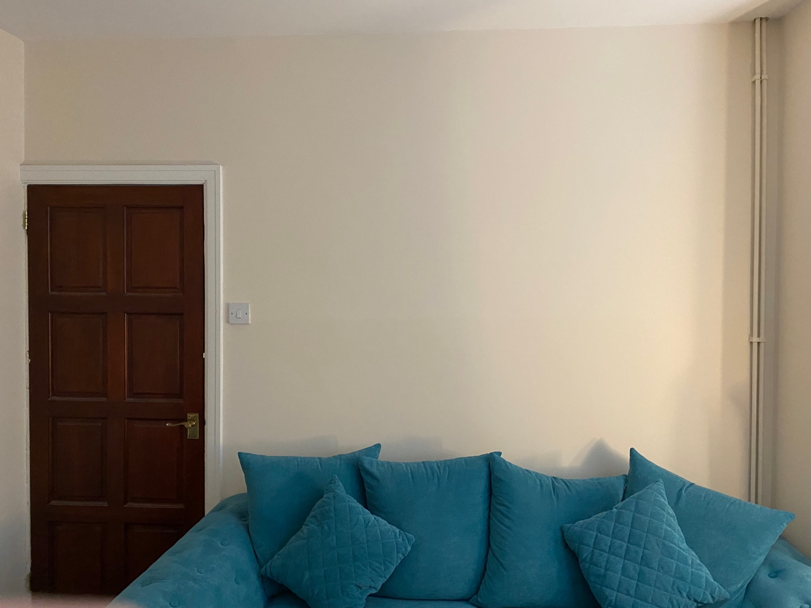
Figure 13 Photo of how my living room looks normally (Jones, 2022)

Introducing projected imagery (figure 11 & 12) to my otherwise mundane and bland walls (see figure 13) enhances the need to incorporate nature, colour and texture into my living room- in order to completely change the ‘living space’. The projection itself is not solely dominating one wall as you would expect, however it is creating different perspectives within the same space. The hybrid florals are not necessarily destined to be portrayed on walls only, as you can witness the projections also hitting the blinds and curtains. Having the projection climb the wall and the ceiling creates an over-arching structure, which changes the dynamics of the room in its own right. The cleverly positioned projector also enables me to create a transition between spaces, using the blinds to indicate that the natural imagery is coming from the outside. The hypothetical thesis of being able to blur fiction and reality and emphasise biophilic and fictioning theories is really highlighted through the use of these images.

Conclusion
As I mentioned in the introduction of this report, my thesis is strictly hypothetical and does not warrant a definitive conclusion. However, my conclusion for this report will be based on how my primary aims have been achieved during this project.

At the beginning of this module, I had set out to explore my interests in creating hybridised nature to depict a parallel to the norm as a way of creating a surrealist and escapist point of view that was deemed a necessary response to the COVID-19 pandemic. The original aim for this was to do this via augmented reality, as the pandemic encouraged an increased use of social media and the filters. I aimed to create a portfolio of work that consisted of fantastical and innovative patterns in order to create a paradox from the norms of expectations. My main concerns for this praxis were to explore how space could be used as a paradox to depict nature within interiors and how nature affected physical and mental well-being.

I believe that I have responded in an appropriate manner, creating a “convergence of technologies that enable multisensory interactions with virtual environments.” (Mystakidis , 2022, p. 486) I have successfully created a series of hybrid flora that are vibrant and creative. The hybrid floras were created as part of surface pattern designs for interiors- blurring the space-time of the inside/outside and fiction/reality. I have used media that I feel is appropriate to represent my work in which has been described prior to this. My praxis explores the definition and research of virtual reality and the metaverse, where my work much more evidently adapts to “AR…adopts a different approach towards physical spaces; it embeds digital inputs, virtual elements into the physical environment so as to enhance it. (Mystakidis , 2022, p. 487), as opposed to fully exploring the benefits of virtual reality in the metaverse.
That being said, I feel that this was the best practice going forward as it leaves scope for further investigations into this theory. I would hope that this theory of ‘fictioning’ in interiors could be developed further in the future with the help of augmented and virtual reality.

Bibliography
Alexander, B. a. (2014). Blurring of the channel boundaries: The impact of advanced technologies in the physical fashion store on consumer experience. International Journal of Advanced Information Science and Technology, 29-42.
Benford, S., Crabtree, A., Reeves, S., Sheridan, J., Dix, A., Flintham, M., & Drozd, A. (2006). The Frame of the Game: Blurring the Boundary between Fiction and Reality in Mobile Experiences. In R. Grinter, & T. Rodden, CHI '06: Proceedings of the SIGCHI Conference on Human Factors in Computing Systems (pp. 427-436). New York: Association.
Bochart, S. (2022). Creating joy through biophilic design. Retrieved from Shepley Bulfinch: https://shepleybulfinch.com/creating-joy-through-biophilic-design/
Braddock-Clarke, S. &. (2012). Digital Visions for Fashion and Textiles: made in code. London: Thames and Hudson.
Breton, A. (1969). Manifestoes of surealism. (R. Seaver, & H. R. Lane, Trans.) Michigan: The University of Michigan Press.
Browning, W., Ryan, C., & Clancy, J. (2015). 14 Patterns Of Biopjilic Design. New York: Terrapin Bright Green.
Ciotti, M., Ciccozzi, M., Terrinoni, A., Jiang, W.-C., Wang, C.-B., & Bernardini, S. (2020). The COVID-19 pandemic. Critical Reviews in Clinical Laboratory Sciences, 365-388.
Dickinson, C. (2022). Design Futures: Shaping the Metaverse. WGSN.
Doyle, C. (2016). A Dictionary of Marketing (4 ed). Oxford: Oxford University Press. Retrieved from https://www.oxfordreference.com/display/10.1093/acref/9780198736424.001.0001/acref-9780198736424
Fodor, A. (2019). Chapter 3 Holy monstrosity of arborescence in Brian Catling’s The Vorrh. In J. Hackett, & S. Harrington, Beasts of the Forest: Denizens of the Dark Woods (pp. 37-48). Indiana: Indiana University Press.
Grinde, B., & Patil, G. G. (2009). Biophilia: Does Visual Contact with Nature Impact on Health and Well-Being? International Journal of Environmental Research and Public Health, 2332-2343.
Izani, M., Mustaffa, F., Razak, A., & Alkhalidi, A. (2023). Metaverse: A Platform for Designers Idea, Concept, and Potential Opportunity in the Digital Realm. In F. Mustaffa, R. Sitharan, & J. Shariza Mohd Nasir, 2nd international Conference on Creative Multimedia 2022 (ICCM 2022) Volume 706 (pp. 134-143). Malayasia: Advances in Social Science, Educaction and Humanities Research.
Jones, S. (2022, November 25). Confirmative Praxis. Retrieved from blogspot: https://sophiejconfirmativepraixs.blogspot.com/
LFS. (2022). London Flower School. Retrieved from The Pioneering of Constance Spry: https://londonflowerschool.com/journal/the-pioneering-life-of-constance-spry
Lundberg, A. (2014). The Environment and Mental Health: A Guide for Clinicians. London: Routledge.
McLeod, N. (2014). Establishing New Patterns For Textile Design: Exploring Opportunities Offered by Digital Technologies for the Development, Fabrication and Presentation of Repeat Pattern. New Zealand: Massey University.
Mystakidis , S. (2022). Encyclopedia . MDPI, 486-497.
Nevelsteen, K. J. (2017). Virtual World, Defined from a technological perspective, and applied to video games, mixed reality and the metaverse. Sweden: Wiley.
O’Sullivan, S. (2017). Mythopoesis or Fiction as Mode of Existence: Three Case Studies from Contemporary Art. Visual Culture in Britain, 18, 292-311.
Riaza, A., Gregora, S., & Lin, A. (2018). Biophilia and biophobia in website design: Improving internet information dissemination. Information & Management, 55, 199-214.
Richardson, T. (2016). Great British tastemakers Constance Spry (1886-1960). Country Life (1886-1960), 74-77.
Ulrich, R. S. (1993). Biophilia, biophobia, and natural landscapes. In S. R. Kellert, & E. O. Wilson, The Biophilia Hypothesis (pp. 73-137). Washington: Island Press.
Zazzera, J. (2015, April 20). Nature in the Space: Indoor Nature Connections. Retrieved from Terrapin Bright Green: https://www.terrapinbrightgreen.com/blog/2015/04/nature-in-the-space/

Table of Figures
Figure 1 14 Patterns of Biophilic Design (Browning, Ryan, & Clancy, 2015, p. 12) 7
Figure 2: shows the self-assessment manikin that was given to participants in the experiment (Riaza, Gregora, & Lin, 2018, p. 211) 13
Figure 3 shows the correlation between biophilia, biophobia and the emotional responses (Riaza, Gregora, & Lin, 2018, p. 205) 13
Figure 4 Figure Three: Image of one of my hybrid florals (Jones, 2022) 15
Figure 5 Constance Spry’s signature chard leaves, c1935. Photograph: Reginald Malby/RHS Lindley Collections 18
Figure 6 My floral arrangements (Jones, 2022) 19
Figure 7 Salvador Dali’s The Persistence of Memory 1931 23
Figure 8 The Surrealist Bouquet (Jones, 2022) 23
Figure 9 shows still image of animated pattern in VR environment. (Jones, 2022) 25
Figure 10 shows 'Biohazard' by Natalie McLeod 27
Figure 11 Blurring fiction with reality (projected imagery within my home) (Jones, 2022) 31
Figure 12 Blurring of fiction and reality continued. (Jones, 2022) 32
Figure 13 Photo of how my living room looks normally (Jones, 2022) 32

