

Module Name: Marketing Management

Module Code: LCMB7024

Student Name: Md Ismail Hossan

Student ID: 2521543

Topic: Amazon’s Brand Extension
“Amazon EcoLife”

Lecturer’s Name: Dr. Mohammed Tariq

Wordcount: 2750

AI use acknowledgement

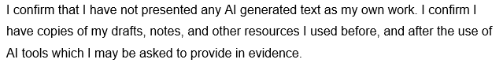

Table of Contents
Introduction 4
Element 1: Poster Presentation 5
Element 2: STDP Analysis for Amazon EcoLife 5
Segmentation for Amazon EcoLife 5
Targeting Strategy 6
Differentiation Strategy 7
Positioning Strategy 8
Element 3: Marketing Mix (4Ps) Strategy for Amazon EcoLife 9
1. Product 10
2. Pricing Strategy 12
3. Place Strategy 13
Promotion Strategy 14
Conclusion 15
Element 4: Reflection Using Gibbs model 15
References 19
Appendix 22

Introduction
Marketing management is defined as the analysis, planning, implementation and control of activities aimed at creating, communicating and delivering value to target customers and attain organisational goals (Kotler et al., 2024). Due to rising environmental issues and the fast development of technology, companies are employing new strategies like brand extension to penetrate new markets and enhance competitive presence. Amazon EcoLife is suggested to be an AI-based and sustainable home system that will blend with the current Amazon smart system to encourage energy conservation and green living (Ibitoye et al., 2025). This report explores segmentation, targeting, differentiation, positioning, and the marketing mix as ways of facilitating the successful introduction and positioning of Amazon EcoLife in the emerging smart home market.

Element 1: Poster Presentation
Please see in the appendix

Element 2: STDP Analysis for Amazon EcoLife

Segmentation for Amazon EcoLife
Segmentation is the strategic activity of breaking up a heterogeneous market into specific segments of consumers with the same needs, characteristics or behaviours (Cooper, 2019).
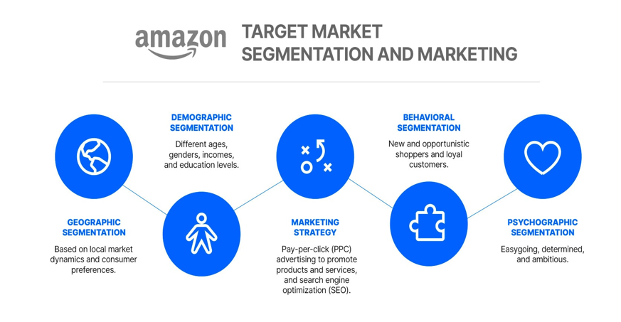
Figure:Market segmentation and marketing of Amazon
Source: (Wedel and Kamakura, 2020)
Geographic Segmentation: Amazon EcoLife will primarily target advanced economies with high smart home adoption and strong environmental regulations, including North America (United States, Canada), Western Europe (Germany, United Kingdom, France), and Japan (Amazon, 2024). Over 60% of worldwide smart home revenue is produced by these areas, and North America alone is estimated to be USD 58.2 billion in 2025 (Global Market Insights, 2026). Secondary markets are found in Australia, South Korea and the UAE where adoption is above 20% and still rising rapidly.
Demographic Segmentation: The target audience will be home owners and renters between the ages of 25-55 and an annual income of USD 75,000 or more, as they have the disposable income and high-tech readiness to invest in such complex smart home technologies. This is supported by the fact that 46% of this market segment already owns smart home devices, which suggests a healthy number of early adopters. Further, this group is especially interested in sustainability, with 68% of millennials and 54% of Gen X prioritising energy efficient systems, an important feature of the Amazon EcoLife solution (Amazon, 2024).
Psychographic Segmentation: The product targets the environmentally conscious consumers who are interested in convenience and innovation. PwC (2024) demonstrates that 80% of consumers are ready to spend a premium to buy sustainable products at an average of 9.7%, and there is growing attention to AI data privacy.
Behavioural Segmentation: The focus is on existing Amazon users of Alexa, Echo, and Ring. Multi-device households use 45% more money each year, and those who use energy-monitoring devices are 35% more likely to adopt sustainable technologies (Data Centre Magazine, 2026).

Targeting Strategy
Targeting Strategy: Differentiated Strategy
Amazon EcoLife uses differentiated targeting, which provides different value propositions to primary and secondary groups. In the case of homeowners, the focus is on overall energy control and cost savings in the long term (Global Market Insights, 2026). Among renters, the emphasis of messaging is put on portability, easy to install and immediate environmental impact. This dual strategy will ensure maximum coverage of the market with premium brand positioning.
Key Focus Group: Eco-Conscious Homeowners (30-50)
This market includes older homeowners who are keen to save energy and have a positive impact on the environment. Their actions are driven by increasing electricity prices and environmental concerns, and they are more open to smart energy technologies. This is shown by the fact that the global energy management systems market is expected to grow to USD 84.2 billion by 2030 (Research and Markets, 2025). This reflects the strong market potential for this segment, which also exhibits high lifetime value due to its high home ownership and willingness to invest in whole-home systems.

Secondary Target Market: Tech-Savvy Renters and Young Professionals (Aged 22-35)
Convenience, automation, and sustainability within the limits of rental are valued among this young group. The segment is more susceptible to portable and non-invasive smart items that need less installation. Amazon EcoLife has the potential to fill this untapped market since 63% of renters indicated their interest in energy-monitoring technology, which is a modular design (Amazon, 2024).

Differentiation Strategy
Technological Differentiation: AI-Powered Energy Intelligence
Amazon EcoLife stands out with a highly developed AI that can optimise the consumption of household energy in real-time. The system can learn user behaviour, make predictions and automatically manage connected devices to optimize demand, unlike simple smart devices. With AWS infrastructure, that is 4.1 times more energy efficient than on-premises systems, EcoLife provides better cloud-based optimisation (The Register, 2026).
Ecosystem Differentiation: Seamless Amazon Integration
EcoLife will integrate with the Amazon smart home system with more than 8% market share worldwide (Global Market Insights, 2026). Integrations with Alexa, Ring, and Echo raise switching costs and make them more user-friendly. Matter protocol support also allows the integration with third-party devices, increasing the market reach.
Sustainability Differentiation: Quantifiable Carbon Reduction
EcoLife can provide quantifiable carbon cutting details congruent with the Climate Pledge of Amazon to achieve net-zero emissions by 2040. With the success of 100% renewable energy matching by Amazon in 2023, EcoLife brings sustainability to the home with real-time monitoring and personalised suggestions (Research and Markets, 2025).
Privacy Differentiation: Edge-First Architecture
Edge computing allows EcoLife to perform local processing on the data, with 40% lower latency and privacy concerns. This strategy generates a robust competitive edge since the majority of consumers are still wary of data transfer (PwC, 2024).

Positioning Strategy
Positioning Statement
Amazon EcoLife is a smart sustainable home solution that provides smart energy savings, reductions in carbon emissions, and ease of use across the Amazon smart home platform, making it an ideal choice for environmentally conscious homeowners and tech-savvy renters (Amazon, 2024). EcoLife stands apart from other energy monitoring solutions or simple smart devices by offering a holistic approach to energy optimisation, privacy considerations and AI-powered insights using Amazon’s cloud computing infrastructure to deliver a more integrated and trusted solution for home energy management.
Perceptual Positioning Map
Amazon EcoLife occupies a distinctive strategic position defined by two competitive dimensions:
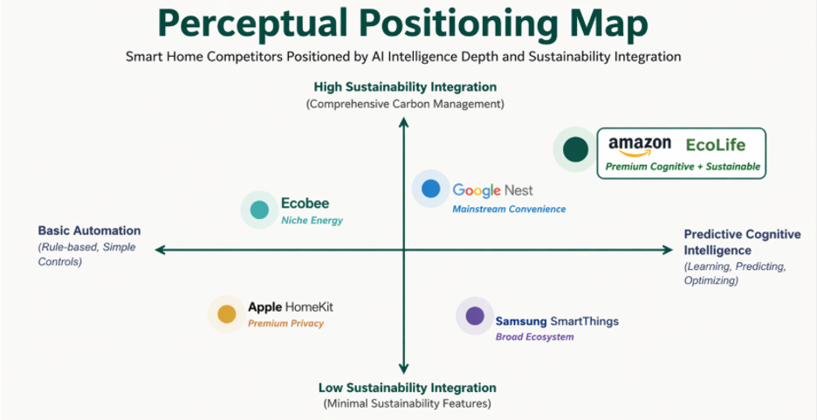

Figure: Positioning Map for Amazon EcoLife
Source: (Amazon Freight UK, 2025)
The market map shows on the x-axis the level of AI intelligence (from automation to predictive cognitive intelligence) and on the y-axis the level of sustainability integration (from low to holistic carbon management). In this map, Amazon EcoLife is located in the top-right quadrant, which corresponds to both high AI and high sustainability integration. This underlines its position in the market and its focus on predictive intelligence and carbon management, which result in a blue ocean opportunity, largely untapped in the market (Wedel and Kamakura, 2020).
Advantage of Competitive Positioning
This stance capitalizes on the two strengths of Amazon; leadership in AI infrastructure with AWS and its sustainability commitment and the Climate Pledge. Focusing on the intersection of cognitive AI and the environment, EcoLife will satisfy 46 percent of consumers who consider energy efficiency and environmental responsibility as the top three criteria when buying a smart home, and the 72 percent of consumers who are open to paying sustainability premiums (The Register, 2026).

Element 3: Marketing Mix (4Ps) Strategy for Amazon EcoLife
Kotler and Armstrong (2016) emphasize that 4P functions as an integrated system that helps to maintain consistency in effective market adoption. Amazon EcoLife integrates 4P of marketing mix to stay competitive in the market

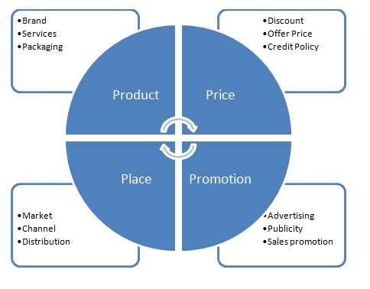
Figure: 4Ps of Marketing Mix
Source: (Ibitoye et al., 2025)

1. Product
AI-Powered Energy Intelligence and Core Offering
Amazon EcoLife is a smart product that combines energy modules, predictive AI software, and smart sensors to build a sustainable home. Using the infrastructure of Alexa, Echo, and Ring, proprietary algorithms learn occupancy trends and automatically calibrate devices to cut household consumption by 15-30% each year (Saberi and Menes, 2020). EcoLife advances reactive assistants to be proactive energy managers and changes the proposition of Amazon to be not convenient hardware, but rather indispensable sustainability infrastructure (Jankovic and Curovic, 2023).
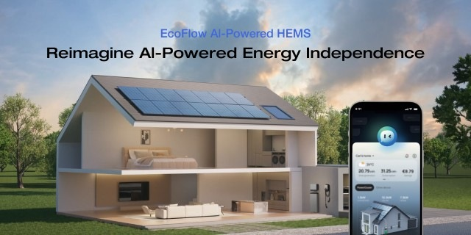
Figure AI-Powered homeEnergy product of Ecolife, Source (Saberi and Menes, 2020)
Privacy-First Edge Architecture
EcoLife uses edge computing architecture, where sensitive data are processed on the devices of Amazon instead of sending all the data to the cloud servers. This lowers by about 40% the latency and handles privacy issues that 72 percent of smart home buyers complain about (Jankovic and Curovic, 2023). The patterns of consumption and the schedules of occupancy are kept at home, and only anonymised measures are sent to improve the algorithms.

Augmented Features and AWS Advantage
The augmented features comprise real-time carbon dashboards, gamified sustainability scoring, and compatibility with 280-plus manufacturers with Matter protocol. The AWS infrastructure is highly competitive, with its power usage effectiveness of 1.15, compared to 1.25 globally, and facilitating analytics of 4.1 times less carbon footprint than an on-premise solution (Data Centre Magazine, 2026). This synergy between enterprise clouds introduces a type of differentiation that competitors cannot replicate easily (Cooper, 2019).

2. Pricing Strategy
Tiered Subscription and Value- Based Justification
Amazon EcoLife uses freemium pricing where EcoLife Basic will be provided free of charge in basic monitoring. EcoLife Plus is priced at USD 4.99 per month or USD 49.99 per year, which unlocks predictive optimisation and Premium at USD 9.99 per month offers whole-home automation. This arrangement is supported by the PwC (2024) results that eight out of ten consumers are willing to pay a 9.7% higher price on sustainable products (Amazon, 2024). The USD 49.99 subscription is a drop in the ocean of the USD 1,425 spent annually by an average household in the US on energy, and the aim of the 15-30% reduction in consumption is a mere 3.5% of the total cost of energy (Saberi and Menes, 2020).
E-Commerce Leverage and Hardware Pricing
The price for the hardware ranges from USD 79.99 sensor kits to USD 349.99 for whole home systems to accommodate varying consumer engagement and budgets. This approach to pricing is in line with the growth of online retailing, especially Amazon, which offers scalable reach to different types of customers. With Amazon's retail sales increasing from USD 309.48 billion in 2020 to USD 491.65 billion in 2024, and set to reach USD 540.29 billion in 2025 (Research and Markets, 2025), it increasingly supports diverse pricing strategies to cater to a wide range of market segments, including low-end and high-end consumers.

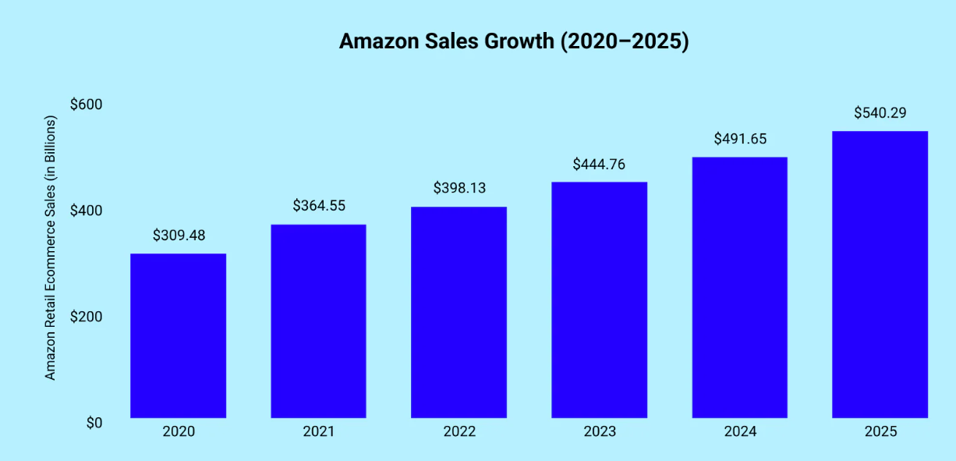
Figure: Amazon sales growth
Source: (Amazon Freight UK, 2025)

3. Place Strategy
Online-Only Distribution and Sales
Amazon EcoLife uses an exclusive online direct-to-consumer distribution model through Amazon.com to take advantage of the platforms' economies of scale, efficiency and cost advantages. This strategy is supported by Amazon's consistent global growth in sales that enables scalable and analytics-driven distribution (Wedel and Kamakura, 2020). US net sales grew by USD 60 billion to USD 220 billion from 2014 to 2024 and other major international markets (including Germany, UK, and Japan) increased by USD 10 billion to USD 75 billion (Amazon, 2024). This robust distribution network, including fulfilment centres located within 20 miles of 65% of Americans, allows for rapid delivery. More importantly, the direct strategy also facilitates affordable hardware prices by bypassing retailers and their associated 35-40% mark-up (PwC, 2024).

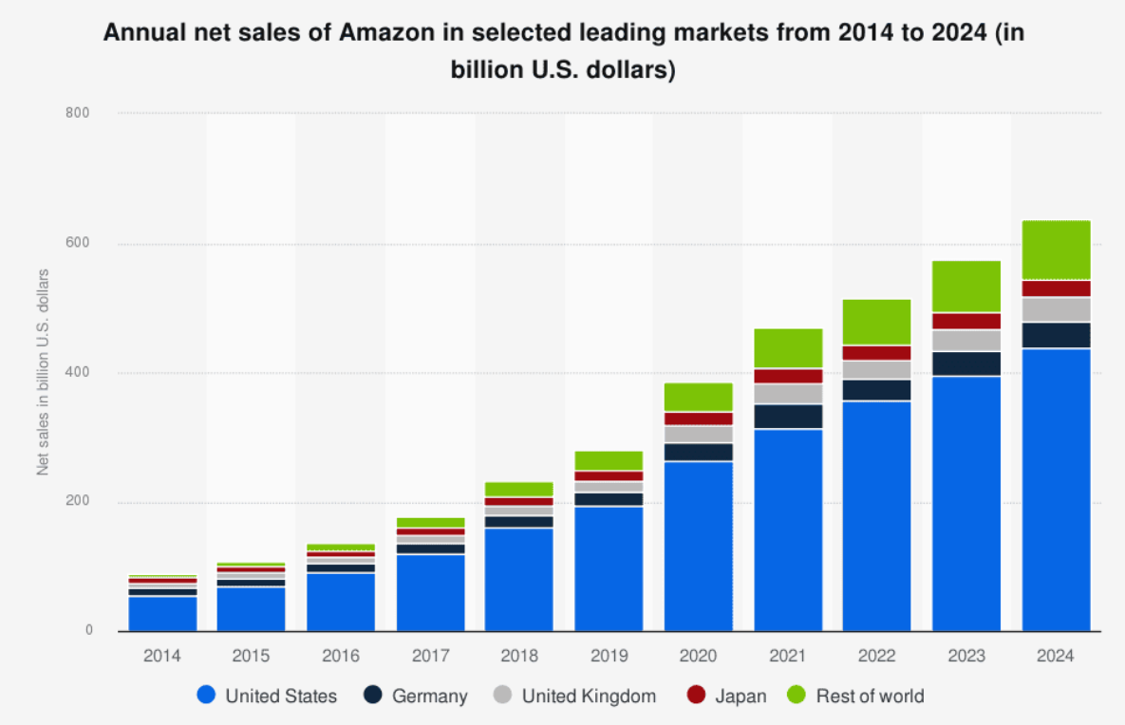
Figure: Amazon annual net sales in leading markets
Source: (Global Market Insights, 2026)
Ecosystems Integration and Strategic Alliances
In addition to the web site, EcoLife uses deep ecosystem integration as a proprietary distribution channel. The EcoLife Basic software will be automatically enabled on new Echo and Ring devices and will essentially seed the market with an installed base of more than 500 million Alexa-compatible devices (Global Market Insights, 2026). This makes the cost of acquiring the customers to be close to zero when they are on the free tier. Moreover, partnerships with physical and institutions enable the brand to reach consumers beyond digital-native audiences (PwC, 2024).

Promotion Strategy
Content Authority and Integrated Digital Marketing
Amazon EcoLife's integrated marketing communications (IMC) plan uses sponsored advertising, programmatic display and content marketing to establish credibility among eco-conscious consumers. A budget split of 60% for digital channels, such as Amazon Sponsored Products and programmatic display, is justified by the fact that these channels target users with a high purchase intention on Amazon.com. This decision is supported by Amazon's retail e-commerce sales of USD 491.65 billion in 2024, suggesting a highly receptive audience (Research and Markets, 2025).
Influencer Engagement and Ecosystem Incentives
Amazon will leverage its Influencer Programme for EcoLife's launch by partnering with more than 1,500 "sustainability influencers" with a following of more than 180 million users to boost awareness and trust. This strategy is justified because 60-70% of consumers prefer to get recommendations from their peers, and not from brands, making influencer marketing a proven strategy to boost EcoLife adoption (Amazon, 2024). Influencers will demonstrate EcoLife hardware and services in action, connecting product attributes to positive environmental impact (Amiri and Vida, 2023).

Conclusion
Amazon EcoLife exhibits a well-calibrated brand extension with a robust segmentation, targeting, and differentiation with AI-enabled energy intelligence and sustainability capabilities. Its positioning is responsive to the increasing consumer demands of intelligent, efficient and greener living solutions. In addition, the integrated marketing mix increases value creation by innovative product, subscriptions pricing, smooth ecosystem distribution, and promotion based on evidence. The strategy shows high prospects of market adoption, but the issues of data privacy concerns and barriers to technology adoption have to be addressed carefully.

Element 4: Reflection Using Gibbs model
Gibbs Reflective Cycle comprises six stages that helps to transforming real-world experience into actionable knowledge particularly relevant for brand extension projects (University of Edinburgh, 2024).
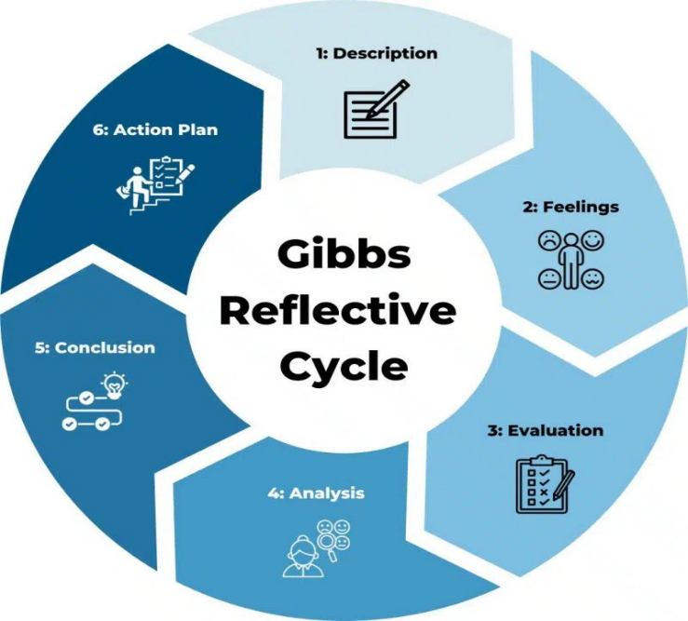
Figure: Gibbs relective cycle
Source: (University of Edinburgh, 2024)
Description
During this evaluation, I was a marketing manager who was creating a brand extension at Amazon. I suggested Amazon EcoLife, which is a sustainable home system powered by AI and is connected to Alexa and Ring. The project entailed a poster presentation and a portfolio consisting of STDP analysis and marketing mix evaluation and reflections to seize the growth in the smart home sustainability market.
Feelings
I was initially overwhelmed by the breadth of Amazon's offerings and question whether a product extension was a wise financial move. The poster design also created significant stress because I found it challenging to visually condense notions of AI, energy intelligence, and sustainability. As I improved the poster storyline and the Climate Pledge data (and market growth) from Amazon, my confidence grew. Encouragement from my peers during the presentation confirmed the EcoLife concept was credible and had commerce potential. Moreover, during the poster presentation in the class, I got fearful and nervous but later my confidence grew up when I could successfully answer the questions asked by my tutor.
Evaluation
The STDP model was effectively implemented and backed by supporting evidence, such as Amazon's retail sales growth from USD 309 billion to USD 491 billion. The poster effectively emphasised EcoLife's strengths using the hierarchy of visuals and measurable sustainability metrics, which were communicated successfully in the oral presentation. Nevertheless, the shortcomings were poor time management when designing the poster and lack of depth in analysing the competitor response, especially Google Nest.
Analysis
The experience has enriched my knowledge on strategic brand management. It supported Cooper (2019) in his opinion that differentiation, based on organisational strengths, is necessary to effectively develop the product. I made sure that I connected EcoLife with AWS and the Climate Pledge to provide meaningful sustainability positioning, not superficial. I also became more proficient at combining theory and actual market data and enhanced my skills in creating concise professional presentations using more visual tools.
Conclusion
This project effectively linked theory and practice to show how tech giants can drive innovation. I demonstrated strong analytical philosophy, but need to improve oral presentation and competitive analysis instincts. The poster presentation emphasised the importance of communicating through visuals and words in professional marketing.My work in analysis was good but I should work on confidence and presentation. Next time I will spend more time on practice and I will be ready to answer the possible questions of the audience in relation to financial issues and competitive issues.
Action Plan
Development Area | Planned Actions | Timeline | Anticipated Outcome
Sustainability Data Fluency | Track Amazon Climate Pledge metrics quarterly; maintain current stats file | 1-2 months | Faster integration of evidence in future reports
Strategic Justification | Evaluate three brand extension alternatives before committing to final concept | Next project | More robust defence of EcoLife positioning
Poster Visual Hierarchy | Draft wireframe before designing; limit text to five key points per section | Immediate | Enhanced audience comprehension during presentation
Verbal Delivery Confidence | Record and review pitch three times; practise with non-marketing peers | 1-3 months | Calmer, more persuasive live presentation delivery

References
Amazon (2024) Amazon Sustainability Report. Available at: https://sustainability.aboutamazon.com/2024-report (Accessed: 17 April 2026).
Amazon Freight UK (2025) Amazon's 2024 sustainability report: What freight partners need to know. Available at: https://freight.amazon.co.uk/newsroom/amazon-sustainability-report-2024 (Accessed: 18 April 2026).
Amiri, S. and Vida, V., (2023). Analysis of marketing strategic issues at Amazon. SEA: Practical Application of Science, 11(31).
Cooper, R.G. (2019) 'The drivers of success in new-product development', Industrial Marketing Management, 76, pp. 36–47.
Cottrell, S. (2023) Critical Thinking Skills. 4th edn. London: Bloomsbury Publishing.
Data Centre Magazine (2026) 'AWS' Carbon Footprint: Inside the Cloud Giant's Green Push', Data Centre Magazine, 19 March. Available at: https://datacentremagazine.com/news/aws-carbon-footprint-inside-the-cloud-giants-green-push (Accessed: 17 April 2026).
Global Market Insights (2026) *Smart Home Products Market Size & Share 2026-2035*. Available at: https://www.gminsights.com/industry-analysis/smart-home-products-market (Accessed: 17 April 2026).
Houda, B., Sabrine, B. and Wahiba, H., (2025). Strategic Analysis of Artificial Intelligence Application in Marketing: Amazon as a Model.
Ibitoye, N.S., Ibitoye, D.D., Ekhalia, B.J. and Ekele, A.O. (2025) 'A Systematic Review of AI-Enhanced Energy Management Technologies for Residential Electricity Optimization', NIPES Journal of Science and Technology Research, 7(4), pp. 245-260
Jankovic, S.D. and Curovic, D.M. (2023) 'Strategic integration of artificial intelligence for sustainable businesses', Sustainability, 15(21), p.15208.
Kotabe, M.M. and Helsen, K. (2022) Global Marketing Management. Hoboken, NJ: John Wiley & Sons.
Kotler, P. and Armstrong, G. (2016) Principles of Marketing. 16th edn. Harlow: Pearson Education.
Kotler, P., Armstrong, G., Harris, L. and He, H. (2024) Principles of Marketing. 9th European edn. Harlow: Pearson Education.
Precedence Research (2025) Smart Home Market Size, Share and Trends 2025 to 2034. Available at: https://www.precedenceresearch.com/smart-home-market (Accessed: 17 April 2026).
PwC (2024) Consumers willing to pay 9.7% sustainability premium: PwC 2024 Voice of the Consumer Survey. Available at: https://www.pwc.com/gx/en/news-room/press-releases/2024/pwc-2024-voice-of-consumer-survey.html (Accessed: 17 April 2026).
Research and Markets (2025) Smart Homes Market Opportunities and Strategies to 2034. Available at: https://www.researchandmarkets.com/reports/6008871/smart-homes-market-opportunities-strategies (Accessed: 18 April 2026).
Saberi, O. and Menes, R. (2020) Artificial intelligence and the future for smart homes. World Bank Group.
The Register (2026) 'Amazon rejects AWS climate disclosure proposal', The Register, 9 April. Available at: https://www.theregister.com/2026/04/10/amazon_climate_goals/ (Accessed: 17 April 2026).
University of Edinburgh (2024) Gibbs' Reflective Cycle. Available at: https://reflection.ed.ac.uk/reflectors-toolkit/reflecting-on-experience/gibbs-reflective-cycle (Accessed: 17 April 2026).
Wedel, M. and Kamakura, W.A. (2020) Market segmentation: Conceptual and methodological foundations. Springer Science & Business Media.

Appendix
Element 1: Poster Presentation


