

Certificate of Higher Education in Skills for the Workplace

Task 2
Professional career development report

Student name:Lidia Rezmuves
Student ID:2129389

Module name: Professional Career Development
Module code: (BMSW4005_LON)
Lecturer name: Sukhpreet Grewal

Table of Contents
Introduction 3
A personal reflection on the role play: Recruitment and Selection - Applying Gibbs learning cycle. 4
The following is an analysis based on my own experiences: 5
Skills and knowledge which contribute toward working effectively 7
My personal strengths and areas for further development 7
SWOT ANALYSIS 7
PERSONAL DEVELOPMENT PLAN 8
My short - medium – long-term targets for the development of my own professional career plan (using Specific, Measurable, Agreed, Realistic, Time-bound –SMART targets) 10
Short-term plan (3 -6 months) 10
Medium-term plan (1-2 years) 11
Long-term plan (2-5 years) 11
Conclusion 12
References: 13
Appendix A: 15
Education and training 15
Qualifications 15
Employment history 16
Your current or most recent employer 16
Previous employers 16
Supporting statement 17
References 17
Declaration 17
Appendix B 18

Introduction
The purpose of this study is to investigate ways in which I may develop both as a person and as a potential babysitter. I have a much better sense of where I am and where I have room for growth in the childcare business as a result of going through the Gibbs Reflective Cycle and doing a SWOT analysis. I'm doing this study to assist me in formulating goals that are SMART so that I can get my professional life headed in the direction I want it to go in the short, medium, and long periods. (specific, measurable, attainable, realistic, and timely). If I plan out a precise strategy to enhance my knowledge and experience in the area of child care, I have a better chance of becoming a reliable carer who is skilled and trustworthy.

A personal reflection on the role play: Recruitment and Selection - Applying Gibbs learning cycle.
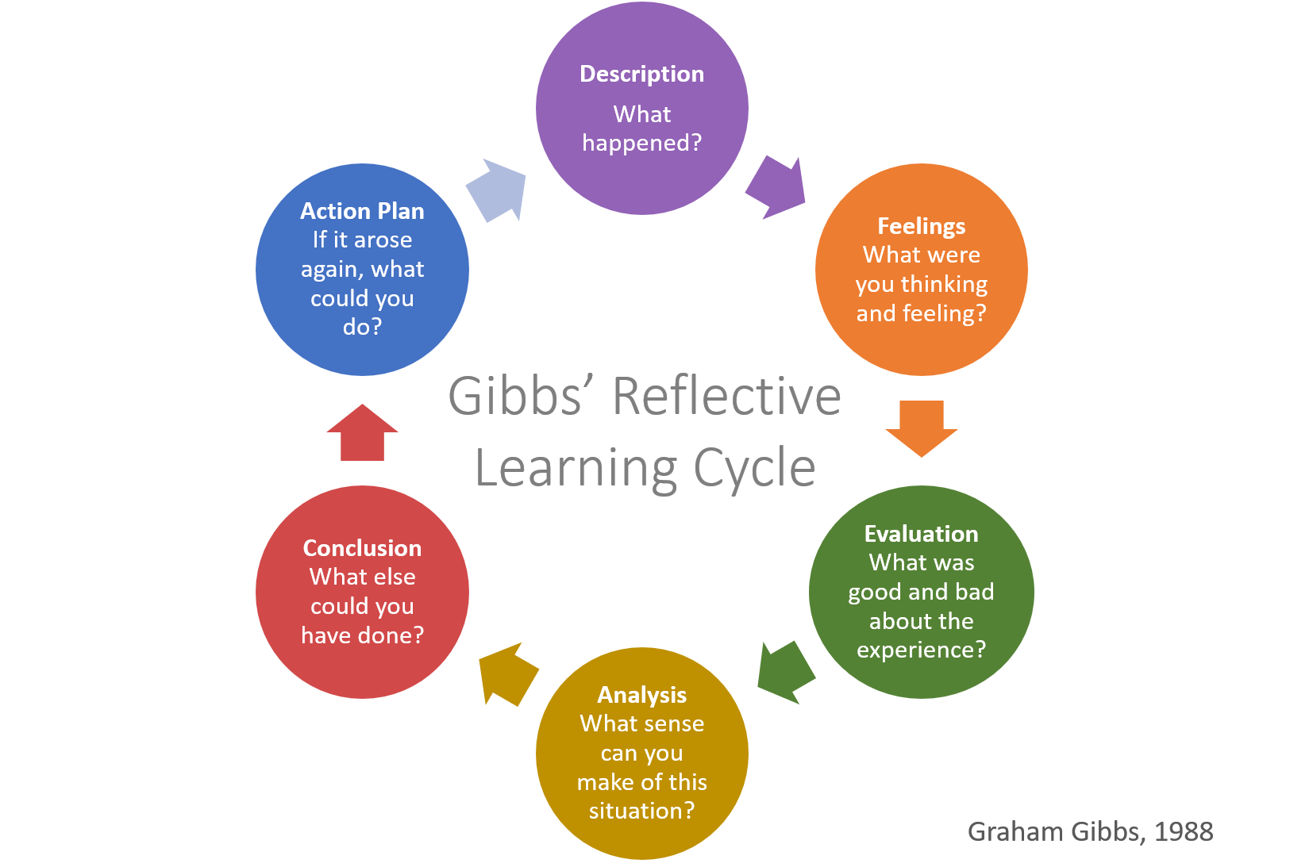

Figure: Gibbs Model
(Source: ED, 2020)

One common strategy for looking back and forward is the Gibbs reflective cycle. It's a six-step procedure designed to encourage introspection and the discovery of personal growth opportunities. The six stages are as follows: introduction, description, feelings, evaluation, analysis, conclusion, and tactics. The cycle provides a systematic format for self-reflection that may be utilised by anybody to learn from their experiences and advance in their careers (Adeani, Febriani and Syafryadin, 2020). The Gibbs reflective cycle has applications for educators, healthcare providers, and anybody else seeking personal growth.

The following is an analysis based on my own experiences:
Description: Miss ANNA acted as the interviewer for the babysitting position, while I played the part of the applicant. The interview was conducted to determine whether I had the skills, qualifications, and experience required for the position. I answered questions about my background and expertise in the interview, as well as my availability, my safety measures, and the interests and activities of the children I would be watching. Miss ANNA asked me pointed questions to find out whether I had the qualifications to be a babysitter, such as how I would ensure the children's safety and deal with conflicts. I gave confident answers to the queries and provided adequate evidence to support her allegations. I improved my communication skills and developed self-awareness about my strengths and weaknesses as a babysitter thanks to the mock interview the coursework conducted. The roleplay interview had two purposes: it assessed my viability as a babysitter and it helped me prepare for future interviews.
The mock interview that we participated in was such a helpful educational opportunity for me. I am going to utilise the six phases of Gibbs' learning cycle in order to conduct a more in-depth study of my experience. These stages are: description, emotions, evaluation, analysis, conclusion, and action plan.
During the roleplay interview session, I posed myself as a candidate for the position of babysitter for Miss Anna. We spoke about my history, my prior babysitting experience, safety precautions, my availability, and the various interests that the children had.
Feelings: Because this was my first time participating in a roleplay interview, I was first apprehensive about it. Nevertheless, as we continued to talk, I started to feel more at ease and gained some self-assurance. I was able to express my opinions clearly and back them up with appropriate examples while answering questions.
Evaluation: I feel confident in saying that I performed a good job during the roleplay interview session. I was able to offer in-depth solutions to the questions, demonstrating both my capabilities as a babysitter and my prior expertise in the field. Having said that, I also came to the conclusion that there were aspects of my performance that may be improved, such as offering more concrete instances to demonstrate my capabilities and expertise.
Analysis: When I think back on the interview, I see that I have a lot of room for improvement in terms of my communication skills, especially when it comes to offering concrete examples to illustrate my capabilities and expertise. I also need to work on my self-assurance when it comes to talking about the things I've accomplished while babysitting.
Conclusion: In conclusion, I have come to the realisation that participating in the roleplay interview was a very beneficial educational experience for me. It provided me with a chance to practise my communication skills while also assisting me in gaining insight into the strengths and flaws that I had as a babysitter.
Action Plan: My aim is to practise giving concrete examples of my talents and experience as a babysitter in order to develop my communication skills. This will be done in the context of being a babysitter. I also want to concentrate on improving my self-assurance while discussing my successes by compiling a list of my accomplishments and practising how to speak about each of them in advance. In addition, in order to bolster my expertise in this subject, I want to do more study on the industry's recommended procedures and precautions for babysitting. Playing the character of Lidia during the roleplay interview session was a very helpful educational opportunity for me. I was able to do an evaluation of my past experiences and pinpoint areas in which I might make improvements by using Gibbs' learning cycle. I have become more certain in my capabilities as a babysitter, and I am dedicated to enhancing both my existing talents and expanding my knowledge in this area.
Skills | How to achieve | Time Span
Improve communication Skill | To further hone my verbal skills, I might attend seminars or read books on the topic. | 2 years
Time management skill | An effective strategy for developing better time management skills is to set goals and deadlines for myself that are realistic and reasonable. | 1 month
Problem Solving Ability | Studying relevant materials or taking relevant seminars might help me strengthen my problem-solving skills. | 6 months
Safety skills | Training sessions and conversations with other carers may help me learn more about and practise safer practises. | 12 months

Skills and knowledge which contribute toward working effectively
Caregivers need several skills and expertise to succeed. First, successful caring requires good communication. Understanding needs and delivering appropriate care requires good communication with children, parents, and other carers. Second, knowing child development and age-appropriate activities is crucial for entertaining and engaging youngsters. Thirdly, scheduling and task completion need time management and organisation. Finally, flexibility and adaptability help with unforeseen events and changes in plans. These abilities and a loving mindset create a happy and productive caregiving environment.

My personal strengths and areas for further development

SWOT ANALYSIS
SWOT ANALYSIS
STRENGHTS  One of my strengths is the clarity with which I can describe myself. I am comfortable interacting with children, their parents, and other carers and can adapt my behaviour accordingly. In addition, I have excellent listening skills, which help me relate to both children and their parents.  Being flexible is one of my many skills. I can bounce back from setbacks and maintain my composure. This ensures that in the case of an unexpected circumstance, I can provide enough care for the children.  I am also very organised and good at keeping track of time. Because I am skilled at prioritising and organising my work, I am able to take care of the kids and meet all of my other responsibilities with ease. | Weakness  A weakness of mine is that I have no previous professional experience in the field of caring for children with special needs. To provide children with exceptional needs the greatest possible care, I have a lot to learn. To do this, I might learn from the advice of seasoned caretakers and enrol in relevant courses.  I also need to work on my very basic verbal skills. I worry that this will hinder my ability to connect with the families of multilingual children. To address this issue, I'm considering taking language classes or utilising a language-learning app.
OPPORTUNITIES  Obtaining more training in child care is an option. I'm thinking of applying for additional babysitting jobs, volunteering at daycares, and maybe even working as a camp counsellor during the summer. I want to use this chance to learn more about child care and become a better provider.  Workshops and seminars on child care are another viable alternative. This will help me expand my knowledge and stay abreast with the latest security and best-practices suggestions. | THREATS  Competition is heating up in the child care industry, which might be bad news. That's why it's crucial for me to maintain developing as a caregiver, so that others may have faith in me.  Another potential hazard arises from the inevitable emergencies and accidents that might occur while caring for children. To handle this, I need to study up on safety rules and emergency procedures, and be prepared to cope with the unexpected.

PERSONAL DEVELOPMENT PLAN
NAME |  | Target Job/career  Example: Teacher, Manager, Business Person

TIME PERIOD | From: | To:

What Skills do I need to achieve my goal?
SKILLS | How Will I get them | What resources or support will I need? | What can prevent me from achieving my goals: (unemployment, illness | How long should it take
Communication Skill | The ability to communicate clearly and effectively is very necessary for any job that requires interaction with children, their parents, or other carers (Stein et al., 2019). I may enhance my communication skills by engaging in active listening practices, using language that is clear and succinct, and training myself to react effectively to a variety of various scenarios. | I may also attend courses or study books on the subject of communication skills to help enhance my abilities. | My anxiousness can cause me trouble in achieving this goal | 2 or 3 years
Time management | Skills are Necessary to Manage my Time Babysitting often requires juggling a number of different jobs and activities at once (Forbes, 2019). I may enhance my ability to manage my time by making a timetable or a to-do list for my duties, and prioritising my chores according to their level of significance and urgency, and learning how to delegate work when it is appropriate to do so. | In order to get better at managing my time, I can also practise creating objectives and deadlines for myself that are attainable and reasonable. | My addiction to social media and tendency to wasting time can cause me trouble in achieving this goal | 1-3 months
Problem Solving | Being a babysitter requires me to cope with a variety of unforeseen circumstances, such as a kid being hurt or a fight breaking out between two youngsters (RCN, 2020). Learn to think critically and creatively, practise brainstorming solutions to future issues, and seek input from other carers or parents to enhance my problem-solving abilities. | Practicing brainstorming solutions to prospective problems may help me develop my problem-solving skills. To further improve my abilities, I might try reading books or attending classes that focus on problem-solving strategies. | My attitude of getting afteraid in the problematic situation can cause me trouble in achieving this | 6 to 8 months
Safety | Abilities in the Area of Safety It is essential for a babysitter to take measures to ensure the safety of the children in their care (Penovich et al., 2021). I may increase my safety abilities by being educated in first aid methods, becoming acquainted with emergency procedures and protocols, and learning how to recognise possible dangers in my surrounding surroundings. | I may also improve my safety skills by attending training programmes specifically geared towards that topic or by consulting with other carers. | Getting afraid and my or inability to manage children can prevent me from learning this ability. | 1 year to 1.5 years

My short - medium – long-term targets for the development of my own professional career plan (using Specific, Measurable, Agreed, Realistic, Time-bound –SMART targets)

Short-term plan (3 -6 months)
Specific | Specifically, in the following three months I want to work more hours in the field of child care.
Measurable | To find two new babysitting gigs per month.
Agreed | I'll look for babysitting jobs in my neighborhood, apply for them, spread the information through word of mouth and social media, and network with families to get more employment.
Realistic | Since there is always a need for trustworthy babysitters in my neighborhood, I should be able to get two new jobs each month.
Time-Bound | I want to enhance my childcare experience by finding at least six new babysitting gigs in the next three months.

Medium-term plan (1-2 years)
Specific | I want to expand my abilities in the field of special needs childcare by participating in relevant courses and training sessions.
Measurable | Attending two special needs daycare courses or training sessions during the next six months is a quantifiable goal.
Agreed | I will look for and sign up for any and all courses or training sessions that are offered in my region or online.
Realistic | Since there are many local and online opportunities, it is feasible for me to attend two seminars or training sessions in the next six months.
Time-Bound | I plan to enhance my knowledge and abilities in special needs childcare by participating in at least two seminars or training sessions over the next six months.

Long-term plan (2-5 years)
Specific | I want to establish myself as a trustworthy and competent carer who often attracts returning customers.
Measurable | get at least five regular customers and get good reviews from them in the following 12 months.
Agreed | I will keep looking for babysitting jobs, taking good care of kids, keeping in touch with their parents, and improving my craft based on their suggestions.
Realistic | There is a need for reliable and capable carers in my area, therefore it is reasonable that I will be able to get at least five regular customers within a year and receive favourable feedback from them.
Time-Bound | Within the next year, I want to establish myself as a trusted and competent carer by securing at least five regular customers and receiving favourable feedback from them.

Conclusion
Finally, I was able to apply what I had discovered during my roleplay interview for the position of probable babysitter to the process of developing short-, medium-, and long-term SMART targets for my professional growth. I mapped out a plan for furthering my education and training in this sector with the use of the Gibbs Reflective Cycle and a SWOT analysis to evaluate how effective I am as a nursery provider and identify my strengths and limitations in that role. I am certain that if I put in the effort and remain committed to my line of work, I will be able to accomplish my goals and become an amazing carer.

References:
Adeani, I.S., Febriani, R.B. and Syafryadin, S., 2020. USING GIBBS’REFLECTIVE CYCLE IN MAKING REFLECTIONS OF LITERARY ANALYSIS. Indonesian EFL Journal, 6(2), pp.139-148.
ED, 2020, “Gibbs' Reflective Cycle”, Available at https://www.ed.ac.uk/reflection/reflectors-toolkit/reflecting-on-experience/gibbs-reflective-cycle#:~:text=One%20of%20the%20most%20famous,analysis%2C%20conclusion%20and%20action%20plan. [Accessed on 8th April 2023]
Forbes, 2019, “Take Your Time Management Skills To The Next Level”, Available at https://www.forbes.com/sites/forbescoachescouncil/2019/04/03/take-your-time-management-skills-to-the-next-level/?sh=19d30e6c4258 [Accessed on 8th April 2023]
Penovich, P., Glauser, T., Becker, D., Patel, A.D., Sirven, J., Long, L., Stern, J., Dixon-Salazar, T., Carrazana, E. and Rabinowicz, A.L., 2021. Recommendations for development of acute seizure action plans (ASAPs) from an expert panel. Epilepsy & Behavior, 123, p.108264.
RCN, 2020, “Handling sibling fights”, Available at https://raisingchildren.net.au/school-age/behaviour/friends-siblings/handling-fights [Accessed on 8th April 2023]
Stein, A., Dalton, L., Rapa, E., Bluebond-Langner, M., Hanington, L., Stein, K.F., Ziebland, S., Rochat, T., Harrop, E., Kelly, B. and Bland, R., 2019. Communication with children and adolescents about the diagnosis of their own life-threatening condition. The Lancet, 393(10176), pp.1150-1163.

Appendix A:
Job application form

Application for [job title] - BABYSITTER
My details

Name :LIDIA REZMUVES

Education and training
Please give details:

I am currently learning how to take good care of children. I am planning to do some courses on child care and development.

Qualifications
Please give details:

I have experience for managing children since I was 13.

Employment history

Your current or most recent employer

Name of employer: Lidia Rezmuves

Job title: Babysitter

Duties:

I have taken good care of the children that I babysit earlier. I used to play with them, feed them, teach them elementary-level rhymes etc.

Previous employers
Please tell us about other jobs you have done and about the skills you used or learned in those jobs.

I have gathered [patience, and I have become comfortable in handling children.

Supporting statement
Please tell us why you applied for this job and why you think you are the best person for the job.

This job can help me support my finance as well as I will be able to be around children, as I love kids.

Right to work in the UK
Do you need a work permit to work in the UK? Yes / No

References
Please give the names and contact details of 2 people who we can ask to give you a reference. We may ask them before an employment offer is made. We will not ask your current employer until we get your permission.

Declaration
I confirm that to the best of my knowledge the information I have provided on this form is correct and I accept that providing deliberately false information could result in my dismissal.

Name: Lidia Rezmuves

Signature: REZMUVES

Date: 08\05\23

