

Assessment Component 1: Marketing Environment Analysis
Selected Company: BHP
Programme: Master of Business Administration (MBA)
Module Name and Code: Marketing Management (LCMB7024)

Assignment Title: Marketing Environment, Strategic Growth and Reflection: BHP’s Transition to Lower-Carbon Products
Lecturer’s Name: Toanga Koanga Sobere-Snithers

Name of the student: Dharmesh Lilabhai Khistariya
Student ID: 2615465
Word count: 2667

Table of Contents
1.0 Task 1: Marketing Environment Analysis 3
1.1 Three external marketing environment actors influencing its transition toward lower-carbon products 3
2.0 Task 2: Strategic Growth and Competitive Positioning 9
2.1 Strategic growth approach for the company using the Ansoff Matrix 9
2.2 Way the organisation can achieve competitive advantage while transitioning to a lower-carbon business mode 12
3.0 Task 3: Managerial and Professional Reflection 13
3.1 Key decisions made throughout this report 13
3.2 Limitations of the analysis 14
References 15

1.0 Task 1: Marketing Environment Analysis

1.1 Three external marketing environment actors influencing its transition toward lower-carbon products
Environment Actor
Climate change, greenhouse-gas emissions, energy use, and the rising demand for transition minerals are significant external marketing actors that influence BHP's transition towards lower-carbon products, making the natural and environmental environment the most important external marketing actor. The scale of the environmental challenge is evident in BHP's FY2025 performance. The company's Scope 1 emissions totalled 7.4 million tonnes (Mt) while Scope 2 emissions totalled 1.3 Mt, resulting in operational emissions of 8.7 MtCO₂-e (BHP, 2025a). This was a decrease from 10.0 MtCO₂-e in FY2024, and was seen as a sign of progress in operational decarbonisation. BHP's operational emissions intensity also dropped, from 1.8 tCO₂-e/tonne copper equivalent production.
Meanwhile, BHP is seizing new market opportunities by being responsive to environmental change. Copper plays a special role due to its demand for electrification, renewable-energy infrastructure and electricity networks. BHP produced record 2.02 Mt of copper in FY2025, an 8% rise from FY2024 and a 28% rise since FY2022 (BHP, 2025b). The price of iron ore was the main driver of BHP's profits, which fell from 13,660 in FY2024 to 10,157 in FY2025, further emphasizing the importance of BHP diversifying into the transition minerals, like copper, as the price of iron ore decreases.
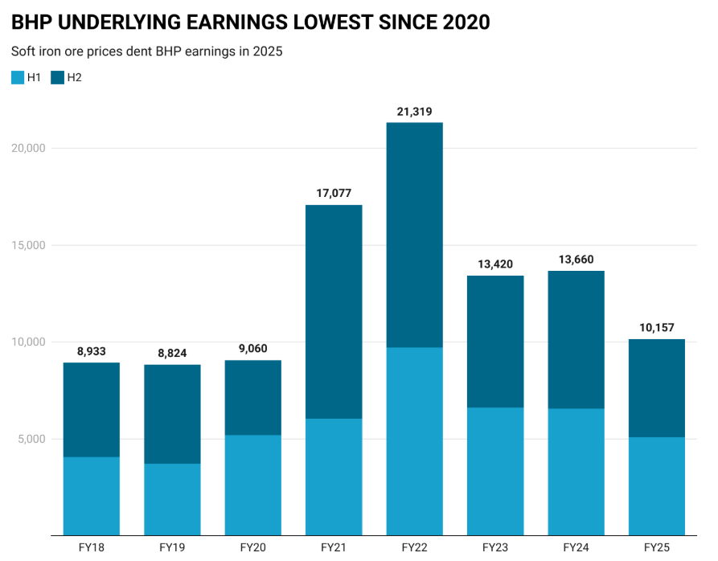
Fig 1: BHP Earnings
Source: (Reuters, 2025)
Another factor of environmental interest is the use of energy. BHP's overall operational energy use declined by 143 petajoules (PJ) in FY2024, to 133 PJ in FY2025, with renewables' share of energy use rising from zero to 28 PJ in FY2025. This suggests that energy efficiency and renewable energy are gaining in significance for BHP's operating model.
The company is also looking at electrification and other technologies that will cut emissions from mining machinery and other energy intensive operations. But the environmental challenge for BHP is great, as the generation of the minerals required for energy transitions can be energy intensive and can also have significant impacts on land, water and biodiversity (BHP, 2025c). Therefore, BHP must make a compromise between the need to increase production and decrease environmental impacts. The environmental strategy needs to be more than just carbon; it's about how responsible they are in using water, protecting biodiversity and being efficient in using resources, which helps to maintain stakeholder confidence and operational continuity.
For marketing, this translates into environmental performance being an ever-greater component of BHP's value proposition. Reducing emissions in operations, increasing use of renewable energy and making full disclosure of environmental reporting can help BHP show it's a more responsible producer of products (BHP, 2026a). This is especially true for industrial customers under pressure to cut down their supply-chain emissions. However, environmental performance is not enough to guarantee competitive advantage as customers also demand competitive prices, quality and reliable supply. On balance, the environmental actor puts pressure and opportunity on BHP: they must both minimise the environmental footprint of its production and enhance the strategic value of its products, like copper. As a result, sustainability is making its way into BHP's positioning and marketing plans (Abbott, 2026).
Political Actor
Government climate targets, critical-mineral policies, energy strategies and international trade relationships are increasingly influencing investment decisions in the mining industry, so the political environment is an important external player affecting BHP's transition to lower carbon products. Australia is one of BHP's key operating bases and the Australian resources industry represents around 22% of national GGHG emissions, making this influence a particular concern for BHP. Consequently, the Australian Government's 2025 Resources Sector Plan both calls for the decarbonisation of the sector and positions Australia as a source of minerals for the global energy transition (IEA, 2025a).
One significant political milestone in 2025 was the adoption of a new emissions-reduction goal for Australia of 62–70% below 2005 levels by 2035, with an existing target of 43% below 2005 levels by 2030. The projected growth of the mining industry from USD 2.16 trillion in 2026 to USD 2.76 trillion by 2030 indicates the rising economic value of the mining industry, alongside a surge in political attention on accessing minerals for energy transition. Also announced by the Australian Government is a $5 billion Net Zero Fund to assist decarbonisation in industry and low-emission manufacturing, along with $2 billion for the Clean Energy Finance Corporation (CEFC). Such policies can also indirectly benefit BHP if they make cleaner electric sources more available, or by incentivizing efforts to deploy technologies that minimise emissions from mining. BHP's transition-mineral portfolio is also being supported by political policy.
The Critical Minerals Production Tax Incentive will offer a 10% tax offset on eligible Australian processing expense, for the period 1 July 2027 to 30 June 2040 (IEA, 2025b). The incentive is not directly for mining or beneficiation but it could provide a greater incentive for increased domestic processing and boost the critical minerals value chain within Australia. This applies to BHP, as copper and other minerals related to electrification are increasingly becoming strategically important, given the increased importance of transition minerals for governments.
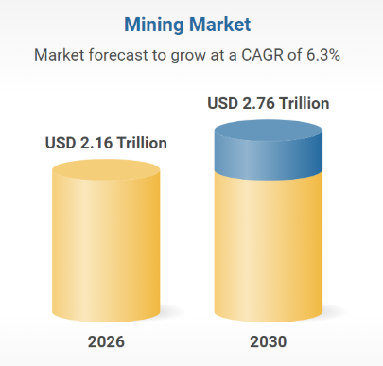
Fig 2: Mining Market
Source: (Research and Markets, 2026)
International political cooperation is also a factor. Australia and the United States agreed in October 2025 to a plan to ensure security of supply of critical minerals. The framework may propose to mobilise both public and private funding and will pinpoint at least US$1 billion of funding for projects in each country in under six months. Geopolitical initiatives can generate opportunities for the Australian mining industry given the potential rise in demand for the supply of minerals that are reliable and diversified.
Political policy, however, also brings uncertainty, as government policies must take into account the competing goals of decarbonisation, employment, energy security, export competitiveness and economic growth (DCCEEW, 2025). BHP's take-home message is that it can be a political choice which investments are more appealing and less expensive. In sum, the political actor generates pressures and opportunities: the greater the political pressure on BHP to reduce emissions, the more pressure on them to meet this target; and Australia's critical-minerals policy can help the growth of commodities that are essential for the energy transition. This highlights the need for BHP to ensure that its lower carbon strategy reflects changing government priorities and has adequate policy sensitivity (Kumar et al., 2026).
Legal Actor
Environmental laws are becoming more stringent, and BHP is being pressured to lower emissions and meet environmental standards, which is an important external driver of BHP's transition towards lower-carbon products. The Safeguard Mechanism covers industrial facilities with a CO₂-e production greater than 100,000 tonnes per year (tpa), including mining facilities, in Australia. The 500 MtCO₂-e of total emissions are expected to drop significantly in the mid-2020s to around 330 MtCO₂-e by 2040, as regulatory pressure continues to build on companies like BHP to cut emissions and meet tougher environmental standards.
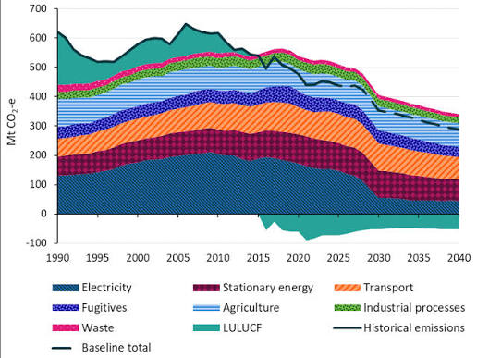
Fig 3: Australia's GHG emissions
Source: (DCCEEW, 2025)
Proposed rules place a legal obligation on covered facilities to cut their emissions by 4.9% each year until 2030, providing an on-the-ground incentive for BHP to invest in renewables, electrification and other lower-carbon alternatives (DCCEEW, 2026). The cost of complying with the law is also rising. The Safeguard Mechanism's default prescribed unit price for 2025–26 was A$36.99 per tonne of CO₂-e, up from A$36.05 per tonne of CO₂-e in 2024–25. This can help reduce the potential for non-compliance with emissions limits and enhances the business argument for the need for long-term emissions reductions. BHP's FY2025 reporting is another one that highlights the importance of environmental law. The company recorded seven environmental fines of US$8.066 million at its operated assets in FY2025 (DISR, 2026a). This shows that there is a direct financial and reputational impact if environmental non-compliance occurs.

2.0 Task 2: Strategic Growth and Competitive Positioning

2.1 Strategic growth approach for the company using the Ansoff Matrix
Market Penetration – Existing Products, Existing Markets
BHP can use existing copper and iron ore businesses to gain market share through expanding the scale, efficiency and the value of these operations in the current markets. This is a relatively low-risk approach as there is a potential to leverage existing mines, infrastructure and customer relationships of BHP. BHP also saw a record 2.0 Mt of copper production in FY2025, more than a third higher than three years earlier, and Western Australia Iron Ore produced a record 257 Mt of iron ore. BHP also has a WAIO production target of over 305 Mtpa in the medium-term (DISR, 2026b).
The company can then expand its market penetration by enhancing the productivity of the mines, decreasing emissions during production and fostering stronger ties with current customers. This is especially true in the lower-carbon growth area, since BHP can provide environmental value to existing products without having to go into new markets (Herlina et al., 2025). The strategy should be based on bringing together greater productivity, consistent supply and lower emission production to maintain their customers and to enhance BHP's competitive position.
Product Development – Lower-Carbon Mineral Products
Product development is very relevant as BHP can improve its current copper and iron ore products with lower carbon production, emissions measurement and customer-centric environmental information. BHP's copper production for FY2025 surpassed 2 Mt for the first time, offering a large existing product base to build upon to create further environmental value (Scott, 2025).
This opportunity is further enhanced by the IEA's 2025 assessment, which calls for a global copper demand to grow by about 30% by 2040 in its Stated Policies Scenario. BHP is therefore able to build a differentiated proposition based on reliable minerals which produce fewer emissions than other minerals and have increased environmental transparency. Similarly the ability to work with steelmakers to reduce the emissions in the processing stage can help add value to its iron ore. Product development is a key part of BHP's future, lower carbon growth model, as this approach enables them to navigate environmental pressures while maintaining their existing markets (Karbovska et al., 2026).
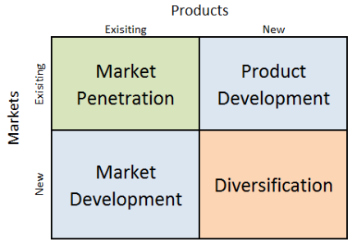
Fig 4: Ansoff Matrix
Source: (Research Methodology, 2026)
Market Development – Expanding Copper into New Growth Markets
Market development is when the same products are introduced to new geographic areas or new customer groups. The electrification, extension of electricity-grid and industrial equipment is increasing demand for copper, which offers BHP a solid opportunity. IEA projects that announced mining projects would be responsible for a 30% copper supply shortfall by 2035 and around US$500 billion in new mining investments would be needed around the world between now and 2040 under the Stated Policies Scenario (Teshayev and Khaydarov, 2026). BHP can react by increasing its copper footprint in markets associated with renewable energy, electric vehicles, electric power and data centres. One of the most notable examples of this is its 2025 acquisition of the 50:50 Vicuña joint venture with Lundin Mining, which involved BHP investing the equivalent of US$2.0 billion in cash. Market development can then develop BHP's visibility to new markets for copper demand and help BHP's transition to minerals linked with electrification (Widhagdha and Murtiyoso, 2025).

Diversification – Potash as a New Growth Business
Diversification is the introduction into new products and new markets which is the riskiest of the Ansoff options. BHP's Canadian potash business, Jansen, is a good example of this approach since potash is significantly different than the area's traditional iron ore and copper operations. In August 2025, BHP announced that it had increased the capital expenditure for Jansen from US$5.7 billion to US$7.0-7.4 billion, with the first production expected by mid-2027 (Scott-Irving, 2026). The earnings drop from 13,660 in 2024 to 10,157 in 2025 illustrates the benefit of BHP's potash diversification, with Jansen being able to offer a new revenue stream and lessen reliance on more traditional commodities like iron ore. But the high capital outlay is an illustration of the importance of properly managing diversification. For BHP, it should be alongside not in place of a more robust focus on productivity and lower-carbon copper production (Nugent-Young, 2024).
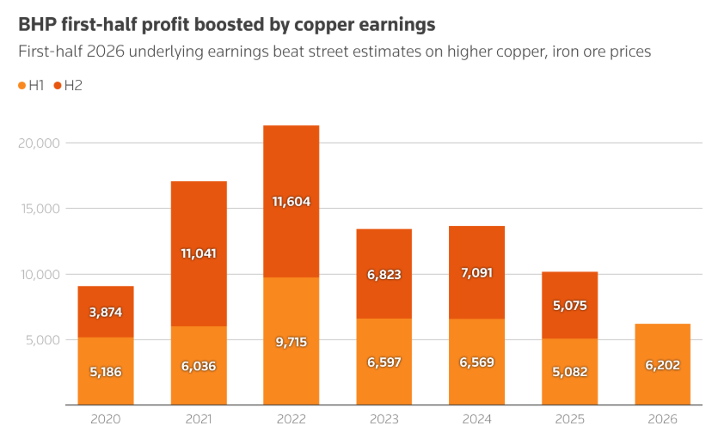
Fig 5: BHP profit boost-up
Source: (Reuters, 2026)

2.2 Way the organisation can achieve competitive advantage while transitioning to a lower-carbon business mode
BHP has the potential to gain a competitive edge with its operational efficiency, low-carbon production, innovation, and responsible use of resources. Investing in renewable energy, electrification and energy-efficient technologies can help lower emissions and operating costs and enhance its environmental brand (Ravoof et al., 2025). BHP's ability to distinguish themselves in copper and iron ore is also through clear emissions reporting, responsible sourcing and reducing carbon emissions during production, all of which are increasing customer demand for sustainable materials. Higher copper demand for renewable energy, EV's and electricity infrastructure. Further, strategic partnerships with customers and technology suppliers can help speed up decarbonisation. The mix can help reinforce BHP's position in the market and help its decarbonisation efforts (Toscano, 2024).

3.0 Task 3: Managerial and Professional Reflection

3.1 Key decisions made throughout this report
When presenting the report to senior leadership I would explain that BHP was chosen as it is a sizeable organisation, operates in a global environment and is exposed to the energy transition, making it a suitable organisation to explore the transition towards a lower carbon business model. The list of the environmental, political and legal actors was determined by those who have a direct impact on BHP's operations, costs, reputation and strategic decisions. Climate change, emissions reduction and increasing demand for transition minerals were of particular importance to the environmental actor, as they directly impact BHP's long-term business model.
The Ansoff Matrix was chosen as it offers a structured approach for analysing various growth opportunities. Market penetration boosts performance in its current minerals business, and product development enables BHP to generate more value with low carbon production. Market development offers opportunities to tap into markets driven by electrification and renewable infrastructure (Bartholomeusz, 2024). Potash is an opportunity to diversify BHP's traditional commodity portfolio, and the company's investment in potash is expected to take a significant bite out of its capital expenditure. BHP's potash investment will likely be a major contributor to its capital expenditure, and diversifying into potash is an opportunity to expand BHP's investments beyond its traditional commodities.
One of the main findings of the analysis is that transitioning to a lower carbon model requires balancing environmental obligations with profitability while being operationally reliable and growing in the long-term. Certain strategic choices involve high investment, and are uncertain, so senior leadership should weigh financial considerations with environment and market considerations.
Further information would be sought if it were possible, on customer preferences, competitor decarbonisation strategy, carbon related costs, future commodity demand, technology investment needs and financial returns for each growth opportunity. This would allow for better informed strategic decisions as well as a better evaluation of BHP's competitive position over the long term.

3.2 Limitations of the analysis
One of the drawbacks to this analysis is that the secondary information used is largely publicly available, and as such may not necessarily be a true reflection of BHP's internal resources, customer relationship or future investment plans. Limited information is also available about confidential customer requirements, competitor strategies and commercial costs of transitioning to lower-carbon production from public reports. Furthermore, commodity prices and government actions and technologies may fluctuate quickly and in unpredictable ways. The analysis is also primarily centred around environmental, political and legal actors, as economic conditions, technological disruption and changes in customers' behaviour may also impact BHP's strategy.
A real consultant would take a variety of financial information internally, detailed costs of the carbon reductions, customer preferences, competitor information and projected demand for copper, iron ore and potash before making recommendations. Availability of renewable energy, technology readiness, regulatory scenarios and expected returns from larger capital investments would be useful information to have as well. Other stakeholder interviews with customers, employees, suppliers, government and industry experts may give further qualitative insights (Lagrotta, 2025). This would enable senior leadership to make more informed decisions about the proposed growth strategies, considering the feasibility, risks and potential returns.

References
Abbott, M., (2026). A Renaissance: The 1990s and 2000s. In Australian Steel in a Globalised World: From 1964 to (2024) (pp. 137-154). Singapore: Springer Nature Singapore.
Bartholomeusz, S., (2024). Diamonds for sale: Inside the plan to crash BHP’s $64 billion party. The Age (Melbourne, Australia), pp.NA-NA.
BHP (2025a) 2025 Annual Reporting Suite. Available at: https://www.bhp.com/news/media-centre/reports-presentations/2025/08/2025-annual-reporting-suite
BHP (2025b) BHP results for the full year ended 30 June 2025. Available at: https://www.bhp.com/es/news/media-centre/releases/2025/08/bhp-results-for-the-full-year-ended-30-june-2025
BHP (2025c) Annual Report 2025. Available at: https://www.bhp.com/-/media/documents/investors/annual-reports/2025/250819_bhpannualreport2025
BHP (2026a) Transition to a Net Zero Economy. Available at: https://www.bhp.com/sustainability/climate-change/transition-to-a-net-zero-economy
Department of Climate Change, Energy, the Environment and Water (DCCEEW) (2025) Australia’s emissions projections 2025. Australian Government. Available at: https://www.dcceew.gov.au/climate-change/publications/australias-emissions-projections-2025
Department of Climate Change, Energy, the Environment and Water (DCCEEW) (2026) Safeguard Mechanism. Australian Government. Available at: https://www.dcceew.gov.au/climate-change/emissions-reporting/national-greenhouse-energy-reporting-scheme/safeguard-mechanism
Department of Climate Change, Energy, the Environment and Water (DCCEEW) (2025) Australia’s emissions projections 2025. Canberra: Australian Government. Available at: https://www.dcceew.gov.au/sites/default/files/documents/australias-emissions-projections-2025.pdf
Department of Industry, Science and Resources (DISR) (2026) Critical Minerals Production Tax Incentive. Australian Government. Available at: https://www.industry.gov.au/mining-oil-and-gas/minerals/critical-minerals/critical-minerals-production-tax-incentive
Department of Industry, Science and Resources (DISR) (2026) Critical minerals. Australian Government. Available at: https://www.industry.gov.au/mining-oil-and-gas/minerals/critical-minerals
Herlina, H., Sulastri, N.M. and Wahyuni, T., (2025). Pelatihan Kewirausahaan" Inovasi dan Kreativitas dalam Bisnis Deterjen: Peluang Usaha Untuk Warga Lokal" di Perumahan BHP. Jurnal Dedikasi Madani, 3(2), pp.70-77.
International Energy Agency (IEA) (2025a) Global Critical Minerals Outlook 2025: Overview of outlook for key minerals. Available at: https://www.iea.org/reports/global-critical-minerals-outlook-2025/overview-of-outlook-for-key-minerals
International Energy Agency (IEA) (2025b) Copper. Available at: https://www.iea.org/reports/copper-2
Karbovska, L., Shuliar, N., Bratus, H., Kalina, I. and Kryshtal, Н., (2026). Marketing strategic planning of enterprises in the mining sector of the Ukrainian economy. Naukovyi Visnyk Natsionalnoho Hirnychoho Universytetu, 2, pp.224-231.
Kumar, S., Saha, S. and Ghosh, D., (2026). Bridging responsibility and survival: An Integrated conceptual framework of stakeholder and legitimacy theories in modern accounting disclosure. EDPACS, pp.1-14.
Lagrotta, L.C.N., (2025). The Perfect Storm of Transnational Enforcement: Litigation Funding, Foreign Forums and Severe Substantive Law in the Mariana v BHP Case. Foreign Forums and Severe Substantive Law in the Mariana v BHP Case (November 21, (2025)).
Nugent-Young, C., (2024). Cash-settled equity swaps and market distortions. COMPANY AND SECURITIES LAW JOURNAL, 40(6), pp.339-344.
Ravoof, A., Gogoi, U. and Bruzco, A., (2025), October. Automated Well Management for Underground Gas Storage (UGS) Systems. In SPE Annual Technical Conference and Exhibition (p. D021S011R004). SPE.
Research and Markets (2026) Mining Global Market Report 2026. Available at: https://www.researchandmarkets.com/report/mining
Research Methodology (2026) Microsoft Ansoff Matrix. Available at: https://research-methodology.net/microsoft-ansoff-matrix/
Reuters (2025) ‘Iron ore sinks BHP FY profit to 5-year low but dividend boosts shares’, Reuters, 19 August. Available at: https://www.reuters.com/world/china/iron-ore-sinks-bhp-fy-profit-5-year-low-dividend-boosts-shares-2025-08-18/
Reuters (2026) ‘BHP profit beats forecasts as copper tops iron ore earnings on AI-driven demand’, Reuters, 16 February. Available at: https://www.reuters.com/business/bhp-group-reports-22-growth-first-half-profit-2026-02-16/
Scott, G.A., (2025). The rise, fall and resurgence of BHP: dynamic capabilities in a leading resource company (Doctoral dissertation, Murdoch University).
Scott-Irving, E., (2026), September. A region in transition: BHP prepares for the closure of Mt Arthur Coal mine. In Mine Closure (2026): Proceedings of the 19th International Conference on Mine Closure (pp. 1-12). Australian Centre for Geomechanics.
Teshayev, B.B. and Khaydarov, O., (2026). THEORETICAL AND METHODOLOGICAL FOUNDATIONS FOR THE DEVELOPMENT OF GREEN PROCUREMENT MARKETING IN INTERNATIONAL INDUSTRIAL ENTERPRISES. PORTUGAL-SCIENTIFIC REVIEW OF THE PROBLEMS AND PROSPECTS OF MODERN SCIENCE AND EDUCATION, 1(17), pp.4-12.
Toscano, N., (2024). BHP may need to pay more to clinch Anglo American in copper mega-deal. The Age (Melbourne, Australia), pp.NA-NA.
Widhagdha, M. and Murtiyoso, M., (2025). Environmental Management Assessment Scheme (EMAS): Addressing the challenges of environmental, social, and economic performance assessment for industry in Indonesia and its opportunities to become a novel standard in ASEAN and Australia. Social, and Economic Performance Assessment for Industry in Indonesia and Its Opportunities to Become a Novel Standard in ASEAN and Australia (November 10, (2025)).

