E-Portfolio
https://alexandruportfolio.000webhostapp.com

Dr. Aliyu Sambo

Crucianu Mircea Alexandru
Table of Contents
Create a mind map using Online Mapping technology. 3
Figure 1 Mind Map --using MindNode— 3
Ideation 4
Project Poster and Chart 5
Figure 2 Project Poster 5
Project Management 6
Figure 3 Gantt Chart 6
Figure 4 Project Management 7
Bibliography 8

Create a mind map using Online Mapping technology.

We can clearly state that the Mind Mapping technique is a clear way to handle any situations where notes will be typically taken and here, we can add some errors, such as [1]:
- Reading longer texts, or having long ideas makes notes to be taken on several pages.
- Linear notes will follow the same steps (chronological) it will not include phases. [2]

As we will want to improve the Mind Mapping, according to the requirements we can also mention this mind map software: [3]

- Google as a beginner is the recommended software to use when using the Mind Mapping Technique;
- MindMeister is allowing teams to brainstorm ideas;
- Anyone for an effective and highly mind mapping;
- MindNode is the software that is available for Apple users for mind mapping;
- XMind 2022 is for personal use for brainstorming;

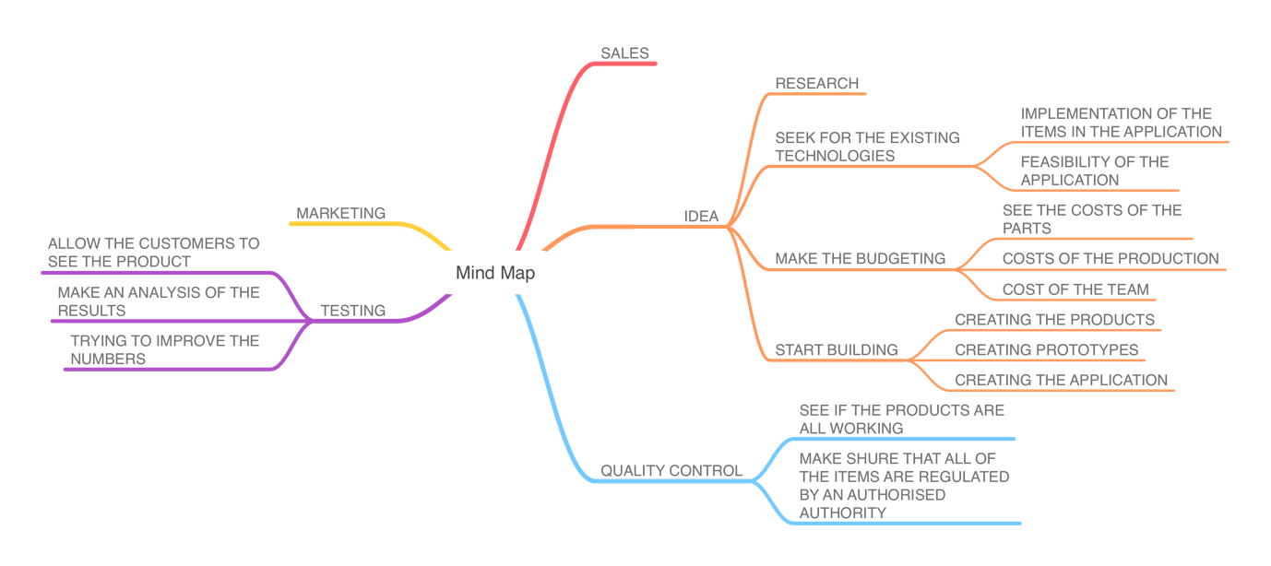

Figure 1 Mind Map --using MindNode—

Research – in this phase we can add more elements such as:
- Focusing on the topic
- Individual or group research
- Keeping my research diary
- Thinking of the methods
- Case studies [4]

Budgeting is a summary of distributed costs from the cash flow or from the external capital from the investors that are specifically used on a pre-defined period. The budgeting must be done after a clear forecast of the costs, time, and income.

Ideation
a) Clearly state, describe, and illustrate your project idea.
The project idea that I’ve chosen is making it possible to travel without having difficulties hitting objects. The idea came after analyzing the need and the demand.
What is determining to choose this project is the utility of the software that will be used by some people that are low morals and are feeling left outside.
The project is based on a pair of sunglasses with a speaker and microphone that will be connected in real-time with an application through a mobile phone. The application will tell people where they can find certain things, after recognizing them from the pictures and setting a geolocation tag for them.
This will be possible by having the picture in a cloud-based hard drive and after mapping the location, guiding the person precisely to the spot where they can find the object.
b) Document how you intend to use this opportunity to develop new Computing Skills.
Having this opportunity to develop this software and application I think that will improve my Computing Skills, after working with AI, Cloud-based applications, and new products that are on the market.
c) Consider and state your project/new skills could have a positive impact on and contribute to society.
As mentioned above the project will have a positive impact on people that are in need, it will help them to have support when they have difficulties, and we know that since the stone age having a tool will improve our confidence and time.

Project Poster and Chart
- Project Planning – Pressing this link will automatically direct you to the Cloud for viewing the Poster for this Project.
https://uowtsd-my.sharepoint.com/:b:/g/personal/2025870_student_uwtsd_ac_uk/EV_3P8xpzYhOlQk1sMEASTABOe2SWl3SNYEFSDHjXwaAJw?e=VD7O0U

Posters are frequently utilised in academia, and most conventions include poster presentations as part of their agenda. To assist advertise and encourage conversation, research posters present information or findings in a succinct and appealing manner.

A poster is often composed of a brief text interspersed with tables, graphs, photographs, and other presentation types. At a conference, the investigator stands near the poster display so that other attendees may see the presentation and engage with the author. [5]

Figure 2 Project Poster

Project Management
For the Gantt Chart please click on the next URL:

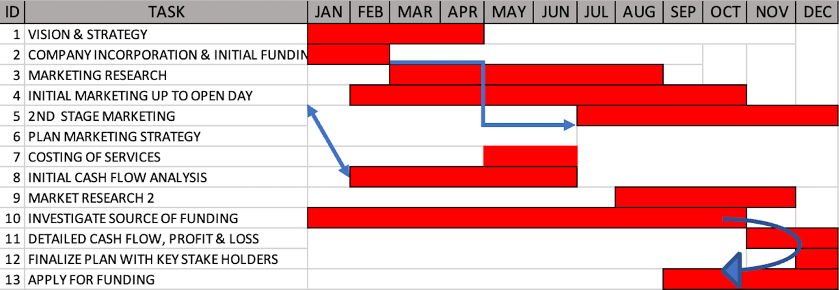

Figure 3 Gantt Chart

https://uowtsd-my.sharepoint.com/:i:/g/personal/2025870_student_uwtsd_ac_uk/EQwBhPXkwjBOmVGrDMZVt5YB4BrKKFiSAPytWRLH-LSTJw?e=BQTDEz

- Valuable knowledge should be visible from around 10 feet away.
- The title is brief and intriguing.
- A word count of 300 to 800 words
- The text is concise and to the point.
- The use of bullets, numbers, and headings makes it simple to read.
- Graphics, color, and typography are used effectively.
- The arrangement is consistent and neat, and it includes acknowledgments, your name, and your institutional affiliation.

The timeframe for the project is shown from across top of the Gantt chart. Tasks are shown as crossbars that cover the whole length of time required.
- Stakeholders in charge of each job
- Task interdependence (often shown with an arrow between taskbars)
- Task duplication (displayed by taskbars that run on top of each other during the same span of time)
Regardless of the additional information you provide, a Gantt chart is a straightforward and understandable depiction of your project's activities, the sequence in which they occur, and the time required to complete them. [6]

Figure 4 Project Management

Bibliography

[1] | T. Buzan, Mind Map Mistery: The Complete Guide to Learning and Using the Most Powerful Thinking Tool in the Universe, Watkins Medial Limited, 13/March/2018.
[2] | "Open House," [Online]. Available: https://warwick.ac.uk/fac/soc/al/globalpad-rip/openhouse/academicenglishskills/reading/note/example1/. [Accessed 25 October 2022].
[3] | H. Guinness, "The best mind mapping software in 2022," Zapier, 22 June 2022. [Online]. Available: https://zapier.com/blog/best-mind-mapping-software/. [Accessed 25 October 2022].
[4] | C. H. M. T. Loraine Blaxter, How to Research, UK: McGraw-Hill Education, 2010.
[5] | N. Libraries, "How to Create a Research Poster," NYU Libraries, [Online]. Available: https://guides.nyu.edu/posters. [Accessed 15 11 2022].
[6] | MIRO, "What is a Gantt chart?," Miro|Blog, [Online]. Available: https://miro.com/blog/what-is-a-gantt-chart/?utm_source=google&utm_medium=cpc&utm_campaign=S%7CGOO%7CNB%7CUK%7CEN-EN%7CPareto-DSAV2&utm_adgroup=&adgroupid=135990198454&utm_custom=17390391082&utm_content=601624388775&utm_term=&matchtype=&device=c&location=. [Accessed 15 11 2022].

