Dear 2nd years – tasks for Anna

This afternoons plan will be tricky to teach as you do not have a plotter and laser cutter in your homes….well at least I’m guessing you don’t!

Do not fear! Let’s use this strange time as an opportunity to rethink and creatively challenge ourselves. You can of course keep researching, drawing, sewing, writing but let’s think of other ways in which this might actually be a good thing.

You suddenly find yourself with minimum distraction, you have more time, that means you can think and actually FOCUS. I feel focus can be really hard to achieve in such busy stressful times, our lifestyles are too fast, too overloaded. Let’s see this isolation time as a creative gift where you will emerge with some beautiful drawings, ideas, imagery, made pieces. Put away the social media and the phone, turn off the tv, get some music on, or an audio book, and calmly focus on what you would like to achieve……

We are creatives! designers and makers are problem solvers and there are studies to say that under limitations or restrictions we are at our most creative. Let’s use that power! Our own homes are full of things we can use to create work with (don’t steal your parents bed sheets before you start cutting them up though for a masterpiece!)

Let’s start with something simple that will allow you to refocus on your project.

I have 2 pin tasks for you – “put a pin in it” as in ‘pause’… the world is just on pause, it’s time to think and reset.

- Start a Pinterest board that is focused on embellishment and detail. Elements that might make a piece of textile very special, it might be stitch, sequins, objects fused with fabric, cuts outs, patchwork, quilting. ‘The devil is in the detail’. It is more than a flat surface it is the beautiful hand touch, the sense of the human being in the work, the sense of something that has labour in it and therefore skill, it becomes special. You might want to imagine you are projected back in time, to the limitations of no machinery, digital printers, screen printers… what is possible in these limitations? how innovative and resourceful can you become? Looking at historical details and techniques might be interesting here?
Maybe make your board private so it is only visible to your tutors? Send us the link.
Make sure you use it for Major A4 self-directed briefs and you can fit it to your
chosen context.

To start you off on this investigation I would like to share one of my boards with you – it’s called ‘details’….look under my Pinterest Anna Lewis jewellery, there are 1000 pins…. Don’t say you can’t find anything haha!

https://www.pinterest.co.uk/annalewisjewel/details/
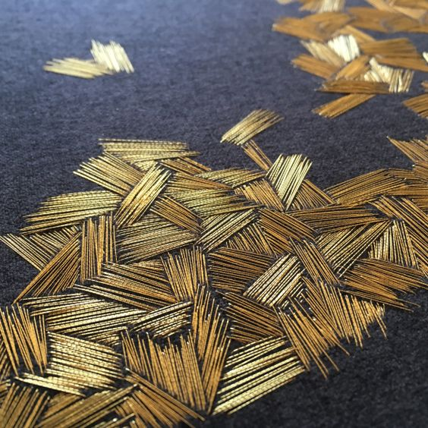

Most of you would have seen the recent Alexander McQueen collection – the one inspired by quilts and collections at St fagans? Investigate this, the imagery, the details, the techniques all refer back to these historical hand skills. Fusing both interior fabrics with a fashion context. Expand on this research in your own area of interest.

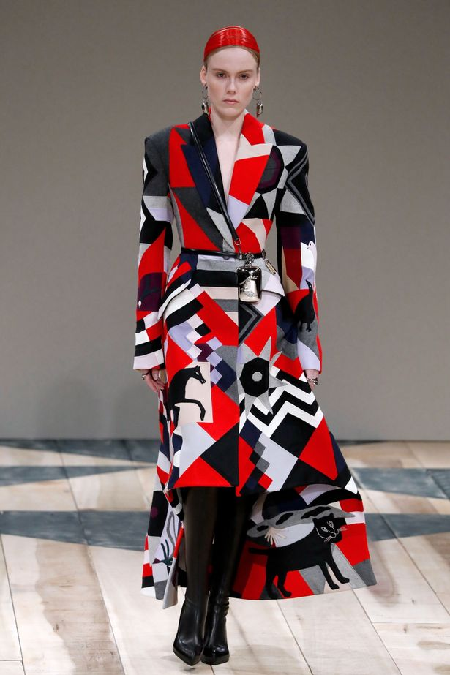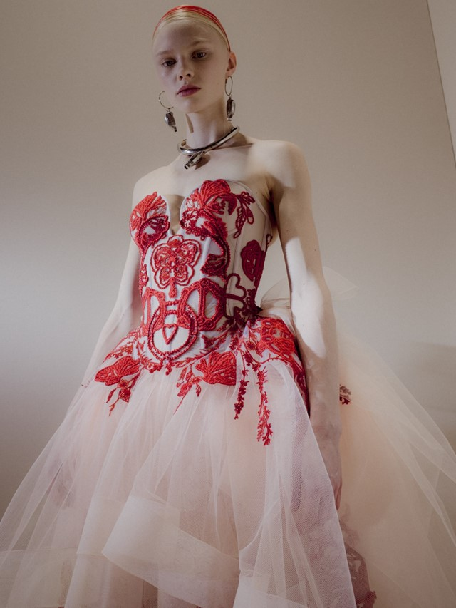

Have fun, be inspired!
Part 2 pin task – will be sent next week…. This week its digital pin, next it’s a real pin!

Anna

