86
Amalia-Carmen Filimon Student number: 2245302 Date: 06 of November 2024

Lecturer: Philippa Fitzgerald
University of Wales Trinity Saint David

Digital Skills for Personal and Professional Growth
(E-Portfolio)
Contents
1.Storytelling 2
2.5 minutes video record 4
3. Questionnaire Analysis 4
4. Website and marketing materials 7
5.Reference list: 10
6. Appendices 12

1.Storytelling

Storytelling is the interactive art of using words and actions to reveal the elements and images of a story while encouraging the listener's imagination (Choo et al., 2020). It is a social and cultural activity that involves sharing narratives, sometimes with improvisation, theatrics, or embellishment (Reason and Heinemeyer, 2016).
Telling stories is a powerful way to make people remember you or your company. It's not just about giving facts. It's about sharing interesting tales that make people feel something. When you tell good stories, people start to care about you or your brand (Kurtz, 2009).
For people trying to make a name for themselves, stories help show who they are. They can talk about things they have done, problems they have faced, and what they have learned. This helps them stand out from others. It shows why they are special and what they are good at. When you share your own story, people can see your journey and understand what makes you unique (Gupta and Jha, 2022).
For large companies, stories make them seem more human. When a company tells stories, it is easier for people to like and remember them. It is not just a faceless business anymore. It becomes something people can relate to. Stories can show what a company believes in and why it does what it does. This helps people feel connected to the company (Denning, 2002).
A good example of this is what IKEA did. IKEA is a company that sells furniture. They started something called "The Wonderful Everyday" to tell their story. This was a smart move that shows how telling stories can make people like a brand more.
IKEA's idea was to focus on small, everyday moments that make life nice. This fits well with what IKEA wants to do - make everyday life better for lots of people. They made short videos that showed how IKEA's stuff can make these everyday moments even better. These videos were not just about selling furniture. They were about showing how IKEA understands what is important in people's lives. The story resonates on multiple emotional levels. It evokes a sense of familial love and connection, highlighting the bond between father and son. The boy's determination to stay awake and greet his father tugs at the heartstrings, creating a poignant moment that many viewers can relate to (Mashup Communications, 2022).
By focusing on this intimate family moment, IKEA successfully shifts the narrative from mere product promotion to storytelling that touches the core of human emotions (Ardath, 2015).
This approach aligns with IKEA's broader marketing strategy of creating emotional connections with their audience. It showcases their understanding that a home is more than just a collection of furniture - it's a space where life happens, memories are made, and relationships are nurtured.
The video's impact extends beyond just promoting products. It reinforces IKEA's brand image as a company that understands and values family life. This emotional resonance helps to build brand loyalty and encourages viewers to see IKEA as more than just a furniture retailer, but as a partner in creating meaningful living spaces (Ardath, 2015).
This way of telling stories works well because it makes people feel something. IKEA is not just talking about tables and chairs. They are talking about the nice moments in life that happen around these things. This helps people connect with IKEA more. When people watch these stories, they might think, "Hey, that's like my life!" This makes IKEA feel more like a friend who understands them, not just a store trying to sell things.
The stories also show what IKEA believes in. IKEA wants to make simple, cheap, and earth-friendly furniture. The stories show how IKEA's stuff fits into normal life and makes it better. This reminds people what IKEA stands for. It is not just about buying furniture, it is about improving your life in small but meaningful ways.
Telling stories this way has been really good for IKEA. More people know about IKEA now. People who already knew IKEA like it even more. By keep telling stories that make people feel good and that match what IKEA believes in, they have made their brand stand out. In a world where lots of companies sell furniture, IKEA is remembered. People do not just think of IKEA when they need a new table. They think of IKEA when they think about making their home a better place (IKEA,2024).
So, whether you are trying to make a name for yourself or running a large company, telling stories is important. Good stories make people remember you. They make people care about you. And in the end, they make people want to support you or buy from you. Stories can do what plain facts cannot, they can touch people's hearts and stick in their minds (Peterson and Boris, 2017).
Effective storytelling is fundamentally about forging connections. It enables people to understand and empathize with individuals or brands on a deeper level. When stories are well-crafted, they transcend the mere promotion of products or services; they offer a glimpse into the essence of the storyteller. By inviting audiences to become part of a larger narrative, storytelling creates a sense of belonging and fosters long-term engagement. This approach taps into emotions and shared experiences, resonating with listeners in ways that facts and figures alone cannot (Slabunova, 2024).
Authentic, relatable, and compelling narratives serve as bridges between brands and consumers, laying the groundwork for enduring relationships built on trust and loyalty. Furthermore, powerful storytelling has the capacity to inspire action, challenge perspectives, and drive meaningful change. In a world inundated with information, a well-told story stands out, cutting through the noise to leave a lasting impression on its audience. Ultimately, storytelling is not just about selling; it is about sharing, connecting, and creating a community around a shared vision or experience (Kadembo, 2024).

2.5 minutes video record

https://www.canva.com/design/DAGJ_6uJJtA/OS-XzkVwfV5femen0zxqng/view?utm_content=DAGJ_6uJJtA&utm_campaign=designshare&utm_medium=link&utm_source=recording_view

3. Questionnaire Analysis

A questionnaire was distributed to gather insights on Bristol Breeze Taxis. A total of 16 participants responded, providing valuable data for analysis.

Questionnaire link:
https://forms.office.com/Pages/ResponsePage.aspx?id=-REPTm4EBUWcuNshUjEeIc3YRH2pif1IrjIo-4SIdzhUMjc0S0hUNExVSk1aN0lQTlhEVFI4WDBFUy4u
Question 1:
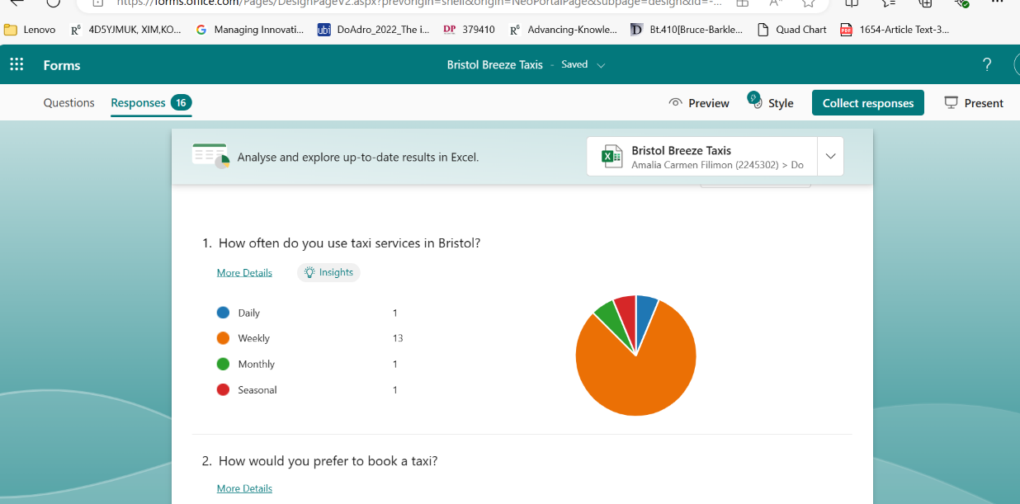

The analysis of taxi usage patterns reveals significant insights that can inform the strategic development of Bristol Breeze Taxis. The predominance of weekly users (respondents) suggests a robust market for regular taxi services, aligning with research by Cramer and Krueger (2016) that indicates the importance of frequent users in sustaining taxi businesses. This trend could be leveraged through the implementation of subscription models or loyalty programs. The presence of daily users (1 respondents) represents a high-value segment that could benefit from premium services, a strategy supported by Chen et al. (2015) in their analysis of taxi service differentiation. Monthly (1 respondents) and seasonal (1 respondent) users present opportunities for targeted marketing and specialized services, such as event-specific transportation packages. To capitalize on these insights, Bristol Breeze Taxis should consider developing a user-friendly booking system, implementing a tiered loyalty program, and offering flexible pricing models, all of which have been identified as key factors in taxi service competitiveness (Rayle et al., 2016). Additionally, investing in a reliable fleet and offering specialized services for different user segments could help Bristol Breeze Taxis differentiate itself in the market. By aligning its services with these usage patterns and implementing targeted strategies, Bristol Breeze Taxis can position itself as a versatile and customer-centric service provider in Bristol's competitive transportation market.
Question 2
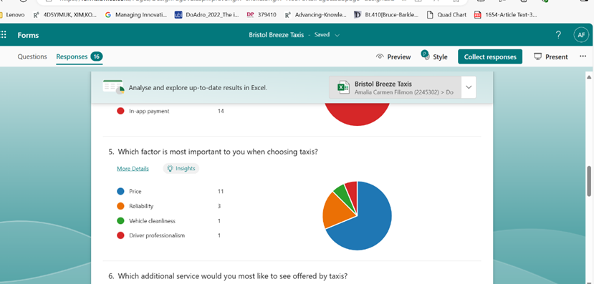

Price was the most important factor, with 11 respondents considering it crucial. This suggests that while customers value reliability, they are also price sensitive. The company should strive to offer competitive pricing while maintaining service quality. Implementing a dynamic pricing model or loyalty programs could help balance affordability with profitability.
Reliability emerges as the cornerstone of customer satisfaction in the transportation industry (Kritikos et al., 2013) with 3 out of 16 respondents prioritizing these factors when selecting a service. This underscores the critical importance of dependable transportation for passengers, who rely on taxis to reach their destinations on time. This indicates that customers highly value dependable and punctual service. Bristol Breeze Taxis should focus on enhancing its reliability by implementing efficient dispatch systems, GPS tracking, and driver performance monitoring to ensure timely pickups and arrivals. Bristol Breeze Taxis should focus on enhancing its reliability by implementing efficient dispatch systems, GPS tracking, and driver performance monitoring to ensure timely pickups and arrivals.
Vehicle cleanliness was important to 1 respondent, indicating that a segment of customers values hygiene and comfort. Regular vehicle maintenance and cleanliness checks should be implemented to meet these expectations.
Driver professionalism, although only chosen by 1 respondent, should not be overlooked. Investing in driver training programs to improve customer service skills and professional conduct could differentiate Bristol Breeze Taxis from competitors.
Question 3
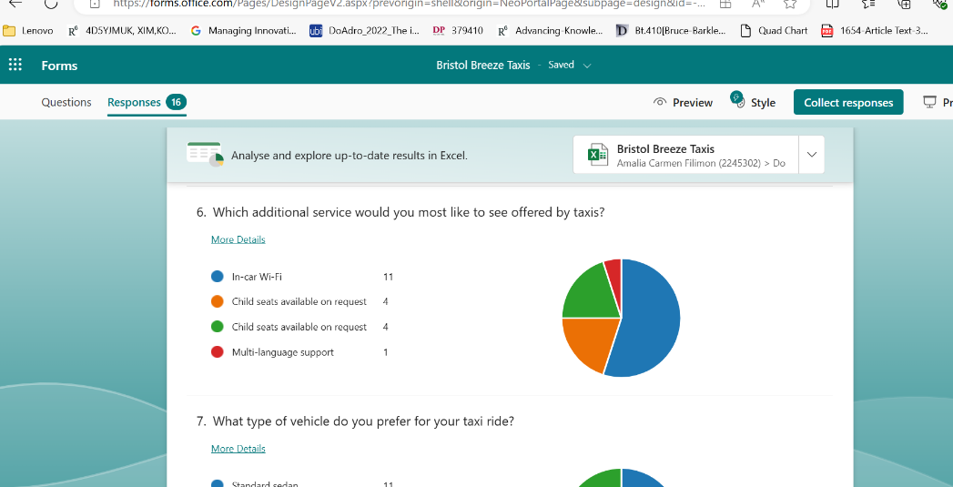

The survey results for Bristol Breeze Taxis reveal significant insights into customer preferences for additional services. In-car Wi-Fi emerged as the most desired feature, with 11 of respondents expressing interest. This aligns with global trends in transportation services, where connectivity is increasingly viewed as essential (Statista, 2023). The second most requested service was child seats on demand, indicating a potential market for family-oriented services. These findings suggest that Bristol Breeze Taxis could enhance its competitive position by prioritizing Wi-Fi implementation and introducing child seat options, strategies that have proven successful for other taxi companies (Uber Newsroom, 2022). The lower interest in multi-language support, while not dismissible, suggests these could be explored as niche offerings.

To capitalize on these insights, Bristol Breeze Taxis should consider a phased implementation approach, starting with Wi-Fi and child seats, followed by careful monitoring of customer satisfaction and usage rates (McKinsey & Company, 2024). This data-driven approach to service expansion can help the company refine its offerings, improve customer experience, and potentially increase market share in the competitive Bristol taxi market. Further research, including follow-up surveys and pilot programs, would be beneficial to validate these findings and ensure successful implementation of new services.

4. Website and marketing materials

The development of the taxi services website and marketing strategy exemplifies the power of data-driven decision-making in digital marketing (Lies, 2022). By carefully analyzing and implementing insights from the Microsoft Questionnaire, the company was able to create a compelling online presence that directly addressed customer needs and preferences.
The resulting website was not just a digital brochure, but a strategic tool designed to attract, engage, and convert potential customers. From the choice of imagery to the emphasis on key features like 24/7 availability and in-car Wi-Fi, every element was carefully considered and implemented based on customer data.

In today's digital age, a company's online presence is often the first point of contact with potential customers (Koufaris and Hampton-Sosa, 2004). For businesses in the transportation industry, particularly taxi services, an effective website can be the difference between attracting new clients and losing them to competitors.
The company's website was developed using Weebly, a popular website building platform known for its user-friendly interface and versatile design options (Lopez, 2023). Weebly's drag-and-drop functionality allowed for efficient creation and customization of the website, enabling the company to quickly implement changes based on customer feedback and preferences (Arafin and Jiang, 2017). The platforms responsive design features also ensured that the website would be accessible and visually appealing across various devices, including smartphones and tablets, which is crucial given the mobile nature of the taxi service industry.
One of the most significant findings from the Microsoft questionnaire was the identification of the primary demographic for taxi services. The survey revealed that young adults constituted most taxi service users. This insight was instrumental in shaping the website's design philosophy and content strategy.
To cater to this younger audience, the website was designed to be vibrant and visually engaging. The colour scheme, typography, and overall layout were carefully chosen to appeal to the aesthetic preferences of younger users.
Understanding that the target audience was primarily young adults, the website heavily featured images of luxury vehicles. This decision assumed that younger users are often attracted to premium experiences and are more likely to engage with visually striking content. High-quality photographs of modern cars were prominently displayed throughout the site, serving as both informational content and aspirational imagery.
The visual strategy extended beyond mere aesthetics. Each image was carefully selected to convey specific messages about the service, such as comfort, style, and reliability. This approach aimed to create an emotional connection with visitors, encouraging them to associate the taxi service with a premium, desirable experience rather than just a utilitarian mode of transport.
The questionnaire highlighted that price and reliability were the two most crucial factors influencing customers' choice of taxi service (Nguyen-Phuoc et al., 2020). This information was pivotal in determining how to structure and present information on the website.
The survey data indicated that most respondents used taxi services on a weekly basis. This frequent usage pattern informed the decision to implement and heavily promote a 24/7 service program. The website featured that, emphasizing the company's commitment to serving customers at any time of day or night. By highlighting this service feature, the company positioned itself as a reliable partner for transportation needs, regardless of the time or day.
Another key finding from the questionnaire was the high demand for in-car Wi-Fi among taxi users. Recognizing this as a potential competitive advantage, the website prominently featured information about the availability of free, high-speed Wi-Fi in all vehicles.
The survey revealed a strong preference for sedan-style cars among taxi users. This insight directly influenced the choice of imagery used throughout the website. High-quality photographs of luxury saloon cars were incorporated into the design, showcasing the company's fleet and aligning with customer preferences (Wheeler, 2012). These images were not just decorative but served multiple purposes. They provided potential customers with a clear idea of what to expect when booking a ride, reinforced the company's commitment to quality and comfort, and created an aspirational element that could encourage users to choose this service over competitors (Cook, 2010).
To complement the website design and extend the brand presence across multiple platforms, Canva, a free-to-use online graphic design platform that enables users to create a wide variety of visual content easily and quickly was utilized for creating various visual assets (Jovel Escalante et al., 2022). This included the company's car logo, which was designed to be memorable, professional, and reflective of the service's quality and reliability.
Social media materials for platforms such as Facebook and Instagram were also created using Canva. These designs-maintained consistency with the website aesthetic while being optimized for each platform's specific requirements and user behaviors. The social media strategy focused on sharing engaging content that highlighted the key selling points identified in the questionnaire, such as luxury vehicles, reliable service, and in-car Wi-Fi.
The preferences and keywords identified in the questionnaire were instrumental in developing the website's content and SEO strategy. The content was crafted to be concise yet informative, energetic in tone to appeal to the younger demographic, and focused on the key factors that influence taxi service choice.
Key phrases and terms frequently mentioned by survey respondents were incorporated into the website's copy, meta descriptions, and tags to improve search engine visibility. This data-driven approach to content creation ensured that the website not only resonated with the target audience but also had a higher chance of appearing in relevant search results (Cioffi, 2019).
The development of the taxi service's website and marketing strategy exemplifies the power of data-driven decision-making in digital marketing. By carefully analyzing and implementing insights from the Microsoft questionnaire, the company was able to create a compelling online presence that directly addressed customer needs and preferences.
The resulting website was not just a digital brochure, but a strategic tool designed to attract, engage, and convert potential customers. From the choice of imagery to the emphasis on key features like 24/7 availability and in-car Wi-Fi, every element was carefully considered and implemented based on customer data.
This approach demonstrates the importance of understanding the target audience in depth and tailoring digital strategies accordingly. As the taxi service industry continues to evolve, particularly with the rise of ride-sharing apps and changing urban transportation landscapes, such customer-centric, data-driven approaches will be crucial for traditional taxi services to remain competitive and relevant in the digital age (Johansson and Leijen, 2023).

5.Reference list:

Arafin, M.S. and Jiang, Y. [2017]. Developing a dynamic website using the online website builder Weebly for Viking Fortune Oy.
Ardath, A. [2015]. IKEA Executes B2C Video Storytelling with Style. [Online] Available at: https://contentmarketinginstitute.com/articles/ikea-b2c-video-storytelling/ [Accessed 20 June 2024].
Choo, Y.B., Abdullah, T. and Nawi, A.M. [2020]. Digital storytelling vs. oral storytelling: An analysis of the art of telling stories now and then. Universal Journal of Educational Research, 8(5A), pp.46-50.
Cioffi, R. [2019]. DATA-DRIVEN MARKETING: Strategies, metrics and infrastructures to optimize the marketing performances (Doctoral dissertation, Politecnico di Torino).
Cook, S. [2010]. Customer care excellence: How to create an effective customer focus. Kogan page publishers.
Cramer, J., & Krueger, A. B. [2016]. Disruptive Change in the Taxi Business: The Case of Uber. American Economic Review, 106(5), 177-82.
Denning, S. [2002]. Using stories to spark organizational change. Systems Thinker, 13, pp.2-6.
Gupta, R. and Jha, M. [2022]. The Psychological Power of Storytelling. The International Journal of Indian Psychology, 10(3), pp.606-614.
IKEA. [2024]. Johan Ejdemo on storytelling and circular design – IKEA Global. [online] Available at: https://www.ikea.com/global/en/stories/design/johan-on-storytelling-and-circularity-by-design-211217/ [Accessed 3 July 2024].
Jovel Escalante, J.M., Martínez Rodríguez, B.M. and Pérez Martínez, K.A. [2022]. The usage of technological tools and virtual platforms to prepare didactic material in distance education (Doctoral dissertation, Universidad de El Salvador).
Kadembo, E.M. [2014]. The narrative/storytelling approach in branding a place: An analytical study of oldham (Doctoral dissertation, University of Huddersfield).
Koufaris, M. and Hampton-Sosa, W. [2004]. The development of initial trust in an online company by new customers. Information & management, 41(3), pp.377-397.
Kritikos, K., Pernici, B., Plebani, P., Cappiello, C., Comuzzi, M., Benrernou, S., Brandic, I., Kertész, A., Parkin, M. and Carro, M. [2013]. A survey on service quality description. ACM Computing Surveys (CSUR), 46(1), pp.1-58.
Kurtz, C. [2009]. Working with stories in your community or organization. Retrieved September, 18, 2020.
Lies, J. [2022]. Marketing Intelligence: Boom or Bust of Service Marketing?.
Lopez, N.J.C. (2023). What is the Best Way to Develop a Website?.
Mashup Communications. [2022]. Storytelling Close-Up IKEA: Every piece of furniture is a story. [Online] Available at: https://www.mashup-communications.de/en/2022/06/storytelling-ikea/ [Accessed 3 July 2024].
McKinsey Chen, M. K., et al. [2015]. Dynamic Pricing in a Labor Market: Surge Pricing and Flexible Work on the Uber Platform. Working Paper.
Mother London. [2018]. IKEA: The wonderful everyday. [online] Available at: https://motherlondon.com/work/ikea-the-wonderful-everyday/ (Accessed: 22 June 2024).
Nguyen-Phuoc, D.Q., Su, D.N., Tran, P.T.K., Le, D.T.T. and Johnson, L.W. [2020]. Factors influencing customer's loyalty towards ride-hailing taxi services–A case study of Vietnam. Transportation Research Part A: Policy and Practice, 134, pp.96-112.
Peterson, L. and Boris, V. [2024]. The science behind the art of storytelling', Harvard Business Publishing Corporate Learning. Available at: https://www.harvardbusiness.org/the-science-behind-the-art-of-storytelling/ (Accessed: 20 June 2024).
Rayle, L., et al. [2016]. Just a better taxi? A survey-based comparison of taxis, transit, and ridesourcing services in San Francisco. Transport Policy, 45, 168-178.
Reason, M. and Heinemeyer, C. [2016]. Storytelling, story-retelling, storyknowing: towards a participatory practice of storytelling. Research in drama education: the journal of applied theatre and performance, 21(4), pp.558-573.
Slabunova, A. [2024]. Love and Tears: Emotions on Media as a Part of Marketing Strategy.
Statista. [2023]. Global In-Vehicle Infotainment Market.
Uber Newsroom. [2022]. Expanding Family-Friendly Ride Options.
Wallsten, S. [2015]. The Competitive Effects of the Sharing Economy: How is Uber Changing Taxis? Technology Policy Institute.
Wheeler, A. [2012]. Designing brand identity: an essential guide for the whole branding team. John Wiley & Sons.

6. Appendices



