Introduction
This part of course work is to understand the importance of site logistics in construction site of commercial building block, I define logistics
For purposes of how I plan the execution, accommodation, site layout, traffic management, material, delivery, tools and safety regulation or the control of procurement, transport, and material, the resources needed for each stage and to achieve the goals of my construction project and to develop my project stage to another stage without any major delay.

Construction and Logistics Plan

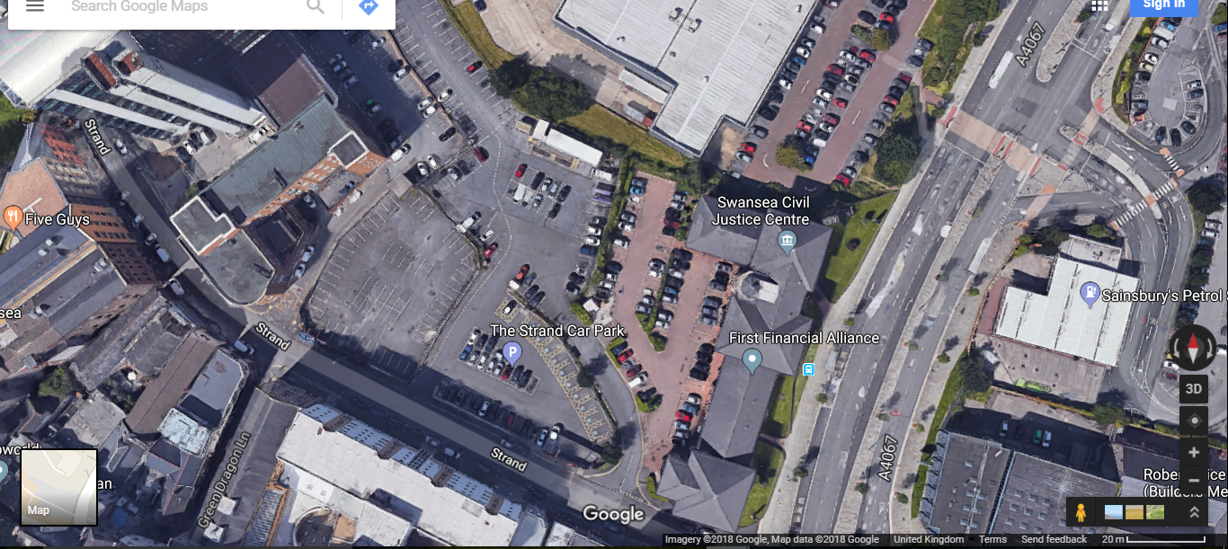
Construction and Logistics Plan
Site horning line
Welfare & accommodation

Tower crane position on site

Pedestrian entrance

Delivery area
Segregated safe zone
Storage area
Vehicle entrance

Traffic rout one-way system

Strand road site logistic and traffic rout plane

A
B
C
D
Slab A =500m2
Slab B =500m2
Slab C =500m2
Slab D=500m2

Sub-block A: 5 Floors
Sub-block B: 7 Floors
Sub-block C: 11 Floors
Sub-block D: 15 Floors

Site layout Plan Commercial Building Block
Before I take any work let me make sure to follow the following steps
Site Investigation
Site Analysis prior to purchasing a building site it is fundamental to lead a careful study to learn whether the site qualities suit the advancement idea. The accompanying direction frames a fundamental checklist:
- Refer to Ordnance Survey maps to determine adjacent features, location, roads, facilities, footpaths and rights of way.
- Conduct a measurement survey to establish site dimensions and levels.
- Observe surface characteristics, i.e. trees, steep slopes, existing buildings, rock outcrops, wells.
- Inquire of local authority whether preservation orders affect the site and if it forms part of a conservation areas
- Investigate subsoil. Use trial holes and borings to determine soil quality and water table level.
- Consider flood potential, possibilities for drainage of water table, capping of springs, filling of ponds, diversion of streams and rivers.
- Consult local utilities providers for underground and overhead services, proximity to site and whether they cross the site.

The basic objective of this form of site investigation is to collect systematically and record all the necessary data which will be needed or will help in the design and construction processes of the proposed work.

Site Layout Considerations

General Considerations prior to a particular contemplations and choices can be made with respect to site design a general gratefulness ought to be acquired by directing a careful site examination at the pre-delicate stage and looking at in detail the illustrations, determination and Bill of Quantities to plan recommendations of how the agreement will be completed if the delicate is fruitful. This will involve a preliminary assessment of plant, materials and manpower requirements plotted against the proposed time scale in the form of a bar chart.

Access Considerations
This must be considered for both on and off site get to. Courses to and from the site must be checked with regards to the reasonableness for transporting every one of the necessities for the proposed works. Access nearby for conveyances and general flow should likewise be precisely considered.

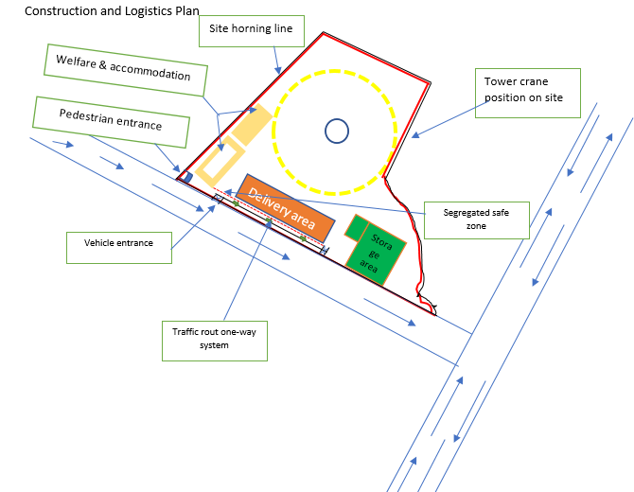
Site boundary
Paved areas and road to completed early stage and use for site access

Site Security
The primary objectives of site security are
- Security against theft.
- Security from vandals.
- Protection from innocent trespassers.
The requirement for and kind of security required will differ from site to site as indicated by the area, neighbourhood vandalism record and the estimation of merchandise put away on location. Edge fencing, interior site assurance and night security may all be vital.

Hoardings
The security system take place my project is Hoardings under the H&S Act a close boarded fence hoarding must be erected prior to the commencement of building operations if such operations are adjacent to a public footpath. The hoarding should be satisfactorily developed to give assurance to the general population, oppose affect harm, and oppose foreseen wind weights and enough lit around evening time. Prior to an accumulating can be raised a permit or allow must be acquired from the neighbourhood specialist who will as a rule expect 10 to 20 days' notice. The permit will set out the base neighbourhood expert prerequisites for hoardings and characterize as far as possible time of the permit.
Site Lighting
This can be used effectively to enable work to continue during periods of inadequate daylight. It can likewise be utilized as an impediment to would-be trespassers. Site lighting can be utilized remotely to enlighten the capacity and flow territories and inside for general development and for particular work assignments. The kinds of light accessible range from straightforward tungsten fibre lights to tungsten halogen and release lights. The course of action of site lighting can be static where the lights are settled to help posts or mounted on things of settled plant such as scaffolding and tower cranes.

Site Accommodation
The site accommodation type I need for this project can be office which mainly use meeting and communicating all party of project team, daily base facilities such as canteen, toilet, shower, hot water.

Site Storage
This can be defined as the arrangement of satisfactory space, insurance and control for building materials and segments hung nearby amid the development procedure, Materials put away on location preceding being utilized or settled may require assurance for security reasons or against the unfriendly impacts which can be caused by presentation to the components.

Little and Valuable Items these ought to be kept in a protected and lockable store, comparable things ought to be put away together in a rack or container. Substantial or Bulk Storage Items for security assurance these things can be put away inside a lockable fenced compound. The type of fencing picked may give visual security by being of an open nature however these are by and large less demanding to move than the nearby boarded write of fence which lacks the visual security property.

Ramps Calculation

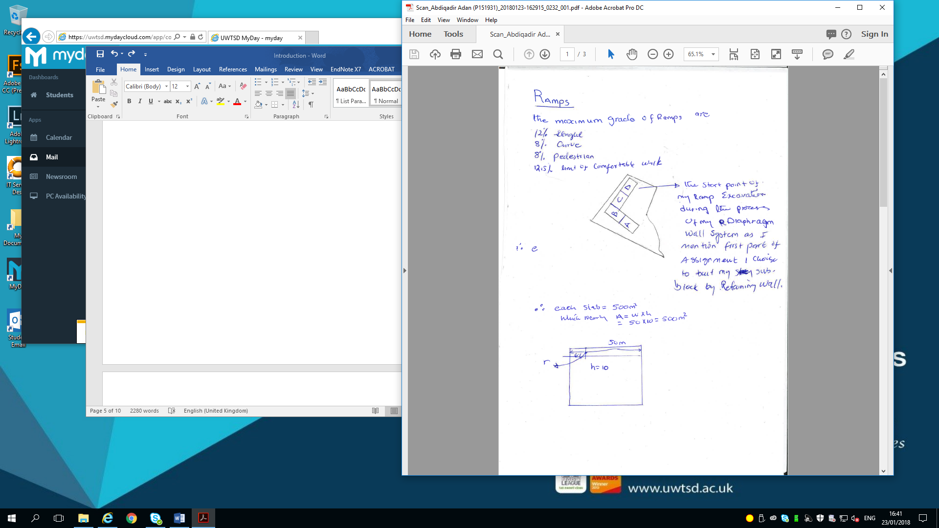

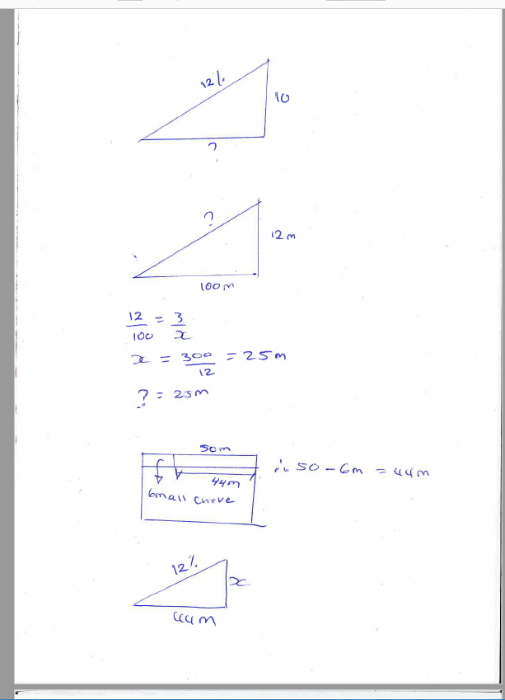



Plant
In general the reason we use the plant in construction as following:-
- Increased production.
- Reduction in overall construction costs.
- Carry out activities which cannot be carried out by the traditional manual methods in the context of economics.
- Eliminate heavy manual work thus reducing fatigue and as a consequence increasing productivity.
- Replacing labour where there is a shortage of personnel with the necessary skills.

These are the plant I need during my construction project of ex Excavation of my diaphragm

Bulldozers:
Bulldozers these machines comprise of a track or wheel mounted power unit with a form sharp edge at the front which is controlled by water driven rams. Numerous bulldozers have the ability to alter the shape cutting edge to frame an edge dozer and the ability to tilt the form sharp edge about a focal swivel point. A few bulldozers can likewise be fitted with raise connections, for example, rollers and scarifies.
The main functions of a bulldozer are:-
- Shallow excavations up to 300m deep either on level ground or side hill cutting.
- Clearance of shrubs and small trees.
- Clearance of trees by using raised mould blade as a pusher arm.
- Acting as a towing tractor.
- Acting as a pusher to scraper machines

Backacters

These machines are suitable for trench, foundation and basement excavations and are accessible as an all-inclusive power unit base machine or as a reason planned pressure driven unit. They can be utilized with or without orderly haulage vehicles since the ruin can be set close by the removal for use in inlaying.

These machines will require a low loader transport vehicle frame go between locales. Backacters utilized as a part of trenching operations with a pail width equivalent to the trench width can be extremely exact with a high yield rating.

Dumper
These is used for the horizontal transportation of materials on and off construction sites for the most part by methods for a vital tipping skip, materials, for example, uncovered ruin along the ground. An extensive variety of dumpers are accessible of different conveying limits and choices for gravity or pressure driven release control with front tipping, side tipping or raised tipping offices. Extraordinary configuration dumpers fitted with level stages, apparatuses to convey materials skips and apparatuses for solid skips for crane raising are additionally realistic. These machines are intended to cross harsh territory however they are not intended to convey travellers and this abuse is the reason for some mischances including dumpers

Cranes
Self-Supporting Static Tower Cranes: high lifting capacity with the mast or tower fixed to a foundation base they are suitable for confined and open sites. This type of crane I need to use my delivery, steel frame, column beam, floor slabs and other material on site to load.

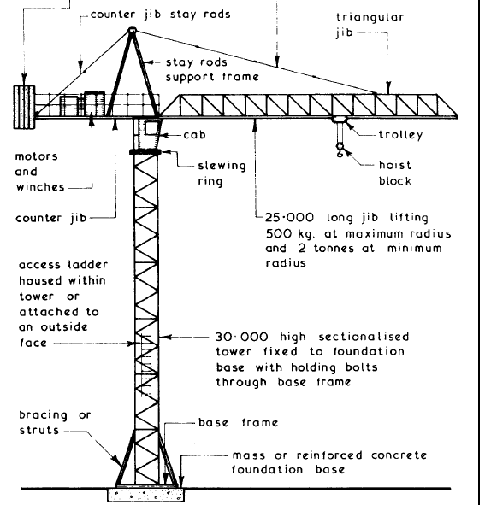

Scaffolding

According to the coursework my project need scaffolding because of the height of my building block in that case I prefer to use Putlog Scaffolds: because of this type of scaffolds have an outer row of standards joined together by ledgers which in turn support the transverse putlogs which are built into the bed joints or perpends as the work proceeds, they are therefore only suitable for new work in bricks or blocks.

The different stage of my project

1. EARTHWORKS SYSTEM
Using an excavator, we should level our development earths by moving parts of the world's surface including unformed shake. We should backfill where required and a portion of the earth will be moved to another area for a reason of levelling

2. DIAPHRAGM WALLING SYSTEM / ACTIVITIES
This method of constructing our basement is the chosen one. A retaining wall is to be constructed along the area of work. Because we intent to build a two storey basement car stop straightforwardly under our building, implies we will achieve a profundity of around 10 meters down, we might utilize a mechanical removal strategy. (5 labours-1 operative grab, 2 operative dumpers and 1 labour and 1 banks man for traffic)

3. EXCAVATION AFTER DIAPHRAGM WALL COMPLETED
Excavating 7m down to basement level it will take 2weeks approximately to complete 500m2 floor plan for Block A, Block B, C and D will take the same period of 2 weeks each block which means all 4 blocks will take 8 weeks to for the 2000m2 area. (5 gangs) required-2 dumper operatives and 1 JCB digger operative and 1 banks-man on the ground. (Looking out for traffic and just making sure of safety operations).
Considering our grabber can dig 3m long per each section means that 17sections +17sections + 3sections will give us 37sections at a rate of 1 day per each section. Digging one section 3m in length, missing an area to dig next section and then coming back in the 3rd day to dig the middle section (2gangs) required, consisting of 1 Vertical grabber operative and 1 banks-man on the ground. (Looking out for traffic and just making sure of safety operations
4. RAFT FOUNDATION SYSTEM / ACTIVITIES
- 1m deep excavation
- Blind concrete 100mm
- Steel reinforcement
- Pouring concrete into form-work

Structural steel frame is choice of our superstructure. A specialist subcontractor will be appointed for this activity. The steelwork will be referenced by a network framework that particularly recognizes each steel segment and shaft area. This is to ensure the steel can be set out precisely in adjust positions additionally to the right levels. A versatile crane will be utilized. One pack on the ground to put chains to the steel then two groups to ensure the steel is in position and catapulted together more than once each floor. Beginning with hinder An and while we begin putting our sections in Block A we are in the meantime putting steel superstructure for Block B proceeding with same example to the end. A static crane will then take over from the 5th floor upwards to the 15th floor.
- Base connections
- Beam-to-column connection
- Column splices
- Beam-to-beam connections(6 gangs )

6. TOP ROOF STRUCTURE SYSTEM / ACTIVITIES
( 5 gangs required) 1 crane operative, 2 gang on the ground-putting chains on zinc sheets to be lifted up on the roof by crane operative, 2gangs on the roof to assemble the zinc sheets to the roof a
8. EXTERNAL WALL – UNITISED CURTAIN WALLING SYSTEM / ACTIVITIE
Will utilize tilt up development framework utilizing the crane with two gangs on the ground dependably to interface chains from the crane onto the board securely and hold it in upright position with the crane lifting into the right position where two groups are prepared to associate board into helper outline structure-floor to roof tallness. (1 crane operative, 2 gangs on ground and 4 gangs on each floor to hold panel in place.1 gang as banks man)

Conclusion

To keep a construction project site productively with good planning is key the general contractor has to create a timeline an each phase of the undertaking far ahead of time of the venture begin the arrangement must incorporate an aggregate stock of materials, gear, and apparatuses required for each phase of the task. When you viably oversee materials from their source to your site you appreciate following advantages.
- Waste reduction savings arranging ahead of time guarantees that the correct materials are nearby consistently so development groups can work without interference.
- Logistical planning likewise implies that materials are put away fittingly, simple to find, and simple to move. This likewise accelerates the undertaking through enhanced productivity.
- Logistical planning helps a site maintain order. At the point when a site is sorted out and clean there are vital advantages venture productivity and health and safety.

Reference
BUILDING CONSTRUCTION HANDBOOK Fifth edition R. Chudley MCIOB and R. Greeno BA (Hons) FCIOB FIOP FRSA

https://www.assignar.om/construction/importance-logistics-construction-sites/(Accessed21 January 2018)

http://www.constructionmanagermagazine.com/management/roles-and-responsibilities-construction-logistics-/(Accessed 20 January 2018)

