

Student Name: ALMAHENDER SINGH

Student ID: 2504913

Module Name: Human Capital Management

Module Code: LCMB7023

Lecturer’s Name: Hoang Nguyen

- Introduction…………………………………………………………………………..3
Overview of Technological Advancements……………………………..3
Impact on Labour Markets: National Market………………………….4
International Labour Market Impact……………………………………….4
Implications for HRM and IHRM Strategies……………………………..4
Conclusion………………………………………………………………………………5

- Introduction……………………………………………………………………………5
Key Demographic Factors Influencing Employment Markets…..6
Key Geopolitical Factors Shaping Employment……………………….6
Challenges for HR Professionals……………………………………………..7
Conclusion……………………………………………………………………………………….7

- Introduction……………………………………………………………………………………..8
Understanding Skills Gaps and Talent Shortages……………………………….8
Strategic HRM Approaches to Address Skills Gaps…………………………….9
Upskilling and Reskilling Programs……………………………………………………9
Partnerships with Educational Institutions……………………………………….9
Technology-Enabled Talent Acquisition and Workforce Planning………9
Employee Retention Strategies…………………………………………………………9
Promoting Diversity and Inclusion……………………………………………………10
Conclusion………………………………………………………………………………………..10

- Introduction……………………………………………………………………………………..10
Description………………………………………………………………………………………11
Feelings……………………………………………………………………………………………11
Evaluation………………………………………………………………………………………..11
- Strengths……………………………………………………………………………….11
- Weaknesses…………………………………………………………………………..12
Analysis……………………………………………………………………………………………12
Conclusion………………………………………………………………………………………13
Action Plan……………………………………………………………………………………..14

REFERENCES……………………………………………………………………………………………..15-17

1 INTRODUCTION
Technological advancements are reshaping the labour market and human resource management (HRM), defined as the strategic approach to recruiting, developing, and retaining talent within domestic organizations (Armstrong & Taylor, 2020). In parallel, international human resource management (IHRM) extends these practices across borders, addressing cultural, legal, and operational complexities in global workforce coordination (Dowling et al., 2017). Emerging technologies such as artificial intelligence (AI), machine learning, big data analytics, and automation are revolutionizing talent acquisition through predictive hiring algorithms, enhancing employee engagement via personalized learning platforms, and streamlining performance management with real time analytics (Stone et al., 2015). cloud based HRM systems and virtual collaboration tools enable seamless cross national talent mobility and compliance with diverse labour regulations (Brewster et al., 2016). However, these innovations raise ethical concerns, including algorithmic bias, job displacement, and data privacy (Tambe et al., 2019). This introduction explores how such technologies drive efficiency and inclusivity in HRM and IHRM while navigating associated challenges in the evolving labour market.
Overview of Technological Advancements
Advancements in AI and automation have led to both the displacement of routine roles and the creation of new specialized positions particularly in fields such as machine learning, data science and digital ethics. Digital platforms are facilitating remote work project based employment and the growth of the gig economy allowing companies to access global talent pools and contract workers with niche skills.​ Automation, powered by AI and robotics, is automating routine and repetitive tasks, leading to displacement in sectors like manufacturing, retail, and administrative services. For instance AI driven tools like chatbots and predictive analytics are replacing entry level customer service roles.( Salari, N. et al. (2025))
- AI automates tasks like screening resumes and matching candidates, promoting fairer hiring practices and reducing biases.​
- Digital platforms enhance employee self service, communication and knowledge sharing within distributed teams.

Impact on Labour Markets: National Market
In national contexts such as the UK technological advancements like AI and automation are transforming the structure and composition of the workforce. Many sectors specially finance, retail, logistics and healthcare are witnessing the rapid integration of intelligent machines and automated systems. While this brings significant productivity and innovation benefits, it also results in job displacement, primarily in routine, entry level and administrative roles. For example UK firms exposed to AI have reduced entry level employment by about 5.8%, yet average pay within these firms has increased as higher level roles and digital skill demands rise (Teeselink,b.k. (2025)).
International Labour Market Impact
Globally digital platforms now enable organizations to recruit, manage and collaborate with talent across borders with good efficiency. International Human Resource Management (IHRM) must navigate diverse legal, cultural, and regulatory environments as remote work, contract employment, and cross-border teams become routine. Advanced HR platforms provide centralized talent management, compliance assurance and automated payroll solutions, helping businesses scale their workforce according to fluctuating global demands

Implications for HRM and IHRM Strategies
The shift toward technologically driven workplaces requires HR professionals to rethink traditional approaches and update their competencies in several key areas:
- Strategic HR Planning: Technology empowers HR to move from administrative functions to strategic decision making, using predictive analytics and data driven insights for talent management and retention.​
- Workforce Flexibility: Organizations must develop standardized processes for onboarding, evaluating, and off boarding contract and gig economy workers, ensuring compliance and consistency across value chains.​
- Employee Experience: With the proliferation of virtual and augmented reality tools for training, HR must cultivate engaging experiences to retain and upskill employees in both national and international contexts.​
- Global Collaboration: IHRM strategies should focus on managing culturally diverse teams, navigating varied legal requirements and leveraging communication platforms for crossborder operations.​
- Ethical and Regulatory Considerations: Responsible use of generative AI and blockchain technologies is essential to safeguard data privacy and maintain ethical standards in workforce management.​
Conclusion
Technological advancements are radically transforming labour markets by automating tasks, enhancing workforce efficiency, and creating opportunities for strategic HRM and IHRM. A critical, research informed approach is essential for organizations to leverage these technologies effectively, ensuring they remain competitive amid global economic shifts and evolving workforce demands

2 INTRODUCTION

The global employment market in 2025 is shaped by complex demographic and geopolitical factors that deeply influence national and international labour markets. Demographic change is affecting the size and age composition of the workforce in most industrialized countries, and there is ample evidence that this will cause societal and economic challenges for nation-states, organizations, and individuals alike (Kulik et al., 2014)These factors present significant challenges for Human Resource (HR) professionals at both domestic Human Resource Management (HRM) and International Human Resource Management (IHRM) levels. Understanding these forces is essential for crafting responsive workforce strategies to thrive in an evolving employment landscape.
Key Demographic Factors Influencing Employment Markets
One of the most pronounced demographic trends is the aging population in many developed countries. Declining birth rates and extended life expectancy are shrinking the working age population, leading to labour shortages and increased demand for healthcare and eldercare professions. This demographic shift pressures HR professionals to adapt recruitment and retention strategies to both attract younger talent and accommodate older workers through flexible work arrangements and reskilling programs. Conversely, emerging economies often experience growing youth populations entering the workforce, intensifying demand for job creation and skills development.​
Generational diversity is also transforming workplace dynamics. Millennials and Generation Z bring different expectations around flexibility, technology use, and corporate social responsibility, prompting HR to innovate in engagement and culture. Additionally skills mismatches persist largely due to rapid technological progress, requiring targeted upskilling and continuous learning initiatives from HR to bridge widening gaps between labour market needs and workforce capabilities.​
Migration remains a critical demographic factor. Migration policies have tightened worldwide amid rising nationalism and geopolitical tensions, limiting traditional talent pipelines and complicating international mobility. Reduced migration inflows in key economies contribute to labour shortages and challenge HR to diversify recruitment sources and invest in local talent development OECD (2024).​
Key Geopolitical Factors Shaping Employment
Geopolitical disruptions have profound implications on labour markets. Ongoing conflicts such as wars in Ukraine and the Middle East and economic sanctions create instability that disrupts supply chains, investment flows, and workforce mobility. HR professionals must anticipate geopolitical risks that impact expatriate safety, global assignments, and talent continuity.​
Trade tensions and protectionist policies, particularly between global powers like the US and China, increase operational costs and market uncertainties. Companies recalibrate supply chains and organizational footprints, often causing shifts in employment demand across regions and sectors. This necessitates agile workforce planning and compliance with diverse regulatory environments, further complicating HRM and IHRM functions.​
Regulatory volatility, including evolving labour, immigration, and environmental laws, introduces continual compliance challenges. Simultaneously, the accelerated advent of AI and automation influences workforce structures globally, emphasizing the need for HR to manage technological transitions humanely and strategically.​
Challenges for HR Professionals
Navigating these demographic and geopolitical forces, HR professionals confront multiple interrelated challenges:
- Talent shortages and skills gaps: Shrinking workforces in developed economies along with rapid technological transformation amplify recruitment challenges. HR must innovate talent acquisition, retention, and upskilling strategies to sustain competitiveness.​
- Workforce diversity and inclusion: Generational, cultural, and skill diversity require inclusive policies and leadership development to harness potential across heterogeneous teams.​
- Employee wellbeing and engagement: Economic pressures, geopolitical anxieties, and rapid change elevate stress, making mental health and financial wellbeing key HR priorities.​
- Global mobility and compliance: Managing international assignments amid geopolitical upheavals, migration restrictions, and safety concerns demands flexibility, risk management, and expertise in legal compliance.​
- Organizational agility: HR must build resilience to geopolitical, economic, and demographic uncertainties through adaptable workforce models and ongoing scenario planning.​
Conclusion
In conclusion, demographic and geopolitical factors in 2025 are intricately interconnected, reshaping employment markets and compelling HR professionals to adopt agile, inclusive, and strategic approaches across national and international boundaries. Successful HRM and IHRM will depend on understanding these trends and proactively addressing the emergent workforce complexities to safeguard organizational performance and employee wellbeing.

3 Introduction
Skills gaps and talent shortages in critical sectors such as technology, hospitality, and healthcare pose significant challenges. These shortages hinder innovation, productivity, and sector growth. Strategic Human Resource Management is an approach to management which encompasses those HR strategies designed to improve organisational performance and measures the impact of these strategies on organisational performance. Boxall(2007) . Strategic Human Resource Management (HRM) plays a vital role in addressing these challenges by aligning workforce capabilities with organizational needs and fostering continuous development.
Understanding Skills Gaps and Talent Shortages
Skills gaps refer to the difference between the skills employers need and those employees currently possess, while talent shortages occur when there are insufficient qualified candidates for available roles. Factors contributing to these issues include rapid technological advancement, demographic shifts, and evolving job requirements. These shortages adversely affect organizational performance, leading to operational inefficiencies and limiting sector growth. (TalentHR. (2023)) Below graph representing Unemployment Rate vs % of Jobs not filled due to Skill Gaps
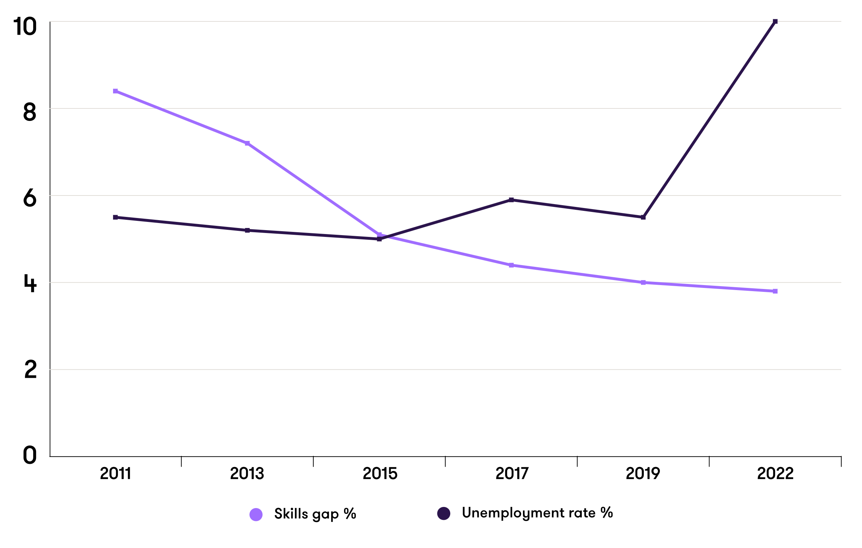
Sourced from-Grant Thornton (2023)
Strategic HRM Approaches to Address Skills Gaps
Strategic HRM closes skills gaps by aligning workforce capabilities with business goals. Start with a strategic skills audit using matrices and AI analytics to map gaps. Build pipelines via internal mobility, upskilling skillsbased hiring , and academia partnerships. Apply the 70-20-10 learning model: experiential projects (70%), peer coaching (20%), micro learning (10%). Incentivize with skill premiums, badges, and KPIs like time-to-proficiency. Foster continuous learning through psychological safety and manager coaching. (Lombardo and Eichinger, 1996)

Upskilling and Reskilling Programs
Continuous employee development is essential to bridge skills gaps. Organizations must invest in upskilling and reskilling through targeted training and certification programs that enable employees to acquire new competencies aligned with industry demands. For example, tech companies offering coding bootcamps or healthcare firms providing specialized medical training help maintain a dynamic, skilled workforce.
Partnerships with Educational Institutions
Collaborating with universities, vocational schools, and training centers supports the development of jobready talent. These partnerships facilitate internships, apprenticeships, and curriculum alignment with industry needs, ensuring graduates possess relevant skills. Such engagements enhance workforce readiness and reduce onboarding times.
Technology-Enabled Talent Acquisition and Workforce Planning
Utilizing artificial intelligence (AI) and data analytics helps refine recruitment and skills mapping efforts. AI powered tools enable skills based hiring, objectively assessing candidate capabilities and predicting workforce gaps. This approach improves recruitment efficiency and matches candidates more precisely to roles requiring critical skills.
Employee Retention Strategies
Retaining skilled employees is vital to mitigate talent shortages. Competitive compensation packages, clear career progression opportunities, and supportive work cultures contribute to higher retention rates. Organizations that focus on employee engagement and satisfaction preserve institutional knowledge and reduce turnover related costs.
Promoting Diversity and Inclusion
Expanding talent pools through diversity and inclusion initiatives enhances innovation and organizational resilience. Diverse teams bring varied perspectives and problemsolving approaches, crucial when addressing complex challenges in sectors like healthcare and technology. Inclusion drives better decision-making and attracts a broader range of skilled candidates.
Conclusion
Integrated strategic HRM is key to effectively addressing skills gaps and talent shortages in critical sectors. By continuously developing employee skills, partnering with education providers, leveraging technology, enhancing retention, and promoting diversity, organizations can build adaptable and resilient workforces. Ongoing, dynamic HR strategies are essential to meet evolving sector demands and sustain growth.

4 Introduction
In todays globalized workplace the ability to work effectively in an international environment is essential, especially given the rapid advancements in technology, the necessity for clear communication, collaboration within diverse teams, leadership capabilities, and the need for ongoing selfdirected learning. Reflecting on my own capabilities in these areas through the lens of Gibbs Reflective Cycle allows me to critically evaluate my strengths and weaknesses and to plan concrete steps for future development. Gibbs (1988)created his “structured debriefing” to support experiential learning. It was designed as a continuous cycle of improvement for a repeated experience but can also be used to reflect on a standalone experience. (Cumbria University (2020))

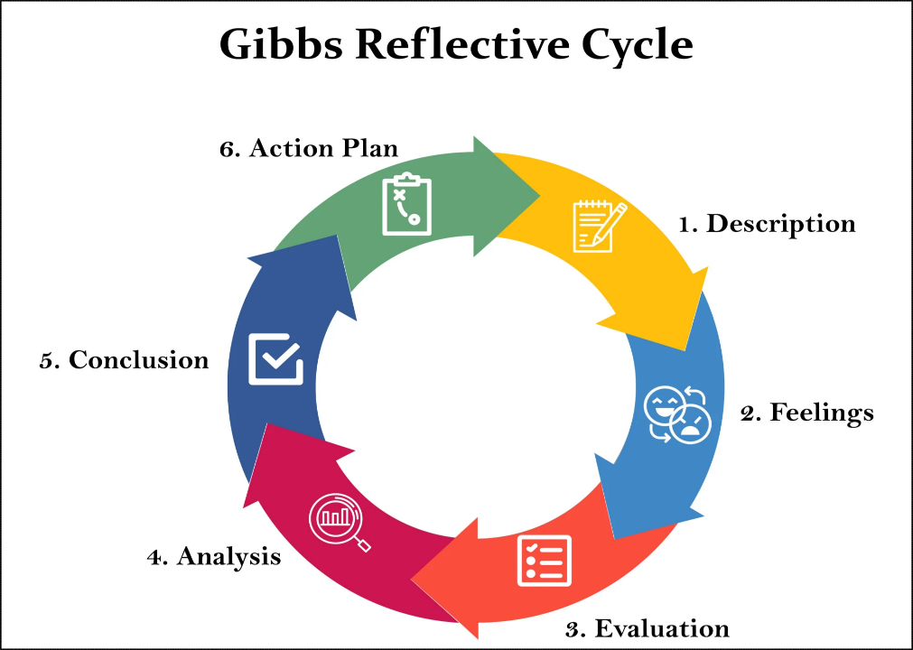
Sourced from -Simply Psychology (2025)
Description
During my recent experiences in an international work environment and academic term, I have been involved in multicultural teams where technology played a vital role in communication and project management. These activities included virtual meetings across time zones, using cloud based collaboration tools, and engaging in self directed learning modules to upgrade my technological and leadership skills. I observed both successes and challenges in adapting to this international setting, which prompted me to reflect on my performance in technology, communication, teamwork, leadership, and self directed learning.
Feelings
Initially, I felt enthusiastic about leveraging technology to bridge geographical distances and cultural differences. However, moments of uncertainty arose when navigating unfamiliar digital tools or when cultural misunderstandings affected communication. While teamwork was generally satisfying due to diverse perspectives, I sometimes felt hesitant to assert my views. Leadership opportunities were both exciting and daunting given my limited experience in directing international teams. Self directed learning felt fulfilling but challenging in balancing with other responsibilities.
Evaluation
Strengths:
- Technology: I am proficient in using core digital platforms like video conferencing, collaboration software (e.g., Microsoft Teams, Google Workspace), and project management tools. This competence supports efficient coordination and document sharing in international teams.
- Communication: I am adaptable in tone and style to accommodate different cultural norms, which fosters clearer and respectful interactions. This helps in building trust and understanding in diverse groups.
- Teamwork: I listen actively and encourage contributions from all team members, promoting inclusiveness and synergy. These qualities enhance team morale and collective problem solving.
- Leadership: I demonstrate motivation and organizational skills effectively managing deadlines and supporting teammates. Feedback from peers highlights my reliability and supportive approach.
- Self-Directed Learning: I am committed to continuous learning, regularly engaging with online courses to enhance my skills in digital literacy and leadership theories.
Weaknesses:
- Technology: I sometimes delay adopting new tools beyond the essentials, which limits innovation and efficiency improvements.
- Communication: Hesitance in unfamiliar cultural settings occasionally reduces my participation or leads to ambiguous messaging.
- Teamwork: At times my accommodating nature causes a lack of assertiveness, potentially diluting my input or leading to decision making delays.
- Leadership: I have limited experience handling conflicts or leading diverse teams under pressure creating gaps in my leadership effectiveness.
- Self-Directed Learning: Inconsistent scheduling and competing priorities sometimes slow my learning progress, causing missed opportunities for skill upgrading.
Analysis
Technology is the backbone of international business and my solid foundational skills help maintain smooth communication and workflow, especially in virtual teams. However, staying current with emerging tools (e.g., AI based collaboration platforms) is vital to maximizing productivity and innovation. The gap in adoption stems partly from comfort with known platforms and time constraints for exploration. Improving this will require deliberate efforts to explore and experiment with new technologies.
Effective communication in intercultural settings is more than language proficiency it demands cultural intelligence, including sensitivity to norms and practices. My adaptability helps mitigate many misunderstandings still, gaining deeper cultural insight and overcoming hesitation in unfamiliar contexts will further improve interaction quality. These improvements hinge on active cultural learning and exposure.
Teamwork thrives on balancing collaboration and assertiveness. While inclusiveness is essential, it must not hinder clear decision making or advocacy of ideas. Developing assertiveness aligns with leadership growth, particularly in managing conflicts and directing diverse groups. Leadership, especially in an international context, requires emotional intelligence and conflict resolution skills, areas where I need more practical experience and formal learning.
Self directed learning drives all these competencies forward. Although motivated, irregular study patterns reduce the effectiveness of my development efforts. Structured learning schedules will increase consistency and better integrate learning with professional demands.
Conclusion
My strengths in technology proficiency, adaptable communication, supportive teamwork, motivational leadership, and dedication to self directed learning provide a strong foundation for working in a globalized workplace. Yet, there are clear areas for growth, particularly in technological agility, confident intercultural communication, assertive participation in teams, advanced leadership in conflict resolution, and disciplined learning routines.
This reflection reveals the interconnected nature of these capabilities: improvements in one area enhance overall effectiveness. For instance, enhanced confidence in communication will feed into stronger leadership and teamwork, while quicker adoption of technology supports more innovative collaboration.
Action Plan
To address identified weaknesses and leverage strengths, I plan the following actions:
- Technology: Dedicate time weekly to explore new collaboration tools and attend webinars on emerging digital workplace technologies. Experiment with AI driven productivity software to integrate innovation into daily tasks.
- Communication: Engage in cultural competence training programs and seek diverse multicultural interactions outside immediate work to build confidence and insight. Practice reflective listening and feedback techniques in meetings.
- Teamwork: Work on assertiveness training through workshops and roleplaying scenarios. Set personal goals to voice ideas more proactively and encourage decisive team discussions.
- Leadership: Enrol in leadership courses focused on conflict management and intercultural team dynamics. Volunteer for leadership roles in group projects to gain practical experience under supervision.
- Self-Directed Learning: Establish a structured weekly learning schedule with specific goals and milestones. Use digital planners and reminder apps to maintain consistency and track progress.

REFERENCES
1) Armstrong, M. and Taylor, S. (2020) Armstrong’s handbook of human resource management practice. 15th edition. London, United Kingdom ; KoganPage. (Accessed: 10 November 2025)
Brewster, C., et al. (2016). International human resource management. CIPD.
Dowling, P. J., et al. (2017). International human resource management. Cengage Learning. (Accessed: 10 November 2025)
Stone, D. L., et al. (2015). The influence of technology on the future of HRM. Human Resource Management Review, 25(2), 216–231. (Accessed: 10 November 2025)
Tambe, P., et al. (2019). Artificial intelligence in HRM. Journal of Management, 45(2), 525–547. (Accessed: 10 November 2025)
Tony Blair Institute for Global Change (2024). The Impact of AI on the Labour Market. Available at: https://institute.global/insights/economic-prosperity/the-impact-of-ai-on-the-labour-market(Accessed: 10 November 2025)
Teeselink,b.k. (2025). ‘New study reveals early impact of AI on job market in UK’. Available at: https://kcl.ac.uk/news/new-study-reveals-early-impact-of-ai-on-job-market-in-uk . (Accessed: 10 November 2025)
Goldman Sachs (2025). How Will AI Affect the Global Workforce? Available at: https://www.goldmansachs.com/insights/articles/how-will-ai-affect-the-global-workforce. (Accessed: 10 November 2025)
Zahidi,S. (2025) ‘The Future of Jobs Report 2025’, World economic forum, Available at: https://www.weforum.org/publications/the-future-of-jobs-report-2025/in-full/.(Accessed: 10 November 2025)
Bankins, S. et al. (2024) ‘A multilevel review of artificial intelligence in organizations: Implications for organizational behavior research and practice’, Journal of organizational behavior, 45(2), pp. 159–182. Available at: https://doi.org/10.1002/job.2735. (Accessed: 10 November 2025)
Salari, N. et al. (2025) ‘Impacts of generative artificial intelligence on the future of labor market: A systematic review’, Computers in human behavior reports, 18. Available at: https://doi.org/10.1016/j.chbr.2025.100652. (Accessed: 10 November 2025)

2 )
OECD (2024) "Demographic Shifts and Labour Markets: Implications for HR Practices." OECD Employment Outlook 2024. Available at: https://www.oecd.org/employment-outlook (Accessed: 10 November 2025)
Kulik, C. T., Ryan, S., Harper, S., & George,G. (2014). Aging populations and management. Academy of Management Journal, 57(4), 929–935. doi:10.5465/amj.2014.400(Accessed: 10 November 2025)
OECD, 2025. OECD Employment Outlook 2025. [pdf] Available at: https://www.oecd.org/en/publications/2025/07/oecd-employment-outlook-2025_5345f034.html(Accessed: 10 November 2025)
Deloitte, 2024. 2025 Global Human Capital Trends. [online] Available at: https://www.deloitte.com/nl/en/services/consulting/research/human-capital-trends-report-2025.html(Accessed: 10 November 2025)

3 Boxall P F (2007), ‘The goals of HRM’, in (eds) Boxall P, Purcell J and Wright P, Oxford Handbook of Human Resource Management, Oxford, Oxford University Press, pp 48- 67 (Accessed: 10 November 2025)
TalentHR. (2023). What is the Skills Gap? HR Glossary. TalentHR. Available at: https://talenthr.io/hr-glossary/skills-gap/ (Accessed: 11 November 2025)
Abakar Saidov (2025). How To Address Skills Gaps In 2025: Part 1. Forbes. [online] 13 Feb. Available at: https://www.forbes.com/councils/forbeshumanresourcescouncil/2025/02/13/how-to-address-skills-gaps-in-2025-part-1/ (Accessed: 11 November 2025)
CIPD. (2025). CIPD | Briefing | Skills gaps here to stay: Future of Jobs Report 2025. [online] Available at: https://www.cipd.org/ie/views-and-insights/thought-leadership/insight/future-of-jobs-report-ie/. (Accessed: 11 November 2025)
Lombardo, M.M. and Eichinger, R.W. (1996) The career architect development planner. Minneapolis: Lominger. (Accessed: 11 November 2025)
Grant Thornton (2023) The skills gap and its impact on productivity. Available at: https://www.grantthornton.co.uk/insights/the-skills-gap-and-its-impact-on-productivity/ (Accessed: 11 November 2025).

4
Cumbria University (2020) (n.d.) Gibbs' reflective cycle: The 6 stages. [PDF] Available at: https://my.cumbria.ac.uk/media/MyCumbria/Documents/ReflectiveCycleGibbs.pdf . (Accessed: 11 November 2025)
Brookes, A. (n.d.) Using Gibbs: Example of reflective writing in a healthcare assignment. [PDF] Available at: https://www.brookes.ac.uk/getmedia/a7265343-34c8-4054-b08d-3c624eb8600e/using-gibbs-example-of-reflective-writing-in-a-healthcare-assignment.pdf (Accessed: 11 November 2025)
Edinburgh University (2016) Gibbs’ Reflective Cycle | Reflection Toolkit. Available at: https://reflection.ed.ac.uk/reflectors-toolkit/reflecting-on-experience/gibbs-reflective-cycle . (Accessed: 11 November 2025)
Assignment Desk (2025) Gibbs Reflective Cycle: 6 Stages + Examples. Available at: https://www.assignmentdesk.co.uk/blog/gibbs-reflective-cycle(Accessed: 11 November 2025)
Simply Psychology (2025) Gibbs Reflective Cycle. Available at: https://www.simplypsychology.org/gibbs-reflective-cycle.html . (Accessed: 11 November 2025)

