ST Fagans Case Study

By Ellis Morgan (2518653)
  - Assignment

Contents
Introduction 2
Analysis of the Terrace Houses 2
Reasons for Changes 5
Conclusion 6
Examples of Typical Construction methods – Pre 1900 7
Examples of Typical Construction methods – 1950s 8
Examples of Typical Construction methods – Post 2000 9
References 10

Introduction
At the St. Fagans National Museum of History, Rhyd-y-car Terrace is a row of six worker's homes that Richard Crawshay developed around 1795 to provide for iron-ore mine workers. The fundamental plan of each house is the same, however it is shown as it could've looked in various years, such as from 1805 to 1985. This makes it possible for tourists to learn about the evolution of working-class homes over time. The terrace becomes a representation of how changes in technology, materials, and living standards have impacted traditional home structures.
The six homes are based on the years 1805, 1855, 1895, 1925, 1955, and 1985. When viewed as a whole, these dates represent over two centuries of changes in traditional working-class housing.

Analysis of the Terrace Houses
Windows & doors
Windows in homes developed between 1805 and 1855 would typically have single-glazed timber windows with small panes, due to the limited and costly making of glass. Typical sash windows were inefficient in holding heat therefore a cold home. The larger panes developed as glass became more affordable and technology improved, which then led to improved light and ventilation in homes. ‘From Georgian through Victorian periods sash windows became more common, with larger panes and stronger frames, reflecting both improved glass production and changing tastes’ (1, History of Hardwood Windows, paragraph “Eighteenth century”).

Double-glazed windows and preventing draught through doors and windows then became in use in UK homes between 1955 and 1985 in a way to stop heat loss. These improvements, which enhanced living conditions and decreased the need for heating, this was particularly due to technology advancements in the building industry. ‘In the UK, before modern building regulations, windows were often a major source of heat loss and draughts; later improvements like double glazing became more widespread from the 1970s and 1980s to address this’. (2, Double Glazing History, “1970s-80s” section).

As living standards developed and laws changed in the 20th century, door designs also improved. Basic timber frames made a way for improved doors with more effective weatherproofing to lower heat loss and increase reliability. (3, Repair or Change Windows in an Older Home section)

Wall Coverings
The walls of the early terrace homes from 1805 to 1855 were most likely produced of lime plaster with limewash, a thin coating that allowed for breathing while keeping the plaster suitable and preventing trapped moisture, which may harm traditional brickwork and living standards. (4).
As time progressed wallpapers along with more intricate wall coverings grew common during the Victorian era as industrialisation developed, showing increasing living standards and design ideas changing. (5)
During the 20th century, most wall decorations were being replaced by gypsum plasters and wall paints were more modern, which improved ease painting on walls as it was more efficient as well as created smoother surfaces. Therefore, the development of wall coverings demonstrates shifts in technology, materials, and reliability. (6)
Roof Coverings
‘Before the development of railways and canals in Britain, roof coverings were typically local materials such as thatch, stone slate or clay tiles, depending on what was easiest to source nearby’ (3, “Roof coverings”). This illustrates that while traditional roofs were useful, they were generally heavy and needed solid structures to support them, and some materials, like thatch, required a lot of maintenance to help the roof. During the Industrial Revolution, access to transportation became more reliable, this made it easier to transport slate across the country. In relation to older finishes, slate was thinner, smoother, and much more durable, increasing weatherproofing. ‘Slate came to dominate the roofing of Wales only in the nineteenth century.’ (7).

As production methods improved by the 20th century, roof coverings were now more secure and common in UK based homes. These improvements increased efficiency throughout working-class housing while mitigating past flaws like weatherproofing and common maintenance.

Eaves
There was very little rainfall control in early traditional UK homes, such as guttering and drainage systems. ‘Many historic buildings were constructed without rainwater goods, relying on roof overhang (eaves) to throw water clear of walls’ (3, “Buildings without rainwater goods”). Water generally ran straight down the roof edge as a result, which could result in water splashback at the bottom of the wall, causing dampness absorption and rising moisture.

Rainwater technologies became more popular with the growth of industry and new materials. ‘Cast iron gutters and downpipes were introduced on buildings in the 18th and 19th centuries’ (3, “Buildings without rainwater goods”). By adding newer gutters and downpipes, damp problems were reduced by gathering and draining water away from the house. Whereas with the wooden or no drainage systems, rainwater systems were less dependable. These new changes in drainage technology on housing suggests that while more traditional designs recognised many damp issues, the addition of rainwater later on shows an increase to improved efficiency, greater weather protection, for greater living standards and longevity of the household.

Floor Coverings
In working-class homes, traditional floor coverings were straightforward. Although these wood floorings were reliable, they were deemed to be often draughty. ‘In traditional buildings, floors were often made from timber boards laid directly over joists, prioritising durability over comfort’ (8, Vernacular buildings).

Floorboards developed more as industrial manufacturing advanced in the 19th century, minimising flaws such uneven surfaces and high loss of air. ‘The introduction of linoleum and early carpet coverings improved hygiene and warmth in domestic interiors’ (8, Domestic interiors). These coverings demonstrated increasing demands for a clean and insulated household but also helping in dealing with earlier poor living standards.

During the 20th century, the latest technologies like vinyl and fitted carpets had become popular, providing improved durability, quicker cleaning, and increased warmth. Therefore, the development of floor coverings demonstrates how comfort, quality and low cost of maintenance replaced basic floor coverings.

Internal Joinery
Architraves, doors, stairs, and skirtings are examples of internal joinery in households. Joinery was efficient and developed locally in early traditional homes in the UK. ‘Internal joinery traditionally used solid timber for structural and decorative elements’ (8, traditional buildings). Since that each carpenter worked differently, the constructed, quality staircases, doors, and trims may have been uneven or different across many homes.

Doors and frameworks became more common and produced as the construction industry advanced in the 19th century, lowering costs and increasing reliability. According to the website Heritage Calling, the improvements when making and producing allowed builders to put in skirting boards and architraves that were more accurate and detailed, which then improved also looks and durability of the product. (8, timber and interior joinery)

Joinery was much more affordable and reliable in the 20th century because of improved production, which highlighted increasing needs for clean fit, finish, and simple replacement if there were to be faulty fixes. It demonstrates how joinery developed from locally produced, only functional items to efficient structures that enhanced quality and satisfaction. (8, timber and interior joinery).

Reasons for Changes
The changes that have been made for each of the Rhyd-y-car Terrace Houses at St Fagans mainly highlight how important it is of solving general issues in early housing while also improving living standards, efficiency, and satisfaction. Several of the earlier households, developed between the years 1805 and 1855, these were simple and functional. Early houses often did not have rainwater drainage systems and had large eaves for draining water, as stated by Historic England (3). It makes sense at the time, although damp problems generally caused near the base of the walls of the early households. More modern use of cast-iron gutters and downpipes solved the problem by improving wall protection and lowering rainwater away from the house, resulting in an improved drainage system instead of a more pleasing to the eye system.

In roof coverings, similarities in the design are shown. The websites Heritage and Historic England, shows that early the roofers used materials that were easily available to them, which could be heavy, fragile or need a lot of care. Welsh slate was common in the 19th century, which improved reliability, weatherproofing, and durability while decreasing drawbacks such water coming in and regular maintenance of the roof. This shift is a result of improved transport of products in this instance slate and advances in technology. (3) (8)

Internal wall and floor finish also changed to address practical issues. As stated by Heritage Calling, early plastered walls and timber floors highlighted permeability and durability but were draughty. To increase warmth, cleanliness, more consistent flooring, carpets, and vinyl were added over time. While certain later materials decreased leakage and might get damp if poorly placed, they show increasing needs for household cleanliness and satisfaction, mainly by 1955. (8)

Internal joinery highlights both aims and mitigating issues. The early handcrafted joinery was generally sturdy yet inconsistent and sometimes ineffective when it came to the fit. The industrial development made common joinery possible, which improved the accuracy, decreased draughts, and lowered costs, as the website Heritage Calling discusses. This made housing less struggle to maintain and repair, which improved total performance of construction. Furthermore, improved mouldings and finishes offer an example of how to create views for an improved look. (8)

Overall, a lot of the terraces over time had changes first made in due to practical issues like dampness, heat loss, and durability. Later changes mainly demonstrate developments in the society, and improved living standards as these problems were handled better over time. The Rhyd-y-car Terraces in St Fagans highlights that working-class housing changed from basic homes to houses based on needs for performance, technology, and changing standards of living by demonstrating six periods side by side.

Conclusion
In Conclusion, the working-class housing has developed over the years 1805, 1855, 1895, 1925, 1955 and 1985 in action to mitigate social, technological, and environmental wants in a household, as demonstrated at Rhyd-y-car Terrace at St Fagans. Developed to give workers a basic place to live, the homes were straightforward, useful, and put housing over standard of living. Early choices in design, such single-glazed windows, little rainwater systems, simple roof coverings, and basic interior decorations, satisfied the demands but led to problems like dampness, heat loss, and unhealthy conditions. Changes have been made over time for improving standard of living and to improve efficiency. Welsh slate roofs, cast-iron gutters, better timber, and more modern floor and wall finishes decreased repair problems, improved reliability, and solved environmental issues including dampness and draughts, as noted by Historic England and Heritage Calling websites.

By the middle of the 20th century, more changes were a result of growing demands for the simple needs of the household. A move to improve ease of living, a clean environment, and look can be seen in the use of flooring, modern paints, standard joinery, and improved windows. These improvements also show the result of houseowners choice, and mass production.

Rhyd-y-car Terraces in St Fagans is an educational example in which small, slow changes to standard structures represent larger developments in history. The terraces highlight how developments in working-class homes were slow rather than fast, developed by changes in society, advances in technology, and solving issues. Analysing the growth of housing designs and standard of living in Wales and across the entire UK becomes easy and efficient by the museum's way of displaying different eras in history from the years 1805, 1855, 1895, 1925, 1955 and 1985.

Examples of Typical Construction methods – Pre 1900

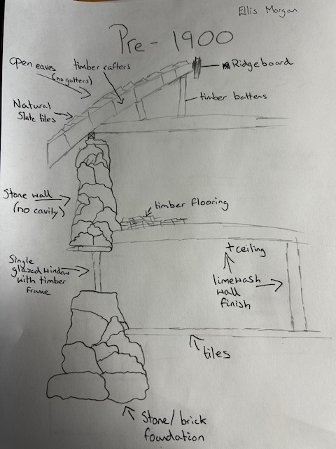

Examples of Typical Construction methods – 1950s

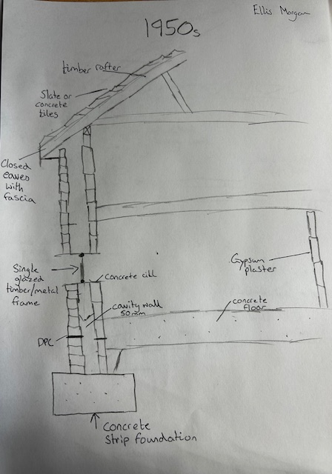

Examples of Typical Construction methods – Post 2000

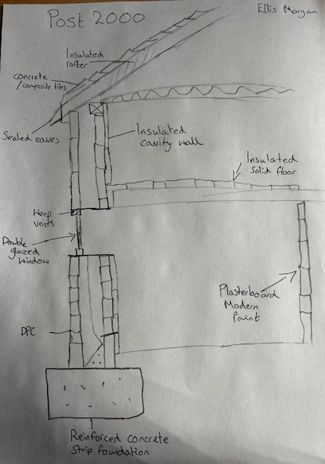

References
(1) https://www.windows-doors-uk.co.uk/the-history-of-hardwood-windows/
(2) https://www.ecopreneurist.com/double-glazing/history/ (Joy Campilan, March 19th, 2024)
(3) https://historicengland.org.uk/advice/your-home/maintain-repair/windows/ (Published 23 July 2013, Updated 23 July 2024)
(4) https://www.buildingconservation.com/articles/lwdistempers/lwdistempers.htm (The Building Conservation Directory, 2002, Elizabeth Hirst)
(5) https://www.thevictorianemporium.com/publications/history/article/victorian-wallpaper-designs-and-their-history (May 05, 2023, By the Victorian Emporium)
(6) https://timothystoolbox.com/blogs/blog/the-history-of-drywall-how-it-s-changed-over-the-years (July 26, 2024)
(7) https://cadw.gov.wales/roofs
(8) https://heritagecalling.com/2022/08/25/a-guide-to-traditional-english-buildings/ (Historic England 25 August 2022)

