The effectiveness of FEA in accurately simulating ballistic impact scenarios.

OWEN MILLER
BAE SYSTEMS, UNIVERSITY OF WALES TRINITY ST DAVID
/2023

- Contents
1. Introduction 3
2. Literature Review 4
3. Validation exercises 13
3.3. Fixing method of plate 29
3.4. Mesh sizing and geometry: 32
Overall validation: 37
4. Review of comp modelling 40
5. Conclusion 40
9. Bibliography 40

Introduction
Computer-Aided Engineering (CAE) plays a pivotal role in simulating complex phenomena, including ballistic impacts, by leveraging advanced computational tools to predict material behaviour and structural response under extreme loading conditions. This report provides an in-depth exploration of the application of CAE, particularly utilizing ANSYS software, in modelling high-velocity projectile interactions with target structures.

The study focuses on identifying and addressing inherent challenges and limitations associated with CAE simulations of ballistic impacts. Key aspects investigated include material modelling accuracy, numerical stability under transient loading, and validation against experimental data. Furthermore, comparisons between different simulation software packages, such as ANSYS and Abaqus, are conducted to assess their capabilities and suitability for modelling dynamic events like ballistic impacts.

The report also delves into the influence of mesh sizing and geometry on simulation fidelity and computational efficiency. By systematically varying mesh densities and configurations, the study aims to optimize simulation practices for accurate representation of deformation patterns and fragmentation effects during ballistic impacts.

Overall, this report aims to provide critical insights and evaluations of CAE methodologies, software capabilities, and best practices in simulating high-velocity impact scenarios using ANSYS. The findings contribute to advancing knowledge in computational modelling for ballistic impact studies and offer practical recommendations for improving simulation accuracy and reliability in engineering applications.

Literature Review
The application of Computer-Aided Engineering (CAE) in simulating ballistic impacts presents inherent challenges and limitations that must be carefully considered to ensure accurate and reliable results. This section reviews existing literature to explore key issues encountered when using CAE for modelling high-velocity projectile interactions with target structures.

One significant limitation highlighted in multiple literature is the accuracy of material modelling under extreme loading conditions. Ballistic impact scenarios involve complex material behaviours such as deformation, fracture, and energy absorption, which can strain the capabilities of traditional material models used in CAE. The ability to accurately capture material response under dynamic loading remains a critical challenge, impacting the fidelity of simulation predictions.

Another commonly discussed challenge is the numerical stability of CAE simulations under rapid and transient loading conditions. High-velocity impacts introduce large stresses and strains that can lead to numerical instabilities, affecting solution convergence and computational efficiency. Essentially rounding errors within CAE nodes can cause compound error that primarily effect the later end of simulation accuracy.

Validation of CAE results against experimental data poses yet another obstacle in ballistic impact simulations. While CAE offers a cost-effective alternative to physical testing, the reliability of simulation outcomes heavily depends on accurate validation. Challenges arise in replicating real-world impact conditions in simulations, including variations in projectile geometry, impact velocity, and target material properties as the perfect environment is assumed in most cases.

  - Issues with Finite Element Analysis (FEA):
In addition to general CAE limitations, Finite Element Analysis (FEA) presents specific challenges in the context of ballistic impact simulations:

Real-World Material Properties: Discrepancies between simulated and real-world material properties can arise due to tolerances and inaccuracies in material specifications. Variations in material composition, manufacturing processes, and product quality can lead to deviations from expected material behaviour in FEA simulations.

Non-linear Material Properties: Modelling non-linear material behaviours, such as thermal and structural loading or impact fragmentation, can be challenging. Limited industry-standard data for non-linear material properties necessitates custom model development, particularly in applications like munitions and crash testing.

Assumptions and Simplifications: Engineers must account for numerous assumptions and simplifications when modelling with FEA. Surface imperfections, material defects, and non-ideal conditions (e.g., perfectly flat surfaces) are often overlooked, leading to discrepancies between simulated and real-world responses.

Interactions Between Parts: Incorrect identification or modelling of part interactions, such as fasteners or contact surfaces, can significantly impact simulation accuracy. Misrepresentation of fasteners or neglecting details like hole tolerances can lead to unrealistic stress concentrations and erroneous results.

  - Review of Simulation Software
    - Review of ANSYS Simulation Software
ANSYS is recognized as a leading simulation software widely utilized across engineering disciplines for its comprehensive suite of tools and capabilities. program serves as a powerful platform for conducting Finite Element Analysis (FEA), Computational Fluid Dynamics (CFD), and other simulations. ANSYS's intuitive user interface and extensive library of material models, which uniquely includes explosive reaction data, establish it as a preferred choice for simulating diverse engineering problems, spanning structural analysis, thermal analysis, fluid dynamics, and more.

    - Benefits of FEA using ANSYS:
- Design Optimization: ANSYS facilitates iterative design optimization to enhance performance, reduce weight, and improve efficiency and reliability.
- Virtual Prototyping: Engineers leverage FEA in ANSYS for virtual testing under diverse conditions, accelerating the design process and minimizing the need for physical prototypes.
- Structural and Thermal Analysis: ANSYS provides in-depth capabilities for linear and nonlinear structural analyses, fatigue assessments, and thermal analyses to optimize cooling solutions and ensure safe operating conditions.
- Fluid Dynamics: The software offers robust computational fluid dynamics (CFD) tools for simulating fluid flow, heat transfer, and aerodynamics, essential for optimizing designs in aerospace, automotive, and other industries.

    - Applications of FEA using ANSYS:
FEA using ANSYS finds broad applications across industries such as aerospace, automotive, manufacturing, civil engineering, biomedical engineering, and ballistics. It serves as a cornerstone for structural analysis, vibration analysis, impact analysis, heat transfer analysis, fluid flow analysis, and more.

    - Advantages and Limitations of ANSYS in FEA:
ANSYS is renowned for its user-friendly interface and capabilities for iterative simulations, allowing for parametric studies without reconstructing entire models. The software seamlessly integrates with third-party CAD packages like SolidWorks, streamlining geometry import and export processes. However, compared to programs like Abaqus, ANSYS may have limitations in adaptability and solver capabilities, for example handling complex nonlinear impacts and thermal effects simultaneously where Abaqus can complete multiple solvers simultaneously without direct request if the correct parameters (thermal values, velocity) are outlined.

    - Challenges with High Energy Transfer and Mesh Interaction in ANSYS:
ANSYS may face challenges with high-energy transfer simulations when using LS-DYNA and Explicit Dynamics. In cases involving intricate mesh interactions between materials with small variations in mesh sizing and shape, ANSYS's capabilities may be impacted. Certain geometries, such as circular or spherical objects, require specific mesh shapes (e.g., triangular meshing), posing constraints on meshing flexibility and shape adaptability when applied with a different mesh dynamic at the point of impact (e.g. squares).

    - Abaqus and its Relevant CAE Package
Abaqus, developed by Dassault Systèmes, is another prominent simulation software widely used for finite element analysis (FEA). Abaqus offers a comprehensive range of analysis capabilities, including structural, thermal, and coupled-field simulations.

In the context of ballistic impact simulations, Abaqus provides an advanced CAE package that supports explicit dynamics analysis. The Abaqus explicit solver is renowned for its accuracy in capturing transient dynamic events and highly nonlinear material behaviour. Like ANSYS, the explicit solver in Abaqus simulate impact and crash scenarios, offering robust capabilities for modelling projectile-target interactions and assessing structural integrity under extreme loading conditions. But ABAQUS is widely seen as the better option for accurate bullet impact scenarios, due to a more robust explicit solver partially designed around impact situations.

Both ANSYS and Abaqus are widely recognized for their reliability, accuracy, and versatility in simulating ballistic impacts and other dynamic events, Abaqus being the industry standard. Engineers and researchers leverage these simulation platforms to gain insights into complex physical phenomena, optimize designs, validate engineering solutions in diverse industries and produce an idea of possible reactions in live trials.

  - Comparison of Simulation Software with Live Firing

comparing simulation software with live firing experiments serves as a good benchmark for evaluating the effectiveness and applicability of CAE tools. While live firing experiments provide direct, real-world data on projectile-target interactions, simulation software offers a cost-effective and controlled alternative for exploring a wide range of scenarios, also argued as the safer option which is the case for any scenario that involves physically taking material above its material limitations.

    - Advantages of Simulation Software:
Simulation software, exemplified by platforms like ANSYS and Abaqus, offers several advantages over live firing experiments:
  - Cost-Effectiveness: Conducting live firing experiments can be expensive and resource-intensive, requiring specialized equipment, ammunition, and safety measures. Simulation software significantly reduces costs by eliminating the need for physical prototypes and materials.
  - Safety and Control: Simulations provide a controlled environment to explore various design configurations and loading conditions without posing safety risks associated with live firing tests.
  - Iterative Design Process: CAE tools facilitate an iterative design process, allowing parameters to be modified, performance assessed, and designs optimized based on simulation results.
  - Data Accessibility: Simulation software generates detailed data on stress, strain, deformation, and other physical quantities that may be challenging to measure accurately in live firing experiments.

    - Limitations of Simulation Software:
Despite their advantages, simulation software has inherent limitations compared to live firing experiments:
- Material Representation: Modelling material behaviour accurately under extreme loading conditions remains challenging. Simulations may rely on simplified material models that do not fully capture complex failure modes observed in live tests.
- Validation Requirements: Validating simulation results against live firing data is essential for ensuring accuracy and reliability. Variations in projectile characteristics, target properties, and environmental factors can pose challenges in achieving accurate simulation-experiment correlation.
- Boundary Conditions: Simulations require precise definition of boundary conditions and contact interactions, which may not fully replicate real-world conditions encountered in live firing tests.

    - Complementary Approach:
A complementary approach that combines simulation software with live firing experiments is often preferred for comprehensive ballistic impact studies. Simulation tools can be used to pre-screen design concepts, optimize configurations, and gain insights into structural behaviour before conducting costly and time-consuming live tests. Live firing experiments, on the other hand, validate simulation results and provide empirical data for refining material models and validating CAE methodologies.
By leveraging both simulation software and live firing experiments, engineers and researchers can maximize the effectiveness of their studies, ensuring robust design solutions and enhancing the understanding of projectile-target interactions in diverse applications.

Validation exercises
  - Major Validation 1 Comparison with Literature Example:
    - Literature background
a previous literature example involving the live impact of 9mm ammunition (copper jacket with lead core) on an aluminium alloy plate (ASTM 2024-T3) was replicated and compared using simulation software. The literature example provided real-life data on the projectile-target interaction, serving as a benchmark for validating the simulation results.
Then, reported the deformation distance observed during the live firing experiment, Aswell as velocity change after impact. The author of the literature conducted a simulation using Inventor 2010, where the material properties were kept constant without specific variable adjustments, as per figures - .
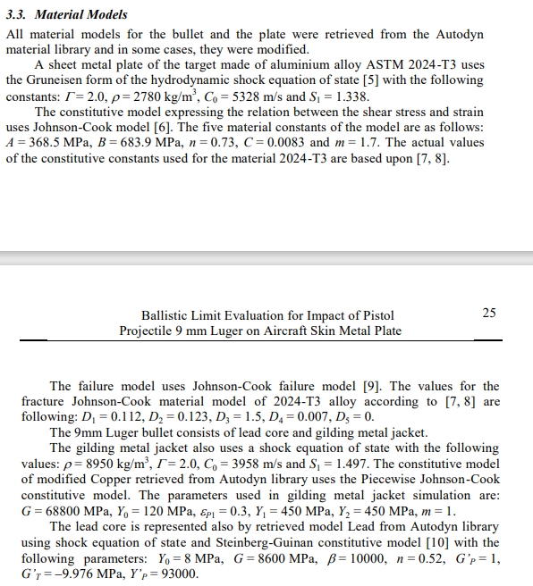
Figure – material properties for aluminium plate.
Figure – material properties for bullet gilded jacket.

Figure – material properties for bullet core.

The original literature described the impact scenario with an:
- Initial bullet velocities of 390 m/s^-1. 159 m/s^-1. 101m/s^-1.
- Plate dimensions, 200mm diameter, 1.5mm thickness.
- gravity having no substantial effect on impact at short distance thus not simulated.
- Air resistance having no substantial effect at short distance with standard 9mm ammunition thus not simulated.

Figure – material properties for bullet core.
The simulation results from Inventor 2010 exhibited a similar deformation distance to that observed in the live firing experiment, Figure -. However, it is noted that Inventor 2010 does not fully capture nonlinear deformation behaviours (splitting), thereby limiting its realism in showcasing the impact scenario comprehensively. Nonetheless, the simulation provided valuable insights into the bullet's initial velocity compared to exit and its behaviour upon striking the plate.
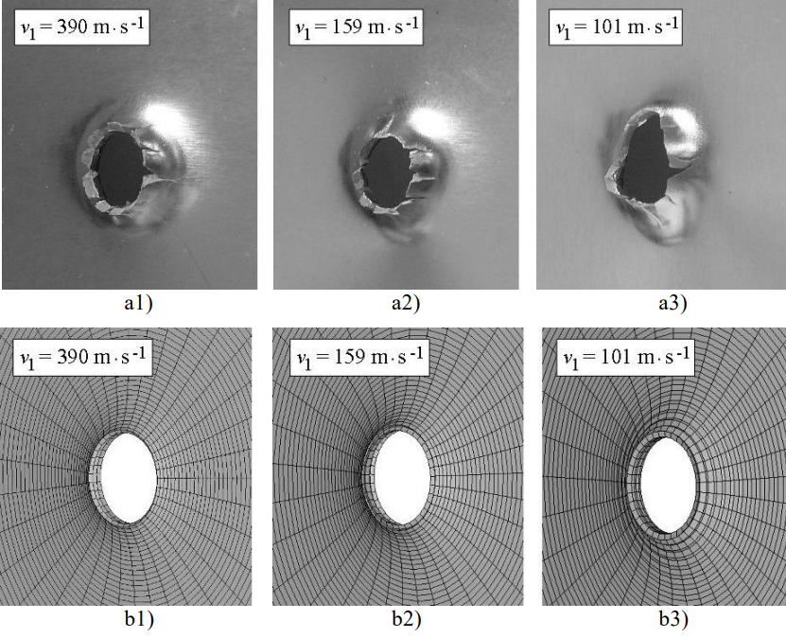
Figure – literature comparison, live firing vs INVENTOR.

The literature compares three different initial velocities, focusing on the upper and lower velocities primarily to prove the deformation effects of Inventor. As a force applied with less magnitude for an extended period should cause a larger deformation space than a high magnitude force applied faster when overcoming the shear modulus of a material as per figure .
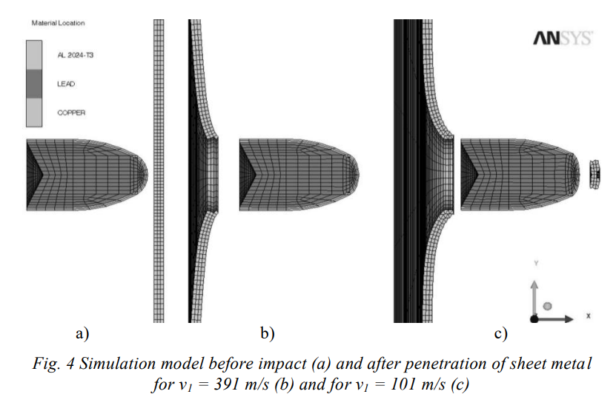
Figure – bullet prior to impact, deformation distances post bullet exit
    - Ansys comparison
ANSYS was employed with the same parameters and conditions as described in the literature example. The aim was to assess whether ANSYS’s explicit dynamics solver, could accurately represent the ballistic impact scenario and provide insights comparable to the live firing experiment.

The decision to compare the ANSYS simulation with external literature stems from the absence of accurate theoretical calculations for validating bullet impact scenarios, unlike scenarios such as wishbone testing where analytical solutions are feasible. This is due to the amount of linear and non-linear inputs causing an increasingly non-linear output e.g. high velocity motion, impact, material deformation.
      - 391 m/s impact
Firstly, material splits were compared to validate correct material deformation as per figures -
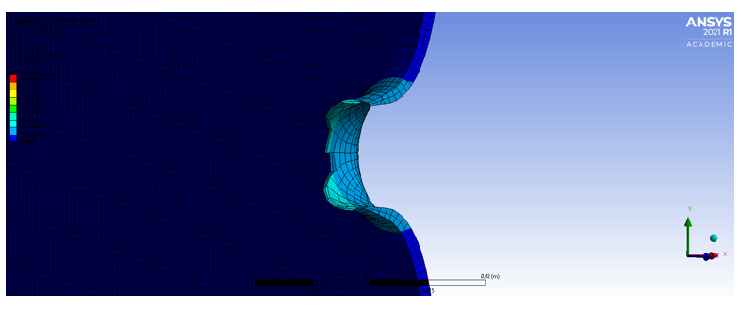
Figure – ANSYS 391m/s impact split.
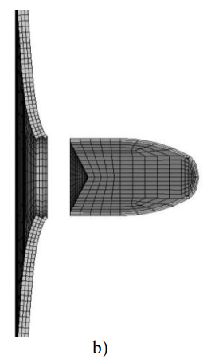
Figure – 391 m/s Inventor impact split.
In initial review it is observed that the Ansys split section has a considerably longer distance of deformation, most likely due to the inability of inventor of produce any splitting/shearing formations around the bullet exit. The ANSYS model showcases deformation in different colours and when the teal colour portions (large deformation) are ignored the deformation distance is considerably similar.
This is backed up by the live firing splitting/shearing formations compared to the ANSYS simulation, figures –
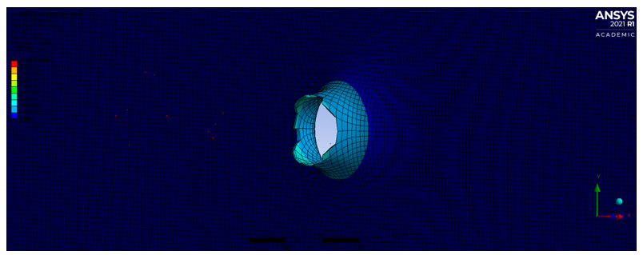
Figure – 391m/s ANSYS output side of sheet metal.
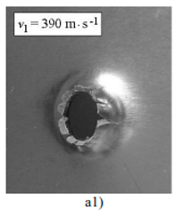
Figure – 391m/s live firing output side of sheet metal.
The above showcases that ANSYS accurately simulates deformation at bullet impact, when visually compared the splitting/shearing formations are relatively similar. Even to the points of where shearing takes place large splits at 0, 90, 180 and 270 degrees from 0, with smaller splits between these areas. Also displaying similar deformation length from 0mm. A stark contrast to figure –

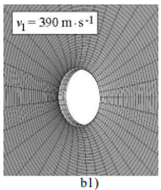
Figure – 391m/s Inventor output side of sheet metal.
      - 101m/s bullet impact
Using the slower impact velocity, we can ensure validity of the ANSYS model by adapting the velocity variable.

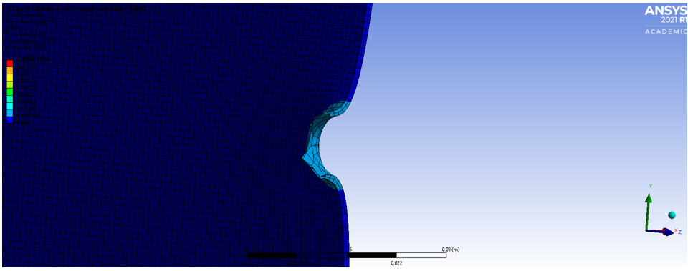
Figure – ANSYS 101m/s impact split.
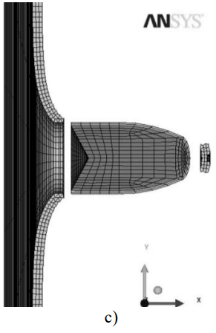
Figure – 101 m/s Inventor impact split.
The same comparison in deformation distance from splits (Figures -) can be made for the 101m/s velocity as the 391m/s, confirming our results with change of velocity. Again, backed up by deformation shape, figure –
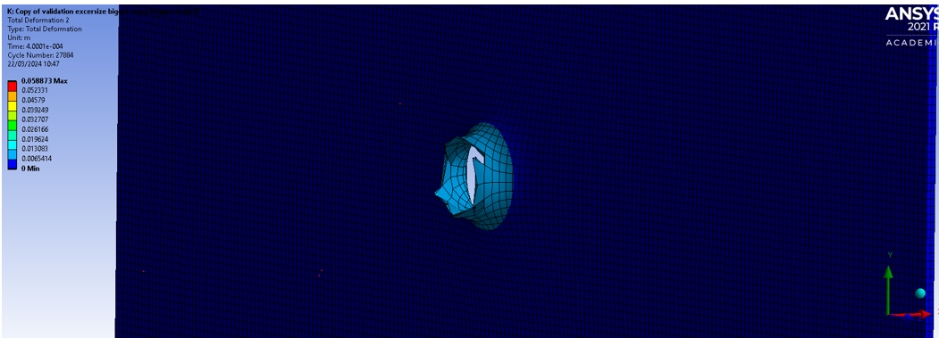
Figure – 391m/s ANSYS output side of sheet metal.
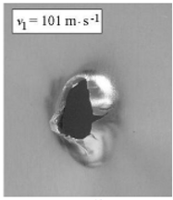
Figure – 391m/s live firing output side of sheet metal.
The Shear formations again show similarities between Figures –, with larger split areas that are expected with an extended interaction time between bullet and plate. Showing similar deformation length as per Figure –
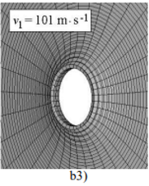
Figure – 391m/s Inventor output side of sheet metal.
This validation showcases the accuracy of ANSYS when replicating identical scenarios from live firing scenario

Major Validation 2: Comparison of ANSYS to previous Abaqus results
Two different simulation software packages (ANSYS and ABAQUS) were compared to assess the impact of material changes and evaluate simulation accuracy under supersonic projectile velocities (1200 m/s). The study simulates the impact of a fully tungsten alloy bullet (9 on an aluminium plate (AL5083H116). Using max principal tension wave formations, as well as deformation to prove validity.
Bullet geometry – 9x50mm
Plate geometry – thickness: 8mm, width: 45mm x 45mm
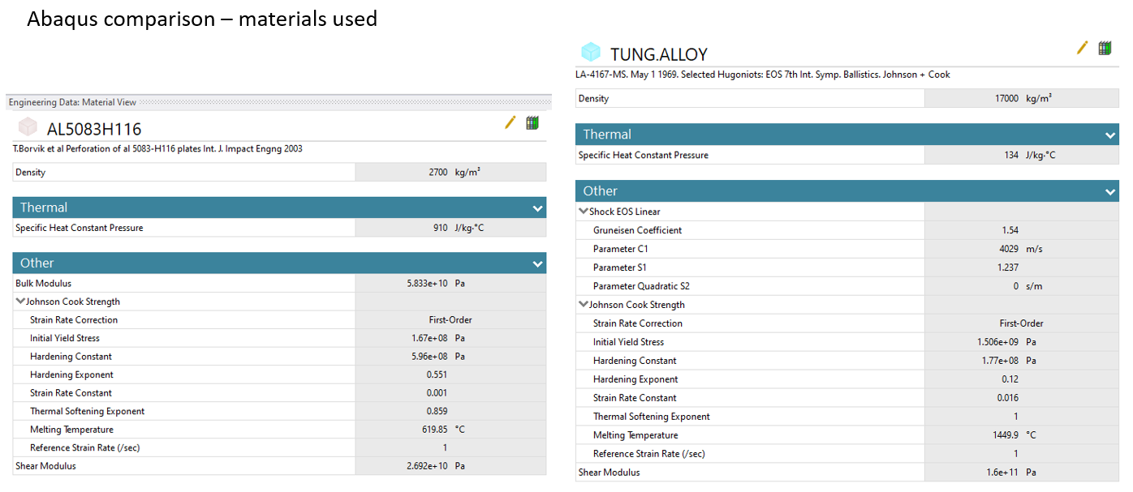
Figure – material values for bullet and plate, ANSYS material library
The Primary reason for Validation 2 is to have a second set of adapted variables from the Validation 1 to produce a general acceptance model, between the two models as well as:
- Supersonic Impact Assessment: Investigate the capabilities of ANSYS in accurately representing ballistic impact scenarios at supersonic velocity (1200m/s ≈ Mach 3.4).

An important note is that the fastest production 9mm bullet is 516m/s ≈ Mach 1.5. The purpose of validation 2 is to prove the extremes, reinforcing the quintessential scenario in validation 1 to gain general acceptance.

    - Max principle tension
      - At plate impact
Due to the quality of the Abaqus simulations the visual propagation of the waves is the focus compared to the numerical values. Figures – show the propagation of max principal tension at impact
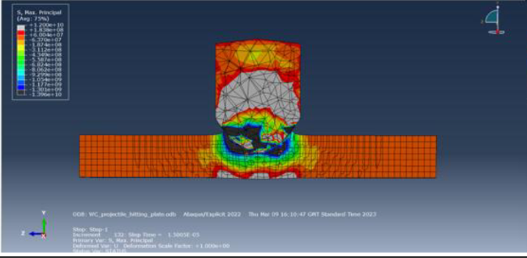
Figure – Abaqus simulation tension at impact.
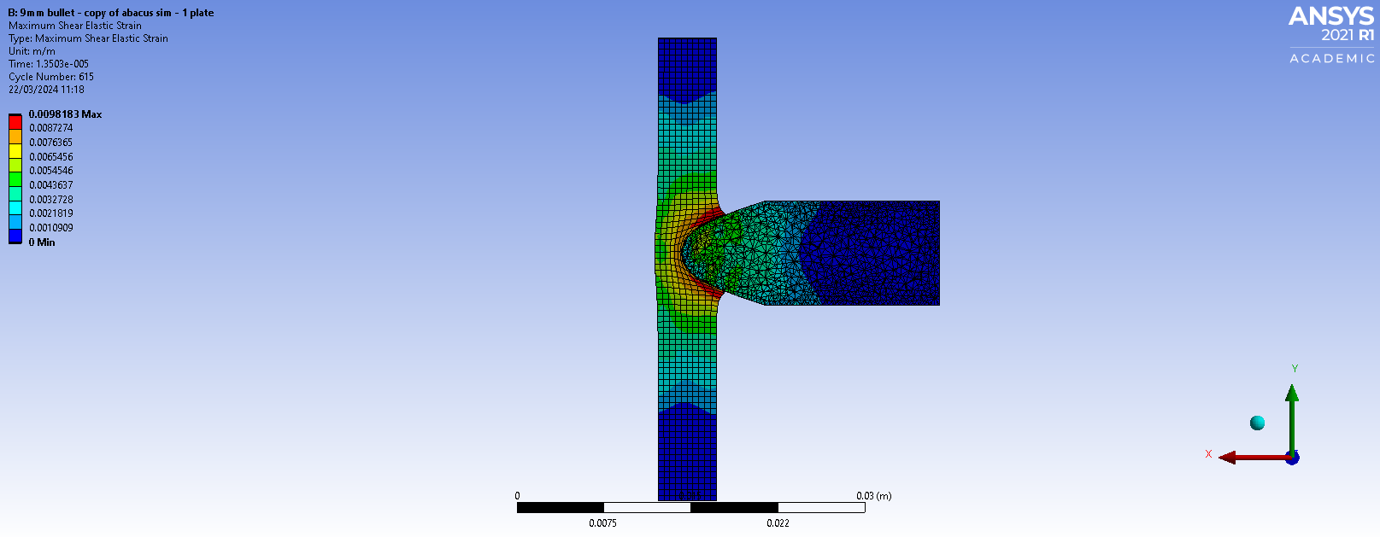
Figure – ANSYS simulation tension at impact.

Visual inspection revealed close relations in the propagation waves of maximum principal tension between the simulations, upon impact, the plate experiences concentrated tension opposite to the bullet's entry point, causing plastic deformation on the opposite side. This phenomenon occurs as high-pressure waves generated by the bullet's impact travel through the plate, creating stress concentrations in the central regions and along the outer edges. The focused tension opposite the bullet's entry results from pressure wave reflection at the plate's rear surface, producing an opposing force.

      - At projectile exit

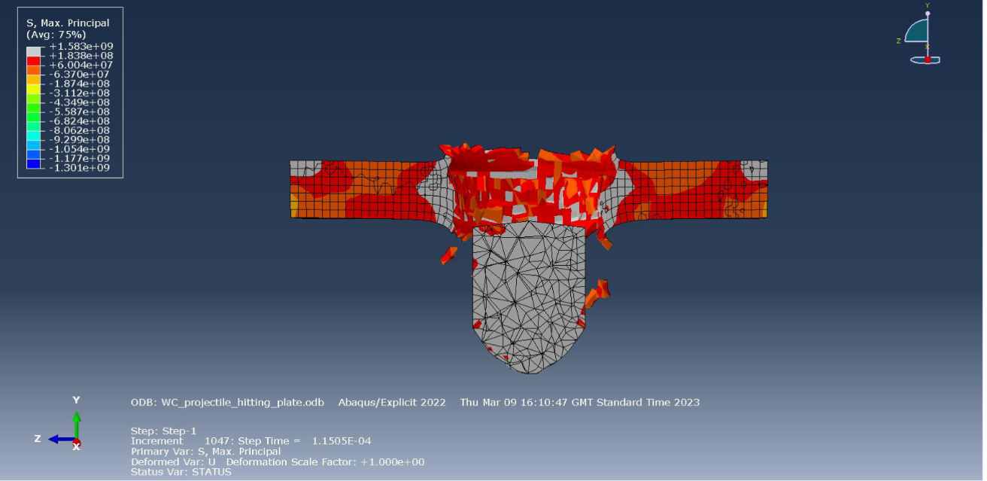
Figure – Abaqus simulation tension at projectile exit.

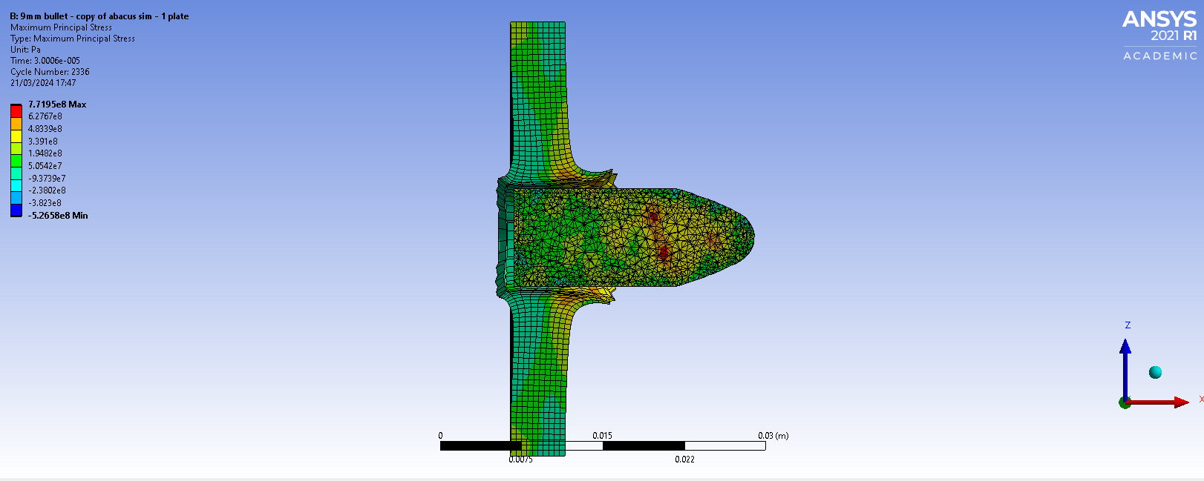
Figure – ANSYS simulation tension at projectile exit.
The tension propagation at projectile exit exhibits the same results, Figures – show both simulations show very similar tension focal points (represented by a black curve). This is due to the extension in the material where the bullet has exited as well as the bending exhibited in the plate that is causing effect on the outer edge and in the curved area.
The primary difference is the after effect on the plate, the ABAQUS simulation has shown fragmentation effects that are expected in this material whereas ANSYS has shown a large area of blowout rather than fragmentation, which is not expected with such a short material interaction, the shock exhibited on the plate at supersonic speed, should cause significant material fragmentation. However, the deformation at the entrance of the bullet is comparable between both simulations, due to material being compressed around the bullet and stretched outward to release tension within the plate.
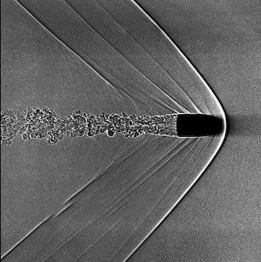
Figure – supersonic wave build up on munitions

      - Shear stress
Shear stressing displays identical reaction within the plate as per figure –
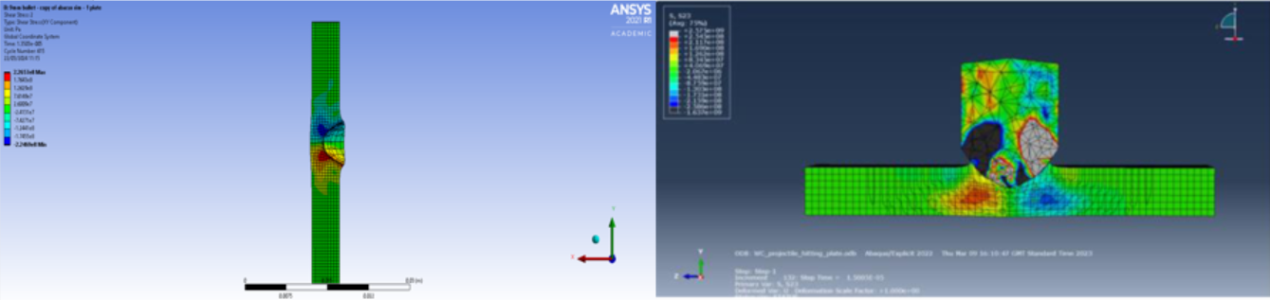
figure – shear stresses at initial impact
      - Overall
Primarily this has shown relative accuracy in simulating supersonic impact between both simulation packages, with the limitation of ANSYS being inaccurate fragmentation simulation, this could due to no air resistance being simulated, which can have effect at this speed due to supersonic wave build up around the bullet shown in figure –.

Also, the material change has exhibited promising results, with similar results shown between the two software’s bar fragmentation. With this, it is assumed a general acceptance for the main study regarding bullet velocity and material accuracy is valid.

Fixing method of plate
The fixing method of the plate is the next area of focus due to the effect it can have on propagation of impact waves as well as effects on deformation. In a live firing example a clamping is primarily on all four edges of the material but the clamps will allow some level of movement due to material tolerances.
In ANSYS any face or edge can be fixed, for this example a comparison is made in the effects of having only 2 fixed faces on the edges of the plate through the Z axis and having all 4 outer faces fixed in place.
The parameters of the simulation are the same as 3.2 and results presented in figures –

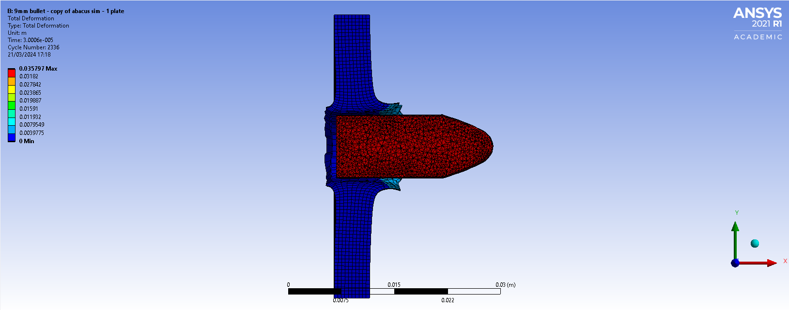
Figure – 4 points fixed

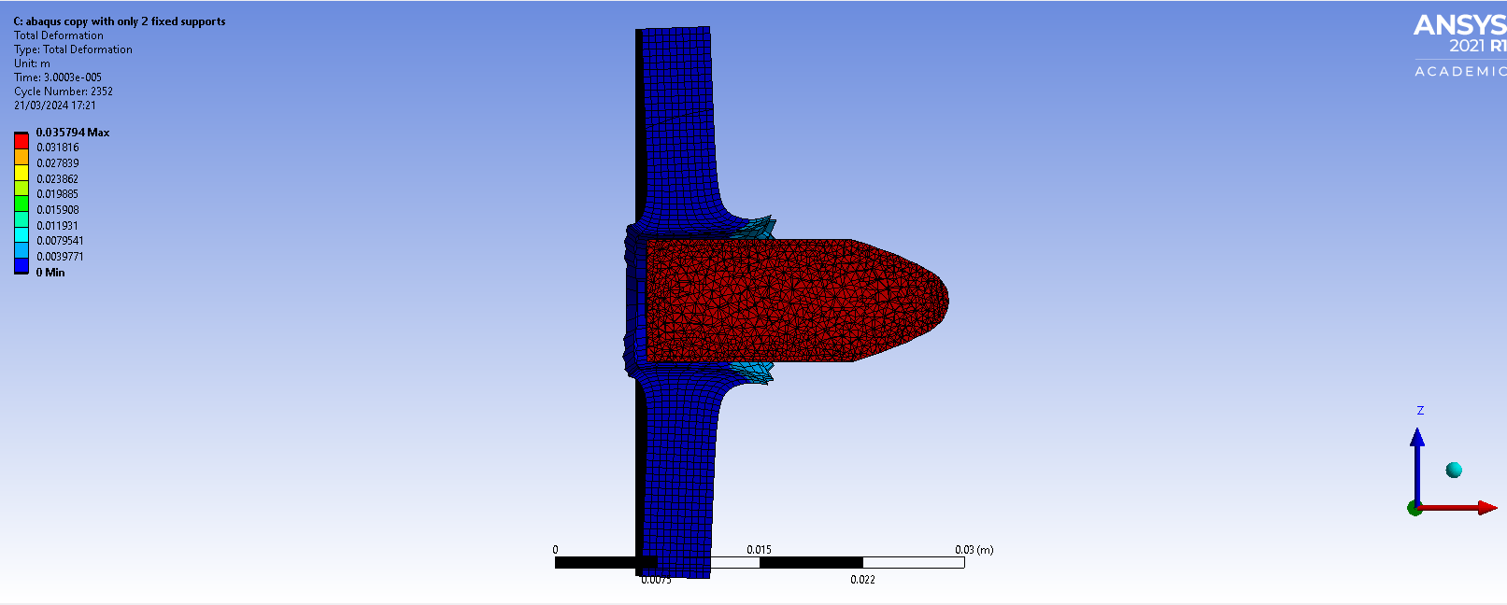
figures –

The simulations with four points of constraint demonstrated improved stability and constraint effectiveness compared to those with only two fixed points. The additional constraint points helped distribute the reaction forces more evenly across the plate, preventing excessive displacement and ensuring a more realistic representation of impact dynamics.

Visual inspection of deformation patterns revealed differences in plate response between simulations with different fixing points. The two-point constraint setup exhibited large lateral movement through the y-axis, absorbing additional kinetic energy in the plate when deforming (displayed in the dark area at the forward face of the plate. This non-symmetrical deformation and propagation of waves when meeting the fixed points at the plate edges resulted in extra energy loss in the bullet.

When comparing simulations to live firing scenarios (commonly using four fixture points), it was observed that the four-point constraint setup in ANSYS displayed a more symmetrical propagation of deformation waves and consistent plate behaviour. This configuration closely mimics the standard live firing fixture method, where some tolerance in movement is expected due to holding methods. The symmetric reaction observed in simulations with four suggests a more realistic representation of ballistic impact dynamics.

Mesh sizing and geometry:
Simulation accuracy and performance can differ under varying mesh element sizes and shapes. This exercise aimed to evaluate the influence of mesh refinement on simulation fidelity, deformation patterns, and computational efficiency.
The same parameters were used from 3.3.

    - Fine Mesh (Element Size: 0.0005):
The fine mesh exhibited enhanced visual depiction of the simulation, with detailed representation of deformation waves and the expected "blowout" effect associated with supersonic bullet impacts.
A detailed area of deformation wave throughout the plate, providing a high-resolution depiction of material response under impact conditions.
However, the fine mesh resulted in longer simulation times due to increased element count and computational complexity.
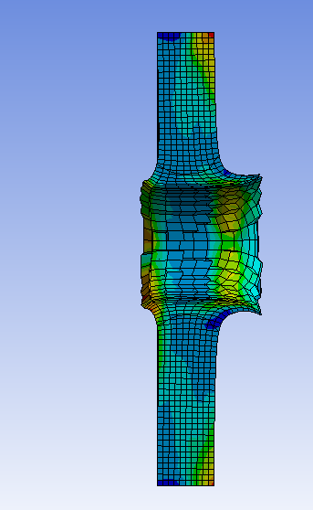
Figure – fine mesh

    - Medium Mesh (Element Size: 0.0007):
The medium mesh demonstrated comparable results to the fine mesh, with a larger section of "blowout" observed but slightly lower fidelity in deformation wave propagation.
The medium mesh captured realistic deformation patterns for an aluminium plate while maintaining reasonable computational efficiency.
The simulation using the medium mesh achieved acceptable accuracy with an average run time suitable for practical simulation scenarios.
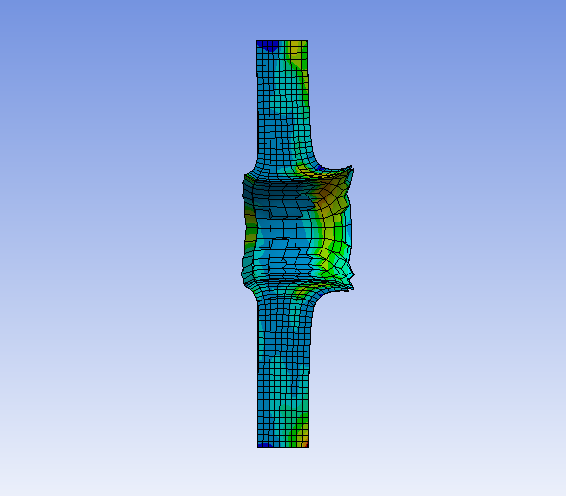
Figure – medium mesh

    - Loose Mesh (Element Size: 0.0009):
The loose mesh provided a good visual depiction of the impact scenario; however, limitations in mesh element size restricted the level of deformation available.
The coarse mesh resulted in a jagged geometric effect on deformed edges, impacting the accuracy and realism of simulation results.
Despite limitations in deformation detail, the loose mesh simulation executed in significantly less time compared to finer mesh configurations.
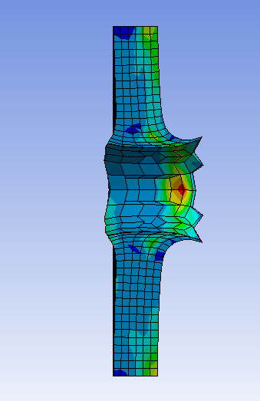
Figure - Loose mesh

    - Mesh geometry
Mesh geometry is vital for ballistic impact due to fragmentation propagation, in linear FEA, geometry primarily changes the fidelity of stress waves (when combined with mesh density) and the limiting factor for mesh geometry is the shape of the object.
Figure – displays the effect of mesh geometry on ballistic impact with mesh density of 0.0007, plate and bullet, when applied to the parameters of 3.2. When compared with 3.2 the fragmentation and deformation of the plate is jagged and disconnected, highlighting an unrealistic pattern. This was also the final frame available, displaying an error in solving when using triangular geometry for ballistic impact most likely due to unrealistic element stretching.

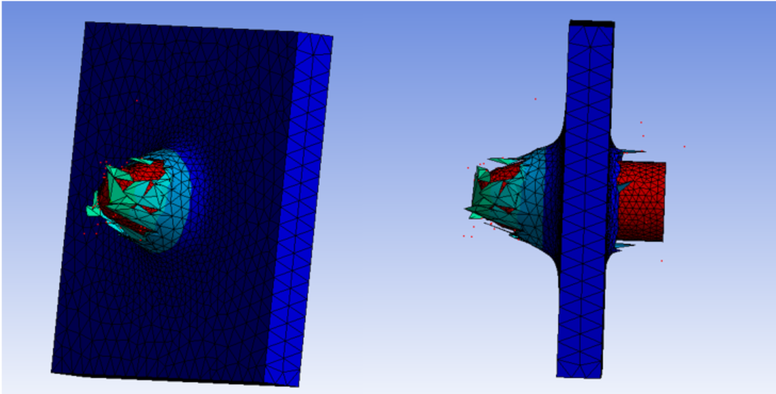

Overall validation:
Considerations Compared to Live Firing
It is important to note that while simulation software like ANSYS offers a cost-effective and controlled environment to study ballistic impacts, certain aspects inherently differ from live firing experiments. In live firing, variables like air resistance, gravity, and real-world material behaviour may influence the outcome differently compared to simulated scenarios. These differences underscore the need for careful interpretation and validation of simulation results against empirical data.

Inaccuracies of Computational Modelling
The validation exercises revealed specific limitations in computational modeling, particularly in capturing nonlinear deformation behaviors such as splitting or fragmentation. Simulation software like Inventor 2010 exhibited challenges in representing complex material responses accurately, highlighting the need for advanced solvers and material models capable of simulating high-energy impacts more realistically.

Benefits Showcased
Despite limitations, the validation exercises demonstrated several key benefits of using ANSYS for ballistic impact simulations. ANSYS's explicit dynamics solver proved effective in capturing large deformations and contact interactions, essential for modeling high-velocity impacts accurately. The software's robust post-processing capabilities allowed for detailed analysis of stress propagation, deformation patterns, and material behavior under dynamic loading conditions.

Overall Accuracy
Overall, ANSYS exhibited a high level of accuracy in simulating ballistic impact scenarios, displaying close correlations with literature benchmarks and ABAQUS FEA software.

Main Case study: the influence of varying mesh densities on multi-layer bullet impact deformation.
Throughout the validation process, it was observed that one of the largest outliers in accuracy for the ANSYS explicit solver (aside from mesh geometry) was mesh density. The mesh density had an effect in visual representation of fragmentation and deformation, each node presented within a mesh with have a calculation associated with it at each time step, each with a level of numerical rounding. This can lead to effective or ineffective change and must have a point at which it is most efficient in accurate model ballistic FEA. This case study aims to understand the compound error that can be developed within FEA calculation over a longer interaction period with variable nodes by extending work done in 3.4.
  - Simulation setup
This simulation uses the validated geometry, velocity and material specifications as set out in 3.2:
Bullet: Geometry - 9x50mm Material - AL5083H116 (figure -) Velocity – 1200m/s
Plate: Geometry – thickness: 8mm, width: 45mm x 45mm Material – TUNG.ALLOY (figure -)
Additionally the set up included four plates aligned centrally on the x-axis with a spacing of 120mm between each plate
Variable: the mesh density of each simulation –
- Fine mesh (0.0005)
- Medium mesh (0.0007)
- Loose mesh (0.0009)
Each figure following that includes all 3 mesh sizes will have these mesh densities from fine to loose (left to right).
  - Simulation results
    - Exit points at plate 1
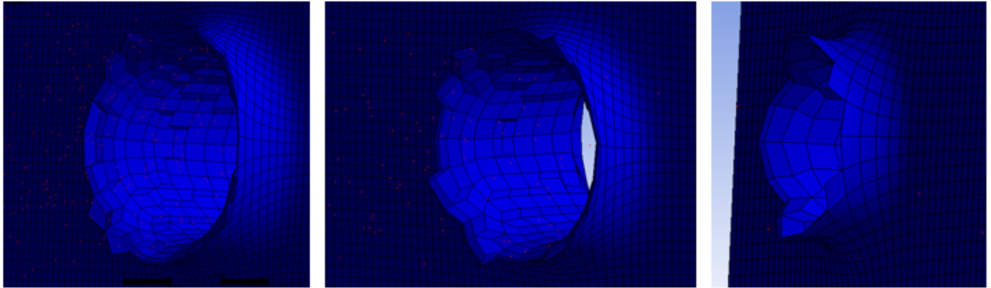
Figure – plate 1 exit point
This shows similar result to 3.4 as this is the first plate interacted, meaning there is considerably less calculation completed when compared to when the third plate interacts. This means that as long as the mesh density is relatively similar the deformation pattern/result of each will align closely with one another.
As seen in 3.4 the mesh density still plays a role in the fidelity of the deformation, where, as the mesh becomes larger the output becomes more symmetrical, showing a less accurate representation of real life impact scenarios. But, has little effect on compound error, compound error begins to show itself relatively to mesh density when the fragmentation impact from the holes generated by plate 1 impact plate 2 (reviewed in 4.2.2)
    - Fragmentation impact on plate 2
Fragmentation effects cause dilemma within ANSYS, figures – showcase fragmentation effects on plate 2 however the fragmentation itself is not displayed by ANSYS rather as a deleted node (red dot) however this isn’t effective in this scenario as these nodes disperse and are not representative of the fragmentation.
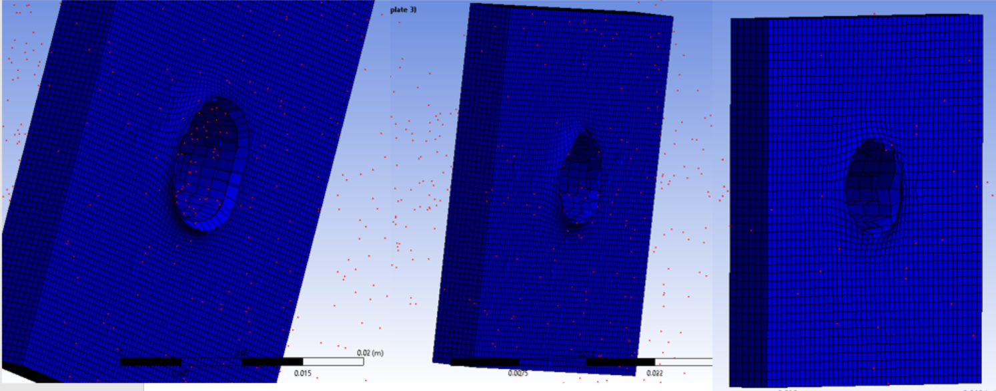
Figure – fragmentation impact on plate 2
As showcased in figure – compound error starts to accumulate as simulation time increases. The fine meshing (left) has an increased representation of fragmentation impact, which is localised around the centre of the plate itself; this is then representative with the medium mesh (centre) bar slight locational change from fragmentation impact points. The loose mesh is where this takes a steep change and fragmentation is only seen in 4-5 locations centrally around the centre of the material, which is a shear difference to that of the almost identical fine and medium meshes, suggesting an unrealistic output for loose meshing.
When comparing to published literature [1] it can be seen that finer meshing on most occasions presents a more accurate result but conversely will the computational time. At the same time, finer meshing can present issues in non-linear bullet impact when fine elements compress into the same space, causing simulation error and in some cases stop the simulation from running to completion. This mentioned by [1] as a issue within any non-linear interaction “Mesh should be well-defined with no intersections or outliers.”
This specific issue is shown in 4.2.3.

    - Computational effectiveness of complete simulation
When significant change in node interactions change such as compression or extrusion, this can cause failures within FEA. This is where the balance between tighter and looser meshing can become vital and does not come down to the fact of a finer mesh being better for computational modelling.

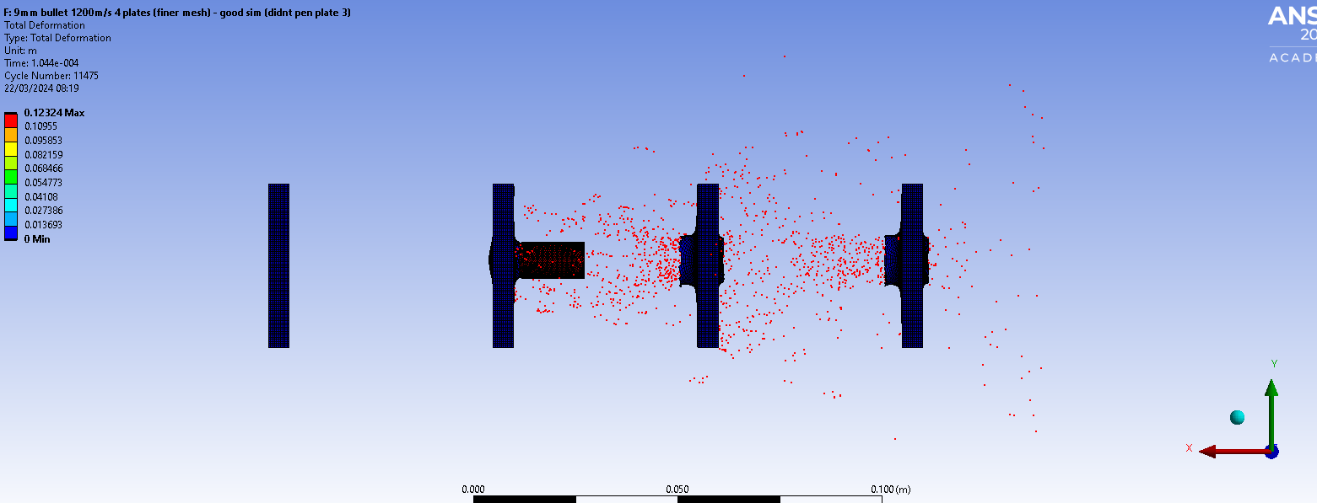
Figure – fine mesh final frame
Figure – shows that finer meshing can cause error within FEA due to incompletion of the full simulation, the most likely causation is that nodes have interacted in a way that the specified solver cannot calculate [2]. This usually means an unrealistic interaction has occurred such as, unrealistic deformation of a node, an extremely high level of energy transfer, multiple node compression into one space, etc [2].
To elevate this an adjustment in the node density needs to be made as per figure -.
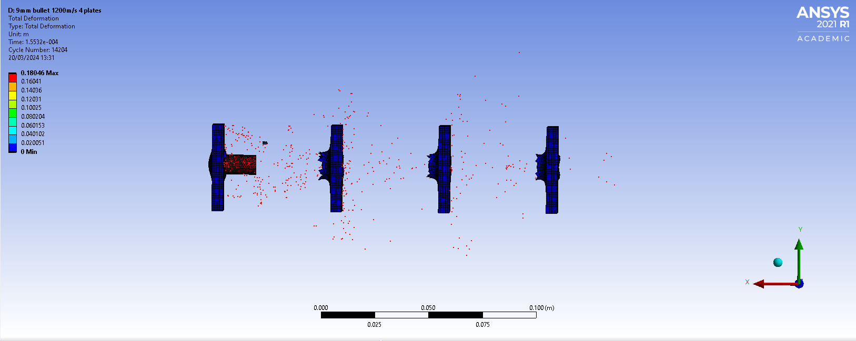
Figure – loose mesh final frame
Figure – shows that reducing mesh density can in some cases positively affect the outcome of a simulation. This has allowed the simulation to complete the requested time period and fully represent the outcome.

More deformation is shown through each consecutive plate displaying what was seen in the validation 1 that as bullet velocity decreases and interaction time increases the deformation distance of the plate increases. Confirming that although the visual representation is not as detailed, it fits in line with accurate FEA.

Additionally, fragmentation is produced visually from the third plate; larger fragments are expected from slower bullet interactions that still cause deformation. Which is also representative of similar modelling scenarios even if not directly related to ballistics [3], comparable literature showcases “in the context of high-velocity projectile impacts, it is observed that a slower velocity projectile, while maintaining sufficient kinetic energy, can produce a larger fragmentation size upon impact. This phenomenon highlights the significant influence of projectile velocity on fragmentation behaviour”.

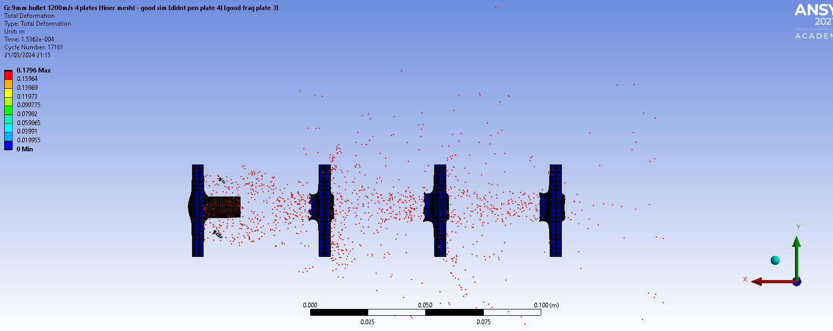
Figure – final frame medium mesh
Figure - exhibits a happy medium between the three mesh densities, exhibiting the good points of both. It has reached the final frame of simulation, has a significant amount of detail of fragmentation effects and accurately shows the effect of deceleration on deformation distance as previously stated. In comparison to the loose mesh that reached this frame an extra fragmentation piece is displayed.
This shows the level of impact small adaptions to mesh density can have on an overall simulation, lower mesh densities will have less compound error in calculation but may not display an accurate outcome and finer mesh densities may have so much compound error that the solver cannot come to a final solution [4].
    - Review
The influence of varying mesh densities on multi-layer bullet impact deformation highlights key considerations for accurate Finite Element Analysis (FEA) simulations. Mesh density impacts both simulation accuracy and computational efficiency significantly.

FEA meshing density presents a trade-off between accuracy and computational feasibility. Finer meshes offer detailed representations but increase computational demands and risk simulation failures. Coarser meshes expedite simulations but may oversimplify outcomes, resulting in less accurate representations.

Trying multiple mesh densities is essential. This approach allows researchers to find the balance between accuracy and computational efficiency that suits their simulation objectives. It helps minimize errors while preserving critical physical phenomena.

Variation in mesh density profoundly affects simulation outcomes, impacting the representation of fragmentation and deformation patterns and overall computational stability. Choosing the right mesh density is crucial for reliable and interpretable FEA results in modelling dynamic interactions like ballistic impacts.

Conclusion
Based on the comprehensive analysis conducted using ANSYS for ballistic impact simulations, several critical assessments and evaluations have been made to advance the understanding of computational modelling for high-velocity impact scenarios.

The study highlighted significant challenges in accurately modelling material behaviour under extreme loading conditions, such as ballistic impacts. Traditional material models struggle to capture complex phenomena like deformation, fracture, and energy absorption. This emphasizes the need for advanced material models and experimental validation to improve simulation accuracy.

Issues with numerical stability under rapid and transient loading conditions, particularly in high-velocity impact scenarios, were identified. Numerical instabilities can adversely affect solution convergence and computational efficiency. Addressing these challenges requires careful consideration of simulation parameters and solver settings.

Validating simulation results against experimental data remains crucial for ensuring the reliability of simulation outcomes. Variations in projectile characteristics, impact velocity, and target properties pose challenges in achieving accurate simulation-experiment correlation. Refining simulation methodologies and enhancing experimental validation techniques are essential.

The comparison between ANSYS and Abaqus displayed the capabilities and limitations of each software package in simulating ballistic impacts. ANSYS's explicit dynamics solver demonstrated effectiveness in capturing large deformations and contact interactions, whereas Abaqus excelled in representing highly nonlinear material behaviour. Understanding these differences aids in selecting the appropriate software for specific simulation requirements.

Mesh density significantly affects simulation accuracy and computational efficiency. Fine mesh configurations provide detailed representations but increase computational demands, while coarse meshes expedite simulations but may oversimplify outcomes. The study underscores the need for balancing mesh density to achieve reliable and interpretable simulation results.

Based on these findings, recommendations include systematically varying mesh densities to identify optimal configurations, integrating advanced material models to enhance simulation accuracy, and refining experimental validation techniques to improve simulation-experiment correlation. These practices contribute to advancing knowledge in computational modelling for high-velocity impact scenarios.

In conclusion, FEA should be used in conjunction with other methodologies such as live firings (in context of ballistic impact) to produce a full picture of what a dynamic system will produce when changing variables are applied to the system. FEA will never produce a perfect picture when compared to a real life scenario due to compound errors in mathematical calculation, variables compared to real life environments and materials, etc. However FEA does provide a cost effective and relatively swift baseline for what to expect of a system in a real life environment, FEA software can produce effective proof of concept in scenarios based around non-linear events.

Review of comp modelling
As a means of demonstrating how the analysis of results can be used as a critical stage of a design process, it would be recommended to make design changes to your parts/case study to generate more data sets to give more depth of analysis. Remember to critically analyse the results you generate. Comparison to published literature is always a good way of assessing how valid your simulations outputs are, even if the quantifiable values wont be the same, you can compare trends in results to published cases
- Reasoning for putting this as a separate entity to the actual main study is to be able to use both the validation exercise and the main study to say how good FEA is in accurately modeling ballistic impact. – could incroach on the conclusion though so may need reviewing.

Conclusion

Bibliography
There are no sources in the current document.

