UNDERSTANDING AND ENGAGING
IN THE
CUSTOMER EXPERIENCE

Customer Relationship Management
Emerging Themes

BUDDHI PATHAK
BMSW 5103

Table of contents

Executive Summary
- Introduction…………………………………………………………………………… Page 3
Part one
- Deliveroo …………………………………………………………………………..… Page 4
  - Customer touch points………………………………………………………… Page 5
Figure 1 - Google.com app downloads……………………………………… Page 5
Figure 2 - Apple.com app downloads……………………………………….. Page 5
  - Customer Experience and Brand Experience……………………………… Page 7
Figure 3 - Trustpilot reviews…………………………………………………. Page 7
Figure 4 - Reviews.io reviews……………………………………………….. Page 7
Figure 5 - Deliveroo ratings…………………………………………………… Page 8
Figure 6 - Trustpilot detailed reviews………………………………………... Page 8
Figure 7 - Glassdoor rider reviews…………………………………………… Page 8
- Recommendations…………………………………………………………………. Page 9
Part two
- Literature review…………………………………………………………………….. Page 10
Deliveroo’s customer experience perspective…………………………………… Page 10
Consumer customer experience perspective……………………………………. Page 11
- Conclusion…………………………………………………………………………… Page 12
- Reference List………………………………………………………………………. Page 13

- Introduction

It has become increasingly important to understand how to enhance customer satisfaction through the concept of customer experience (Jain, Aagja and Bagdare, 2017). Lemon and Verhoef (2016) and Adak, Pradhan and Shukla (2022) address that one of the top management objectives is creating a positive customer experience, and by providing an excellent one will result in more purchases, increase loyalty and gain more referrals. Furthermore, by doing so, companies will no doubt gain that competitive advantage that every company strives towards.

This business report will be carried out in two parts with the first examining how Deliveroo's customer experience fits into the following themes of 1) Customer touch points (CTP) as well as 2) Customer Experience (CE) and Brand Experience (BE) in the Information Technology industry. Deliveroo's impact on Customer Relationship Management will be critically discussed in this report, including the importance and suitability of their operations within the technology domain. Upon the findings in the report, recommendations will be put forward. The second part will include a critical literature review exploring the two important perspectives on customer experience: the perspective from the firm Deliveroo and that from co-creation. The customer experience for Information Technology firms can be improved by understanding these two concepts.

- Deliveroo

Will Shu, the founder and CEO of Deliveroo moved to London in 2013 and was amazed at how few businesses were delivering food (Deliveroo.co.uk, 2022). He made it his personal goal to bring the finest restaurants direct to people's homes by introducing ‘Deliveroo’, an online food delivery service. Deliveroo’s niche affiliated with premium restaurants that did not offer a food delivery service of their own (Deliveroo.co.uk, 2022) which was appealing to many consumers. Deliveroo expanded their market further by partnering with top supermarkets such as Waitrose, M&S, Sainsburys and Asda (Armstrong, 2022). To date, there are more than 150 thousand companies that work with the organisation, and it operates in more than ten different countries around the world (Lock, 2022). The next part will look into how Deliveroo’s customer touch points fits into their CE.

2.1. Customer touch points

The term ‘customer touch point’ (CTP) can literally refer to anything that connects a supplier with a customer or vice versa and transfers some sort of information from one party to another (Aichner and Gruber, 2017). Consumer purchases, customer service calls, payment transactions and market research studies are all examples of CTP (Kotler et al, 2019, p126). There is an increasing trend in users using mobile applications rather than browsers to access the internet (Unal, Temizel and Eren, 2017) with 88% of UK adults using a smartphone as found in Hiley’s (2022) study. An important factor to look at is Deliveroo’s app rating, it addresses a lot about user experience and enables others to see feedback on their experiences so that the public may decide whether they would like to use the app or not. Deliveroo appears to be straightforward to access either by logging onto their website or downloading the mobile phone application. Once logged in, it prompts the user to enter their postcode, in order to display the nearest food providers. At a glance, you are able to see the name of the organisation, how far they are situated, an approximate time for delivery and the review rating. Customers have the option to compare and choose from a variety of restaurants including filtering the types of cuisines, customer and hygiene ratings and dietary requirements etc. The following figures show Deliveroo downloads on Google Play (Figure 1) recorded over ten million downloads with a rating of 4.5* from 892,000 reviewers whilst Figure 2 shows Apple’s IOS downloads achieving an impressive 4.6* rating from 139,700 reviewers.

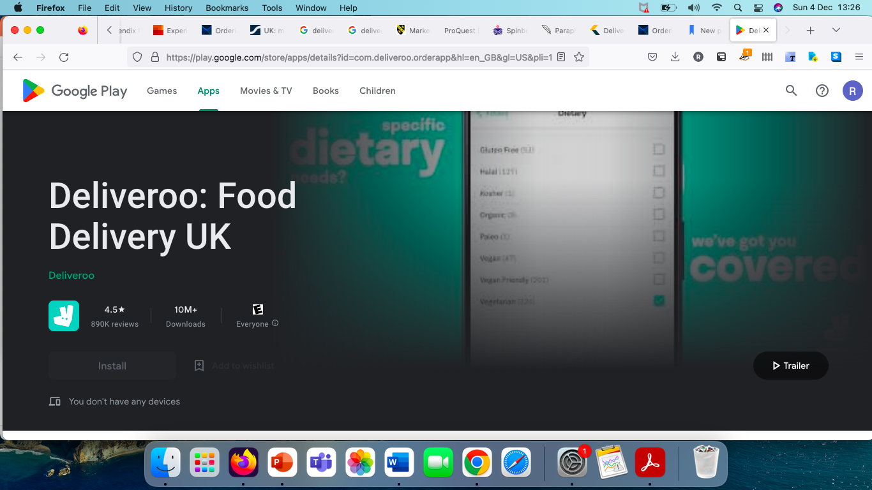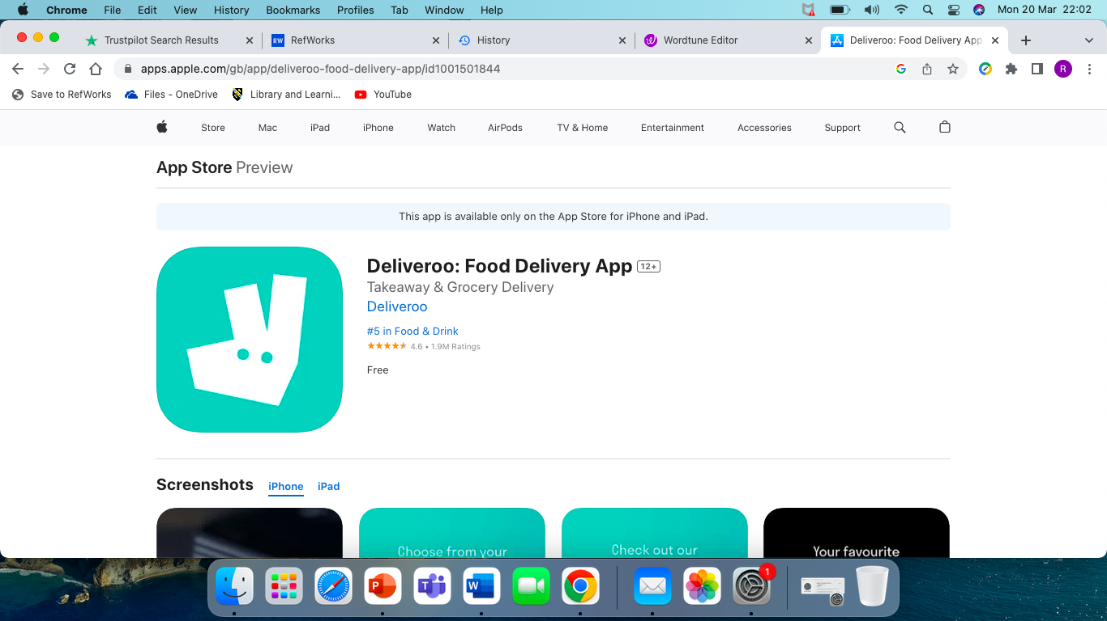
Figure 1 - play.google.com, Deliveroo, 2023 Figure 2 - apps.apple.com, Deliveroo, 2023

Looking at the figures above indicates that many customers have downloaded the app and their ratings are above average, e.g., near 5* but the question is whether they have managed to do a good job on Customer Relationship Management (CRM)? CRM can be defined as a largely used tool for acquiring new customers, retaining existing customers, and growing relationships with existing customers (Anshari et al, 2019).

As a technology-driven organisation, Deliveroo needs to provide ongoing excellent online user experiences, especially as consumers connect via these digital CTP across various channels and media. Although CTP plays an important role in maximising customer satisfaction, this could potentially distract the attention from what should be the most important issue which is the entire customer journey from beginning to end (Maechler, Neher and Park, 2016). With the widespread use of technology, not only are services being reshaped but also the way customers experience those services, as well as how their service expectations and behaviour are influenced (Furunes and Mkono, 2019). This will be discussed further in the next part of Customer Experience and Brand Experience.

2.2. Customer Experience and Brand Experience

Schwager and Meyer (2007) define Customer Experience (CE) as the perception a consumer has of any contact a company has with them. Examples of direct contact would be a customer who initiates interaction with the company after purchasing, using, or receiving services. As an indirect contact, a person comes into contact with a company's products, services, or brand in an unplanned manner, such as word-of-mouth recommendations, advertising or reviews. Brand Experience (BE) refers to a customers' emotions or responses after having used a brand for a period of time (Manzoor et al. 2022). Organisations have become increasingly focused on providing a unique and memorable BE to customers and it has become an area of interest amongst academics (Verhoef et al. 2009). Customers' loyalty and satisfaction with a brand can be improved as a result of a positive BE (Brakus, ‌Schmitt and Zarantonello, 2009). If a loyal customer had a negative experience with a Deliveroo representative, this would have an impact on their customer satisfaction as well as their loyalty, prompting the customer sharing their experience on social media where others have done the same. An accumulation of negative feedback cannot be reversed so the onus lies with the company to put things right. Trustpilot is a popular site to record user experiences with brands and customers often put their reviews of a company they have had interaction with. By sharing experiences, it can assist others in making better choices and more importantly encourage companies to improve (Trustpilot Reviews, 2023). A negative correlation in CRM can be seen in the figures below from 2 different review platforms:

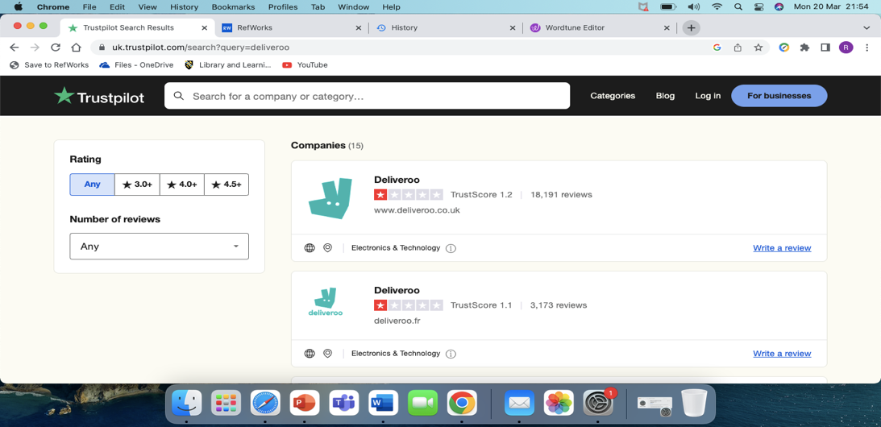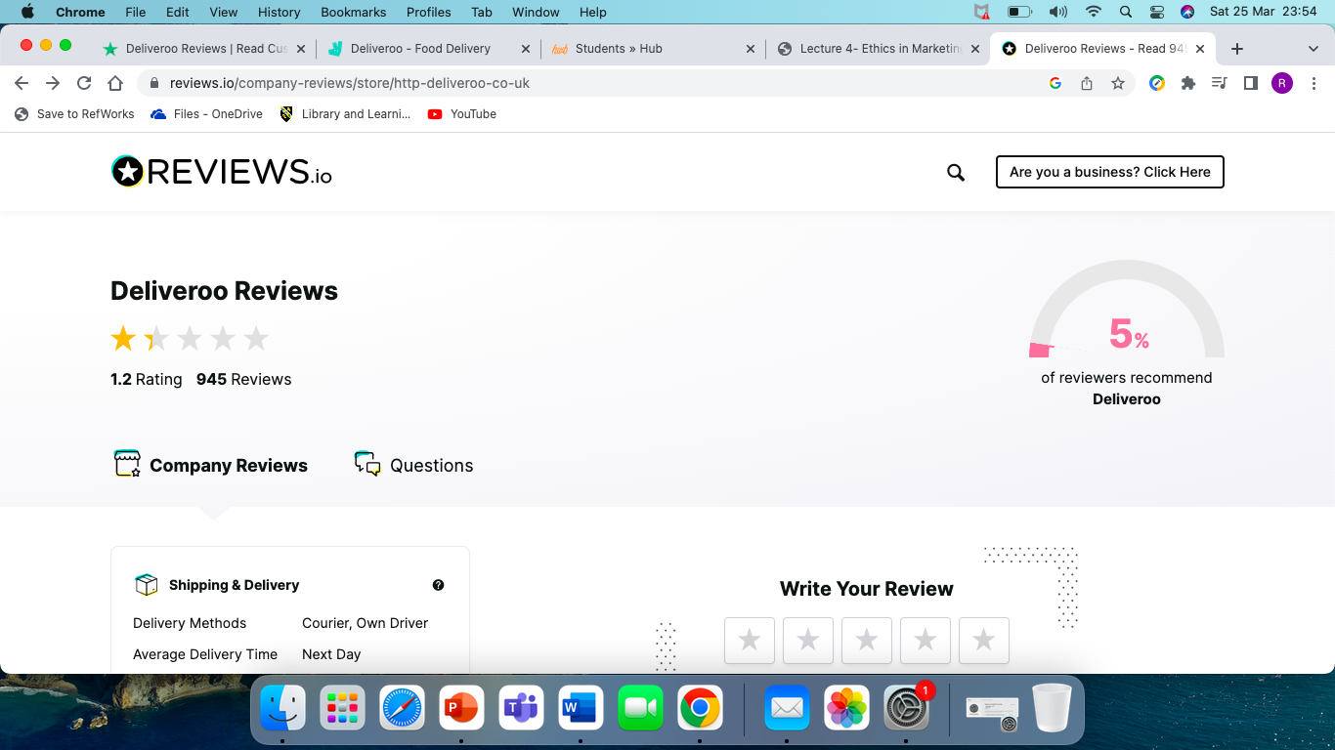

Figure 3 - Trustpilot reviews (2023) Figure 4 - Reviews.io (2023)

All of the Trustpilot reviews are not limited to the UK either, Deliveroo appear to have a negative impact on consumers worldwide as shown in Figure 5 below:
COUNTRY | RATING | COUNTRY | RATING
UK | 1.2 | Ireland | 1.1
France | 1.1 | Netherlands | 1.3
Italy | 1.2 | Australia | 1.3
Belgium | 1.5 | UAE | 1.6
Spain | 1.3 | Hong Kong | 1.6
Singapore | 1.3

Figure 5 - Deliveroo ratings (Trustpilot, 2023).
The shocking reviews read from missing items, food not being delivered at all and rude Deliveroo drivers. It is therefore quite reasonable to suggest that although many users have downloaded the app to use, Deliveroo has not been successful in maintaining good CRM. Customers are leaving negative reviews of their experience which are all the same issues:
- Missing food
- Food not being delivered
- Rude drivers

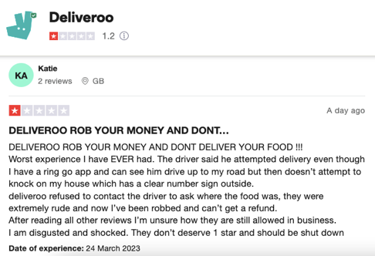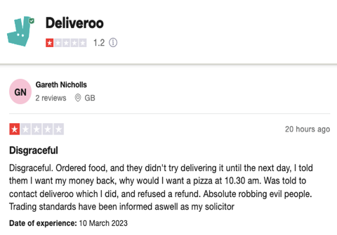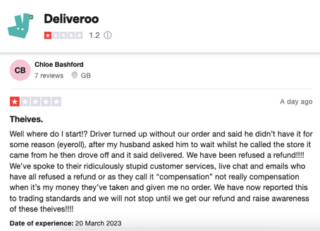
Figure 6 - Trustpilot detailed reviews (2023)

Deliveroo riders are also complaining about working for them:
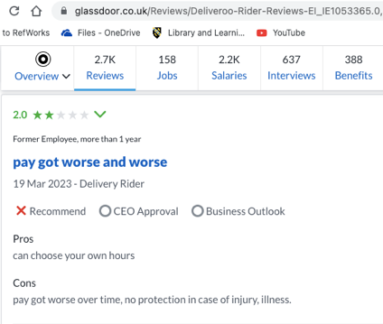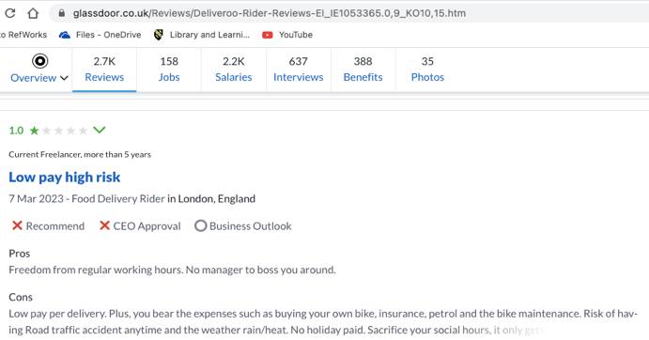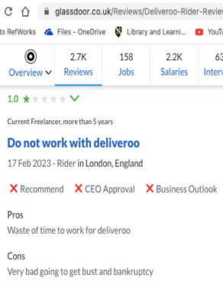
Figure 7 - Glassdoor rider reviews (2023)

- Recommendations

Deliveroo should ensure that their complaints process is quick, clear, and personalised so that feedback can be provided. By providing customers with a personal response instead of generic complaint handling processes would decrease negative emotions and the likelihood of the customer reusing the service would increase (Nottingham Trent University, 2022). Deliveroo need to give its customer’s a voice when things have gone wrong and be apologetic about their mistakes, in doing so, they will be able to rebuild a trusting relationship (Lu, Cai, and King, 2020). Although it was ruled that Deliveroo drivers were not considered workers by the UK High Court (gov.uk, 2017), Deliveroo needs to make other suitable arrangements and grant some form of employment benefits and security for their drivers. Finally, Deliveroo need to adopt quality measures in marketing. According to Kotler et al, (2017, pg. 231), quality is defined as "defect-free". Crosby’s cost of quality is recommended to use in this case, Crosby (1979) defended the importance of paying attention to customer needs and preventing product defects. According to Crosby, achieving quality costs money, but not maintaining it costs more. In Deliveroo’s case, they will lose their position in top Food Delivery Service to other competitors if action is not taken to put things right with their customers. They need to adopt better post-purchase communication with its customers to avoid the negative image on their brand. They also need to increase opportunities to digitally interact with consumers on social media platforms.

- Literature review

Deliveroo’s customer experience perspective
Monitoring CE systematically can lead to significant improvements in customer satisfaction and profitability ‌(Schwager and Meyer, 2007). Before, consumers used to physically go and collect food from the shops, nowadays it is as easy as clicking a few buttons and arranging delivery. Using online pre-orders dramatically improves the customer experience and reduces customer effort (Poncin and Walter-Malcurat, 2021). In Deliveroo’s case, as previously discovered, that although consumers were downloading the app to order goods, their customer experience had not been the best. Could this be due to the working conditions of the drivers? Lord, C. et al. (2022) states that in addition to fatigue, workers felt pressure to violate traffic regulations in order to complete work by a certain time, and they were distracted by the apps that have become an integral part of their daily lives. Furthermore, pressure was mounted on drivers to deliver food successfully without complaints and problems following the pandemic. The adoption of food delivery had accelerated more during Covid as people were not allowed to eat in food outlets (Hobbs, 2020). Tang (2019) indicated that mobile-commerce businesses rely heavily on customer trust as a key to success and sustainable growth, however scores of consumers were left distraught with bad experiences with the firm, and it is Deliveroo’s duty to uphold their marketing ethics and consumer rights. These should include providing customers with a high-quality service, prioritise truthfulness in all situations, embrace ethical values and build relationships with their consumers by enhancing their confidence in goods sold, be responsible, fair, uphold respect and transparency. Schwager and Meyer (2007) state that customers' experiences are shaped by brands embedding fundamental value propositions into every aspect of their offerings. Since Deliveroo's launch several years ago, it has lost money on every delivery it makes (Ball, 2020) but they have since made future plans to automate delivery and double their profit- margins by creating its own food offerings, customised for customers; halving food costs; and halving their own costs (Panja, 2018). Furthermore, Deliveroo needs to adopt improved IT systems, as customer review data continues to grow, a robust end-to-end framework with artificial intelligence can provide accurate customer sentiment prediction (Adak et al., 2022). Another interesting proposition is customer-centricity. A customer-centric organisation can increase its market value and success for a variety of reasons. According to marketing research and through transformational activities, a company can achieve customer satisfaction and loyalty (Fornell et al., 1996; Shah et al., 2006). A product-centric approach aims to make as many sales as possible (Shah et al., 2006; Rust, Moorman and Bhalla, 2010) whereas an organisation that is customer-centric is focused on meeting the needs of the customer. In order to meet these needs of customers, businesses need to change paradigms, among others, in the way processes and systems are designed and implemented (Shah et al., 2006).

Consumer customer experience perspective
Customers are most satisfied with meals that are delivered quickly and are as hot as possible during the meal delivery process (Van Dun et al., 2020). However, there is a lot of complexity involved in running a meal delivery service. Deliveries from one depot or a sequence of depots are made to a variety of customers who are usually spread out over a wide area by a certain number of couriers. The level of satisfaction with ecommerce platforms plays a significant role in whether or not people decide to use them - and that is one of the main factors that contributes to the success of these platforms (Thakur, 2018). When purchasing items, customers expect an improved and more consistent experience ‌(Riaz et al., 2022) including delivery on time, discounts, and being able to communicate with the staff. Furthermore, it is important for customers to feel valued and connected when they are asked for their opinions on products or experiences (Adak et al., 2022). In addition to providing insights into customer service's weaknesses, negative reviews can also become opportunities for improvement. Are Deliveroo acting on these feedbacks? What changes have they made? It is evident that nothing has actually been done because the reviews are still the same today as they were 8 years ago. According to Riaz et al. (2022), although food delivery applications have become more adaptable, academic researchers have not fully examined and considered the contributions of cognitive and affective experiences to application satisfaction and repurchase intention.

6. Conclusion

This report examined Deliveroo’s customer experience in their TP’s and BE looking to see how they had an impact on their CRM. The points highlighted were very unhappy consumers as well as delivery drivers in their service. Deliveroo need to look at these negatives and turn them into positives by rebuilding the trust of these consumers who have been let down by the service which they have received. Instead of continuously taking orders to gain more profit, they need to personalise the consumers experience by actually listening to each and every one of their customers. Only then might they be able to turn around the much negativity that has burdened their brand image. By understanding the two CE perspectives, firms involved in interacting with customers such as Deliveroo, through digital online ordering systems can improve the total CE. It has been noted from reviews of customers and delivery drivers that there is not much help from Deliveroo when problems occur. Deliveroo need to change their strategic goals in order to turn this around and become more customer-centric where they are looking after their customers by listening to them more and looking after their needs. Furthermore, by accommodating their drivers with better working conditions and not putting too much pressure on them to deliver the goods to consumers, they may find that there are not so many complaints. This may take some time to change things around but by doing so, they will be able to turn their business around with hopefully more positive feedback.

6. Reference List

Adak, A., Pradhan, B. and Shukla, N. (2022) Sentiment Analysis of Customer Reviews of Food Delivery Services Using Deep Learning and Explainable Artificial Intelligence: Systematic Review. Foods, 11(10), pp. 1500. Available at:
https://www.proquest.com/docview/2670149657?accountid=130472&parentSessionId=wC%2FsPHHdal54lAbRSV9xsMSkfeELMnRortVLhO3yc3c%3D&pq-origsite=primo
(Accessed 10th November 2022).

Adak, A., Pradhan, B., Shukla, N. And Alamri, A. (2022) Unboxing Deep Learning Model of Food Delivery Service Reviews Using Explainable Artificial Intelligence (Xai) Technique. Foods, 11(14), Pp. 2019. Available at:
https://www.proquest.com/docview/2693974634?accountid=130472&parentSessionId=r6fI9LcErNsne6QTzWGlDFXPFKxKBV7vdgcWEFRlCwc%3D&pq-origsite=primo
(Accessed: 27th March 2023).

Aichner, T. and Gruber, B. (2017) Managing Customer Touchpoints and Customer Satisfaction in B2B Mass Customization: A Case Study. International Journal of Industrial Engineering and Management, 8(3), pp. 131-140. Available at:
https://www-proquest-com.ezproxy.uwtsd.ac.uk/docview/2628309254?pq-origsite=primo&accountid=130472
(Accessed 10th November 2022).

Anshari, M., Almunawar, M.N., Lim, S.A. and Al-Mudimigh, A. (2019) Customer relationship management and big data enabled: Personalization & customization of services. Applied Computing and Informatics, 15(2), pp. 94-101. Available at:
https://www-sciencedirect-com.ezproxy.uwtsd.ac.uk/science/article/pii/S0022435916300781
(Accessed: 16th November 2022).

apps.apple.com (2023) Deliveroo: Food delivery. [online] App Store. Available at: https://apps.apple.com/us/app/deliveroo-food-delivery/id1001501844
(Accessed: 1st March 2023).
‌Armstrong, J. (2022) John Lewis Partnership - Waitrose and Deliveroo boost partnership with new rapid grocery service trial. Available at: https://www.johnlewispartnership.co.uk/media/press/y2022/waitrose-and-deliveroo-boost-partnership.html
(Accessed: 15th November 2022).
Ball, J. (2020) Deliveroo was the poster child for venture capitalism. It’s not looking so good now. The Guardian. Available at:
https://www.theguardian.com/commentisfree/2020/may/02/deliveroo-venture-capitalism-food-delivery-business-model.
(Accessed: 31st March 2023).

Brakus, J.J., Schmitt, B.H. and Zarantonello, L. (2009) ‘Brand Experience: What Is It? How Is It Measured? Does It Affect Loyalty?’, Journal of Marketing, 73(3), pp. 52–68. doi:10.1509/jmkg.73.3.052. Available at:
https://web-p-ebscohost-com.ezproxy.uwtsd.ac.uk/ehost/pdfviewer/pdfviewer?vid=0&sid=8f5bb297-3a9a-463a-9382-aece8185630e%40redis
(Accessed: 16th November 2022).

Crosby, P.B. (1979) Quality Is Free, McGraw-Hill, New York, NY.

Deliveroo. (2022) The Story of Deliveroo. Available at:
https://deliveroo.co.uk/about-us.
(Accessed: 8th November 2022).

Fornell, C. et al. (1996) ‘The American Customer Satisfaction Index: Nature, Purpose, and Findings’, Journal of marketing, 60(4), p. 7–. Available at:
https://doi.org/10.2307/1251898.
(Accessed: 30th March 2023).

Furunes, T. and Mkono, M. (2019) ‘Service-delivery success and failure under the sharing economy’, International journal of contemporary hospitality management, 31(8), pp. 3352–3370. Available at:
https://www.proquest.com/docview/2283794477?accountid=130472&parentSessionId=Et7tUp6y1aZehjzRWnH9xaz%2Fy0oRlb%2BUitX4GAkjTgM%3D&pq-origsite=primo
(Accessed:15th November 2022).

Gov.uk (2017) Case Number: TUR1/985(2016) 14 November 2017. Available at:
https://assets.publishing.service.gov.uk/government/uploads/system/uploads/attachment_data/file/663126/Acceptance_Decision.pdf
(Accessed: 2nd March 2023).

Hiley, C. (2022) UK mobile phone statistics 2022. Uswitch. Available at: https://www.uswitch.com/mobiles/studies/mobile-statistics/
(Accessed: 15th November 2022).

Hobbs, J. E. (2020). Food supply chains during the COVID‐19 pandemic. Canadian Journal of Agricultural Economics, 68(2), 171–176. Available at:
https://doi-org.ezproxy.uwtsd.ac.uk/10.1111/cjag.12237
(Accessed: 15th March 2023).
Jain, R., Aagja, J. and Bagdare, S. (2017) Customer experience - a review and research agenda. Journal of Service Theory and Practice, 27(3), pp. 642-662. Available at:
https://www.proquest.com/docview/1891344496/fulltextPDF/243EE67263A84999PQ/1?accountid=130472
(Accessed: 3rd November 2022).

Khan, I. and Rahman, Z. (2016) ‘E-tail brand experience’s influence on e-brand trust and e-brand loyalty’, International journal of retail & distribution management, 44(6), pp. 588–606. Available at:
https://www.proquest.com/docview/2116066788?accountid=130472&parentSessionId=vajgon12g94yZuVDZB%2BnOEOruAKu%2F1Jbic3Pk7NoA%2Fg%3D&pq-origsite=primo
(Accessed: 16th November 2022).

Kotler, P. et al. (2020) Principles of Marketing. Eighth European Edition. Harlow, Pearson. Available at:
https://ebookcentral.proquest.com/lib/trinity/reader.action?docID=5978379
(Accessed: 3rd March 2023).

Kotler, P. T, Armstrong, G, Harris, L. C, and He, H. (2019) Principles of Marketing, Pearson Education Limited, Harlow, United Kingdom. Available at:
https://ebookcentral.proquest.com/lib/trinity/reader.action?docID=5978379
(Accessed: 11th November 2022).

Lemon, K.N. and Verhoef, P.C. (2016) ‘Understanding Customer Experience Throughout the Customer Journey’, Journal of marketing, 80(6), pp. 69–96. Available at: https://doi.org/10.1509/jm.15.0420.
(Accessed: 3rd November 2022).

Lock, S. (2022) Topic: Deliveroo, Statista. Available at: https:£www.statista.com/topics/10043/deliveroo/
(Accessed: 10th November 2022).

Lord, C. et al. (2022) ‘The sustainability of the gig economy food delivery system (Deliveroo, UberEATS and Just-Eat): Histories and futures of rebound, lock-in and path dependency’, International journal of sustainable transportation, ahead-of-print(ahead-of-print), pp. 1–13. Available at:
https:£doi.org/10.1080/15568318.2022.2066583.
(Accessed: 8th March 2023).

Lu, L., Cai, R. and King, C. (2020) ‘Building trust through a personal touch: Consumer response to service failure and recovery of home-sharing’, Journal of business research, 117, pp. 99-111. Available at:
https://www-sciencedirect-com.ezproxy.uwtsd.ac.uk/science/article/pii/S014829632030357X
(Accessed 29th March 2023).

Maechler, N., Neher, K. and Park, R. (2016) Creating value through transforming customer journeys. [online] McKinsey & Company. Available at: https://www.mckinsey.com/~/media/mckinsey/industries/public%20and%20social%20sector/our%20insights/customer%20experience/creating%20value%20through%20transforming%20customer%20journeys.pdf
(Accessed: 15th November 2022).

Manzoor, U., Baig, S.A., Sami, A. and Sajjad, I. (2022) The Impact of Brand Experience, Service Quality, and Perceived Value on Word of Mouth and Repurchase Intentions. Antecedents and Outcomes of Employee-Based Brand Equity. Hershey, PA, USA: IGI Global, pp. 198-218. Available at:
https://www-igi-global-com.ezproxy.uwtsd.ac.uk/gateway/chapter/full-text-html/305619
(Accessed: 17th November 2022).

Nottingham Trent University. (2022) Listen, respond, say sorry – food delivery customers reveal how to make it right after failures in service. Available at:
https://www.ntu.ac.uk/about-us/news/news-articles/2022/09/listen,-respond,-say-sorry-food-delivery-customers-reveal-how-to-make-it-right-after-failures-in-service
(Accessed: 2nd March 2023).

Nunn, J. (2021) Covid should have been a boon for Deliveroo – but it still hasn't turned a profit. The Guardian. Guardian News and Media. Available at: https://www.theguardian.com/commentisfree/2021/mar/31/covid-boon-deliveroo-still-hasnt-turned-a-profit
(Accessed: 25th March 2023).

Pang, X., Shang, Y. and Song, J. (2022) An Analysis of Deliveroo’s Operation Strategy and Food Takeaway Industry. Available at:
www.atlantis-press.com. doi:10.2991/aebmr.k.220307.023.
(Accessed: 16th November 2022).
‌
Panja, S. (2018) Deliveroo plans to make its own food and replace chefs and riders with robots. Eater London. Available at:
https://london.eater.com/2018/3/29/17175482/deliveroo-future-plans-robots-profits-investors.
(Accessed: 17th March 2023).

play.google.com. (2023) Deliveroo: Food Delivery - Apps on Google Play. Available at:
https://play.google.com/store/apps/details?id=com.deliveroo.orderapp&hl=en_GB&gl=US (Accessed: 1st March 2023).

Poncin, I. and Walter-Malcurat, J. (2021) DiVA Digitala Vetenskapliga Arkivet. Jönköping University. Available at:
https://www.diva-portal.org/smash/get/diva2:1562405/FULLTEXT01.pdf
(Accessed: 10th March 2023).

Reviews.io. (2023). Deliveroo reviews. Available at:
https://www.reviews.io/company-reviews/store/http-deliveroo-co-uk
(Accessed: 25th March 2023).
‌Riaz, H., Davidaviciene, V., Hassaan, A. and Meidute-Kavaliauskiene, I. (2022) Optimizing Customer Repurchase Intention through Cognitive and Affective experience: an insight of food delivery applications. Sustainability, 14(19), pp. 12936. Available at:
https://www.proquest.com/docview/2724324818/2C501F35D08449CPQ/4?accountid=130472
(Accessed 29th March 2023).

Rust, R.T., Moorman, C. and Bhalla, G. (2010) Rethinking Marketing. Harvard Business Review. Available at:
https://hbr.org/2010/01/rethinking-marketing
(Accessed: April 30, 2023).

Schwager, A. and Meyer, C. (2007) Understanding Customer Experience. Harvard Business Review. Available at
https://hbr.org/2007/02/understanding-customer-experience
(Accessed: 4th November 2022).

Shah, D. et al. (2006) ‘The Path to Customer Centricity’, Journal of service research : JSR, 9(2), pp. 113–124. Available at:
https://doi.org/10.1177/1094670506294666.
‌(Accessed: 30th March 2023).

Tang, A. K. (2019) A systematic literature review and analysis on mobile apps in m-commerce: Implications for future research. Electronic Commerce Research and Applications, 37(1), 100885. Available at:
https://doi-org.ezproxy.uwtsd.ac.uk/10.1016/j.elerap.2019.100885
(Accessed: 16th March 2023)

Thakur, R. (2018) ‘Customer engagement and online reviews’, Journal of retailing and consumer services, 41, pp. 48–59. Available at: https://doi.org/10.1016/j.jretconser.2017.11.002.
(Accessed 30th March 2023).

Trustpilot. (2022) Electronics & Technology Reviews. Available at: https://uk.trustpilot.com/review/www.deliveroo.co.uk?sort=recency&stars=1
(Accessed: 14th November 2022).

Trustpilot Reviews. (2023). Experience the power of customer reviews. Available at:
https://uk.trustpilot.com/
(Assessed: 1st March 2023).

Unal, P., Temizel, T.T. and Eren, P.E. (2017) What installed mobile applications tell about their owners and how they affect users’ download behaviour. Telematics and Informatics, [online] 34(7), pp.1153–1165. doi:10.1016/j.tele.2017.05.005. Available at:
https://www-sciencedirect-com.ezproxy.uwtsd.ac.uk/science/article/pii/S0736585317300497
(Accessed: 16th November 2022).

Van Dun, C.G.J. et al. (2020) Customers Like It Hot and Fast - Incorporating Customer Effects into the Meal Delivery Process. Available at: https://www.semanticscholar.org/paper/Customers-Like-It-Hot-and-Fast-Incorporating-into-Dun-Fehrer/fa90a87965e8418e4cc90ca55f625b46d417e3a6
(Accessed: 30th March 2023).

Verhoef, P.C. et al. (2009) ‘Customer Experience Creation: Determinants, Dynamics and Management Strategies’, Journal of retailing, 85(1), pp. 31–41. Available at:
https://www.proquest.com/docview/228627521?accountid=130472&parentSessionId=bfy5ozozhFXBttZYw1owLixwl2I%2BFV8Kh9CQYpCOjHw%3D&pq-origsite=primo
(Accessed: 16th November 2022).

‌

