
Skills for the Workplace
Module Assignment Submission
Student Name: | Nicola Pritchard
Student Number: | 1811455
Module No: | BMSK4006
Module Title: | Managing Enterprise in the 21st Century

Statement of Confirmation of Authenticity
By the act of making this submission, the student declares that this is the work of the student named above. The work has not, in whole or in part, been knowingly presented elsewhere for assessment, or where assessment has been built on a previous assessment, this has been identified. Where materials have been used from other sources it has been properly acknowledged. If this statement is untrue, the student acknowledges that an assessment offence has been committed.
Attention is drawn to the plagiarism and unfair practice policies of both the University and of ILM.
Table of Contents

Managing Enterprise in the 21st Century 1
Introduction 3
Managing Enterprise in the 21st Century Reflection 4
1.0 Reflective Review 4
2.0 Reflection on Skills Learnt 8
Conclusion 10
References 11

Introduction

Throughout the assignment I will be able to work as a team to deliver a business plan presentation. I will be reflecting back on the whole experience and using my skills I have learnt and putting them into practice to achieve a common goal.

Managing Enterprise in the 21st Century Reflection

Reflective Review

Using Gibbs, G. (1988) reflective method to write an in-depth reflection reviewing and how I worked within a group to complete a business plan.
I was put into a group, the group consisted of 3 individuals NP (me), NB and JA Team leader, we were given the task to think of an interesting business idea and complete a business plan. The business plan which will be presented to our lecturer at the end of the module.
Having worked in a team with JA and knowing how uninvolved JA is in group work, made me very concerned and immediately knew I would have to be very proactive and motivating they group. I was not aware of JA’s leadership skills and offered my assistance straight away, to ensure JA I was fully supportive of her being team leader.
Referring back to Tuckman, B. and Jensen, M. (1977) Stages of Group Development Theory, I had an understanding of the stages and how to put the stages into practice to help develop our group into a team. Knowing I had time to do this and acting on this and putting it into practice helped me and my team understand how to develop into a group. The forming staged had already developed because we have been studying together for nearly a year and knowing each others weakness and strengths.
I knew the group had a month to meet up or discuss potential business ideas before Residential Weekend. I set up a Whatapp group in order to communicate and share ideas and move onto storming stage. I offered ideas to the group and asked for feedback, on times I found the communication skills of others not very effective and this frustrated me. Conflict did happen and I expressed how I felt and JA team leader did not offer support, ideas or any form of communication or leadership at this stage.
A week before Residential Weekend, I was informed by a team member they were unable to attend. I was happy I had been informed but I was unhappy that the team leader did not communicate with me and this built up more conflict.
Using the skills I have learnt and understanding how effective communication and how Peter Morgan (Morgan, 2017) describes the importance of effective communication in the workplace and how the context of the communication cycle is used by individuals. I felt this was holding myself and the group back.
JA contacted me a few days before residential via Whatsapp expressing her worries, of the unknown. I maintained being supportive and as I have completed the Belbin.com. (2019) Team Roles previously I knew I was assertive but encourage and able to help JA guide the team.

Arriving at the campus for residential was very daunting for me, I had not been away from my family for that amount of time and was walking into the unknown not knowing what was expected of me. I met up with my fellow peers and realised we all felt the same, which was a relief for me.
Once I had signed for my room key and took my belongings to my room, I made my way to the first class following the itinerary. I sat with Bridgend Cohort but in our groups. Myself and JA sat together. Once I received the check list, I made notes against the list to what I felt would suit our strengthens. I communicated via Whatsapp with NB who was unable to attend, involving and sharing information with NB.
Knowing JA is passive aggressive, was an advantage to me and gave me an understanding how to approach and keep her interested in conversation.
I found the classes were very organised and interesting, due to different lecturers. Myself I felt I learnt a lot from the different communication styles delivered by the lecturers and a verity of information. I felt I was able to network with the lectures and cohorts. I felt I was on my own, as JA team leader did not contribute towards delegating sections of the business plan. I encouraged and suggested different sections to the team leader and JA was in agreement.
Over the process of the residential, I felt I was doing the whole project on my own. With no communication from the team leader JA and little from NB. I was making my own notes and networking to gather information from lecturers.
Once I arrived back from residential I circulated a survey using “surveymonkey” via social media, I had previously used this method and found it successful to show results. I informed my team and asked them to share as we live away from each other to reach further afield.
I continued to communicate and suggest meeting times and dates, but JA was not communicating. NB was very supportive and we began devising a plan to concentrate on our own sections. I continued to suggest dates, knowing once we had met we could move onto the Norming stage and motiving JA, explaining we have a common goal and myself and NB want to achieve it together.
Understanding I am assertive and part of being assertive is putting myself forward and taking responsibility for the team to achieve our goal. I decided to privately speak to JA and expressed my concerns, as we had not met as a group, did not have clear instruct of what we were meant to be contributing to the business plan. I explained I was also concerned for her well being. JA expressed her appreciation of my contact and decided it was best for the team to step down and for me to become team leader. I advised JA to speak with the lecturer and also explained I would make contact to express my concerns.
I contacted lecturer to explain and expressed my concerns, with only 2 weeks left till deadline, my own mental health was failing. NB was also feeling stressed and I felt a change needed to be made. My own view, I would have not been put in this situation if I was completing a task within my own workplace as this would have become a disciplinary.
After speaking with my lecture, changes were made and I became team leader, NB was offered to become team leader but declined. I felt more stressed because I knew I had to encourage, motivate and start the norming stage straight away.
My confidence and communication skills have improved since I have started university, I felt with the support of NB I was able to guide the team to performing stage and achieving our goal.
I set a meeting date, during the meeting I set deadlines, we had discussion and shared ideas. NB supported me keeping JA interested, motivated and shared the responsibility of collecting all the information. NB I appointed Finances Director, NB felt this was a strength because he participates in finance in his current workplace. JA currently runs her own business and felt Operations Director would suit her skills.
I was appointed Marketing and Sales director and I researched all areas, I shared information with my team to enable them to complete their section.
During my research I gathered primary and secondary research, this included contacting local companies to provide advertising cost, fixtures and fittings, location, premises, target market and competitors. I gathered all the information and translated it onto the business plan including all the evidence. I made a mistake and did not reference the business plan. I took the view of not treating it as an assignment but as an actually business plan.
Unfortunately NB had personal issues and could not attend the presentation, as team leader I was more concerned about NB’s well being and health. I explained to JA only the relevant details needed. JA was very concerned and as a team we decided it was in our best interest to postpone the presentation until wait till we could all attend.
I spoke to our lecture who was aware and we decided it was in our best interest to postpone.

Performing Stage –
We had our individual sections to explain how the business would be viable. We performed as a team and achieved our goal.
I felt I communicated well and enjoyed the experience of explaining how the business will be viable and potential investors have shown an interest to bring more custom to their business. I delegated myself to put the business plan together, once I received all information from JA and NB I was able to collate and NB arranged to print and bind hard copies.
Overall as a team we performed even with the plan not going to plan. A plan as you see it will not always pan out that way, we over come this as a team.

Reflection on Skills Learnt

Using a Personal Development Plan (inserted below) I have a understanding of my own skills, how I have improved and developed. Comparing current PDP and first assignment PDP shows improvement of skills. Gap Analysis – see appendix C, and the evaluation sheet enables me to improve my communication skills.
Current PDP
What do I want to learn? | What do I have to do? | What support and resources will I need? | How will I measure success? | Target date and review
Public Speaking | Deliver a successful speech/ presentation | Supporting team / colleagues | Feedback and achieving a presentation | Ongoing
Conflict management | Leading a team to achieve their goal. | Supporting team / understanding each other. | Achieving goal | Ongoing
Communication Skills | Using effective communication to lead a team to success | Understanding your teams weaknesses and strengths | Feedback from team and achieving plan. | Ongoing

Past PDP
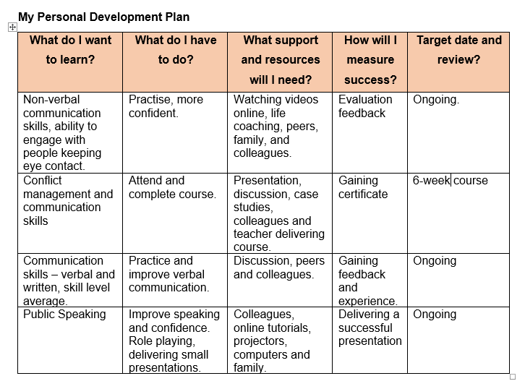
Completing personal development plans and enforcing them has improved my skills. I have an understanding how I fit into a team and how I can continue to improve my skills.

Conclusion

Working as a team and understanding my own role and communications skills will enable me to be self-aware of how I am communicating.
From my own experience I do feel I can step in and lead a team under pressure, I am also comfortable taking instruction and supporting a team leader. I don’t feel being self employed is for me, as it can be lonely, very pressured and partnerships can dissolve through conflict and other means.
I feel from completing this assignment I have an greater understanding of how to start up a business and I feel this assignment I could have completed on my own and would have felt less pressured without relaying on team members to provided information.

References

Belbin.com. (2019). The Nine Belbin Team Roles. [online] Available at: https://www.belbin.com/about/belbin-team-roles/ [Accessed 26 Apr. 2019].
Gibbs, G. (1988) ‘Learning by doing: A guide to teaching and learning methods’. London: FEU
Morgan, P. (2017). The business student's guide to study and employability. London [etc.]: SAGE Publications, pp.245 - 246.
Surveymonkey.com. (2019). Log in to your account. [online] Available at: https://www.surveymonkey.com/analyze/pTb6CqKpJvNipR1pbSKxzMV1pGkErjUGg9HXAeA1ENk_3D?tab_clicked=1 [Accessed 20 September 2019].
Tuckman, B. and Jensen, M. (1977). Stages of Small-Group Development Revisited. Group & Organization Studies, 2(4), pp.419-427.

