Lecturer: Riaz Bhatti
Student: Tsonyo Todorov
ID: 2021609
Date: 27/07/2024

Management Economics

(LCBB5008)


Assignment 1

Table of Contents
Introduction 2
COVID-19 Rules of Doing Business 2
Supply Shortages 3
Increased Demand 3
Price Changes 4
Economic Uncertainty 4
Brexit Impact 5
Resolving Economic Problems 5
Factors Influencing Demand 6
Economic Diagrams 6
Diagram 1: Shifts in Demand Curve 6
Diagram 2: Shifts in Supply Curve 7
Price Elasticity of Demand (PED) 9
Conclusion 13
References 14

Introduction
The COVID-19 pandemic has fundamentally altered the global economic landscape, disrupting supply chains and altering demand patterns across various industries (Martin, Sancez and Wilkinson, 2023). This essay examines the profound impacts of the pandemic on the UK supply chain and demand, highlighting the fundamental economic problems it has introduced. By analyzing market equilibrium, price elasticity, and the laws of supply and demand, this essay offers insights into the economic challenges posed by the pandemic and suggests strategies for businesses to navigate these turbulent times.The COVID-19 pandemic has created several economic challenges that have disrupted the UK supply chain and demand. These challenges include changes in the rules of doing business, supply shortages, increased demand, price fluctuations, economic uncertainty, and the impact of Brexit (Jones, Palumbo and Brown, 2021).

COVID-19 Rules of Doing Business
The onset of the COVID-19 pandemic necessitated the implementation of stringent health protocols and lockdown measures to curb the spread of the virus. These measures included social distancing, mandatory quarantines, and restrictions on non-essential businesses. While crucial for public health, these protocols significantly impeded production and distribution processes, leading to operational inefficiencies. Factories operated below capacity due to reduced workforce availability, and transportation networks faced delays and disruptions. Consequently, businesses incurred increased costs due to the need for additional health and safety measures, reduced productivity, and logistical challenges (Zhou and Kan, 2021).During the pandemic, many businesses had to adapt to new ways of operating. For instance, companies implemented remote working where possible, which significantly altered the demand for office space and commercial real estate. Retail businesses had to shift to online platforms, which required investments in digital infrastructure and logistics. The hospitality and tourism sectors were among the hardest hit, with travel restrictions and social distancing measures severely limiting their operations. These changes underscored the importance of flexibility and adaptability in business operations during crises (Merchant, 2021).

Supply Shortages
The pandemic exacerbated existing supply chain vulnerabilities, leading to significant shortages of drivers and raw materials. The exodus of European Union (EU) drivers from the UK, driven by both Brexit and the pandemic, created a substantial labor shortage. The stringent border controls and quarantine requirements further complicated the movement of goods and personnel. This shortage of drivers and disruptions in the supply of raw materials resulted in delays and increased costs for businesses, affecting their ability to meet consumer demand (Younis, Alsharairi, Younes and Sundarakani, 2023).The automotive industry, for example, faced significant disruptions due to shortages of semiconductor chips, which are essential components in modern vehicles. The global chip shortage, exacerbated by factory shutdowns and increased demand for consumer electronics, forced several car manufacturers to halt production temporarily. Similarly, the construction industry experienced delays and cost increases due to shortages of essential materials such as timber and steel. These supply chain disruptions highlighted the need for businesses to diversify their supplier base and develop contingency plans to mitigate the impact of such crises (Younis, Alsharairi, Younes and Sundarakani, 2023)

Increased Demand
Panic buying and stockpiling behavior among consumers led to sudden spikes in demand for essential goods, exacerbating the strain on supply chains. The fear of shortages prompted consumers to purchase more than they typically would, leading to temporary scarcities of products such as food, medical supplies, and fuel. This phenomenon was particularly evident in the fuel market, where the fear of running out led to long queues at petrol stations and rapid depletion of stock (Jazemi, Farahani, Otieno and Jang, 2024).The grocery sector witnessed unprecedented demand, with consumers stockpiling essential items such as toilet paper, hand sanitizers, and canned goods. This sudden surge in demand overwhelmed supply chains, leading to empty shelves and rationing of certain products. E-commerce platforms also experienced a boom as consumers shifted to online shopping to avoid physical stores. This shift required retailers to scale up their logistics operations rapidly to meet the increased demand, often resulting in delivery delays and logistical challenges (Jazemi, Farahani, Otieno and Jang, 2024).

Price Change
The combination of supply shortages and increased demand resulted in significant price fluctuations. The price of fuel, for instance, saw dramatic increases as supply struggled to keep up with demand. These price changes were not limited to fuel but extended to other essential commodities, reflecting the broader impact of the pandemic on market equilibrium. Businesses faced challenges in pricing their products competitively while managing increased costs, leading to price adjustments that affected consumer behavior. The construction industry experienced a notable increase in the prices of raw materials such as lumber and steel, driven by supply chain disruptions and heightened demand. These price increases were passed on to consumers, leading to higher costs for housing and infrastructure projects. Similarly, the food industry saw price hikes for various staples, including meat and dairy products, due to processing plant closures and labor shortages. These price fluctuations underscored the importance of pricing strategies that balance profitability with consumer affordability during times of crisis (Bairagi, Mishra and Mottaleb, 2022).

Economic Uncertainty
The pandemic introduced a high degree of economic uncertainty, affecting consumer behavior and business planning. Uncertainties regarding the duration of lockdowns, future waves of the virus, and government policies made it difficult for businesses to forecast demand and plan production. This uncertainty led to cautious consumer spending, with many households prioritizing essential goods and services while reducing expenditure on non-essential items. Businesses had to navigate this uncertain environment, balancing the need to meet demand with the risks associated with overproduction and potential losses (Brien, Harari, Keep and Ward, 2022).The hospitality and tourism sectors faced prolonged uncertainty due to travel restrictions and changing consumer preferences. Many businesses in these industries struggled to survive, leading to widespread closures and job losses. On the other hand, some sectors, such as technology and healthcare, saw increased demand for their products and services, driven by the need for remote working solutions and healthcare supplies. The varied impacts of the pandemic highlighted the need for businesses to remain agile and responsive to changing market conditions (Brien, Harari, Keep and Ward, 2022).

Brexit Impact
The concurrent impact of Brexit compounded the challenges faced by businesses during the pandemic. Brexit led to new trade barriers, increased border checks, and changes in regulatory requirements, all of which disrupted the smooth flow of goods between the UK and EU countries. The combination of Brexit and the pandemic created a perfect storm, straining supply chains and increasing operational costs for businesses reliant on cross-border trade. The uncertainty surrounding future trade agreements added another layer of complexity to an already challenging situation (Gupta, R., et.al., 2023).The food and beverage industry, heavily reliant on imports from the EU, faced significant challenges due to increased customs checks and delays at ports. These disruptions led to shortages of certain products and increased costs for businesses. The pharmaceutical industry also experienced delays in the supply of critical medicines and medical supplies, affecting patient care and treatment. The dual impact of Brexit and the pandemic underscored the importance of resilient supply chains and diversified sourcing strategies (Gupta, et.al., 2023).

Resolving Economic Problems
To address these economic problems, various strategies can be employed. Government intervention is crucial in stabilizing supply chains. Policies such as subsidies for critical industries, reducing import tariffs, and providing financial support to struggling businesses can help mitigate the impact of the pandemic. Easing some COVID-19 restrictions, where safe, can also reduce operational inefficiencies and lower costs for businesses. Developing strategic reserves for essential goods can buffer against sudden demand spikes, ensuring stability in supply. Improving supply chain collaboration through enhanced communication and cooperation among suppliers, manufacturers, and distributors can help mitigate disruptions and ensure a more efficient flow of goods. Encouraging domestic production and reducing reliance on imports can increase self-sufficiency and resilience in critical sectors, thereby reducing vulnerabilities to external shocks (GOV.UK, 2024).

Factors Influencing Demand
Several factors influence the demand for goods and services in the context of the pandemic. The price of substitutes, such as electric vehicles (EVs) for fuel-powered cars, plays a significant role. If the price of EVs decreases, consumers may switch from fuel-powered vehicles, reducing the demand for fuel. Conversely, an increase in the price of complementary goods, such as car maintenance services, can decrease overall car usage and, consequently, fuel demand. Consumer income also affects demand; economic downturns reduce consumer income, leading to decreased demand for non-essential goods. Conversely, increased consumer income can drive higher demand for various products (Chanona, et.al., 2020). Consumer preferences have shifted significantly during the pandemic. The rise of remote working has reduced the demand for commuting-related products, including fuel. Additionally, consumers have become more health-conscious, prioritizing products and services that promote well-being. Expectations of future price increases can lead to current demand spikes as consumers attempt to purchase goods before prices rise further. Demographic changes, such as population growth or shifts in age distribution, also affect the overall demand for goods and services. An increasing population generally leads to higher demand, while an aging population may shift demand towards healthcare and related services (Chanona, et.al., 2020).

Economic Diagrams
The analysis includes diagrams illustrating shifts in demand and supply curves due to the aforementioned factors.
- Diagram 1: Shifts in Demand Curve
The demand curve shift illustrates how various factors influence the demand for goods and services. An outward shift in the demand curve (D1 to D2) indicates an increase in demand, which can result from factors such as higher consumer income or favorable changes in consumer preferences. Conversely, an inward shift (D1 to D3) indicates a decrease in demand, possibly due to increased substitute prices or economic downturns.
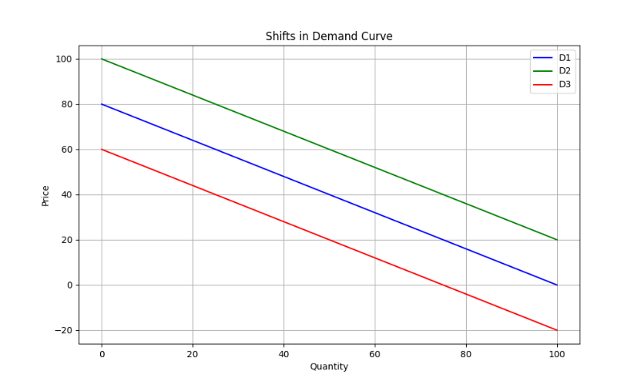
Source : Autor

- Diagram 2: Shifts in Supply Curve
The supply curve shift illustrates how factors affect the supply of goods and services. An outward shift in the supply curve (S1 to S2) indicates an increase in supply, potentially due to improved production technologies or lower production costs. An inward shift (S1 to S3) indicates a decrease in supply, possibly due to higher production costs or labor shortages.
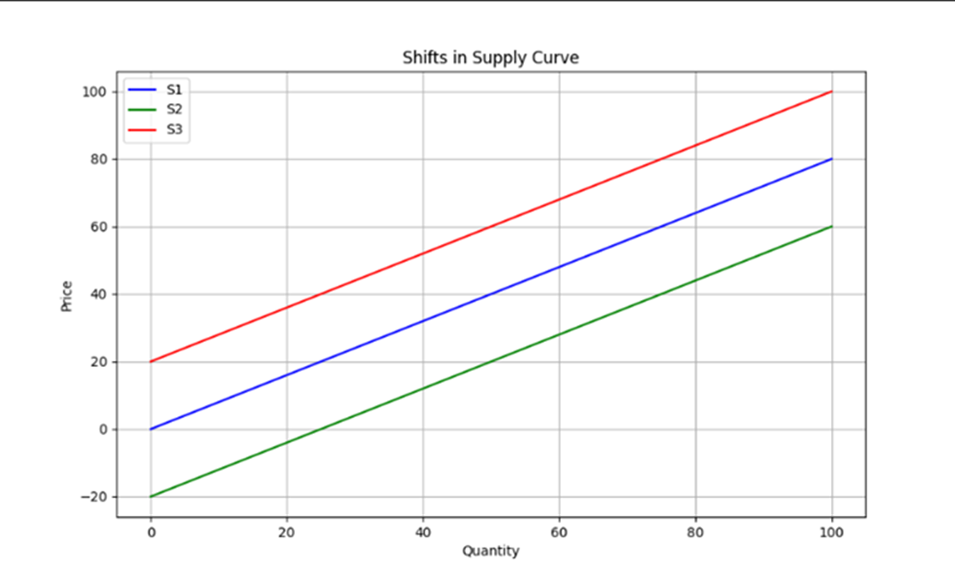
Source : Autor

Price Elasticity of Demand (PED)
Price elasticity of demand (PED) measures the responsiveness of the quantity demanded to changes in price. In the context of the COVID-19 pandemic, several factors have influenced the PED for various products, particularly fuel. Understanding these factors helps businesses and policymakers make informed decisions about pricing and supply management (Pettinger, 2019).
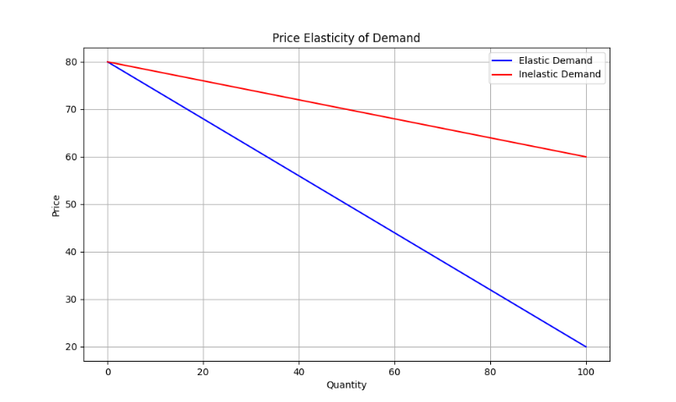
Source : Autor

- Substitution Effects:
Substitution effects play a significant role in determining the elasticity of demand. When there are readily available substitutes for a product, its demand tends to be more elastic. During the pandemic, many consumers sought alternatives to traditional fuel-powered transportation due to various factors, including health concerns and economic constraints. For example, the increased use of electric vehicles (EVs) and bicycles as substitutes for fuel-powered cars has made the demand for fuel more elastic. If the price of fuel rises, consumers can switch to these alternatives, reducing their reliance on fuel (Nasrudin, 2024).Conversely, if substitutes are limited or not readily accessible, the demand for a product becomes inelastic. Despite the availability of alternatives, fuel remains a necessity for many consumers, especially those who do not have access to efficient public transportation or cannot afford an EV. This necessity makes the demand for fuel relatively inelastic, as consumers will continue to purchase fuel despite price increases because they rely on it for essential activities, such as commuting to work or transporting goods (Nasrudin, 2024).
- Necessity vs. Luxury:
Fuel is generally considered a necessity, making its demand inelastic. During the pandemic, even with fluctuating fuel prices, many consumers continued to purchase fuel because it was essential for their daily activities. The inelastic nature of fuel demand is evident in how consumers responded to price changes; despite higher prices, the quantity demanded did not decrease significantly because fuel is crucial for transportation and logistics (Federal Reserve Bank of St.Louis, 2024). However, the demand for luxury goods, such as high-end fashion items or non-essential electronics, showed greater elasticity. Consumers were more likely to reduce their spending on luxury goods in response to price increases or economic uncertainty brought about by the pandemic. This contrast highlights the difference in elasticity between necessities and luxuries: while the demand for necessities like fuel remains stable despite price changes, the demand for luxuries is more sensitive to price fluctuations and economic conditions (Federal Reserve Bank of St.Louis, 2024).
- Income Effects:
The income effect also influences the price elasticity of demand. For higher-income consumers, fuel expenditures represent a smaller portion of their budget, making the demand for fuel relatively inelastic. These consumers are less sensitive to price changes because fuel costs do not significantly impact their overall financial situation. During the pandemic, high-income households continued to purchase fuel despite price increases, reflecting the inelastic nature of their demand (Pettinger, 2019). In contrast, for lower-income consumers, fuel costs constitute a larger share of their budget. As a result, the demand for fuel among these consumers is more elastic. During periods of economic downturn, such as the one induced by the pandemic, lower-income households are more likely to reduce their fuel consumption in response to price increases. This increased elasticity is due to the greater financial impact of fuel costs on their overall budget. As fuel prices rise, lower-income consumers may seek alternative modes of transportation or reduce non-essential travel to manage their expenses (Pettinger, 2019).To illustrate the impact of PED during the pandemic, consider the following examples:
- Fuel Demand During Lockdowns: During the initial lockdowns, there was a significant reduction in commuting and travel, leading to a temporary decrease in fuel demand. However, as restrictions eased and people resumed work and travel, fuel demand rebounded, demonstrating the inelastic nature of fuel as a necessity. Despite price fluctuations, consumers continued to purchase fuel for essential activities.
- Grocery and Essential Goods: The demand for groceries and essential goods also showed inelastic characteristics during the pandemic. Despite occasional price increases due to supply chain disruptions, consumers continued to purchase these items. For instance, the price of dairy products rose due to processing plant closures, but demand remained relatively stable as these products are staples in many households. (Stanford, 2021)
- Non-Essential Goods: In contrast, the demand for non-essential goods, such as luxury clothing and high-end electronics, was more elastic. During the pandemic, many consumers reduced their spending on these items in response to economic uncertainty and shifts in spending priorities. Retailers had to implement discounts and promotional pricing strategies to stimulate demand, highlighting the elastic nature of these products (Stanford, 2021).
- Impact on Business Strategies:
Understanding PED is crucial for businesses in setting pricing strategies, especially during a crisis like the pandemic. For products with inelastic demand, such as fuel and essential groceries, businesses can raise prices to cover increased costs without fearing a significant drop in sales. This approach helps maintain revenue and profitability even when supply chain disruptions drive up costs. For products with elastic demand, such as luxury goods, businesses need to be more cautious with price increases. During the pandemic, many retailers offered discounts and promotions to attract price-sensitive consumers and maintain sales volumes. This strategy helped mitigate the impact of reduced consumer spending on non-essential items. Moreover, businesses need to consider the income effect when setting prices. Understanding that lower-income consumers are more sensitive to price changes can help businesses develop tiered pricing strategies that cater to different income groups. For example, offering budget-friendly product lines or financing options can help retain customers with varying financial capabilities. (Pettinger, 2019).
- Policy Implications
Policymakers can use insights from PED to design effective interventions during economic crises. For instance, subsidies for essential goods can help stabilize prices and ensure accessibility for all income groups. During the pandemic, governments provided financial support to critical industries to prevent supply chain disruptions and maintain the availability of essential goods. Additionally, understanding the elasticity of different products can guide tax policies. For inelastic goods, such as fuel, policymakers can impose higher taxes to generate revenue without significantly reducing consumption. Conversely, for elastic goods, tax increases might lead to substantial drops in demand, negatively affecting both businesses and consumers. In conclusion, the price elasticity of demand is a vital concept in understanding consumer behavior and making informed business and policy decisions, especially during unprecedented events like the COVID-19 pandemic. By analyzing substitution effects, the necessity of products, and income effects, businesses and policymakers can develop strategies that balance profitability, accessibility, and economic stability. The pandemic has underscored the importance of flexibility and responsiveness in pricing, as market conditions can change rapidly in response to external shocks (Dörr, et.al. 2022).
- Factors Influencing Price Elasticity
- Availability of Substitutes: The more substitutes available, the higher the price elasticity.
- Necessity vs. Luxury: Necessities tend to have lower price elasticity compared to luxuries.
- Proportion of Income: Goods that consume a larger portion of income tend to have higher price elasticity.
Based on the analysis, businesses should consider adopting dynamic pricing strategies to navigate the challenges posed by the pandemic. Dynamic pricing involves adjusting prices based on real-time demand and supply conditions, maximizing revenue without deterring consumers. For instance, fuel prices can be adjusted during peak and off-peak times to balance demand and supply effectively. Additionally, businesses can implement price discrimination by offering differential pricing for different consumer segments, optimizing sales. For example, offering discounts to regular customers or bulk buyers can stimulate demand and ensure a steady revenue stream. Promotional pricing can also be used during periods of low demand to stimulate sales and clear inventory, ensuring business continuity and customer retention (Abdelnour, Babbitz and Moss, 2020).

Conclusion
The COVID-19 pandemic has significantly impacted global supply chains and market demand, exposing vulnerabilities and creating new economic challenges. By understanding these challenges and employing strategic measures such as government intervention, improved supply chain collaboration, and effective pricing policies, businesses can navigate these turbulent times. This essay highlights the importance of applying economic theories to real-world scenarios to devise practical solutions that promote market stability and economic recovery.

References
1. Abdelnour, A., Babbitz, T. and Moss, S. (2020) ‘Pricing through the pandemic: Getting ready for recovery’, McKinsey & Company , Available at: https://www.mckinsey.com/~/media/mckinsey/business%20functions/marketing%20and%20sales/our%20insights/pricing%20through%20the%20pandemic%20getting%20ready%20for%20recovery/pricing-through-the-pandemic--getting-ready-for-recovery.pdf/ (Accessed: 17 July 2024).
2. Bairagi, S., Mishra, A.K. and Mottaleb, K.A. (2022) ‘Impacts of the COVID-19 pandemic on food prices: Evidence from storable and perishable commodities in India’ , PLOS ONE ,17(3).
3. Brien, P., Harari, D., Keep, M. and Ward, M. (2022) ‘Economic impact of covid-19 lockdowns’ , House of Commons Library , CDP 2022-0215.
4. Chanona, R.M.R., Mealy, P., Pichler, A., Lafond, F. and Farmer, J.D. (2020) ‘Supply and demand shocks in the COVID-19 pandemic: an industry and occupation perspective’ , Oxford Review of Economic Policy, 36(1) , pp. 94–137.
5. Dörr, J.O., et.al. (2022) ‘An integrated data framework for policy guidance during the coronavirus pandemic: Towards real-time decision support for economic policymakers’ , PLOS ONE 17(2).
6. Federal Reserve Bank of St.Louis, (2024) ‘Elasticity of Demand’ , The Economic Lowdown Podcast Series , Available at: https://www.stlouisfed.org/education/economic-lowdown-podcast-series/episode-16-elasticity-of-demand/ (Accessed: 14 July 2024).
7. GOV.UK. (2024) ‘Critical imports and supply chains strategy’ , Available at: /https://www.gov.uk/government/publications/uk-critical-imports-and-supply-chains-strategy/critical-imports-and-supply-chains-strategy-html-version/ (Accessed: 14 July 2024).
8. Gupta, R., Hasan, M.M., Islam, S.Z., Yasmin, T., Uddin, J. (2023) ‘Evaluating the Brexit and COVID-19’s influence on the UK economy: A data analysis ’, PLOS ONE 18(6).
9. Jazemi, R., Farahani, S., Otieno, W. and Jang, J. (2024) ‘Review on Panic Buying Behavior during Pandemics: Influencing Factors, Stockpiling, and Intervention Strategies’ , Behavior Science , 14(3) .
10. Jones, L., Palumbo, D., and Brown, D. (2021) ‘Coronavirus: How the pandemic has changed the world economy’ , BBC News , Available at: /https://www.bbc.co.uk/news/business-51706225/ (Accessed: 16 July 2024).
11. Martin, F.M., Sanchez , J.M. and Wilkinson, O. (2023) ‘The Economic Impact of COVID-19 around the World’ , Federal Reserve Bank of St. Louis Review, pp. 74-88.
12. Merchant, P. (2021) ‘Pivoting During the Pandemic’ , How These Businesses Succeeded, Available at: /https://www.entrepreneur.com/growing-a-business/pivoting-during-the-pandemic-how-these-businesses-succeeded/362003/ (Accessed: 18 July 2024).
13. Nasrudin, A. (2024) ‘How substitution affects elasticity?’ Penpoin , Available at: /https://penpoin.com/how-does-substitution-affect-elasticity/ (Accessed: 14 July 2024).
14. Pettinger, T. (2019) ‘Income Elasticity of Demand (YED)’ , Economics Help , Available at: /https://www.economicshelp.org/microessays/equilibrium/income-elasticity-demand/ (Accessed: 16 July 2024).
15. Pettinger, T. (2019) ‘Price Elasticity of Demand (PED) ‘ , Economics Help , Available at: / https://www.economicshelp.org/microessays/equilibrium/price-elasticity-demand/ (Accessed: 16 July 2024).
16. Stanford , M. (2021) ‘Growing up in lockdown: the impacts of pandemic life on children's early physical development’ Early Intervention Foundation , Available at: /https://www.eif.org.uk/blog/growing-up-in-lockdown-the-impacts-of-pandemic-life-on-childrens-early-physical-development/ (Accessed: 17 July 2024).
17. Younis, H., Alsharairi, M., Younes, H. and Sundarakani, B. (2023) ‘The impact of COVID-19 on supply chains: systematic review and future research directions’ , Oper Res Int J, 23, (48).
18. Zhou, M. and Kan, M.Y. (2021) ‘The varying impacts of COVID-19 and its related measures in the UK’ A year in review.

