

BMSW4009

Effective Team-work and Communication

Viorel’s Presentation

Student Name:Vasile Baciu
Student ID:1815810
Slide 1:
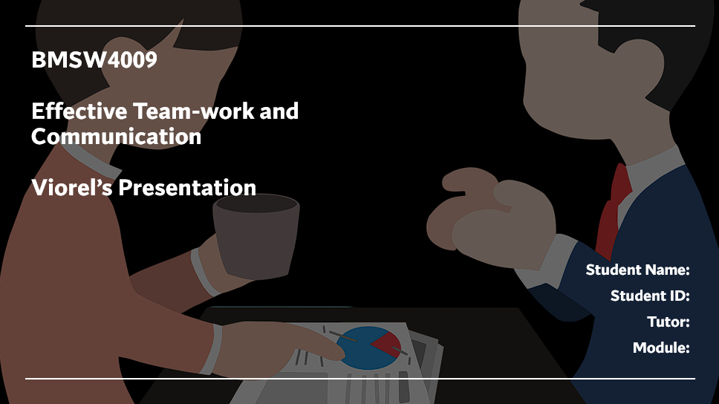
Slide 2:
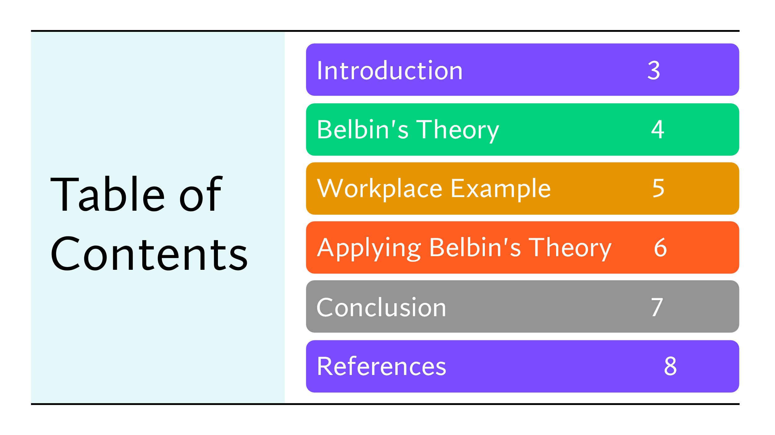
Slide 3:
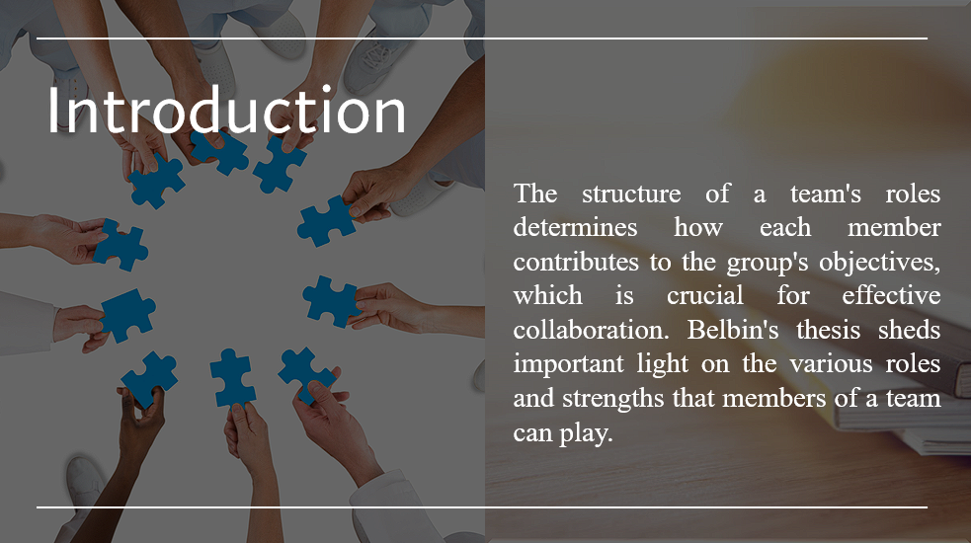
Notes:
Understanding team dynamics and individual contributions is essential for effective teamwork. A key tool in this effort is Belbin's Team Role Theory, which assigns responsibilities to people and emphasises diversity for best results. The presentation delves into individual experiences within our team to examine real-world implementations of Belbin's thesis. We provide insights that support productive teamwork and successful collaboration, from identifying strengths to handling obstacles and using conflict resolution techniques.
Slide 4:
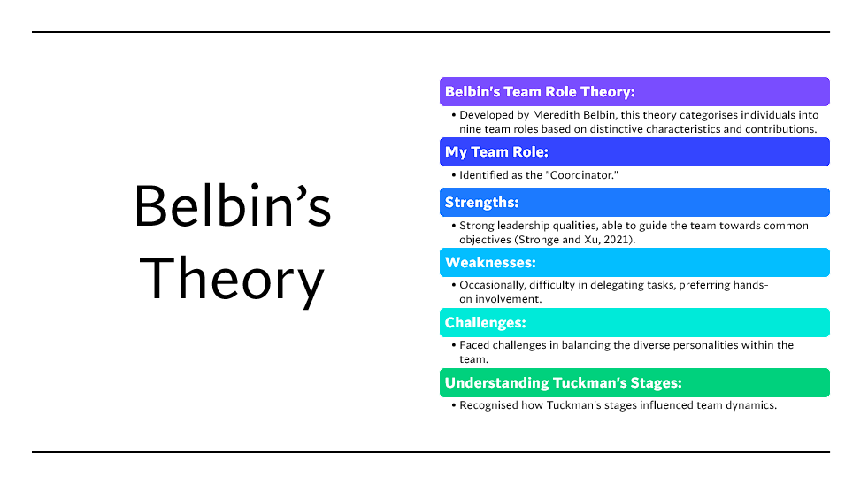
Notes:
Meredith Belbin's Team Role Theory outlines nine different roles that members of a team can play, emphasising the need for a variety of contributions. My primary responsibilities as the team's "Coordinator" are to promote communication and make sure that every team member makes a significant contribution. Exceptional interpersonal and leadership abilities that steer the team towards common goals are noteworthy characteristics. However difficulties also arose: my willingness to compromise occasionally resulted in compromises, and my hands-on style occasionally impeded work delegation. Opening lines of communication and letting team members voice their concerns were necessary for resolving issues. Understanding Tuckman's Stages highlighted the significance of goal-setting and role clarity, especially in the forming stage, providing a strong basis for successful team integration.
Slide 5:
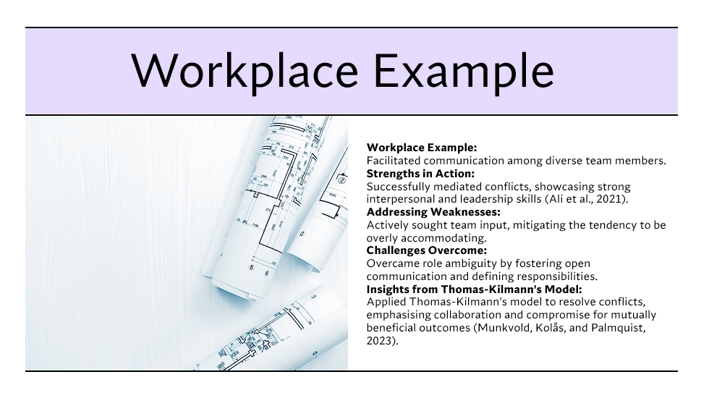
Notes:
I served as the coordinator in a recent project, where I coordinated efficient communication between a diverse team and matched tasks to individual abilities. My abilities were highlighted during this project, as I was able to resolve disputes amicably while showcasing my strong interpersonal and leadership abilities. I deliberately sought out team opinion, addressing my inclination to be too accommodating and encouraging a collaborative environment. Open communication and responsibility definition helped to overcome obstacles, especially role uncertainty. Furthermore, I used the Thomas-Kilmann model's insights to prioritise cooperation and compromise in conflict resolution, which led to outcomes that benefited the team as a whole.

Slide 6:
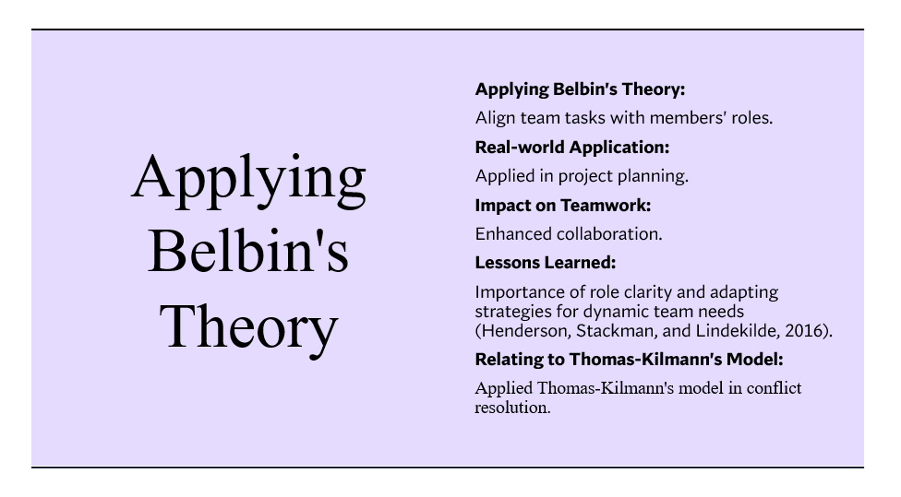
Notes:
By carefully matching tasks to each member's assigned job and utilising Belbin's theory, our team managed to maximise the utilisation of various strengths within the group. This method was successfully applied in a real-world setting to project planning, guaranteeing that every team member made a significant contribution and utilised their talents. Significant improvements in task efficiency, enhanced teamwork, and overall team cohesion were fostered by the impact on teamwork. Important lessons were learned, emphasising the need for job clarity and the adaptation of techniques to meet changing team demands. Additionally, the Thomas-Kilmann model's insights were used to navigate disputes, giving collaboration and compromise priority. This produced favourable results and emphasised the significance of cooperative conflict resolution in team dynamics.

Slide 7:
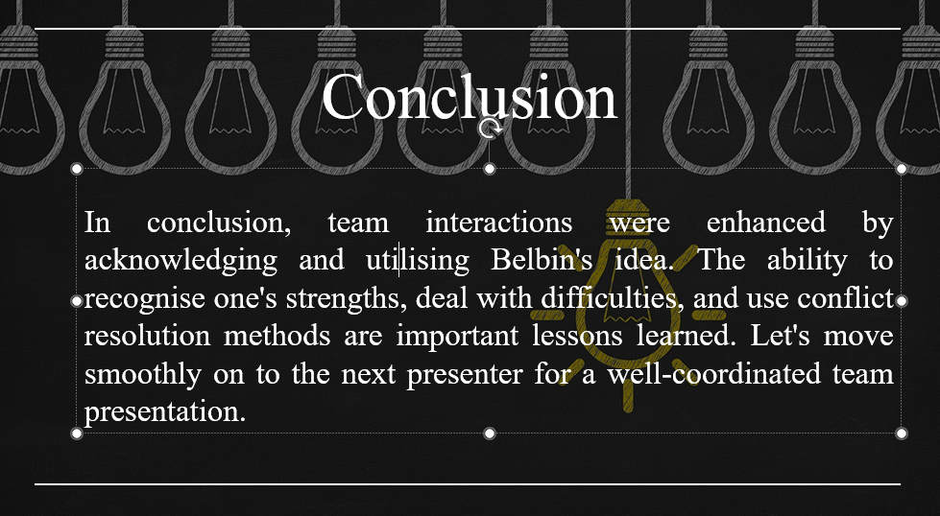
Notes:
In conclusion, the use of Belbin's theory greatly enhanced our team dynamics through the development of an awareness of each member's capabilities, skilful problem-solving, and application of conflict resolution models. The main lessons stress the significance of using conflict resolution techniques, utilising strengths, and overcoming obstacles through honest communication. By using these insights, we can smoothly move on to the next presenter and make sure the team presentation is well-coordinated and knowledgeable.
Slide 8:


