

Course: BA (Hons) Leadership and Management Skills for the Workplace
Module Code and Title: LCLM-5003 Project Management
Assignment Title: Project Portfolio
Student ID: 2334848
Student Name: Camelia Cenusa
Word Count: 600 (Part B) + 2612 (Part C)

Table of Contents
PART A: POSTER 3
PART B: REFLECTION 4
PART C: PROJECT MANAGEMENT PLAN 6
1. Introduction 6
2. Project Description 7
3. Scope 7
4. Work Breakdown Structure 8
5. Quad Chart 9
6. Gantt Chart 10
7. Stakeholders’ Involvement 12
8. Allocation of Resources 13
9. Risk Analysis 13
10. Conclusion 14
Reference List 16

PART A: POSTER
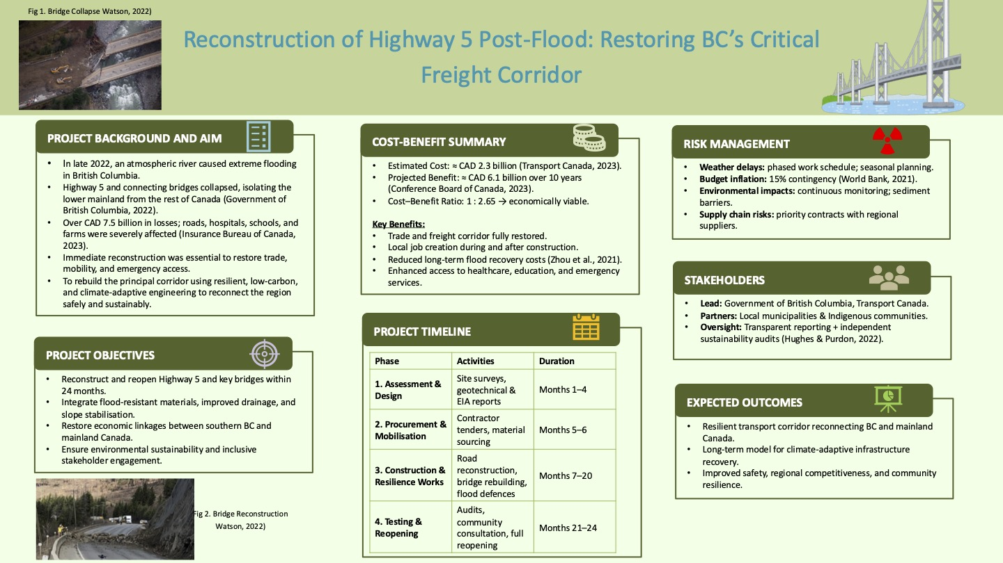

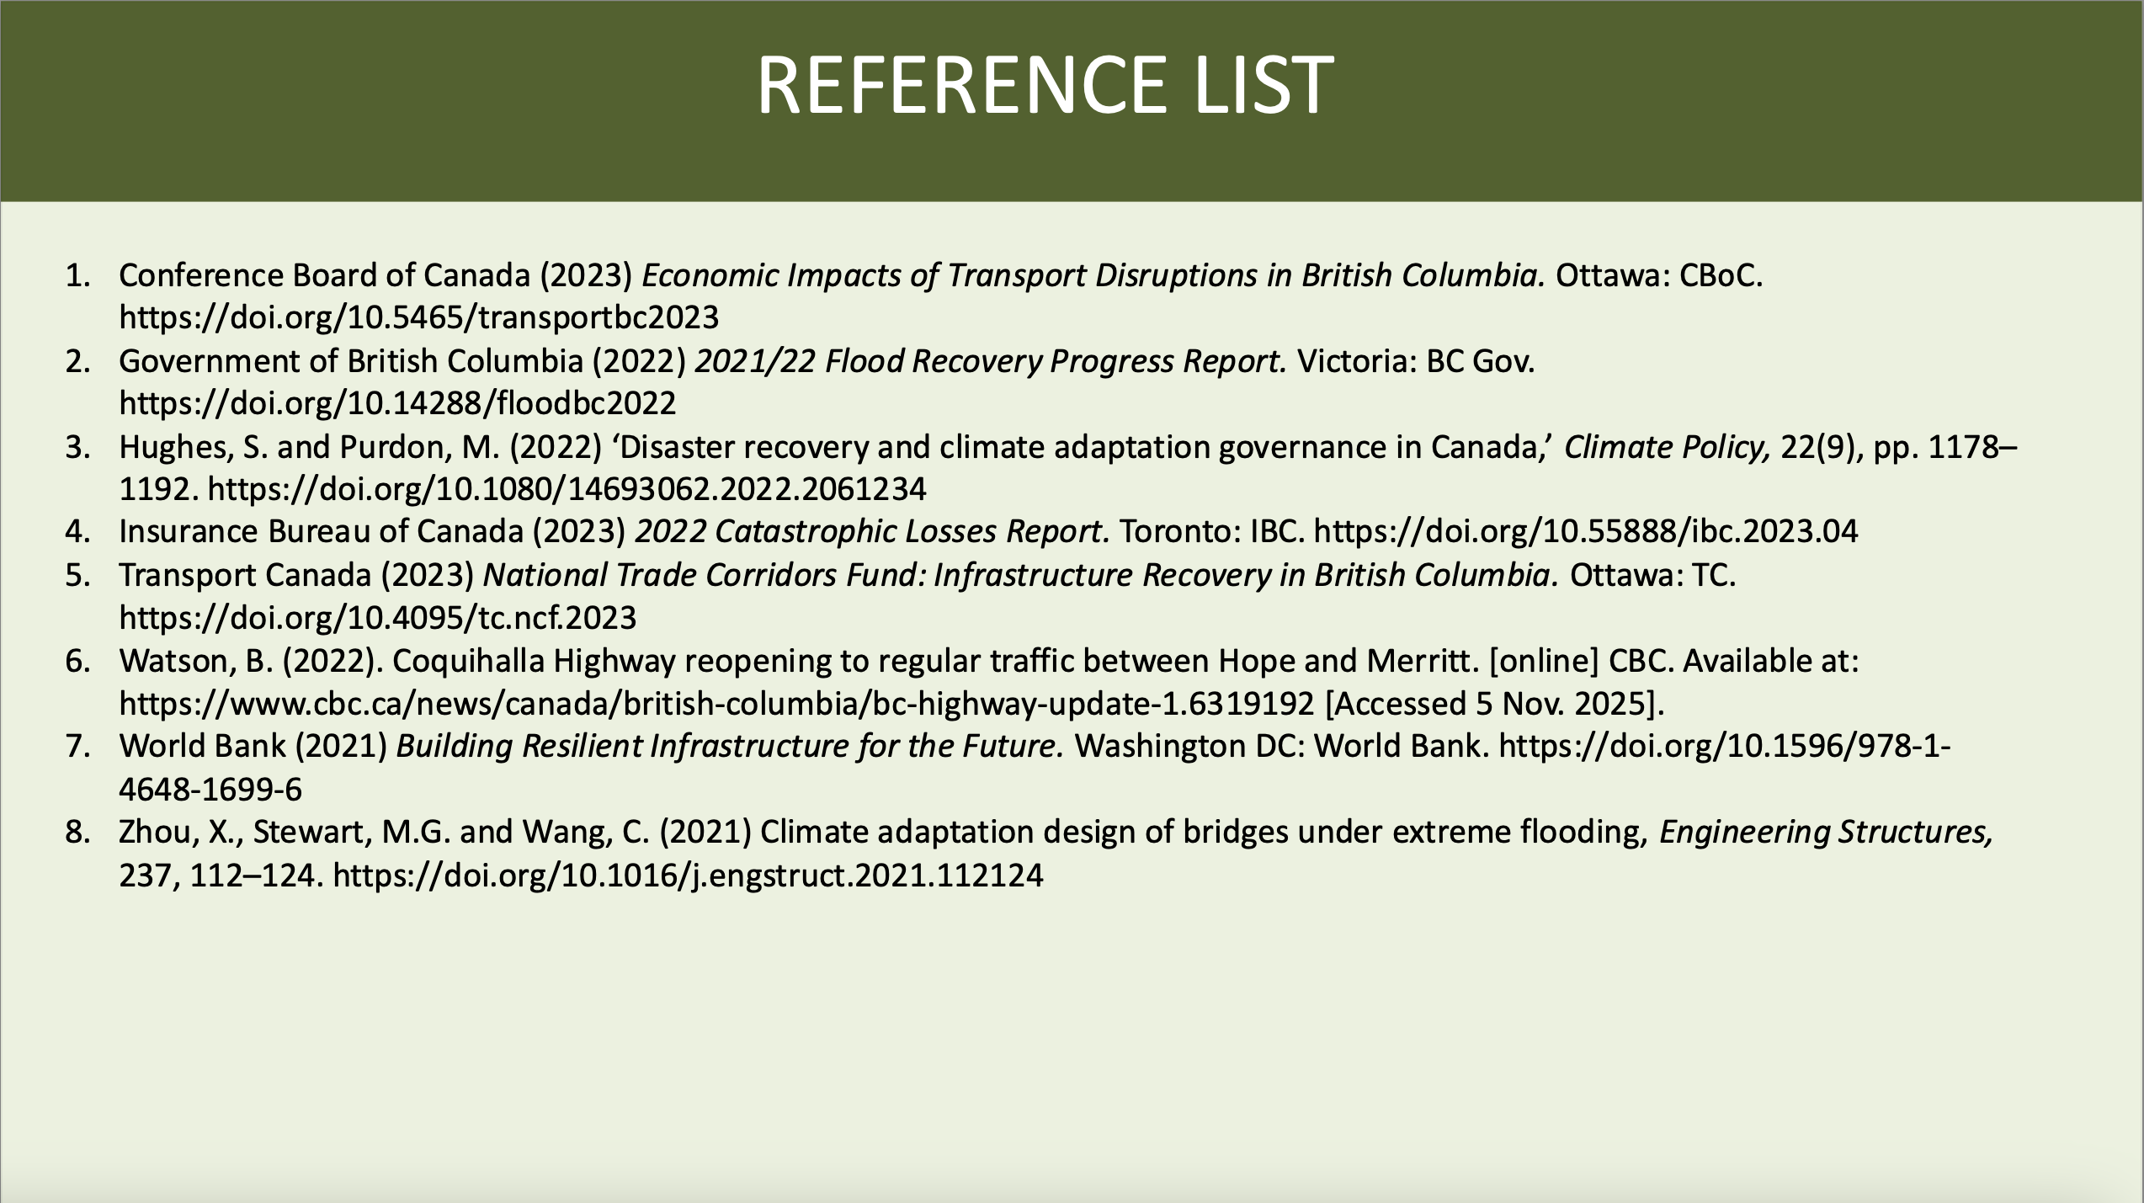

PART B: REFLECTION
When I started planning for this poster presentation, I was filled with anxiety about delivering the verbal presentation. Public speaking has always been a struggle for me because English is not my first language and I have a health condition that increases my anxiety. The pressure of presenting to an audience consisting of colleagues with both academic and professional backgrounds was particularly intimidating. I did not know if I would be able to communicate my thoughts in a manner that would give the audience sufficient understanding of my topic and therefore, I experienced increased anxiety based on how prepared I felt for this presentation task. I was able to talk with my tutor and this allowed me to take advantage of additional time to prepare, which was of great benefit for me.

Using this extra time allowed me to adopt a more strategic method when preparing for my presentation. I practiced my presentation many times in the comfort of my home, and I limited myself to working on the sequencing of my explanation and to how I presented my material in a logical and cohesive manner. The additional time spent practicing my presentation also allowed me to have a greater sense of control over the content of my presentation and helped improve my confidence in my ability to deliver my presentation without feeling anxious about having to deliver it. The experiences I gained from my poster presentation support the research findings of Bodie (2010), which indicate that if an individual engages in systematic preparation and rehearsal for their presentation, the level of anxiety will decrease, and the individual will be able to perform at a higher level.

Even though I experienced some anxiety while delivering my presentation, I believe that I delivered it adequately, based on the constructive feedback that I received from my tutor and my classmates. The feedback I received suggested that my poster's content was well-organised, easy to read, and presented clearly, and that my explanation of my project was coherently presented and easy to follow. The positive comments I received provided confirmation that my preparation was adequate and that my result was directly related to the additional time I was provided to prepare. The constructive comments I received suggested to me that I could improve the visual engagement of my audience by including both image and icon elements and that my overall layout was well-received by the audience. The feedback I received illustrated a gap for future presentations in terms of where I can improve.

I was worried my presentation will sound overly rehearsed because I prepared well prior to delivering my presentation. I now realise the benefit of being appropriately prepared out-weighs the disadvantages of having such anxieties regarding public speaking and delivering a quality presentation. As I continue to gain experience with public speaking through practice, I believe I will find a balance in my preparation while delivering a presentation naturally. The use of reflective practices, as mentioned by Schön (1983), is essential in identifying one’s strengths and weaknesses in developing one's personal and professional qualities.

Overall, I feel that my experiences with this presentation will benefit me both personally and academically. Even though I will have challenges to overcome my anxiety due to pre-existing medical concerns, I feel that I will have the tools to present myself to a broader range of audiences now that I am better equipped for success when I am adequately prepared. I will also continue to learn from both the experience of this presentation and from my tutor and peers when developing my public speaking abilities.

PART C: PROJECT MANAGEMENT PLAN

1. Introduction
In British Columbia in 2022, severe flooding from an extreme atmospheric river devastated the province's roads and bridges and caused extensive damage to both private and commercial structures. The failure of important sections of Highway 5, which connects the southern part of Canada to other provinces in Canada, caused severe disruptions to the delivery of goods and services and significantly reduced the availability of health, education and emergency services to the public. The sheer number of displaced residents, businesses and damaged infrastructure made it patently clear that immediate coordinated recovery efforts were required.

Project management is critical to the recovery of communities following a disaster, especially in situations where there are many stakeholders. Uncertainty is high and the long-term outcomes of a project have societal impact. Therefore, in contemporary project management literature, the ability to engage stakeholders in a meaningful way, assess and manage risks and demonstrate sustainability and ethical considerations in the project recovery process are key aspects of successful recovery projects (Deeprose, 2021; Portny, 2020). This project management plan provides a structured methodology for the reconstruction of Highway 5 by drawing on:

1. Project management principles
2. Stakeholder theory
3. Risk management frameworks derived from project management and disaster recovery scholarly literature.

This Project Management Plan will outline a comprehensive approach to project management that addresses both the urgent need to restore transportation connectivity and the need to improve highway corridor resiliency in future climate-related disasters. The intended audience is representatives from government, communities, indigenous nations, construction contractors and similar regulatory authorities. This plan provides an example of how project management concepts and tools can be applied to infrastructure recovery in a post-disaster environment.

2. Project Description
Highway 5 is a critical corridor for the transport of freight and passengers in support of our regional supply chain and the movement of goods in support of Canada’s National Trade Strategy and daily movement of people. The failure of Highway 5 in 2022 due to flooding revealed many weaknesses in the existing infrastructure, increasing the need for climate resiliency-based design and prioritizing resource allocation based on climate resiliency.

The reconstruction of Highway 5 is planned to be a large public infrastructure recovery project being managed by the Government of British Columbia and federal partners, including Transport Canada. The goal of this project is to reinstate full useability of Highway 5 within 24 months while adhering to environmental legislation and regulatory requirements as well as safety protocols. In addition to reconstruction of physical infrastructure, the project will also implement resilience infrastructure improvements such as, enhanced drainage capacity, reinforced bridge footings, slope stabilisation techniques based on climate resiliency research (Zhou, Stewart, & Wang, 2021).

Managing this project from a project management perspective as well as other functional areas will be a complex and high-risk environment due to the larger number of interrelated and dependent activities as well as limited resources. Additionally, this project will face external uncertainties from weather condition and supply chain challenges. According to Abualkishik and Almajed (2019), in order to successfully complete this type of project, it is imperative to implement a framework for planning, executing, monitoring, and coordinating all stakeholder interests and expectations, and to use strategic data-based approaches for the allocation of resources to optimise outcomes, managing trade-offs between time, cost, and performance.

3. Scope
The project scope for reconstructing Highway 5 provides guidelines to establish the scope of the project work and to establish the expectations of the project's stakeholders. The project scope includes all work to restore all segments of Highway 5 that have been affected by least 20% or more damage into their original operational status, but with enhanced resilience against future flooding (Zhou, Stewart, & Wang, 2021). Additionally, as part of the Highway 5 reconstruction project, the scope includes the following work: rebuilding all collapsed bridges; reconstructing all roadway segments that have been damaged; and stabilising all adjacent slopes. Improving the drainage and flood control systems will be included in the scope of the project.

As part of the Highway 5 Reconstruction Project, the environmental assessment and mitigation project scope includes an assessment for compliance with both provincial and federal regulations. Due to the historical and ecological sensitivity of the area, the Highway 5 Reconstruction Project is to include continuous monitoring and adaptative management of the assessment throughout the life cycle of the project as part of the sustainable principles of project management (Cvijović, Obradović, and Todorović 2021). Stakeholders will be consulted during the entire project lifecycle in order to address all impacts and concerns of affected communities, indigenous nations, and impacted industries.

In addition, the Highway 5 Reconstruction Project and its project scope do not include long-term land-use planning for anything beyond the Highway 5 corridor nor do they include the reconstruction of any unrelated local infrastructure such as private buildings or municipal facilities. It is important that the project define what is explicitly excluded from the scope of the project so there is no scope creep and to ensure the project is aligned to the project objectives, as recommended by best practice in project management (Portny, 2020).

4. Work Breakdown Structure
The Work Breakdown Structure (WBS) is a hierarchical breakdown of the project's larger parts into smaller tasks so that it is easier to plan, coordinate, and control. The WBS for the Highway 5 Restoration Project was divided into the major project phases per standard project management practices, thereby providing a clear understanding of what is expected at each stage as well as the stakeholders who will own those phases (Deeprose, 2021).

The project's first phase is the assessment and design, which includes geotechnical assessments, environmental impact assessments, and detailed design specifications. This phase forms the basis for establishing the technical specifications and regulations and enables the project team to make informed decisions during the remainder of the project. The next phase, procurement and mobilisation, will consist of procuring the contractors to perform the construction work, obtaining the necessary materials, and setting up the site facilities. Coordinating these three steps will mitigate the cost and schedule risks that will arise, especially in a post-disaster environment where the demand for construction resources is surging.

The construction phase is the heart of the project; it consists of reconstructing the bridges, constructing the roads, stabilising the slopes, and installing flood prevention systems. The activities during this phase are all closely connected, and therefore sequencing them correctly is essential to ensure no delays or unsafe conditions occur. Finally, once the construction activities have been completed, testing, inspections, and commissioning must be performed to ensure that all the project's infrastructure meets or exceeds the minimum performance and safety requirements before being opened to traffic.

Using a WBS for the project enables the project management team to manage the allocation of resources efficiently, monitor the project's progress, and identify and resolve any potential issues early in the project's lifecycle, thus ensuring project success (Abualkishik & Almajed, 2019).

5. Quad Chart
The quad chart provides an overview of the project and provides all the major points about its objectives, schedule, cost and risk. In this project, the quad chart describes the strategic goal to restore Highway 5 to be a resilient transportation corridor, the anticipated 24-month time frame to deliver the project, an approximate budget of CAD 2.3 billion and the most significant risks associated with the project. As shown in Figure 1, the construction of Highway 5 is broken into four quadrants (Objectives, Timelines, Budget and Resources, Risk Management). Each quadrant provides a quick strategic overview for senior-level stakeholders to make informed decisions based on clearly stated project priorities, constraints and risk mitigation efforts.

The quad chart provides a governance tool by providing a clear means to communicate with senior decision making and external stakeholders in an open way so that everyone is working toward the same priorities and has a clear understanding of the constraints. Karlsen (2015) noted that all projects are complex and involve many different stakeholders, which makes it critical to provide simple to understand communication tools which convey information accurately. The quad chart provides an easy way to communicate the strategic aspect of the project but does not replace the need to develop more detailed plans for specific aspects of the project.
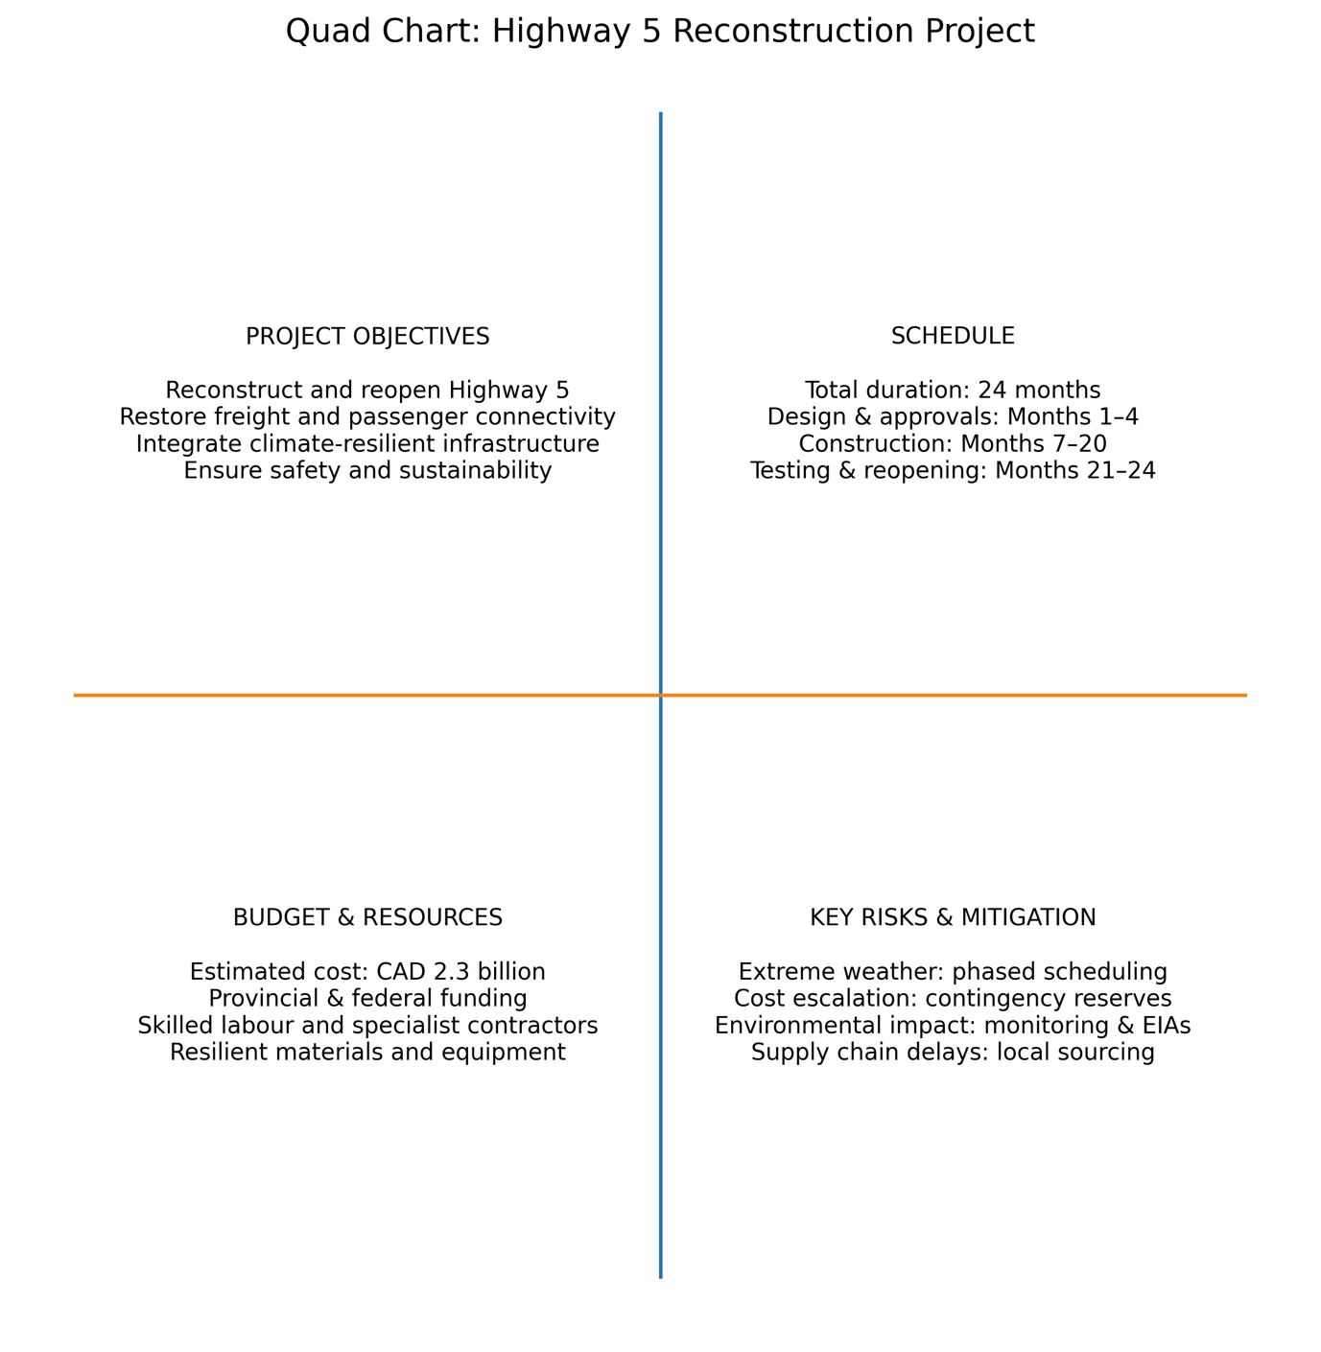
Figure 1. Quad Chart: Highway 5 Reconstruction Project (Source: self-created).

6. Gantt Chart
The Gantt Chart has been utilised as the primary means of creating a scheduling plan for the Highway 5 Reconstruction Project, by identifying when project activities are sequenced and how long each will take to finish. The Gantt Chart also illustrates how the project has been organised into phases, where activities may be performed at the same time, if necessary, in an effort to minimise overall duration. For instance, procurement can take place prior to finalising a detailed design in order to decrease overall duration, however the risk associated with this type of approach will need to be evaluated and approved by the regulatory authorities prior to proceeding. The proposed 24-month reconstruction project schedule for Highway 5 is shown in Figure 2 in Gantt Chart format. This figure indicates how all major phases will be overlapped throughout the life of this project including:
(1) Assess and Design Phases
(2) Procurement Phase
(3) Construction Activities
(4) Final Commissioning Phase.
Each section of the Gantt Chart indicates the relationships between tasks. This configuration of tasks in the Gantt Chart is designed to allow for completion of the overall project on schedule while minimising risk due to seasonal weather patterns and limited availability of construction-related resources.

Despite some criticisms regarding their inability to accurately depict uncertainties or complexities, Gantt charts continue to remain as one of the most widely utilized tools for scheduling projects (Geraldi & Lechter, 2012). For this reason, the Gantt chart will continue to be utilised with regular reviews on a progress basis, along with concurrent assessments of risk, to allow the project to adapt to changing environmental conditions, such as delays due to weather or interruptions in the supply chain. This application of Gantt charts exemplifies how modern project management has embraced the concept of balancing the discipline of planning with the flexibility to be able to respond effectively to changes, which is further illustrated by Deeprose (2021).

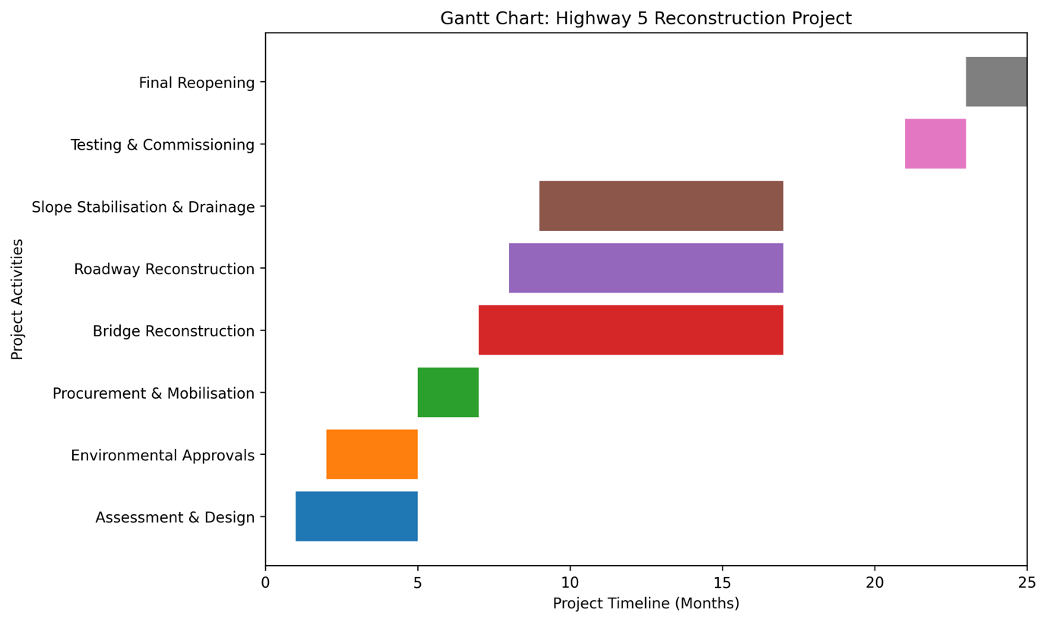
Figure 2: Gantt Chart: Highway 5 Reconstruction Project (Source: self-created).

7. Stakeholders’ Involvement
The Highway 5 Reconstruction Project places a strong emphasis on stakeholder involvement, as this reflects the different interests that have been impacted by the natural disaster as well as the recovery process. Some of the main stakeholders involved with the Highway 5 Reconstruction Project are government agencies at the provincial and federal levels, municipalities, indigenous communities, freight and logistics operators, local residents, environmental organisations, and construction contractors. Each of these stakeholder groups has its own expectations of the project, the ability to influence the project, and the ability to affect the outcomes of the project.
In general, stakeholder theory maintains that project success can only be achieved by the creation of value for all stakeholders and not just for the most powerful stakeholders (Freeman et al., 2025). With regard to this Highway 5 Reconstruction Project, it is critical to engage Indigenous communities and local residents in a meaningful way given the potential for social and environmental changes resulting from the reconstruction activities. Engagement through open lines of communication, consultation with stakeholders, and respect for stakeholder feedback helps to create trust and reduce risk.
Sustainability research indicates that a focus on only internal stakeholders can lead to disputes, delays, and damage to reputation (Cvijović, Obradović, and Todorović, 2021). Therefore, the project is taking a proactive approach to stakeholder management by integrating stakeholder engagement activities into all phases of the project rather than as an isolated action.

8. Allocation of Resources
The Highway 5 reconstruction project is a large and complex undertaking that is being conducted in the wake of a natural disaster, and therefore it will require effective resource allocation to ensure its successful completion. The resources needed for the Highway 5 reconstruction project include: financial capital, labour, construction materials, equipment, and management expertise. The allocation of project-specific resources must take into consideration competing demands related to cost, time, quality, and sustainability, while also balancing these competing demands with one another.
According to research published by Abualkishik and Almajed (2019), using a data-driven method for allocating project resources will enhance the overall performance of projects by allowing for better decision making and optimisation. In order to allocate resources for the Highway 5 reconstruction, project team members will utilise detailed cost estimates as well as schedule analysis and project risk assessments to inform the allocation of resources. In addition, the Highway 5 Reconstruction Project will prioritise critical path activities, such as bridge reconstruction, to minimise the overall project delays in restoring connectivity.
The Highway 5 Reconstruction Project also considers sustainability in its approach to allocating project resources. For example, the Highway 5 reconstruction will place a higher emphasis on the use of materials and construction methods that will minimise future maintenance costs and reduce environmental impacts. As stated by He, Li, and Wang (2021), incorporating cost, time, and energy considerations into the planning and execution phases of an infrastructure project is essential to achieving optimal outcomes.

9. Risk Analysis
Given the uncertainty surrounding post-disaster recovery environments, risk management is a key aspect of the overall Highway 5 Reconstruction Project. Aspects of risk management either positively or negatively impact an organisation's ability to respond to disaster recovery. For example, one of the key risk categories for this project is adverse weather conditions; other examples include escalating costs due to inflation or shortages, environmental threats, and opposition from stakeholders (Jędrusik, 2024).
The project employs a formalised, structured risk management methodology, which includes identifying risks, evaluating and analysing risks, developing an appropriate response to identified risks, and monitoring the implementation of response plans. Quantitative and qualitative methodologies will be used to evaluate risk severity and assess the impacts of mitigation strategies and contingency funding. Mitigating the impact of weather on the project will involve construction in multiple phases and seasonal planning. Mitigating the financial impacts of inflation and supply chain shortages will include the inclusion of contingency allowances and implementation of flexible procurement processes.
Wang et al. (2025) highlight the intersection of sustainability and risk management systems, particularly in projects subject to climate change impacts. To address climate change risks and create value from improved sustainable practices, the project incorporates climate adaptation measures into the risk management framework.

10. Conclusion
The reconstruction of Highway 5 in response to the 2022 flooding in British Columbia is a multifaceted and high-profile project that has far-reaching implications for the economy, society, and environment. The project manager's plan demonstrates a dedication to redefining how a project can achieve value when using project management best practices as defined by the project management body of knowledge and a body of contemporary research.
This Project Management Plan's objectives are to rebuild Highway 5 and its associated infrastructure, establish a framework for how to communicate with the community, manage stakeholder engagement, allocate logistics and resources, and recognise all risks across multiple facets of the project. The goal will be to make Highway 5 a well-connected transportation corridor and improve the long-term resilience of this important asset. The synthesis of stakeholder theory and sustainability concepts represents a shift in how project managers measure success, moving from the traditional output-based measurement to value creation for multiple parties (Freeman et al., 2025).
By executing this plan successfully, it will not only be possible to recover a very important transportation corridor but will also create best practices and frameworks to manage other complex climate-impact projects in the future.

Reference List
Abualkishik, A.Z. and Almajed , R. (2019). Strategic Resource Allocation in Project Management: A Data-Driven Framework. American Journal of Business and Operations Research, 00(02), pp.97–103. doi:https://doi.org/10.54216/ajbor.000204.
Bodie, G. D. (2010). A racing heart, rattling knees, and ruminative thoughts: Defining, explaining, and treating public speaking anxiety. Communication Education, 59(1), 70–105. https://doi.org/10.1080/03634520903443849
Cvijović, J., Obradović, V. and Todorović, M. (2021). Stakeholder Management and Project Sustainability—A Throw of the Dice. Sustainability, [online] 13(17), p.9513. doi:https://doi.org/10.3390/su13179513.
Deeprose, D. (2021). Project Management. Oxford: Capstone.
Freeman, R.E., Menghwar, P.S. and Grushka-Cockayne, Y. (2025). A Stakeholder Theory Perspective for Project Management. International Journal of Project Management, [online] p.102764. doi:https://doi.org/10.1016/j.ijproman.2025.102764.
Geraldi, J. and Lechter, T. (2012). Gantt Charts Revisited: A Critical Analysis of Its Roots and Implications to the Management of Projects Today. International Journal of Managing Projects in Business, [online] 5(4), pp.578–594. doi:https://doi.org/10.1108/17538371211268889.
He, W., Li, W. and Wang, W. (2021). Developing a Resource Allocation Approach for Resource-Constrained Construction Operation under Multi-Objective Operation. Sustainability, 13(13), p.7318. doi:https://doi.org/10.3390/su13137318.
Jędrusik, A. (2024). Project Risk Management Based on Known Project Management Methodologies. European Research Studies Journal , 27(4).
Karlsen, J.T. (2015). Project Stakeholder Management. Engineering Management Journal, 14(4), pp.19–24. doi:https://doi.org/10.1080/10429247.2002.11415180.
Khan, R. (2025). The Role of Risk Management in Project Success: A Comprehensive Study of Project Management Practices. TEXILA INTERNATIONAL JOURNAL OF MANAGEMENT, [online] 11(01). doi:https://doi.org/10.21522/tijmg.2015.11.01.art015.
Portny, S. (2020). Project Management . 5th ed. Hoboken, Nj: John Wiley & Sons, Inc.
Samarth, R. (2023). Importance of Stakeholder Management in Project Management. School of Professional Studies. [online] Available at: https://commons.clarku.edu/graduate_school_professional_studies/7/?utm_source=commons.clarku.edu%2Fgraduate_school_professional_studies%2F7&utm_medium=PDF&utm_campaign=PDFCoverPages.
Schön, D.A. (1983) The Reflective Practitioner: How Professionals Think in Action. New York: Basic Books.
Tinnirello, P. (2021). Project management. 1st ed. Boca Raton: Auerbach.
Wang, F., Antwi-Afari, M.F., Anwer, S., Umer, W. and Mehmood, I. (2025). Risk management in sustainable building projects: A systematic literature review and scientometric analysis. Cleaner Production Letters, [online] p.100111. doi:https://doi.org/10.1016/j.clpl.2025.100111.

