
Student’s Name: Md. Shajal Mia
Student ID: 2437642
Module Name: International Marketing: Principles and Practices
Module Code: LCMB7026
Lecturer's Name: Tushara Balendran
Assessment component 1: Individual report
Term 2

Table of Contents
1. Introduction 4
2. Comparative Macro-Environment Analysis 6
2.1 PESTEL Overview 7
2.2 Social and Cultural Comparison 10
2.3 Legal Comparison 14
3. Comparative STP and International Marketing Mix (7Ps) 15
3.1 STP and Targeting Strategy 15
3.2 Product: Depth and Width 18
3.3 Price 20
3.4 Place and Store Comparison 20
3.5 Promotion and IMC 22
3.6 People, Process and Physical Evidence 23
3.7 Similarities and Differences Across the 7Ps 25
4. Directional Development Strategy - IKEA in Japan 27
5. Ethical Issues in IKEA's Marketing Mix 28
5.1 Supply Chain and Labour Ethics 28
5.2 Environmental Sustainability and Greenwashing 28
5.3 Critical Assessment 28
6. Recommendations 30
6.1 Sweden 30
6.2 Japan 30
6.3 Shared Priority 30
7. Conclusion 31
7.1 Conclusion for Sweden 31
7.2 Conclusion for Japan 31
Section 2: Reflective Account 32
Description 32
Feelings 33
Evaluation 33
Analysis 34
Conclusion 34
Action Plan 35
References 36

1. Introduction
The question that emerges in international marketing is whether the products should be standardised or localised in international and local markets. In this report, we answer this question with the help of IKEA, a Swedish retailer of home furnishings that was established in 1943 with the essence of providing functional, well-designed furniture at low prices (Hollensen, 2020; IKEA Sweden, 2026a). Sweden is the domestic market and centre of brand logic of IKEA and a strategically significant, yet culturally distant, place where IKEA initially fell flat in 1986, but subsequently made a successful re-entry in 2006 (Lee and Hsu, 2018). This comparison conveys a test of a consistent value proposition to work across the polar situations of cultures.
The report is in a systematic form of analysis. It will start with a PESTEL analysis to look at the difference in macro-environment and the analysis of culture based on the dimensions by Hofstede, but not in a mechanistic way (Hofstede, 2001; McSweeney, 2002). It will then analyse segmentation, targeting, and positioning (STP), and consider the marketing mix based on the 7Ps.
In the second part, the Ansoff Matrix is used to measure the strategic growth of IKEA in Japan and its ethical aspects. The report wraps up by providing recommendations and reflective narration designed with the Reflective Cycle pioneered by Gibbs, which connects theory to the realities of making marketing decisions.
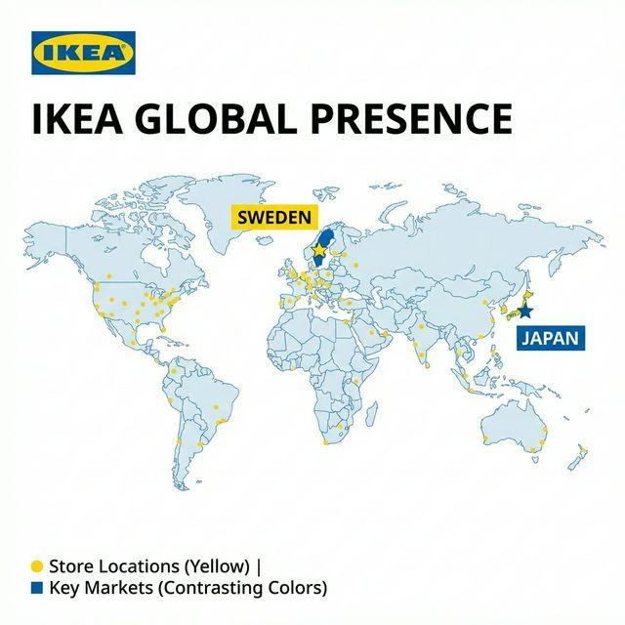
Figure 1: IKEA's global presence with Sweden and Japan highlighted
Source: original image retained from the submitted copy

2. Comparative Macro-Environment Analysis
PESTEL is utilised as a screening instrument on the macro level. It determines the political, economic, social, technological, environmental and legal situations that determine the market attractiveness before any firm-level STP decision-making.

2.1 PESTEL Overview
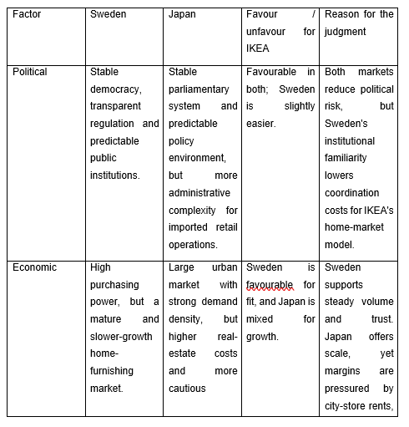
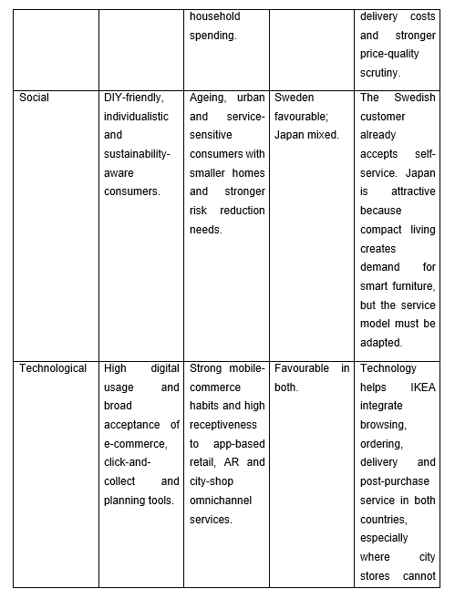
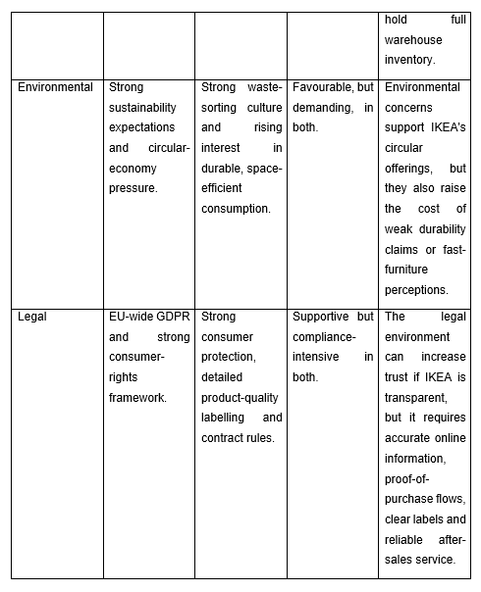
Table 1: PESTEL comparison of Sweden and Japan
Source: adapted from Hollensen (2020); EDPB (2026); European Commission (2026); Japanese Law Translation (2021; 2024); IKEA Sweden (2026a); IKEA Japan (2026a)
In Table 1, neither of the two countries can be considered to be politically unstable or technologically weak, and hence, the actual point of differences is not concerning the rudimentary market viability. It has to do with the trade-off between adaptation pressure and fit. Sweden would be preferable, since IKEA's original formula, i.e., self-service, large format retailing and democratic design has been shaped within that cultural and legal context.

2.2 Social and Cultural Comparison
By segregating social and cultural factors, the tutor was actually correct in his/her decision not to combine them into a single elusive discussion. Social conditions are a statement of how life appears daily. Hofstede incorporates a systematic approach of providing reasons as to why such behaviours vary in each country.
That distinction enhances the analysis since IKEA does not sell in the abstract into culture, but into the post-purchase services and routines of commuting, storage, cooking, family organisation, and other routines. In Sweden, the traditional formula of blue-box is supported by the more spacious dwelling, increased car usage for shopping for bigger products, and the more DIY ethos. In Japan, less spacious housing, increased mobility via trains, and more people looking to be directed alter the definition of convenience.
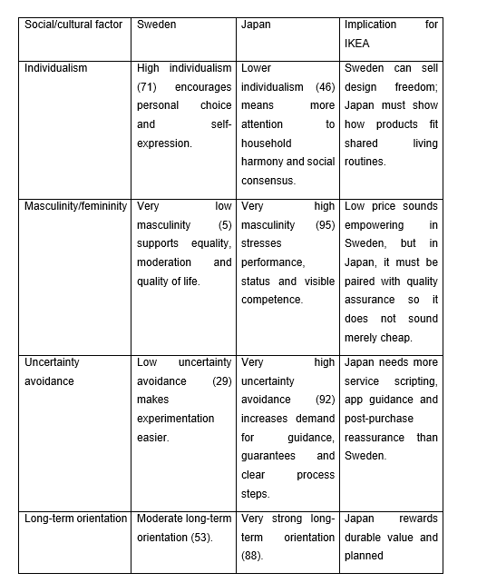
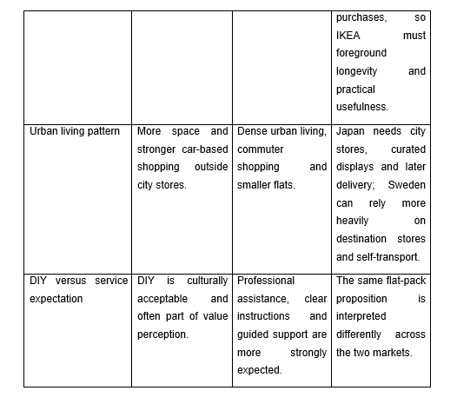
Table 2: Social and cultural factors shaping IKEA's market fit
Source: adapted from Hofstede (2001); De Mooij and Hofstede (2010); De Mooij (2019); IKEA Sweden (2026b); IKEA Japan (2024a)
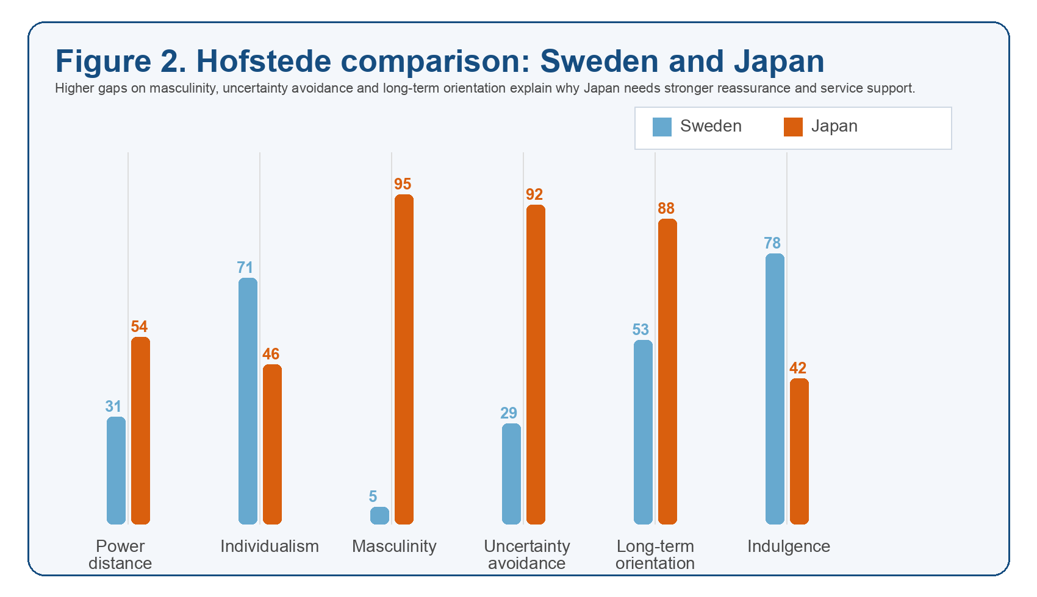
Figure 2: Hofstede score comparison between Sweden and Japan
Source: author-generated from Hofstede (2001) country scores
The cultural distance can be seen in Figure 2. The largest gaps are the masculinity, uncertainty avoidance and long-term orientation. Those gaps are subject to why IKEA Sweden can count on autonomy, simplicity and a low-contact service model, whereas IKEA Japan has to place even greater stress on reassurance, directed trajectories, in cues to excellence and the art of living small. The graph thus substantiates the wider PESTEL conclusion; that the Japanese market is not bad, but due to a low demand but more curated retail experience is desired by consumers.
Meanwhile, it is important to make use of Hofstede but in a critical manner. Nationwide scores do not foretell any consumer decision, and McSweeney (2002) warns against viewing entire countries as homogenous. But the framework is relevant in this context as it is not applied as such. Combining the cultural scores with the housing density, commuting habits, service expectations and the history of market performance research of IKEA itself, they contribute to understanding why the company did not pay off in its previous entry into Japan, and why subsequent changes in its city-store and omnichannel became one of the strategic necessities.

2.3 Legal Comparison
The legal comparison indicates similarities and differences, as well. Their similarity is that the countries are both very vigilant of the consumer, which would come in handy when IKEA wishes to gain trust by ensuring that its policies are clear. Sweden falls within the framework of the EU, and therefore, GDPR aligns the rules of personal-data protection, and the Consumer Rights Directive enhances the termination of obligations and rights to cancel in any consumer contract (EDPB, 2026; European Commission, 2026).
Japan achieves the same goal of bonding with each other by other tools. The Consumer Contract Act covers consumers in case of informational imbalance or unfair terms of the contract, whereas the Household Goods Quality Labelling Act obliges to labelled household products with proper quality (Japanese Law Translation, 2024; 2021). In the case of IKEA Japan, the practical impact is not the same as in Sweden, where GDPR is heavy-handed; the focus lies more on the accuracy in providing precisely the product information, observable returns-counter procedures and observable proof-of-purchase regulations in urban stores.
This comparison of law also elucidates why the detail of operation is important in the marketing mix. Simplicity promise in a campaign may fail given that the delivery windows are not clear, the labels are absent, or the instructions on returning the objects they put up are vague; the legal environment translates a communication weakness into a trust issue. Sweden and Japan pressurise IKEA to carefully handle customer data and distance-selling rights and to make product facts, service counters and exchange procedures particularly apparent on-site at the point of sale respectively.

3. Comparative STP and International Marketing Mix (7Ps)
The macro comparison only holds to the extent of being translated into segment choices, target priorities and execution between the 7Ps. This section observes that the actual adjustment of IKEA in the marketing mix occurs in the areas of the service aspect of the marketing mix and not within the products.

3.1 STP and Targeting Strategy
Sweden has a differentiated and broad segmentation. Demographically: IKEA can divide students, young families, families, home improvers, and psychographically (value-conscious and design-aware consumers) and behaviourally (self-service shoppers who prefer assembly in flat-pack, and visit stores to inspire and shop). It is still mass-market - Kamprad's conception of serving the many people is still reasonable, as the Swedish market is already predisposed to trade-offs on price and sustainability, in framing how a purchase and a comparatively free shopping process that Kamprad envisioned (Hollensen, 2020).
Japan employs a similar segmentation variable but with more focus on targeting. Urban singles, couples and young families in smaller homes, and mobile-first shoppers that require access to the city, delivery and pickup over warehouse shopping make up the most valuable segments. Targeting strategy can thus be characterised as being selectively differentiated: IKEA, of course, wants to reach the entire country, but the offer is most narrowly focused on small city families in densely populated areas. Positioning also shifts. In Japan, the identical brand is marketed more like a smart-living companion that assists customers to upscale their limited space and make purchases effortlessly across the store, the app, and subsequent delivery (IKEA Japan, 2024a; IKEA Japan, 2026a).

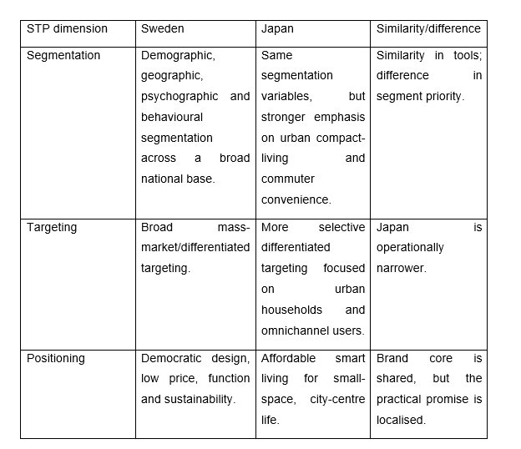
Table 3: Similarities and differences in STP
Source: adapted from Hollensen (2020); Lee and Hsu (2018); IKEA Sweden (2026a); IKEA Japan (2024a)
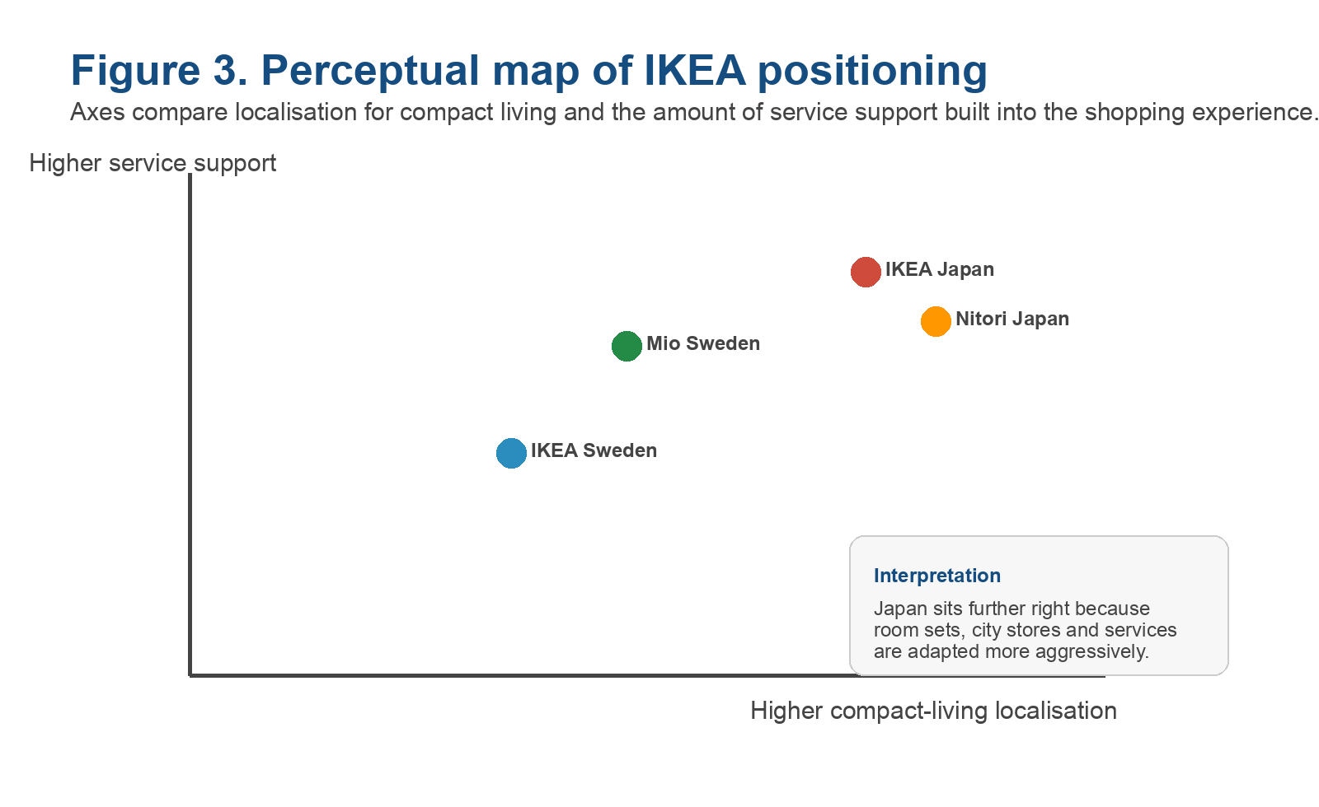
Figure 3: Perceptual map of IKEA's positioning
Source: author-generated from the report's STP analysis
The perceptual map explains the reason why IKEA Japan seems to be much more service-oriented and more localised, compared to IKEA Sweden, yet both are still distinctively IKEA. That looks important since it was a requirement of the tutor to call out and demonstrate the targeting strategy rather than to suggest it. According to the widely-used definition, marketing is the management activity which identifies, predicts and fulfils customer needs in a profitable manner (Chartered Institute of Marketing, 2023). The STP decisions of IKEA in Sweden and Japan will be a useful example of that definition.
The target of the brands for both countries is quite the same: both want inexpensive consumers, yet, at the same time, they are concerned about design and practical use. The distinction lies in the fact that in Sweden, IKEA can attack the mass market with a relatively light adaptation, whereas in Japan, the choice in favour of urban households, small space and service-based shopping paid off. This is the case with positioning. Brand core is consistent, whereas the promise is translated in different ways. Sweden is a statement that speaks of freedom, familiarity; Japan is a statement that talks of smart utilisation of space, assurances and convenience without sacrificing the low-price identity.

3.2 Product: Depth and Width
The term product width is used to denote the number of categories a retailer has, whereas product depth denotes the number of variants existing within a category. IKEA maintains this wide product range in both countries since it still occupies the core rooms of the house with living room, bedroom, kitchen, dining, storage and textile for both countries; however, the depth of the in-store offering varies based on local usage and store format. Sweden can help in greater in-store penetration in the bulky furniture families, as customers are more accustomed to destination shopping, automobile transportation and self-assembly. Japan, on the contrary, drives depth to small-space storage, modular furniture and items to take home, and gives a choice to the customers to order a broader product range (9,500 items) to receive it at home later via the app or online shop (IKEA Japan, 2026a).
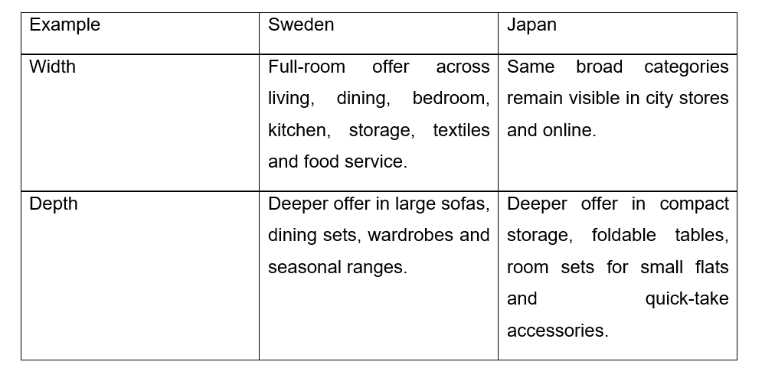
Table 4: Example of product width and depth
Source: adapted from Burt, Johansson and Thelander (2011); IKEA Japan (2026a); IKEA Sweden (2026b)
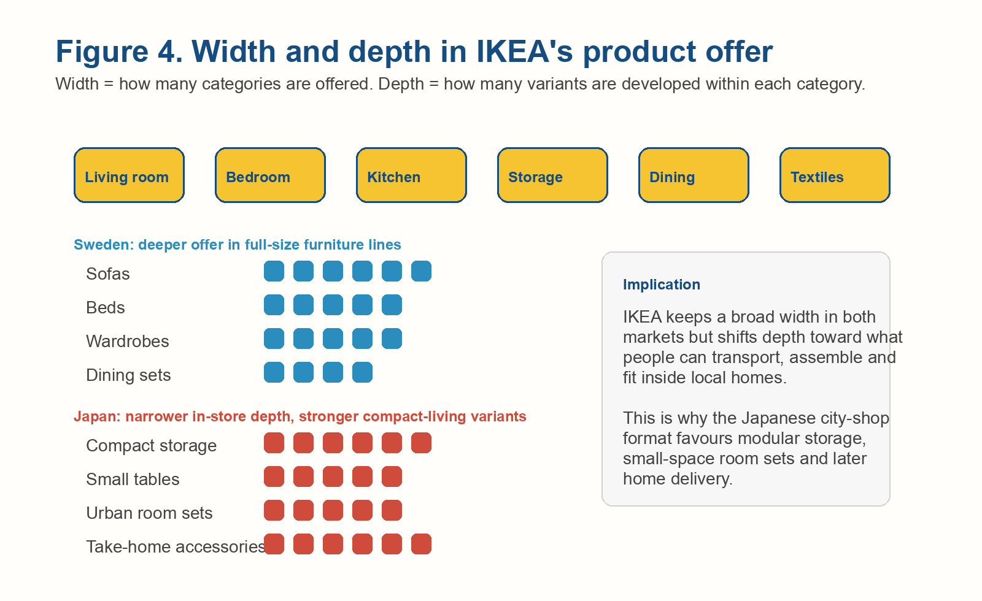
Figure 4: Product width and depth example for IKEA
Source: author-generated from IKEA's market-format comparison
What is vital is that IKEA does not resolve this issue in Japan by forsaking product width; it resolves it by varying the contents that are carried, presented and emphasised in each local format. That makes the adaptation of the products more specific than the imprecise statement that the company just sells smaller furniture in Japan.
It is here that product and service are also dependent. In both nations, there may be a line of wardrobe perhaps, but the depth is realised by the advice of planning, which is delivered and the confidence the buyers have in the assembly. A Swedish customer is able to designate a wide range of types of furniture as a convenient self-service purchase. Similar categories require a higher level of room-setting inspiration, more understandable dimensional interaction and open fulfilment encouragement in Japan.

3.3 Price
One of the most uniform aspects of IKEA is price. The takeaway of the two markets is the low price versus design quality being done by scale, flat-pack logistics and target-cost design (Hollensen, 2020). The distinction is one of communication and not of the comprehensive price philosophy. It is the low price that fits well into an egalitarian Swedish culture and seldom requires any serious explanation to the locals. The low-price position is best in Japan, where the more quality-sensitive consumer is more cautious and is provided with durability cues, precise information, convenience in picking up, and decreased shopping burden. The Shibuya renovation exemplifies this: price is not yet out of the value narrative, yet it is backed by walking paths, Scan & Pay and omnichannel service to make the notion of affordability appear effective instead of cheap (IKEA Japan, 2024a).
That is, the interpretation of price promise is construed on local meaning systems. Low price might be used as an indicator of fairness and access in a democratic way in Sweden. Low price in Japan: a low price alone can be viewed to undermine the quality of the design unless it is backed by the signs of design ability, dependability and comfort. Japanese values: The best value proposition about the Japanese that can be made is not cheap furniture but the smart value of compact urban living, where the overall shopping experience saves the non-monetary expense of searching and the inconvenience of not being able to deliver products.

3.4 Place and Store Comparison
The place is the area where the most noticeable difference between the two markets is visible. The classic destination-store model is still applicable to Sweden, although even there, IKEA now operates on a city format to be close to commuters. Stockholm Gallerian is an urban store that is 3-storey and has over 8,000 square metres, without a warehouse in self-service and, additionally, planning services and a restaurant built around short visits in the city (IKEA Sweden, 2026b). Japan takes this line of thinking. IKEA Shibuya is a 7-floor store occupying approximately 4,800 square metres, located within walking distance of Shibuya Station, with no parking, a guided path closer to a blue-box experience, and approximately 1,700 products available for same-day delivery, with the rest ordered to be delivered later (IKEA Japan, 2024a; IKEA Japan, 2026b).
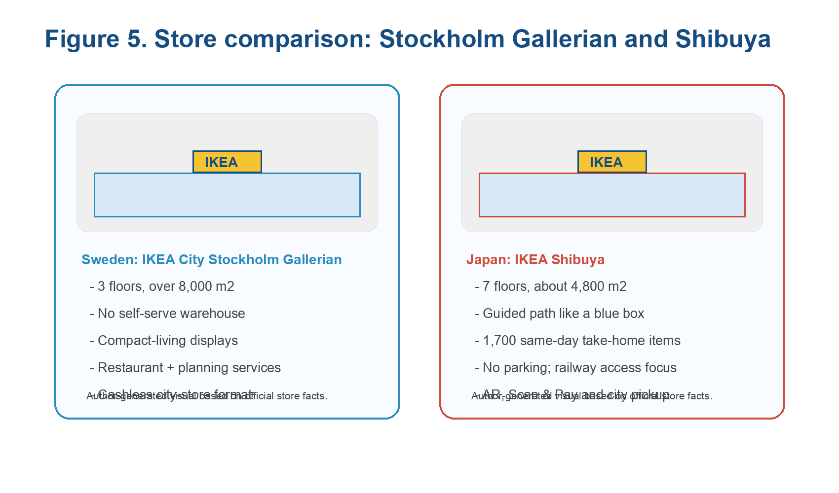
Figure 5: Visual comparison of store formats in Sweden and Japan
Source: author-generated from IKEA Sweden (2026b) and IKEA Japan (2024a; 2026b)
The place choice thus varies between suburban warehouse convenience within the domestic market and the urban convenience and omnichannel connectivity within Japan. The likeness is that the two formats are unsurpassingly IKEA. The difference lies in the fact that a Japanese format will need more work logistically on its part with respect to the customer.
The significance of the store comparison lies in the fact that it depicts that there is a spatial and cultural adaptation. A Swedish customer will tend to visit the store as part of a bigger, car-based shopping experience, and is willing to put the effort into exploring the store when the shopping experience can give him or her breadth of range and inspiration. The customer of a Japanese city store will appreciate being near transit, fast navigation, and being sure that there won’t be any issues with such products as large items being ordered. Place strategy is thus not an apolitical distribution option. It is a direct reaction to the impact of everyday movement and household space on what consumers find convenient.

3.5 Promotion and IMC
Integrated marketing communication (IMC) is a planned synchronisation of messages through channels to ensure customers are presented with a single communicable brand message as opposed to fragmented marketing communications. In the context of IKEA, IMC is reported in Sweden to tie the website, IKEA Family offers, store experience, restaurant cues, sustainability, service pages and messages around just one thing people know about IKEA: affordable design for everyday life. In Japan, coordination is more plainly dotted out. The renewal of Shibuya integrated PR, in-store exterior screens, IKEA app and Scan and Pay, an augmented reality activation, curated room settings and guided path around the store, based on the promise of making the life of the city-centre easier and more inspiring (IKEA Japan, 2024a).
It is not that IMC is used in Sweden, and is not used in Japan, but both use it. The distinction lies in the fact that Japanese IMC will have to strive more to eliminate the ambiguity and urbanise and small-space high-traffic retail environment by projecting the brand into it.
The latter aspect is important since promotion has been overly simplified in that it is synonymous with advertising. The use of app features, direction signs, in-room, and exterior screens, loyalty communication and post-sale service tone are among some of the IMC in this instance. No channel can create a message isolated. It is made through the uniformity of channels. In the case where those channels are in alignment, the customer has a single plausible brand promise. Low prices may even seem baffling rather than empowering when they fail to do this. Japan thus illustrates better than Sweden that the quality of communication is inherent in the entire retail system and not just in media content.

3.6 People, Process and Physical Evidence
The people dimension indicates the difference in scales of the two markets. The exact number that is published by Japan is 3,467 employees in IKEA Japan K.K. and 79 employees in IKEA Distribution Services K.K., and thus totals up to 3,546 employees as of 31 August 2024 (IKEA Japan, 2026a). Sweden does not release an equivalent specific number on the pages that it has gone through in this copy of the correction, but IKEA Sweden indicates that it has tens of thousands of co-workers in Sweden, which is not an unusual number in comparison with the extensive domestic network of 22 stores and plan-and-order units (IKEA Sweden, 2026a; 2026d). This means that the Swedish market will have the capability to support a more comprehensive nationwide support system, whereas Japan will focus personnel and skills on fewer but more well-thought-out customer meeting locations.
In Japan, the process is also more explicit. In Sweden, returns may be registered ahead of time, and the finished item may be returned, picked up or delivered (store, parcel or pickup) with receipts and photos part of the speedy options to process a claim in-store or with customer service (IKEA Sweden, 2026c; 2026e). In Japan, returns and exchanges are transferred via returns counters or customer-service counters in in-town stores where advance registration is encouraged, a check of purchase proof is carefully conducted, and exchanges are normally taken up as a refund-plus-repurchase (IKEA Japan, 2026c). These differences in processes have physical evidence.
The customer complaint handling is a good example. The process design in Sweden presupposes the comfort of numerous customers with using digital form, service pages and self-service returns prior to contacting someone. The complaint will be less likely to be stabilised in Japan using visible counters, a more straightforward step-by-step confirmation and a more formal routine of exchange
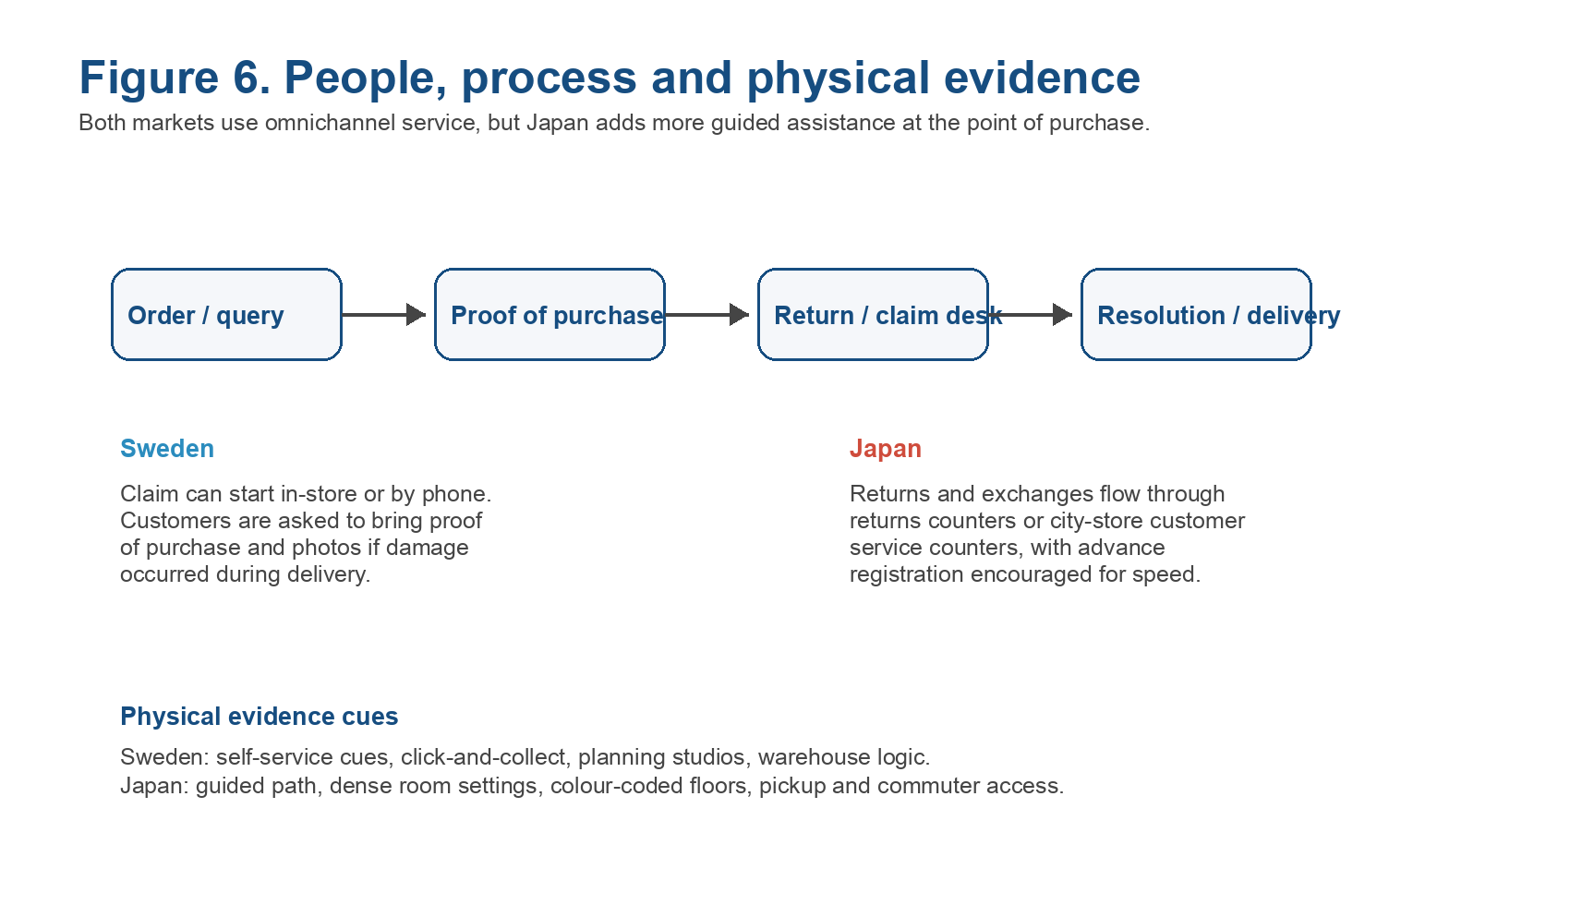
Figure 6: People, process and physical evidence across the two markets
Source: author-generated from IKEA Sweden (2026c; 2026e) and IKEA Japan (2024a; 2026c)

3.7 Similarities and Differences Across the 7Ps
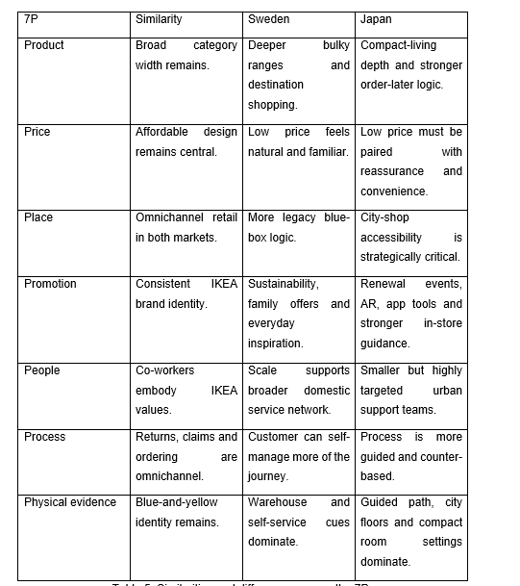
Table 5: Similarities and differences across the 7Ps
Source: author synthesis from the 7Ps analysis above
The general trend is evident. The similarities of IKEA lie in the design of its brand: a combination of low prices, Scandinavian identity and consistency of both offline and online channels. Place, Process and Physical Evidence have the biggest differences, and next are people and Promotion. It is important as it demonstrates that transforming the product alone will not make the company achieve success abroad. The heavy adaptation can be imposed on the service-based Ps in culturally alienated markets.
The debate on standardisation versus adaptation is also solved with the help of this comparison. IKEA is standardised to the extent necessary to guard scale, identities and world recognisability. It is not strategic enough to be dogmatic. Sweden is nearer to standardised end as the original formula was determined by the domestic market. Japan is more towards adaptation since the cost of not understanding everyday behaviour is higher. They also should enquire about what factors produce scale efficiencies and what factors produce local legitimacy. At IKEA Japan, the most evident approach to establishing legitimacy is at the service-intensive Ps.

4. Directional Development Strategy - IKEA in Japan
The matrix of Ansoff can be used to follow the changes in the Japanese strategy of IKEA, which seemed to be unsuccessful at first, but provided a more appropriate channel to develop. Market development in 1974 was the first entry, which was, in a way, market development: IKEA took an existing offer, and transferred it to a new geographic area with an insufficient local adaptation. The 1986 withdrawal demonstrated that there was an insufficiency in geographic expansion without behavioural adjustment (Lee and Hsu, 2018).
In the re-entry of the year 2006, market development was still involved, but focused on product development due to the different course of IKEA, where range mix, delivery, room settings and service features were modified. Gradually, the strategy expanded more and more. The Shibuya renewal, Scan and Pay, AR activation and guided path in the city-store reveal how IKEA has transformed Japan into a test kitchen when it comes to developing retail formats as opposed to just another store to carry on with their Swedish routine (IKEA Japan, 2024a).
In this light, Japan would be of strategic value to sales outside of its contribution to sales. It is a learning market that IKEA is experimenting with the extent of the blue-box model compression, digitisation and re-sequencing in the context of an urban lifestyle. A few of those lessons can be brought back to Sweden, where urban forms will take on even greater significance. The strategic role of Japan is hence dual: it is a challenging foreign market which can generate revenue, and a place where capability can be developed and will have an impact on the overall international business.

5. Ethical Issues in IKEA's Marketing Mix
Ethics is important as IKEA does not only sell products but also a promise of a better everyday life, sustainability and affordability. When the marketing message fails to be backed in the chain of supply, then the marketing message becomes weak.

5.1 Supply Chain and Labour Ethics
The most notorious labour ethics scandal is the child-labour crisis in South Asia during the 1990s. The reaction of IKEA - collaboration with UNICEF and Save the Children, and improved governance of its suppliers with IWAY was a demonstration of real organisational learning as opposed to the gesture post-apology (Edvardsson and Enquist, 2009). However, the moral risk will not cease to exist merely due to the existence of a policy. The low-price model puts continuous pressure on suppliers, and this implies that nothing can be left as far as the labour is concerned unless marketing remains responsible in their obligation as in their marketing statements.

5.2 Environmental Sustainability and Greenwashing
Ethics of the environment are less clear. IKEA has spent a lot of money on renewable energy, on sustainability and lower-impact materials, but as the Earthsight (2020) investigation into supposedly illegal timber revealed, sustainability positioning can be easily bitched and a third-party certification is required to achieve it. It is particularly a sensitive issue in Japan, since living in a compact area and the concept of mottainai lead to a higher demand for products not to be wasteful. In Sweden, where sustainability is already mainstream, the brand is rated more on whether it is a leader and not whether it is a complier.

5.3 Critical Assessment
IKEA leads a pack of retailers in ensuring that ethics are visible, but the company continues to drive its business on high volumes and cost control. Frankly, a company that is potentially unique in maintaining a tense situation is not unethical; it simply means that the marketing mix is vulnerable to over-promising always. The most ethical stance that can be taken by IKEA is not to invade flawlessness, though, but to show traceability, repairability and quantifiable enhancement.
This holds importance as it concerns marketing and not just a peripheral issue. The assertions made on product features about the duration, the assertions made on the product that it is sustainable, the assertions made on the product that it is of low price and even physical evidence cues within the shops all give expectations that can be verified about the supply-chain reality. Ethical credibility is an aspect of market performance in international marketing since potential customers are becoming increasingly conscious of what companies and products are offering in the market, rather than how responsibly they are manufacturing those products and conveying their information.

6. Recommendations
The recommendations are also country split to ensure that they are operational as opposed to generic.

6.1 Sweden
In the first place, circular services repair, resale and take-back should be better developed in Sweden and linked more to the planning of city-store appointments. That would add to the environmental fit that is already ensuring that Sweden is favourable in relation to IKEA. Second, urban formats like Galleria should be kept in the Swedish market so that the inspiration and purchase distance can be minimised, particularly in cases of kitchens, storage and planning-intensive products in which advice generates value.

6.2 Japan
Japan needs to keep on growing the bundling of small spaces and guided online shopping. Meal picked up in the room sets, city pickup, ordering and assembly options via the app respond directly to the cultural need to get reassured, and the physical constraints of urban housing. Another way that IKEA Japan needs to continue to develop IMC is the focus on quality, room efficiency, and convenience over low price.

6.3 Shared Priority
IKEA in both countries needs to become more specific in its country-level sustainability communication and enhance the supply-chain traceability. The moral discourse demonstrated that there is no longer a need to make general global claims. Evidence based on the country would be more effective for the brand in the two markets.

7. Conclusion

7.1 Conclusion for Sweden
IKEA is most likely to be in Sweden, and the formula fits best there. Democratic design, self-service and mass-market targeting are all supported by the political and legal environment, and the cultural environment. Adjustment remains to be made at the fringe - particularly with the city forms and the circular services, but it is hardly radical.

7.2 Conclusion for Japan
Japan shows that IKEA can be able to work in a culturally distant market, but only when it makes some changes to the customer-facing aspects of its model. Brand identity and value promise are the aspects that make the most similarities with Sweden, whereas service design, clarity of store format and process are the most different aspects. Sweden favours brand continuity, and Japan favours brand continuity and adaptability of operations.

Section 2: Reflective Account
Quick summary: The Reflective Cycle of Gibbs assisted me in getting beyond merely describing Sweden and Japan with unclear explanations of how tutor feedback enabled me to improve the order of the framework, the application of visuals, and the quality of the market comparison.
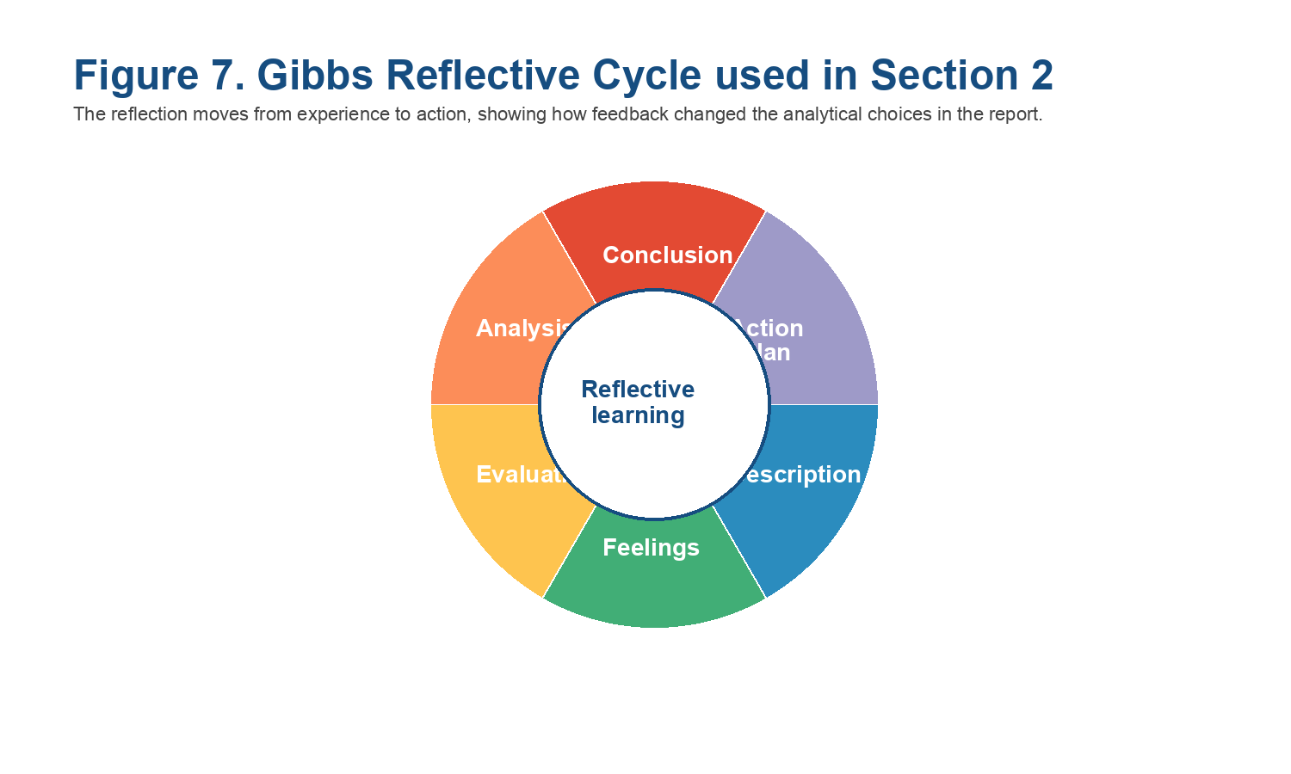
Figure 7: Gibbs Reflective Cycle used to structure the reflection
Source: author-generated from Bolton and Delderfield (2018)

Description
This assignment helped me focus on the marketing techniques employed by IKEA because I needed to juxtapose Swedish and Japanese marketing practices and reflect on how I conducted the research and organised the analysis. My attitudes towards the task were initially reduced to a mere two market comparisons, with the primary aim of finding the differences. As I moved on, because it made me realise that it was the application of frameworks in a logical manner that made the report effective. It comprised beginning with PESTEL analysis, then moving on to a comparison of social and cultural, STP (Segmentation, Targeting and Positioning), 7Ps marketing mix and lastly strategic direction, ethics and suggestions.
The input of tutor feedback was significant in this procedure. It demonstrated that all the areas of my weakest points were not because of the missing information, but as a result of ineffective organisation and lack of clarity in outlining the strategies. This helped me to realise that structure is of the same significance as content in academic writing.

Feelings
I figured IKEA would be an easy company to analyse due to the fact that it is a world-renowned brand. The Japanese market complicated the task further when I came to realise that IKEA had failed in the market before. This made me even more interested in how such a good company will falter in another cultural setting.
The tutor's feedback was a challenge to me. It made me realise that one must have the right ideas. Academic writing needs to be distinctively evidenced, properly structured and utilise correct strategic terminology. Though it was hard to take this feedback in at the beginning, it was an encouraging incentive to work better.

Evaluation
There are a number of areas in my revision that were a success. A tool for responding to Hofstede's dimensions of culture by being critical and not assuming as a fact was a strength. This assisted in relating cultural theory to the actual marketing choices. The greatest enhancement was made to the tutor feedback. PESTEL analysis was not graphically clear in my initial draft, and I failed to clearly differentiate social and cultural aspects. I also had a poor explanation of targeting and positioning, which lacked support. Once these changes had been made, the report was easier to comprehend and became more structured.
One of the shortcomings of my initial draft was to be able to presume the strategy to be obvious to the reader without stating it in this way. It was revealed through the feedback that the differentiated targeting and integrated marketing communication (IMC) strategies have to be verbalised and defined. My source usage was also enhanced. In the first versions, mainly I had relied on academic theories, but in the revised version, more realistic and convincing evidence on IKEA was presented; this reason made the analysis more realistic and compelling.

Analysis
The usefulness of the Gibbs Reflective Cycle is that it prompts one to think more intimately. Interrelated marketing structures are one of the lessons I learned to be the most effective. PESTEL is used when explaining the external environment, and cultural analysis is used when explaining consumer behaviour. STP includes the determination of the target customer, and the 7Ps explain the implementation of the strategies.
This tutor's feedback assisted me in getting a step further than merely defining differences in how they have an effect. I was not simply taught that Japan is a culturally different country, and I was taught how this intrudes into the store design, customer service and communication strategy.
The other important observation is that the various aspects of the marketing mix might not be important in all markets. Initially, I placed a lot of emphasis on the differences between products. However, I learnt that it was more important to have Place, Process and Physical Evidence that were relevant in the Japanese context. This is an improvement in perception of retail marketing, which is a hugely diverse aspect of customer experience.

Conclusion
The central insight of this reflection is that the expertise of cultural aspects in marketing should be reasonable. When making real business decisions, which should be related to cultural differences, store layout and service processes, the most powerful points of my final report are.
Another thing I came to know is that tutor feedback is useful as it can be used to enhance content and structure. A good academic report entails not only having good ideas, but it also involves a clear arrangement. Tables and diagrams are useful in visualising arguments to make them more straightforward and efficient. This course has enhanced my academic writing and enabled me to learn about the ways to implement the marketing models logically and systematically.

Action Plan
More planning I will do at an earlier stage in future assignments. My prewriting process will include writing a structure and determining where the visuals (tables and diagrams, etc.) will be required. This will assist in ensuring that there is clarity and organisation. I will also ensure to explicitly mention and explain all strategies, as I shall not expect the reader to infer all about them. Furthermore, I will keep enhancing my use of sources using a combination of theory in the academic world and real-life examples.
Lastly, I will be more successful in terms of counting words and dividing the space to each section beforehand. This will assist in making sure that the entire assignment has been developed aptly. Through these measures, I would have even more powerful, concise and professional scholarly work going forward.

References
Bolton, G. and Delderfield, R. (2018). Reflective practice: writing and professional development. 5th edn. London: SAGE Publications.
Burt, S., Dawson, J., Johansson, U. and Hultman, J. (2020) 'The changing marketing orientation within the business model of an international retailer - IKEA in China over 10 years', International Review of Retail, Distribution and Consumer Research, 31(1), pp. 1-22. doi:10.1080/09593969.2020.1857294.
Burt, S., Johansson, U. and Thelander, A. (2011) 'Standardised marketing strategies in retailing? IKEA's marketing strategies in Sweden, the UK and China, Journal of Retailing and Consumer Services, 18(3), pp. 183-193. doi:10.1016/j.jretconser.2010.09.004.
Chartered Institute of Marketing (2023) 'What is marketing?' Available at: https://www.cim.co.uk/content-insights/articles/what-is-marketing/ (Accessed: 21 April 2026).
De Mooij, M. (2019). Consumer behaviour and culture: consequences for global marketing and advertising. 3rd edn. London: SAGE Publications.
De Mooij, M. and Hofstede, G. (2010) 'The Hofstede model: applications to global branding and advertising strategy and research', International Journal of Advertising, 29(1), pp. 85-110. doi:10.2501/S026504870920104X.
Earthsight (2020) Flatpack forests: IKEA's illegal timber problem. London: Earthsight. Available at: https://www.earthsight.org.uk/investigations/ikea-flatpack-forests (Accessed: 21 April 2026).
Edvardsson, B. and Enquist, B. (2009) 'Corporate social responsibility and values-based service brands: the case of IKEA', International Journal of Retail and Distribution Management, 37(10), pp. 898-915. doi:10.1108/09590550910956232.
European Commission (2026) 'Consumer rights directive'. Available at: https://commission.europa.eu/law/law-topic/consumer-protection-law/consumer-contract-law/consumer-rights-directive_en (Accessed: 21 April 2026).
European Data Protection Board (EDPB) (2026) 'What is the GDPR?'. Available at: https://www.edpb.europa.eu/sme-data-protection-guide/faq-frequently-asked-questions/answer/what-gdpr_en (Accessed: 21 April 2026).
Hofstede, G. (2001). Culture's consequences: comparing values, behaviours, institutions and organisations across nations. 2nd edn. Thousand Oaks: SAGE Publications.
Hollensen, S. (2020). Global marketing. 8th edn. Harlow: Pearson Education.
IKEA Japan (2024a) 'IKEA Shibuya Renewal Open on Tuesday, 27 August 2024'. Available at: https://www.ikea.com/jp/en/newsroom/corporate-news/20240826-ikea-shibuya-re-born-pub8fde2780/ (Accessed: 21 April 2026).
IKEA Japan (2026a) 'About IKEA Japan'. Available at: https://www.ikea.com/jp/en/this-is-ikea/about-us/about-ikea-japan-pub3c09f721/ (Accessed: 21 April 2026).
IKEA Japan (2026b) 'IKEA Shibuya'. Available at: https://www.ikea.com/jp/en/stores/shibuya/ (Accessed: 21 April 2026).
IKEA Japan (2026c) 'Return, exchange, cancellation'. Available at: https://www.ikea.com/jp/en/customer-service/returns-claims/ (Accessed: 21 April 2026).
IKEA Sweden (2026a) 'Find your IKEA store'. Available at: https://www.ikea.com/se/en/stores/ (Accessed: 21 April 2026).
IKEA Sweden (2026b) 'IKEA City - Stockholm Gallerian'. Available at: https://www.ikea.com/se/en/stores/stockholm-gallerian/ (Accessed: 21 April 2026).
IKEA Sweden (2026c) 'Services'. Available at: https://www.ikea.com/se/en/customer-service/services/ (Accessed: 21 April 2026).
IKEA Sweden (2026d) 'How many people work at IKEA in Sweden?'. Available at: https://www.ikea.com/se/sv/customer-service/knowledge/articles/37e7fcef-6625-4269-b77f-5f2g36d61337.html (Accessed: 21 April 2026).
IKEA Sweden (2026e) 'Returns and claims of products and furniture'. Available at: https://www.ikea.com/se/en/customer-service/returns-claims/ (Accessed: 21 April 2026).
Japanese Law Translation (2021) Household Goods Quality Labelling Act. Available at: https://www.japaneselawtranslation.go.jp/en/laws/view/3935/en (Accessed: 21 April 2026).
Japanese Law Translation (2024) Consumer Contract Act. Available at: https://www.japaneselawtranslation.go.jp/en/laws/view/4431/en (Accessed: 21 April 2026).
Lee, S. and Hsu, S. (2018) 'An exploratory study on the success and failure factors of multinational companies - IKEA in Japan', International Journal of Business and Management, 13(5), pp. 146-155.
McSweeney, B. (2002) 'Hofstede's model of national cultural differences and their consequences: a triumph of faith - a failure of analysis', Human Relations, 55(1), pp. 89-118. doi:10.1177/0018726702551004.

