GREENLEAF CAFÉ WEBSITE DEVELOPMENT REPORT
Website Design and Development Report
Student Name: Jawad Safi
Student Number: 2511186
Course: IT
Module: Introduction to Web and Database Concepts
Submission Date: 22/07/2026
Website: GreenLeaf Café

Table of Contents
- Introduction
- Requirements
- Implementation
  - Website Development
  - Homepage
  - About Page
  - Menu Page
  - Contact Page
  - HTML Validation
  - CSS Validation
- Evaluation
  - Website Usability
  - Website Accessibility
  - Search Engine Optimisation
  - Evaluation of the GreenLeaf Café Website
  - Comparison of Two Existing Websites
- Conclusion
- References (IEEE)
- Appendices

Introduction

Abstract

This report details design, development, implementation and evaluation of the “GreenLeaf Café” Web site. The site has been written in HTML5 and CSS3 and offered to the user as a pleasing and informative website, for an imaginary independent coffee shop. The main purpose of the website is to give users the necessary information in an easy-to-use, responsive and accessible way, such as information about the café, the items on the menu, opening hours and contact details. The project is developed in accordance with contemporary development of the Web, including semantic use of HTML5 elements and external CSS stylesheet, as well as responsive Web design. The site has been designed to work on desktop computers, tablets and mobile devices equally, providing an optimal user experience no matter where a user is viewing the site from.
Usability, accessibility & search engine optimisation (SEO) were given a special attention throughout the development process. The website underwent validation with HTML and CSS standards and was tested for compatibility with various devices using responsive design.
The report discusses the design considerations throughout the development process and explains the implementation of the website, compares the final website to the two websites of commercial cafes and assesses the website against recognised principles of web development. The report ends with the strengths of the finished website and other suggestions for future improvements.

Requirements

Website Purpose
The objective of the GreenLeaf Café webpage is to offer an educational and aesthetically pleasing website for customers who want to find out more about the café and the services they offer. The website advertises the café, displays the entire menu of food and beverage products, presents the company and its location to the community and allows customers to easily access opening hours and contact details.
The purpose of the website is also to invite prospective patrons to the café, by providing a pleasant initial experience based on appealing pictures, navigation and organisation. The website makes sure there is accurate information online, which increases the communication between the café and its users, and reinforces the café's digital presence.

Target Audience
The website will be visited by a variety of potential customers, including:
Student seeking a relaxing place for study or relaxation.
Families looking for an appealing cafe atmosphere.
A need to obtain breakfast, lunch or coffee during work hours.
The residents of local are interested in independent cafés.
People in the vicinity who are looking for restaurants and pubs.
The structure of the Web site has therefore been made simple, with legible typography and easy-to-use navigation, so that even those with varying technical skills and proficiencies can access information.

Website Objectives
The main aim of the website is to:
Encourage prospective customers to get word of the existence of GreenLeaf Café.
Present information using an attractive and professional design.
Ensure that there's explicit navigation between all webpages.
Display menu items and café information.
Indicate hours and phone numbers.
Get customers to come to the café.
Exhibit responsive web design techniques.
Adhere to known web standards of HTML5 and CSS3.
Website Features

Home Page
The homepage is the introduction to the GreenLeaf Café. It has a warm “Hero Section” with a headline, introduction and a call-to-action button that points customers to the menu page. Other sections emphasise the features of the café such as quality coffee, healthy menu items and customer friendliness. Images of the café are shown in the gallery section, creating the visual overview for people visiting the place and taking in the environment and products offered.

About Page
The About page will present an introduction to GreenLeaf Café, its background and values. The importance of Sustainable sourcing of good quality ingredients and locally sourced produce and excellent customer service is communicated to the visitors. Open times are also programmed to indicate with supporting images for a welcoming attitude.

Menu Page
The Menu page displays the Café items of food and beverage in an organised and structured format. Menu categories enable users to easily and instantly access the array of available products, without sacrificing simplicity of page structure. The page is created to help customers decide before they enter the café what they want to buy.

Contact Page
The Contact will give customers contact details that will enable the visitors to easily interact with the café. The location, telephone number and email address are clearly presented. The page will allow customers to know where the café is, or they can ask questions prior to visiting.

Functional Requirements
The finished website meets the following criteria of functioning:
Four fully linked webpages.
Providing consistent navigation throughout the entire site.
Design that adapts to desktop, tablet and mobile device.
Image gallery.
External CSS stylesheet.
Semantic HTML5 structure.
Alternative text for images that is accessible.
Internal navigation links.
Creating hyperlinks from page to page.
Non-Functional Requirements
The site also meets some non-functional requirements.

Performance
The site is quick to load because of the low quantity of web pages and streamlined use of images.

Usability
Using a simple navigation menu and consistent page layouts enhances the user experience by making it easy for users to find information.

Accessibility
Alternative text has been provided for images, semantic HTML elements improve screen reader compatibility and colour contrast has been considered to improve readability.

Maintainability
A single external CSS stylesheet allows for ease of future changes as all webpages will reflect the same changes.

Portability
Modern web browsers such as Google Chrome, Mozilla Firefox, Safari, Microsoft Edge can be used to access the website without the need of additional software.

Implementation

Website Development
The GreenLeaf Café website has been built in html5 and css3 in visual studio code. The website has been handcrafted, not built with a web design application, and is found to be compliant with the guidelines of the assignment, and recognised standards in web development. To ensure that all webpages would have a consistent look and feel and to ease future maintenance and updates, an external CSS stylesheet was used. The website comprises of 4 interconnected web pages: Home, About, Menu and Contact. The navigation links are also partway up the page every time so user can move from page to page easily to different parts of the website. To enhance accessibility and search engine optimisation several HTML5 elements have been introduced, such as <header>, <nav>, <section>, <main> and <footer>. The overall design is minimalistic, sleek and chic with the green of the colours reflecting the own natural image and ambience of the café. Incorporating images into website throughout to promote visual appeal and accompany site textual information presented to user. Google Fonts has been added to help to have a professional and consistent typography on each webpage. The website is developed with responsive design approach. The pages are built for flexibility and can be adapted to utilize different sizes by using Flexible Layouts and CSS Styling, so that they are usable on desktop computers, tablets and smartphones.

Home Page
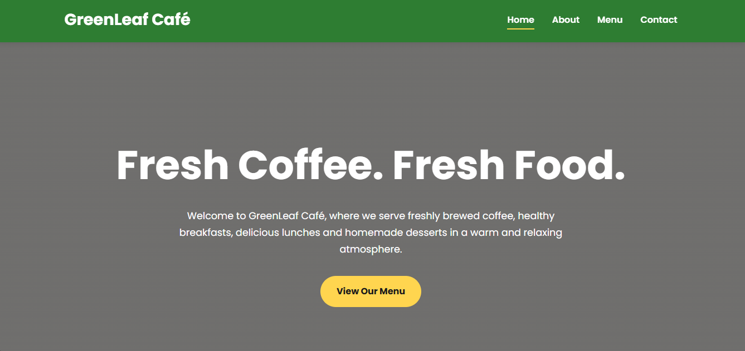

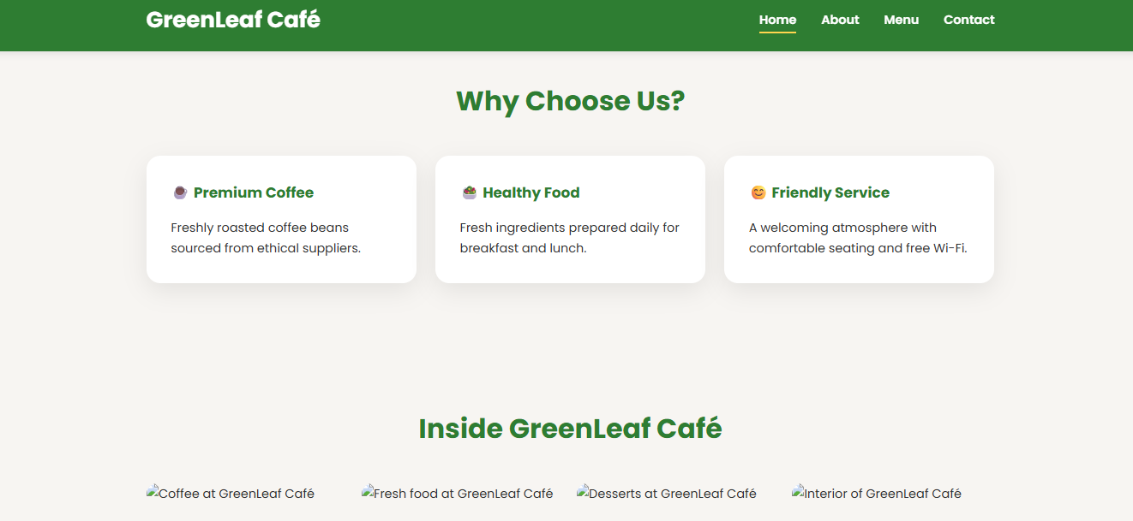
The homepage is the primary page that visitors will land on and sets the overall impression of the GreenLeaf Café. Immediately, a large sized hero section will welcome and direct visitors to the menu page with very clear heading, text and call to action button. This enables first-timers to garner the clear and quick message about website's purpose. Below the hero section, three feature cards highlight the café's key strengths: premium coffee, healthy food and friendly customer service. Such features offer succinct details, making it easier for users to continue navigating the site. Additionally, an image gallery is included on the homepage, which features the café environment, the food and beverages. Quality imagery makes the café look more appealing and helps to convey the atmosphere of the café. Menus are at the top of the page for easy navigation from one web page to another in all 4 pages. You can't miss any navigation patterns on the website.

About Page
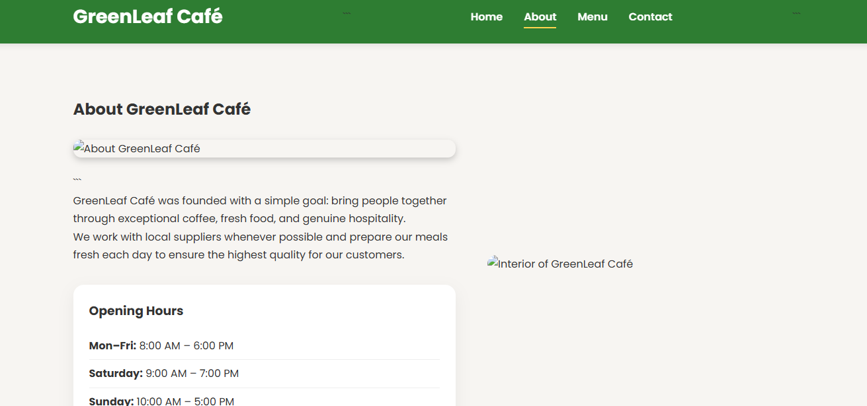
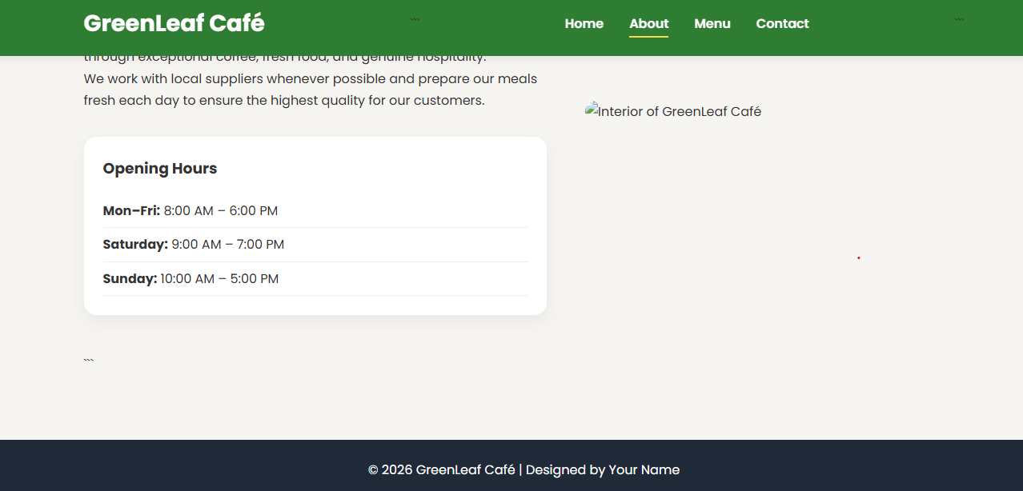
The About page includes information for visitors about GreenLeaf Café. It describes the café's values, the quality ingredients the café is based on, and the café's focus on quality customer service. This information contributes to establish trust with the people who are possibly interested in visiting the café as they know what the café is and what is the business concept and philosophy. The hours are listed in a readily organized space, making information easily accessible. Supporting images enhance the welcoming atmosphere of the café and make it a more interesting browsing experience. The page features a clear structure with appropriately formatted headings and spacing for ease of readability and to ensure consistency through the site's design.

Menu Page
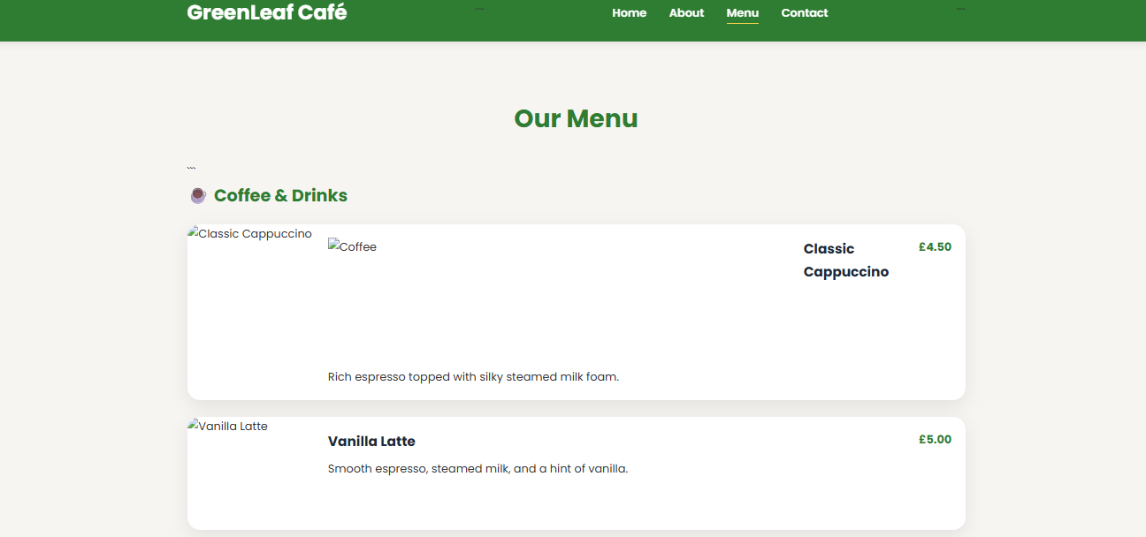

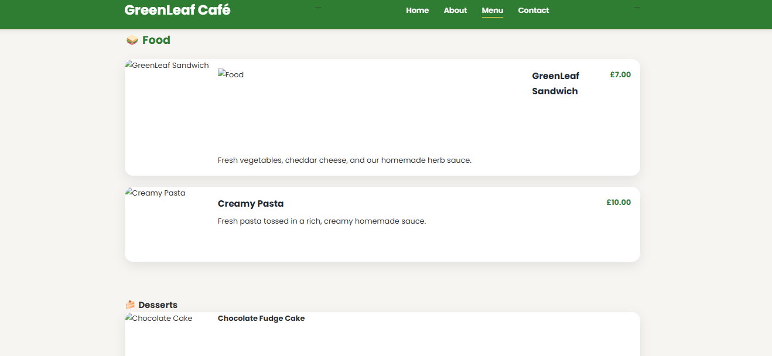
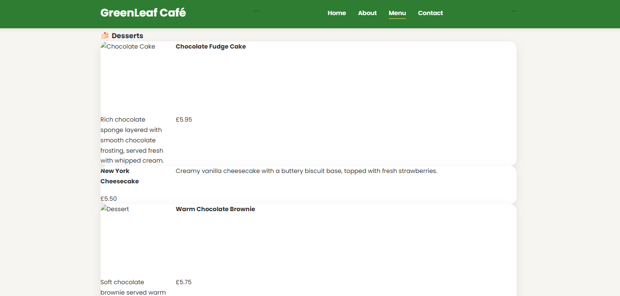
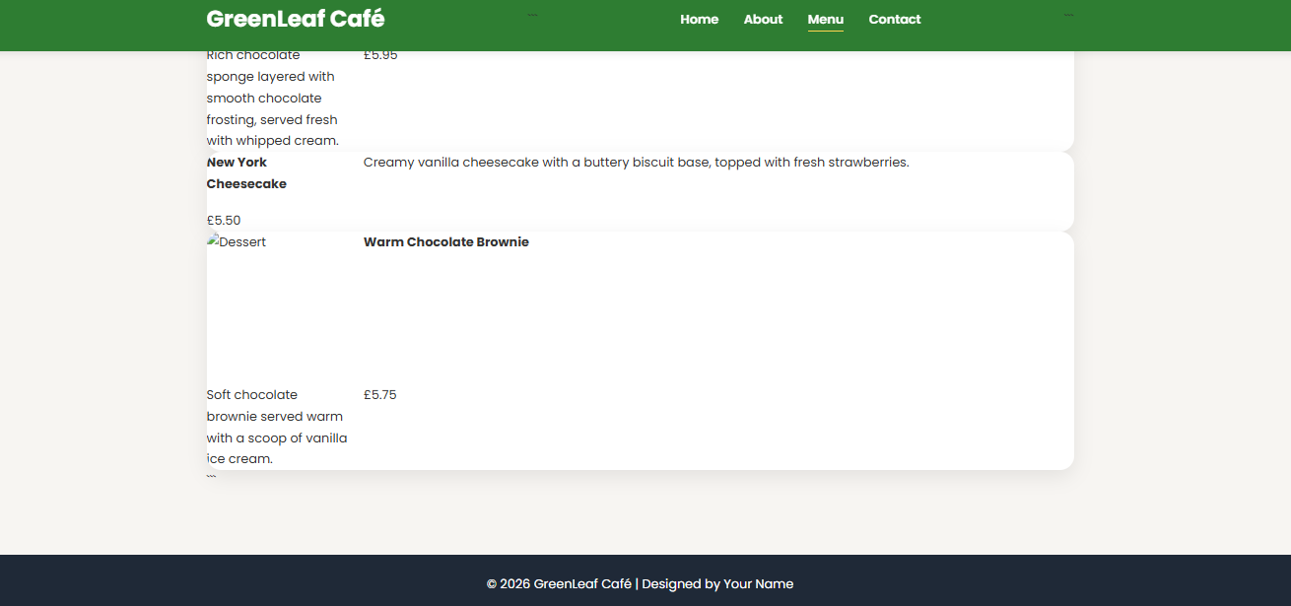

The Menu page tells you what food and drinks you can order at GreenLeaf Café. The menu is logically structured, making it easy for visitors to quickly navigate and see what products are available. Menu items are presented in a structured format, which can help the customer to identify what type of meals and/or drinks they are interested in before making a trip to the café. The use of typography and spacing in communication is clearly thought through for ease of reading and maintains consistency with the other webpages. The overall design aims to provide users with clear and accessible information without unnecessary clutter.

Contact Page
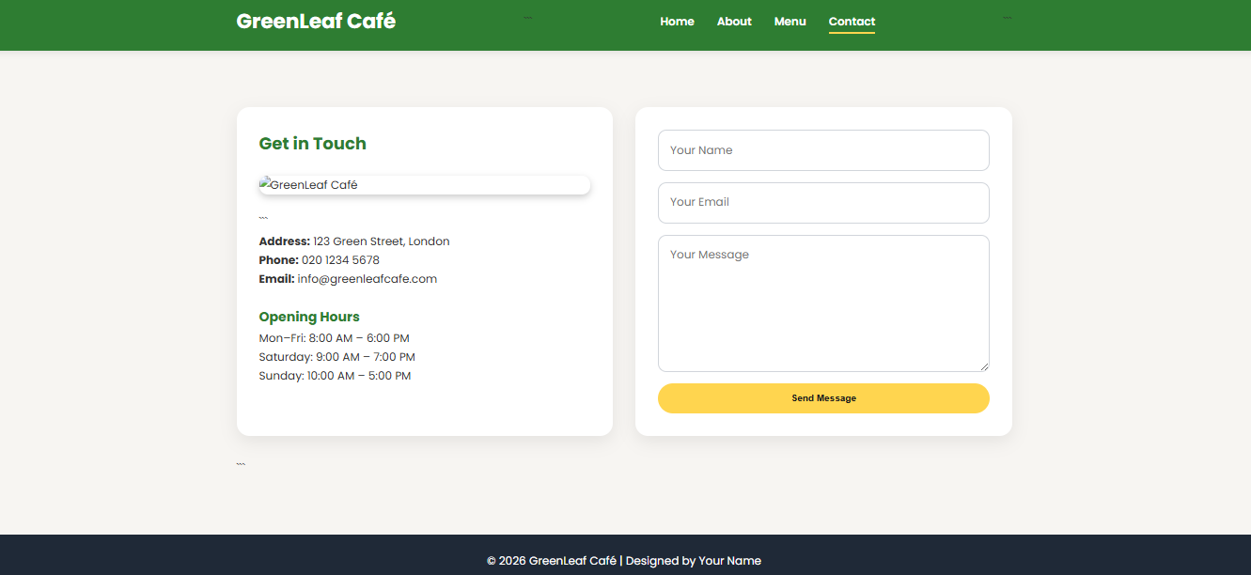
GreenLeaf Café's Contact page gives visitors the information they need to get in touch with us. Numbers, contact email and location are clearly displayed to allow for customer enquiries or ease the place to locate the café. The page is visually consistent with the rest of the website; this means that the navigation structure, typography and colour scheme are consistent within the website, providing a familiarity and uniformity to the user. The neat organization makes it easier to use, as it will only show the details needed by visitors who wish to get in touch with the company.

Website Navigation
One of the most critical aspects of a site is navigation, as it allows visitors to find information easily with an efficient manner. A uniform structure of the navigation bars has been introduced into the 4 webpages to enhance user friendliness and minimize user confusion.
The Home, About, Menu and Contact pages are all linked in the navigation bar at the top of each page and are easy to find. Placing it consistently makes you feel free from the opportunities to visit another page without going back to the home page. Simple labels for navigation improve readability and ease of understanding and lessen cognitive load, especially if they are not familiar with the site.

Responsive Design
The website has been designed with responsive web design principles which allows it to display the pages well on various screen resolution and various devices, including mobile devices. The elements of the page can resize and position itself automatically as per the width of the screen.
Testing was done responsive using the Device Toolbar in Google Chrome Developer Tools. Each of the following devices was tested:
- iPhone 14 Pro Max
- iPad Air
- Samsung Galaxy S20 Ultra (or Responsive Mode)
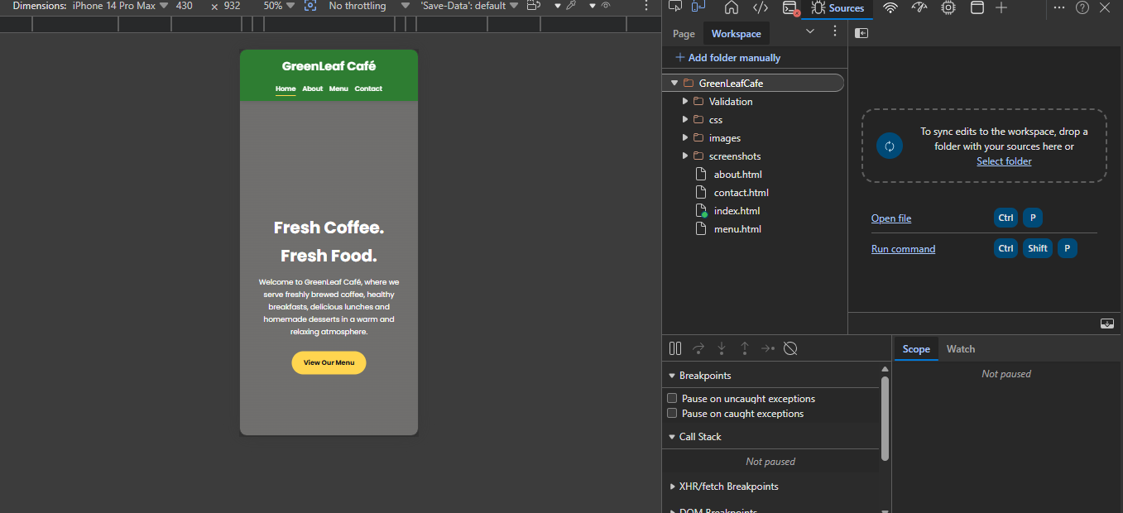
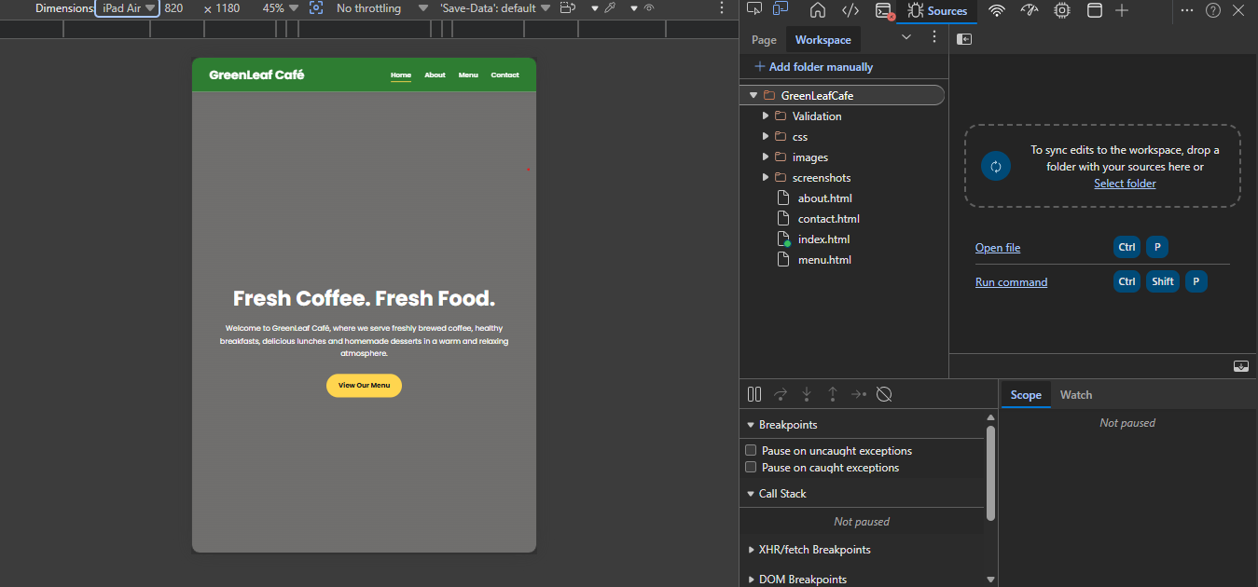
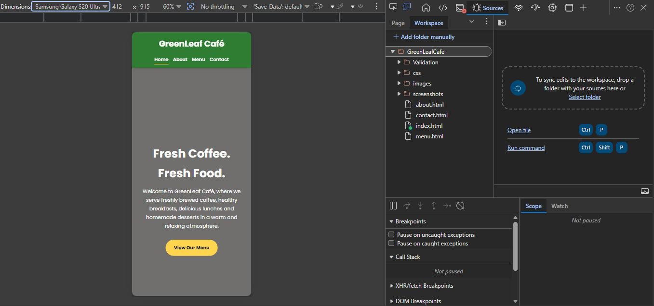
The Site was tested and found to be adaptive on smaller screens. Resize of images had not spoiled readability of text nor caused problem with navigation. This responsive design didn't require a horizontal scroll during testing, which means it functions well on various devices.

HTML Validation
A World Wide Web Consortium (W3C) Markup Validation Service was used to ensure adherence to web standards such as HTML5 by validating the HTML files.
All web pages (Home, About, Menu and Contact) were validated with success when checked prior to publication, eliminating incorrect code. First validation revealed that there were some problems such as the closing brackets being lost, nesting HTML elements or some markdown formatting characters missing. These errors were addressed by going over the structure of the html and making sure you use proper nesting of a tag and closing a tag.
All web pages validated after correction, there were no validation errors.
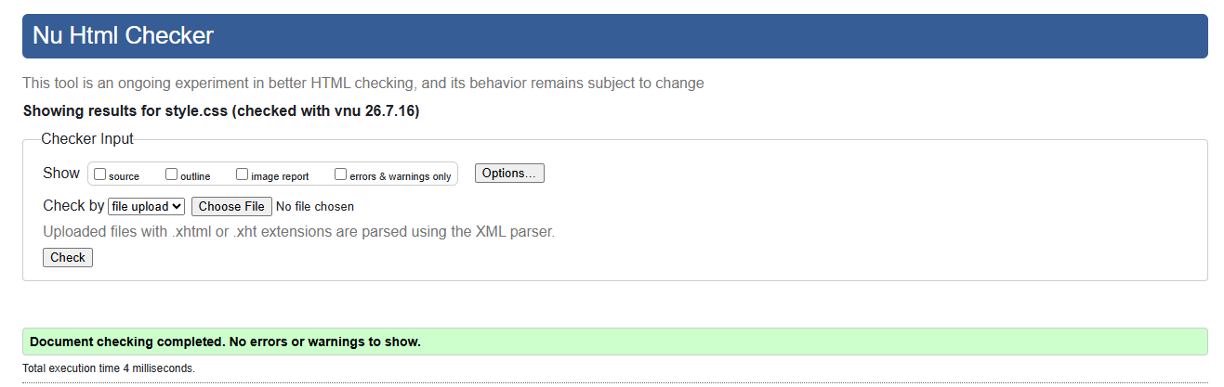
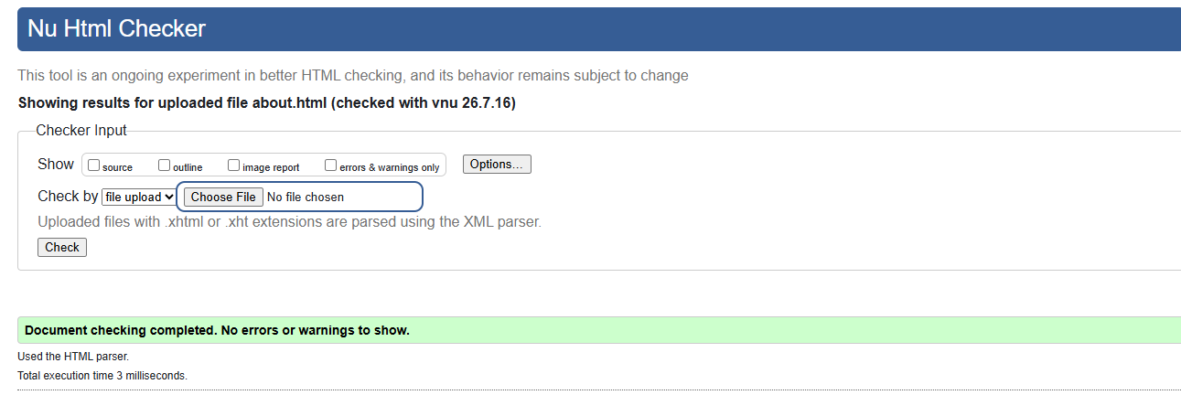
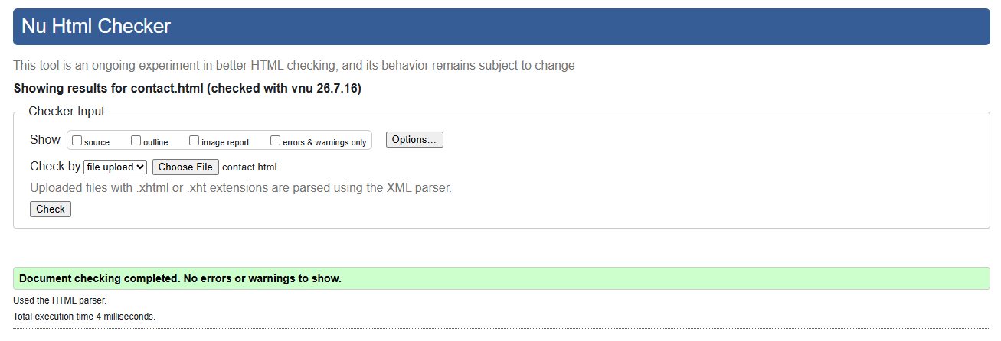
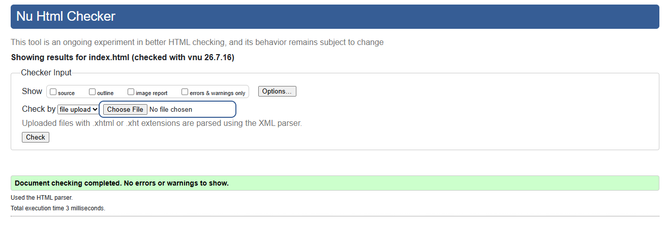
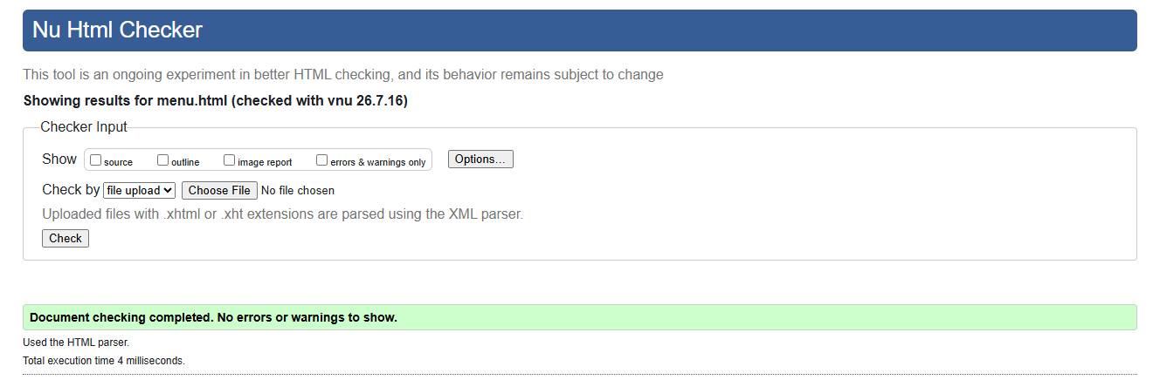
Validation shows that the site is compatible with the modern browsers and follows HTML standards.

CSS Validation
The external stylesheet was made valid by means of the CSS Validation Service from the W3C.
Some of the CSS contained mis-syntaxes elements, namely in the absence of semicolons, the presence of an extra ending brace and a falling apart string of text, which caused the stylesheet not to be successfully interpreted. The following issues were addressed by inspecting the line-by-line application of the stylesheet and making sure each CSS declaration was correct.
After these corrections, there were no validation errors in the stylesheet.
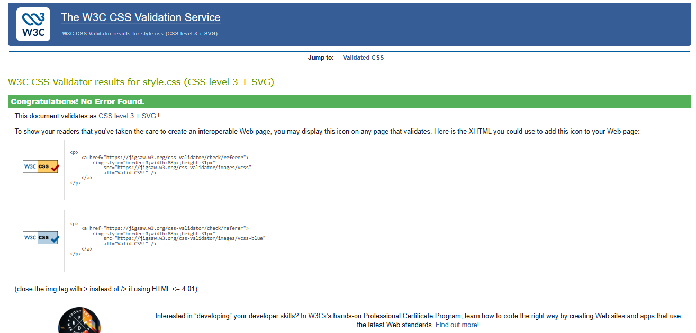
The external stylesheet was used to enhance the maintainability of the design. Design changes can be implemented on all pages by editing a single file.

Summary of Implementation
The completed GreenLeaf Café website satisfies the functional requirements identified during the planning stage. Four interconnected webpages were successfully developed using HTML5 and CSS3 while following recognised web standards. Responsive design techniques ensure compatibility across desktop, tablet and mobile devices, while HTML and CSS validation confirms compliance with W3C standards. The completed implementation provides a professional, user-friendly and visually appealing website that effectively promotes the GreenLeaf Café business.

Evaluation

Website Usability
Website Usability: The ease, efficiency and satisfaction with which users can use a website to achieve their goals. As per ISO 9241-11, usability can be quantified as the effectiveness, efficiency and satisfaction of the completion of tasks achieved by users. Good website usability means that visitors don't have to "wonder over what the site is about", can find things easily and can carry out tasks without much effort.
The usability was a top priority in the design of the GreenLeaf Café website. One navigation bar, located at the top of each page, was added to help users navigate between pages: the Home, About, Menu and Contact pages. Having consistent navigation eliminates the need for users to spend time looking for what they need to find and enhances their overall experience.
For the website's homepage, a large hero image along with welcoming header and a prominent call to action button directs the user to the website's menu page. The information is logically segmented with adequate white space leading to a scanning-friendly page and minimal cognitive overlord. Images used to reinforce text but not the content. Google Fonts was used to choose the typography for readability on various devices. The overall colour scheme was consistent, providing a strong brand identity recognisable throughout the website and visually cohesive between pages.

Peer-reviewed Research
To see if site usability relates to site use, Downing and Liu (2009) compared the academic ratings of site usability with the actual number of website visits of retail websites. They concluded that there was a positive correlation between the usability of a website and the duration of user engagement and use over time. Based on their results, the attributes of good usability positively correlate with website traffic, meaning that ease of navigation and understanding on websites would lead to a higher audience retention. The results corroborate the design decisions that were taken during the implementation of the GreenLeaf Café website, including uniformity of navigation, sense-making in the organization of pages and simplicity of design.
Also, during the redesign of a college library Web site, Carlisle and Wise (2011) conducted a usability study. The results indicated that when the navigation was logical as opposed to one that had a search focus, the users undertook information retrieval tasks more efficiently. This emphasizes the need for an easily understood navigation menu that was used to create the structure for the GreenLeaf Café website.

Website Accessibility
Accessibility in the web sector is adding a facility so that websites are easily accessible to everyone regardless of vision impairment, hearing loss, motor disabilities or cognitive problems. Accessibility means that information, education, and products and services are equally accessible to people with and without disabilities, with and without assistive technologies.
World Wide Web Consortium (W3C) has created Web Content Accessibility Guidelines (WCAG 2.1) that are grounded in four basic Web principles:

Perceivable
Information should be provided in a way that enables the users to be able to perceive it despite any disability.
The GreenLeaf Café website implements this through:
- Alternate text for all pictures
- Appropriate heading structure
- Readable typography
- Adequate space between content sections
Alternative text ensures visually impaired users can access information through text read aloud and headings provide context as to how content on a page is organised.

Operable
- All interface components should be usable with multiple input modes.
The website includes:
- clear navigation links
- clickable buttons
- responsive layouts
- consistent page navigation
Responsive design also makes for easier operation on touch screen technology.

Understandable
Information and interface behaviour should be easy to understand.
It does this on the website by:
- simple language
- predictable navigation
- consistent layouts
- descriptive headings
By this, users can figure out what each page is intended for and therefore do not have to figure it out.

Robust
Content needs to still be compatible with present and future browsers and assistive technologies.
Here are some of the semantic HTML5 elements used in the GreenLeaf Café website:
<header>
<nav>
<section>
<footer>
HTML and CSS were successfully W3C validated also, making it much more compatible with modern browsers and screen readers.

Accessibility Evaluation
An accessibility test was done on it using the accessibility evaluation tool WAVE. The website adhered to the following good accessibility practices: semantic HTML, alternative text for images, responsive design to ensure readability on shrinking browsers and logical heading hierarchy.
No accessibility problems are known to exist although the following could be considered for future enhancements:
- Skip navigation links
- Improved focus markers on the keyboard.
- ARIA landmarks
- Further colour contrast testing
In addition to these changes, the following improvements will make compliance with WCAG 2.1 even stronger.

Peer-reviewed Research
One study, by Rømen and Svanæs (2011), aimed to assess WCAG's effectiveness through usability tests with people who are disabled. The research revealed that WCAG is an important roadmap for fostering accessibility, but automated guideline compliance does not show all accessibility problems. The researchers found there was a need to integrate WCAG criteria with usability tests with real users in evaluating accessibility. This impacted the evaluation of the GreenLeaf Café website as it acknowledged the need for working with practical usability testing tools alongside the validation tools.
Schmutz, Sonderegger and Sauer (2016) found that page accessibility scores positively correlate with task completion, user satisfaction and perceived trust for disabled and non-disabled visitors to web pages: that is, the higher their website's WCAG compliance score, the better they were able to complete tasks, to be satisfied with the site, and perceived as trustworthy. These results validate the approach to accessibility in the GreenLeaf Café website.

What is Search Engine Optimisation (SEO)?

Methods of improving SEO
Search engine optimization (SEO) is the process of optimizing a website to rank higher on search engine results pages. Improved SEO allows for a better chance of getting found when online users are looking for a website that offers products or services that match their query.
The GreenLeaf Café website stopped Google from performing a “noobs attack” using multiple on page optimization tactics.
These include:
- descriptive page titles
- meta descriptions
- semantic HTML5 elements
- meaningful heading hierarchy
- alternative text for descriptive images.
- logical page structure
Different pages of the website have different page titles - each one identifying its page content; the page title of the webpage and the home page have an informative meta description to explain what the café offers. Each web page is structurally organized with correct hierarchical heading tags that letting search engines better understand the structure of each page. All images have been accompanied with alternative text which increases accessibility and eases the indexing of the images by search engines.

Peer-reviewed Research
Visser and Weideman (2011) explore the correlation of usability of websites with SEO. They found that numerous usability features such as logical navigation, well-organised content and headings did the same thing for the search engines as well. According to the study, it should not be multiple points made of usability and SEO, instead it should be combined and used as a single design process when creating websites. The results confirm the need for a semantic HTML, for descriptive headings and structured content on the website of the GreenLeaf Café.

Evaluation of the GreenLeaf Café Website

Utility
The website is effective in achieving its purpose as they provide essential information about the café for their customers. Opening hours, menu and contact information as well as some information about the company are easily accessible.
There is potential for improvement in the future including:
- online table booking
- online food ordering
- maps on Google maps have been added and can be integrated interactively.
- customer reviews
- image slideshow
- social media integration

Usability
The website has a clean and user-friendly interface. Uniform navigation, easily readable typography and good spacing allow users to find information easily. A café website with just four pages could be improved by adding a search function to larger sites, but this would be unneeded for this site.

Content
Content is relevant, concise and well organised in a logical sequence throughout the Webpages.
Images, in conjunction with the text, enhance the visual impact, convey meaning, complement and reinforce textual content and are kept consistent throughout the website.

Other content that could be added to help the website:
- nutritional information
- seasonal menus
- promotional offers
- customer testimonials

Accessibility Evaluation (WCAG 2.1)
GreenLeaf Cafe web site is an example of a reasonably good accessible website.

Strengths:
- semantic HTML
- image alternative text
- responsive layout
- logical heading structure
- readable typography
- areas for Improvement

Some future improvements that could be made are:
- keyboard focus indicators
- skip navigation links
- ARIA landmarks
- increased contrast in colours for chosen elements
- add messages to be spoken on screen for form invalidating. Add screen reading messages for form invalidation.

Search Engine Optimisation Evaluation
Implementing the following SEO techniques was successful.
On-page SEO techniques:

✔ descriptive titles

✔ meta descriptions

✔ semantic HTML

✔ heading hierarchy

✔ image alt attributes

✔ meaningful filenames

Future improvements include:

- XML sitemap
- robots.txt
- structured data (Schema.org)
- google Search Console integration
- open Graph metadata
To evaluate, the official website of Costa Coffee and the official website of Starbucks were compared with GreenLeaf Café website.
Section | Nuvia's Coffee Shop | Starbucks
View of the Screen | Simple, modern design with clear navigation. | Visually appealing design with larger promotional banners.
Menu / Navigation | Super mega menu is extremely user-friendly and logically designed. | User-friendly menu structure with slightly more content.
Accessibility | Strong colour contrast and semantic structure. | Good accessibility, but more visually complex.
SEO | Well-structured headings and metadata. | Strong metadata and descriptive content.
Mobile Responsiveness | Excellent responsive design. | Excellent responsive design.

Overall Comparison
Both sites exhibit good web design techniques and good user experience. Both brands have a similar look in terms of a clean, simple navigation, but Starbucks is seen to be more focused on sending promotional images and marketing content.
Several principles are noted in these business websites that are utilised for the GreenLeaf Café website, such as using semantic HTML and creating appealing graphics, having a responsive design and making the site easy to navigate. While the project is far more modest in scope, it illustrates many of the same concepts of usability and accessibility.

Overall Evaluation
The GreenLeaf Café website is successful in achieving its objectives. It will offer the users a beautiful, informative and responsive internet experience while meeting the standards of recognised HTML5 and CSS. The site was validated for a successful run-out of HTML and CSS errors and was successfully tested for responsiveness when run on desktop, tablet and mobile devices.
Further functionality such as online booking, ordering, interactive maps and user-friendly features would further enhance the website's use and usability.

Evaluation of the GreenLeaf Café Website
The final GreenLeaf Café website is successful in achieving its key aim of offering users a nice, informative and accessible online platform to check out the online version of a "real" café. As part of this process, usability, accessibility, responsive design and search engine optimisation were all considered, accounting for the fact that people will be accessing the information on various types of devices to locate information. Quality that makes something functional. An attribute that renders something useful.
The website effectively provides visitors with all of the essential information expected from a café website. Presented in an engaging HERO section with a welcome message and a prominent call-to-action button, the homepage starts off by introducing GreenLeaf Café to its audience. The About page is an explanation of the background and values of the Café, which builds trust for customers and awareness of the business. The Menu page clearly displays the food and drink options available whereas the Contact page displays information about the café, to allow the visitor to make enquiries and easily find the café.

All four webpages have a similar “menu bar” so that the person using the site can easily move from one section to another. Information is fully labelled each of the navigation links, thereby decreasing the time needed to find information. This helps to provide uniformity to the user experience, making it easier for visitors to navigate the website and always know where they are.
There is a lack of clutter and disorganization throughout. Headings, paragraphs and images tell the reader the information coming in what follows. There is sufficient whitespace throughout the design which aids readability and does not leave the pages crowded. Being able to use good quality images of cafes to help with the text really adds some interest to a website and can help support that content.
They've been able to pass this responsive design test with Google Chrome Developer Tools on iPhone 14, iPad Air and Samsung Galaxy S20 Ultra. The layout automatically changed the width too to fit the different screens without horizontally scrolling. Resize images proportionally, text remained readable, navigation continued to work, it shows that the website has a consistent user experience on any-type device—desktop, tablet, and mobile.
The website offers a positive user experience by enabling visitors to easily find the information they need and having a professionally designed and appealing look.

Website Content
Content throughout the GreenLeaf Café website is suitable to the audience and serves the purpose of the website. Every page contains useful information but not too much extraneous text. The homepage provides a short description of the café, and the About page welcomes and outlines the business and their beliefs. The Menu page lets customers check the list of food and beverages before they arrive; the Contact page gives information on a contact. The website uses images in an appropriate manner to make the website look interesting and attract the attention of the users and also arouse a pleasant image of the café. Every image has had a description added to it (also known as alt text), which not only helps make it more accessible, but also helps with search engine optimisation.
There is enough information on the website for a small café, but if they had more information on food nutrition and seasonality, along with any promotions offered, customers could get more use out of their visit to the website.

Search Engine Optimisation (SEO)
The development of the GreenLeaf Café website was done with some on page Seo techniques were included to boost the website's visibility to search engines.
These include:
- effective, descriptive titles of each page.
- a general description on the main page on the page summarising the services the café offers.
- semantic xHTML elements (<header>, <nav>, <section> and <footer>).
- description text (alternative text) for all media images.
- identify the levels of a hierarchy with <h1>, <h2> and <h3> tags.
- preserve meaningful filenames and organisation structures.
These techniques enable major search engines to comprehend each page of the Web, and they enhance usability for people using assistive technology to access the Web. The site does show good on page SEO, however there are a few areas that could be improved as follows:

Accessibility Evaluation
The GreenLeaf Café website is good for its accessibility and has applied many of the recommendations in WCAG 2.1.
Images have relevant alternative text to aid using a screen reader. Use of HTML5 elements to build pages is easier and more semantically correct, making it easier for assistive tech to access. Encouraging navigation allows users to navigate smoothly between webpages, and responsive designs keep them accessible on all devices and screen resolutions.
The site also checked all HTML and CSS coding against the W3C using its HTML and CSS validators, making it more likely to be compatible with most browsers.
The WAVE accessibility testing tool gave the website accessibility scores, showing it adheres to most known web accessibility guidelines. But a number of changes could be made in the next versions to make this more accessible. These include adding skip navigation links for keyboard users, improving keyboard focus indicators, increasing colour contrast in selected areas where necessary and implementing ARIA landmarks to provide additional information for assistive technologies. In general, the site is well accessible with room for improvements. Ideas for enhancements to be considered for future projects.
The finished website achieves its goals, but there are opportunities for improvements to further enhance its users and usefulness.
Future developments are:
- using an online table booking system.
- incorporating online food ordering and payment.
- adding Google Maps for local directions.
- including customer reviews and recommendations.
- generating a gallery slide show with captions for the photos.
- creating a social media presence for the website.
- introducing seasonal promotions and exclusive offers.
- incorporating a search feature for big websites.
- adopting dark mode for greater accessibility.
- compliant with W3C Web Accessibility Guidelines to increase access, including extra WCAG 2.1 capabilities consisting of skip links and ARIA landmarks.
An overall assessment of the GreenLeaf Café website, in terms of its intention to fulfil the goals, shows that the website overall is highly effective in meeting its goals, and provides a good and accessible online presence that is visually pleasing. Navigation is easy, structure and semantic HTML5, and responsive layouts coupled with modern CSS-styling result in a professional website, which is not only great for promoting a small independent café, but also serves as an excellent starting point for future development.

Comparing two live websites.
To test the GreenLeaf Café website, and its adherence to professional website standards in the café industry, two well known websites in the café industry were selected for analysis to see their adherence to the standards; Starbucks and Costa Coffee. Both websites offer similar services, which predominantly consist of the promotion of café products, the display of menus and the impetus to put in the effort to go into the real cafe. They are compared based on usability, accessibility, search engine optimisation (SEO) and mobile responsiveness.

Usability
Costa Coffee has an easy to use layout and their navigation is well organised. When visitors visit the homepage they are shown straight to main areas like a Menu, a rewards programme and a store locator. You can easily attract the visitor's attention by using large pictures, consistent branding and clearly visible call-to-action buttons, which helps visitors find the information they are looking for in no time. The Web site has a sensible organization which decreases navigating effort among the pages. Likewise, the Starbucks web site presents an attractive web design, solid branding with excellent promotional photos. The navigation feature is also placed at the top of every page and lets them easily reach menus, rewards, locations, or company information. The homepage, however, features more than Costa Coffee's, and it is a bit more cluttered.
The difference between the GreenLeaf Café website and these commercial sites, in my opinion, is the simplicity of the website and the scale of the business.The commercial websites are more suited to global marketing, and the GreenLeaf Café website a simpler approach to a small independent business. Navigational functions are constant throughout the site, the use of information is orderly and it is easy for users to find important information like the menu, hours of service and contact details. The web site is relatively simple to use, making for less distraction but fewer interactive features than Costa Coffee or Starbucks.

Accessibility
Accessibility was addressed through an analysis of both the website and development of staff resources to support websites using widely accepted website accessibility principles and accessibility functionality evaluation tools in the browser software. Accessibility: Costa Coffee uses the following for good accessibility: appropriate colour contrast, meaningful alternative text, appropriate heading structures, and meaningfully navigated pages by keyboard in combination. They also have typography that is usable and layouts easily readable on a variety of devices.
The Starbucks website also shows a lot of good accessibility, however, such as descriptive headings, responsive layouts, and alternative text. But in some instances, the more use of promotional content also leads to visual complexity, and this can sometimes involve more cognitive load on some users.
The GreenLeaf Café web site has numerous features that make it more accessible such as Semantic HTML5 elements, descriptive alternative text for images, logical heading structures and responsive layout. The website has been validated using HTML and CSS to ensure it meets recognised web standards to ensure compatibility with assistive technologies. Other enhancements that could be made include providing skip navigation links, updating keyboard focus indicators, adding more ARIA landmarks to increase accessibility.

Search Engine Optimisation (SEO)
We can compare the implementation of both Costa Coffee’s and Starbucks’s on page SEO in order to get the better search engine visibility. They have descriptive web page titles, organized heading hierarchies, URLs with meaning, alt text for images and detailed metadata. The sites are also enhanced through the use of the structured data and internal link structure to aid the search engines in indexing the contents.
GreenLeaf Café website has implemented many basic search engine optimisation (SEO) techniques, such as descriptive page titles, a homepage meta description, the use of semantic HTML5 elements and appropriate alternative text for all pictures. Subsequent logical content hierarchy (with proper usage of heading tags) helps search engines to better understand the content of the page.
The website has some on-page SEO issues, such as the lack of structured data, XML sitemap, and Google Search Console integration. They could benefit from the use of Schema.org structured data, XML sitemap and integration with Google Search Console to enhance their visibility in the search engine results.

Mobile Friendliness
These coffees chains showcase great responsive websites – Costa Coffee and Starbucks. They have websites that automatically adjust to fit screen sizes and still display the text and images in a readable way, and they're touch-friendly, meaning you can interact with them while using a cell phone. Google Chrome is the browser tested on the website of the GreenLeaf Café; the tests were conducted on an iPhone 14, iPad Air and Samsung Galaxy S20 Ultra. The results of testing showed the layout was successfully adapted by any device without horizontal scrolling. These images were scaled appropriately, there was no loss of functionality in the navigation and content was always readable, proving responsive web design applied. The GreenLeaf Café website is mobile-friendly and suitable for its use; while the commercial sites have the more advanced responsive features, including animated elements and interactive menus, the GreenLeaf Café site has its own benefits.

Overall Comparison

The fact that Costa Coffee Shop and Starbucks are professionally developed commercial websites which include cutting edge functionality, sophisticated brand and detailed online services are just a couple of examples of such sites. They also offer online ordering systems, promotional benefits (such as loyalty schemes), and store locators along with tailored customer experience which goes beyond what can be achieved in the context of this academic research.
Nevertheless, there are many of the same basic elements of web development principles that are illustrated in the GreenLeaf Café website. It offers stable navigation, flexible layouts, semantic HTML5 layout, content access and effective on page optimization. The website has accomplished the goal of making the particular café popular and it has provided a good user experience throughout both desktops and mobile devices.
The website produced by this project is suitable for future improvements and conveys a good understanding of current web development practices, given the scope of this project.

Conclusion
The intention of this project was to draft and create a responsive website designed with HTML5 and CSS3, based on the recognised web standards for the GreenLeaf Café. Overall, the finished site achieves this goal by offering visitors an informative, visually appealing and user-friendly online platform.

Throughout the development, usability, accessibility, responsive design and search engine optimisation was given due attention. A consistent navigation, semantic HTML5 structure and an external CSS stylesheet help to look professional and makes it easier to maintain and compatible between browsers. The website has been validated through the W3C HTML and CSS validation services which confirms that, after its development challenges, it meets the recognised web standards.
Responsive Testing caught up with the website and proved it to be performant across PCs, tablets and smartphones – thus ensuring a favourable experience for users of all screen sizes. Elements of accessibility were included by using semantic HTML elements, descriptive alternative text, logical heading structures, and SEO techniques like descriptive page titles and metadata enhance discoverability when searching online.
The website has successfully met its aims but there is scope for further improvements to function through an online ordering system, table services, as well as allowing customer reviews and the introduction of interactive maps and accessibility features. Overall, the GreenLeaf Café website is a successful result of applying the modern principles of Web development, and a professional solution for a small independent café.

References (IEEE)
[1] J. Nielsen, Usability Engineering. San Diego, CA, USA: Academic Press, 1994.
[2] International Organization for Standardization, ISO 9241-11:2018 Ergonomics of Human-System Interaction – Part 11: Usability: Definitions and Concepts, Geneva, Switzerland: ISO, 2018.
[3] World Wide Web Consortium (W3C), Web Content Accessibility Guidelines (WCAG) 2.1, 2018.
[4] World Wide Web Consortium (W3C), HTML Living Standard. Available: https://html.spec.whatwg.org/
[5] World Wide Web Consortium (W3C), CSS Snapshot. Available: https://www.w3.org/TR/CSS/
[6] A. Downing and C. Liu, "Assessing Web Site Usability," Journal of International Technology and Information Management, vol. 18, no. 3, pp. 301–318, 2009.
[7] H. Schmutz, A. Sonderegger and J. Sauer, "Implementing Recommendations From Web Accessibility Guidelines," Human Factors, vol. 58, no. 4, pp. 611–629, 2016.
[8] J. Visser and M. Weideman, "The Influence of Website Usability on SEO," South African Journal of Information Management, vol. 13, no. 1, 2011.

Appendices

Appendix A – HTML Source Code
Paste your complete source code for:
- index.html
- <!DOCTYPE html>
- <html lang="en">

- <head>
- <meta charset="UTF-8">
- <meta name="viewport" content="width=device-width, initial-scale=1.0">
- <meta name="description" content="Fresh coffee, healthy meals and homemade desserts at GreenLeaf Café.">
- <title>GreenLeaf Café | Home</title>

- <link rel="stylesheet" href="css/style.css">

- <link rel="preconnect" href="https://fonts.googleapis.com">
- <link rel="preconnect" href="https://fonts.gstatic.com" crossorigin>

- <link href="https://fonts.googleapis.com/css2?family=Poppins:wght@300;400;600;700&display=swap" rel="stylesheet">
- </head>

- <body>

- <header class="site-header">
- <div class="container nav-container">

- <h1 class="logo">GreenLeaf Café</h1>

- <nav>
- <ul class="nav-links">
- <li><a href="index.html" class="active">Home</a></li>
- <li><a href="about.html">About</a></li>
- <li><a href="menu.html">Menu</a></li>
- <li><a href="contact.html">Contact</a></li>
- </ul>
- </nav>

- </div>
- </header>

- <section class="hero">
- <div class="container hero-content">

- <h2>Fresh Coffee. Fresh Food.</h2>

- <p>
- Welcome to GreenLeaf Café, where we serve freshly brewed coffee,
- healthy breakfasts, delicious lunches and homemade desserts
- in a warm and relaxing atmosphere.
- </p>

- <a href="menu.html" class="btn">View Our Menu</a>

- </div>
- </section>

- <section class="features">

- <div class="container">

- <h2>Why Choose Us?</h2>

- <div class="cards">

- <div class="card">
- <h3>☕ Premium Coffee</h3>
- <p>Freshly roasted coffee beans sourced from ethical suppliers.</p>
- </div>

- <div class="card">
- <h3>🥗 Healthy Food</h3>
- <p>Fresh ingredients prepared daily for breakfast and lunch.</p>
- </div>

- <div class="card">
- <h3>😊 Friendly Service</h3>
- <p>A welcoming atmosphere with comfortable seating and free Wi-Fi.</p>
- </div>

- </div>

- </div>

- </section>

- <section class="gallery">

- <div class="container">

- <h2>Inside GreenLeaf Café</h2>

- <div class="gallery-grid">

- <img src="images/image1.jpg.avif" alt="Coffee at GreenLeaf Café">

- <img src="images/image2.jpg.avif" alt="Fresh food at GreenLeaf Café">

- <img src="images/image3.jpg.avif" alt="Desserts at GreenLeaf Café">

- <img src="images/image4.jpg.avif" alt="Interior of GreenLeaf Café">

- </div>

- </div>

- </section>

- <footer>
- <p>&copy; 2026 GreenLeaf Café | Designed by Your Name</p>
- </footer>

- </body>

- </html>

- about.html
- <!DOCTYPE html>
- <html lang="en">
- <head>
- <meta charset="UTF-8">
- <meta name="viewport" content="width=device-width, initial-scale=1.0">
- <title>GreenLeaf Café | About</title>
- <link rel="stylesheet" type="text/css" href="css/style.css">
- <link rel="preconnect" href="https://fonts.googleapis.com">
- <link rel="preconnect" href="https://fonts.gstatic.com" crossorigin>
- <link rel="stylesheet" type="text/css" href="https://fonts.googleapis.com/css2?family=Poppins:wght@300;400;600;700&display=swap">
- </head>
- <body>
- <header class="site-header">
- <div class="container nav-container">
- <h1 class="logo">GreenLeaf Café</h1>

- ```
- <nav>
- <ul class="nav-links">
- <li><a href="index.html">Home</a></li>
- <li><a href="about.html" class="active">About</a></li>
- <li><a href="menu.html">Menu</a></li>
- <li><a href="contact.html">Contact</a></li>
- </ul>
- </nav>
- ```

- </div>
- </header>
- <main class="page-section">
- <div class="container about-grid">
- <div>
- <h2>About GreenLeaf Café</h2>
- <img src="images/about.jpg" class="page-image" alt="About GreenLeaf Café">
- ```
- <p>
- GreenLeaf Café was founded with a simple goal: bring people together
- through exceptional coffee, fresh food, and genuine hospitality.
- </p>
- <p>
- We work with local suppliers whenever possible and prepare our meals
- fresh each day to ensure the highest quality for our customers.
- </p>
- <div class="hours-card">
- <h3>Opening Hours</h3>
- <ul>
- <li><strong>Mon–Fri:</strong> 8:00 AM – 6:00 PM</li>
- <li><strong>Saturday:</strong> 9:00 AM – 7:00 PM</li>
- <li><strong>Sunday:</strong> 10:00 AM – 5:00 PM</li>
- </ul>
- </div>
- </div>
- <div class="about-image">
- <img src="images/image4.jpg.avif" alt="Interior of GreenLeaf Café">
- </div>
- ```

- </div>
- </main>
- <footer>
- <p>&copy; 2026 GreenLeaf Café | Designed by Your Name</p>
- </footer>
- </body>
- </html>

- menu.html
- <!DOCTYPE html>

- <html lang="en">
- <head>
- <meta charset="UTF-8">
- <meta name="viewport" content="width=device-width, initial-scale=1.0">
- <title>GreenLeaf Café | Menu</title>
- <link rel="stylesheet" href="css/style.css">
- <link rel="preconnect" href="https://fonts.googleapis.com">
- <link rel="preconnect" href="https://fonts.gstatic.com" crossorigin>
- <link href="https://fonts.googleapis.com/css2?family=Poppins:wght@300;400;600;700&display=swap" rel="stylesheet">
- </head>

- <body>

- <header class="site-header">
- <div class="container nav-container">
- <h1 class="logo">GreenLeaf Café</h1>

- ```
- <nav>
- <ul class="nav-links">
- <li><a href="index.html">Home</a></li>
- <li><a href="about.html">About</a></li>
- <li><a href="menu.html" class="active">Menu</a></li>
- <li><a href="contact.html">Contact</a></li>
- </ul>
- </nav>
- ```

- </div>
- </header>

- <main class="page-section">
- <div class="container">
- <h2 class="section-title">Our Menu</h2>

- ```
- <div class="menu-section">
- <h3>☕ Coffee & Drinks</h3>
- <div class="menu-grid">
- <div class="menu-item">
- <img src="images/image1.jpg.avif" alt="Classic Cappuccino">
- <div class="menu-content">
- <div class="menu-header">
- <img src="images/coffee.jpg" class="menu-image" alt="Coffee">
- <h4>Classic Cappuccino</h4>
- <span>£4.50</span>
- </div>
- <p>Rich espresso topped with silky steamed milk foam.</p>
- </div>
- </div>

- <div class="menu-item">
- <img src="images/image2.jpg.avif" alt="Vanilla Latte">
- <div class="menu-content">
- <div class="menu-header">
- <h4>Vanilla Latte</h4>
- <span>£5.00</span>
- </div>
- <p>Smooth espresso, steamed milk, and a hint of vanilla.</p>
- </div>
- </div>
- </div>
- </div>

- <div class="menu-section">
- <h3>🥪 Food</h3>
- <div class="menu-grid">
- <div class="menu-item">
- <img src="images/image3.jpg.avif" alt="GreenLeaf Sandwich">
- <div class="menu-content">
- <div class="menu-header">
- <img src="images/food.jpg" class="menu-image" alt="Food">
- <h4>GreenLeaf Sandwich</h4>
- <span>£7.00</span>
- </div>
- <p>Fresh vegetables, cheddar cheese, and our homemade herb sauce.</p>
- </div>
- </div>

- <div class="menu-item">
- <img src="images/image4.jpg.avif" alt="Creamy Pasta">
- <div class="menu-content">
- <div class="menu-header">
- <h4>Creamy Pasta</h4>
- <span>£10.00</span>
- </div>
- <p>Fresh pasta tossed in a rich, creamy homemade sauce.</p>
- </div>
- </div>
- </div>
- </div>
- <br>

- <h3>🍰 Desserts</h3>

- <div class="menu-item">

- <img src="images/dessert.jpg" class="menu-image" alt="Chocolate Cake">

- <h4>Chocolate Fudge Cake</h4>

- <p>
- Rich chocolate sponge layered with smooth chocolate frosting,
- served fresh with whipped cream.
- </p>

- <span>£5.95</span>

- </div>

- <div class="menu-item">

- <h4>New York Cheesecake</h4>

- <p>
- Creamy vanilla cheesecake with a buttery biscuit base,
- topped with fresh strawberries.
- </p>

- <span>£5.50</span>

- </div>

- <div class="menu-item">
- <img src="images/dessert.jpg" class="menu-image" alt="Dessert">

- <h4>Warm Chocolate Brownie</h4>

- <p>
- Soft chocolate brownie served warm with a scoop of vanilla ice cream.
- </p>

- <span>£5.75</span>

- </div>
- ```

- </div>
- </main>

- <footer>
- <p>&copy; 2026 GreenLeaf Café | Designed by Your Name</p>
- </footer>

- </body>
- </html>

- contact.html
- <!DOCTYPE html>

- <html lang="en">
- <head>
- <meta charset="UTF-8">
- <meta name="viewport" content="width=device-width, initial-scale=1.0">
- <title>GreenLeaf Café | Contact</title>

- <link rel="stylesheet" href="css/style.css">
- <link rel="preconnect" href="https://fonts.googleapis.com">
- <link rel="preconnect" href="https://fonts.gstatic.com" crossorigin>
- <link href="https://fonts.googleapis.com/css2?family=Poppins:wght@300;400;600;700&display=swap" rel="stylesheet">
- </head>

- <body>

- <header class="site-header">
- <div class="container nav-container">
- <h1 class="logo">GreenLeaf Café</h1>

- ```
- <nav>
- <ul class="nav-links">
- <li><a href="index.html">Home</a></li>
- <li><a href="about.html">About</a></li>
- <li><a href="menu.html">Menu</a></li>
- <li><a href="contact.html" class="active">Contact</a></li>
- </ul>
- </nav>
- ```

- </div>
- </header>

- <main class="page-section">
- <div class="container contact-grid">
- <div class="contact-info">
- <h2>Get in Touch</h2>
- <img src="images/about.jpg" class="page-image" alt="GreenLeaf Café">

- ```
- <p><strong>Address:</strong> 123 Green Street, London</p>
- <p><strong>Phone:</strong> 020 1234 5678</p>
- <p><strong>Email:</strong> info@greenleafcafe.com</p>

- <h3>Opening Hours</h3>
- <p>Mon–Fri: 8:00 AM – 6:00 PM</p>
- <p>Saturday: 9:00 AM – 7:00 PM</p>
- <p>Sunday: 10:00 AM – 5:00 PM</p>
- </div>

- <form class="contact-form">
- <input type="text" placeholder="Your Name" required>
- <input type="email" placeholder="Your Email" required>
- <textarea rows="6" placeholder="Your Message" required></textarea>
- <button type="submit" class="btn">Send Message</button>
- </form>
- ```

- </div>
- </main>

- <footer>
- <p>&copy; 2026 GreenLeaf Café | Designed by Your Name</p>
- </footer>

- </body>
- </html>

Appendix B – CSS Source Code
- style.css
- /* ===== RESET ===== */
- *{
- margin:0;
- padding:0;
- box-sizing:border-box;
- }
- /* ===== GLOBAL ===== */
- body{
- font-family:'Poppins',sans-serif;
- background:#f7f5f2;
- color:#333;
- line-height:1.7;
- }

- .container{
- width:min(1100px, 90%);
- margin:auto;
- }

- img{
- width:100%;
- display:block;
- border-radius:14px;
- }

- .section-title{
- text-align:center;
- color:#2e7d32;
- margin-bottom:2rem;
- font-size:2.2rem;
- }

- /* ===== HEADER ===== */
- .site-header{
- background:#2e7d32;
- position:sticky;
- top:0;
- z-index:100;
- box-shadow:0 2px 10px rgba(0,0,0,.1);
- }

- .nav-container{
- display:flex;
- justify-content:space-between;
- align-items:center;
- padding:1rem 0;
- }

- .logo{
- color:#fff;
- font-size:1.8rem;
- font-weight:700;
- }

- .nav-links{
- display:flex;
- gap:2rem;
- list-style:none;
- }

- .nav-links a{
- color:#fff;
- text-decoration:none;
- font-weight:600;
- position:relative;
- }

- .nav-links a::after{
- content:"";
- position:absolute;
- left:0;
- bottom:-6px;
- width:0;
- height:2px;
- background:#ffd54f;
- transition: width 0.3s;
- }

- .nav-links a:hover::after,
- .nav-links a.active::after{
- width:100%;
- }

- /* ===== HERO ===== */
- /* ===== HERO ===== */
- .hero{
- background:
- linear-gradient(rgba(0,0,0,.55), rgba(0,0,0,.55)),
- url("../images/hero.jpg") center center/cover no-repeat;
- min-height:100vh;
- display:grid;
- place-items:center;
- text-align:center;
- color:#fff;
- }
- .hero-content h2{
- font-size:clamp(2.5rem, 6vw, 4.5rem);
- margin-bottom:1rem;
- }

- .hero-content p{
- max-width:700px;
- margin:0 auto 2rem;
- font-size:1.1rem;
- }

- /* ===== BUTTON ===== */
- .btn{
- display:inline-block;
- background:#ffd54f;
- color:#1b1b1b;
- padding:.9rem 1.8rem;
- border-radius:999px;
- text-decoration:none;
- font-weight:700;
- border:none;
- cursor:pointer;
- transition:transform .2s, background .2s;
- }

- .btn:hover{
- background:#ffca28;
- transform:translateY(-2px);
- }

- /* ===== SECTIONS ===== */
- .features,
- .page-section,
- .gallery{
- padding:5rem 0;
- }

- .features h2,
- .gallery h2{
- text-align:center;
- color:#2e7d32;
- margin-bottom:2.5rem;
- font-size:2.2rem;
- }

- /* ===== CARDS ===== */
- .cards{
- display:grid;
- grid-template-columns:repeat(auto-fit, minmax(240px,1fr));
- gap:1.5rem;
- }

- .card{
- background:#fff;
- padding:2rem;
- border-radius:18px;
- box-shadow:0 10px 30px rgba(0,0,0,.08);
- transition:transform .25s;
- }

- .card:hover{
- transform:translateY(-6px);
- }

- .card h3{
- margin-bottom:1rem;
- color:#2e7d32;
- }

- /* ===== GALLERY ===== */
- .gallery-grid{
- display:grid;
- grid-template-columns:repeat(auto-fit, minmax(220px,1fr));
- gap:1rem;
- }

- .gallery-grid img{
- height:240px;
- object-fit:cover;
- }

- /* ===== ABOUT ===== */
- .about-grid{
- display:grid;
- grid-template-columns:1.1fr .9fr;
- gap:3rem;
- align-items:center;
- }

- .hours-card{
- background:#fff;
- padding:1.5rem;
- border-radius:16px;
- box-shadow:0 8px 24px rgba(0,0,0,.06);
- margin-top:2rem;
- }

- .hours-card ul{
- list-style:none;
- margin-top:1rem;
- }

- .hours-card li{
- padding:.45rem 0;
- border-bottom:1px solid #eee;
- }

- /* ===== MENU ===== */
- .menu-section{
- margin-bottom:3rem;
- }

- .menu-section h3{
- color:#2e7d32;
- margin-bottom:1.2rem;
- font-size:1.5rem;
- }

- .menu-grid{
- display:grid;
- gap:1.5rem;
- }

- .menu-item{
- display:grid;
- grid-template-columns:180px 1fr;
- gap:1.2rem;
- background:#fff;
- border-radius:18px;
- overflow:hidden;
- box-shadow:0 8px 24px rgba(0,0,0,.08);
- }

- .menu-item img{
- height:100%;
- min-height:160px;
- object-fit:cover;
- border-radius:0;
- }

- .menu-content{
- padding:1.2rem 1.2rem 1.2rem 0;
- }

- .menu-header{
- display:flex;
- justify-content:space-between;
- gap:1rem;
- margin-bottom:.5rem;
- }

- .menu-header h4{
- font-size:1.2rem;
- color:#1f2937;
- }

- .menu-header span{
- color:#2e7d32;
- font-weight:700;
- }

- /* ===== CONTACT ===== */
- .contact-grid{
- display:grid;
- grid-template-columns:1fr 1fr;
- gap:2rem;
- }

- .contact-info,
- .contact-form{
- background:#fff;
- padding:2rem;
- border-radius:18px;
- box-shadow:0 8px 24px rgba(0,0,0,.08);
- }

- .contact-info h2{
- color:#2e7d32;
- margin-bottom:1rem;
- }

- .contact-info h3{
- margin-top:1.5rem;
- color:#2e7d32;
- }

- .contact-form{
- display:grid;
- gap:1rem;
- }

- .contact-form input,
- .contact-form textarea{
- width:100%;
- padding:.9rem 1rem;
- border:1px solid #d1d5db;
- border-radius:12px;
- font:inherit;
- }

- .contact-form input:focus,
- .contact-form textarea:focus{
- outline:none;
- border-color:#2e7d32;
- box-shadow:0 0 0 3px rgba(46,125,50,.15);
- }

- /* ===== FOOTER ===== */
- footer{
- background:#1f2937;
- color:#fff;
- text-align:center;
- padding:1.5rem 0;
- }

- /* ===== RESPONSIVE ===== */
- @media (max-width: 768px){

- .nav-container{
- flex-direction:column;
- gap:1rem;
- }

- .nav-links{
- gap:1rem;
- flex-wrap:wrap;
- justify-content:center;
- }

- .about-grid,
- .contact-grid{
- grid-template-columns:1fr;
- }

- .menu-item{
- grid-template-columns:1fr;
- }

- .menu-content{
- padding:1rem 1.2rem 1.2rem;
- }

- .menu-item img{
- min-height:220px;
- }
- .hero{
- background:
- linear-gradient(rgba(0,0,0,.55), rgba(0,0,0,.55)),
- url("../images/hero.jpg") center center/cover no-repeat;
- }
- }
- .page-image{
- display:block;
- width:100%;
- max-width:700px;
- margin:25px auto;
- border-radius:12px;
- box-shadow:0 4px 10px rgba(0,0,0,.2);
- }

- .menu-image{
- width:100%;
- border-radius:10px;
- margin-bottom:15px;
- }

