STUDENT NAME: OANA SIMONA UNGUREANU
STUDENT NUMBER: 2209544
LECTURE NAME: KATHRYN FLYNN

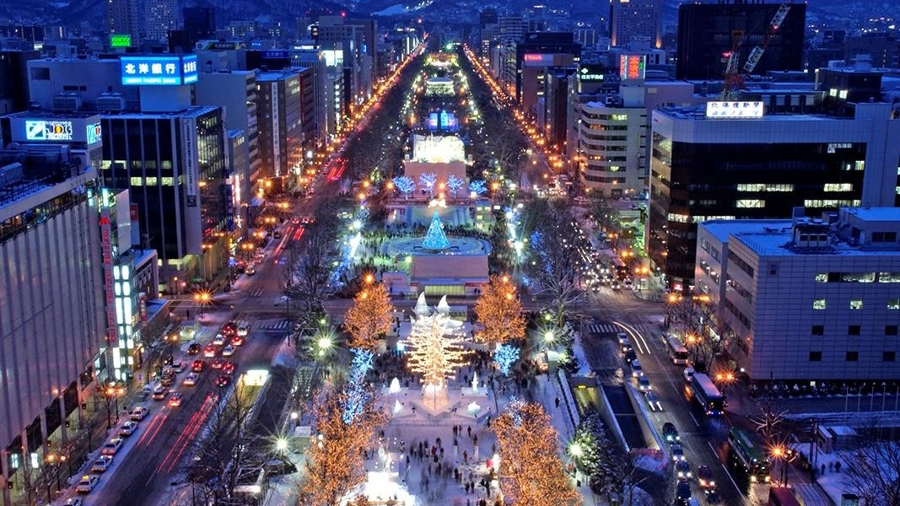
SAPPORO SNOW
FESTIVAL
FEASIBILITY PLAN FOR AN
INTERNATIONAL MEETING





TABLE OF
CONTENTS
Introduction
Feasibility and strategic pre
-
planning for Sapporo Snow festival
Event content and context
Market factors
Cont..
Operational factors
Cont.
Financial factors
Cont..
Conclusion
References
Bibliography
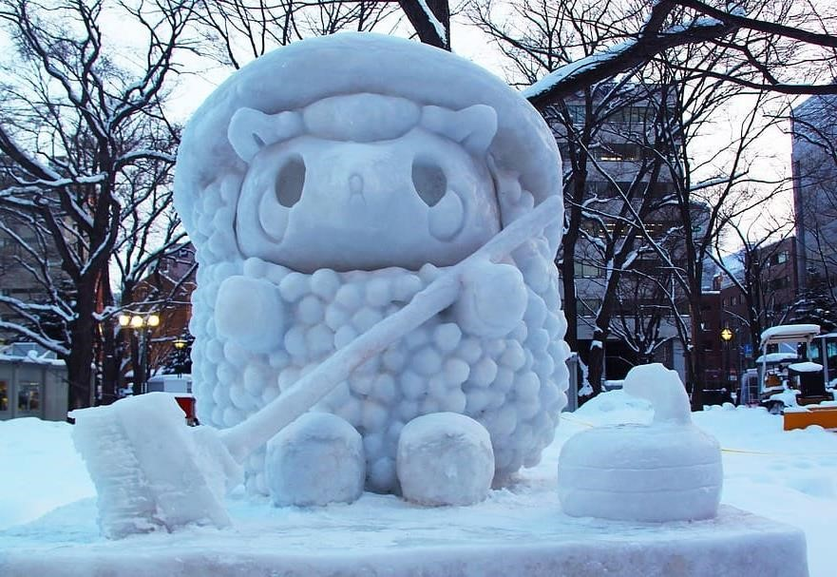
INTRODUCTION
•
The feasibility of an event depends on the
market, operational, and financial factors
(
Dalir,
2024)
•
The role of event planner in event feasibility
includes:
o
Strategic planning of events
o
Search for venues
o
Negotiation with vendors
o
Overall budgetary management
o
Logistics management (Allen
et al
.,
2022)
•
Chosen theme for the event: Winter
•
Chosen event: Inspired by the Sapporo Snow
Festival (Sapporo Yuki Matsuri) in Japan
FEASIBILITY AND
STRATEGIC PRE-PLANNING


FOR SAPPORO SNOW FESTIVAL
- Factors to highlight:
  - Detailed market research o Strategic planning and considerations o Budgetary planning and predictions o Prospective collaboration and partnership guideline
  - Logistics and supply-demand integrity o Post-event marketing analysis

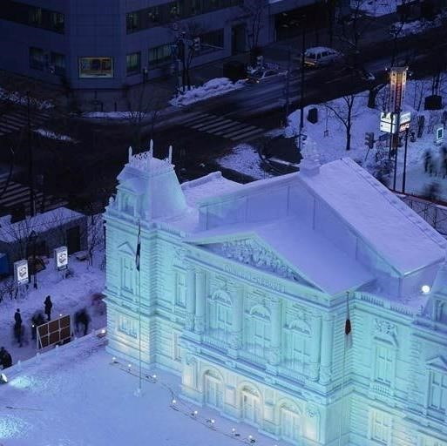
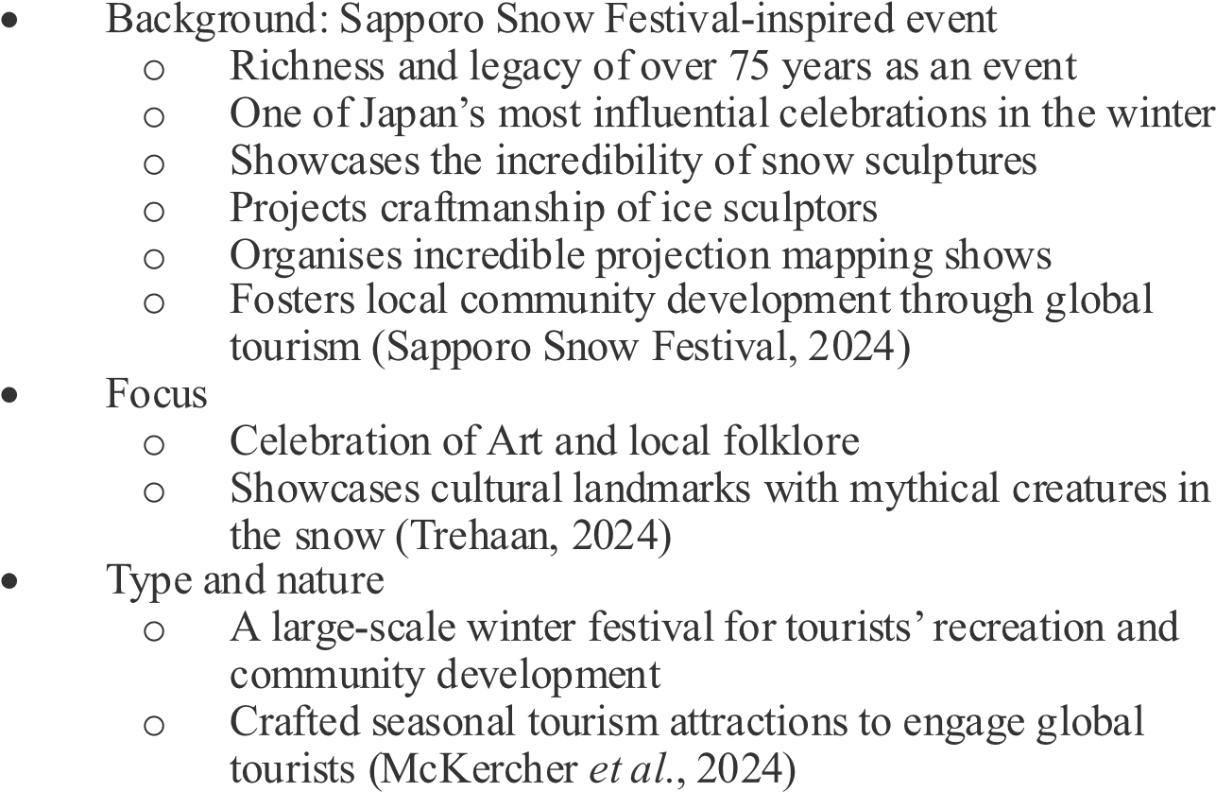
EVENT
CONTENT AND CONTEXT
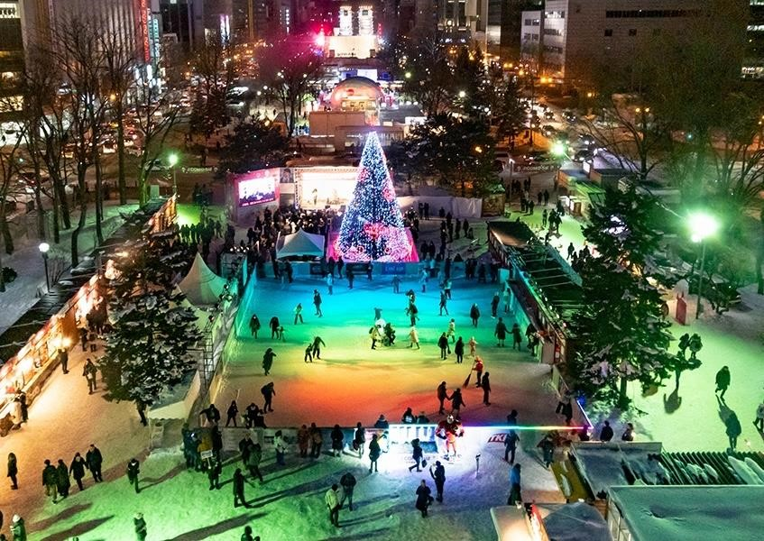

MARKET
FACTORS
•
Target market: Children,
families, international and
domestic visitors, young adults,
art enthusiasts, and millennials
•
Demand: The legacy of
interactive tourism experiences,
the popularity of the Sapporo
Snow Festival globally (Fay,
2024)

•
Factors for driving demands:
Winter tourism, community
development impact, and
economic growth
Supply: Weather conditions and
feasibility of the location
CONT..
Competition: Competing events on
Christmas
Marketing activities: Digital
marketing campaign and partnership
programs (Mallick, 2023)

OPERATIONAL
FACTORS
•
Proposed location: Snowdonia, Wales
•
Venue
o
Availability: Large venues with
open spaces for crafting snow
sculptures, and nearby
accommodational availability for
tourists (Brown and Stokes, 2021)
o
Suitability: Considerably low
temperature to build and maintain
these sculptures
•
Staffing requirements
o
Staff Skill sets: Schedule and
coordinate events, sculptors for
craftmanship artistry, technical and
hospitality staff for overall
management.


CONT..
•
Resource allocation: Snow
machines, catering services for
tourists, parking, and
transportation facilities (Gulak
-
Lipka and Jagielski, 2020)
•
Staff and Tourists’ safety: First
aid kits, insurance of the event,
FINANCIAL FACTORS
Expenses |  |  | Cost estimation pounds) | (in
Rent of the venue |  |  | 45000
Sculptors’ compensation manufacturing costs | and | additional | 30000
Technical equipment costs |  |  | 25000
Food stalls and services |  |  | 10000
Security measures |  |  | 5000
Parking facilities |  |  | 10000
Staffing |  |  | 30000
Miscellaneous |  |  | 4000
Total Estimated costs |  |  | 159000
Expenses | Cost estimation (in pounds)
Sales of the event tickets | 120000
Event sponsorships | 50000
Food stalls | 35000
Product sales | 18000
Additional winter activity tickets | 100000
Total Estimated costs | 323000
Predicted breakdown of revenue/earnings
Overall profit: (£323000-£159000) = £164000
Predicted breakdown of costs
CONT..
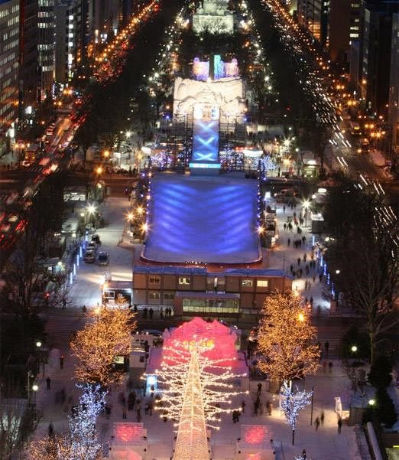
- Funding resources: UK government, Beverage brands, and sales of event tickets.
- Revenue generation mediums: Ticket price packages, sponsorships from brands, and advertisement sponsorships (Hayes et al., 2021).
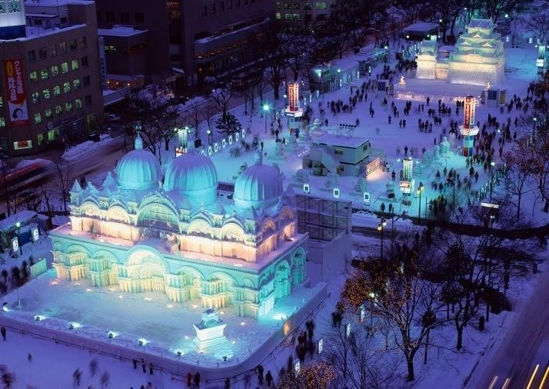
CONCLUSION
•
This Sapporo snow festival
-
inspired event in the UK will be
financially feasible
•
It will benefit the tourism
economy of the UK
•
Proper selection of venue,
revenue streams, and resource
management leads to extensive
tourism market growth in the
UK.
REFERENCES
•
Allen, J., Harris, R. and Jago, L., 2022.
Festival & special event management
. John Wiley & Sons.
•
Bladen, C., Kennell, J., Abson, E. and Wilde, N., 2022.
Events management: An introduction
. Routledge.
•
Brown, T. and Stokes, P., 2021. Events management as a community of practice.
Journal of Hospitality and Tourism Insights
,
4
(2)
, pp.
224
-
242.
•
Camilleri, M.A., 2021. Tourism, Hospitality &_ Event Management.
•
Dalir, S., 2024. Innovative strategies to tackle seasonality issue in hospitality and tourism industry.
International Journal of Contemporary Hospitality Management
,
36
(5)
, pp.
1690
-
1709.
•
Devesa, M. and Roitvan, A., 2022. Beyond economic impact: The cultural and social effects of arts festivals. In
Managing cultural festivals
(
pp.
189
-
209)
. Routledge.
•
Fay, T., 2024.
Hokkaido
. Bradt Travel Guides.
•
Gulak
-
Lipka, P.A.T.R.Y.C.J.A. and Jagielski, M.I.C.H.A.Ł., 2020. Incorporating sustainability into mega
-
event management as mean
s of providing economic, social, and environmental legacy: a comparative analysis.
Journal of
Physical Education and Sport
,
20
(5)
, pp.
2859
-
2866.
•
Hayes, D.K., Hayes, J.D. and Hayes, P.A., 2021.
Revenue management for the hospitality industry
. John Wiley & Sons.
•
Japan Guide, 2023.
Sapporo Snow Festival (Sapporo Yuki Matsuri)
. Available at: https://www.japan
-
guide.com/e/e5311.html [Accessed on: 1 October 2024].
•
Kantar UK, 2023.
5
reasons why marketing research is important to your business
. Available at: https://www.kantar.com/inspiration/research
-
services/why
-
marketing
-
research
-
is
-
important
-
pf [Accessed on: 1 Octo
ber 2024].
•
Kharouf, H., Biscaia, R., Garcia
-
Perez, A. and Hickman, E., 2020. Understanding online event experience: The importance of commu
nication, engagement and interaction.
Journal of Business Research
,
121
, pp.735
-
746.
•
LinkedIn, 2023.
How can you determine if a live event idea is feasible and viable?

Available at: https://www.linkedin.com/advice/1/how
-
can
-
you
-
determine
-
live
-
event
-
idea
-
feasible
-
viable [Accessed on: 1 October 2
024].
•
Mallick, S.U., 2023. Promoting Tourism Through Digital Marketing.
The American Journal of Agriculture and Biomedical Engineering
,
5
(10)
, pp.
62
-
85.
•
McKercher, B., Prideaux, B. and Thompson, M., 2024. The impact of changing seasons on in
-
destination tourist behaviour.
Tourism Review
,
79
(6)
, pp.
1197
-
1209.
•
Sapporo Snow Festival, 2024.
Sapporo Snow Festival official website
. Available at: https://www.snowfes.com/en/ [Accessed on: 1 October 2024].
•
Schulenkorf, N., Welty Peachey, J., Chen, G. and Hergesell, A., 2024. Event leverage: A systematic literature review and new
res
earch agenda.
European Sport Management Quarterly
,
24
(3)
, pp.
785
-
809.
•
Trehaan, A., 2024.
Experience the magic of Sapporo Snow Festival, Japan
. Available at: https://www.newsbytesapp.com/news/lifestyle/experience
-
the
-
magic
-
of
-
sapporo
-
snow
-
festival
-
japan/story [Accessed
on: 1 October 2024].
•
Wickham, M., Donnelly, T. and French, L., 2021. Strategic sustainability management in the event sector.
Event Management
,
25
(3)
, pp.
279
-
296.
- Business Events Thailand, 2020. Knowing TCEB & MICE in Thailand. Available at: https://www.youtube.com/watch?v=i2o542R6MDA [Accessed on: 1 October 2024].
- Expo 2020 Dubai, 2020. World Expos’ history | Expo 2020 Dubai. Available at: https://www.expo2020dubai.com/en/understanding-expo/world-expos-history [Accessed on: 1 October 2024].
- Expo 2023, 2023. Expo 2023 Doha Theme | About Us | Expo 2023 Doha. Available at: https://www.dohaexpo2023.gov.qa/en/about/ [Accessed on: 1 October 2024].
- Jones-Evans, D., 2022. The huge economic impact of the UK’s event industry. Available at: https://www.business-live.co.uk/opinion-analysis/huge-economic-impact-uks-event23563660 [Accessed on: 1 October 2024].
- Julia Charles Event Management, 2023. Entertainment Options. [Available at: https://www.juliacharleseventmanagement.co.uk/entertainment/type/winter-wonderlandshows/event/corporate-events/ [Accessed on: 1 October 2024].




- Luminate Wales, 2024. Luminate Light Trail - Margam Country Park. Available at: https://luminate.live/margam-country-park?gad_source=1& [Accessed on: 1 October 2024].
BIBLIOGRAPHY
- Mfullard, 2020 The UK Events Report reveals depth of £70bn events industry. Available at: https://www.conference-news.co.uk/news/uk-events-report-reveals-depth-ps70bn-eventsindustry/ [Accessed on: 1 October 2024].
- Teambuilding, 2024. Murder Mystery Team Building Evening. Available at: https://www.teambuilding.co.uk/activities-evening/murder-mystery-evenings.html [Accessed on: 1 October 2024].
- The Events Company, 2024. CORPORATE CHRISTMAS PARTIES. Available at: https://www.theeventscompany.co.uk/corporate-events/christmas-parties/ [Accessed on: 1 October 2024].
- Visit Cardiff, 2024. Cardiff’s Winter Wonderland | Ice Rink & Ice Walk | Events in Cardiff. Available at: https://www.visitcardiff.com/events/cardiff-winter-wonderland-ice-skating/ [Accessed on: 1 October 2024].
- Visit Wales, 2024. Events and festivals in Wales during December. Available at: https://www.visitwales.com/en-us/things-do/events/events-wales-during-december [Accessed on: 1 October 2024].



Thank you for your time, any questions? THANK YOU

