

ACCA5033 - Changemakers Creativity and Value Creation
August 12, 2025

Mohammed Ansari - 2024571

Digital Forensic Investigation:
Project Management, Enterprise, and Reflection

Table of Contents

List of Figures / Tables 2
1: Introductions 3
2: Task 1: Project Management: 5
2.1 Project Scope & Proposed Solution 5
2.2 Technologies and Resources 5
2.3 Project Timeline & Gantt Chart 6
2.4 Development Methodology 6
2.5 Project Design Artefacts 6
3: Task 2: Enterprise & Innovation: 7
3.1 PEST & SWOT Analysis for Magnet Forensics 7
3.2 Legal & Ethical Considerations 8
3.3 Digital Forensics Start-up Proposal 9
4: Task 3: Project Reflection: 9
4.1 Skills Development 9
4.2 Societal Impact 9
4.3 Risks and Mitigation Strategies 9
Conclusion: 9
References: 10
Appendices: 10

List of Figures / Tables

Figure 1: | Project Timeline & Gantt Chart | ------------------------------------------------------- | 5
Figure 2: | Network Security Architecture Diagram | ------------------------------------------------------- | 6
Table 1: | Requirements Specification Table | ------------------------------------------------------- | 5
Table 2: | PEST Analysis for Magnetic Forensics | ------------------------------------------------------- | 6
Table 3: | SWOT Analysis for Magnetic Forensics | ------------------------------------------------------- | 7

1: Introductions
The field of Digital Forensic Investigation (DFI) represents a specialized and methodologically rigorous area focused on the acquisition, preservation, analysis, and presentation of digital evidence in a manner that is legally admissible [1].

Today, where technology infiltrates nearly every facet of personal, organizational, and governmental operations, the significance of DFI has grown increasingly paramount. Cybercrime, encompassing data breaches, financial fraud, intellectual property theft, and cyberterrorism, has surged in both frequency and complexity, with perpetrators utilizing sophisticated obfuscation, encryption, and anti-forensic strategies to avoid detection [2].

This shifting threat landscape demands the implementation of advanced, legally compliant investigative techniques capable of yielding reliable, court-admissible evidence.

Contemporary digital forensics has expanded beyond conventional computer analysis to include mobile devices, cloud systems, industrial control networks, corporate infrastructures, and the Internet of Things (IoT) [3].

Each of these environments poses distinct forensic challenges, such as the jurisdictional intricacies involved in accessing cloud-stored data, the volatility and encryption associated with mobile information, and the proprietary protocols governing IoT devices. The complexity of these issues highlights the need for frameworks that not only incorporate technical proficiency but also a thorough understanding of legal and ethical implications.

Despite the availability of various forensic tools and methodologies, a significant research challenge remains: there is no universally standardized, adaptable framework that effectively addresses technical diversity, procedural rigor, and cross-jurisdictional legal compliance [4].

Numerous current solutions are predominantly tool-centric, placing significant emphasis on the functionalities of specific software or are confined to certain device types or environments, which results in a lack of the necessary flexibility for contemporary investigations. Additionally, the swift pace of technological progress frequently surpasses the evolution of related forensic processes, thereby creating a disparity between investigative requirements and the capabilities of existing methodologies.

The aim of this project is to develop a thorough digital forensic investigation framework that amalgamates modern forensic tools, standardized yet adaptable operational procedures, and strict compliance with both national and international legal standards. This framework will emphasize the efficiency of evidence management while ensuring its integrity and admissibility are not compromised. This aspect is vital, as even minor procedural shortcomings can lead to the exclusion of evidence from legal proceedings, potentially jeopardizing the results of an investigation [5].

The suggested framework will integrate validated best practices in forensic science, while also investigating the incorporation of automation, artificial intelligence-assisted analysis, and secure, tamper-proof evidence storage solutions. It will outline procedures for imaging, analysis, reporting, and chain-of-custody management, and will include protective measures against anti-forensic tactics. Notably, it will be designed to adapt to emerging technologies and evolving cyber threats, thereby maintaining its relevance over time.

This report is organized into three main sections. The initial section concentrates on Project management and design, detailing the methodology, milestones, resource allocation, and strategies for risk mitigation. The second section discusses Enterprise considerations, which encompass scalability, interoperability with existing investigative systems, and adherence to organisational and regulatory standards. The final section offers a Reflective analysis that assesses both the development process and the wider societal consequences of implementing the framework, especially concerning privacy, ethics, and public trust.

Research Gap: Presently, digital forensic investigation processes tend to be disjointed, excessively reliant on specific tools, or narrowly focused, lacking a cohesive approach that harmonizes technical flexibility, procedural rigor, and legal compliance across various digital contexts.

Research Aim: The objective is to create a comprehensive digital forensic investigation framework that improves the efficiency of evidence handling, maintains the integrity of evidence, and guarantees legal admissibility across jurisdictions.

Research Questions:
1. In what ways can a digital forensic framework be constructed to support a variety of devices, platforms, and investigative settings?
2. What blend of tools and processes can guarantee both procedural efficiency and the integrity of evidence?
3. How can the framework be modified to adapt to changing legal, technical, and organizational demands?

2: Task 1: Project Management:

2.1 Project Scope & Proposed Solution

Project Aim:
To create and execute a thorough Digital Forensic Investigation framework aimed at the secure acquisition, analysis, and reporting of digital evidence.

Problem Statement:
Contemporary forensic investigations frequently encounter obstacles such as evidence tampering, insufficient analysis, and prolonged turnaround times [6]. These constraints diminish the efficacy of legal proceedings.

Proposed Solution:
The initiative suggests a modular structure that includes:
• Acquisition Module: Reliable imaging instruments (such as FTK Imager and EnCase) equipped with write blockers.
• Analysis Module: Automated keyword searches, timeline reconstruction, and artifact correlation.
• Reporting Module: Standardized templates along with secure chain-of-custody documentation.

Scope:
• Concentrate on digital forensics pertaining to computers and mobile devices.
• Incorporation of both open-source and proprietary tools.
• Compliance with the ISO/IEC 27037:2012 standards.

2.2 Technologies and Resources
Hardware:
- Forensic workstations with high storage capacity.
- Write blockers for HDD/SSD and mobile devices.
Software:
- FTK Imager, Autopsy, Cellebrite UFED, Wireshark.
Human Resources:
- Digital forensic analyst.
- Legal advisor.
- IT security consultant.
Other Resources:
- Availability of training datasets.
- Laboratory with restricted access.

2.3 Project Timeline & Gantt Chart

The completion of the project is scheduled to occur within a span of 12 weeks.

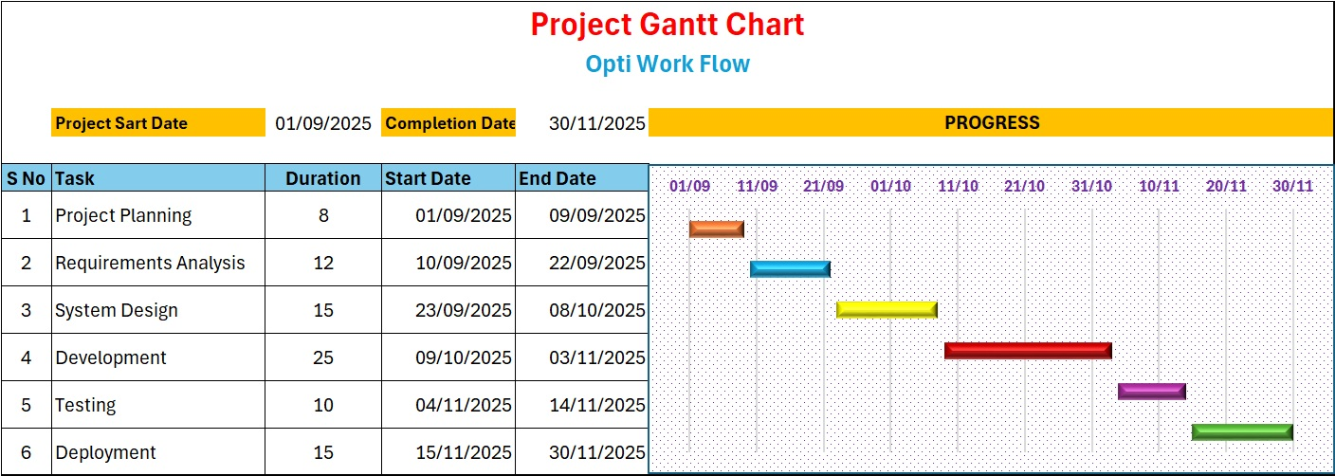
Figure 1

2.4 Development Methodology
The Waterfall Model is chosen because of the sequential and evidence-sensitive characteristics inherent in digital forensic tasks [7]:
1. Requirements collection (ensuring legal compliance, selecting appropriate tools).
2. System architecture (creating workflow diagrams, establishing security frameworks).
3. Execution (integrating various modules).
4. Evaluation (validating with test datasets).
5. Rollout (setting up in a laboratory environment).
6. Ongoing support (implementing updates, providing training).

2.5 Project Design Artefacts
Table 2: Requirements Specification
Functional Requirements | Non-Functional Requirements
Functional requirements delineate the essential functions that a system is required to perform. They encompass specific actions or behaviours exhibited by the system. | Non-functional requirements specify the expected performance of a system. They outline the quality characteristics of the system, including performance, security, and usability.
• Evidence integrity: The system is required to guarantee that digital evidence remains unaltered and uncorrupted. | • System performance: The system should accommodate 100 simultaneous users while maintaining a response time of under 2 seconds.
• Chain-of-custody logging: The system must document every instance of access and every action performed on a piece of evidence. | • System availability: The system is required to be operational 99.9% of the time.
• Reporting accuracy: The system is obligated to produce reports that faithfully represent the data and events. | • Security: The system must implement end-to-end encryption for all data transfers.
• User authentication: The system must facilitate user login through a valid username and password. | • Usability: The user interface should be designed to be intuitive and straightforward for new users.
• Data backup: The system is required to execute nightly backups of all data.
Network Security Architecture Diagram

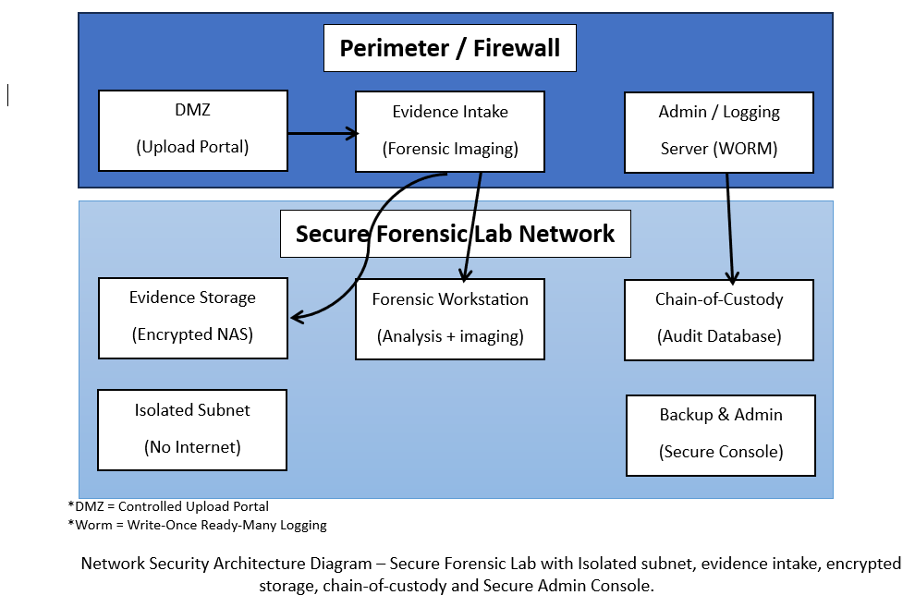
Figure 2

3: Task 2: Enterprise & Innovation:

3.1 PEST & SWOT Analysis for Magnet Forensics
Table 2: PEST Analysis for Magnetic Forensics
Factor | Key Considerations
Political | - Adherence to both national and international regulations regarding the management of digital evidence (for instance, GDPR, CCPA).  - Government procurement regulations that prioritize the use of accredited forensic software.  - Cybersecurity laws mandating the use of certified forensic tools within law enforcement agencies.  - The political stability of significant markets (such as North America and the EU) influences the duration of long-term contracts.
Economic | - The escalating demand for cybercrime investigation services is a result of the increasing frequency of cyberattacks.  - Variations in exchange rates impact the costs associated with international licensing.  - The presence of competition from alternative forensic tool providers is shaping pricing strategies.  - The availability of governmental funding or grants is crucial for the acquisition of technology by law enforcement agencies.
Social | - There is a rising public apprehension regarding data privacy and security.  - The enhancement of digital literacy among investigative agencies and corporate security teams is notable.  - Public confidence in law enforcement's capacity to manage sensitive data in an ethical manner is essential.  - There is a necessity for multi-language support to facilitate adoption in the global market.
Technological | - The swift advancement of mobile technology, cloud storage solutions, and the Internet of Things necessitates ongoing software updates.  - The incorporation of artificial intelligence and machine learning facilitates expedited evidence analysis.  - Compatibility with new file systems and encryption protocols is essential.  - There is a demand for cross-platform tools that accommodate forensic workflows across Windows, macOS, and Linux.

Table 3: SWOT Analysis for Magnetic Forensics
Factor | Key Considerations
Strengths | - A thorough array of digital forensic tools.  - Robust collaborations with law enforcement agencies.  - Significant brand recognition and trust within the industry.  - Ongoing innovation and updates to products.
Weaknesses | - The price point is higher in comparison to certain competitors.  - There is a limited presence in emerging markets.  - There is a reliance on trained forensic professionals to utilize the tools effectively.
Opportunities | - The growing need for digital forensics in cybersecurity incidents.  - The extension into new international markets.  - The advancement of AI-driven forensic technologies.
Threats | - Fierce rivalry among various forensic software vendors.  - Swift advancements in the regulations and standards governing digital evidence.  - Modifications in the regulations and standards related to digital evidence.  - Economic recessions impacting the financial resources of law enforcement agencies.

3.2 Legal & Ethical Considerations
Digital forensic investigations are required to adhere to stringent legal regulations, including:
• UK Computer Misuse Act 1990.
• Data Protection Act 2018.
• GDPR compliance.
Furthermore, from an ethical standpoint, analysts are obligated to uphold objectivity, safeguard confidentiality, and refrain from bias in their reporting [8].

3.3 Digital Forensics Start-up Proposal
Proposed Company Name: CyberCare Ltd.

Business Type: Private Limited Company (Ltd).

Approach:
• Focus on law enforcement agencies and private investigation firms.
• Deliver mobile and network forensic services.
• Conduct training workshops.

Financial Support:
• Grants from Innovate UK.
• Venture capital funds dedicated to cybersecurity.
• Consultancy services offered for a fee.

4: Task 3: Project Reflection:

4.1 Skills Development
This initiative aims to improve both technical abilities (such as forensic tools and chain-of-custody protocols) and interpersonal skills (including report writing and legal awareness). Gaining experience with sophisticated analysis tools will foster proficiency in managing encrypted and cloud-based evidence [9].

4.2 Societal Impact
• Positive Impact: Enhanced capabilities for investigating cybercrime.
• Public Trust: The provision of accurate and unbiased evidence analysis fosters greater public confidence in justice systems.
• Education: Training programs contribute to improved preparedness of the workforce.

4.3 Risks and Mitigation Strategies
Risk 1: Incompatibility of tools.
Mitigation: Ensure a diverse range of tools and conduct compatibility assessments.

Risk 2: Legal obstacles in transnational investigations.
Mitigation: Collaborate with legal professionals specializing in international law.

Risk 3: Security breaches within forensic laboratories.
Mitigation: Establish physical security protocols and utilize encryption techniques.

Conclusion:
The suggested Digital Forensic Investigation framework offers a systematic method for addressing contemporary cybercrime issues. By merging effective project management, strategic enterprise planning, and thoughtful analysis, this initiative adheres to legal requirements and ethical principles while providing advantages to society. The incorporation of secure data acquisition streamlined analysis, and transparent reporting guarantees that the framework is both practical and sustainable.

References:
[1] E. Casey, “Digital Evidence and Computer Crime” 3rd edition Academic Press, 2011.
[2] V. Baryamureeba and F. Tushabe, “The Enhanced Digital Investigation Process Model” in Process. 4th Digital Forensics Research Workshop (DFRWS), Baltimore, USA, 2004.
[3] M. K. Rogers, J. Goldman, R. Mislan, T. Wedge, and S. Debrota, “Computer forensics field triage process model” in Process Conf. Digital Forensics, Security and Law, 2006, pp. 27–40.
[4] D. Quick and K. K. R. Choo, “Impacts of increasing volume of digital forensic data: A survey and future research challenges” Digital Investigation, vol. 11, no. 4, pp. 273–294, 2014.
[5] M. Pollitt, “A History of Digital Forensics” IFIP Advance Information Communication Technology vol. 337, pp. 3–15, 2010.
[5] E. Casey, Digital Evidence and Computer Crime: Forensic Science, Computers, and the Internet, 4th ed. Academic Press, 2015.
[6] B. Carrier, "Risks in digital forensic investigations," Journal of Digital Investigation, vol. 6, no. 2, pp. 112–120, 2010.
[7] R. Pressman, Software Engineering: A Practitioner's Approach, 8th ed. McGraw-Hill, 2015.
[8] S. Garfinkel, "Digital forensics research: The next 10 years," Digital Investigation, vol. 7, pp. S64–S73, 2010.
[9] M. Reith, C. Carr, and G. Gunsch, "An examination of digital forensic models," International Journal of Digital Evidence, vol. 1, no. 3, 2002.

Appendices:
Appendix A | Project Timeline & Gantt Chart
Appendix B | Network Security Architecture Diagram
Appendix C | Requirements Specification Table
Appendix D | PEST Analysis for Magnetic Forensics
Appendix E | SWOT Analysis for Magnetic Forensics

