Academic and Employability Skills.

Ismail Fasesan. Student No:1906877.

Introduction:
As someone who value education and is impart on employment, I am going to be writing about employment skills, why it is important, which part of employability skills are valued and why? I will then go on to deal with core skills needed, such as Trustworthiness, Diligence, Loyalty, Ability to handle difficult situation, Leadership/Followership, Responsibility, Good personal boundary and much more. I also be writing about the importance of continuing professional development. The last part of my work will be about academic skills and how it can aid employment.
What is Employability Skills:
This can be defined as the transferable skills needed by an individual, to make them employable. They are the basic skill needed to find job, keeping and doing well on a job(www.excetor.ac.uk) The concern of employers is how to find the right employees, not only good enough for the job, but to be able to do well and to keep improving on the job. This is the major headache for employers as it is not an easy task for human resources department. The difference between the skills needed on the job and those possessed by applicant, which is sometimes call Skill Gaps(The Workplace Alabama Cooperative Extension System. Vol 1, Iss.3), is a major area of concern for employers. How do employer bridge the gaps? Is it by looking for those without this gap? Or is it by employing and training the staff members? Employability Skills has three components and they are as follows:
Basic Academic skills: Reading, Writing, English, Mathematics, Oral communication.
Higher Order Skills: Learning, Reasoning, Decision Making, Thinking Creatively, Problem solving.
Personal Qualities: Team spirit, Punctual and Efficient, Good Work Attitude, Self Motivation, Self Management, Cooperative, Well Groomed, and many more.
The Basic Academic Skills is the minimum requirement as entry into job market. This might be seen as not too difficult, but an employee must be able to read and write, speak good English, analyse figures with basic addition, multiplication and division.
Higher Order Skills is much more important, employee should have the ability to listen and absorb what he is been told, reason along the line, be able to think critically and be creative. He must have the ability to solve problems that may arise in line of duty and use his own discretion to solve problems when allowed to make decision in the interest of the company.
Personal Qualities. Team Spirit, employee should be able to work as part of a team without creating conflicts among staff. Punctuality and Efficiency is an essential quality that is required at a higher level of jobs. Cooperation among staff members is very important, employee should be able to get along with his colleagues. Well Groomed, it can apply to any area of specialisation , such as engineering, fashion, medical and so on. The main purpose is to train them to become confident at their job, so the objective will be to enrich their mind and inspire them to perform optimally, so much that they become an integral part of the company. This will in turn enhance the quality of service they provide to the public. Self Motivation, employee should be able to work on his own when necessary and to produce maximum achievable outcome without supervision. Self Management is equally important, employees should be able to supervise himself and still accomplish the company objectives. In my workplace, we have to renew our certificate every two years to keep up to date , we do undergo continue training, we have what is called gang members, with a group of ten people working together, every night. Team spirit is very important in this situation and the cooperation of every member of staff is required in other to achieve the given task every night. The company encourage us to go for further education and trainings that may be relevant to our job. As an incentive, the company pay for our training and further education.
Personal Qualities components is also important in my work, we are monitored to make sure that we are always on time and work efficiently, because of the nature of my work, which is safety critical. We have to cooperate with the client staff as well as our gang members. There are some jobs that I have to do on my own, so my discretion is applied in that situation. All the employability skills are very important, but depending on the nature of job that is been undertaken, the basic academic skill is essential for any job. In my work personal quality is important because of the reason stated above.
Core Skills: There is discussion about how to acquire core skills needed for employment. How do one acquire the skills? Is it from Parent? Or is it from Educational Sector? What about from Employment?
I think we learn from parents some of these skills, like trustworthiness, responsibility. When we are young , our parent teach us to be truthful, to be responsible, polite, and be respectful. They even help to teach us the basic of how to read and write. We take this basic knowledge to primary school. In the primary school, we are also thought the basic and improve on what we already learn from home. We then take that to secondary school where we continue to improve the basic as well as going on to learn about higher order skills. From there we take it to university. In the university we learn the higher order skills as well as the personal qualities. In the workplace we learn a lot about higher order and personal qualities skills and we have to be able to apply the knowledge to our work otherwise we might not be able to achieve much or accomplish the company objectives. Some of the core skills are as follows:
Leadership/Followership: It is identified that the character associated with leadership and followership are different, but a lot of people also think that it is interrelated. You can learn this skill in the university, you had to then apply it to your work and be made effective. It is important to note that there cannot be a leader without a follower. So good leader tends to have good followers as he must have acquired the skill and then apply it to make it easy for staff to follow him and to help him achieve whatever he set out to accomplished
Loyalty: This apply more to follower than the leader, one of the characteristics of a good follower is loyalty to a leader or his establishment. Leader can also be loyal to the organisation or company. In Chinese democratic settings, the loyalty of followers is essential or even a must as the leader do not expect less.
Trustworthiness: In work setting, leader expect the follower to be trustworthy, to be reliable, honest, supportive and sincere all the time. This is important for the smooth running of a company. Leader can delegate a jobs to followers and expect a good outcome, if the followers are not honest and reliable , it will be difficult for the leader to do this and that means more work load for him to do.
Ability to Handle Difficult Situation: It is not all the time that we have job that is straight forward to do, in actual fact, we find out that we have challenges at work, so it is important to have employee that can withstand challenges without given up. He had to be able to use his discretion and initiatives to make the right decision and to come out with flying colours.
Diligence: This is a character expected from follower, the constant and earnest effort made to accomplish the set goals and objectives of the company. A good employee is expected to have this in abundance as it can help in the smooth running of company. The physical and mental exertion of mind is what is needed to achieve this all the time.
Responsibility: Employee need to be responsible all the time. At work we make decisions on behalf of the company, we must be answerable for that decision. A responsible worker will make constant effort to be accountable and will not do anything to tarnish the image of his company.
Good Personal Boundary: In anything we do, there should be limit, boundary is therefore the limit that one will not go beyond. It is known as rules and principles which one will live and abide with all the time. It is saying, this what I will do and the other I would not do. A good personal boundary had to be effective, otherwise people will not take you as serious person. It is meant to protect you and to let people know where you stand on any given situation.
The Importance of Continue Professional Development:
In any sector of employment, the importance of continue professional development cannot be over emphasised, whether you pick health, education, science, finance, it is important to continue to have CPD after initial certificate. In the concept of CPD, According to editorial by Du Boulay and Asbjam Holm, Jan, 2000.(CPD is a process of lifelong learning in practice), In other word, you have to continue to learn to be relevant and up to date in your profession. In the business setting, in other to to meet your target or objective, you ought to have professional staffs who are current with what is going in the world with your competitors, otherwise you will be left behind. The need to improve myself has meant that I had to continue learning. After leaving secondary school, I went to college to obtain Advance Diploma in Business Administration. That enable me to get a job as a Bookkeeper, from there I proceeded to study accountancy, which help me to improve on the job. I later move on to work in the Engineering Sector as maintenance Engineer. I had to undergo training to get the job and I continue to improve with further training on the job. The need to continue to be relevant is what made me to apply to University of Wales to study Academic and Employability Skills in Workplace. I am already getting the benefit of further education as my manager can see improvement in my work, especially the team spirit that I am now applying to work with my colleagues.
Academic Skills: Academic skills is the skill needed to be able to read, write and communicate effectively in the society. This skills start from parent and then as we go to primary school, we learn the basic skill, English, mathematics, oral communication and so on. From there we move on to higher skill in secondary school, where we are thought the basic plus the higher order skills like science, commerce, economics, information technology, sport, religious knowledge and others. In the university we learn more higher order skills and we end up specialising in particular area, like, medicine, economics, politics and so on. This skills enable us to seek for work and when we get it to continue to improve by seeking more knowledge. It is believe that the more academic skill we have the more the chance to get a good job. Also the more we are prepare to train on the job, the more the scope of moving higher on the job and even to be able to diversify into another area of our job or move on to something else. My case is a good example, as I have been able to switch from my accounting to engineering. So academic skills is very important as it lead us to better things in live. Academic skills lead us to a higher skills and personal qualities and this skills is essential to our continue improvement at work.
Conclusion:
I have been able to define employability skill, the difference between skill needed and those possessed by employee. I wrote about how to bridge the gap. I manage to break down the components of employability skill and how it relate to employment. I touch on core skills and how it can be integrated into work environment . I also dealt with the importance of CPD and how it help to improve individual looking to still be relevant with their jobs. The last part was on academic skill and the impact on employment.
References:
Edward S, Shapro(Academic Skills Problems) 4TH Edition.
Margret R Burchivial, Ellen Peisner-Feinberg, Robert Pinanta, Corolle Hows(Development of Academic Skills)
Christine Overtoom(Eric Digest, 2000). Employability Skills
Ruth Bridgstock(Higher Education vol.28, 2009) Employability Through Career Enhancing Graduate Employability.
Skill Development Scotland (Core Skills and Modern Apprentiships)
Tanoff,Gregg F, Barlow, Cassie.B , 2000.(Leadership and Followership.)
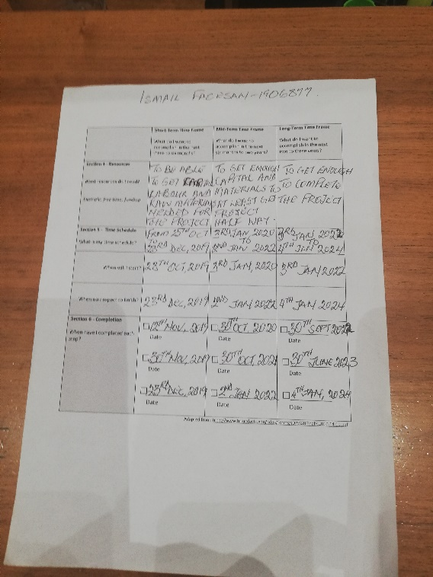
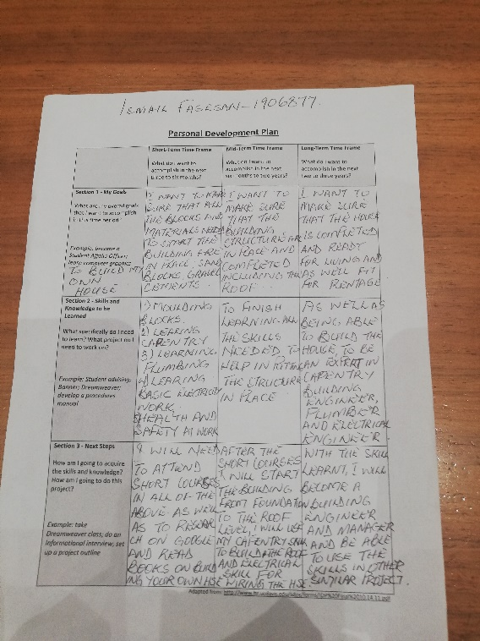
Appendix:

