Report 2

Assignment for Software Development (ACCC 4006)

Author: Gergely Somogyi (1814098)
Lecture: Joy Botu
University of Wales, Trinity Saint David, London Campus
Cloud Computing – Term 2
Acknowledgment

This report was written for Software Development subject. I would like to say thanks to lecture Joy Botu for the syllabus, what is reachable on Moodle.

Table of Contents
Section 1 4
Part A (Understanding) 4
Variable and constant: 4
Data types: 4
Control Structures: 5
Part B (Interpretation) 6
Application description: 7
Line-by-line explanation: 11
Part C (Implementation) 16
Exercise 1 16
Exercise 2 18
Exercise 3 21
References 29

Section 1

Part A (Understanding)

Variable and constant:

In the C# environment there are two kind of data items: variable and constant. Variable data items can have different values at different time. Variable is a storage area that C# could changes and manipulate. Each variable has a specific type, which have a size and layout rules in variable`s memory. The set of operations that can be applied to the variable. Constant data items cannot vary, the program not change them during execution.

Data types:

There are more than a dozen different intrinsic types in the C#. Each kind of data type has a unique size and layout. The most common types of data are: bool, char, double, float, int and string. All of them stores alphabets, numbers in its own range. When a type of data has been declared, the system allocates memory to store it. The type should choose carefully, because there are some values what could store only few types of data. The following table shows the most common types name`s, size`s and range`s.

Type | Represents | Range (values) | Default Value
Bool | Boolean value | True or False | False
Char | Single Unicode character | Unicode symbol used in text | `\0`
Double | Double-precision floating point type | -1.79769313486232e308 to 1.79769313486232e308 | 0.0D
Float | Single-precision floating point type | -3.402823e38 to 3.402823e38 | 0.0F
Int | Signed integer type | -2,147,483,648 to 2,147,483,647 | 0
String | A sequence of characters
Table 1: Data types description

When an arithmetic operation has been done by C# with the same type of data`s, the constants and variables remain the same type after the operation, what they were before execution. Occur, that users must use different types of values in the same program. There are rules followed by C# for implicit numeric conversions. Implicit type conversion is performed by C# in a type-safe manner. Explicit conversions require a cast operator. Casting is required when information might be lost in the conversion, or when the conversion might not succeed for other reasons.

Control Structures:

Control structures is the primary concept of a programming language, in simple way the block of code. In more detail, control structures are blocks of code that order the flows of control, using function calls, instructions and statements. Struct statements have been used to define a structure. Three main types of statement are existing: iteration statements, jump statements and selection statements. Iteration statements are the `do`, `for`, `foreach` and `while` looping. Jump statements are the `break`, `continue`, `goto` and `return` statements. Selection statements are the `case`, `else`, `if` and `switch` branching.
Selection or decision-making statements require one or more conditions. This condition been testing by the program and executing way depend on the conditions are true or false. When a decision-making statement implanted by a programmer the code has different paths, the program performs along that path what the condition determines.
Boolean operators could use in decision-making. Boolean Logical AND (operator: &&): two operands given, and condition will true if both operands are true. Boolean Logical OR (operator: ||): two operands given, and condition will true if any of operands is true. Boolean NOT (operator: !): usually one operand given, and condition will true if the operand is false. The tables below contain the Boolean operators in order.

Operator A | Operator B | Boolean Logical AND
false | false | false
true | false | false
false | true | false
true | true | true
Table 2: Boolean Logical AND

Operator A | Operator B | Boolean Logical OR
false | false | false
true | false | true
false | true | true
true | true | true
Table 3: Boolean Logical OR

Operator | Boolean NOT
false | true
true | False
Table 4: Boolean Logical NOT

Part B (Interpretation)

Application description:

The codes in the appendix giving a little application. Goal of the application is to show some features of the user`s given numbers. After executing codes users see the Screenshot #1.

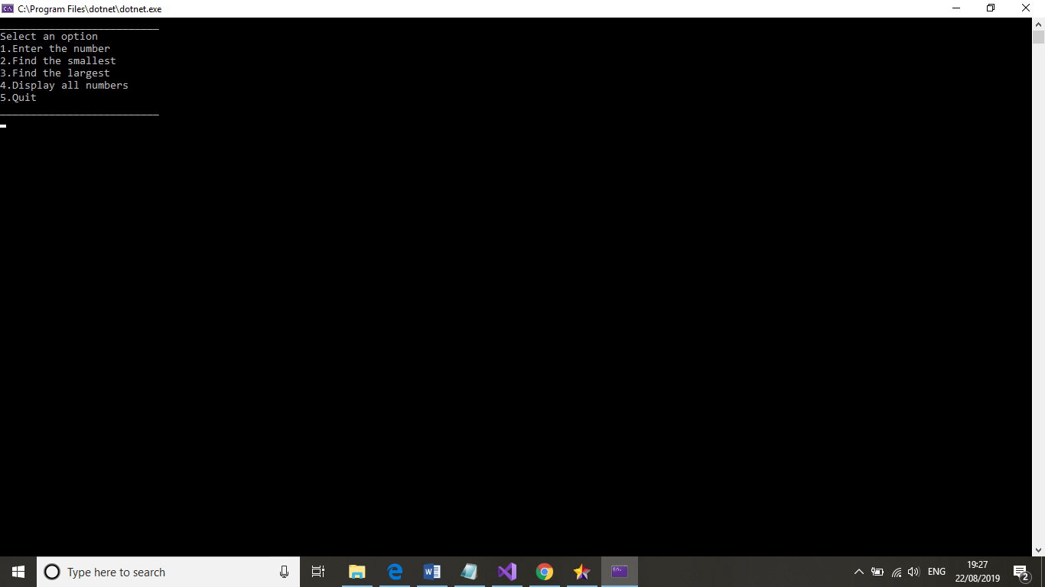
Screenshot #1

As the program said user may select an option by giving a number 1 to 5. If user choses a number out of this range, application displays a `wrong` message and redirect to the starting header, see Screenshot #2.

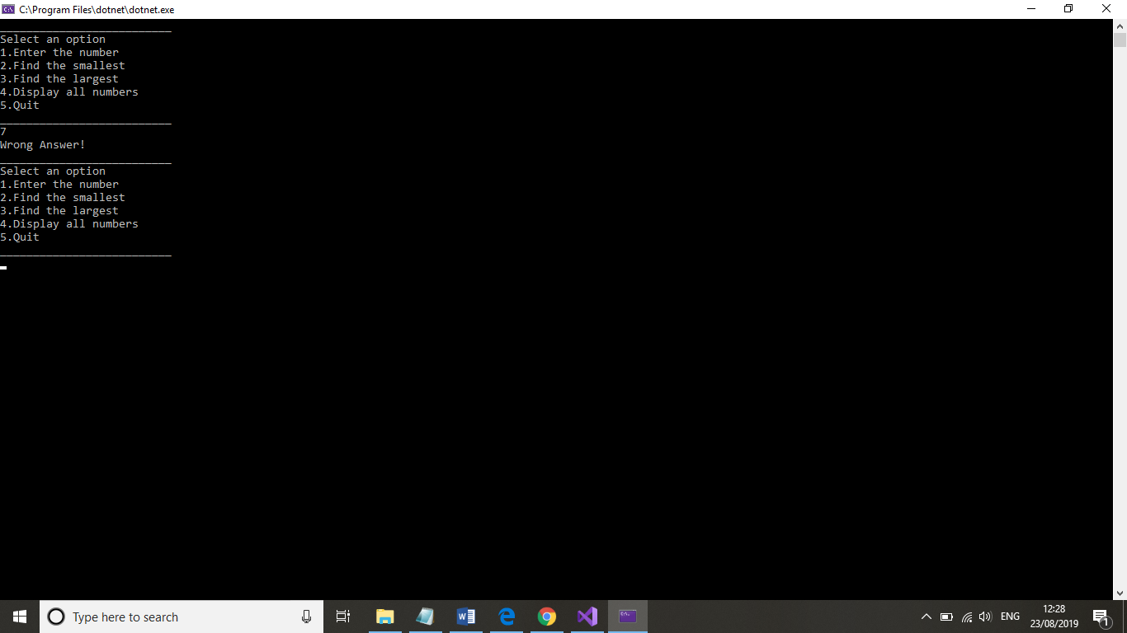
Screenshot #2
Look through the flow of the program in order of the option numbers. By choose the number 1, user could give the numbers, as shows the Screenshot #3.

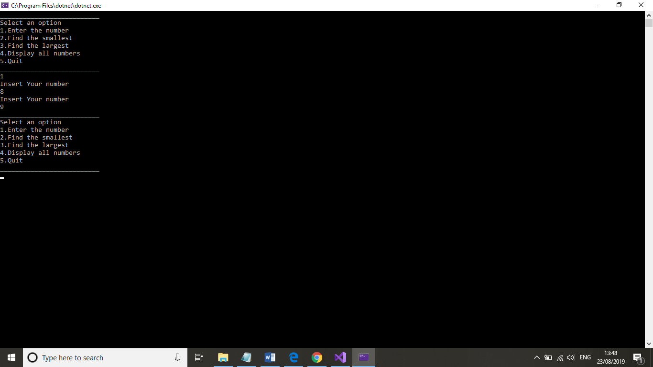
Screenshot #3

After the numbers has been given, option 2, 3 and 4 execute `normal` way as shown by the Screenshot #4.
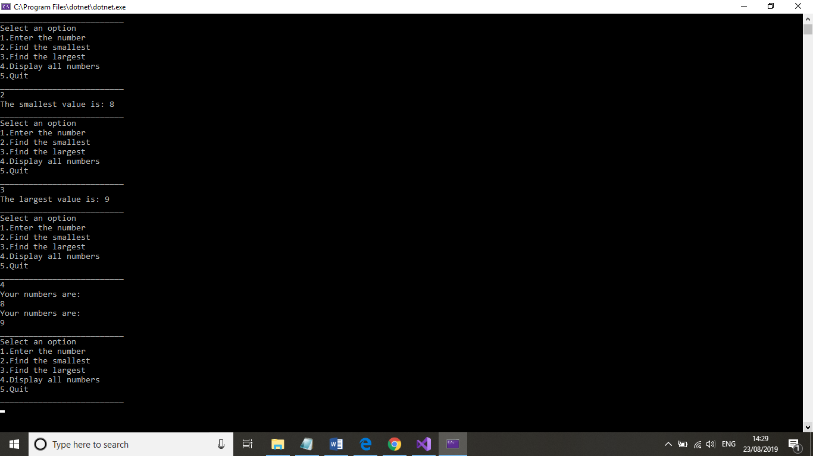
Screenshot #4

In that case we choose for first option 2, 3 or 4, without inputted the numbers, the Screenshot #5 will be displayed by the program. The flow continues like user choose the option 1, giving the numbers.

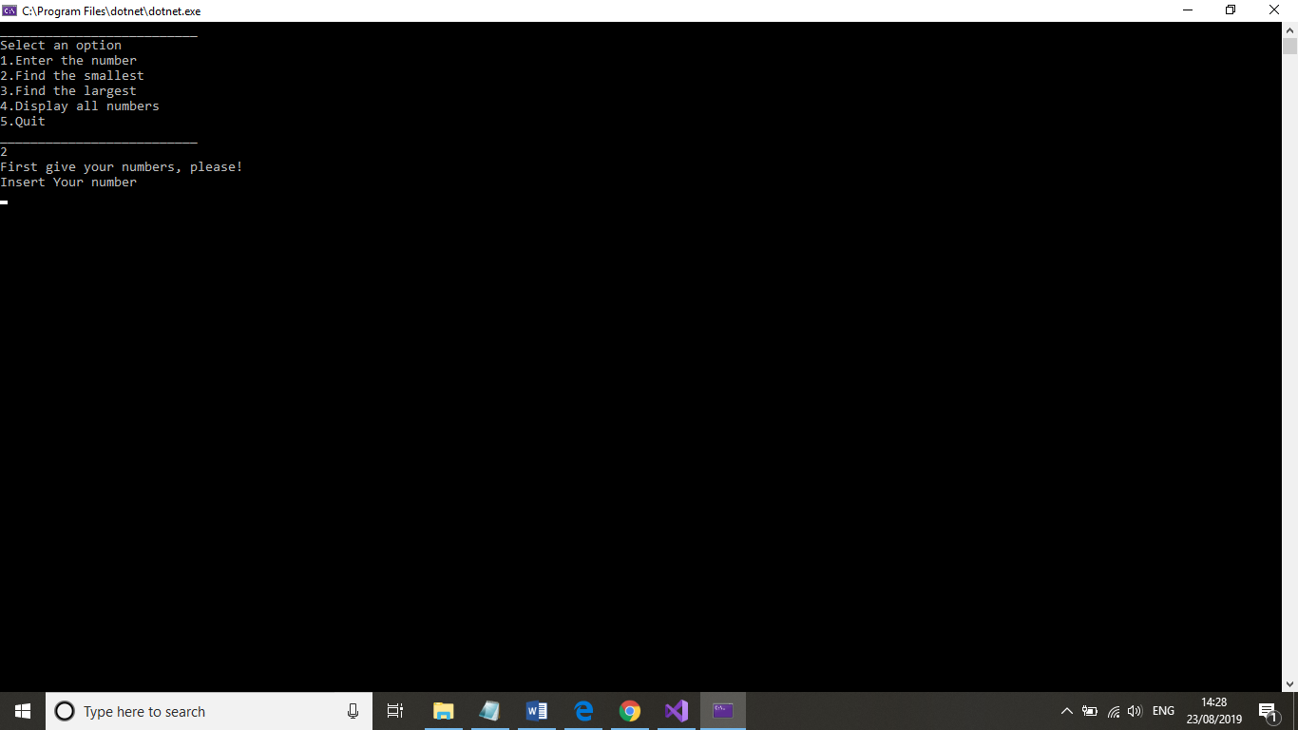
Screenshot #5

Last option is number 5. It does not matter when we choose this number, the process to leave is the same, if user type the right answer. The exiting shown by the Screenshot #6. Right answers are `Yes`, `Y`, `yes` and `y`.

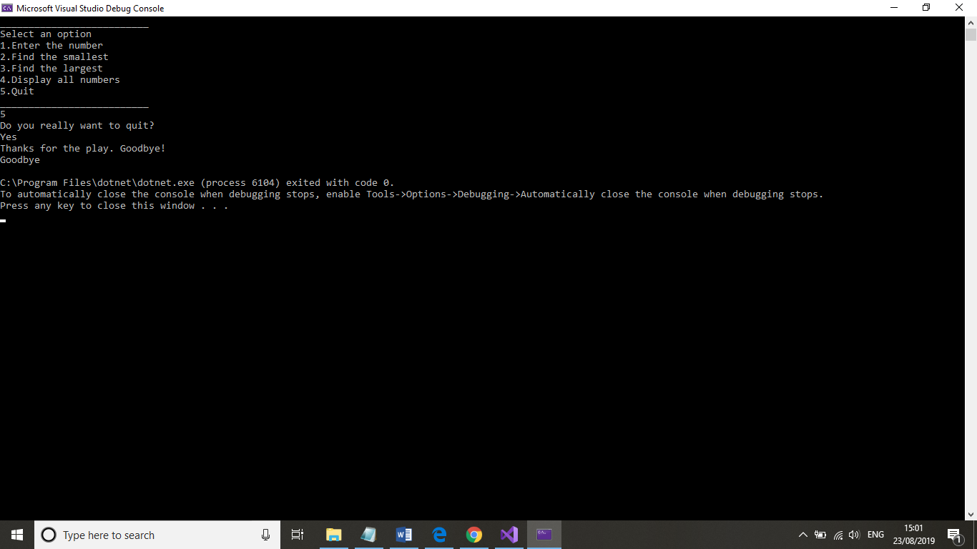
Screenshot #6

If the user gives a wrong answer, the Screenshot #7 shows the result, redirecting to the beginning.

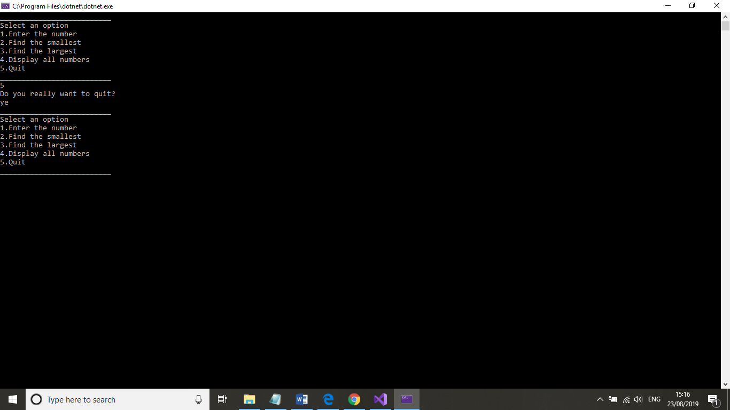
Screenshot #7

A proper flowchart may give a clear picture about the flow, because flowchart demonstrates all the way the flow, not parts of it only, like screenshots of the program. Screenshot #7 shows the flowchart of the program, flowchart was made with StarUML.

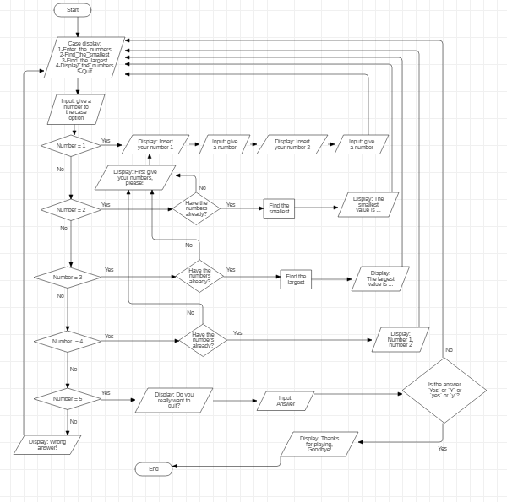
Screenshot #7

Summarizing the screenshots and flowchart, the flow of the program seems simple and straight, if we give the Number 1 and Number 2 first. Otherwise the program forced us to enter them. Note: only four wright answer are existing, what quit the application.

Line-by-line explanation:

using System; // basic peripherals namespace
using System.Collections.Generic; // collection namespace
using System.Linq; // data namespace
using System.Text; // text namespace
using System.Threading.Tasks; // multi-thread application namespace
namespace Assignmen2014_15 // name namespace
{
class Program // class name
{ const int MAXNUMBERS =3; // declare a constant field
static void Main(string[] args) // static modifier
{
int[] theNumbers = new int[MAXNUMBERS]; //declare an array
int chosenOption = 0; bool quit = false;
InitialiseNumbers(theNumbers);
while (quit == false) // while loop
{
DisplayHeader();
DisplayMenu();
chosenOption = ReadNumber("Please choose an option: ");
quit = ProcessMenu(chosenOption, theNumbers);
Console.Clear();
}
}
static void InitialiseNumbers(int[] numbers) // static modifier
{
for (int index = 0; index < MAXNUMBERS; index++) // for loop
{ numbers[index] =0;
}
}
static void DisplayHeader() // static modifier
{
WriteText("*******************************************************************************", 0, 0); // Top left hand corner of screen is x = 0, y = 0;
WriteText("* This application is designed to allow you to choose numbers *", 0, 1); // Next line down is x = 0, y = 1, etc WriteText("* and finds the biggest and the smallest value *", 0, 2);
WriteText("*******************************************************************************", 0, 3);
}
static void DisplayMenu()// static modifier
{
WriteText("Select an option", 20, 8); // Display menu at at x = 20, y = 8
WriteText("1. Enter the numbers", 20, 9);
WriteText("2.Find the smallest", 20, 10);
WriteText("3. Find the largest", 20, 11);
WriteText("4. Display all numbers", 20,12);
WriteText("5. Quit", 20, 13);
}
static void WriteText(string text, int x, int y) // static modifier
{
Console.CursorLeft = x;
Console.CursorTop = y;
Console.Write(text);
}
static int ReadNumber(string prompt) // static modifier
{
string text; int
number;
WriteText(prompt, 20, 14);
text = Console.ReadLine();
number = int.Parse(text);
ClearText(20, 14, prompt.Length + text.Length); // Clear the text at this line
return number;
}
static void ClearText(int x, int y, int length) // static modifier
{
// Write space ' ' characters starting at x, y for 'length' times
WriteText(new String(' ', length), x, y);
}
static bool ProcessMenu(int option, int[] numbers)
{
bool quit = false;
switch (option) // switch declare
{
case 1: // case option
GetNumbers(numbers);
break;
case 2: // case option
WriteText(string.Format("The smallest value is {0}", FindSmallest(numbers)), 20, 15);
Console.ReadKey(); // Pause
break;
case 3: // case option
WriteText(string.Format("The largest value is {0}", FindLargest(numbers)), 20, 15);
Console.ReadKey(); // Pause
break;
case 4: //case option
quit = IsQuitting();
break;
case 5: // case option
quit = IsQuitting();
break; default:
WriteText("Unknown option value entered", 20, 15);
Console.ReadKey(); // Pause break;
}
return quit;
}
static void GetNumbers(int[] numbers) // static modifier
{
for(int index = 0; index < MAXNUMBERS; index++) // for loop
{
numbers[index] = ReadNumber("Enter number: ");
}
}
static int FindSmallest(int[] numbers) // static modifier
{
int smallest = numbers[0]; // declare smallest
for (int index = 0; index < MAXNUMBERS - 1; index++) // <-- subtract 1 // for loop
{
if(numbers[index + 1] < smallest) // if statement
{
smallest = numbers[index + 1]; // if statement
}
}
return smallest;
}
static int FindLargest(int[] numbers) // static modifier
{
int largest = numbers[0]; // declare largest
for (int index = 0; index < MAXNUMBERS - 1; index++) // <-- subtract 1 / for loop
{
if (numbers[index + 1] > largest) // if statement
{
largest = numbers[index + 1]; // if statement
}
}
return largest;
}
static bool IsQuitting()
{
string response; bool
quit = false;

WriteText("Do you really wish to quit? ", 20,13);
response = Console.ReadLine();
if (response == "YES") // if statement
{
quit = true; // if statement
}
return quit;
}
}
}

Part C (Implementation)

Exercise 1

As different kind of data exist in C#, developer task to chose carefully among them for coding. When declare a variable, first think what we use for it. Looking the Exercise 1, we find three different data which will given by the user. First user input a name. This remedy is simple, because names usually contains characters means letters. Not necessary to declare a data type, the given characters use only for display. Second user input a price. Prices mostly have two decimals, so double data type seems good solution. Third and last input is the quantity. Quantity represents int his exercise the number of the ordered product. A product number can be only integer number, so for this data type perfect to choose integer. The application contains one calculation, where price multiply with quantity. The result must declare. As quantity is integer data type and price is double data type, must choose double data type for result. C# has implicit conversation method to convert the integer to double, so developer does not need to care about the conversation. After declaring all the input and output data`s, the solution could be this:

using System;
public class Program
{
public static void Main()
{
Console.WriteLine("Give the name: ");
string Name = Console.ReadLine();
double price;
Console.WriteLine("Give the price of product: ");
string pri = Console.ReadLine();
double.TryParse(pri, out price);
int quantity;
Console.WriteLine("Give the quantity of product: ");
string qua = Console.ReadLine();
int.TryParse(qua, out quantity);
double amount = (price * quantity);
Console.WriteLine("{0} will pay £ {1}.", Name, amount);
}
}

Now look, how to flow the application. Screenshot #8 shows it, if user give correct numbers.

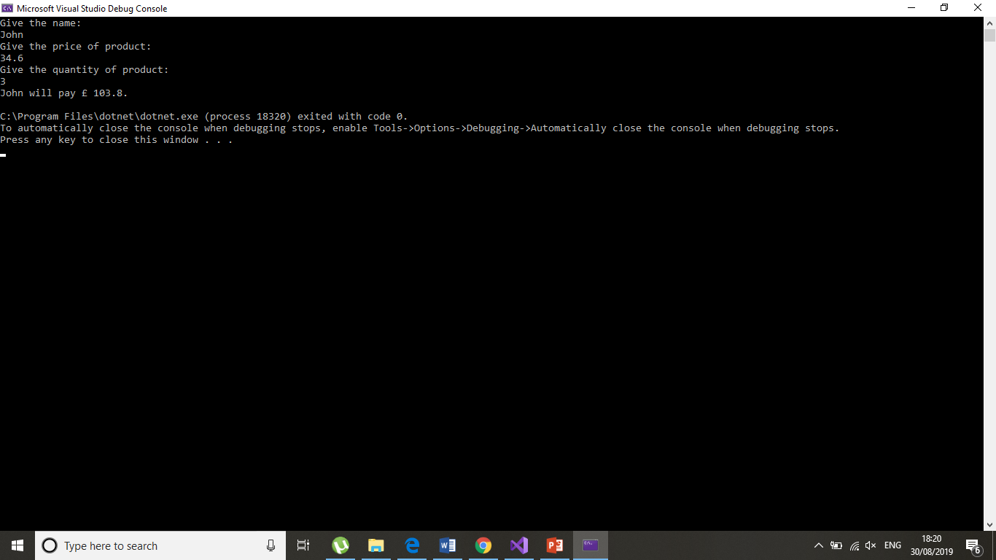
Screenshot #8
In case of user giving a non-integer number to quantity, the program cannot calculate the amount of pay, display only 0 for paying, as Screenshot #9 perform it.

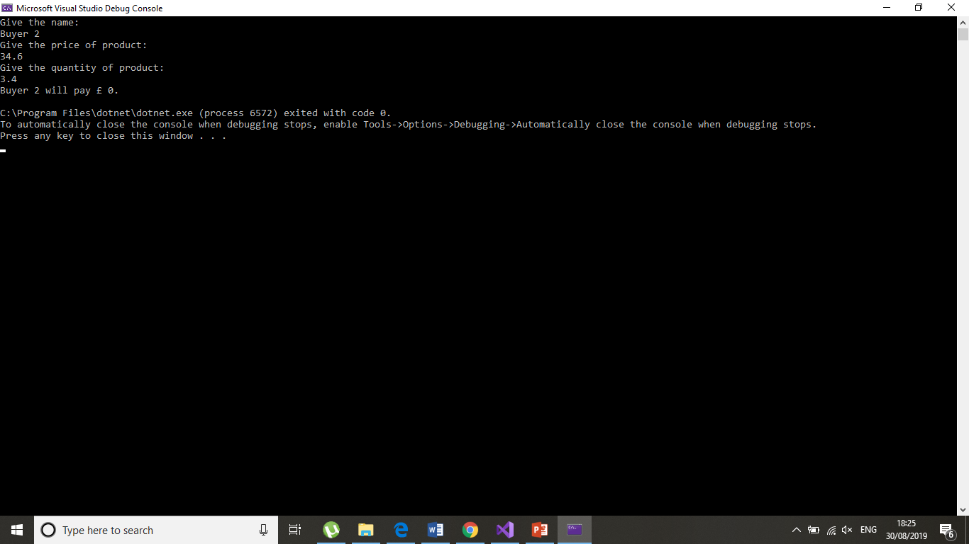
Screenshot #9

Exercise 2

To solve this problem, abstract the given figure. Step 1: first, take a normal rectangle, with side X cm and side Y cm. Colour with yellow all the area of the rectangle, obviously, the coloured area is X*Y cm² now. Step 2: assign a `little` rectangle from right hand side top corner, `little` rectangle is 7 cm long on the side of X and 3 cm on the side of Y. The yellow coloured area is still the same. In step 3 measure the rectangle – called `useless` rectangle, what is under the `little` rectangle, its sides are 7 cm long on the side of X and (y-3) cm long on the side of Y. The coloured area does not change. Cut off the `useless` rectangle from the original rectangle, in step 4. The yellow area now changes to (X*Y) – (7*(Y-3)) cm². With step 5 place a 2 cm long-sided `Square` inside the original rectangle. The right low corner of the `Square` matched with the left low corner of the `little` rectangle and cut down the area of the `Square` from the original rectangle. As the 2 cm sided square area is 4 cm², the coloured area changes to (X*Y) – (7*(Y-3)) – 4 cm². By step 5, getting the same shape area like in the figure 1. The formula to calculate this area is A = (X*Y) – 7Y + 17 cm². The steps are shown by the Screenshot #10, figures in screenshot was made by Microsoft Excel.

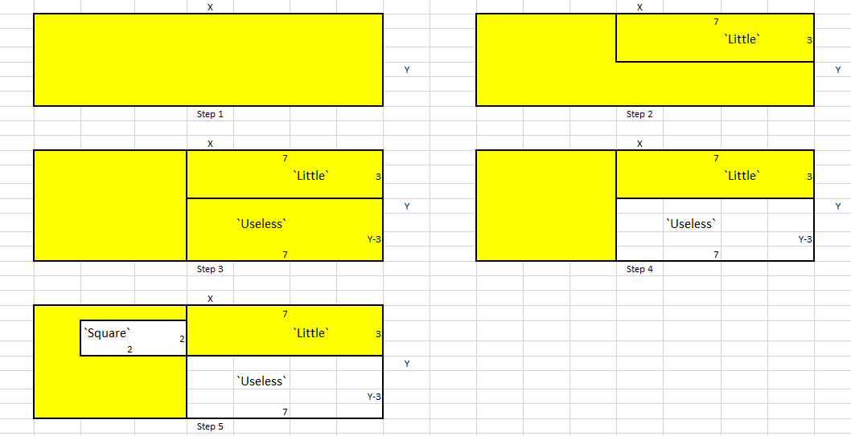
Screenshot #10

However, the formula is general there are some values, what pointless to use. If the X side is smaller than 9 cm or the Y side is smaller than 3 cm, we would not get this shape for the object.
As having a general formula for the solution, place the problem in codes seems easier. Basically, need to write a program, what giving the area of a rectangle. The formula, what gives the area supposed to change to this one. Only one more special feature has the code lines, do not accept numbers for X, what smaller than 9 and do not accept numbers for Y, what smaller than 3. Double data type was used for the program, because a rectangle used to be sides, what real numbers.
using System;

public class Program
{
public static void Main()
{
double width;
Console.WriteLine("Give the X: ");
string xed = Console.ReadLine();
double.TryParse(xed, out width);
double height;
Console.WriteLine("Give the Y: ");
string yed = Console.ReadLine();
double.TryParse(yed, out height);

if (width < 9 || height < 3)
{
Console.WriteLine("One or two of your given values are to small. X should be greater than or equal to 9, Y should be greater than or equal to 3.");
}
else
{
double result = ((width * height) - (7 * height) + 17);
Console.WriteLine("The area of the shaded region is {0}", result);
}
}
}

Next two screenshot demonstrate the flow of the program. Screenshot #11 shows when user gives valid numbers.

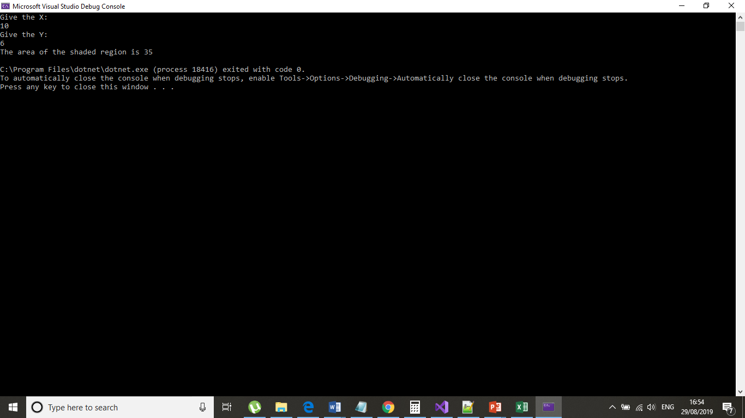
Screenshot #11

Screenshot #12 shows when user gives an invalid number.

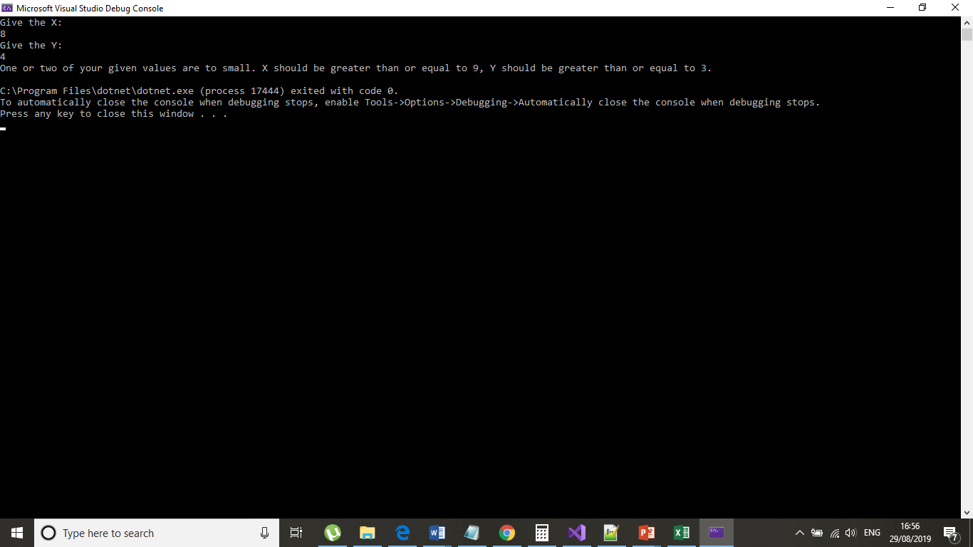
Screenshot #12

Exercise 3
Fruit machine game represents three fruit during playing. Transform this feature into program language or mathematical method: three variables given to examine. Developing this program, need to shred the task to few smaller problems. First, design that part of the program, what responsible for scoring. These codes are record the same way as the given rule in the exercise. Now, the application presents the points of user, but execute only one round, working with given umbers and cannot accumulate the points. Second version extends with a list, what stores the points and display the total of points end of the executing. Missing features: more round and random numbers. In the third interpretation the codes execute many times, end of every round with a question to spin again or end the game. If user choses quitting, will get the total points.
First version:

using System;
namespace Conditional
{
class Nestedtochoose
{
public static void Main()
{
int first;
Console.WriteLine("Give the first number: ");
string fir = Console.ReadLine();
int.TryParse(fir, out first);
int second;
Console.WriteLine("Give the second number: ");
string sec = Console.ReadLine();
int.TryParse(sec, out second);
int third;
Console.WriteLine("Give the third number: ");
string thi = Console.ReadLine();
int.TryParse(thi, out third);
if (first == second && second == third)
{
if (first == 9)
{
Console.WriteLine("You win. Your points are 2000!");
}
else
{
Console.WriteLine("You win. Your points are 15!");
}
}
else
{
if (first == second)
{
if (first == 9)
{
Console.WriteLine("You win. Your points are 200!");
}
else
{
Console.WriteLine("You win. Your points are 5!");
}
}
else
{
if (second == third)
{
if (second == 9)
{
Console.WriteLine("You win. Your points are 200!");
}
else
{
Console.WriteLine("You win. Your points are 5!");
}
}
else
{
if (first == third)
{
if (first == 9)
{
Console.WriteLine("You win. Your points are 200!");
}
else
{
Console.WriteLine("You win. Your points are 5!");
}
}
else
{
Console.WriteLine("You lost. Your point is 0!");
}
}
}
}
}
}
}

Second version:
using System;
using System.Linq;
using System.Collections.Generic;
namespace Game.Lists
{
class Conditionals
{
public static void Main(string[] args)
{
int first;
Console.WriteLine("Give the first number: ");
string fir = Console.ReadLine();
int.TryParse(fir, out first);
int second;
Console.WriteLine("Give the second number: ");
string sec = Console.ReadLine();
int.TryParse(sec, out second);
int third;
Console.WriteLine("Give the third number: ");
string thi = Console.ReadLine();
int.TryParse(thi, out third);
var points = new List<int>();
if (first == second && second == third)
{
if (first == 9)
{
Console.WriteLine("You win. Your points are 2000!");
points.Add(2000);
}
else
{
Console.WriteLine("You win. Your points are 15!");
points.Add(15);
}
}
else
{
if (first == second)
{
if (first == 9)
{
Console.WriteLine("You win. Your points are 200!");
points.Add(200);
}
else
{
Console.WriteLine("You win. Your points are 5!");
points.Add(5);
}
}
else
{
if (second == third)
{
if (second == 9)
{
Console.WriteLine("You win. Your points are 200!");
points.Add(200);
}
else
{
Console.WriteLine("You win. Your points are 5!");
points.Add(5);
}
}
else
{
if (first == third)
{
if (first == 9)
{
Console.WriteLine("You win. Your points are 200!");
points.Add(200);
}
else
{
Console.WriteLine("You win. Your points are 5!");
points.Add(5);
}
}
else
{
Console.WriteLine("You lost. Your point is 0!");
points.Add(0);
}
}
}
}
var res = points.AsQueryable().Sum();
Console.WriteLine("Your final points are {0}", res);
}
}
}
Unfortunately, I cannot implant random number generator and a right loop for more round, so I haven` t got version 3 and 4.

References

https://www.tutorialsteacher.com/csharp/csharp-tutorials

https://www.geeksforgeeks.org/csharp-programming-language

https://www.tutorialspoint.com/csharp

https://docs.microsoft.com/en-us/dotnet/csharp

http://freeasphosting.net/csharp-tutorial.html

https://www.valid-computing.com

https://www.programiz.com

https://www.tutlane.com

https://www.javatpoint.com

