

Postgraduate/Distance Learning
Assignment coversheet & feedback form

THIS SHEET MUST BE THE FIRST PAGE OF THE ASSIGNMENT YOU ARE SUBMITTING (DO NOT SEND AS A SEPARATE FILE)

For completion by the student:
Student Name: Alana Davies

Module code: HPEN 7018  Module title: Researching and Writing to a Single Focus | Student ID number:  2113336 |  |  | Educational support needs:  Yes/No
Module tutor: Dr Ros Hudis

Assignment due date: 17/01/2022
If your module has multiple submissions please indicate which piece of work this is.

1st 2nd 3rd 4th 5th 6th
I confirm that this is my original work and that I have adhered to the University policy on plagiarism.
Signed …………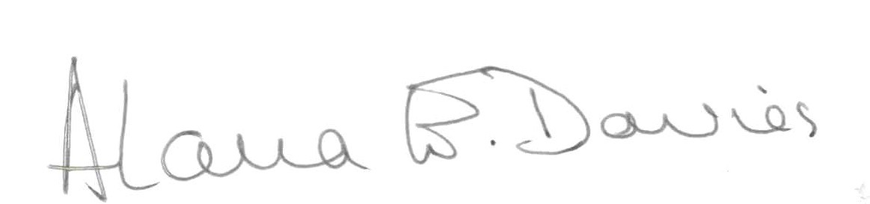…………………………………………………
Email submission: if you are submitting this form via email, please tick this box
(as a substitute for your signature) to confirm that you agree to the above declaration.
Assignment Mark
1st Marker’s Provisional mark
2nd Marker’s/Moderator’s provisional mark
External Examiner’s mark (if relevant)
Final Mark

NB. All marks are provisional until confirmed by the Final Examination Board.

For completion by Marker 1 :
Comments:

Marker’s signature: |  |  | Date:
For completion by Marker 2/Moderator:

Comments:

Marker’s Signature: |  | Date:
External Examiner’s comments (if relevant)

External Examiner’s Signature: |  | Date:

HPEN 7018
REFLECTIVE ESSAY
The single focus I have chosen to research and write on for this module is that of Domestic Abuse, and for my portfolio, I have written two short stories on this theme: Geraldine and Perceptions.

General reflections
I had written a story as a vehicle for undertaking research as an exercise for Session 1 of the Module: What is Writerly Research? I was intrigued by the variety of methods used by some authors in their research methods. For example, Langley Hyde writes ‘Typically, by the time I’ve started writing, I’ve completed all of my direct research ’ which seemed a far more organised and disciplined way of researching than my method with previous writing; Tess Brady’s description of her method as ‘I needed to function a little like a bowerbird that picks out the blue things and leaves all the other colours’ I found a most engaging image, while Hilary Mantel’s assertion that ‘Facts are not truth’ is was surprising, as well as reassuring.
But my choice of genre stems largely from an exercise undertaken in session 2 of the module: The Lonely Voice - crafting the short story around a theme. The genre of the short story appealed to me, as it has for a long time. I have, in the past, submitted stories to magazines and collections; I was thrilled to have one published in People’s Friend many years ago. The idea of saying more with less as set out in this session, of ensuring that every part of the story reflects the main theme of the story, I found particularly interesting. And, as it turned out, particularly challenging.
Having studied Session 3: The Personal - Turning Life Experiences into Literature, I considered some settings and situations I have encountered, or have been involved with in both my personal and my professional life. The topic of Domestic Violence, or Domestic Abuse, is one I have taken an interest in over a number of years. It is something I witnessed in my home as a child. In my memoir, I recounted some of the ways in which my father psychologically abused my mother. I have seen domestic abuse affect other members of my family, and it was an area I was able to lead on as a County Councillor. I have drawn on my personal experiences and used them to create works of fiction in the shape of two short stories, covering themes of dominance, intimidation, fear, and escape. These are all typical features of domestic abuse, and I hoped to show these aspects in action, and how they affect the characters involved.

My Research
The starting point of my research for these stories, then, was my own memories and experiences. While the vast majority of victims of domestic abuse are women, men can also be abused, as I have shown in Perceptions. This fact came into sharp focus for me when my brother was, himself, a victim. As in the story, where Michael says ‘…. Can you come and fetch me?’, I was the one receiving the phone call late at night, not from a hospital, but from a telephone box in Monmouth, where my six-foot-three confident, clever brother stood sobbing over the telephone to me. I chose not to include all of the of details of this event in my story, and to discard any background or future information, as my intention was to set up a situation where it was assumed until the last that it was the woman who was being abused; for this reason I limited Michael’s response to the last few sentences of dialogue, as a means of thematic dramatization.
I carried out some primary research in the form of interviews with close friends and family. These were all women, and the research was mainly for the story Geraldine, although the types of abuse employed in this story can be common to all genders.
My secondary research was largely in the form of searching for books, writings and articles on the internet. There was no shortage of information available on the incidence of domestic abuse. However, for Geraldine, I was interested in the circumstances prevailing in the 1950s and ’60s, and the environment in which too many women found themselves, before some important changes to the law came about. A well-known campaigner from the 1960s and ’70s was Erin Pizzey, who has published her memories of that time in This Way to the Revolution, and has been written about in a recent article by the BBC: The Woman Who Looked Beyond the Bruises . Various newspaper articles carry interviews with survivors of domestic abuse. Kaitlyn Mendes, then a student at Cardiff University, wrote her thesis on the subject, entitled Reporting the Women’s Movement, which compares feminism and equal rights between the UK and the USA, covering the period I was interested in. From these studies, I took some specifics of both physical, mental and emotional abuse which could directly impact on my story. The most instructive information on the mid-twentieth century aspects of domestic abuse I found in a booklet written by Pat Thane, and published by the British Academy as ‘Happy Families? History and Family Policy.’ Here I found such shocking revelations as
‘… despite considerable resistance to “intrusion” by the state into the historic rights of husbands and fathers over their wives and children, including the right to beat them …’ (P39) and ‘Not until 1978 were men legally fully restrained from beating their wives’ (p44) .

I picked up this element and included it in my story: ‘What he’s doing should be illegal, and it’s not! … a man has a right to chastise his wife’
The lack of available housing for abused women in the 1960’s was a major reason for their staying with their abuser, a point I raise in Geraldine. This was before the emergence of refuges, Women’s Aid and safe houses, as discussed in both pieces by Erin Pizzey mentioned above. Her book Scream Quietly or the Neighbours will Hear proved to be a turning point in the campaign for women’s refuges. I found it difficult to access specific legislation regarding housing prior to the 1977 Housing Act, but the wording in that act makes it clear that the provision before this time was woefully inadequate for those people – women and men – who were being abused.
Although my stories are fictitious, as are the characters, I did not need to fictionalise fact. All of the actions I have written about are found in my research. And all of my research had a wealth of dramatic potential. Some case studies I discovered included the quotes: It was May 1973, there was no law against marital rape in the UK, lone women could not apply for a mortgage’‘ and ‘She married the first man who came into her life when she was sixteen to escape her mother’ , something that is reflected in Geraldine’s situation: She married Len. And she found that, at sixteen, she wasn’t too tall after all. And yet, despite the many examples of domestic abuse available, I found it impossible to discover case studies of survivors who had broken away, or had attacked their abuser, apart from the example of Erin Pizzey herself.
There was much information available, but I concentrated on the ‘Bowerbird’ methodology (as above), picking out the main themes of lack of acknowledgement of the problem, lack of support, lack of legislation, and lack of safe places. I discarded the larger political and social campaigning in sway at the time, and the improvements brought about since then, and tried to concentrate the main issues into stories about one woman and one man.

Literary Context
I have been influenced in my writing by detective and crime fiction, from authors such as Mick Herron and Harlan Coben insofar as the setting up of plots, the psychological aspects of the stories, the character flaws, the reveal, etc. are concerned. This influence I have used in showing the character and situation of Len, for example, in: ‘…he had been living on his own for quite a while’, ‘… if he was sometimes a bit quiet, a bit offhand, well that was to be expected…’, ‘This big, handsome, older man…’ and of Geraldine: ‘She was a stupid ignorant girl … She believed it now’ and throughout the story. The turning point in Geraldine is ‘She could see clearly for the first time in years’, with the climax ‘she thrusts it under his outstretched arm and deep into his chest’ written in the present tense to convey a sense of urgency. In a sense, Geraldine becomes a detective figure herself, gradually identifying through her reading and research that what is being done to her is abuse, and a crime. The reveal in Perceptions is shown at the end in: ‘Fight back? I can’t, Lyn. You know I’d never hit a woman.’ The structure of the plots can be seen as a reversal of much crime fiction: the gradual revelation of what the crime is.
Historical fiction, too, has inspired me over the years, for example Edward Rutherfurd’s books Sarum, Dublin and Ireland Awakening, and while at least one of my stories is set in the twentieth century, this is still history, and there are important historical aspects to be addressed through action and dialogue, as well as some general narration. To give a sense of place and of time, I have given small clues rather than a geographical or date reference. For example, ‘The little two-up-two-down terraced cottage in the south Wales valley’ in Geraldine tells us where, and ‘She danced around the kitchen to Peggy Sue and April Love as she dusted’ tells us that the story is set in the early 1960s.
More recently I have identified a connection with the author Maeve Binchy, many of whose books I have read in the past, and who writes about social and domestic issues, set in her home country, as I have done in Geraldine. There are also some impactful scenes in the BBC series ‘Call the Midwife’ which is set in the era of my interest.

Structure
I chose to write as a third person narrator rather than in the first person, as this allowed me to demonstrate some distance from the events themselves, as there could have been a danger of drifting into the melodramatic. I wanted the story of Geraldine, in particular, to be told in a somewhat detached way, with emotion showing through dialogue. I was greatly helped in this by my tutor, who encouraged me to dramatize some scenes through such dialogue.
In Perceptions, the majority of the writing is via dialogue, with the speaker being unknown, keeping a sense of ambiguity until the final reveal as to which of the main characters was the abuser, and which the victim. This is a very short story, and I needed to cover the main elements in an even shorter space than with Geraldine. As advised in the material provided in Session 2: A Succinct Guide to the Short Story: ‘ … you need to establish who/where/when/why/ main character/main conflict, quite early on and economically. No time for lengthy back story.’
In Perceptions, there was no need for much detail as to ‘who’, as this element was part of the unknown, fundamental to the story itself. However, I covered the initial party setting succinctly, in ‘The two women pause to enjoy the party food, each snatching a second amuse-bouche from the circulating tray … and a later setting in a hospital, by the few words: ‘So here we are again!’ ‘Yes. Sorry Nurse …’
I introduced the main characters early on in Geraldine by establishing the setting in the first paragraph: ‘She married Len. And she found that, at sixteen, she wasn’t too tall after all … her new husband, twenty years her senior.’ This goes on to give a physical description of the main character, as well as the ages of both of them, and a suggestion that someone had previously described her as unattractive.
The information and advice given by Paul Magrs in Session 7: Representing Time, I put to good use in both stories. In Geraldine I was able to move the story forward quite quickly, using short, specific sentences and repetition, shown in ‘She had a solicitor. She had the photographs. She had a letter from the hospital …’ and slow it down in, for example, the section beginning ‘She served up his dinner as usual that night …’ where I lingered on details such as ‘… feeling the clammy sweat of her hands as she held them, still, in her lap. Her plate was in front of her, the food untouched …’ and ‘He waited until his meal was eaten and two cups of tea drunk, ….’ In Perceptions I used words such as ‘silent’, crawls’, and ‘sluggishly’ in the section ‘The journey home is silent …’ to slow the story down.
In Geraldine, I used a fairly contained sentence structure, often using short, impersonal sentences that carry a weight of unspoken emotion, such as ‘She didn’t dance any more’. I also used line breaks in the dialogue for dramatic effect. For example:
Push.
And if she turned away too soon in bed,
Bite.
It was because she could be so irritating, so stupid.
…
Slap.
I tempered the aggression and fear with some tenderness by bringing friends and allies into both stories. In Geraldine, her father, her friend Gaynor, and the photographer; in Perceptions, the paramedic, the nurse, and Michaels’s sister. This is often a feature of traditional stories, where the protagonist meets allies along the way.
I found the chapters on ‘The Flawed Self’ and ‘Plots, Endings and Meaning’ in Will Storr’s The Science of Storytelling particularly constructive in setting out Geraldine’s initial lack of self- belief and her ‘deeply significant test’ in ‘She could feel the warm trickle of blood as the little life inside her died. As part of her died too’ (pps 198-199).

Challenges, Learning and the Future
I have learned a great deal from the processes of writing and of researching. The main challenge I overcame in my writing was in showing rather than telling. My default position is to explain, and sometimes to over-explain, not trusting the reader to work out details for him or herself. I also tend to write more narrative than is necessary, or is suited to the short story genre. I have taken on board the advice I was given by my tutor in this respect, and I am pleased with the result. Becoming aware of the myriad methods of researching for a story, a poem, or a piece of non-fiction was a real eye-opener for me, and as I continue to write – perhaps short stories, perhaps a novel - I will once again apply the ‘bowerbird’ analogy to picking out the blue pieces that best fit my future writing.

END NOTES

See APPENDIX 1: The Doll Collector
Langley Hyde: extract from How do I read for Writerly research Jan 2016 – Session 1,HPEN 7018
Tess Brady: extract from An Exegesis concerning the novel- Fragments of a map – Session 1,HPEN 7018
Hilary Mantel on History and Historical Fiction: What is Writerly Research? Session 1, HPEN 7018: https://theconversation.com/facts-are-not-truth-hilary-mantel-goes-on-the-record-about-historical-fiction-79359 June 2013, accessed October 2021
See APPENDIX 2: People’s Friend story pps 1&2
APPENDIX 3: Extract from ‘My Lovely Arms’
APPENDIX 4: DA Questionnaire
Erin Pizzey This Way to the Revolution Kindle Edition (March 2013)
Bethan Bell, Erin Pizzey: The woman who looked beyond the bruises, 2021 https://www.bbc.co.uk/news/uk-england-london-59064064 [accessed November 2021]
Sandra Laville Domestic violence: how the world’s first women’s refuge saved my life, 2014 https://www.theguardian.com/lifeandstyle/2014/apr/28/domestic-violence-first-womens-refuge-saved-my-life [accessed November 2021]
Kaitlyn Mendes PhD Thesis (Cardiff University): Reporting the Women’s Movement: A cross-national comparison of representations of second wave feminism and equal rights issues in the United Kingdom and United States daily press, 1968-1982. Jan. 2009 https://orca.cardiff.ac.uk/54494/1/U584595.pdf [accessed October 2021]
Pat Thane Happy Families? History And Family Policy: A Report Prepared For The British Academy. London, [Published October 2010 Revised September 2011] ISBN 978-0-85672-590-6 [pps 39 & 44]
Erin Pizzey Scream Quietly or the Neighbours will Hear New edition ISBN: 9780140221718 [Pelican S. 1971]
National Archives: Housing (Homeless Persons) Act 1977: https://www.legislation.gov.uk/ukpga/1977/48/section/1/enacted [accessed November 2021]
APPENDIX 5: Case Studies DA
Sandra Laville Domestic violence: how the world’s first women’s refuge saved my life, 2014 https://www.theguardian.com/lifeandstyle/2014/apr/28/domestic-violence-first-womens-refuge-saved-my-life [accessed November 2021]
Erin Pizzey This Way to the Revolution Kindle Edition (March 2013)
Mick Herron Slow Horses (Kindle version) Great Britain, John Murray [2015]
Harlan Coben Tell No-one Great Britain Orion Books [2010, kindle version 2013]
Edward Rutherfurd Sarum Arrow Books New Ed edition [1992]
Edward Rutherfurd Dublin Arrow Books [2005]
Edward Rutherfurd Ireland Awakening Cornerstone Digital, New Ed edition [2011]
Maeve Binchy: Light a Penny Candle Ireland; Century [1982]; Tara Road (Kindle version) [1999];
BBC.co.uk Call the Midwife https://www.bbc.co.uk/programmes/p0118t80
I have deliberately used the word ‘victim’ here as opposed to ‘survivor’ (see also Endnote ii)
Paul Magrs Short Circuit Pg 208 (Salt Publishing, 2009): Session 7 of Module 2: Representing Time
Will Storr The Science of Storytelling: Why Stories Make Us Human, and How to Tell Them Better Harper Collins Publishers Dublin Paperback Edition [2020]
Extract from ‘My Lovely Arms – a memoir: ‘… my father played on all her fears. He knew she was afraid of heights, so when offering to take the family for a run in the car, he drove to the top of the Bwlch - a 1600ft mountain just north of Bridgend – and stopped the car. She was terrified. He knew she was afraid of fire, but he brought home a can of petrol and put it on the hearth next to the coal fire. But most of all she was afraid she was going mad and would have her children taken off her. He played on this. He had often told her she was stupid, but now he told her she was insane, not a fit mother. He would call the police in the middle of the night, saying that she was not fit to look after the children.’
The preferred term for those subjected to such abuse is ‘survivor’ rather than ‘victim’. While ‘victim’ is a legal definition necessary within the criminal justice system, ‘survivor’ can be used as a term of empowerment, to convey that a person has at least started the healing process. For this reason, I will now use the latter term in the remainder of this exegesis, with any exception noted.
My husband and I drove miles through a snow storm to find him, to bring him home, not understanding what had happened, or how, or why. We didn’t probe, we didn’t ask, we gave him time, and eventually he told us that such abuse, both physical and emotional, had been going on for a long time. He had never anyone the slightest clue that anything was wrong in his relationship with X. He had hidden it well, out of shame, and a loyalty to his partner, misguided though that seemed to me. As in the story, where Michael says ‘Fight back? I can’t, Lyn. You know I’d never hit a woman’ , my brother, too, had been brought up never to hit a woman, taking lessons from our own childhood rather than imitating our father’s behaviour. I chose not to include all of the above details in my story, and to discard any background or future information, as my intention was to set up a situation where it was assumed until the last that it was the woman who was being abused; for this reason I limited Michael’s response to the last few sentences of dialogue, as a means of thematic dramatization
Some telling quotes from ‘Happy Families? History And Family Policy’: - ‘… despite considerable resistance to “intrusion” by the state into the historic rights of husbands and fathers over their wives and children, including the right to beat them. P39 - P 44: Domestic violence was even less acknowledged for a long time. In the 1950s and 60s police were told “not to meddle; it was a family affair and we weren’t allowed to meddle in it.”80 Reports of wife-beating were not recorded as assaults and the Criminal Investigation Department (CID) often refused to be involved in reported cases. Police who wanted to assist could not prosecute; women complainants had to pursue their own action.81 - The post 1968 women’s movement brought domestic violence and sexual violence against women into public prominence as never before. They provided refuges to support women fleeing abusive partners, and publications such as Erin Pizzey’s Scream Quietly or the Neighbours will Hear (1974) made a lasting impact. - In 1974-5. In 1976 the Domestic Violence and Matrimonial Proceedings Act empowered county courts to grant orders forbidding molestation of a spouse or child and excluding a spouse from the family home or part of it; powers extended to couples who were not married but had been living together on a stable basis. 170 years after men were prevented from beating their cattle they were restrained from beating their wives. Not until 1978 were men legally fully restrained from beating their wives. ‘A person is also homeless for the purposes of this Act if he has accommodation but— (a)he cannot secure entry to it, or (b)it is probable that occupation of it will lead to violence from some other person residing in it or to threats of violence from some other person residing in it and likely to carry out the threats… ’
‘A person is also homeless for the purposes of this Act if he has accommodation but— (a)he cannot secure entry to it, or (b)it is probable that occupation of it will lead to violence from some other person residing in it or to threats of violence from some other person residing in it and likely to carry out the threats… ’
‘It was May 1973, there was no law against marital rape in the UK, lone women could not apply for a mortgage, and domestic violence was rarely mentioned. Smith had endured two years of violence from her mentally unstable husband, including vicious beatings, knifings, burns, bites and an attempted drowning.’ :‘She married the first man who came into her life when she was sixteen to escape her mother; also because he was much older and reminded her of her father. José was a self-employed builder. She soon discovered that he was as physically abusive as the mother she had left behind
Storr, Will. The Science of Storytelling: Why Stories Make Us Human, and How to Tell Them Better HarperCollins Publishers. Kindle Edition. Chapter 2: The Flawed Self’: At the start of a story, we’ll often meet a protagonist who is flawed in some closely defined way. The mistakes they’re making about the world will help us empathise with them. As the story gives us hints and clues about the causes of their errors, we’ll warm to their vulnerability and become emotionally engaged in their struggle. When the dramatic events of the plot coax them to change we’ll root for them. (p 62) ﻿Chapter 4: Plots, Endings and Meaning:A gripping plot is one that keeps asking the dramatic question. It uses its story event to repeatedly change and gradually break the protagonist’s model of who they are and how the world ﻿ ﻿works before rebuilding it. This requires pressure. These models are tough. They run to the core of the character’s identity. If they’re going to crack, the protagonist needs to hurl themselves at the drama. It’s only by being active, and having the courage to take on the external world with all its challenges and provocations, that these core mechanisms can ever be broken down and rebuilt. … many stories have a point, just prior to their resolution, in which the hero endures some deeply significant test. For one final, decisive time, they’re posed the dramatic question. It’s the moment they have to decide, once and for all, whether or not to become someone new. ﻿In archetypal storytelling, especially as it emerges in fairytales, myths and Hollywood movies, this event often takes the form of some life-or-death challenge or fight in which the protagonist comes face-to-face with all they most dread. This occurence on the surface is symbolic of what’s taking place in the second, subconscious layer of the story. Because the story event has been designed to strike at the core of this character’s identity, the thing they need to change is precisely that which is hardest. The flawed models they’re required to shatter run so deep that it takes an act of almost supernatural strength and courage to finally change them for good. ﻿Properly written characters, with effective internal drama, don’t need to rely on overblown and ﻿hyperactive drama to satisfy. (pps 198-199) REFERENCES Hyde, Langley: extract from How do I read for Writerly Research Jan 2016 – Session 1, HPEN 7018 Brady, Tess: extract from An Exegesis concerning the novel- Fragments of a map – Session 1, HPEN 7018 Mantel, Hilary on History and Historical Fiction: What is Writerly Research? Session 1, HPEN 7018: https://theconversation.com/facts-are-not-truth-hilary-mantel-goes-on-the-record-about-historical-fiction-79359 June 2013, accessed October 2021 Pizzey, Erin This Way to the Revolution Kindle Edition (March 2013) Bell, Bethan Erin Pizzey: The woman who looked beyond the bruises, 2021 https://www.bbc.co.uk/news/uk-england-london-59064064 [accessed November 2021] Laville, Sandra Domestic violence: how the world’s first women’s refuge saved my life, 2014 https://www.theguardian.com/lifeandstyle/2014/apr/28/domestic-violence-first-womens-refuge-saved-my-life [accessed November 2021] Mendes, Kaitlyn PhD Thesis (Cardiff University): Reporting the Women’s Movement: A cross-national comparison of representations of second wave feminism and equal rights issues in the United Kingdom and United States daily press, 1968-1982. Jan. 2009 https://orca.cardiff.ac.uk/54494/1/U584595.pdf [accessed October 2021] Thane, Pat Happy Families? History And Family Policy: A Report Prepared For The British Academy. London, [Published October 2010 Revised September 2011] ISBN 978-0-85672-590-6 [pps 39 & 44] Pizzey, Erin Scream Quietly or the Neighbours will Hear New edition ISBN: 9780140221718 [Pelican S. 1971] National Archives: Housing (Homeless Persons) Act 1977: https://www.legislation.gov.uk/ukpga/1977/48/section/1/enacted [accessed November 2021] National Archives: Housing (Homeless Persons) Act 1977: https://www.legislation.gov.uk/ukpga/1977/48/section/1/enacted [accessed November 2021] Mick Herron Slow Horses (Kindle version) Great Britain, John Murray [2015] Coben, Harlan Tell No-one Great Britain Orion Books [2010, kindle version 2013] Rutherfurd, Edward Ireland Awakening Cornerstone Digital, New Ed edition [2011] Rutherfurd, Edward Sarum Arrow Books New Ed edition [1992] Rutherfurd, Edward Dublin Arrow Books [2005] Binchy, Maeve Light a Penny Candle Ireland; Century [1982]; Tara Road (Kindle version) [1999]; BBC.co.uk Call the Midwife https://www.bbc.co.uk/programmes/p0118t80 Storr, Will The Science of Storytelling: Why Stories Make Us Human, and How to Tell Them Better Paperback Edition [Dublin: Harper Collins Publishers 2020] BIBLIOGRAPHY Mantel, Hilary History and Historical Fiction: https://theconversation.com/facts-are-not-truth-hilary-mantel-goes-on-the-record-about-historical-fiction-79359 June 2013, accessed October 2021 Pizzey, Erin This Way to the Revolution Kindle Edition (March 2013) Bell, Bethan Erin Pizzey: The woman who looked beyond the bruises, 2021 https://www.bbc.co.uk/news/uk-england-london-59064064 [accessed November 2021] Laville, Sandra Domestic violence: how the world’s first women’s refuge saved my life, 2014 https://www.theguardian.com/lifeandstyle/2014/apr/28/domestic-violence-first-womens-refuge-saved-my-life [accessed November 2021] Mendes, Kaitlyn PhD Thesis (Cardiff University): Reporting the Women’s Movement: A cross-national comparison of representations of second wave feminism and equal rights issues in the United Kingdom and United States daily press, 1968-1982. Jan. 2009 https://orca.cardiff.ac.uk/54494/1/U584595.pdf [accessed October 2021] Thane, Pat Happy Families? History And Family Policy: A Report Prepared For The British Academy. London, [Published October 2010 Revised September 2011] ISBN 978-0-85672-590-6 [pps 39 & 44] Pizzey, Erin Scream Quietly or the Neighbours will Hear New edition ISBN: 9780140221718 [Pelican S. 1971] National Archives: Housing (Homeless Persons) Act 1977: https://www.legislation.gov.uk/ukpga/1977/48/section/1/enacted [accessed November 2021] Herron, Mick Slow Horses Great Britain, John Murray [Kindle version 2015] Coben, Harlan Tell No-one Great Britain Orion Books [2010, kindle version 2013] Rutherfurd, Edward Ireland Awakening Cornerstone Digital, New Ed edition [2011] Rutherfurd, Edward Sarum Arrow Books New Ed edition [1992] Rutherfurd, Edward Dublin Arrow Books [2005] Binchy, Maeve: Light a Penny Candle Ireland; Century [1982]; Tara Road (Kindle version) [1999]; BBC.co.uk Call the Midwife https://www.bbc.co.uk/programmes/p0118t80 accessed November 2021 Storr, Will The Science of Storytelling: Why Stories Make Us Human, and How to Tell Them Better Harper Collins Publishers Dublin Paperback Edition [2020] Murray, Kathleen and others The Fish Anthology 2007: A Paper Heart is Beating, A Paper Boat Sets Sail [Bantry, Co. Cork: Fish Publishing 2007] Hughes, Ted Poetry in the Making Paperback edition [London: Faber & Faber Ltd 2008] Rhydderch, Francesca The Rice Paper Diaries [Wales, UK: Seren 2013] APPENDICES APPENDIX 1 – THE DOLL COLLECTOR Session 1, Exercise 2 part 2 The topic I chose for this exercise is Doll Collecting. The sources I could refer to in order to research this topic include: - Specialist websites - Specialist books - My own knowledge I will be referencing via endnotes in this piece of work, rather than footnotes. I will also include a reference list, which I will post as a separate document, along with my reflections The Doll Collector It can’t be here, surely. Lydia had walked this backstreet a hundred times, rushing, short -cutting, checking her watch. She’d never seen a doll shop. Surely the man at the toy store was wrong. What had he said exactly? She hadn’t taken too much notice. He was mumbling, irritating. And she was in a hurry. But – something niggled at her. And here she was. Goodness knows why. And there it was. Hidden away between a tattoo parlour and a newsagent’s shop. No wonder she’d never noticed it. There was no shop window, nothing to tell a passing high-flying lawyer that this was anything other than someone’s house. Except for the small easily-missed sign above the door that read ‘The Dolls House’. She tutted to herself, glancing at her watch again. The sound of the bell on the door as it opened was a gentle one, tinkling, not clanging. And the sight that greeted her stopped her on the threshold. Dolls. From floor to ceiling, on shelves and tables, in prams and on chairs. Every conceivable size, shape and condition of doll. From Cabbage Patch to Cupie-dolls, Barbies to baby dolls. She drew a breath. This wasn’t going to work. How would she ever find that one, that doll she was looking for? The one her mother had asked for in one of her rare, lucid moments? There didn’t seem to be anyone to ask. ‘Who are you looking for, dear?’ The clear voice came from nowhere, and caught Lydia off-guard. She spun around, looking for its owner, but all she could see was dolls. Shaken, she was about to leave the shop when a slight movement within the array of miniature figures caused her to stop. There sat a woman, tiny, her eyes huge in her face, tight curls clinging fast to her head, her mouth curved into a sweet mile. Lydia cleared her throat, composed herself. ‘I’m looking for …’ ‘Over there, dear. In the corner.’ Lydia turned – and there it was. She’d know it anywhere. The smiling mouth, the dainty white teeth, the rosy cheeks, the moulded hair. The doll she’d seen so many times in photographs of her mother as a child. Her mother holding it, cradling it, kissing it. Her mother carrying this same doll as she sat on the train seat, waving goodbye to her own mother, a moment captured in black and white for the family album, all pain forgotten, all blame forgiven. And images of her mother as a child rose up before her, concealing those of old age and forgetfulness. She swallowed hard, suddenly understanding the lump in her throat, the stinging behind her eyes. ‘But how did you know …?’ ‘The twenty-two inch hard plastic smiling Roddy doll? She’s been waiting for you. For a long time.’ The woman smiled. ‘Take her now, before it’s too late. Your mum doesn’t have much longer. It will mean such a lot to her, to know that you went looking. Take her.’ ‘How much is she?’ ‘Oh you don’t have to pay me, dear. She’s yours. Or should I say – she’s your mum’s. I don’t sell these dolls, I collect them, take care of them, until their rightful owners come along to claim them. That doesn’t always happen. But you came. Let your mum cuddle her. It will soothe her. She’ll have someone to care for again, while she’s being cared for.’ The tiny woman smiled. ‘Run now! Your mum’s waiting.’ Lydia felt her face relaxing, her shoulders dropping, and she smiled. ‘Thank you,’ she said. And she picked up the precious memory, and went. APPENDIX 2: Short story published in People’s Friend 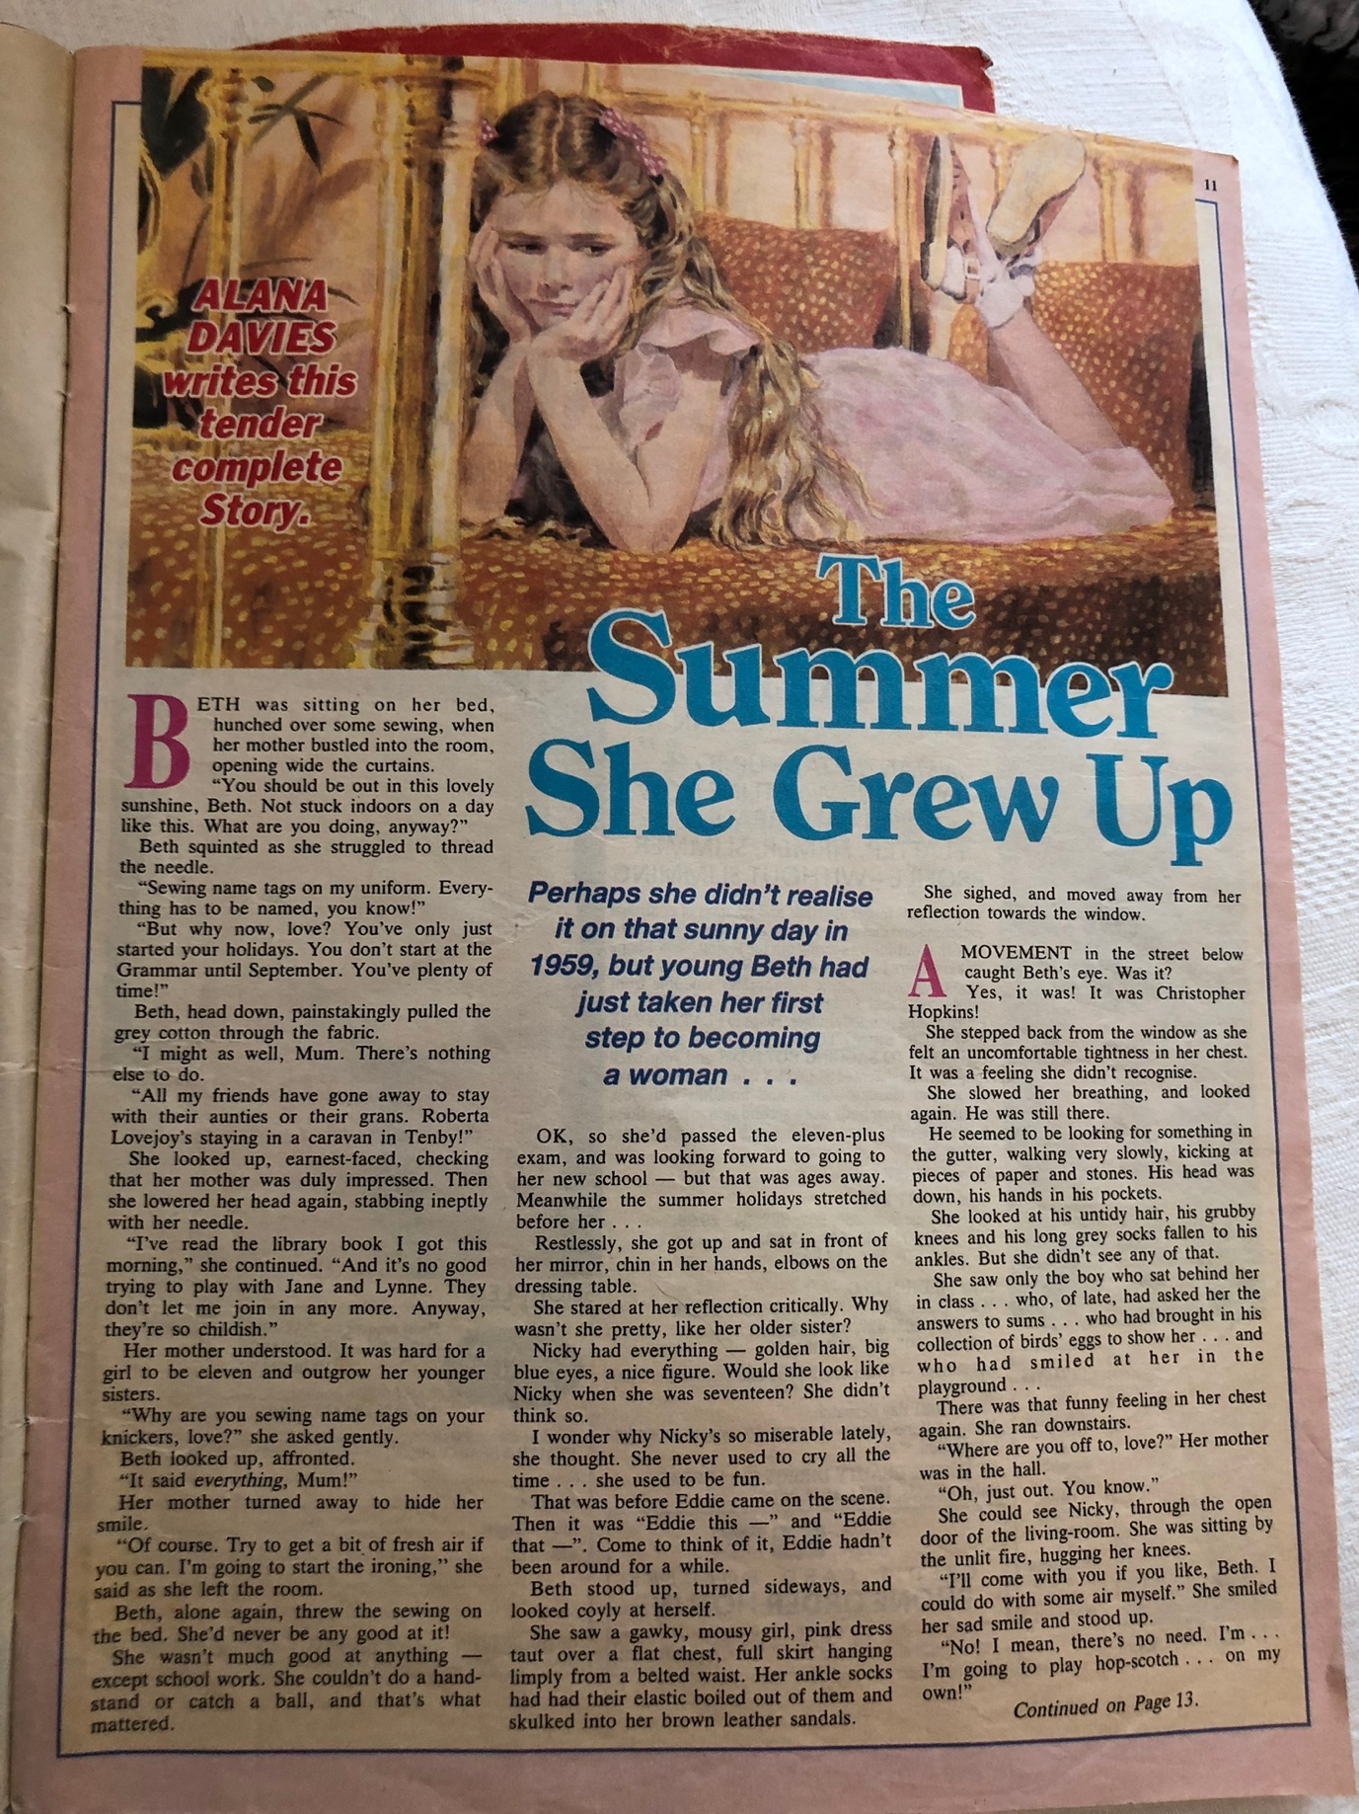 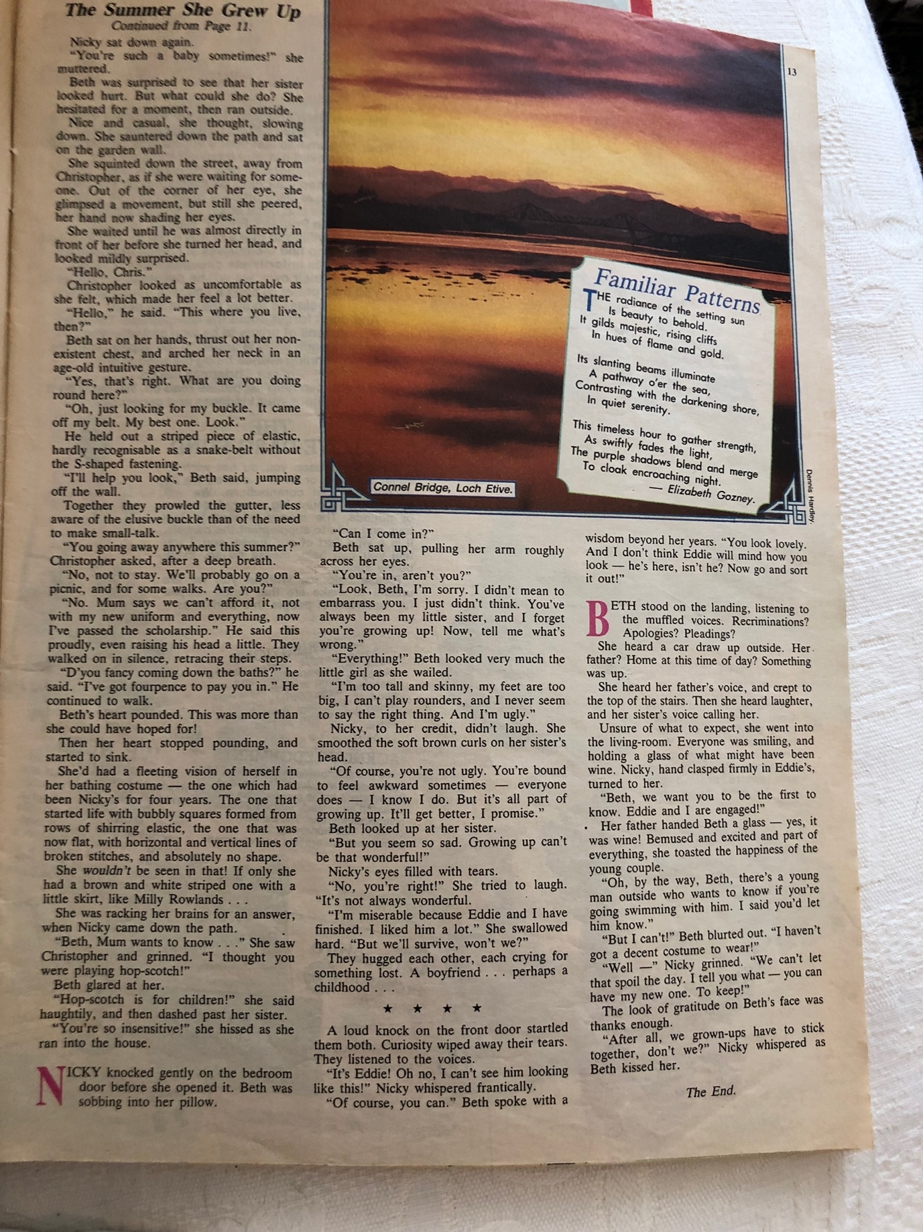 APPENDIX 3: EXTRACT FROM ‘MY LOVELY ARMS’ An extract from one of my family-orientated memoirs, published as ‘My Lovely Arms’ , in which I have described some such incidents of domestic abuse in my family. I have down-played the physical abuse involved because of my intended audience, mainly my grandchildren. Page 78: Many of her symptoms were being masked by her home life. She and my father barely spoke, unless it was to argue. He had become more and more difficult to live with – his long working hours were no doubt contributing to his often irrational and violent behaviour, but there was something else. He had been invalided out of Persia as he had contracted glandular malaria. He had also been diagnosed as a paranoid schizophrenic. I doubt whether that diagnosis would have been made so glibly today, but he certainly showed signs of paranoia. The diagnosis had been written in a letter for my father to give to his GP when he arrived home. I don’t think he ever did this, because that letter was the cause of many of the fierce and furious rows at home over the years. My mother wanted to keep it, as evidence against my father, presumably in a future divorce case, or maybe just to give her some leverage. But my father wanted it back. At one point my mother gave the letter to our next-door neighbour Nan Thomas for safekeeping, while my father ransacked the house. He tore up floor boards, and threw mattresses down the stairs. We were sleeping on them at the time. I’m not sure how many he threw, but he certainly threw mine. My mother pretended it was all quite funny, just a rather silly game, so we didn’t worry too much. She was very good at doing that. We never knew, as children, that she was afraid of thunderstorms, because she would say ‘Ooh, isn’t this exciting? We’re all cwtched up nice and cosy, while it’s raining and blowing outside’ and everything was all right. I’ve never been afraid of thunderstorms thanks to her. It turned out that she had an over-active thyroid, and suffered badly with what was then referred to as ‘nerves’. Because of the deteriorating relationship between them, my father played on all her fears. He knew she was afraid of heights, so when offering to take the family for a run in the car, he drove to the top of the Bwlch - a 1600ft mountain just north of Bridgend – and stopped the car. She was terrified. He knew she was afraid of fire, but he brought home a can of petrol and put it on the hearth next to the coal fire. But most of all she was afraid she was going mad and would have her children taken off her. He played on this. He had often told her she was stupid, but now he told her she was insane, not a fit mother. He would call the police in the middle of the night, saying that she was not fit to look after the children. Sergeant Evans from Pendre would call to the house, and just say ‘You all right, Mrs Jones?’ Police had no powers to interfere in domestic situations, even when they could see that things weren’t right. Sgt Evans could see what was going on but was helpless to stop it. He was very kind to my mother. APPENDIX 4: DA QUESTIONNAIRE Domestic Abuse Questionnaire/Interview I am writing a piece of fiction for my Masters degree in Creative Writing. It is set in the 1950s and 60s, and focuses on domestic abuse. I need to demonstrate that I have researched the subject, and while I have done some research re legislation at the time, and around incidence etc, primary research based on first-hand experience is very powerful. Domestic abuse could take one or more of the following forms: - Physical - Psychological - Emotional - Controlling - Other … Thank you for agreeing to share some of your experiences of abuse – not an easy subject to discuss. All your answers will be anonymous. I may need to mention some of my questions, but not your answers. But hopefully I will be able to include some of your experiences in my piece of writing. Your answers can be of any length, and could be a single word. Yes or No would be fine. As would ‘No Response’ or ‘Not Applicable’. If you would prefer to do this as a face-to-face interview I’ll be happy to do that. Otherwise you can give written responses, simply numbered as the questions are. You don’t have to answer every question. My questions are overleaf. Questions - Do you feel that you have ever been subjected to domestic abuse? If your answer is NO, perhaps you would like to read through the following questions and consider if anything sounds familiar to you. - What form/s did the abuse take? - At what stage in your relationship did the abuse start? - Did you recognise your partner’s behaviour as abuse from the start, or did it take a while to register? - Looking back to before your relationship became serious, were there any signs that may have alerted you to possible future problems? - Did you feel you were to blame in any way? That the abuse was deserved? - Where there any particular triggers that seemed to initiate an episode of abuse? - Did you and your partner ‘make up’ after an episode of abuse? - Did your partner apologise afterwards? - Did you apologise? - Did he/she promise not to repeat it? - Did he/she say that their behaviour was your fault? - Did you ever seek, and/or receive, medical treatment for any abuse you received? - Did he/she ever prevent you from keeping in contact with your family and/or friends? - Did you consider leaving? If you didn’t leave immediately, why not? - Did you feel you had somewhere to go if you left? - Did you contact any support organisations? - Did you tell your family/friends what was happening? - Did you have children living with you at the time the abuse was taking place? - If you answered YES to the last question, in what ways do you think/know they were affected by the abuse you suffered? - If you left, was there a particular incident that made you do that? - Is there anything at all you would like to add? APPENDIX 5: CASE STUDIES DA https://www.theguardian.com/lifeandstyle/2014/apr/28/domestic-violence-first- womens-refuge-saved-my-life (footnote 8) In 1973, Jenny Smith became one of the first abused women to find sanctuary at a refuge. Forty-one years later, she says women are suffering more than ever Jenny Smith will never forget the phone call that saved her life. It was her second attempt after finding herself incapable of speech the first time. Trying again a few days later, she managed a few gasped words: "I'm a battered wife, can you help me?" After being ignored by a doctor and a psychiatrist and told to go home and make peace with her husband by a priest, this time a woman's calm, soft voice, said: "Can you make your way here? We are in Chiswick, 2 Belmont Terrace. Can you get here? Just try to get here." It was May 1973, there was no law against marital rape in the UK, lone women could not apply for a mortgage, and domestic violence was rarely mentioned. Smith had endured two years of violence from her mentally unstable husband, including vicious beatings, knifings, burns, bites and an attempted drowning. Within 48 hours of that call, with the help of a neighbour, she had left her home in Hackney, east London, and was standing outside an ordinary terraced house in west London – her seven- month-old daughter in one arm, her 23-month-old at her side. When the door swung open she was enveloped in a woman's embrace. "Come in, love," she said. "You're safe now." As she stepped over the threshold, Smith unwittingly became a small part of feminist history: one of the first women to be given sanctuary in the world's first women's refuge. https://theconversation.com/you-couldnt-leave-your-husband-it-wasnt-done-the-story-of-the- women-behind-the-first-domestic-violence-refuges-160895 I did leave a few times with the children. I got us all out. But it was so frowned on ... You couldn’t leave your husband. It wasn’t done. I would have been horribly ashamed if anyone found out. And if I left, how would I support them? And there was never anywhere to go to ... I didn’t have the money for a rented flat – I didn’t have any money at all of my own ... just what I sneaked from the housekeeping he gave me, without him noticing. What could I do? After a few hours – or once we spent a night in a cheap hotel – we always went back. These are the words of Edna*, who was speaking to me with great sadness in 1994 about her experiences of trying to leave home because of long-term and extreme domestic violence in the 1950s and 1960s. The interview was carried out towards the very end of Edna’s life, when she was aged about 80. She died shortly afterwards. Another woman, Narina, who now has a successful career working with survivors of sexual violence, was able to transform her life, thanks to her time in a refuge as a young child, 30 years ago. She told me: When my family and I first got help, what I felt as a child was that I met this kind lady who I sensed in my gut was safe. I was about nine or ten years old, and the kind lady was at the women’s refuge that my mother had taken me to. I knew the moment we stepped in the door that we were safe, no more walking on eggshells, no more shouting, screaming, banging, bruises, lies, then sorry, and the cycle starting again. That’s what the refuge meant to young me: safety and escape. Timeline - legislation https://www.centreforwomensjustice.org.uk/timeline Police attitudes https://womensaid.scot/just-a-domestic-or-treacherous-double-bind-police-and-social-work- responses-to-domestic-abuse-in-late-twentieth-century-scotland/ https://hansard.parliament.uk/lords/2021-01-05/debates/ 1384371F-73F4-40BC-A44A-B0358CF839B6/DomesticAbuseBill Domestic Abuse Bill Volume 809: debated on Tuesday 5 January 2021 Baroness Williams of Trafford: ‘Some pay the ultimate price: on average, two people are killed each week at the hands of their current or former partner. It is only fitting that I pay tribute to Claire Throssell, who received an MBE in the New Year’s honours list for her tireless work campaigning for children experiencing domestic abuse. She lost her own two sons, Jack and Paul, who were killed by her ex-partner. Case studies: Erin Pizzey The hammering continued, and I opened it to find Kathy’s husband standing on the doorstep. I stood there looking at him and realized I was not afraid. That was the moment I discovered that I was afraid of no male apart from my father – whom I hadn’t seen in years. I could face this man quite calmly. ‘How did you know she was here?’ I asked. ‘She rang me.’ ‘Well, you’re not coming in. You beat her very badly – I’ve seen the bruises! Go home, and I’ll talk to you tomorrow.’ He was crying and shaking. ‘I can’t be without my Kathy,’ he sobbed. I felt the rage rising in my chest. ‘You’ll have to manage,’ I said curtly and shut the door in his face. Watching his behaviour reminded me of the times as a child I had seen my father crying and unsteady after a particularly ugly session of bullying and screaming at my mother. It roused feelings of disgust rather than sympathy in me. As I walked back into the sitting-room I mused over the fact that Kathy indeed must have phoned the man she claimed had beaten her so badly that she was afraid for her life. As a child I had been incredulous that my mother never made any serious attempt to leave my father. Often, during the seventeen years of Pizzey, Erin. This Way to the Revolution (pp. 69-70). Peter Owen Publishers. Kindle Edition. Now here was Kathy summoning her husband when for once she was safe and he had no way of knowing her whereabouts. I was confused, but I grasped that she, like my mother, was not simply a victim fleeing her husband’s violence; somehow she was complicit in the relationship and unwilling to extricate herself from a dangerous situation. Pizzey, Erin. This Way to the Revolution (p. 70). Peter Owen Publishers. Kindle Edition. Very quickly, as word got round that there was a place that would take in women and children, the little house started to fill up. One of the first to arrive was Becky, pregnant and with a small child. When she turned up she was calm and composed, unlike many of the women who came for our help who seemed bewildered and unable to cope with the hand they had been dealt. She told us that her partner was a drunken brute and she no longer wanted to live with him. He had beaten her so badly that he had detached a retina and left her partially blind. Pizzey, Erin. This Way to the Revolution (p. 73). Peter Owen Publishers. Kindle Edition. She married the first man who came into her life when she was sixteen to escape her mother; also because he was much older and reminded her of her father. José was a self-employed builder. She soon discovered that he was as physically abusive as the mother she had left behind. Pizzey, Erin. This Way to the Revolution (pp. 74-75). Peter Owen Publishers. Kindle Edition.

