BMSW5102
Developing Relationships and Workplace Achievement

Student Name: IONUT DINU
Student ID:1812392
Lecturer name:ZE ZOOK

Contents
Introduction 3
Determine appropriate knowledge, skill, and behavior that are required by HR professionals across the department. Please refer to Appendix A for an overview of HR Office responsibilities. 4
Conduct a personal skills audit for yourself (with the use of appendix B) and identify training and development needs considering the knowledge, skills, and behaviors you identified in the task (1) 6
Personal Skill Audit 6
Critically assess the potential benefits to the organization of developing you as an HR officer through effective training and development. 9
Conclusion 11
References 12

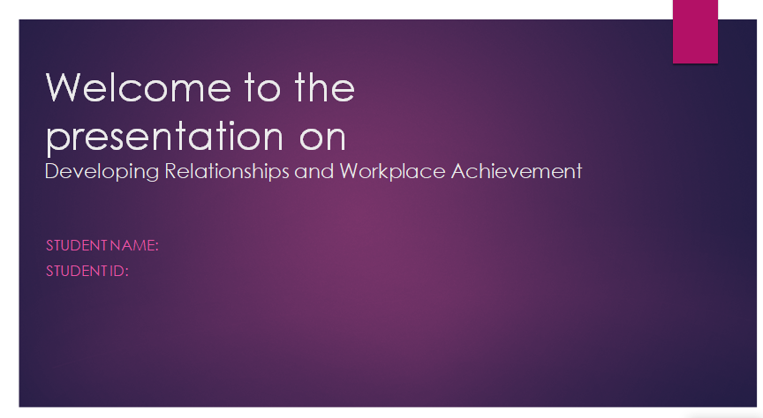

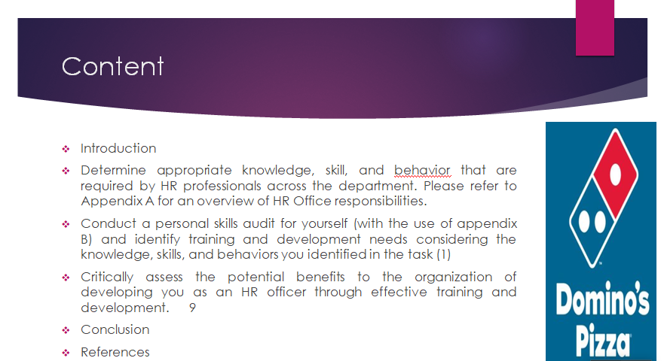

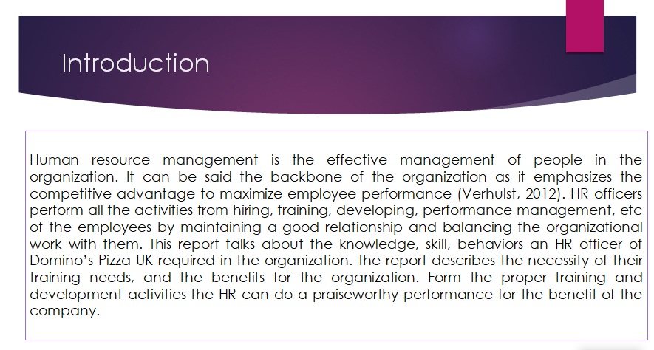

Introduction
Human resource management is the effective management of people in the organization. It can be said the backbone of the organization as it emphasizes the competitive advantage to maximize employee performance (Verhulst, 2012). HR officers perform all the activities from hiring, training, developing, performance management, etc of the employees by maintaining a good relationship and balancing the organizational work with them. This report talks about the knowledge, skill, behaviors an HR officer of Domino’s Pizza UK required in the organization. The report describes the necessity of their training needs, and the benefits for the organization. Form the proper training and development activities the HR can do a praiseworthy performance for the benefit of the company.

Determine appropriate knowledge, skill, and behaviour that are required by HR professionals across the department. Please refer to Appendix A for an overview of HR Office responsibilities.
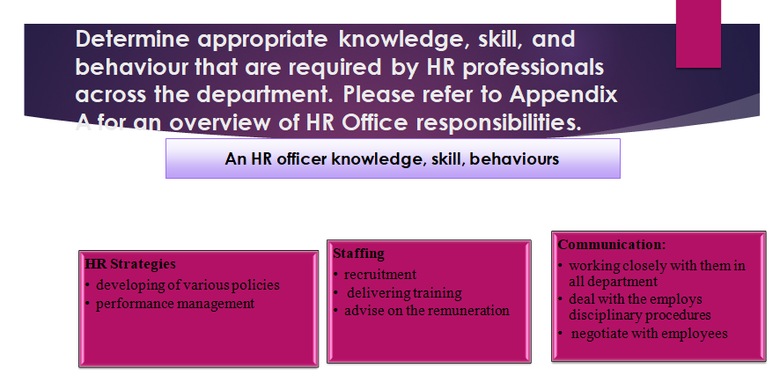
HR manager of Domino’s Pizza UK performs a wide variety of tasks in an organization to enlarge the business of the company. To perform those tasks HR manager is required to have various skills, knowledge, and behaviours with everyone those are given below-
HR Strategies: As an HR officer of Domino’s Pizza UK, the strategies will be for long term like- staff requirements from Appendix A. HR strategies involve developing various policies for the workplace and the performance management of employees (Armstrong, 2015).
Staffing: As an HR officer, the main activity stays with recruitment, delivering training, advise on the remuneration, staff handbooks from Appendix A, how much an employee can do their work effectively HR selected those persons.
Communication: As an HR officer, communication with employees involves working closely with them in all departments. For example, HR department of Domino’s Pizza UK deals with the employee's disciplinary procedures, and negotiates with them from Appendix A. HR is required to do those jobs.

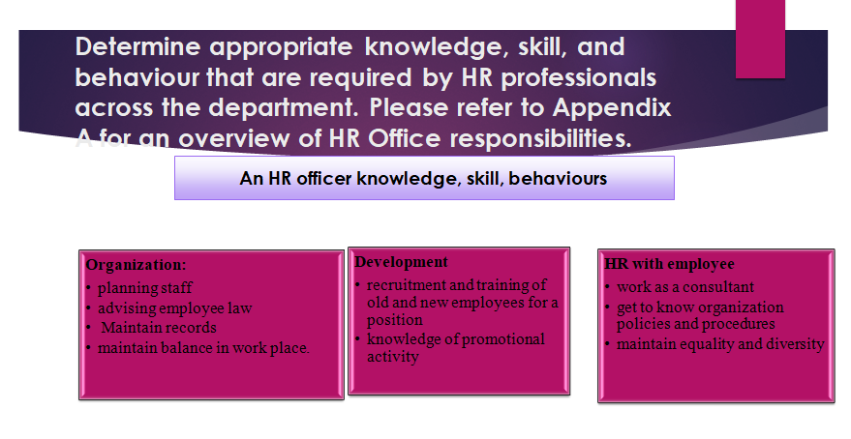
Organization: As an HR officer Domino’s Pizza UK, all the organizational works like- planning staff, advising employee law. An HR officer should have that behaviour like maintain records, maintain from balance with staff from recruiting to all the situations in the workplace of an employee from Appendix A,.
Development: As an HR officer, it is to recruit employees and train them with proper planning, and to realize the need for training for old or new employees from Appendix A, an HR should have those behaviours for the company (Mahapatro, 2010).
HR with the employee: As an HR officer of Domino’s Pizza UK, working as a consultant with an employee to make him realize about the company policies, with that their performance and health and safety must be taken care by HR by ensuring equality and diversity in the organization from Appendix A, an HR should have this knowledge in the workplace.
So, being an HR officer of an organization those knowledge, skill, and behaviours are required for the business to enhance their performance and achieve the company's aim.

Conduct a personal skills audit for yourself (with the use of appendix B) and identify training and development needs considering the knowledge, skills, and behaviors you identified in the task (1)
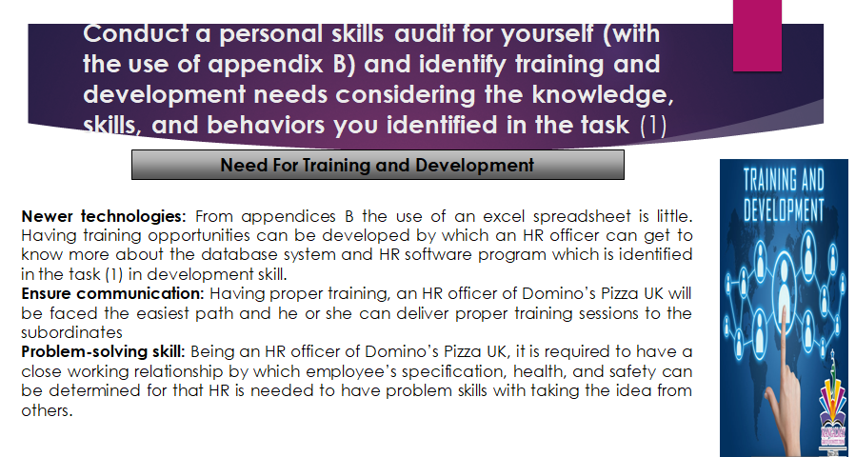Being an HR officer of Domino’s Pizza UK, proper training and development need is required to develop knowledge, skill, and behaviors. From the personal skill audit, some training is required in some sectors which can enrich the business performances. The need for training and development is given below-
Newer technologies: From appendices B the use of an excel spreadsheet is little. Having training opportunities can be developed by which an HR officer can get to know more about the database system and HR software program which is identified in the task (1) in development skill.
Ensure communication: Having proper training, an HR officer of Domino’s Pizza UK will be faced the easiest path and he or she can deliver proper training sessions to the subordinates. If any disputes occur on how to resolve it with that proper interviewing question while recruiting from Appendix B, an HR officer’s main job is to staff related which has been identified in the task (1) in communication skill (Milkovich, 2017).
Problem-solving skill: Being an HR officer of Domino’s Pizza UK, it is required to have a close working relationship by which employee’s specification, health, and safety can be determined for that HR is needed to have problem skills with taking the idea from others. It will ensure a friendly environment in the working sector which is identified in the task (1) in HR officer and employee relation. With training, more ideas can be developed which will provide more than one solution to every problem from Appendix B.
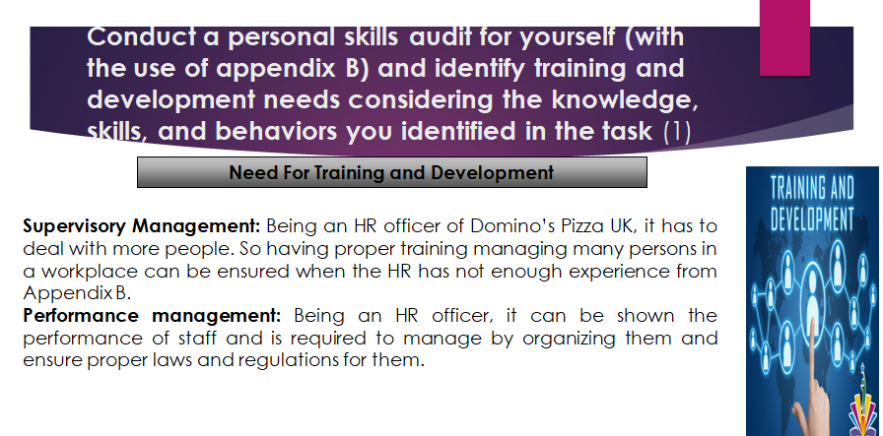
Supervisory Management: Being an HR officer of Domino’s Pizza UK, it has to deal with more people. So having proper training managing many persons in a workplace can be ensured when the HR has not enough experience from Appendix B. By supervising staff, the company can get more idea and proper workplace satisfaction which has been identified in the task (1) as staffing skill of an HR (Martocchio, 2016).
Performance management: Being an HR officer, it can be shown the performance of staff and is required to manage by organizing them and ensure proper laws and regulations for them. Workplace balance can be ensured if the HR officer has proper training with the staff which has been identified in a task (1) in HR strategies.
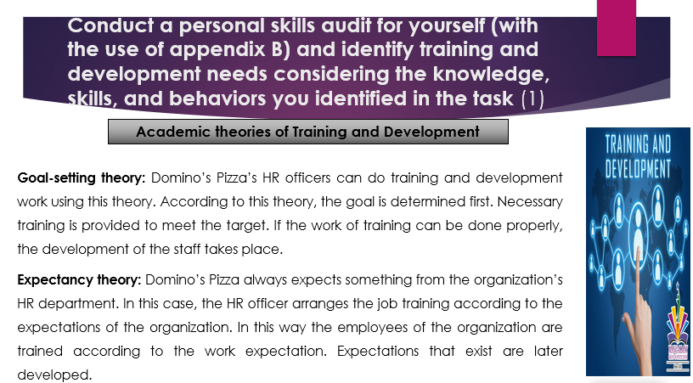
Goal-setting theory: Domino’s Pizza’s HR officers can do training and development work using this theory. According to this theory, the goal is determined first (Jain, 2019). Necessary training is provided to meet the target. If the work of training can be done properly, the development of the staff takes place.
Expectancy theory: Domino’s Pizza always expects something from the organization’s HR department. In this case, the HR officer arranges the job training according to the expectations of the organization (Noe, 2013). In this way the employees of the organization are trained according to the work expectation. Expectations that exist are later developed.

Critically assess the potential benefits to the organization of developing you as an HR officer through effective training and development.
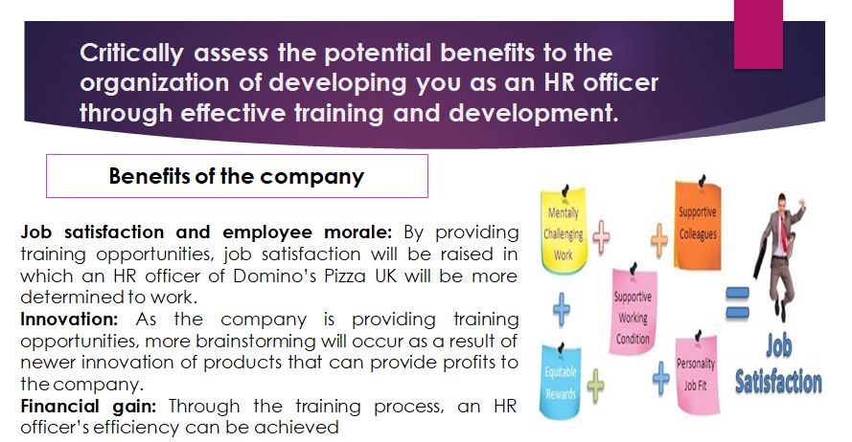
Being an HR officer for an organization, the company can get benefit by giving them effective training and development and by which the company can enhance its profits with various effective planning of HR managers.
Job satisfaction and employee morale: By providing training opportunities, job satisfaction will be raised in which an HR officer of Domino’s Pizza UK will be more determined to work as the company is emphasizing on developing proper relationships with employees (Rue, 2014). So, the determination towards work will rise.
Innovation: As the company is providing training opportunities, more brainstorming will occur as a result of newer innovation of products that can provide profits to the company.
Financial gain: Through the training process, an HR officer’s efficiency can be achieved. It will result in making proper financial decisions about whether to take the opportunity for the company or not. For example, Domino’s Pizza’s HR officer is required to hire staff, develop them so financial gain can be possible by recruiting proper employees for a position.

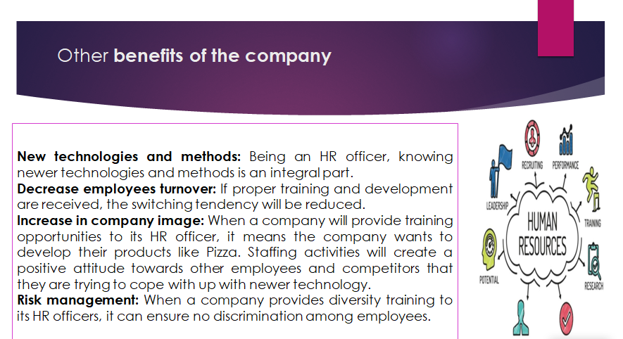
New technologies and methods: Being an HR officer, knowing newer technologies and methods is an integral part. Having trained in this newer technology, the HR manager can improve his work opportunities and earn much profit for the company by using those technologies.
Decrease employees turnover: If proper training and development are received, the switching tendency will be reduced at by which the Domino’s Pizza UK can get good officers by having a friendly environment with development activities for the officers (Valentine, 2018).
Increase in company image: When a company will provide training opportunities to its HR officer, it means the company wants to develop their products like Pizza. Staffing activities will create a positive attitude towards other employees and competitors that they are trying to cope with up with newer technology.
Risk management: When a company provides diversity training to its HR officers, it can ensure no discrimination among employees. As an HR officer, it is related to mainly staffing if they discriminate in employees or gender then the company cannot be profitable. A negative attitude will rise from everyone for the company.

Conclusion
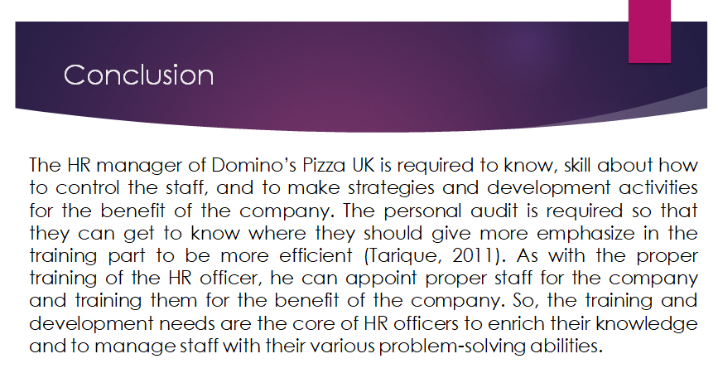The HR manager of Domino’s Pizza UK is required to know, skill about how to control the staff, and to make strategies and development activities for the benefit of the company. The personal audit is required so that they can get to know where they should give more emphasize in the training part to be more efficient (Tarique, 2011). As with the proper training of the HR officer, he can appoint proper staff for the company and training them for the benefit of the company. So, the training and development needs are the core of HR officers to enrich their knowledge and to manage staff with their various problem-solving abilities.

Appendix B

Personal Skill Audit
Name
Job role: Human Resource Officer
Please tick as appropriate to indicate how you would rate your skills with the following work / functional areas.
 | Very good | Good | Adequate | Little or no
Information Technology
Use Microsoft Office Word
Use an Excel spread sheet
Use a Database
Use specialist HR software
Use the internet
Use e-mail
Use PowerPoint

 | Very good | Good | Adequate | Little or no
Communication Skills
Drafting contracts of employment
Taking notes of disciplinary
Write reports
Produce material to support
Delivering a training session
Resolving disputes/complaint
Interviewing
Advising on HR issues
 | Very good | Good | Adequate | Little or no
Problem-solving skills
Make good use of verbal reasoning skills, able to handle complex data and make selective use of information
Explore more than one solution to solve a problem
Consider the ideas of others to help solve problems

Supervisory Management
How much experience have you had in your role? |  |  | < 1 month | 1-3 months | > 3 months
How many people have you managed at any one time? |  |  | None | 1-5 | Above 5

I declare that the information given in this form is true
Signed
Date

References
Armstrong, M., and Taylor, S.,2015. Armstrong's Handbook Of Human Resource Management Practice.
Ivancevich, J., and Konopaske, R., 2013. Human Resource Management. New York: McGraw-Hill.
Mahapatro, B., 2010. Human Resource Management. New Delhi: New Age International Ltd.
Martocchio, J., 2016. Strategic Compensation.
Milkovich, G., 2017. Human Resource Management. Chicago: Irwin.
Rue, L., Ibrahim, N. and Byars, L., 2014 Human Resource Management.
Sparrow, P., Brewster, C., and Chŏng, C., 2012. Globalizing Human Resource Management.
Tarique, I., Briscoe, D., and Schuler, R., 2011. International Human Resource Management.
Valentine, S., Mathis, R., Jackson, J., and Meglich, P., 2018. Human Resource Management.
Verhulst, S. and DeCenzo, D., 2012. Fundamentals Of Human Resource Management.
Jain, S., 2019. Key Trends In Corporate Training & Development. Ashland: Society Publishing.
Noe, R., 2013. Employee Training And Development. New York: McGraw-Hill/Irwin.

