Customer Relationship Management Emerging Themes

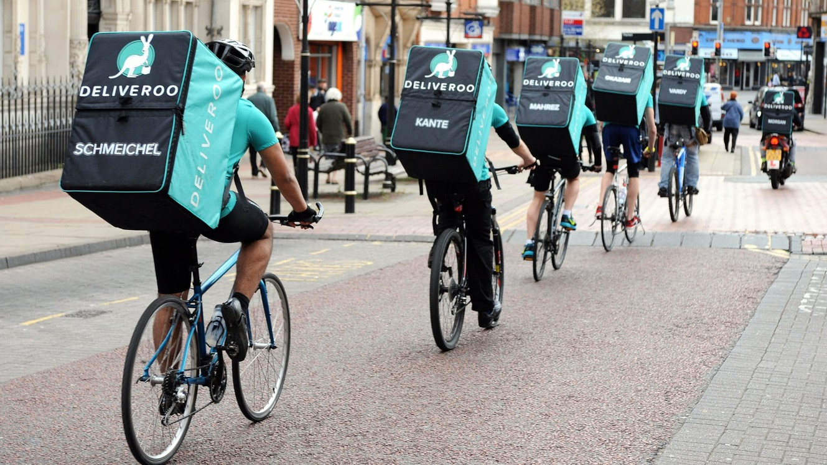

Student name: Julia Mansell
Student number: 2110746
Module: Understanding and Engaging in the Customer Experience (BMSW 5103)
Lecturer: Buddhi Pathak
Date: 03/11/2022



Executive Summary

Deliveroo is a successful start-up tech company which launched various campaigns and activities on social media. Their digital marketing extends in order to link with the customers and therefore build brand awareness, connect it and maintain it.
Some of the interactive activities on social media are still limited as there is no link to the website or app attached and this is therefore impacting the direct customer journey from social media to Deliveroo’s main touch points website and app.
Social media for Deliveroo is an advertising tool with a lack of responses or slow responses to customers in comment sections, unlike their website with the Deliveroo Help section where a customer can have a direct dialogue so important for the post-purchase stage. Consumers see value in seeking out others’ opinions on specific products.
In addition to that their use of photos is good, providing aesthetic value and this may increase appeal for consumers.
(Hanienduong, 2020).
To summarise, their touchpoints are social media mostly in the pre-purchase stage, website and app in the purchase stage, and email and phone in the post-purchase stage.
Customer experience is being maintained as the website and app are constantly developing to meet the needs and expectations of consumers and secure leadership on the market.
From a customer relationship management point of view, Deliveroo’s company structure, and values are clear and well-established, contributing to a positive customer journey. Their culture and strategy are still evolving as the company grows. Deliveroo offers skills development for their employees, however, the company needs to make improvements on employee benefits for their staff.

Table of Contents
Title Page………………………………………………………………………………………….……………………………..1

Executive summary………………………………………………………………………………………………………….2

Table of content……………………………………………………………………………………………………………...3

Introduction 4

Customer touchpoints 5

Customer and brand experience……………………………………………………………………………………6-8

Customer relationship management (CRM)…………………………………………………………………9-10

Conclusions and Recommendations 10

Critical literature review on the customer experience………………………………………………11-12

References 13-14

Introduction

- My business report will examine the customer experience of the successful start-up UK Tech company Deliveroo.
Deliveroo was founded by its CEO, Will Shu. When he moved to London in 2013, he noticed the city is full of good restaurants, but not many offered delivery services. His personal mission became to bring the best food from restaurants directly to customers’ doors.
Today, Deliveroo operates in 11 markets worldwide, working with thousands of restaurants, supermarkets, and riders serving millions of customers.
This company is offering reliable and fast delivery and customers can track it online. The intelligent technology enables completing thousands of orders at the same time and allows continuous improvement of the nuances for delivering in different areas. It has also opened opportunities for business to grow their business through delivery. Since 2013, Deliveroo now works with 160 000 restaurants and food stores (deliveroo.co.uk, 2022).

This report aims to look at the customer touch points as well as customer and brand experience.

I will then further identify and critically discuss Deliveroo’s impact on customer relationship management. My findings will be highlighted, and recommendations will be given for the customer touch points and experience.

- Critical literature review on the customer experience of Deliveroo.
I will critically discuss the two most important perspectives: the co-creation and the firm perspective of Deliveroo. I will use examples of each of the perspectives and draw a conclusion on how they can help in the shaping of customer experience.

Customer touchpoints
In this section, we will focus on the customer touchpoints of Deliveroo. So, what is the definition of the customer touchpoint?
Touch points are the individual contacts between the company and the customer at distinct points (Homburg et al. 2015; Schmitt 2003).
To put it simply, it is a journey of a customer interacting with your brand. There are different ways how a consumer interacts. It could be through the website, an employee, a store, an advert, or an app. Needless to mention, their experience with the brand will shape how they view the company; therefore, it is an opportunity for the business to shine and impress the customer. The brand needs to achieve client satisfaction so the potential consumer can become a loyal consumer.
To ensure that the customer stays loyal to our brand, their journey or touchpoint map must include customer support and evaluation or feedback (Zendesk UK, 2022). As an example, Deliveroo may have a nice, easy-to-use app, but if the customer has an issue with the restaurant and we do not offer customer support or feedback, that would more likely lead to the loss of a customer if there is nobody who can help
Now l will look further at Deliveroo’s touchpoints and the journey of the customer. The process model for the customer journey and customer experiences developed by Lemon & Verhoef, 2016, has been applied. According to this model, a general model goes through 3 stages:
- pre-purchase, purchase and post-purchase.
Pre-purchased touchpoints of Deliveroo are:
- content created by this brand through social media, such as Facebook, Instagram, YouTube or Twitter as well as advertising via TV or radio. For example, they choose high-quality images of delicious food to charm potential consumers and convince them to purchase.
- Content created by the user, often called word of mouth
Purchase touchpoints:
- their platform, whether we use an app or website to use their service
Post-purchase touchpoints:
- customer support via phone, e-mail or Twitter

(Hanienduong, 2020).

Customer and brand experience
Both customer and brand experience focus on the customer. Please see below what differs between customer and brand experience.
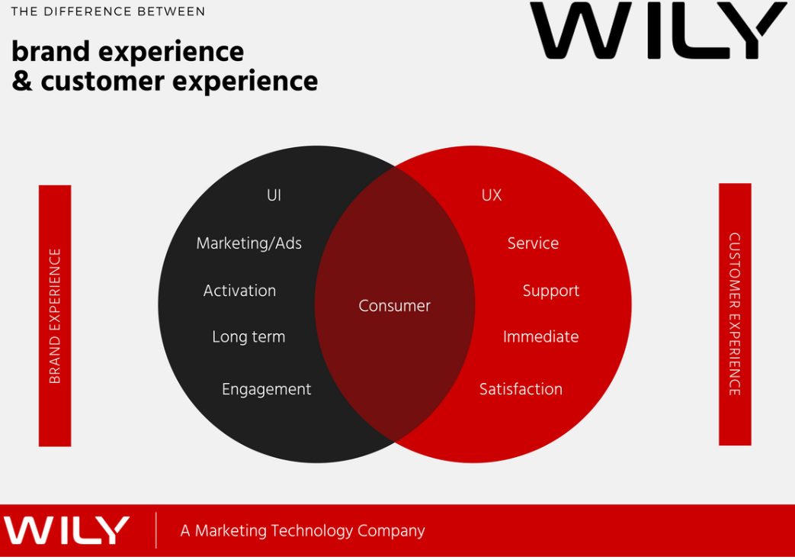
Fig.1: Source: https://www.wilyglobal.com/the-difference-between-brand-experience-and-customer-experience-part-2/
Brand experience is therefore related to design, leaving customers feeling a certain way about the brand. This can often make or break the brand’s perception. This tool is here to create new opportunities for the business and promote it in the best possible way. (Business, 2018).
Deliveroo’s social media advertisement can “wow” the customer with its attractive offerings of restaurants containing images of food, and therefore “make” the brand experience, as well as their participation in events, however, current reviews on their service found on trustpilot.com or Reviews.io can easily harm the brand’s experience.
Customer experience has many different variations and definitions. I define customer experience as customers’ journey to interact with the company’s touchpoints.
Customer experience can be viewed from:
- Firm’s perspective
The company takes responsibility for designing and crafting customer experience, but the willingness of customers to receive these offerings depends on the value propositions of the offerings (Berry et al, 2002; Stuart and Tax 2004).
From Deliveroo’s perspective, their website and app are unique, as compared to other competitors, the website is also built for their riders, restaurants and businesses.
- The customer’s perspective (Schmitt 2011)/ The co-creation perspective (Chandler and Lusch, 2015):
In this case, the customer experience is recognised as the role in the co-construction of the experience, while their interaction depends on value propositions.
Below is an example of the consumer’s experience and their perspective on Deliveroo’s website.
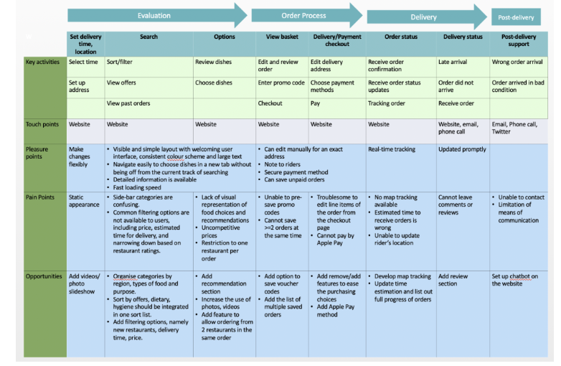
Fig.2: Source: https://hanienduong.wordpress.com/2020/06/22/a-critique-of-deliveroos-online-customer-journey-and-customer-experience/.
As we can see in Fig.2. the customer experience is as follows:
Touchpoints:
As mentioned previously website along with email, phone calls and Twitter.
Pleasure points:
We can evaluate that its layout is simple and welcoming with detailed information and it is loading fast. The order process can be edited manually for the exact location of the address, and the note to riders can be written. Unpaid orders can be saved, and the payment method is secure. The tracking is updating in real-time and so is the delivery status.
I have used the Deliveroo website, and I would like to contribute with additional pleasure points, as when I registered, I received free delivery for orders over £25and a 12-month subscription to Deliveroo Plus as an Amazon Prime customer.
Pain points:
Filtering options by price, rating and delivery time are not available. This was relevant in June 2020; however, I visited the website today and can confirm that I could filter from the following options: Distance, Hygiene ratings, quickest delivery, recommended and top-rated and so the only option unable to filter by is the price.
Other pain points can be uncompetitive prices and restrictions to one restaurant per order up to this day. I was still unable to save promo codes and orders. Regarding editing items on the checkout page, I was able to add or remove the item I ordered, however, still unable to pay by Apple Pay. Map tracking was not available in 2020, now I can confirm it is available. The estimated time can be wrong, but I noticed that this is happening for other competitors as well, such as Just Eat or Uber Eats. The website/app is also still sometimes struggling to update riders’ locations, you can leave a review once you made an order, but I found that a big negative point is that you can not read reviews, just see the ratings.
I will discuss opportunities in my conclusion.

Customer relationship management (CRM)

Customer relationship management is a ‘top-down’ view, in which CRM is contemplated to be a customer-centric business strategy focused on winning and keeping profitable customers (Ellis,2011). CRM is about the management of customer details and the management of touchpoints to achieve customer satisfaction.
In order to grow the company, it is vital to be improving relationships with the customers.
According to McKinsey’s Seven S Framework developed by Tom Peters and Robert Waterman (Waterman et al., 1980), we need to look at:
Strategy: What is the plan of senior management to maintain and build a competitive advantage? For example, Deliveroo has a modern, charming and fast-loading app and Website, but they need to offer more competitive pricing in order to grow their business and satisfy customers
Structure: What is the structure of Deliveroo and how are the responsibilities allocated? The structure is clear with the allocated Chief Officer for a particular department, General Counsel, Chief Advisor to CEO and Founder & CEO (Deliveroo plc (LSE: ROO), 2002).
Shared values: Core values of the company.
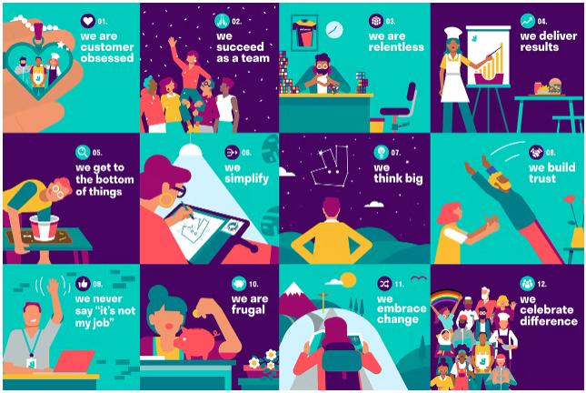
Fig. 3: Source: https://deliveroo.co.uk/about-us/
Values are guiding them on how to work together and make decisions, from recruitment to developing people, teams or products (deliveroo.co.uk, 2022).
Style: Culture and management style of Deliveroo had to be adjusted as the company has grown rapidly, internal decision-making takes more time and trust with new customers and employees needs to be built (Nast,2022).
Skills: Company’s competencies of employees and corporate strengths. Deliveroo has launched Deliveroo Academy, offering their riders free online courses focused on skills development. Riders can choose between 300 courses, such as learning of new language or web design (Restaurant Dive, 2022).
Staff: Human Resources and policies for Deliveroo are often hot topics for the media. The staff is often missing benefits, such as sick pay or paid holiday, as collaborators struggle to be considered as workers (Martinez, 2019).

Conclusions and Recommendations
From the pre-purchase and purchase points of view, the company touchpoints (social media, website and app) are set to a high standard and overall good customer satisfaction.
Based on the analysis, they need a stronger web presence to grow the business further in the pre-purchase stage (Hanienduong, 2020).
In the purchase stage, filters have been added to ease the order process, however, if Deliveroo group further their customers into segments depending on their needs and benefits, it will solve its consumption problem (Goyat, 2011). According to Fig.3, the option to filter by price and dietary needs is still unavailable and needs to be developed. Apple Pay option to be offered is strongly advised along with the option to save orders and the ability to order from two restaurants in the same order. Map tracking is not always functioning, and further development is necessary.
The main pain point and area to improve is in the post-purchase stage. Deliveroo is offering customer support, however, when the customer tries to ring, the phone line is often left unanswered and customer issues are often not resolved to their satisfaction. Consumers’ reviews are alarming, with 1.3 stars out of 5. Some never received their order or refund, and others received only a partial refund. Customers are also complaining about food being cold when delivered and rude customer service (Trustpilot, 2022), therefore Deliveroo need to ensure that their staff is adhering to the company values.
The company also need to better itself in treating its staff better, by offering employee benefits and considering them as workers (Martinez, 2019).
I will now provide a critical discussion below.

Critical literature review on the customer experience

In this section, I will draw critical discussion on the major customer experience perspectives:
The firm’s perspective:
It is Deliveroo’s responsibility to craft and design customer experience, but the willingness of customers to receive these offerings depends on the value propositions of the offerings (Berry et al, 2002; Stuart and Tax 2004).
This means from Deliveroo’s firm perspective they are innovating customer experience by using touchpoints. Customers’ interest is therefore dependent on the value of what they offer on social media, website or app. Deliveroo deploys technology, such as Frank’s algorithm, to find the best solution for connecting restaurants and riders with consumers. Frank’s algorithm is being continuously innovated to measure the time spent preparing the meal in restaurants as well as delivery time in particular routes at different times. This gives a customer a good value proposition and makes service more efficient, but it does not end there. Deliveroo provides data insights to restaurants, so they know which kind of cuisine is popular in a particular area as well as delivery-only kitchen concept. This helps the restaurants to grow their business in new areas without the high upfront costs of high street premises. As a result, restaurants can grow faster, and customers have better food selections (deliveroo.co.uk, 2022). This concept came with criticism and the delivery-only kitchen concept has been named “dark kitchens” as this system is criticised for replacing hospitality with a supply chain and seeing food as a manufactured item. Many of these kitchens are operating in areas without planning permissions and there were several nuisance complaints clashed by Deliveroo, however, it can become a bigger problem as this sector grows (Watch,2021).
Companies are increasing investments in customer experience as they are expecting that this will provide better financial returns. Gartner’s (2019) global survey of a wide range of industries shows that 74% of firms are increasing their budgets for customer experience from 2020 onwards, being an area of the biggest investment for upcoming years (Cambra-Fierro et al., 2021).
Is Deliveroo one of these firms? According to Watch (2021), the company is making decent money from deliveries but suffers huge losses due to admin costs as well as software engineers running and maintaining the app as the company expands, therefore they are investing to keep growing their business and keep the customers interested. I will further critically discuss their interests in the co-creation experience.

The customer’s perspective (Schmitt 2011) often refers to the co-creation perspective (Chandler and Lusch, 2015):
Potential customers of Deliveroo are playing a key role in the co-construction of the experience, while their interaction depends on Deliveroo’s value propositions.
Co-creation is understood to be the practice of developing systems, services or products by collaborating with customers, but it could be also the other company stakeholder or employees (Ramaswamy & Gouillart, 2010).
Deliveroo claims that they spent years working to understand what their customers want and appeal to each culture and consumer, whether it is a family, professional or student. They are working on the best selection and availability to bring to offer value and decent experience.
When it comes to their employees, they offer flexible working to meet the individual needs of employees, good income or security. They are amongst the first food delivery platforms providing third-party liability and personal accident insurance for free.
Deliveroo is co-creating the customer experience with restaurants and grocery shops from which 90% have never previously offered delivery services (deliveroo.co.uk, 2022).
Although the customer’s perspective may look often different to what they claim. I took some time to read about customer experiences with Deliveroo, and I was unpleasantly surprised by some reactions. The tools designed to help the customer, such as e-mail and helpline are often hard to reach and many customers are claiming that their food was not delivered, refunded or cold and the customer service advisor was rude (Trustpilot, 2022). This can become an obstacle when trying to maintain loyal customers as the focus of customers’ perception of value from co-created service is driven by its benefits (Pathak, Ashok and Leng Tan, 2021).
Another problem is the relationship between the firm and its staff, particularly riders. Strikes across the UK and court cases against employment practices are widely known and medialised. IWGB union is focusing currently on grievances over low pay, employment status or unfair dismissals (Watch,2021).
Therefore, in order to improve customer co-creation perspective, Deliveroo should invest in their employees and provide them with better pay and benefits, such as paid annual leave and sick pay. This could improve customer service and customer experience which is currently alarming. They should be less focused on expanding and try to resolve the existing problems, before continuing to grow. This will ensure that they will stay on top of things and avoid further criticism and poor customer reviews.

References
Berry, L. Carbone, P. and Haeckel, S. H. (2002), “Managing the Total Customer Experience,”
MIT Sloan Management Review, 43 (3), 85–89.
Business (2018). The Difference Between Brand Experience and Customer Experience (Part 2). [online] WILY | Marketing Technology. Available at: https://www.wilyglobal.com/the-difference-between-brand-experience-and-customer-experience-part-2/.
Cambra-Fierro, J., Gao, L. (Xuehui), Melero-Polo, I. and Trifu, A. (2021). How do firms handle variability in customer experience? A dynamic approach to better understanding customer retention. Journal of Retailing and Consumer Services, 61, p.102578. doi:10.1016/j.jretconser.2021.102578.
Chandler, J.D. and Lusch, R.F. (2014). Service Systems. Journal of Service Research, 18(1), pp.6–22. doi:10.1177/1094670514537709.
deliveroo.co.uk. (2022). Deliveroo. [online] Available at: https://deliveroo.co.uk/about-us/.
Deliveroo plc (LSE: ROO). (n.d.). Executive team. [online] Available at: https://corporate.deliveroo.co.uk/about-us/executive-team/.
Ellis, N. (2011). Business-to-Business Marketing: Relationships, Networks & Strategies,
Oxford University Press
Gartner. (n.d.). 2019 Customer Experience Management Study. [online] Available at: https://www.gartner.com/en/marketing/research/2019-customer-experience-management-study.
Goyat, S. (2011). The basis of market segmentation: a critical review of literature. [online] European Journal of Business and Management, pp.45–54. Available at: https://core.ac.uk/download/pdf/234624114.pdf.
Hanienduong. (2020). A Critique Of Deliveroo’s Online Customer Journey And Customer Experience. [online] Available at: https://hanienduong.wordpress.com/2020/06/22/a-critique-of-deliveroos-online-customer-journey-and-customer-experience/.
Homburg, C. Jozic, D. and Kuehnl, C. (2015), ´ “Customer Experience Management: Toward
Implementing an Evolving Marketing Concept,” Journal of the Academy of Marketing
Martínez, A.D. (2019). App Capitalism. NACLA Report on the Americas, 51(3), pp.236–241. doi:10.1080/10714839.2019.1650485.
Nast, C. (n.d.). How Will Shu turned Deliveroo into the firm Uber wants to eat. [online] Wired UK. Available at: https://www.wired.co.uk/article/deliveroo-will-shu-uber.
Pathak, B., Ashok, M. and Leng Tan, Y. (2021). Value co-creation in the B2B context: a conceptual framework and its implications. The Service Industries Journal, pp.1–28. doi:10.1080/02642069.2021.1989414.
‌

Ramaswamy, V., & Gouillart, F. (2010). The power of co-creation: Build it with them to boost growth, productivity, and profits. Free Press. [Google Scholar]
Restaurant Dive. (n.d.). Deliveroo offers free skills training to its drivers. [online] Available at: https://www.restaurantdive.com/news/deliveroo-offers-free-skills-training-to-its-drivers/554806/.
Science, (published electronically August 19), [DOI: 10.1007/s11747-015-0460-7].
Stuart, Ian F. and Stephen S. Tax (2004), “Toward an Integrative Approach to Designing
Service Experiences: Lessons Learned from the Theatre,” Journal of Operations
Management,22 (6), 609–27.
Schmitt, B. H. (2011), “Experience Marketing: Concepts, Frameworks and Consumer
Insights, “Foundations and Trends in Marketing, 5 (2), 55–112
Schmitt, B. H. (2003), Customer Experience Management: A Revolutionary Approach to
Connecting with Your Customers. New York: The Free Press.
Trustpilot. (n.d.). Deliveroo is rated ‘Bad’ with 1.3 / 5 on Trustpilot. [online] Available at: https://uk.trustpilot.com/review/www.deliveroo.co.uk.
Watch, C. (2021). Deliveroo: we profile the dodgy delivery firm set to cash in on the stock market. [online] Corporate Watch. Available at: https://corporatewatch.org/deliveroo-we-profile-the-dodgy-delivery-firm-set-to-cash-in-on-the-stock-market/ [Accessed 5 Nov. 2022].
‌ Waterman, R.H., Peters, T.J. and Phillips, J.R. (1980). Structure is not an organization. Business Horizons, 23(3), pp.14–26. doi:10.1016/0007-6813(80)90027-0.
Zendesk UK. (2022). Understanding customer touchpoints—and why they matter. [online]
Available at: https://www.zendesk.co.uk/blog/customer-touchpoints/

‌

‌

‌

