Coursework BMDS7004 – Data Analytics
Descriptive Statistics
 | N | Minimum | Maximum | Mean | Std. Deviation
high_bp | 94 | 15 | 25 | 19.41 | 2.649
resp_illness | 94 | 8 | 20 | 13.76 | 2.430
mental_illness | 94 | 4 | 14 | 9.62 | 2.338
diabetes | 94 | 3 | 10 | 5.94 | 1.343
health_status_poor_or_fair | 94 | 14 | 34 | 21.47 | 5.054
smoker | 94 | 14 | 36 | 25.37 | 4.207
bmi_overweight_or_obese | 94 | 48 | 63 | 55.81 | 3.952
Valid N (listwise) | 94

The descriptive statistics table shows a high standard deviation for all of the disease groups except Diabetes. This suggests that the incidence of Diabetes across Wales is fairly uniformly distributed as the lower standard deviation shows that the majority of the data points are clustered around the mean.
Conversely, the high standard deviation shown for Health Status Poor or Fair demonstrates great variance of the data from the mean which shows that Health Status varies widely across different areas of Wales. This is also true of Smoking and High BMI.
The Forest Plot shows more graphically how the incidence of Respiratory Disease varies across different areas of Wales as suggested by the fairly high standard deviation shown in the table. This makes it easier to identify areas with a higher or lower incidence of respiratory disease compared to the All Wales figure even within a particular geographical area.
For example, the USOAs from 3000085 to 300094 are all in Cardiff (Office for National Statistics, 2022) but the confidence limits for 3000092 and 3000094 are higher than and do not overlap the All Wales line suggesting that the incidence of respiratory disease in these areas is significantly higher than the All Wales figure and also than in the other areas of Cardiff. This visual way of displaying the variances in the data allows the identification of geographical areas in need of further investigation and possible health interventions
Other factors for analysis.
It would be interesting to investigate potential correlations between both historic and current industrial activity such as mining or manufacturing in an area and the incidence of respiratory disease.
Is mental illness more prevalent in areas that are in the more deprived deciles in the index of deprivation?
Is there a link between mental illness and the rural-urban classification of an area or even employment rates?

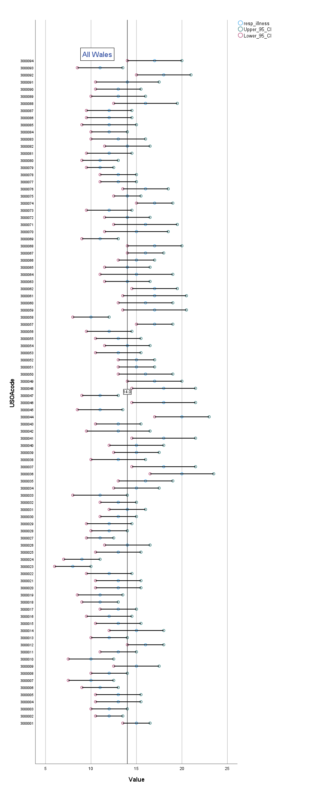
Dissertation Analysis Plan
Context and Scope
This project is an evaluation of pharmacy compliance to reporting information on service availability using a recently developed reporting tool that now provides live information on pharmacy services to the directory of services (DoS) used by NHS 111 Wales and the "Services Near You" page of the NHS 111 Wales website.
NHS 111 Wales is a free-to-call single non-emergency telephone number and digital service available across Wales 24 hours a day, seven days a week for urgent medical and health advice. It serves an estimated population of 3.2 million people (Office for National Statistics, 2023) and in the last 12 months, it has offered over 1 million calls and the website has received over 9 million hits with the DoS accounting for approximately 30% of the web traffic. (Stats Wales, 2023).
The system covers five pharmacy services provided by the Clinical Community Pharmacy Service (CCPS): Common Ailments Service (CAS), Emergency Contraception Service (ECS), Emergency Medicines Supply Service (EMSS), Seasonal Flu Vaccine Service (SFV), and Sore Throat Test and Treat (STTT) (Community Pharmacy Wales, 2022).
Usage data is not currently available for the SFV or STTT services but 342,374 patients accessed the other 3 services in the last financial year. (Stats Wales, 2023c)
The DoS is a pan-Wales system owned and managed by the Welsh Ambulance Services NHS Trust (WAST) and mainly hosts Urgent and Emergency Care information to support NHS 111 referrals and also access to primary care and community services. The system now uses an Application Programming Interface (API) to pull data from the All Wales Pharmacy Database (AWPD), which is held by NHS Wales Shared Services Partnership (NWSSP) (NHS Wales Shared Services Partnership, 2023), to provide geographical information, contact numbers, opening hours, and the list of services that each of the 712 pharmacies(Stats Wales, 2023b) in Wales is commissioned to provide.
However, the provision of the commissioned service depends on the presence of a qualified pharmacist who has completed the necessary training as outlined in the service specification (Mackridge, 2023b). Before this intervention, the DoS did not show the live service availability of the services listed above as it did not gather information on the capacity of the pharmacy to provide any of the services at a particular time.
The tool covers five pharmacy services provided by the Clinical Community Pharmacy Service (CCPS): Common Ailments Service (CAS), Emergency Contraception Service (ECS), Emergency Medicines Supply Service (EMSS), Seasonal Flu Vaccine Service (SFV), and Sore Throat Test and Treat (STTT) (Community Pharmacy Wales, 2022).
Usage data is not currently available for the SFV or STTT services but 342,374 patients accessed the other 3 services in the last financial year. (Stats Wales, 2023c)
At this time the reporting tool only collects availability data for the 5 services listed. It does not collect data on any of the other community pharmacy enhanced services commissioned across Wales; therefore, these are not part of this project's scope. This project also only includes community pharmacies as the listed services are not available in hospital or prison pharmacies.

Figure 1 shows the Donabedian model of quality care applied to the new reporting tool
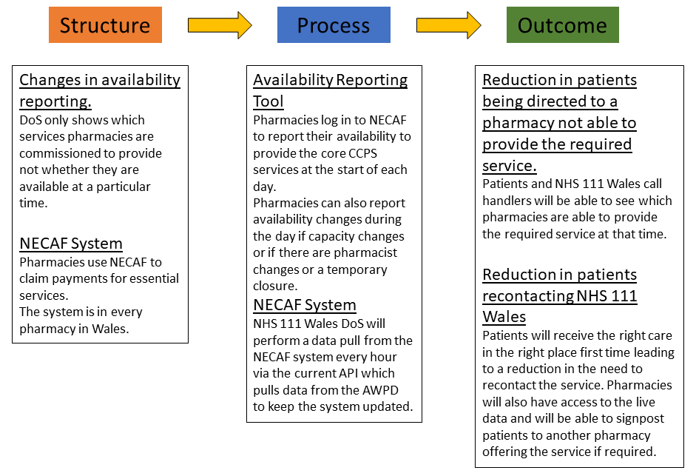

Initially, the use of the reporting tool by pharmacies will not be mandatory due to concerns by Community Pharmacy Wales (CPW) that the data would be used by the health boards in contract negotiations as the specification states that:
“The service could be accessed for the entire contracted opening hours of the pharmacy on no fewer than 80% of the days on which the pharmacy is open (including part days).”(Community Pharmacy Wales, 2023)
Before the implementation of the reporting tool, availability was self-declared retrospectively each quarter as required by the service specifications.
Project Aim and Research Objectives
In 2017, the Director General for Health and Social Services in Wales sent a letter to all Trust Chief Executives emphasising the significance of the DoS and expressing the intention to initiate a project aimed at consolidating it into a single, reliable source of information. Subsequently, in 2018, the Deputy Chief Executive of NHS Wales issued a letter designating the NHS DoS within the Welsh Ambulance Service Trust (WAST) as the primary source of information for NHS Wales, while Dewis Cymru was identified as the primary source for local government information. (Dean, 2018)
There have been various challenges that have hindered the achievement of a unified DoS, including the absence of consistent funding and growing disparities among the existing systems.
Despite these challenges, some progress has been made in consolidating the number of directories. However, multiple directories still exist, and there is no agreed-upon single point of access or information standard.
Presently, three main DoS systems operate in Wales, each with varying levels of access, capabilities, users, and information:
- NHS 111 Directory of Services
- Digital Health and Care Wales (DHCW) Directory of Services
- Dewis Cymru Directory of Services.
As well as hosting data for internal WAST and 111 use the NHS 111 Wales DoS also provides the public-facing information hosted within the Services Near You pages of the NHS Wales 111 website that is used by the general public to obtain information with regards to primary, secondary, tertiary and associated health and social care services.
Despite hosting thousands of services, the management of the system relies on a small team consisting of only two staff members and the system is predominantly manual, which leads to time-consuming processes. Manual data entry inherently carries a high margin for error. The time-consuming nature of data entry increases the risk of displaying inaccurate information to users while updates are made manually.
Due to the limited standardisation of the information provided to the team the staff responsible for data entry face challenges, leading to additional calls and discussions to resolve queries and inconsistencies. (Anonymised Agency, 2022)
Because of these factors and the retrospective nature of the availability data provided before the implementation of the reporting tool, a case could be made that the website and the call handlers and clinicians of NHS 111 Wales have inadvertently been providing inaccurate information to patients. This has been borne out by complaints the service receives and is in contravention of the NHS 111 Wales terms of use. (NHS 111 Wales, 2022)
As a result, call handlers and clinicians advise patients to call ahead to see if the required service is available at their chosen pharmacy. If patients fail to follow this advice and attend a pharmacy where their required service is not available, they may re-access the NHS 111 Wales telephone service leading to increased call wait times and delays in their receiving care. This is especially an issue during out-of-hours periods and in rural areas where distances between pharmacies may be considerable. This does not represent positive seamless integrated patient care which is the aim of the government policy, “Six Goals for Urgent and Emergency Care” (2021). This project aims to assess the changes made to help remedy this problem.
To address this issue, NHS 111 Wales, Welsh health board community pharmacy leads, and NWSSP have worked together to roll out a nationwide system where pharmacies can log in to the National Electronic Claim and Audit Forms (NECAF) system and report the availability of CCPS services on each day that the pharmacy is open, enabling better signposting, reducing delays in patients accessing care, enabling pharmacies to manage their capacity and reducing system burden. These are all hoped-for outcomes of the aim of the implementation of the reporting tool to provide callers, patients, carers and clinicians with the most up-to-date information.
It is important to consider that although the Service Reporting Tool is a digital solution, the DoS that it informs is used not only by users of the NHS 111 Wales website but also by call handlers and clinicians staffing the 111-telephone service. This is relevant due to digital inclusion challenges seen in Wales which include an ageing population and rural areas with poor broadband connectivity (Gann, 2019). Rural patients with poor broadband access are more likely to access NHS 111 Wales by using the telephone service and if the information being relayed to those patients is inaccurate the consequences are potentially greater due to the greater distances between services. Rurality has also been shown to be a factor in health inequality (Asthana and Gibson, 2020) so there is significance in identifying if there are issues for community pharmacies serving rural communities in completing the reporting tool.
This project aims to evaluate the usage of the reporting tool by community pharmacies across Wales and in turn to understand more about the pharmacies that have and have not used the reporting tool.
By looking at the characteristics of note for pharmacies that have and have not utilised the reporting tool such as:
- Rurality
- Health Board
- Large Multiple, Multiple or Independent Pharmacy
it is hoped to identify areas where pharmacies may need support and also to help future projects see where work may be required.
The research objectives of this project are:
- Determine how many community pharmacies complete the Service Reporting Tool during 1 month. This time frame has been selected to allow comparison with the service specification of monthly retrospective recordings.
- Identify the barriers that stop community pharmacies from completing the reporting tool.
- Identify any shared characteristics between community pharmacies that complete the reporting tool.
- Identify any shared characteristics between community pharmacies that do not complete the reporting tool.
The answers to these questions will provide insights into how making changes to a current national platform such as NECAF can be used in change management and the development of services. This will be useful when considering how to apply a similar methodology to other areas of the health service such as the availability of the Eye Health Examination Wales (EHEW) from opticians or the availability of specific services from Minor Injury Units (MIUs). This will make this research more generalisable and this better value for money.
Data Collection and Analysis Methods
NECAF is an online system developed by the Prescribing Services Unit of the Shared Services Partnership and enables community pharmacies to make reimbursement claims for a range of services (NHS Wales Shared Services Partnership, 2022) including:
- Care Home Support & Medicine Optimisation
- Dispensing Compensation
- Smoking Cessation
- Pharmacy Independent Prescribing Service (PIPS)
As described above, completion of the Service Availability tool is not mandatory although it is highly recommended in the service specifications (Mackridge, 2023b). To try and maximise usage of the tool by a group of healthcare professionals already identified as having an increasing workload (Lea, Corlett and Rodgers, 2012) it was added to the landing page of the NECAF system that community pharmacists first see when logging into the system. This means that no extra steps are required to access the tool. It should be noted that the NECAF system is present in all community pharmacies so no additional infrastructure is required to implement the availability tool. There are also no training requirements as the NECAF system is used frequently in all community pharmacies in Wales.
It is hoped that because there is also a signposting requirement in the service specifications where if a pharmacy is unable to provide one of the CCPS services it is required to signpost a patient to the nearest pharmacy where the service is available that this also will help drive usage of the tool.
This study will adopt a sequential explanatory design with two defined steps. The first step will be quantitative and the second step qualitative as described by Cresswell et al (2003). It is envisaged that this approach will provide a more comprehensive understanding of the research objectives of this study by combining the benefits of each method (Tashakkori and Teddlie, 2003). According to Mason (2006), qualitative data has the potential to augment and enrich research findings. Additionally, Stange et all (2006)suggest that qualitative data can contribute to the generation of new knowledge. The sequential explanatory design of this study combines the strengths of both quantitative and qualitative research establishing connections between concepts and conducting comparisons by incorporating data from various contexts (Alhojailan and Ibrahim, 2012)
Phase 1
The initial quantitative phase of the study will involve data extraction from the NECAF system which is completely non-intrusive with respect to the community pharmacies. This will consist of usage data for the Availability Reporting tool over the time frame of a month to allow comparison with the current system of monthly retrospective reporting. The data extraction will show those pharmacies that reported their availability during the selected month and in doing so because the AWPD provides a list of all the pharmacies in Wales it will also show which pharmacies have not completed the reporting tool. The options for availability within the tool are as follows:
- The service is available with no restrictions
- The service is available but capacity is limited and there may be a wait or the patient may be asked to return at a later time
- The service is not available
If a community pharmacy has not reported its availability the following will be generated by the system:
- Availability has not been reported please contact the pharmacy to check the availability of your chosen service before attending
By use of the NECAF system, this data collection method is targeted to all the community pharmacies in Wales. This total population sampling is a purposive sampling method as the entire population is included in the study.
The advantages of this approach include a comprehensive representation of the entire population eliminating the potential bias that can arise from sample selection, and ensuring that the findings accurately reflect the population. There is also no sampling error or uncertainty associated with estimating population parameters. The results obtained from the analysis are exact and applicable to the entire population. In this study a community pharmacy will either complete the Service Availability Tool or it won’t. Both of these outcomes are equally valuable as they will provide the opportunity to conduct in-depth analysis and explore various relationships, patterns, or subgroups within the population as effectively data is collected from every individual pharmacy (Etikan, Abubakar Musa and Sunusi Alkassim, 2015). This also negates one of the limitations of total population sampling which is non-response, as normally this would affect the representativeness of the data.
After collecting the data, initially, it will undergo descriptive analysis. Descriptive studies aim to provide a comprehensive portrayal of individuals, events, or conditions by observing them in their natural state (Houser, 2016). In descriptive studies, the researcher does not manipulate variables; rather, they focus on describing the sample and/or the variables themselves (Siedlecki, 2020). Descriptive analysis offers several advantages, including its high level of objectivity and impartiality. Furthermore, it provides a broad overview of a phenomenon, enabling a better understanding of concepts and aiding in the planning of future experiments (Baha, 2016). Additionally, descriptive analysis facilitates the description of relationships with the known world, enhancing users' comprehension and enabling effective planning for future experiments as well as making the data more accessible to stakeholders.
Descriptive analysis aims to provide a comprehensive understanding of data, identify patterns, and describe the characteristics of variables or groups. This study aims to examine two primary groups: pharmacies that utilised the reporting tool and pharmacies that did not. Two of the four objectives of this study are to identify any shared characteristics within each of these two groups. To accomplish this, the study will delve into the demographic data stored in the AWPD (All Wales Pharmacy Database). This data will provide insights into various aspects such as the health board each pharmacy is based in. Additionally, the study will explore whether a pharmacy operates in a rural area or an urban setting and also whether a pharmacy is part of a large or small multiple chain or operates as an independent contractor. This distinction between these different organisational structures that exist within the pharmacy sector will contribute to a comprehensive understanding of the groups being analysed.
Statistical significance
The study aims to conduct a comprehensive examination of the participating pharmacies, taking into account various factors such as the health board, rural/urban classification, and organisational structure. By doing so, the study aims to identify commonalities and distinctions within each group, thereby gaining a thorough understanding of the involved pharmacies. The focus is on uncovering patterns, relationships, and trends in the data or identifying patterns that may warrant further investigation, without necessarily relying on formal statistical inferences.
The primary objective of this study is to determine the extent to which pharmacies are utilising the availability tool within a given time frame of one month. By examining the number of pharmacies that complete the tool within the designated time frame, this study aims to provide valuable insights into the tool's implementation and effectiveness. This will show how much accurate information is available in the DoS to be passed to patients or accessed via the web.
It is hoped that this research may build a foundation upon which other researchers or other methods could be used to analyse this data such as cross-tabulation followed by chi-square analysis.
Operational significance
The absence of live service availability information in the DoS signifies an operational gap, as it compromises the accuracy and reliability of the information provided to users. Integrating live service availability information into the DoS, will enhance the overall quality of the data and ensure that individuals seeking pharmacy services receive up-to-date and reliable information about their local pharmacies service availability. Currently, there is no live service availability data as the tool is in the process of being rolled out so the DoS contains no live service availability information. It could be argued that the addition of any live service availability information to the DoS is operationally significant as it increases the accuracy of the information contained within the DoS. It is difficult to determine the operational significance in this case as it is subjective and difficult to determine the magnitude and practical implications of the provision of live service availability.
However, one health board has implemented an ad-hoc paper-based system, developed by the community pharmacy lead, to collect pharmacy service availability data. This system serves as a voluntary method for pharmacies to submit their service availability information. Currently, the completion rate of this paper-based system is estimated to be around 40-50% (Mackridge, 2023a) and these figures could potentially be used as a comparison to suggest operational significance.
Another potential measure of operational significance would be equity of availability data across Wales. Pharmacy engagement with the service availability tool across all the health boards would go some way to demonstrating the operational significance of this intervention.
Phase 2
The second phase of the study entails the qualitative component that aims to investigate themes surrounding the completion and non-completion of the reporting tool. To accomplish this, two questionnaires will be created. The first questionnaire is designed for pharmacies that have completed the service availability tool, while the second questionnaire targets pharmacies that did not complete the tool. Microsoft Forms will be utilised to generate these questionnaires, which will then be dispatched via email to the designated nhs.wales.uk email address allocated to every pharmacy in Wales. The questionnaires will feature open-ended questions allowing the gathering of useful data, and offering unique insights into the experiences, perspectives, and challenges faced by both groups. By employing a comparative approach, the study aims to identify potential differences, similarities, and underlying factors that contributed to the two different outcomes displayed by the two groups.
The questionnaire for the pharmacies that completed the service availability tool will explore their feedback, opinions, and reflections regarding their engagement with the tool. It will delve into the perceived benefits, drawbacks, and any notable changes they may have observed in patient attendance as a result. Additionally, it will gather their recommendations for modifications to the tool and capture their overall satisfaction with the process.
On the other hand, the questionnaire tailored for pharmacies that did not complete the availability tool will seek to understand the reasons behind their non-participation. It will explore any barriers or challenges they encountered that prevented their engagement with the tool. This questionnaire will aim to shed light on potential factors such as time constraints, resource limitations, or any other pertinent circumstances that influenced their decision. By understanding the underlying factors, the study aims to offer valuable recommendations for future implementation strategies and address any barriers that hinder widespread adoption.
The qualitative nature of this phase ensures a comprehensive exploration of the subject matter, as it allows for an in-depth understanding of the perspectives and experiences of the participating pharmacies (Yin, 2015). The data collected from these questionnaires will undergo thematic analysis.
Thematic Analysis is a technique that involves the identification, examination, and presentation of patterns or themes within a dataset (Braun and Clarke, 2006). It is considered a descriptive approach that offers flexibility in reducing data, aligning well with other methods of data analysis and is widely employed due to its applicability to diverse research questions and subjects (Vaismoradi and Turunen, 2013)
The findings will contribute valuable insights to the overall study and help shape future initiatives aimed at enhancing service availability in pharmacies.
By capturing the perspectives, experiences, and barriers, the study aims to gain a comprehensive understanding of the underlying factors influencing engagement with the service availability tool and provide valuable recommendations for future implementation strategies. In simple terms, how can it be made easier for pharmacies to complete the availability tool?
Saturation
Saturation refers to the point at which collecting additional data or conducting additional analysis no longer yields new or meaningful information (Fusch and Ness, 2015). This is not a fixed point but rather a dynamic and context-dependent process. There are some general principles that are detailed in the literature to help determine saturation: no new data, no new themes, no new coding, and ability to replicate the study (Guest, Bunce and Johnson, 2006).
Instead of focusing solely on the size of the sample (Burmeister and Aitken, 2012), it is more beneficial to conceptualise data in terms of its richness and thickness (Dibley, 2011). A useful distinction can be made by considering rich data as indicative of quality and thick data as indicative of quantity. Thick data refers to a large volume of information, whereas rich data encompasses multiple layers, intricacy, detail, nuance, and more. It is possible to possess a significant amount of thick data that lacks richness, and conversely, to possess rich data without a substantial quantity. The key lies in attaining both elements concurrently.
At this point, it isn’t possible to predict the levels of response from each group which will affect the thickness of the data and ultimately have a large bearing on data saturation. Tran et al (2016) suggest that as the number of participants increases, the median probability of discovering a new theme for the next subject declines rapidly. Specifically, after including 30, 50, and 100 subjects, the probabilities stood at 32%, 24%, and 12%, respectively. They conclude that data saturation for a survey using open-ended questions is achieved for samples greater than 150 participants. This would require at least 300 responses to the questionnaires if the responses were equally distributed between each group which is a level that the study is unlikely to achieve as the literature suggests that the average response rate to an online survey is 44.1% (Wu, Zhao and Fils-Aime, 2022).
Transferability
Polit and Beck (2010) state that transferability is commonly viewed as a collaborative endeavour in qualitative research and that while it is the researcher’s role to offer comprehensive descriptions that enable readers to infer the applicability of findings to different contexts, the primary responsibility for transferability lies with the readers and consumers of research.
The themes uncovered in this study have the potential to enhance the accessibility and user-friendliness of the service availability tool. Moreover, these findings can be extended to the development of comparable systems in other domains of the healthcare sector. For instance, the EHEW service provided by Opticians, which operates throughout Wales, could greatly benefit from real-time service availability data. It is worth mentioning that opticians and community pharmacies share several similarities, such as their presence on high streets nationwide and a mix of multiple and independent contractors within the industry.

