Assessment 2
Environmental Analysis of an Industry

Module Name: The Global Business Environment
Module Code: LCCB4005
Student name: Vasile Ciprian Alin Diaconu
Student number: 2030168

Table of Contents
Introduction…………………………………………………………………………..………......3
Company overview ………………………………………………………...……..………...…...3
Evaluating business environment challenge ……………….………………..…….4
Internal environment analysis of Land Rover…………………………………..….……4
SWOT analysis of Land Rover……..………………………………………………...………….4

External environment analysis of Land Rover…………..…………..…………....6

Porter’s Five Forces Analysis……………………………………………...…………………..6
PESTLE Analysis of Land Rover…………………………………………….………………..7

Value chain analysis…………………………………………………………...……………….9

Land Rover's competitive advantages assure its survival…………………...……..….12
Conclusion…………………………………………………………………………..………….12

References…………………………………………………………………………...…………..12

Introduction
Business is unquestionably a part of life. Selling certain products or services generates profit. Every global workforce member is involved in corporate operations (Cuervo., 2017). Now corporate organizations are functioning in overseas environments, across national borders. Business functions have become increasingly crucial due to globalization. They now face numerous hurdles when doing business abroad. These issues are essential in the car business. Previously, just a few car brands dominated the worldwide auto industry. However, with the advancement of technology, numerous new firms have emerged. Globalization and technological advancement have given buyers more alternatives (Drahos., 2016). So car manufacturers are always developing new models to attract buyers. The purpose of this study is to describe and analyze the difficulties that a company's internal and external environments provide within the context of Land Rover as a company. SWOT, PESTLE, PORTER`S FIVE FORCES, and VALUE CHAIN ANALYSIS will be used to determine how their core values assist them to acquire competitive advantages over other industries and assure long-term success.

Company overview

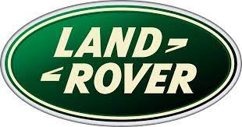
It has been owned by Jaguar Land Rover since 2013. Land Rover is a British automobile manufacturing company. It has been owned by a variety of people over the years. As a result of its royal warrant in 1951, the Land Rover brand was born. Founded by Rover Company in 1948. Throughout its history, it has been owned by British Leyland, Rover Group, BMW, Ford Motor Company, and Tata Motors, among others. Since its merger with Jaguar Cars in 2013, it has been known as Jaguar Land Rover and is headquartered in Solihull, West Midlands, UK. As of right now, it is operating manufacturing facilities in the United Kingdom and Brazil as well as in China, India, Slovakia, and China, and is a global leader in the automotive industry. Additionally, Land Rover contributes to the defense sector in many countries around the world. Most of them serve in the armed forces of the UK and Australia.

Evaluating business environment challenge
The term "business environment" refers to everything that affects a company, both directly and indirectly (Kankaanranta., 2017). All of the aspects of an organization's environment must be considered in order to run a successful firm. Internal and external forces are broken down into two categories. Managers of commercial enterprises are obligated to constantly assess the business environment in which they operate (Weismann, 20016). No manager can make ad hoc judgments without a thorough understanding of the surrounding environment. Every aspect of the organization's work is aided by environmental study. It also determines the most likely result and any associated risks of a strategy.
For this purpose, both external and internal analyses of Land Rover will be done in order to provide the most relevant information.

Internal environment analysis of Land Rover
An examination of a company's internal environment is the subject of an examination known as "internal" analysis. It aids in the discovery of issues pertaining to the organization's internal structure (Karaszewski., 2017).
SWOT analysis of Land Rover
In a SWOT analysis, the strengths, weaknesses, opportunities, and threats (SWOTs) of a company are analyzed. The acronym for the four components of a strategy is SWOT (GURL., 2017). Managers use this approach to come up with the best possible outcomes. It also aids in the creation of four interconnected strategies, such as SO, WO, ST, and WT strategies.

- Strengths of Land Rover

The aspects of a company's strength through which it can gain advantages are referred to as its strengths.
Land Rover has a specialized department that conducts market research on competitors and newcomers to the market in order to gain a competitive advantage for the company. A demographic analysis is carried out in order to ensure that customers are completely satisfied. When a company has a well-developed distribution network, it finds it much easier to reach potential customers. The brand's value increases as a result of continuous innovation in specialized models. It has a sufficient amount of cash on hand. It has a large dealer community, which aids in the operation of the company on a global scale.

- Weaknesses of Land Rover
They haven't been spending enough on research lately to bring the newest technologies to market. Even though their brand is well-known, they risk losing market share if they don't spend as much time and money on advertising. Inappropriate allocation of resources is caused by a miscalculated budget. The amount of money spent on staff education and training has increased significantly in recent years. The progress is hampered by insufficient research initiatives.
- Opportunities of Land Rover
Preparation meets opportunity, and the result is luck. As a result, Land Rover is wary of seizing lucrative chances. a few of its possibilities
There has been a decrease in the number of products available for sale in person because of Covid19. As a result, it placed a greater emphasis on internet marketing to guard against financial setbacks. The establishment of regional manufacturing facilities may minimize transportation expenses as well as the total cost of production. It's now possible to get into contracts with other nations' armed forces since they've already supplied cars to the British and Australian militaries. Land Rover has also come up with new strategies in response to the new environmental policies that have been implemented by the British Parliament.

- Threats of Land Rover
The term "threats" refers to the challenges that might arise in the workplace. It is also true that Land Rover faces various dangers. In terms of technical advancement, Land Rover is slipping behind its competitors. New models are stifled by inadequate research initiatives. The car business is getting more competitive as a result of globalization and technological advancement in communication. Its brand value is eroding as a result of poor marketing efforts (Lashine., 2013.).

External environment analysis of Land Rover

Outside influences on an organization are referred to as the "external environment." It covers a wide range of topics. The actions of the firm are affected by a wide range of factors. An international company such as Land Rover must do in-depth research on these issues (Shtal., 2018).

Porter’s Five Forces Analysis
In directing a company toward its ultimate aim, management is the responsibility of the bosses. To do so, it will need to conduct a variety of tests. Analysis of industry-related aspects using Porter's five forces theory. In reality, the five pillars of a company's identity may be summed up by these five forces (Bruijl., 2018).

- Competitive Rivalry: By aggressively lowering costs and conducting high-impact marketing efforts, corporations in a sector where competition is fierce are able to attract consumers. Suppliers and customers are more likely to leave if they don't think you're giving them a decent deal. It's also possible that if you're doing something no one else is doing, you'll have a lot of influence over your competitors and a good profit margin.

- The Buyer's Power: Customers have "buyer power" when the number of buyers outnumbers the number of providers in a sector. This implies that they are likely to be able to easily move to new, lower-cost rivals, which might eventually result in lower costs... When you're dealing with a small number of well-informed clients, they have greater sway. In contrast, the more clients you have, the more powerful you become.

- Supplier Power: The more service providers you have to choose from, the easier it will be to find a lower-cost one (Boiko, 2019). As a result, the more dependent you are on your suppliers, the more powerful their position and capacity to raise prices are. In the event that you are compelled to sign pricey contracts, this might have an effect on your profitability.

- The threat of substitutes: When it comes to technical content, most retail products do not have greater levels of quality and are more likely to be imitated, making the alternative more dangerous to purchase.

5. The threat of a new entry: the capacity of individuals to join your market might have an impact on your position. If it costs little money and effort to enter your market and compete successfully, or if your critical technologies are not adequately protected, competitors may enter quickly and erode your position (Liu., 2019). However, if you have substantial and long-lasting barriers to entry, you will be able to maintain an advantageous position and take full use of it in the future.

PESTLE Analysis of Land Rover

- Political Factor: Changes in an organization's business operations are influenced by political issues. These elements have a direct impact on a company's foundation (Perera., 2017). International business means that Land Rover must deal with governments from all around the globe. In order to be successful, a company must adhere to all applicable laws and regulations. There are several elements that contribute to the political climate, such as irregular elections, strikes, and misguided government policies. The recent intercommunal conflicts in Myanmar have made it difficult to do business there. In addition, the recent Brexit problem has wreaked havoc on Land Rover. Among other factors, the ongoing US-China trade conflict has helped Land Rover gain market share in those nations.
- Social factors: The term "social factors" refers to those aspects of life that have an effect on a customer's choices, either directly or indirectly (Samiee, 2018). It has a huge impact on every sort of company's environment. Land Rover's worldwide operations need an understanding of cultural variations, individual preferences, and purchasing power. People in the United States, for example, may choose cars with flashy amenities, whereas those in India may prefer cars with high gas efficiency. The company could also provide a more affordable two-wheeler for middle-class clients.
- Economic Factors: Inflation rate, foreign currency exchange rate, tax rate, VAT, economic cycle, etc. are all included in this category. Consider both national and global economic factors while making decisions as a multinational corporation. Such as, for example, in the developing world, where labor costs are cheap and manufacturing expenses are low. In contrast, in industrialized nations, labor costs are higher than in developing ones. In addition, it is creating local manufacturing facilities in the countries where it operates in order to lower the costs of raw materials, transportation, import/export, and total production.
- Technological factors: These are the business environment's most erratic variables. In the car industry's newcomers, we can clearly observe that the firm with the most advanced technology has expanded more quickly than its competitors. In the automotive business, Land Rover is a well-known name. However, during the most recent pandemic, the organization's technology infrastructure was not appropriately focused, resulting in losses for the corporation. In order to boost sales and reclaim market share, the company is putting greater focus on online activities including website creation and marketing.
- Legal Factors: For a company like Land Rover, legal considerations are critical. Because the government makes the final market judgments and has the authority to change them whenever necessary, this has an impact on every firm. It is necessary for Land Rover to take into account the legal aspects of each nation in which it does business. A vehicle's engine cannot be larger than 160 cubic centimeters in certain nations, including Bangladesh. If Land Rover wants to develop its business in these nations, it must produce vehicles that are in compliance with local regulations. Labor laws, minimum wage requirements, and other regulations are among the most important.
Value chain analysis
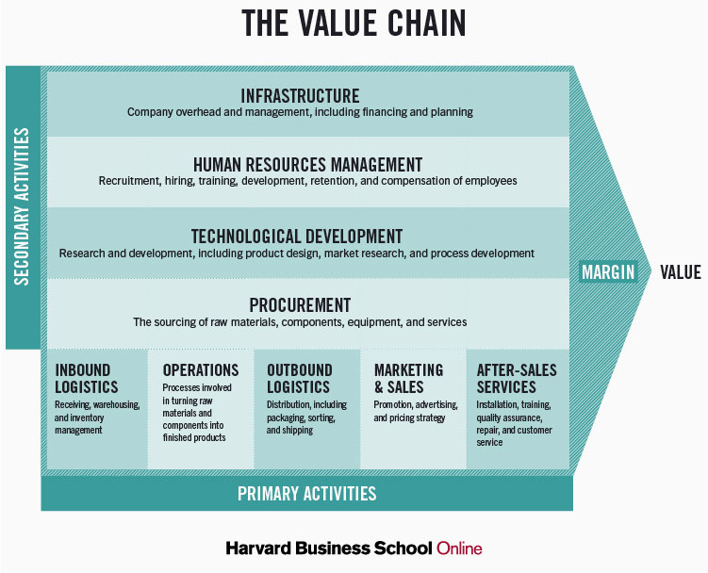

A product's value chain is comprised of all the steps necessary to bring it to market. It involves everything from distributing materials to launching the final product. Generally speaking, it is thought that each action contributes to the product. Value chain analysis is the process of evaluating every step of the supply chain. According to Porter's concept, the value chain activities are divided into two types: main activities and supporting activities. The offers benefit from both types of content (Gereffi., 2017).

Primary responsibilities
The activities that directly contribute to the development of a product or the performance of a service are referred to as primary activities. They are following
- Operations: Processing of raw materials and components to produce a final product
- Inbound logistics: Receive, store, and keep track of raw materials and components in inventory
- Outbound logistics: Various distribution-related activities such as packing, sorting and shipping
- Marketing and sales: Activities connected to the promotion, advertising, and pricing strategy of a product or service.
- After-sales services: In post-sale activities such as installation and training and quality inspection and maintenance of the product

Secondary responsibilities
Assist main tasks in becoming more efficient, so successfully establishing a competitive edge. They are following
- Procurement: procurement of raw materials, components, equipment and services for use in the production process
- Technological development: Product design, market research, and process development are just a few of the activities associated with research and development (R&D).
- Infrastructure: Financing and planning for the company's overhead and management are examples of these kinds of activities.
- Human resources management: personnel-related tasks such as finding and employing personnel, training them, keeping them happy, and paying them
A company's ability to cut costs while still producing a unique product or service offerings may be attributed to both primary and secondary operations.

Land Rover's competitive advantages assure its survival
All around the world, Land Rover is a well-known brand name. It is presently producing autos in five nations in order to meet the enormous demand (Hsieh., 2018). Complex managerial operations are required to keep such a large company running smoothly. Land Rover uses SWOT analysis to gauge the quality of its performance. It also aids in the advancement of the organization's internal administration. Because it is a global brand, it does a PESTLE study to determine the external environment's favorability and adversity. It also examines Porter's five forces in order to assess the state of a firm from five distinct angles, each of which helps to define a company. This study identifies the areas in which management should concentrate their efforts in order to ensure maximum profit. The value chain analysis was able to classify all of the actions that contribute to the value of the company's products and services. Resources are being mismanaged, and this tool helps identify and address the problem. Land Rover has a leg up on the competition by using these methods.

Conclusion
The era of globalization has arrived. The rapid growth of the vehicle industry has been fueled by the rapid introduction of new technology (Drahos., 2016). Land Rover must comprehend both the internal and external pressures of a company in order to compete at both local and international levels. It has used a variety of studies to keep tabs on the environment, including SWOT, PESTLE, Porter's Five Forces, and Value Chain Analysis. These evaluations provide the management authority with all the information they need to promptly and properly make the essential choices. Land Rover has therefore assured its long-term viability and high brand value for the company.

References
Braithwaite, J. and Drahos, P., 2016. Global business regulation. Cambridge university press.
Cuervo‐Cazurra, A., 2017. Global strategy and global business environment: The direct and indirect influences of the home country on a firm's global strategy. Global Strategy Journal, 1(3‐4), pp.382-386.
Dunning, J.H. and Dunning, J.H., 2006. Alliance capitalism and global business. Routledge.
Ferraro, G.P. and Briody, E.K., 2017. The cultural dimension of global business. Routledge.
Gereffi, G. and Fernandez-Stark, K., 2017. Global value chain analysis: a primer.
GURL, E., 2017. SWOT analysis: A theoretical review.
Hsieh, N.H., 2018. Does global business have a responsibility to promote just institutions?. Business Ethics Quarterly, 19(2), pp.251-273.
Kankaanranta, M. and Salminen, L.L., 2013. " What language does global business speak?"-The concept and development of BELF. Ibérica: Revista de la Asociación Europea de Lenguas para Fines Específicos (AELFE), (26), pp.17-34.
Karaszewski, R., 2017. Leadership in global business environment through a vision creation process. The TQM Journal.
Mohamed, E.K. and Lashine, S.H., 2013. Accounting knowledge and skills and the challenges of a global business environment. Managerial finance.
Perera, R., 2017. The PESTLE analysis. Nerdynaut.
Samiee, S., 2018. Global marketing effectiveness via alliances and electronic commerce in business-to-business markets. Industrial Marketing Management, 37(1), pp.3-8.
Shtal, T.V., BURIAK, M.M., AMIRBEKULY, Y., UKUBASSOVA, G.S., KASKIN, T.T. and TOIBOLDINOVA, Z.G., 2018. Methods of analysis of the external environment of business activities. Revista Espacios, 39(12).
Thomas, D.C., 2008. Cultural intelligence: People skills for global business. ReadHowYouWant. com.
Weismann, M.F., 20016. The Foreign Corrupt Practices Act: The failure of the self-regulatory model of corporate governance in the global business environment. Journal of Business Ethics, 88(4), pp.615-661.

