Build IT framework and model to solve information security problems based on Caribbean coffee
Shengqing Pei
Abstract
In the information age, due to the demand for timely, efficient and shared financial accounting information, the extensive use of modern computer network technology will become an inevitable trend in the development of financial management and accounting. But in the network environment, financial management and accounting in an open platform, is bound to face hacker attacks, virus infection and many other risks.With the continuous innovation of computer technology, the Internet promotes the development of information society.In the Internet, computer network database plays the role of public library, storing all kinds of important data and information.Once the information data in the "public library" is tampered and stolen, it is necessary to rebuild the information database, or it will cause serious social crisis.With the wide popularization of computer technology and the opening of network environment, the control right of computer network database is easy to be embezzled by criminals, which will cause immeasurable losses to the public interest.In this paper, the Caribbean coffee as an example, this article will focus on the current situation of computer network security as the starting point, focusing on several special IT frameworks and models to solve computer network security information.For example, P2DR2 ,IAFT,and Information Technology Infrastructure Library (ITIL)

Keywords: IT frameworks network security network environment public library P2DR2 IAFT Information Technology Infrastructure Library ITIL

- Introduction
The characteristics of computer network openness and anonymity lead to more and more security problems of database system. Virus infection, hacker attack, data theft and other phenomena seriously threaten the security of computer network.This is not only related to the information security of a user, but also related to the information security of financial institutions, social enterprises and the national government. Therefore, it is urgent to strengthen the database security construction and realize the computer network database security management.The main security problems of network database are as follows The next few aspects.
(1) Virus infection.
Computer virus is a group of program codes that can destroy computer data, affect the use of computer and have the function of self replication. It pars in computer programs, has the characteristics of concealment , and has great harm.There are many reasons for virus infection. First of all, users are not familiar with the specific installation and application of firewall because they lack the understanding of security technology. As a result, firewall can not play its original function of security protection, which increases the probability of virus invasion.Secondly, if the relevant personnel of program compilation make mistakes or work negligence, it will lead to virus implantation in the process of work.Computer virus has strong parasitism and long-term latency, it is difficult to find and clear, and it poses a great threat to the security of database.
(2) Access to the database is not standardized.
There are a lot of files and confidential data in the computer network database, which need to be well protected.However, the characteristics of computer network openness lead to the phenomenon of illegal elements invading the database, which poses a great threat to the information security in the database.Some of them will illegally access the computer network database without permission for the sake of interests.It is an illegal means for hackers to use the loopholes of network database to access the network database illegally, even if the legitimate users engage in forgery activities without authorization.In addition, when accessing the computer network database In the process, the non-standard access method will also damage the information stored in the database .After the information of a certain node in the database is modified, the whole processing system will be in disorder.The database is not working properly
When running, more information will be lost, resulting in greater losses.

- Security Frameworks and Models
This chapter mainly introduces three kinds of network framework[1] and model:P2DR2 ,Information Assurance Technical Framework (IAFT),and Information Technology Infrastructure Library (ITIL).The following will focus on their advantages and disadvantages, advantages and disadvantages, requirements for specific aspects, and the aspects that can give full play to their greatest advantages

  - Policy Protection Detection Response Recovery(P2DR2)

P2DR2 dynamic security model is a dynamic security model structure based on enterprise network object, time and policy characteristics (policy, protection, detection, response, recovery).[2] It is a dynamic security model based on closed-loop control and active defense. Through the analysis and formulation of regional network routing and security policy, it establishes real-time detection and monitoring in the network interior and boundary The multilevel, all-round and three-dimensional regional network security environment is constructed by using the methods of disaster backup and recovery of diverse systems and redundancy design of key systems.

2.1.1 Elements and core ideas of P2DR2 theoretical model
P2D R2 model is a new security protection model based on the characteristics of traditional models such as P2D R model and P D R model.[3] It includes five links: strategy, protection, response, detection and recovery, as shown in Figure 2. Among them, strategy is the part of technology management in enterprise management system, which specifies the main goal of security management of scientific and technological secrets. The elements of protection, detection, response and recovery need to be implemented around the strategy. Through comprehensive security technical means, we should establish defense against the system, timely monitor and detect loopholes, intrusion behavior and other problems, and take corresponding measures to prevent attacks and record them, so as to recover the system or even launch counterattack in the shortest time after being attacked.
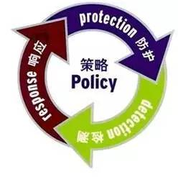
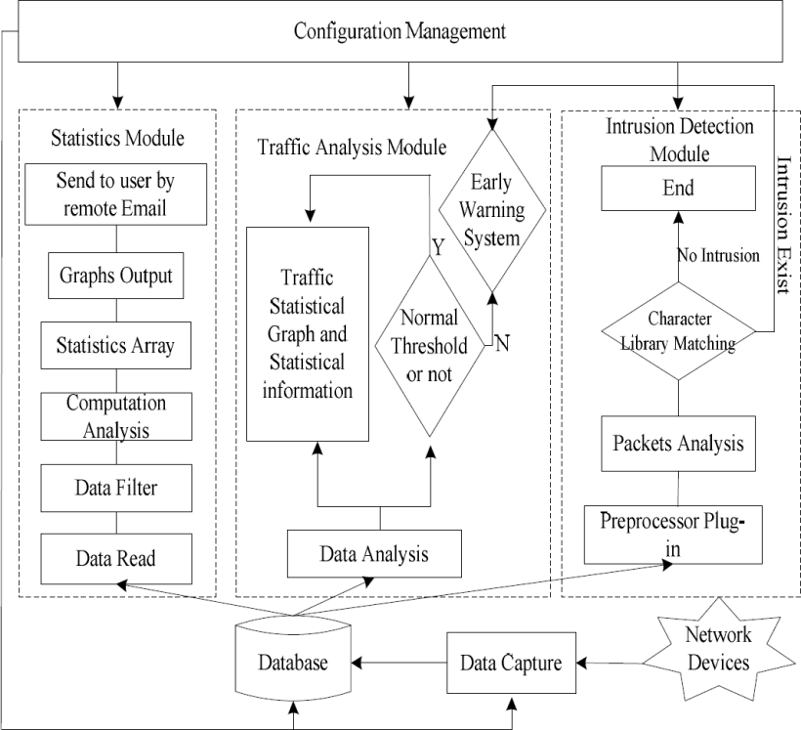
Figure 2 basic elements of P2DR2 theoretical model

2.1.2 Analysis of the proportion of each factor resource in P2DR2 theoretical model

In the implementation process of P2DR2 model, the resource allocation ratio of each element can be dynamically adjusted according to the actual application scenarios of different enterprises. Let security policy be policy, protection , inspection be detection, response be reaction and recovery be recovery. The proportion of resource input of each element in the specific implementation is expressed as α, β, γ and δ respectively. Then the proportion of each element resource in the enterprise dynamic security protection model is shown in formula (1)
Policy =α*Protection +β*Detection +γ*Reaction+δ*Recovery (1)
2.1.3 Security analysis of P2DR2 theoretical model
On the other hand, the security of P2DR2 model can be improved and extended according to PDR theory and time theory. Suppose that the enterprise security policy is policy, the system time is T, the system protection time is PT, the system detection time is DT, the system response time is r e st, and the system recovery time is CT, then the system exposure time ET can reflect the enterprise security policy policy validity of YT.

2.1.4 Architecture design of enterprise technology security protection system based on P2DR2 theoretical model
Compared with the traditional PDR and P2DR models, P2DR2 model has more complete elements and better security protection effect. At the same time, it is easier to deploy and implement than the most complex security protection system models such as PDR, p2otpd2 and po2p, which is more in line with the actual needs of enterprises.
2.1.5 Management layer based on P2DR2
The management layer belongs to the top layer of the system architecture. In the deployment, it first needs to determine the organizational structure and personnel composition of the science and technology security protection system according to the overall strategy of enterprise security protection, then formulate the relevant science and technology security protection system, and finally form the specific management process of the science and technology security system, so as to improve the management ability of enterprise science and technology security. In this layer, strategy making (the strategy element of P2D R2 model corresponding to the strategy link module) is the core content of this layer, and provides management and strategy support for the lower layer.
2.1.6 Element layer based on P2DR2
The element layer belongs to the middle layer of the architecture, which includes the protection link, detection link, response link and recovery link. By adjusting the resource composition proportion of each dynamic protection element, it forms the security technology prevention ability, confidentiality inspection ability and emergency recovery ability of the enterprise's scientific and technological secrets. In this layer, how to dynamically coordinate the resource proportion and relationship among technical protection, confidentiality inspection and emergency recovery according to the needs of different enterprises, and meet the strategic objectives of the management layer in the upper architecture is the core content of this layer, and provides support for the implementation layer at the bottom. The key elements of enterprise technology secret protection are not completely isolated, but interrelated and coordinated. Technical protection includes security protection technology of classified places, host and carrier protection technology, communication and network protection technology, which is the embodiment of protection elements. Security check is the embodiment of detection elements, which can be implemented with the help of security check at all levels to detect possible attacks in the process of system operation. The emergency remedy corresponds to the response elements and recovery elements, which will minimize the loss when and after the security incident. The element layer takes management strategy as the center, and on the basis of the basic defense ability constructed by the three elements of technical protection, confidentiality inspection and emergency remedy, it finds problems through timely detection ability and improves the remedial ability to deal with problems, so as to form a closed-loop control of finding problems and solving problems.
2.1.7 Application and Implementation Suggestions of management
The planning and design of enterprise technology security protection system architecture is important, but the effective operation of the system is also inseparable from the perfect guarantee and operation and maintenance. If there is no targeted operation and maintenance, the long-term stable operation of the protection system is difficult to guarantee, and the advantages of the system are difficult to play. Therefore, when building the management layer in the system architecture proposed in this paper, we need to accurately grasp the enterprise protection management strategy, formulate corresponding system guarantee, organization guarantee and resource guarantee measures, pay attention to the organic combination of technical protection and management system, constantly improve the management process, and standardize the scientific and technological confidentiality behavior of relevant personnel.

2.1.8 Application and Implementation Suggestions of implementation layer
When building the implementation layer of the architecture proposed in this paper, enterprises need to make full use of the existing technology security protection means, and constantly combine with the latest technology means to achieve, such as big data, cloud computing, artificial intelligence and blockchain, so as to constantly meet the changing needs of enterprises in physical security, host security, network security and data security And then comply with the latest international development trend of science and technology confidentiality.

2.1.9 Application and Implementation Suggestions of element layer
When constructing the element layer of the system architecture proposed in this paper, based on the existing enterprise confidentiality management system, organizational structure and information security system, according to the needs of enterprise management strategy, the resource allocation proportion of each basic element should be reasonably planned, and the resource proportion between each element should be dynamically adjusted according to the actual needs of the enterprise, so as to ensure the coordination between each element We should work in a unified way and stress the key points. At the same time, it is necessary to analyze the security of enterprise science and technology system in real time according to the dynamic factors such as time according to the enterprise security strategy, and make timely prevention and response, so as to realize the dynamic adjustment of security protection strategy.

  - Information Assurance Technical Framework (IAFT)
The information assurance technical framework (IATF) is formulated and released by the National Security Agency (NSA) of the United States[5]. Its predecessor is the network security framework (NSF). Since 1998, NSA has been focusing on the current situation of information technology and the needs of information security in the United States, and established NSF. In 1999, NSA renamed NSF as IATF and released IATF 2.0. Until now, with the progress of information technology and the deepening understanding of information security in the United States, IATF is still constantly improving and revising.
IATF is a series of guidelines to ensure the security of information and information facilities. It defines a process for the construction of information assurance system and its software and hardware components. According to the so-called defense in depth strategy, it provides a multilevel and in-depth security measure to ensure the security of user information and information system.
    - Four technical framework focus areas in IATF
IATF divides the information assurance technology level of information system into four technical framework focus areas: local computing environment, enclave boundaries, networks & infrastructures and supporting infrastructures, as shown in Figure 3. In each focus area, IATF describes its unique security requirements and corresponding controllable technical measures. The purpose of IATF's four focus areas is to make people understand different aspects of network security, comprehensively analyze the security requirements of information system, and consider the appropriate security defense mechanism.
Among the four focus areas, the local computing environment includes servers, clients and their installed applications, operating systems, etc.; the regional boundary refers to the collection of local computing devices connected through LAN, adopting a single security policy and regardless of physical location; the network and infrastructure provide regional interconnection, including operational area network (OAN), metropolitan area network (man) and campus Area networks (can) and local area networks (LANS), involving a wide range of social groups and local users; supporting infrastructure provides a supporting basis for the information assurance mechanism of network, regional and computing environment.
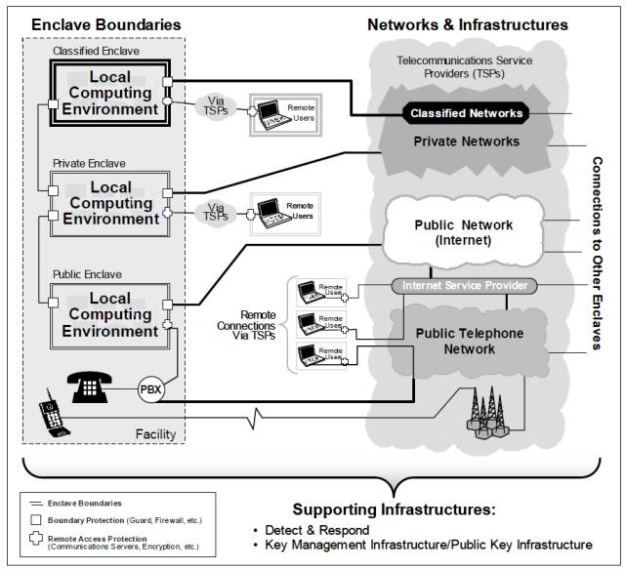
Figure 3 IATF focus area

    - The core of IATF Information Assurance

The core idea of IATF information assurance is defense in depth strategy, which provides an all-round and multilevel guiding ideology for the information assurance system. By adopting multilevel and implementing the assurance mechanism in each technical framework area, it can minimize risks, prevent attacks, and ensure the security of user information and its information system. The defense in depth strategy of IATF is shown in Figure 4, in which people, technology and operation are the main core factors, which are essential elements to ensure information and system security.
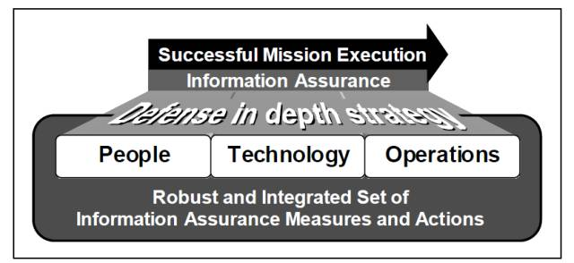
Figure 4 defense in depth strategy of IATF

Protect local computing environment

    - Protect local computing environment on IATF
Users need to protect the internal system applications and servers, including a variety of existing and emerging applications in the high-end environment of the system, from the use of identification and authentication access control, confidentiality, data integrity and non repudiation and other security services. In order to meet the above requirements, the following security objectives should be achieved: to ensure that the client, server and application are re divided to prevent denial of service, unauthorized data disclosure and data change; whether the client, server or application is located in or outside a certain area, it must ensure that the data processed by it has confidentiality and integrity; to prevent unauthorized use of the client, unauthorized disclosure and data change It is necessary to ensure that the client and server comply with the security configuration guidelines and correctly install all patches, maintain the configuration management of all clients and servers, track the patch and system configuration change information, and have sufficient ability to prevent internal and external trusted personnel from engaging in violations and attacks on the system.

    - Boundary of protected area

In order to obtain information and services from professional or public networks, many organizations connect with these networks through their information infrastructure. [6] Once, these organizations must protect their information infrastructure, such as protecting their local computer environment from intrusion. A successful intrusion may result in damage to usability, integrity or confidentiality. The objectives of meeting this requirement include: ensuring that the physical and logical areas are fully protected; adopting dynamic suppression services against changing threats; ensuring that the systems and networks in the protected areas maintain acceptable availability and will not be inappropriately leaked; providing boundary protection for the systems that cannot be protected by themselves due to technical or configuration problems in the area; providing security services Risk management measures, selectively allowing important information to flow across regional boundaries; protecting systems and data in the protected area from external systems or attacks; providing strong authentication and authenticated access control for users to send or receive information outside the area.
2.2.5 Protect network and infrastructure on IATF
In order to maintain information services, protect public, private or confidential information, and avoid inadvertent disclosure or change of such information, institutions must protect their networks and infrastructure. The target protection in line with the requirements: ensure that the data exchanged in the whole Wan will not be leaked to any unauthorized network visitors; ensure that the WAN supports critical tasks and data tasks to prevent denial of service attacks; prevent the delay, transmission and non transmission of protected information in the process of sending; protect the network infrastructure control information; ensure the protection mechanism It is not interfered by various seamless operations existing between other authorized hubs or regional networks.
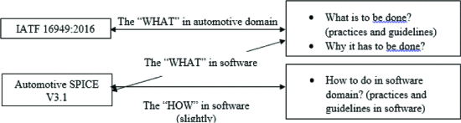

2.2.6 Protecting supporting infrastructure on IATF

Supporting infrastructure is another technical aspect of defense in depth.[7] It can provide key management, detection and response functions for defense in depth strategy. The required supporting infrastructure components for detection and response include intrusion detection system and audit configuration system. The objectives of meeting this requirement are as follows: to provide infrastructure supporting key, priority and certificate management, and to be able to identify individuals using network services; to be able to quickly detect and respond to intrusion and other violations; to implement plans and report requirements for continuity and reconstruction.

  - Information Technology Infrastructure Library (ITIL)
Since the information technology infrastructure library (ITIL) was proposed by the British Department of Commerce in the mid-1980s, as a de facto international standard for it service management, ITIL has been fully supported by almost all it giants in the world. IBM, HP, Microsoft, CA, BMC, ASG and other well-known multinational companies are active advocates of ITIL. Based on ITIL, they have launched the software and implementation scheme of IT service management. ITIL has been widely used in Europe, North America and Australia. More than 10000 leading enterprises in various industries have brought us many successful cases of implementing ITIL. The implementation of ITIL has greatly improved the quality of enterprise IT services and promoted the integration of it and business.
In recent years, ITIL has developed rapidly all over the world. For example, in the United States, when the it SMF annual meeting was held for the first time in 2001, only 200 people attended, 800 people attended in the second year, and more than 1600 people attended the third annual meeting in 2003!
ITIL in foreign countries, especially in Europe and the United States, can be said to present a "hot" scene, then how is its development in China?
ITIL was first introduced into China in 1999. In the first three years of its introduction, due to the fact that there are not many units to know about it and the successful cases in this respect are quite limited, it is in a state of not sulking in China. But since 2002, ITIL has attracted more and more attention in China. Especially in 2003, ITIL appeared several firsts in the development process of China: Han Wei IT management research and consulting center published the first Chinese ITIL monograph, China computer users weekly founded the first it service management column in China, the first ITIL Oriented Portal "ITSM information network", which is also in Han Wei IT management research and consulting center and ITSM portal It was officially founded in cooperation with international.
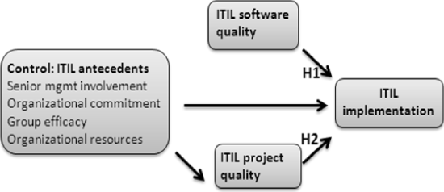
FIGURE 5. RESEARCH MODEL

    - Core module on ITIL
The core module of ITIL is "service management", which includes 10 processes and one function.[8] These processes and functions are divided into two process groups, namely "service provision" process group and "service support" process group. The service support process group summarizes a management function related to it management and five operation level processes, namely accident management, problem management, configuration management, change management and release management; the service provision process group summarizes five tactical level processes related to it management, namely service level management, it service financial management, capability management, it service continuity management and availability management Li. ITIL follows the PDCA methodology for continuous service improvement.

    - Reception in ITIL
Service desk service desk is a single point of contact between IT departments and it service users. It facilitates the integration of organizational business processes and service management infrastructure by providing a centralized and dedicated service point of contact. The main goal of the service desk is to coordinate the contact between customers (users) and it departments, and provide support for it service operation, so as to improve customer satisfaction.
    - Accident management in ITIL
Accident management is responsible for recording, classifying and arranging experts to deal with accidents and supervising the whole process until the accidents are solved and terminated. The purpose of incident management is to restore it system to the service level defined by service level agreement under the condition of minimal impact on customer and user business.
    - Problem management in ITIL
Problem management refers to a service management process that minimizes the negative impact of problems and accidents on the business by investigating and analyzing the weak links of IT infrastructure, identifying the potential causes of accidents, and formulating solutions and measures to prevent accidents from happening again. Unlike accident management, which emphasizes the speed of accident recovery, problem management focuses on finding out the root cause of the accident, so as to formulate appropriate solutions or preventive measures to prevent its recurrence.
    - Service level management in ITIL
Service level management is a service management process composed of a series of activities such as planning, drafting, negotiation, monitoring and reporting for signing service level agreements (SLAS), and evaluation of service performance after signing service level agreements. Service level management aims to ensure that the quality of IT services required by the organization can be maintained and gradually improved within a reasonable cost.

- Discussion and Comparison
P2DR2:2dr2 dynamic security model is a kind of dynamic security model based on closed-loop control and active defense. Through the analysis and formulation of regional network routing and security policy, it can establish real-time detection and monitoring in the network interior and boundary The multilevel, all-round and three-dimensional regional network security environment is constructed by using the methods of disaster backup and recovery of diverse systems and redundancy design of key systems.

A good network security model should fully understand the security requirements of the network system, and express the security architecture through the security model, which usually has the following properties: accurate and unambiguous; simple and abstract; general; fully embodies the security policy.
IATF :IATF is a series of guidelines to ensure the security of information and information facilities. It defines a process for the construction of information assurance system and its software and hardware components. According to the so-called defense in depth strategy, it provides a multilevel and in-depth security measure to ensure the security of user information and information system.
ITIL : The background of ITIL is that in order to improve the quality of IT services of government departments, the British government launched a project to invite well-known IT manufacturers and experts at home and abroad to jointly develop a set of standardized and quantifiable IT resource usage methods. This approach should be vendor independent and suitable for organizations of different sizes, technologies and business needs. The final product of this project is now widely recognized ITIL.

- Applying three security frameworks to solve the information security problem of Caribbean coffee shops
Caribbean coffee company sells Jamaican Blue peak coffee, one of the best and most popular blends in the world. Caribbean coffee has a wide range of business in the world. The company uses cloud services to provide IT services to employees and customers. According to statistics, 95% of the company is wireless network. The company also has a large amount of Internet information and social media to promote its business activities.
Because of its huge staff and international customers, the company has been facing great pressure, and requires its staff and customers to pay attention to network security when using personal devices to access the company's network / resources, and the security of personal staff data and customer data is the main concern of the company. The company protects its billions of dollars worth of intellectual property. Information security is the top priority of the company, but everything is chaotic. Their information security needs to be planned and implemented
As for how to protect the network information security of thousands of customers and employees of Caribbean coffee, I plan to build a network information security system based on ITIL framework to protect the network information of customers and employees from being used by illegal elements. At the same time, I will also establish a mature protection system to maintain the network security of the whole company.
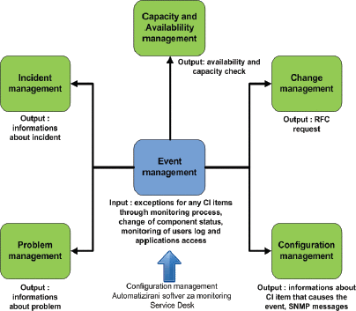

Fig 6. The security framework for Caribbean coffee

  - configuration management

Configuration management is a process of identifying and confirming system configuration items, recording and reporting configuration item status and change requests, and verifying the correctness and integrity of configuration items. Its purpose is to provide the logical model of IT infrastructure and support other service management processes, especially the operation of change management and release management.

4.2 IT Security
Risk management is a method for it managers to balance the protection costs and benefits of IT systems and data Risk assessment;Risk mitigation;
Continuous evaluation;The role of risk management is to provide the organization with:More secure it system;More effective IT security budget;It system operation accreditation basis;
  - The key role of risk management

Senior management provides effective resource guarantee for risk management projects and applies the results of risk analysis to management decisions;Chief Information Officer (CIO), who applies risk management principles and methods to it planning, budgeting and execution activities;System and information owners support risk management projects and apply risk management principles and methods to the protection of IT systems and data;Business and functional managers apply risk management principles and methods to business operations and it procurement decisions, so that it systems can support business activities more safely and effectively;Information system security officer (isso), the specific person in charge of it risk management project, formulates a comprehensive plan for it system risk identification, assessment and mitigation, and provides suggestions to senior management;It security practitioners, including network, system, application, database administrators, computer experts, security analysts and security consultants, support and participate in risk management of relevant IT systems, including identifying risks in the system and deploying appropriate preventive measures to provide appropriate security protection for the system;

Security awareness trainers, who understand risk management methods and develop training materials related to risk management, provide training evaluation education for users in training projects.

- Conclusions
Preventive measures and suggestions of Caribbean coffee enterprise network information security.Installation of protection software at the technical level: at the technical level, the installation of network information security protection software can meet the requirements of all aspects. As Caribbean coffee enterprises are not professional network practitioners, it is necessary to cooperate with advanced network information enterprises in the society. Security protection is gradually upgraded: first of all, the network security equipment, firewall, anti-virus and other measures of Caribbean coffee enterprise foundation can filter a lot of viruses. Second, hacker attacks will leave traces of operation on the network either through database triggers or through network bypass. Caribbean It is the top priority for coffee enterprises to refine the login account, detection and authority, and improve the user operation behavior chain. Finally, through the processing of the login account big data, we can continuously develop the value of access information, analyze the user's behavior, detect and alarm the unreasonable behavior, and take special protection measures. Strengthen the "management requirements": Caribbean coffee enterprises set up a network information security department, strengthen the network security education for the Department staff and even all staff, popularize relevant knowledge, improve the awareness of network security and confidentiality, and formulate the network information security system, which is required to be strictly observed. (network security vulnerability scanning: according to the way of simulating network attacks, obtain the vulnerable links that may be attacked in advance, provide reliable analysis report for system security, discover unknown vulnerabilities and timely repair the discovered vulnerabilities. File encryption: all files including encryption, re-use need to use password, password technology, biotechnology two or more kinds of authentication technology to obtain use. Data backup and recovery: backup the network information data, store the backup data in other security areas, implement the highest authority protection, ensure that the system and data can be quickly and safely recovered when the system or data is damaged, and avoid the paralysis of Caribbean coffee enterprise due to system attack.

References
- S. Sahibudin, M. Sharifi, and M. Ayat, "Combining ITIL, CobiT and ISO/IEC 27002 in Order to Design a Comprehensive IT Framework in Organizations", 2 Asia International Conference on Modeling & Simulation (AICMS 2008), pp. 749-753, May 2008.
- A. Tanovic, I. Androulidakis, and F. Orucevic, "Design and implementation of the IP Multimedia Subsystem by using ITIL V3 recommendations", 11 WSEAS International Conference on Applications of Computer Engineering (ACE'12), pp. 39-48, March 2012.
- S. Taylor, S. Lacy, and I. Macfarlane, "ITIL Version 3 Service Transition", The Office of Government Commerce, July 2011.
- Francois Zielemans, "ISO 20000 unveiled How to elicit added value from yet another new standard", 2006.
- Ivanka Menken, "ISO/IEC 20000 Foundation Complete Certification Kit - Study Guide Book and Online Course", The Art of Service 2009.
- Forrester, The Top Priorities For IT Execs in 2007, in: Forrester Trends: IT Execs Boost Focus On Business In 2007.
- H. M. Chen, "Towards Service Engineering : Service Orientation and Business-IT Alignment, ' in 41st, Hawaii International Conference on System Sciences (HICSS), 2008.
- Luftman, J.N., Ed. "Competing in the Infonnation Age: Strategic Alignment in Practice", Oxford University Press, New York, 1996.

