UNDERSTANDING AND MANAGING
ASTHMA IN ADOLESCENTS
CASE STUDY 2 | RESPIRATORY PHYSIOLOGY

BSc Health and Social Care
BMHP5023 - Introduction to Physiology
Component 1: Written Assignment (Case Study Report)
Student name: Shamaila Shafaq
Student number: 2504607

Table of Contents
Introduction 3
Respiratory anatomy and mechanical breathing 4
Gas exchange and the effect of obstruction 5
Why smoking, vaping and infection aggravate asthma 6
Using peak flow and respiratory records 7
Evidence-based lifestyle and clinic recommendations 8
Conclusion 10
References 11

Case study report

Introduction
Asthma is a chronic inflammatory condition of the airways with varying degrees of narrowing of the passageways, wheezing, cough, shortness of breath and tightness of the chest. In the scenario, we have adolescents who have been going to a general practice clinic weekly and the attacks have increased over the past few weeks as their social activities and patterns of exposure have changed. The nurse thus has to link up respiratory physiology with self-management and not just advise young people not to socialise. Risk factors include genetic susceptibility, parental asthma, allergic sensitisation and environmental exposures; once someone has a diagnosis, it can be exacerbated by smoke, vaping aerosols or viral infection (Fang and Roth, 2021; Levy et al., 2023). Even if symptoms go away for a short time, asthma can still be dangerous. Therefore, the nurse needs to assess the individuals underlying risk factors and ask about school, sport, friendships and access to medication before discussing appropriate self-management strategies.
This is not something that is of a small scale. Kim et al. (2025) analysed Global Burden of Disease estimates and reported 2021 asthma prevalence rates of 4,471 per 100,000 at ages 1-4, 5,427 at ages 5-9 and 3,641 at ages 10-19 (Figure 1). These rates are not locally measured and are based on population modelling. These distinct patterns of age suggest the importance of age-appropriate education and ongoing follow-up.
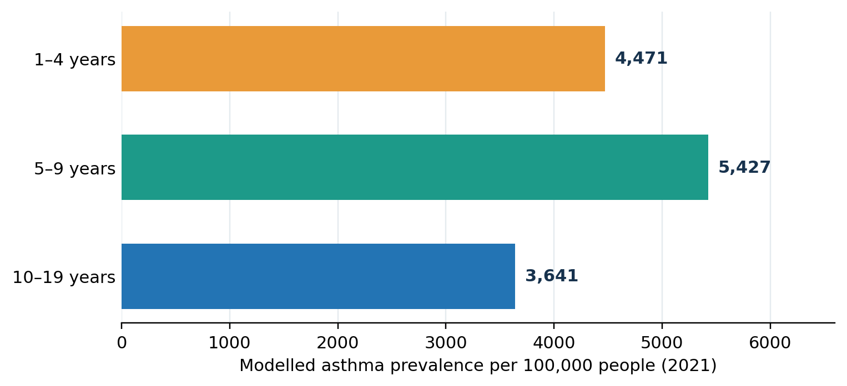
Figure 1. Global asthma prevalence by age in 2021 (modelled cases per 100,000). Data reproduced as a new chart from Kim et al. (2025), Table 1; not local practice data.

Respiratory anatomy and mechanical breathing
The air passes through the nasal cavity or mouth, and the mouth and nose connect to the pharynx, larynx and windpipe (trachea) before entering into the right and left bronchi. Bronchioles branch repeatedly to terminate in alveoli which are surrounded by pulmonary capillaries. Cartilage supports the larger airways, while smooth muscle controls the diameter of the bronchioles. Alveolar capillary membrane is thin allowing rapid diffusion of gases and surfactant decreases the surface tension and prevents the alveoli collapsing. These structures in cooperation provide the supply of oxygen and the elimination of carbon dioxide. The conducting airways are lined by cilia and protective mucus to trap and get rid of particles. Narrowing is particularly critical at the smallest air passages where there is limited air passage. A relatively small decrease in the radius of the air passages can lead to a significant increase in air passage resistance, and the work of breathing.
Inspiration is an Active process: Diaphragm contracts downwards and External intercostal muscles expand rib cage. The expansion of the thorax will decrease the pressure within the lungs and air will enter the lungs. Quiet expiration: these muscles are relaxed; elasticity increases alveoli pressure causing air to pass out of the alveoli. When a flare-up occurs, the bronchioles narrow, causing greater resistance to air movement, especially when they are exhaling. Patients might be struggling to empty their lungs and have rapid breathing; (Levy et al., 2023; Fang and Roth, 2021).
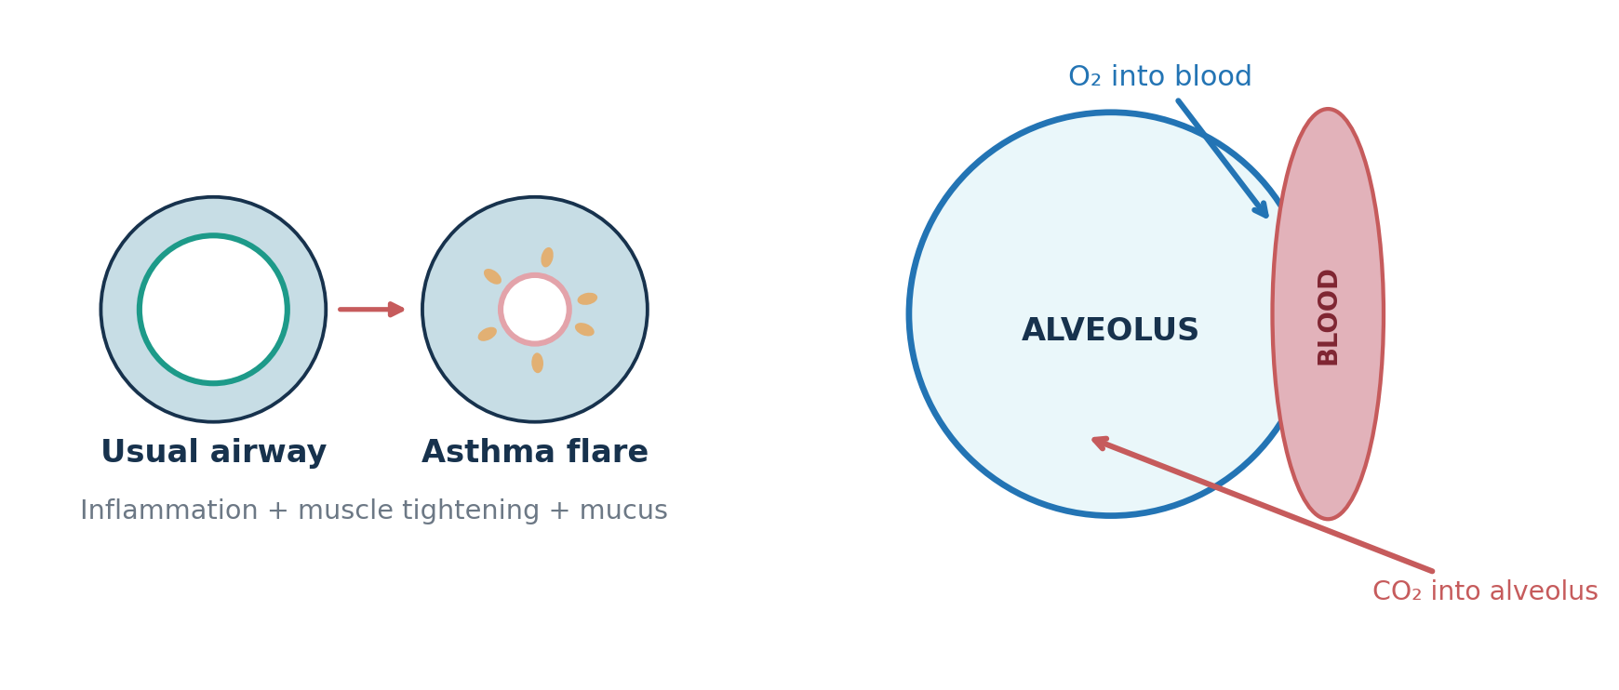
Figure 2. Explanatory schematic: inflamed bronchiolar lumen and oxygen/carbon-dioxide exchange. Original schematic based on the physiology described by Fang and Roth (2021) and Levy et al. (2023).

Gas exchange and the effect of obstruction
At the Alveoli, there is transfer of oxygen down its partial-pressure gradient, across a thin alveolo-capillary membrane to the pulmonary capillary blood, where most oxygen is bound to haemoglobin. From there, the blood goes to the left side of the heart to circulate throughout the body. Venous blood carries CO₂ generated by tissue metabolism, CO₂ diffuses in the opposite direction into alveolar air and it is exhaled. For efficient exchange, fresh alveolar ventilation and adequate capillary blood flow is needed. O2 and CO2 are not actively pumped across the membrane but there are separate gradients. The nurse can ask the patients about this difference in their own language: air must first pass to the alveolus and then, gas must cross into or out of the adjacent blood.
Asthma typically does not cause direct injury of alveoli. However, when less air is ventilated, areas will exist in which the blood will be deprived of sufficient oxygen. However, in severe attacks, there is an increasing ventilation perfusion mismatch which may lead to hypoxaemia, and during fatigue and significant obstruction carbon dioxide removal may be compromised. As shown in Figure 2, in inflammation of the airways, the airflow decreases even before gas exchange takes place (Fang and Roth, 2021).

Why smoking, vaping and infection aggravate asthma
Vulnerable airways react to irritants by turning on inflammatory mechanisms. The lining swells up, there is increased mucous production and contraction of smooth muscle, which reduces the size of the airway. Long-lasting inflammation can also be responsible for remodelling and thickening of the airways wall. Particles and toxic gases from smoking are irritating to epithelium and vaping aerosol is NOT harmless water vapour. When it comes to the social hotspots/surgery, both direct and second-hand exposure count (Fang and Roth, 2021; Islam et al., 2022).
After adjustment for other exposures to smoking, Tackett et al. (2024) found an association between recent e-cigarette use and bronchitic symptoms (adjusted odds ratio [OR] 1.55, 95% confidence interval [CI] 1.18-2.05) and shortness of breath (OR 1.48, 95% CI 1.01-2.18) in a prospective study that began with 2,094 adolescents and young adults. The wheeze estimate (OR 1.41, 95% CI 0.99-2.01) crossed the null value. These observations results relate to respiratory symptoms, rather than the risk of an asthma attack and cannot prove that vaping caused the symptoms.
Worsening symptoms are also thought to be due to viruses. Epithelial injury and immune activation are mechanisms by which rhinovirus and respiratory syncytial virus are implicated with the development of wheezing and asthma exacerbations (Nguyen et al., 2025). Rather than pointing fingers at every crowded place visited, the nurse should take into account individual exposures, other recent infections and medications taken. Important clinically, is that the risk of exacerbation cannot be directly quantified in already diagnosed asthma patients, in a study of general respiratory symptoms. What it is useful for is to recognise modifiable exposures that are worth talking about, not to provide an accurate individual risk prediction. Hence the nurse needs to integrate the evidence with the history of the symptoms and clinical examination.
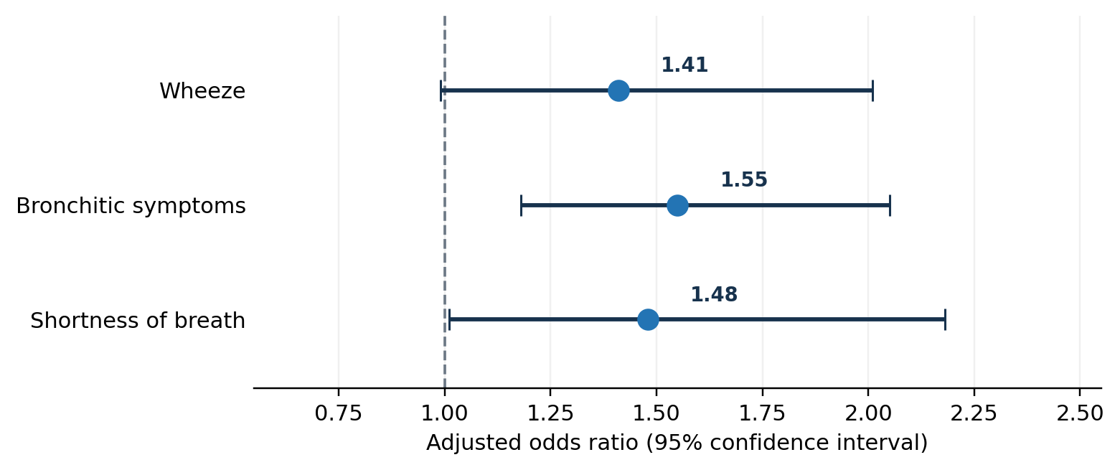
Figure 3. Recent vaping and respiratory symptoms: fully adjusted odds ratios and 95% CIs. Data redrawn from Tackett et al. (2024), Table 3, Model 2 (lag 0); associations are not causal risk estimates.

Using peak flow and respiratory records
The peak expiratory flow (PEF) is the maximum speed at which a person can blow air out after taking a deep breathe in. The nurse should have the student show how to use the device, and take three technically successful attempts and record the best result. PEF, symptoms, night wakes, activity restriction, reliever use and triggers can be noted on an agreed diary. Changes are not to be viewed mechanically as a comparison to other patients, but rather as a change from the adolescent's personal best and as related to the written action plan. For instance, if a person's personal best is 500L/min and they have a measurement of 350L/min, then 350 is 70% of their personal best. This is merely a 'suggestive calculation' and by no means an actual patient observation and not an instruction to change treatment. The patient should use his own clinically agreed areas and emergency assistance should be sought in the event of any of the following: Extreme breathlessness; patient unable to speak and signs of exhaustion.
A random allocation study to evaluate PEF feedback versus supportive counselling with 354 children (aged 10 to 17) is included. The difference in the percentage of personal best PEF was statistically significant in favour of the feedback group at 12 months, as was the difference in symptom-perception accuracy, though no difference was found between groups for asthma-control nor healthcare use at either 7 or 12 months (Feldman et al., 2025). The severity categories shown in Figure 4 are for the teenagers involved in the trial at baseline, and not of the distribution of all teenagers. The reason why self-management advice has to be individualised is due to its combination of mild and severe cases.
Making records easier to review using digital tools. Pais-Cunha et al. (2024) found 40 paediatric telemonitoring studies that included 20 studies that gathered spirometry or peak-flow data. Van der Kamp et al. (2023) also emphasized that there is great diversity in the home-monitoring options that can be applied. But, if not used properly, usefulness is compromised by bad technique, failure to keep records, and overwork. PEF should never be used as an oxygen-saturation test and if any of the symptoms seem alarming, they should be assessed urgently without waiting for a seemingly acceptable PEF reading.
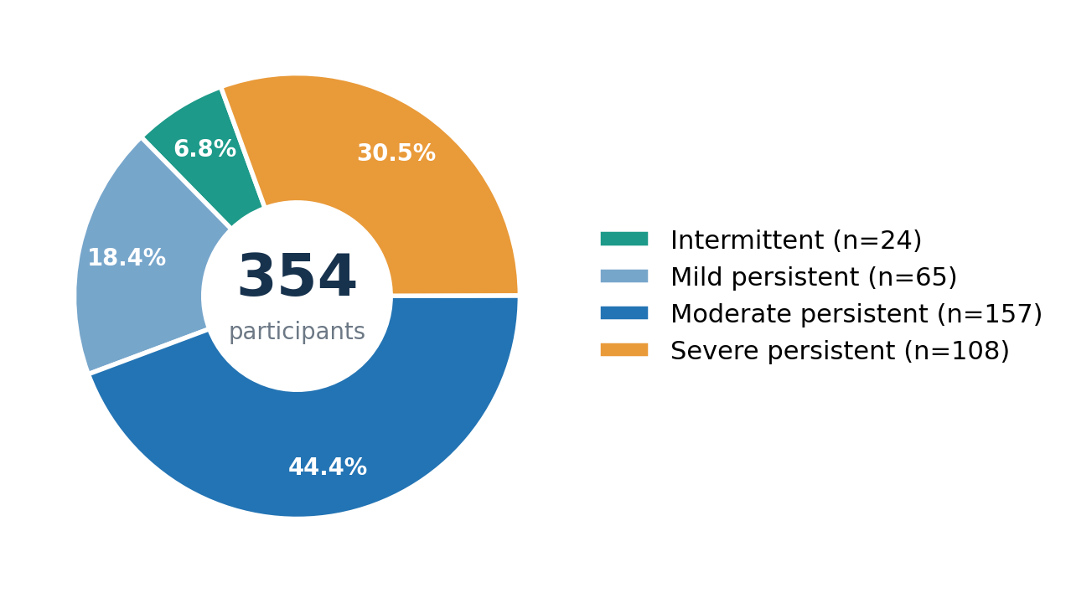
Figure 4. Baseline asthma severity among 354 participants in Feldman et al. (2025), Table 1 (both randomised arms combined). This is a selected trial sample, not population prevalence.

Evidence-based lifestyle and clinic recommendations
First, have a confidential and non-judgmental discussion about smoking, vaping, peer pressure and second-hand smoke. Plans for smoking cessation and exposure avoidance should include realistic, agreed goals and age-appropriate signposting to support services. Islam et al. (2022) found that bronchitic symptoms (OR 1.40) and shortness of breath (OR 1.53) were correlated with second-hand nicotine vapour exposure. This can help lower the risk of exposure, without suggesting that young people are to blame for their disease.
Second, education about how to avoid contracting an infection: washing hands, avoiding contacts who are visibly unwell (where possible), getting more fresh air into the home and discussing with GP any immunizations that are recommended. The goal is to enjoy more secure participation in education and social life, NOT isolation. Have patient identify personal early-warning indicators (Nguyen et al., 2025).
Third, promote correct movement and not inactivity. A meta-analysis assessed the effectiveness of different structured exercise interventions in children with CF in 24 paediatric trials (n=1031; Jiang et al., 2022) and concluded that structured exercise was likely to have beneficial effects on quality of life and exercise capacity, but there was not consistent evidence for the effect on individual lung-function measures. Prescribed asthma therapy should be accompanied by warm ups and training of manageable activity and review of activity related symptoms.
Lastly, audit inhaler technique, adherence and personalised written action plan at each clinic visit. The plan should include details of any medicines that are prescribed as a way to prevent deterioration, medicines for relief, deterioration steps and emergency contact details. Levy et al., (2023) have stressed the importance of treatment with inhaled corticosteroid not only in absence of short acting bronchodilator only therapy, but also among adolescents. Interventions to improve adherence were shown by Osama et al. (2024) to be associated with a pooled improvement of 0.44 (standardised mean difference), however there was significant heterogeneity. The consultation is practical and respectful by teaching back, asking the adolescent to retell the plan to you. Assess progress by symptoms, night-time awakenings, level of participation in activities and unscheduled care, and not attendance. The nurse can ask adolescents to show him or her each step of the process, find out if the teen can get a repeat of his or her inhaler and talk about any problems with remembering to take the inhaler. The systematic review evidence should be viewed with some caution as there was considerable heterogeneity and a lot of younger children were included in the trials. A short-shared goal that is reviewed at his/her next fortnightly clinic is more likely to be achieved than a long list of demands.

Conclusion
The adolescent asthma clinic should explain the importance of keeping the airways clear and maintaining effective ventilation and alveolar gas exchange. These processes may be disrupted by airway inflammation, exposure to smoke or vaping and respiratory infections. A reliable record of symptoms (and selectively, peak flow), correct inhaler technique, assisted lifestyle changes and a personalised action plan are a workable response. These recommendations are supported by published statistics, which should not be confused with individual predictions and observational associations.

References
Fang, L. and Roth, M. (2021) ‘Airway wall remodeling in childhood asthma—A personalized perspective from cell type-specific biology’, Journal of Personalized Medicine, 11(11), 1229. https://doi.org/10.3390/jpm11111229
Feldman, J.M., Rastogi, D., Warman, K., Serebrisky, D. and Arcoleo, K. (2025) ‘Peak flow feedback intervention improves underperception of airflow limitation in pediatric asthma: A randomized clinical trial’, Annals of the American Thoracic Society, 22(3), pp. 403–415. https://doi.org/10.1513/AnnalsATS.202406-637OC
Islam, T., Braymiller, J., Eckel, S.P., Liu, F., Tackett, A.P., Rebuli, M.E., Barrington-Trimis, J. and McConnell, R. (2022) ‘Secondhand nicotine vaping at home and respiratory symptoms in young adults’, Thorax, 77(7), pp. 663–668. https://doi.org/10.1136/thoraxjnl-2021-217041
Jiang, J., Zhang, D., Huang, Y., Wu, Z. and Zhang, W. (2022) ‘Exercise rehabilitation in pediatric asthma: A systematic review and network meta-analysis’, Pediatric Pulmonology, 57(12), pp. 2915–2927. https://pubmed.ncbi.nlm.nih.gov/36103241/
Kim, T.H., Kim, H., Oh, J., Kim, S., Miligkos, M., Yon, D.K. and Papadopoulos, N.G. (2025) ‘Global burden of asthma among children and adolescents with projections to 2050: A comprehensive review and forecasted modeling study’, Clinical and Experimental Pediatrics, 68(5), pp. 329–343. https://doi.org/10.3345/cep.2025.00423
Levy, M.L., Bacharier, L.B., Bateman, E., Boulet, L.-P., Brightling, C., Buhl, R., Brusselle, G., Cruz, A.A., Drazen, J.M., Duijts, L., Fleming, L., Inoue, H., Ko, F.W.S., Krishnan, J.A., Mortimer, K., Pitrez, P.M., Sheikh, A., Yorgancıoğlu, A. and Reddel, H.K. (2023) ‘Key recommendations for primary care from the 2022 Global Initiative for Asthma (GINA) update’, npj Primary Care Respiratory Medicine, 33, article 7. https://doi.org/10.1038/s41533-023-00330-1
Nguyen, V.T., Roth, K., Engelhardt, E., Pearlstein, A., Davita, T.R. and Grayson, M.H. (2025) ‘The usual suspects: Respiratory syncytial virus and rhinovirus drive asthma development and exacerbation’, Annals of Allergy, Asthma & Immunology, 135(3), pp. 261–267. https://doi.org/10.1016/j.anai.2025.04.013
Osama, H., Alghamdi, S., AbdElrahman, M. and Abdelrahim, M.E.A. (2024) ‘Evaluating adherence and inhaler monitoring among adolescent asthmatic patients: A systematic review and meta-analysis of interventions’, The Egyptian Journal of Bronchology, 18, article 85. https://doi.org/10.1186/s43168-024-00336-4
Pais-Cunha, I., Fontoura Matias, J., Almeida, A.L., Magalhães, M., Fonseca, J.A., Azevedo, I. and Jácome, C. (2024) ‘Telemonitoring of pediatric asthma in outpatient settings: A systematic review’, Pediatric Pulmonology, 59(10), pp. 2392–2413. https://doi.org/10.1002/ppul.27046
Tackett, A.P., Urman, R., Barrington-Trimis, J., Liu, F., Hong, H., Pentz, M.A., Islam, T.S., Eckel, S.P., Rebuli, M., Leventhal, A., Samet, J.M., Berhane, K. and McConnell, R. (2024) ‘Prospective study of e-cigarette use and respiratory symptoms in adolescents and young adults’, Thorax, 79(2), pp. 163–168. https://doi.org/10.1136/thorax-2022-218670
van der Kamp, M.R., Hengeveld, V.S., Brusse-Keizer, M.G.J., Thio, B.J. and Tabak, M. (2023) ‘eHealth technologies for monitoring peadiatric asthma at home: Scoping review’, Journal of Medical Internet Research, 25, e45896. https://doi.org/10.2196/45896

