DIGITAL SKILLS AND RESEARCH METHODS
TERM 2

IMPACT OF VIRTUAL LEARNING ENVIRONMENT (VLE) ON STUDENTS
Tutor Name: Amitave Banik

Student Id:1921557

Student Name: Fotios Bouraimis

Table of Contents
1. Introduction 3
2. Data Analysis 3
2.1 Primary Research 3
2.2 Secondary Research 8
3. Conclusion 11
Reference List 12
Appendices 13
Appendix 1: Questionnaire 13

1. Introduction
It is very crucial for a student to follow a particular learning environment for being compatible with studies. There are many different learning tactics, and all of those are effective with the students of different learning styles. A particular learning environment may be sufficient for a specific student or maybe not for another one. It is essential for a college to identify if it is able to fulfil the individual learning needs of its students through a learning environment. VLE, i.e. virtual learning environment, is also effective for any student. This research tries to identify the impact of virtual learning environments on students. It is important to gather information from different perspectives, and that is why both primary and secondary data are collected for data analysis. Those data will be used for interpretation, and it enables the research to get the output.

2. Data Analysis

2.1 Primary Research
At the beginning of primary research, it is important to know if all the students are aware of distinct specifications of VLE. Only then they will be able to answer properly (Cassidy, 2016). It shows that all the teachers and students are aware of the virtual learning environment. It will make the researcher able to get appropriate answers to make an unbiased result.
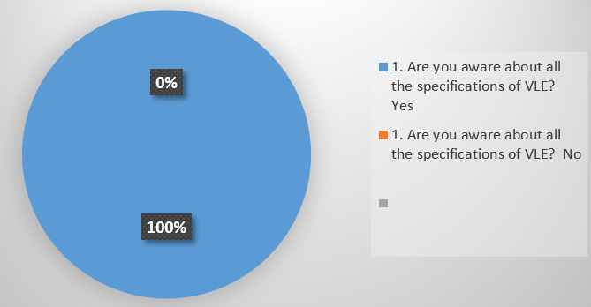
Figure 1: Awareness about VLE
Among ten students, 80% agree that a virtual learning environment has a positive impact on their learning experiences. It means that the provided services through VLE to the students appropriate and the college is able to satisfy the students through it. It can either because of proper implementation of the services or because the services itself are very much effective. On the other hand, 20% of students have marked it as moderate. There may also be distinct reasons behind it, which make their responses neutral. Positively, there is not a single negative response regarding it. However, it ensures that the college is able to use VLE appropriately for the benefit of its students.
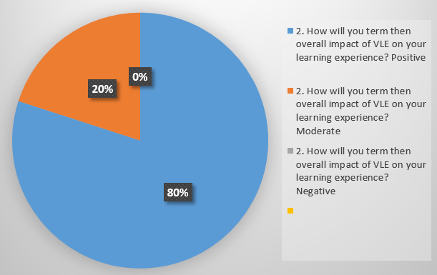
Figure 2: Impact of VLE on learning experience
VLE consists of distinct components, and all of those are for fulfilling the individual needs of students. The satisfaction rate through those needs also depends on the needs of students. It shows that there is an equal number of satisfied students with all the provided services. Their personalised learning, real-time learning and teaching, effective time management etc., as it is mentioned that the students have different needs that are why they have chosen the best options according to their need. It makes the overall structure of the VLE complete (Ivan, 2017). It is because if a college is able to satisfy the students of different types and backgrounds through a learning environment, then it is on the right track.
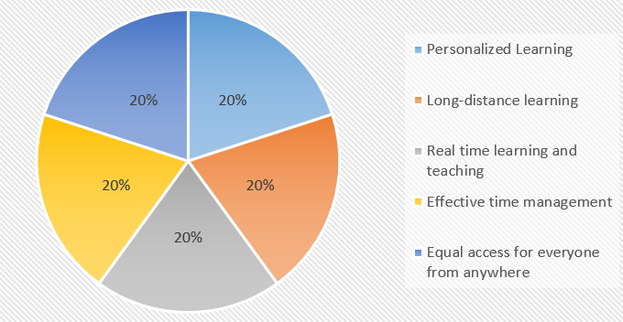
Figure 3: Liked components of VLE
In higher education, the students try to use the learning environment for some benefits. For example, if a particular student lacks any skill, then you would like to improve that through the learning environment. The responses of the student so that VLE is able to enhance the time management and self-management skills of most of the students. Besides, it has also a strong influence on critical thinking ability and task organising capacity. All of these skills are important from the perspective of a student's personal and professional life. In a broader context, all of these skills are for making personal and professional development.
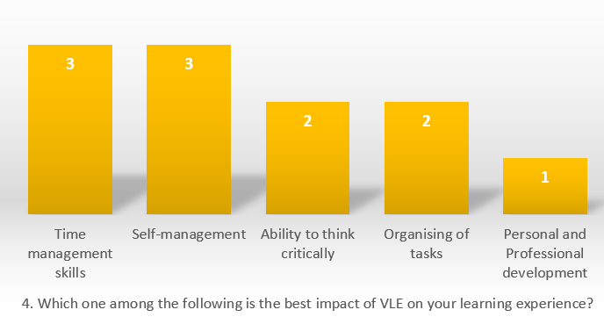
Figure 4: Impact on learning experience
In a college or any academic environment, it is important to work collaboratively. It is for the benefit of every single member of a team. If a learning environment is able to promote collaborative work, ok then the college is going towards making an equal environment for every student. According to the responses, 71% of students agree that VLE encourages them to work with others. However, the number of negative responses is also a little high, and there is a requirement of focus from the college.
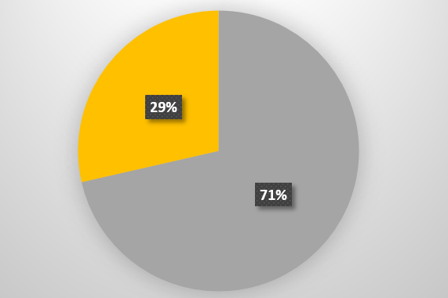
Figure 5: Encouragement towards collaborative work
Another essential factor for both teachers and students is to make informed decisions. If both teachers and students can take proper decisions, then the academic environment will stay away from unnecessary conflicts. It will enable all of them to maintain the smooth progress of education. Only 40% of students think that there are possibilities of making better-informed decisions through VLE. 30% of the responses are moderate, and there are 30% negative responses. Somehow, it shows that the application of VLE requires improvement.
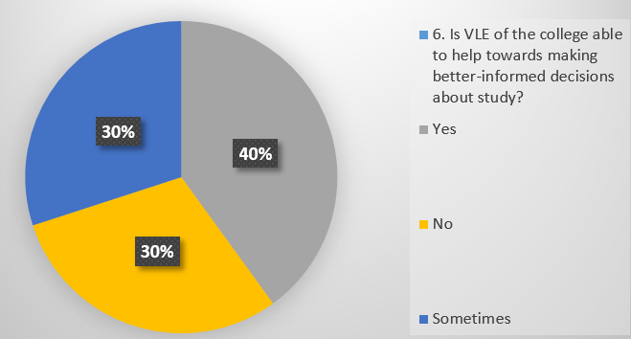
Figure 6: Better-informed decisions through VLE
There are many digital trends in the current educational system (Xiaoyun and Siqi, 2018). It is vital for every college to follow that to make its students familiar with different digital environments. There are requirements for strategies to work according to the trends. 80% of the respondents say that the college is able to modify its VLE according to the trends. It is more important to focus on the other two responses because those are negative. The college needs to identify the reason for negative answers to fulfil the remaining gaps in the learning environment.
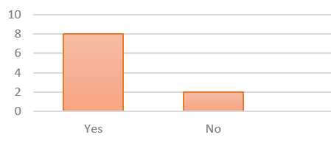
Figure 7: VLE according to trends
The following question is to know if VLE is able to influence positively on the teaching and learning environment of the college. It is all about the proper flow of information and maintenance of communication through different media. 50% of the students agree that the college is able to really influence the teaching and learning process. Hence, it shows the students are enjoying the learning environment, and there are positive vibes among teachers and learners.
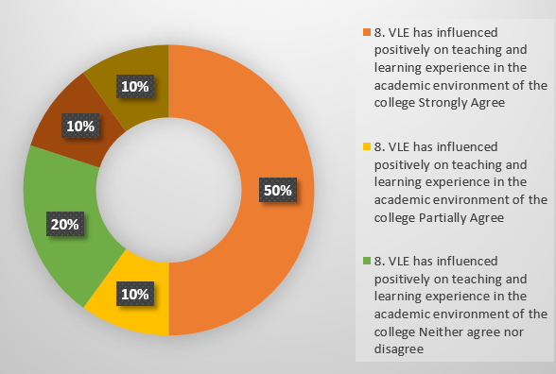
Figure 8: Positive influence of VLE on teaching and learning
The following question is to know if VLE is able to improve the ways of different approaches towards lessons. The teaching method of a particular relationship may or may not be appropriate for students with different learning styles. If VLE is able to provide opportunities with different ways for new approaches, then it will be effective for the learning environment. In overall, 60% of students, it is great with this fact. 20% of students have neutral responses, and 20% of students have negative responses. Hence, the progress is on the correct track, but there is also the scope of improvement.
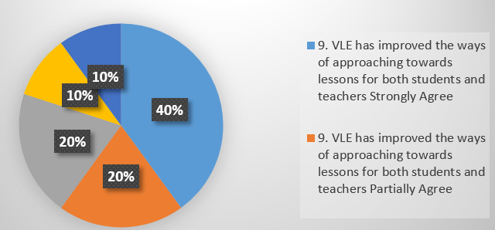
Figure 9: Approaching lessons
The learning environment is essential because it has the capacity to engage students with studies. This is the power of attracting students towards it. The college is able to implement it appropriately as most of the students agree with it. 8 out of 10 students have agreed that there is the development of ways through VLE and the students are able to make a better engagement with studies. There are also a few negative responses, and those can be because of individual perceptions. Most importantly, not even a single student has chosen the option of 'strongly disagree'. It can also be taken as a positive complement.
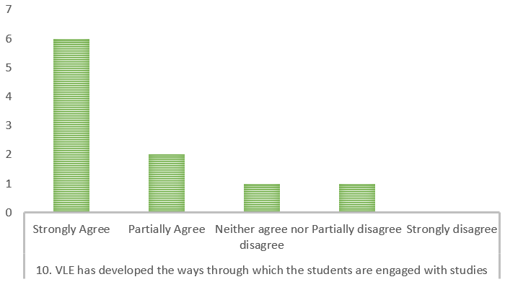
Figure 10: VLE and engagement of students with studies

2.2 Secondary Research
The impact of a learning environment varies depending on the scenario. It is also partially controlled by the requirement of students. If VLE is not able to fulfil the individual requirements that it can be considered as effective. The following image shows that VLE is effective from the perspective of a student if the learning environment is able to respond to the student's queries and improve the overall learning experience (Herrera Mosquera, 2017). Both of these options also have individual votes, and it shows improving the learning experiences of students is preferable than solving the queries of them. It is because solving queries is also a part of the learning experiences. Hence, there is not any individual requirement of it.

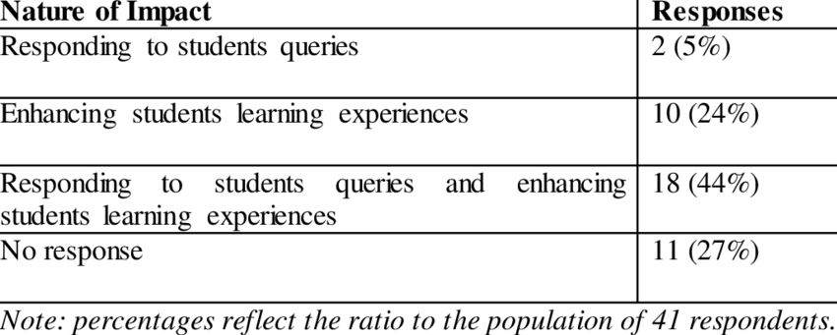
Figure 11: Nature of VLE’s impact
(Source: researchgate.net, 2018)
VLE benefits students with different positive impacts, but according to this research, the students think that allowance towards differentiation of works is the primary benefit. On the other hand, there are also many other positive responses (Hussain et al., 2018). The students feel there is flexibility on the outlines of homework. It also impacts positively on communication and new job opportunities. There are possibilities for enhancing student learning and a variety of activities. All of these have equal preferences by the students.
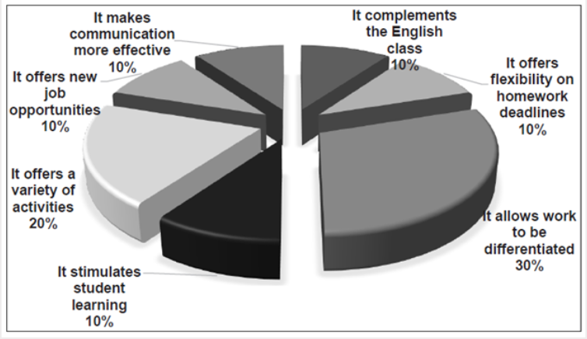
Figure 12: Benefits of VLE
(Source: redalyc.org, 2017)
VLE has different purposes in a college, but the success of those depends on appropriate implementation. The virtual learning environment is used for designing appropriate contents and presentation. It is also directly connected with digital learning. There is a requirement of software and tools with a ready network (Omar and Geer, 2018). A learning map is also necessary for sharing the details with students. A college can modify the framework of VLE according to its objectives or courses. Different contents can also be posted there such as learner guide, online library, mentor support, counselling etc. All of these are for fulfilling the individual needs of the students (Ryan and Poole, 2019).
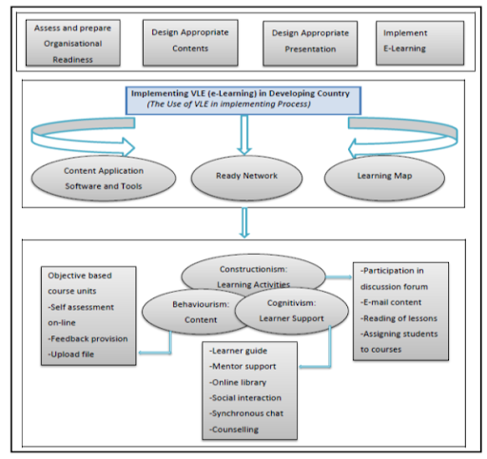
Figure 13: Use of VLE
(Source: Ryan and Poole, 2019)
The following data is about the impact of a virtual learning environment on moodle. It is to know if the model of a college is able to impact positively on the effectiveness of a student. It is also required to be connected with the individual learning importance of a student. Only then it can create engagement (Waheed et al. 2020). The following chart of responses so that the students learn their primary thing from moodle. It also shows that the quality of students' learning is improved by the moodle provided by the college. Hence, the overall responses of this research suggest that it is better for a college to guide its students through moodle as it makes the process of learning more straightforward for them.
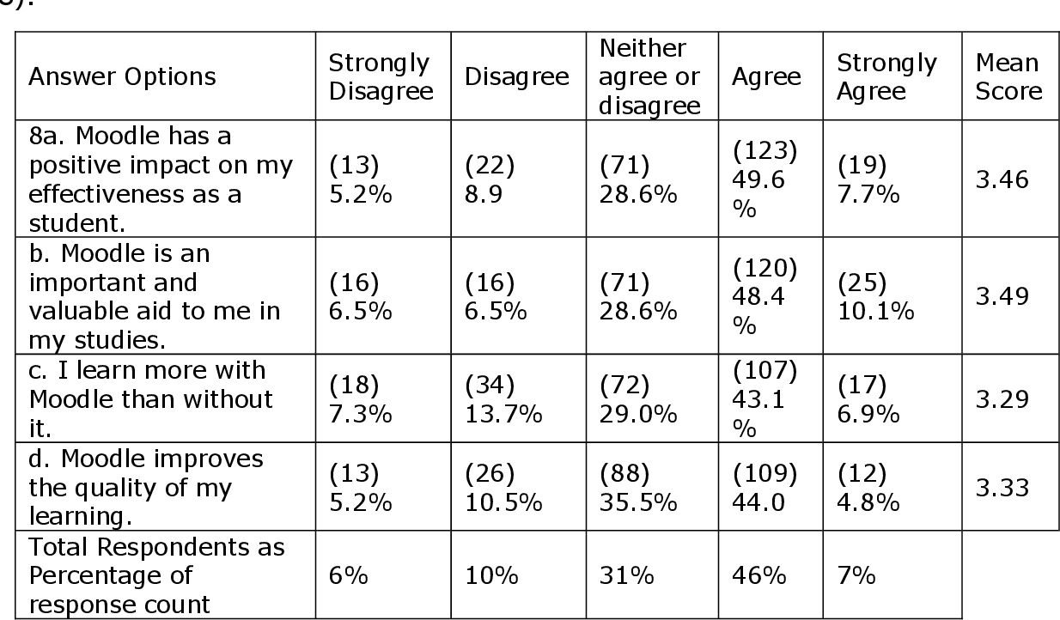
Figure 14: Impact of VLE
(Source: Waheed et al. 2020)

3. Conclusion
It is always crucial to follow a particular approach in a learning environment. The application of improper approaches makes the process of learning more complex for students. VLE is a good solution for this management of learning. Most importantly, the students also prefer it. This preference makes the application of it easier. The output of primary and secondary research is almost similar as in both cases; most of the students are in favour of VLE. There are only a few cases when VLE is not able to fulfil the individual needs. It is good for our academic environment in higher education, and the modification of existing strategies can fulfil the gaps.

Reference List
Cassidy, S., 2016. Virtual Learning Environments as Mediating Factors in Student Satisfaction with Teaching and Learning in Higher Education. Journal of Curriculum and Teaching, 5(1), pp.113-123.
Herrera Mosquera, L., 2017. Impact of implementing a virtual learning environment (VLE) in the EFL classroom. Íkala, Revista de Lenguaje y Cultura, 22(3), pp.479-498.
Hussain, M., Zhu, W., Zhang, W. and Abidi, S.M.R., 2018. Student engagement predictions in an e-learning system and their impact on student course assessment scores. Computational intelligence and neuroscience, 2018.
Ivan, Z., 2017. An impact of Virtual Learning Environments on communication process between students and instructors.
Omar, N. and Geer, R., 2018, June. virtual learning environment (VLE): Its Impact on primary school children's learning. In EdMedia+ Innovate Learning (pp. 1916-1922). Association for the Advancement of Computing in Education (AACE).
redalyc.org, (2017) Available at: https://www.redalyc.org/jatsRepo/2550/255053749007/html/index.html [Accessed on: 15/12/2020]
researchgate.net, (2018) Available at: https://www.researchgate.net/figure/Impact-of-VLE-on-student-experience-41-respondents-who-make-use-of-online-learning_tbl2_234569494 [Accessed on: 15/12/2020]
Ryan, E. and Poole, C., 2019. Impact of Virtual Learning Environment on Students’ Satisfaction, Engagement, Recall, and Retention. Journal of medical imaging and radiation sciences, 50(3), pp.408-415.
Waheed, H., Hassan, S.U., Aljohani, N.R., Hardman, J., Alelyani, S. and Nawaz, R., 2020. Predicting academic performance of students from VLE big data using deep learning models. Computers in Human Behavior, 104, p.106189.
Xiaoyun, P. and Siqi, M., 2018. The number of virtual learning environment and their effective using impact on students’ information literacy. Journal of Advances in Humanities and Social Sciences, 4(2), pp.93-103.

Appendices

Appendix 1: Questionnaire
Total number of participants: 10
1. Are you aware of all the specifications of VLE?

Yes | No
10 | 0

2. How will you term the overall impact of VLE on your learning experience?

Positive | Moderate | Negative
8 | 2 | 0

3. Which one of the following components of VLE is liked by you the most?

Personalised Learning | Long-distance learning | Real-time learning and teaching | Effective time management | Equal access for every one from anywhere
2 | 2 | 2 | 2 | 2

4. Which one among the following is the best impact of VLE on your learning experience?

Time management skills | Self-management | Ability to think critically | Organising of tasks | Personal and Professional development
3 | 3 | 2 | 2 | 1

5. Does VLE encourage you to work collaboratively with others?

Yes | 5
No | 2
Sometimes | 3

6. Is VLE of the college able to help towards making better-informed decisions about the study?

Yes | 4
No | 3
Sometimes | 3

7. Is there a regular analysis of VLE data according to the trends?

Yes | No
8 | 2

8. VLE has influenced positively on teaching and learning experience in the academic environment of the college

Strongly Agree | Partially Agree | Neither agree nor disagree | Partially disagree | Strongly disagree
5 | 1 | 2 | 1 | 1

9. VLE has improved the ways of approaching lessons for both students and teachers

Strongly Agree | Partially Agree | Neither agree nor disagree | Partially disagree | Strongly disagree
4 | 2 | 2 | 1 | 1

10. VLE has developed the ways through which the students are engaged with studies

Strongly Agree | Partially Agree | Neither agree nor disagree | Partially disagree | Strongly disagree
6 | 2 | 1 | 1 | 0

