“Module: Financial Management for the Hotel Industry”
“Module code: BMIH5007”
Lecturer: Chris Wilkin
Student: Cornelia Dumitrescu
Student ID: 2114996
“Assignment 2”

Table of Contents
Introduction 3
Discussions 3
Comparison of Insourced Housekeeping Team Vs Outsourcing Housekeeping 3
Abilities of Business Employees in Accor International 4
Cost implications related to Accor International 5
Performance results related to employees of Accor International 5
Sustainability related to Accor International 6
Employee Consistency in Accor International 7
Guest Experience in Accor International 8
Conclusions 9
References 10

Introduction
Employee engagement and retention are essential for every individual business that provides a positive structural support of business internal operating control. Through the engagement of a supportive volume of employees, the general operating structure including strategic development is also initiated that manages and formulates the general growth formulation of business on a more sustainable basis (Tuomi et al., 2021). In the present position, after the pandemic a significant level of marketing demand while initiating a huge level of employee retention support related to the hospitality business, alternatively the engagement of Russia Ukraine war also initiated the burden through huge labour charges.
This report mainly evaluates a general analysis regarding current employee engagement in the business of Accor International, UK associated with sustainability and other associated aspects.

Discussions

Comparison of Insourced Housekeeping Team Vs Outsourcing Housekeeping
The primary presence of Human Resource Management in every business is responsible to provide a significant volume of importance over the human capital which is optimised for the maintenance of business operations and processing. In a business, the presence and processing support of employee improvement initiated with the support of the HR department is generally recognised as insourced employee engagement. Alternatively, the same approach of employee recruitment while initiated with the presence of any third party is identified as Outsourcing employee engagement (Kotera et al., 2021). As per the general engagement, the primary involvement of such a housekeeping approach is mainly initiated regarding the hospitality processing mainly with the initiative of such the progressive operating position is mainly managed.
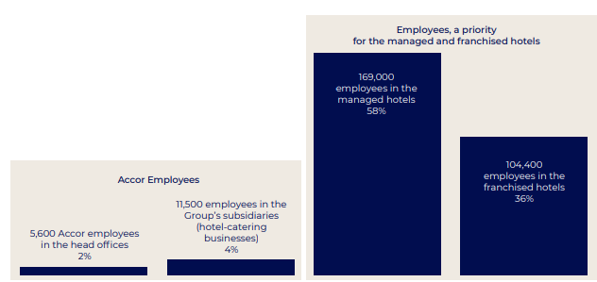
According to the primary identifications and the processing approach in the case of Accor International, the general involvement related to the HRM engagement associated with the employee processing is initiated which provides a systematic opportunity including compatibility benefits support mainly. In the present situation in the business a total of 290500 employee existences is noticed with 300 professions support that initiate a sustainable level of employee engagement approach in this business (accor.com, 2022). Out of this particular volume, 97% of employees are associated with the sustainability processing which is initiated to maintain the progressive value maintenance support on an effective basis.

Abilities of Business Employees in Accor International
Over the strategic approach of Accor International, the primary engagement and operating formulation related to positive employee engagement has been initiated for the maintenance support of the internal operating structure. In the present position for initiating a supportive employee development support including an operating stability approach the management of the business has initiated five different strategic approaches related to employee formulation and retention that also applied for enhanced comparative support of employee processing.
Sharing a common fusion related to employee processing in a systematic communication structure is established in the business which is applied to formulate the strategic goals among the employee properly. The business established proper inspirational support for every individual member including the leader in a simultaneous order which provides positive encouragement related to employee compatibility (accor.com, 2022). Considering the current operating positions important to the processing of diversity in the business is one of the primary and complementary skills approaches which are essential for establishing the performance formulation on an effective basis.
Additionally, a proper challenging approach and formulations strengthen cohesion associated with the emulation processing among individual employees and also initiate innovation processing related to Planet21 Day at Accor effectively (Accor, 2018). Along with providing importance to the sustainable development approach proper collective success formulations are also initiated in this business which provides a positive opportunity related to employee formulations on a proper and optimum basis. Even the present strategic approach related to the employee retention program and beneficial planning in this business also provides an opportunity to establish the employee formulation progress mainly. Apparently, the approach of employee talent management also initiates a formulated progressive support.

Cost implications related to Accor International
According to the basic operating approach and formulation processing support, the business consumed around €2 billion in wages and staff costs in the present accounting period. As per the present operating position support the level of business basic wages level related to employees in the present period resulted in 1129 million, out of which around 1029 million is spent for management and others to supervisors and ordinary employees (accor.com, 2022).
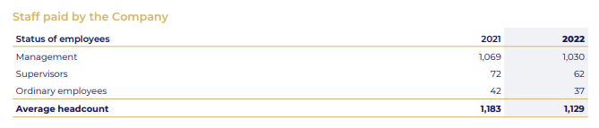In the present situation, the organisation spends around €70 million pledged related to Heartist Fund purposes that initiate a sustainable level of employee operational progress. Associated with the general operating position support the overall volume of “lost-time injury rate and severity rate of workplace accidents” in this business is around 1.56 per hour basis that initiates the optimised developmental growth effectively (Drury, 2015). “In the present period under the basic collective profit-sharing scheme of this business individual employees received €1,305 per person and a total of 3,294 employees mainly benefited from this scheme which resulted in worth approximately €263,000 during the present accounting period. Associated with the same approach the special profit-sharing reserve for fiscal year 2021 amounted to €3,934,000 and benefited 3,143 employees in the present period”. For initiating supportive promotional and social support, following the invasion of Ukraine in February 2022 the group initiated a fundraising campaign for the UNHCR that arranged more than €233,000 for employee and community benefits purposes.

Performance results related to employees of Accor International
In the present period, the organisation provides a systematic volume of importance over the employee retention approach and for such a purpose it hires around 123,596 employees. With the primary intention of formulating a proper performance development and processing in this business, the management provides a systematic volume of opportunity related to the branding approach on an effective basis which provides a systematic volume of importance over the distribution channels' marketing and loyalty services. In the present position, the applied Group’s centralised purchasing system and Académie Accor for employee training and development support initiate a sustainable processing engagement that manages the performance formulation effectively (Guilding, 2013). In the present situation with the initiative of “Be Limitless”, the management of the business provides a systematic level of focus on employee engagement and operational processing with the cultural diversity approach that ultimately initiates the progressive performance development approach on an effective basis.
Even in the present position the management of this business also initiates a developmental approach regarding the operations leadership so that a sustainable level of performance evaluation including the talent management approach can be initiated. With the same approach, the management is also intended to initiate sovereignty support including the cultural formulation approach also, so that the ultimate position regarding the organisational growth including the performance values can effectively be initiated.

Sustainability related to Accor International
In the present situation according to the basic operation structure around 42% of women engagement is noticed in the business associated with 34% managerial presence mainly. Identifying the engagement of this particular processing generally initiates a systematic sustainability formulation including and optimising cultural progressive support as well which is comprehensive for the maintenance of business operation progress (Mahiette, 2022). In the present situation for initiating proper sustainability support, the business also initiates the sustainability development programme approach mainly waiting for the initiative of which is scientifically based operational processing and maintenance approach has been initiated. The presence of this particular approach is also initiated to maintain proper formulations including the integrated operational processing support mainly with the initiative of which the sustainable development including the accountability formulation is also balanced (Hayes and Miller, 2012).
For initiating a proper sustainability development initiative support in this business during 2022, “around 2,627 employees invested in a Corporate Savings Plan (PEEG) for savings purposes and 1,977 employees invested in a Group Retirement Savings Plan (PERCO). Through the initiative of this approach, the operating development including the progressive performance structure of the business is also managed on an effective basis (accor.com, 2022). The primary involvement of a sustainable business model in this business also initiates a systematic volume of stakeholder engagement including employee population support mainly which is progressive for maintaining the operation of stability under this particular Hospital business. Associated with the present operation all processing the integration support of present financial strategy associated with the operation and formulated approach of this business initiate and optimised and formulated operation pillar support in this business that ultimately provides the effective volume of employees stability and accountability progress.

Employee Consistency in Accor International
The primary volume of employee consistency under this particular business is initiated with the engagement of an effective level of training and development basis which ultimately initiated to maintain the operation progress and other stability support more appropriately. In the present situation, 90% of employees are eligible in this business related to the ESG training approach that provides a positive Short term incentive planning structure including a proper managerial formulation approach on an effective basis.
The primary talent formulation related to individual employees initiates a systematic volume of consistency support also which is formulated with the approach of three different strategic supports (Atrill and McLaney, 2015). Proper importance to the engagement of attract, select and on-board is the primary approach of such talent journey where proper importance to the branding approach, recruitment processing and integration initiative has been initiated related to individual employees.
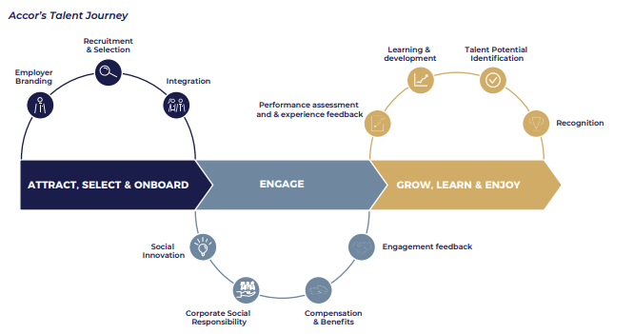
The second phase is generally indicating the engagement approach where a proper volume of importance over the performance assessment and the general evaluations of the individual employee have been initiated with the processing of social innovations, CSR support and also through the approach of compensation and beneficial processing basis. The last stage is used to identify the approach of growth learning and the general beneficial support which is provided to individual employees associated with the approach of employee consistency structure (group.accor.com, 2023). Under these particular phases along with providing general importance to the performance efficiency and equal progress related to learning and development and talent management has been initiated which provides a proper volume of recognition including the compatibility initiative approach on an effective basis. The primary environment of this particular approach is initiated to maintain the optimum value processing growth including the stability approach related to employee foundation that brings the development of business stability and operation growth initiative.

Guest Experience in Accor International
Along with providing a general volume of importance related to the operational processing the management of this particular business generally focuses on the customer-centric approach mainly which initiates a proper volume of progressive support for individual employees. The primary approach of cultural diversity initiative in this business is to formulate a progressive stability and accountability formulation support which is progressive for managing the level of business cultural attributes and other associated performance efficiencies more appropriately. Along with maintaining the importance of employee behavioural formulation, the initiated approach of the talent management program is generally applied to groom every individual employee according to the market requisition which ultimately initiated to develop the stability and structural progressive positions more appropriately.
According to the general feedback approach provided by individual customers, the service and operation maintenance of this particular hospitality business provide a positive response which indicates a proper volume of customer engagement and revenue formulation support in general. A proper volume of positive responses including an optimised progress approach generally initiates 5-star rating support to this particular hospitality business along with a proper volume of revenue-generating positivity (Tripadvisor.co.uk, 2023).

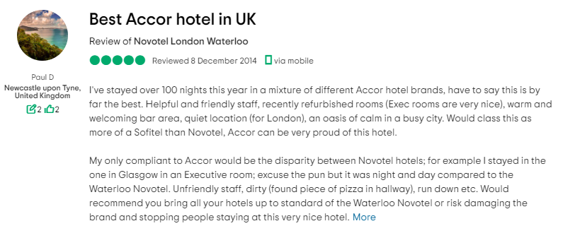

Conclusions
In summary, the engagement of both the insourced and outsourced employee engagement is generally noticed in Accor International; however, the level of insourced employee level is comparatively higher. Proper business employee engagement in this business initiates a sustainable operating opportunity including an optimised processing approach that manages the value chain growth. The present initiative approach of insource housekeeping processing in this business initiates a systematic development including the cultural stability formulation approach mainly which is optimised for the maintenance support of business performance growth more appropriately. The environment of this type of approach including the present diversity support in this business is also to initiate proper structural growth including some of the optimised value maintenance approach effectively that brings the ultimate benefit of business stability and accountability.

References
Accor. (2018). Accor – Newsroom | North, Central America & Caribbean | AccorHotels Celebrates Planet 21 Day with Rollout of New Global & Regional Commitment. [online] Available at: https://press.accor.com/americas/accorhotels-celebrates-planet-21-day-with-rollout-of-new-global-regional-commitment/?lang=en [Accessed 12 Jun. 2023].
accor.com. (2022). 5-essential-practices-employee-engagement. [online] Available at: https://group.accor.com/en/Actualites/2019/11/5-essential-practices-employee-engagement [Accessed 12 Jun. 2023].
accor.com. (2022). Annual report . [online] Available at: https://group.accor.com/en/finance/results-and-publications/financial-result [Accessed 12 Jun. 2023].
Atrill P, and McLaney E (2015) Management Accounting for Decision Makers, FT Prentice Hall
Drury C (2015) (9 th Ed) Management and Cost Accounting, London, Prentice Hall
group.accor.com. (2023). Accor transforms the guest experience. [online] Available at: https://group.accor.com/en/Actualites/2021/04/digital-hotel-ibis-styles-london-gloucester-road [Accessed 12 Jun. 2023].
Guilding, C.(2013) Accounting Essentials for Hospitality Managers, London, Taylor and Francis.
Hayes, M. and Miller, A. (2012) Revenue Management for the Hospitality Industry, London, Wiley
Kotera, Y., Adhikari, P. and Sheffield, D., 2021. Mental health of UK hospitality workers: Shame, self-criticism and self-reassurance. The Service Industries Journal, 41(15-16), pp.1076-1096.
Mahiette, M. (2022). Accor sets its employees on the path to sustainable transformation. [online] Accor – Newsroom. Available at: https://press.accor.com/accor-sets-its-employees-on-the-path-to-sustainable-transformation/?lang=en [Accessed 12 Jun. 2023].
Tripadvisor.co.uk. (2023). Review: Best Accor hotel in UK - Novotel London Waterloo, London - Tripadvisor. [online] Available at: https://www.tripadvisor.co.uk/ShowUserReviews-g186338-d192031-r243524848-Novotel_London_Waterloo-London_England.html [Accessed 12 Jun. 2023].
Tuomi, A., Tussyadiah, I.P. and Stienmetz, J., 2021. Applications and implications of service robots in hospitality. Cornell Hospitality Quarterly, 62(2), pp.232-247.

