Name | Student Number | Date | Lecturer’s Name | Your score
Ana Maria Ivan | 2505619 | 26.10.2025 | Arshad Sher | To be filled by the marker  ___/40
You will have 75 minutes to complete this assessment. It is divided into three sections: note-taking, paraphrasing and writing a paragraph.
---------------------------------------------------------------------------------------------------------------------
1. Take diagrammatic notes from the passage below using the space provided:

The university experience is not just about subject knowledge, but also about developing skills that will equip you for your future life. For starters, it's impossible to graduate without a range of people skills under your belt. You'll meet new people from different backgrounds. You'll also interact with lecturers, tutors and university staff almost daily. Another life lesson that university teaches you is taking responsibility for yourself, your own schedule and learning. A lot of university study is self-directed - it's up to you to plan and organise your work, juggle multiple projects and manage deadlines – you will need to develop self-motivation if you want to succeed. Let’s not forget learning how to overcome obstacles; whether academic, work-related or personal, you'll face your fair share of hurdles as a student, but you will develop resourcefulness and resilience in the process. If you were a bit unorganised before you went to university, you won't be by the time you leave. To successfully navigate student life you'll need to handle a variety of study, work, social and personal commitments and the only way to do this is with organisation and time management. Finally, university provides plenty of opportunities to work on and boost your confidence: you'll work in groups, deliver presentations, complete assessments and maybe even become a class representative.
Adapted from: https://www.prospects.ac.uk/applying-for-university/university-life/7-life-skills-youll-learn-at-university

Space for your notes (max 12 marks):
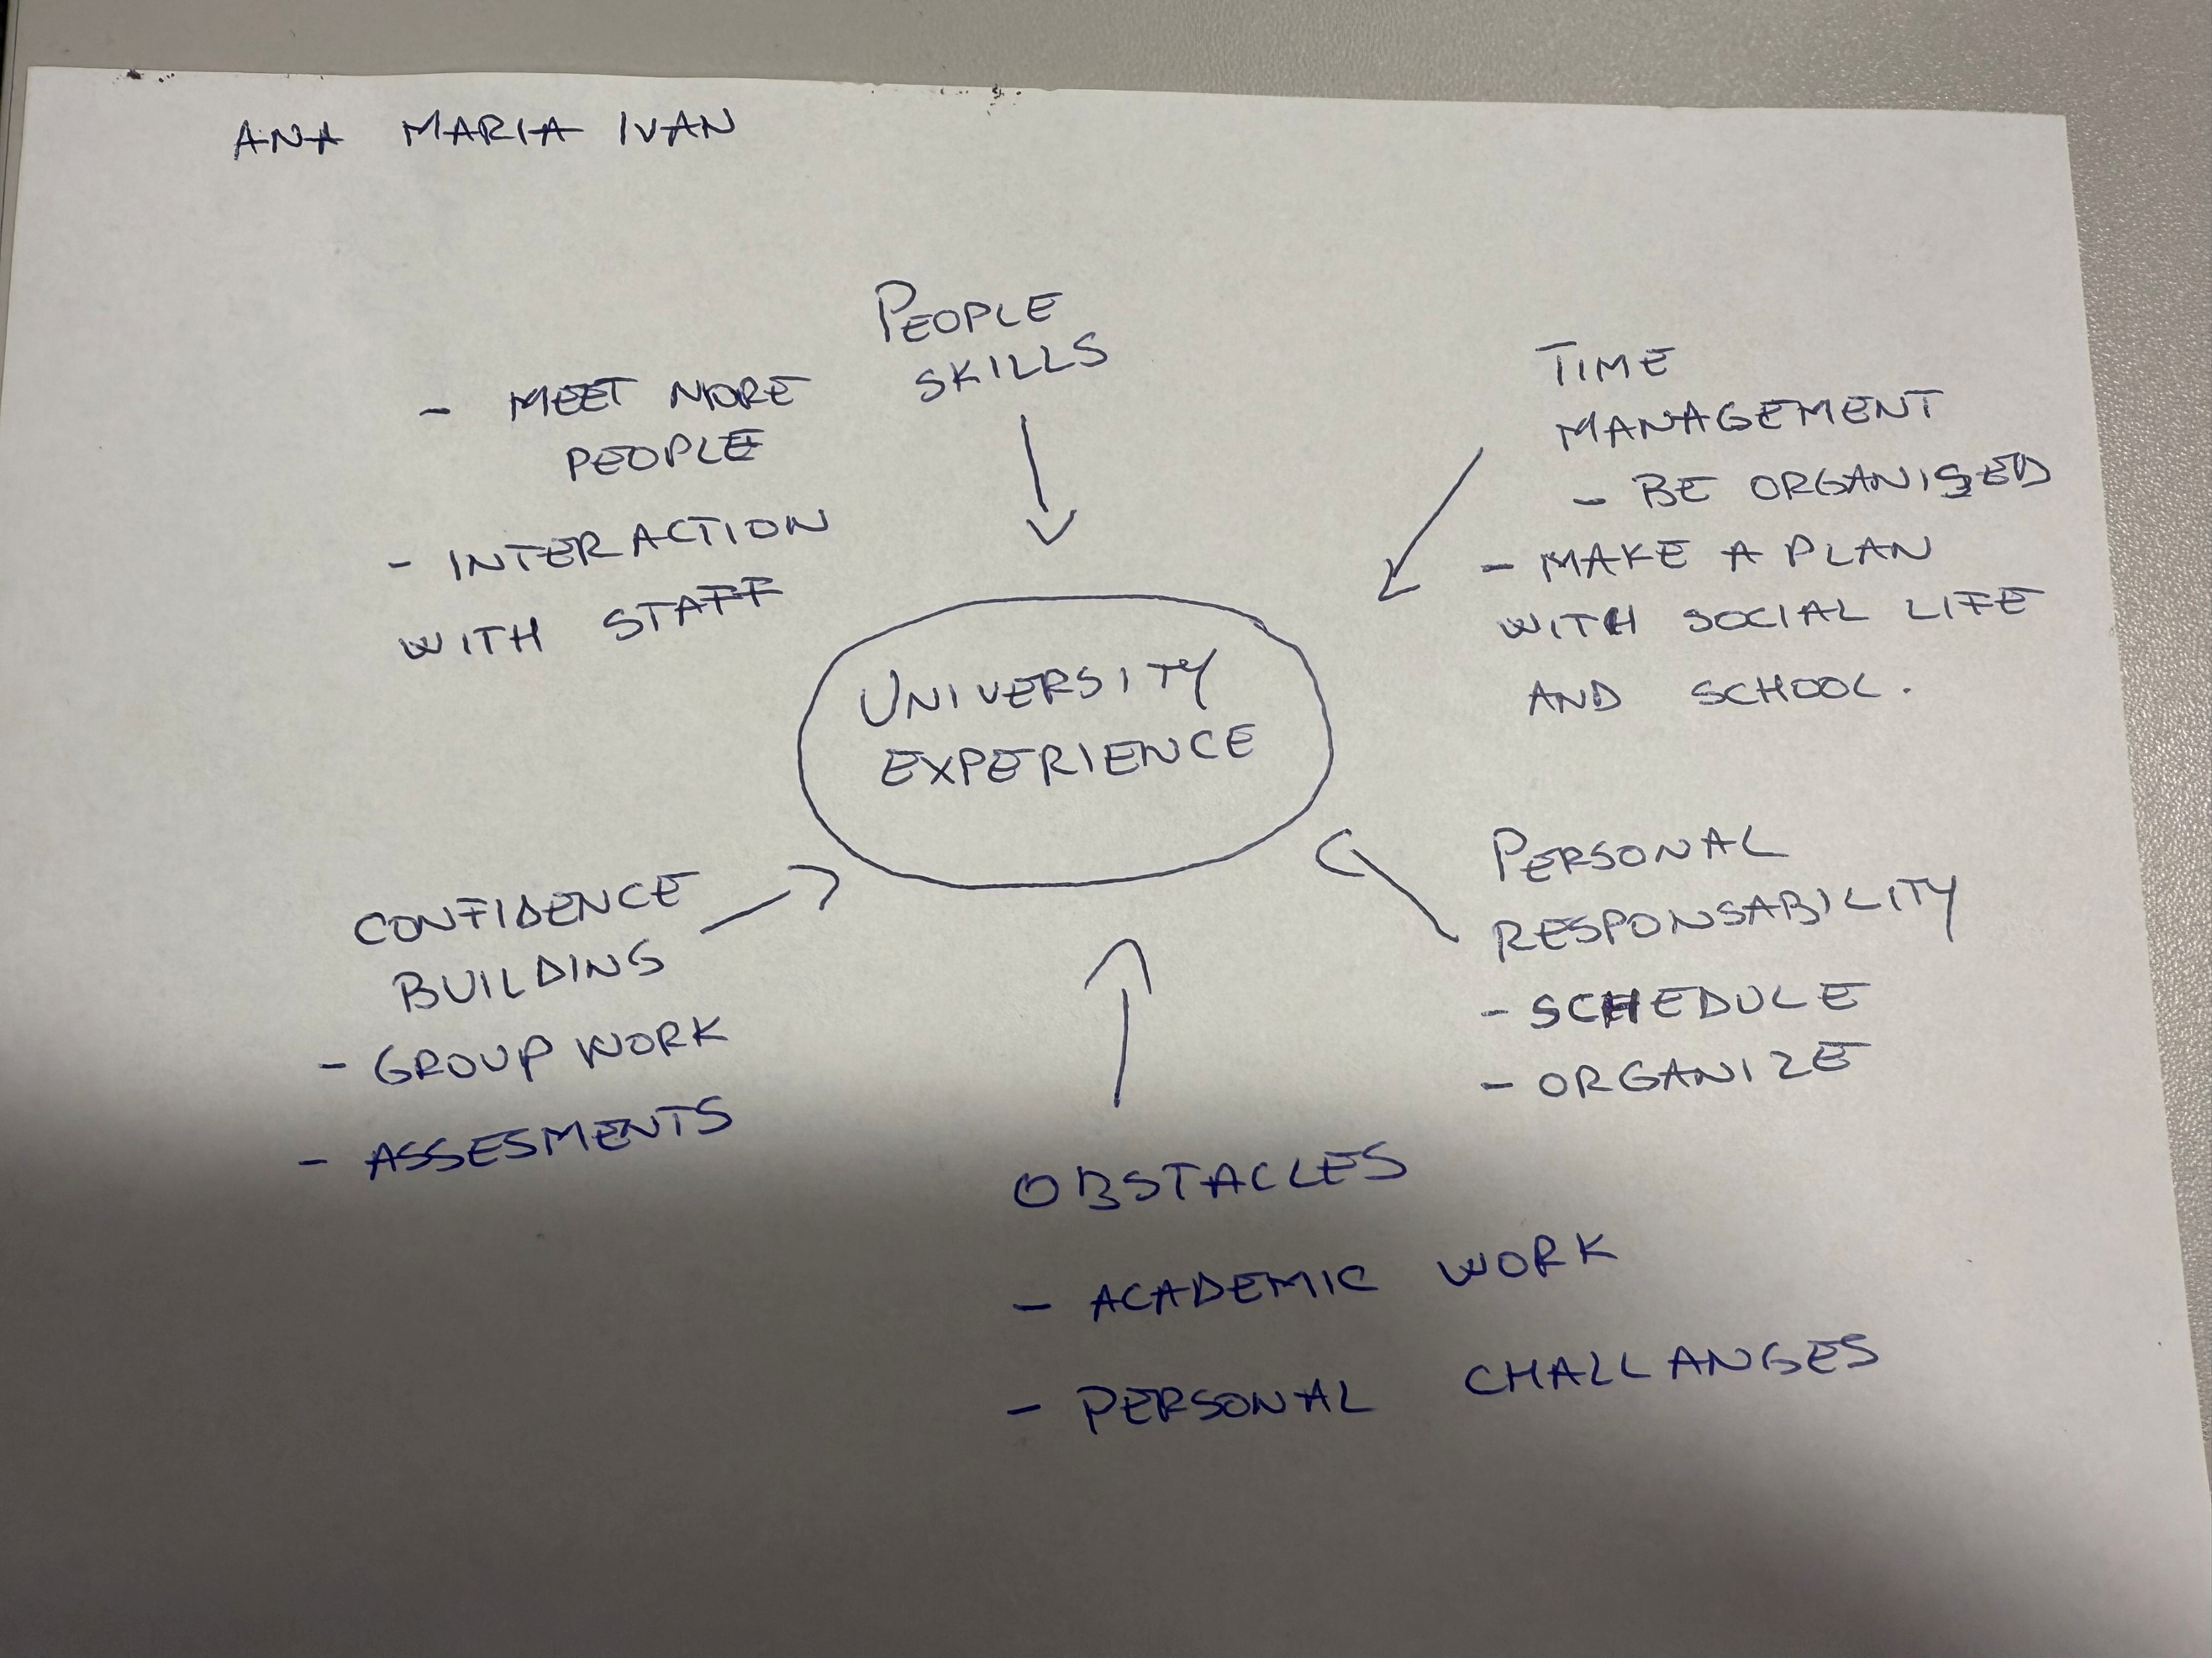

2. Paraphrase the following sentences (max 3 marks for each, max 12 marks in total):

- To successfully navigate student life you will need to handle a variety commitments.

_To_manage_student__life__more_easily,You_will_need_to_have_a_lots_of__responsabilities.__________________________________________________________________________________________________________________________________________________________________________________________________________

b) You will need to develop self-motivation if you want to succeed at university. _____________________________________________________________________________________________Succes at university depends on your ability to build self-motivation.
____________________________________________________________________________________________________________________________________________________________________________________________________________________________________________________________________________________________

c) Many students find it challenging to manage stress during assessment periods. _____________________________________________________________________________________________A large number of student struggle with stress in the exam periods.
______________________________________________________________________________________________________________________________________________________________________________________________________________________________________________________________________

d) Frequent reading can help you become a more effective communicator.

______________________________________________________________________________________________Reading regulary can improve your ability to understand ideas clearly. ___________________________________________________________________________________________________________________________________________________________________________________________________________________________________________________________________________________________

3. Write a well-structured paragraph (8 sentences) on the following topic:

Effective time management techniques for university students

Your paragraph must be written in full sentences (no bullet points) and in an academic style.

(max 16 marks in total)

_______________________________________________________________________________________________
__Effective time management is essential for students to balance their personal life and studies.They need to create a plan in which to organize their activities. To transform the large break into smaller. Reduce the stress and stay calm. To maintain positivity.Prioritizing task using the Eisenhower Matrix. Set SMART Goals:Specific,Measurable,Achievable,Relevant,Time-bound.By applying these strategies consistently, students can stay organized, meet deadlines, and achieve academic success.
____________________________________________________________________________________________________________________________________________________________________________________________________________________________________________________________________________________________________________________________________________________________________________________________________________________________________________________________________________________________________________________________________________________________________________________________________________________________________________________________________________________________________________________________________________________________________________________________________________________________________________________________________________________________________________________________________________________________________________________________________________________________________________________________________________________________________________________________________________________________________________________________________________________________________________________________________________________________________________________________________________________________________________________________________________________________________________________________________________________________________________________________________________________________________________________________________________________________________________________________________________________________________________________________________________________________________________________________________________________________________________________________________________________________________________________________________________________________________________________________________________________________________________________________________________________________________________________________________________________________

