Mohammed Dampas
2522564
E-Portfolio
Learning in the Digital Era
Contents
Task 1 3
Introduction 3
Communication Skills 3
Critical Thinking & Problem Solving 3
Teamwork & Digital Skills 3
References 4
Task 2 5
Introduction 5
Why Teamwork Matters 5
Mind map 6
Application to Your Career 6
Task 2b 7
References 8
Task 3 9
Introduction 9
What is Virtual Collaboration? 9
Benefits 10
Challenges 10
Conclusion 10
Part B – Evidence of Using RefWorks 11
task 4 14
Task 4 15

Click the link below to view the home e-portfolio
https://sites.google.com/view/dampasportfolio/home


Figure 1 shows home page of the e-portfolio

Task 1

Introduction
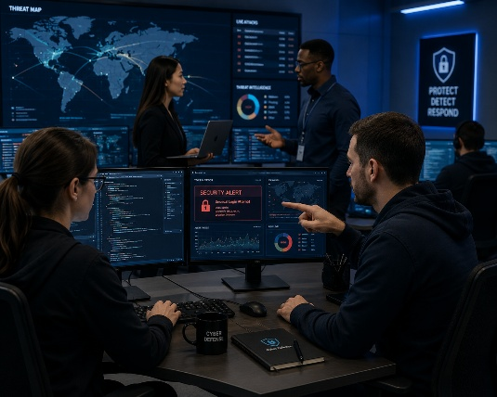
Technical expertise alone is no longer sufficient for graduates entering the cybersecurity field. Employers are increasingly looking for candidates with both technical expertise and transferable skills such as communication, teamwork, critical thinking, and lifelong learning [1]. These brief outlines the main academic and professional abilities required for success in cybersecurity, as well as how acquiring these skills throughout university helps with future career growth.
Figure 2 cybersecurity professionals

Communication Skills
Effective communication allows cybersecurity specialists to communicate complicated technological challenges to clients, management, and non-technical stakeholders [2]. Effective written and verbal communication enhances incident reporting, documentation, and teamwork. Report writing, presentations, as well as group projects at university allow students to hone their communication abilities and prepare them for professional careers.

Critical Thinking & Problem Solving
Cybersecurity specialists are constantly analysing threats, investigating occurrences, and developing appropriate solutions. Critical thinking promotes evidence-based decision-making and allows professionals to accurately assess risks [3]. Academic examinations, practical laboratory exercises, and research activities assist students in building critical thinking skills that are directly applicable to workplace problem-solving.

Teamwork & Digital Skills
Collaboration between network engineers, software developers, and security analysts is essential to modern cybersecurity operations. Knowledge exchange and organisational resilience are enhanced by effective teamwork [4]. Distributed teams can manage complex projects and communicate effectively thanks to digital collaboration tools like GitHub and Microsoft Teams

References

[1] A. Author, Title of Book, 3rd ed. London, UK: Publisher, 2023.
[2] B. Author and C. Author, "Graduate employability skills in cybersecurity,"
Journal of Information Security, vol. 18, no. 2, pp. 115–129, 2024.
[3] National Cyber Security Centre, "Cyber Security Careers,"https://www.ncsc.gov.uk/, accessed Jun. 30, 2026.
[4] OpenAI, "ChatGPT," https://chatgpt.com/, accessed Jul. 1, 2026.

Task 2
Why Effective Teamwork Matters in Cybersecurity

Introduction
Effective teamwork is recognised as one of the most valuable employability skills across technical professions. In cybersecurity, professionals regularly collaborate to investigate incidents, manage security risks and develop defensive strategies. Universities prepare students for these environments through
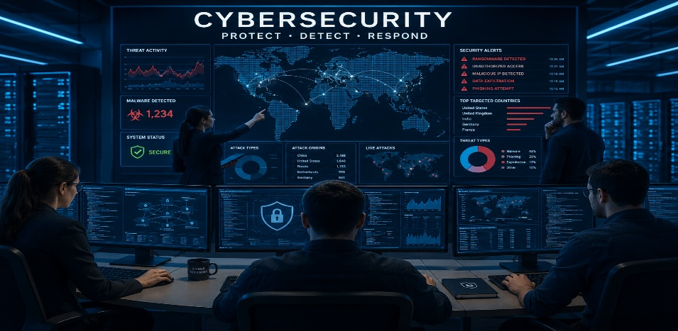
Figure 3 cybersecurity professionals

Why Teamwork Matters
Skill | Academic Discussion
Communication | Enables accurate sharing of information and reduces misunderstandings.
Leadership | Helps coordinate tasks and motivates team members.
Trust | Encourages knowledge sharing and accountability.
Problem Solving | Multiple viewpoints improve decision-making.
Collaboration | Increases productivity and innovation.
Figure 4 Teamwork Matters
Effective communication improves team coordination by ensuring that objectives, expectations and responsibilities are clearly understood [2].

Mind map
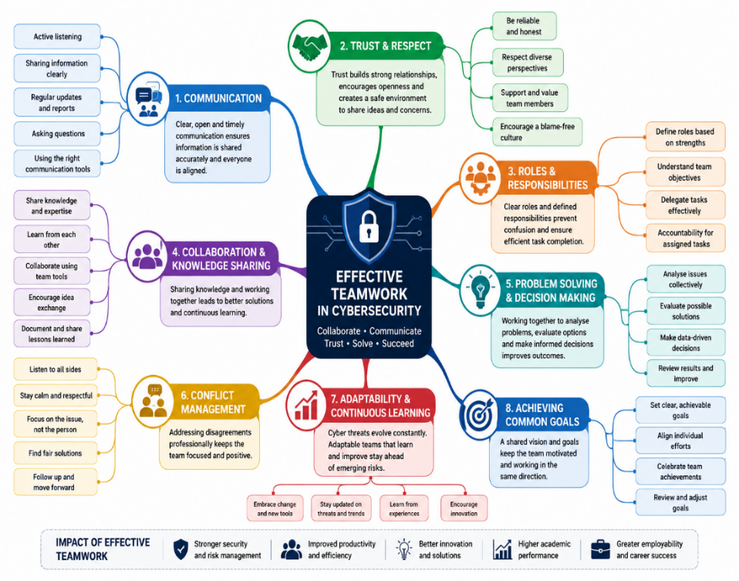
Figure 5 Mind Map

Application to Your Career
Teamwork Concept | Workplace Example
Communication | Reporting cyber incidents
Leadership | Managing incident response
Collaboration | Security Operations Centre
Trust | Sharing threat intelligence
Problem Solving | Malware investigation
Figure 6 Teamwork Concept
Security analysts rarely work independently. Responding to cyber incidents requires continuous communication between analysts, network engineers and management to minimise organisational risk [3].

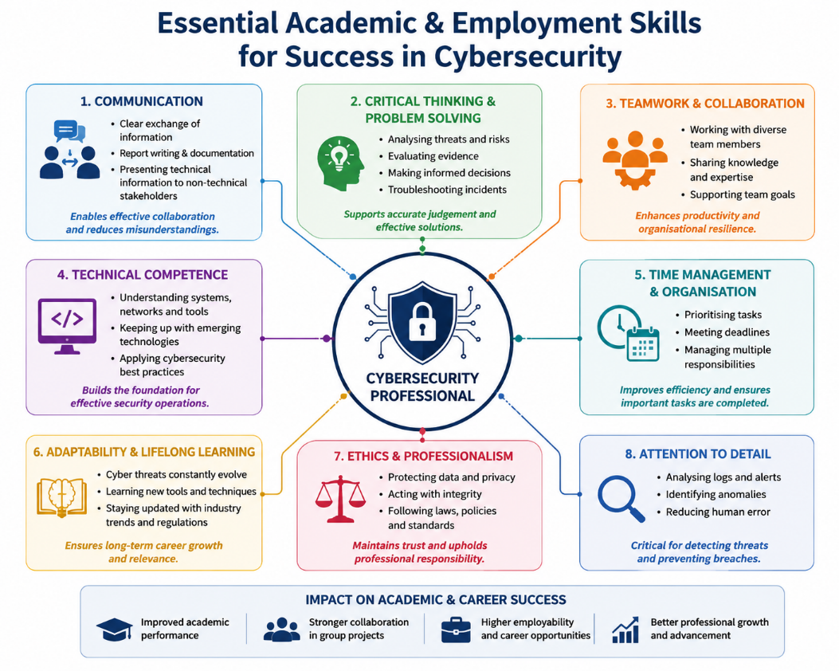
Figure 7 Essential Academic Skills

Task 2b
Click the link below to view my mind map
https://docs.google.com/document/d/1bNHJoq60ps_u8UeVht3ezA2P07m6YEjfbG1FrTA95mY/edit?usp=sharing
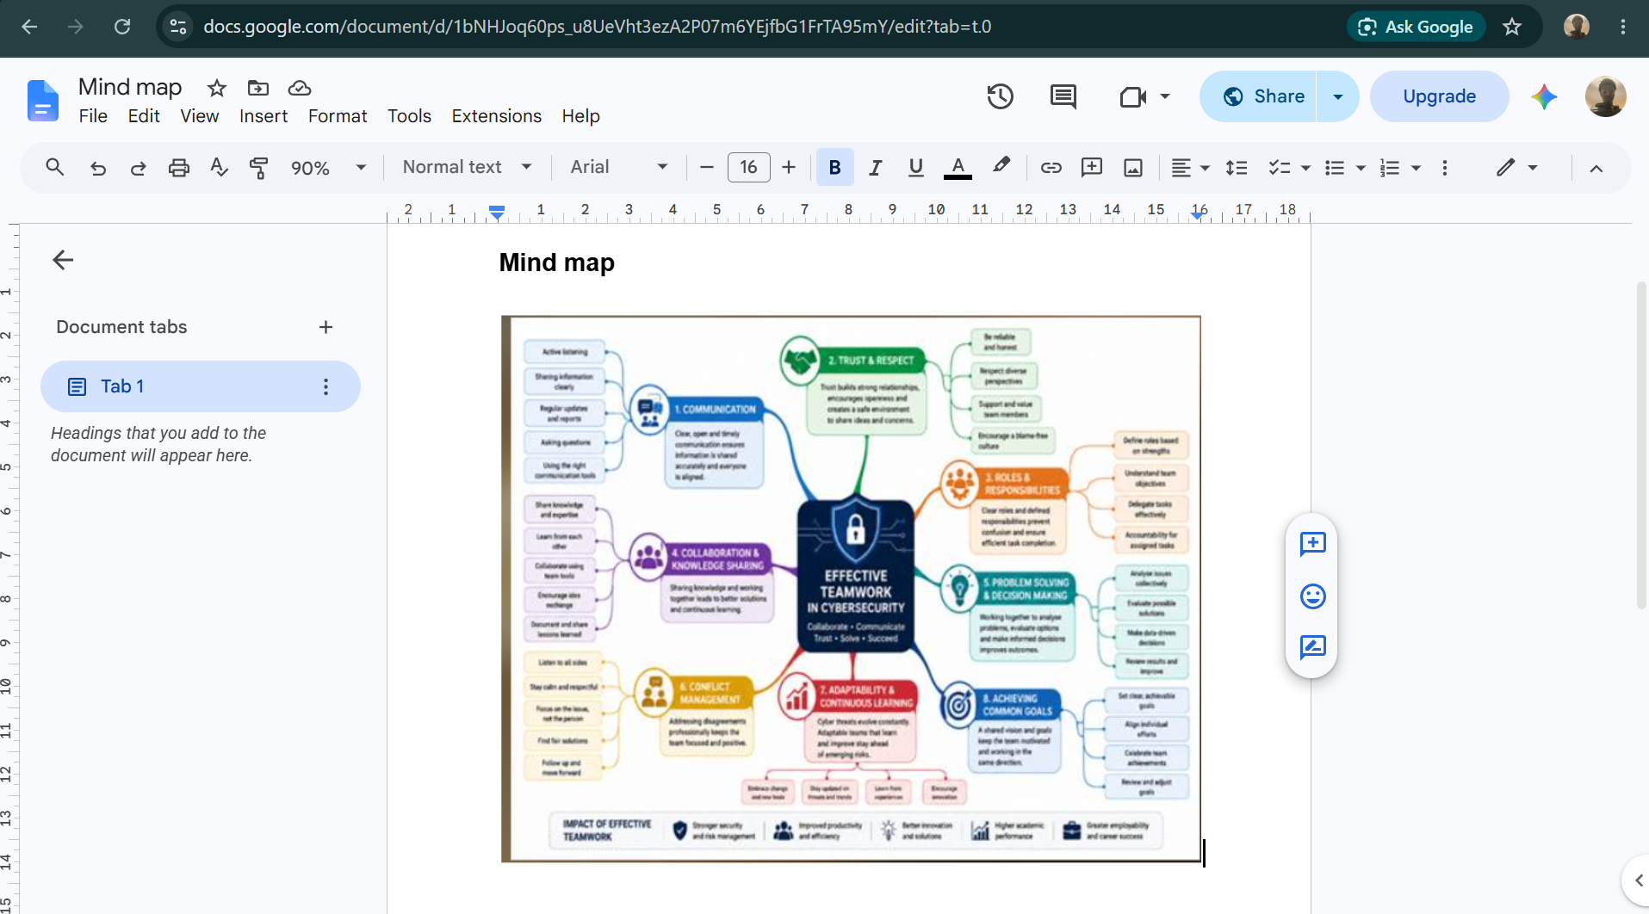
Figure 8 shows mind map

Click the link below to view/download the poster
https://docs.google.com/document/d/1qnb0_spVynV53SscQwrag-SLiy1V0rGX/edit?usp=sharing&ouid=102488912816533067760&rtpof=true&sd=true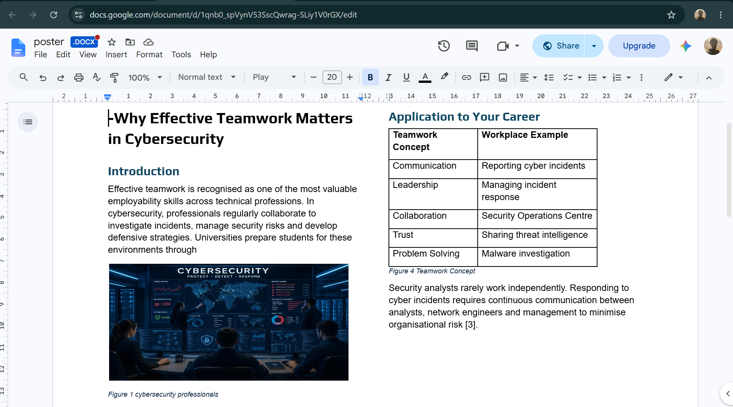
Figure 9 shows the poster

References
[1] IEEE article on teamwork in engineering education.
[2] P. G. Northouse, Leadership: Theory and Practice, 9th ed.
[3] National Cyber Security Centre.
[4] Prospects UK, "Employability Skills."
[5] OpenAI, ChatGPT, https://chatgpt.com, Accessed Jul. 1, 2026.

Task 3

Introduction
Virtual collaboration has become a crucial component of modern organisations, especially in cybersecurity, where professionals frequently work across physical boundaries and time zones. Security analysts, incident response teams, and software engineers can effectively interact, exchange information, and coordinate responses to cyber threats using digital collaboration platforms such as Microsoft Teams, Zoom, Slack, and GitHub. As businesses increasingly adopt hybrid and remote working models, efficient virtual collaboration has emerged as a vital employability skill for cybersecurity professionals [1], [2].

What is Virtual Collaboration?
Cybersecurity operations rarely rely on a single person. Instead, businesses employ multidisciplinary teams that work together to monitor networks, investigate security issues, assess threat intelligence, and respond to cyberattacks. Tanimoto et al. offer a Cybersecurity Operation Activity Model, demonstrating that successful collaboration between organisations increases security information exchange and collective cyber defence capabilities [1]. This collaborative strategy allows businesses to discover new risks faster and coordinate responses to large-scale cyber catastrophes.
Modern collaboration technology also provides organisational flexibility. Virtual teams can connect using video conferencing, instant messaging, collaborative documentation, and cloud-based project management tools. These technologies break down geographical barriers, allowing cybersecurity professionals to collaborate seamlessly across several geographies and time zones [3].

Benefits
According to research, communication is one of the most essential variables impacting virtual team success. Effective communication allows team members to share accurate information, coordinate work, and avoid misunderstandings [4]. Rapid communication is especially critical in cybersecurity, as delays during incident response can raise organisational risk.
Knowledge exchange is another key benefit. Virtual collaboration platforms allow analysts to share threat intelligence, technical skills, and lessons learnt from previous instances. This communal knowledge enhances decision-making and promotes ongoing organisational learning [1].
Virtual cooperation increases flexibility and productivity. Remote working enables organisations to hire cybersecurity specialists regardless of location while preserving secure collaboration via cloud technology and encrypted communication systems [2]. As cyber risks increase, virtual cooperation enables faster decision-making and more efficient problem-solving.

Challenges
Despite its benefits, virtual collaboration poses certain problems. One of the most important is building trust among team members. Unlike traditional office environments, virtual teams may never interact in person, making it more difficult to form interpersonal relationships. Research shows that trust is critical for information sharing, cooperation, and successful decision-making in global virtual teams [5].
Cultural differences, time zones, and various communication styles can all create communication difficulties. According to studies, ineffective communication can lead to more misconceptions, lower productivity, and poor team performance [4]. Furthermore, while employing digital collaboration platforms, cybersecurity teams must protect important organisational information through secure authentication, encryption, and access control mechanisms [1].

Conclusion
Virtual collaboration has altered the way cybersecurity professionals work, allowing for secure communication, information sharing, and coordinated incident response across geographically distributed teams. Although trust, communication obstacles, and cybersecurity concerns remain challenges, research shows that businesses may increase team performance by using effective communication strategies, fostering trust, and utilising safe collaboration tools. As a result, virtual collaboration has become an important academic and practical ability for students preparing for employment in cybersecurity.

Part B – Evidence of Using RefWorks
This screenshot shows the IEEE Xplore Digital Library being used to search for scholarly articles on virtual collaboration in cybersecurity. Appropriate keywords and Boolean operators were applied to identify relevant, peer-reviewed research suitable for this assignment before exporting the references to RefWorks.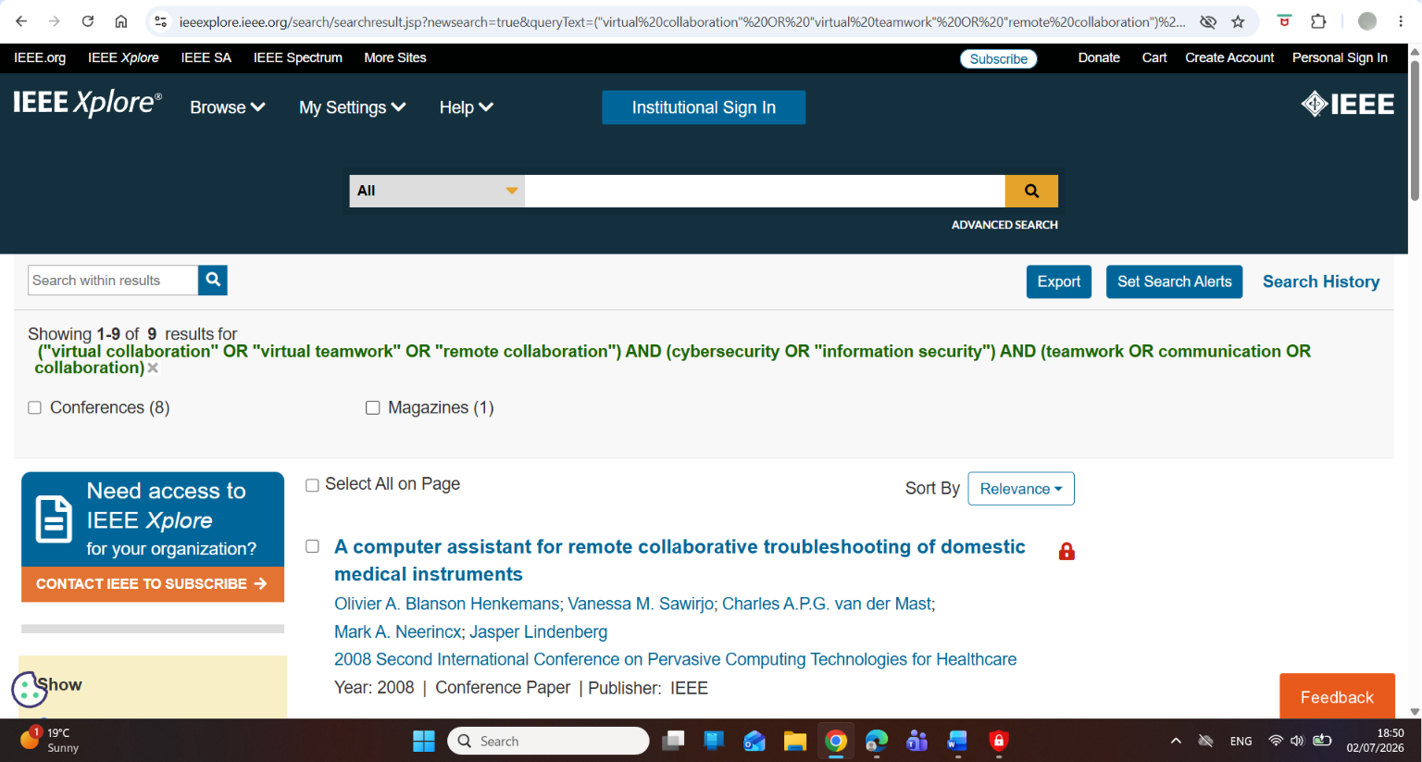
Figure 10 Searching IEEE Xplore

This screenshot shows the RefWorks homepage after signing in. RefWorks was used as the reference management tool to organise sources and create citations for this assignment.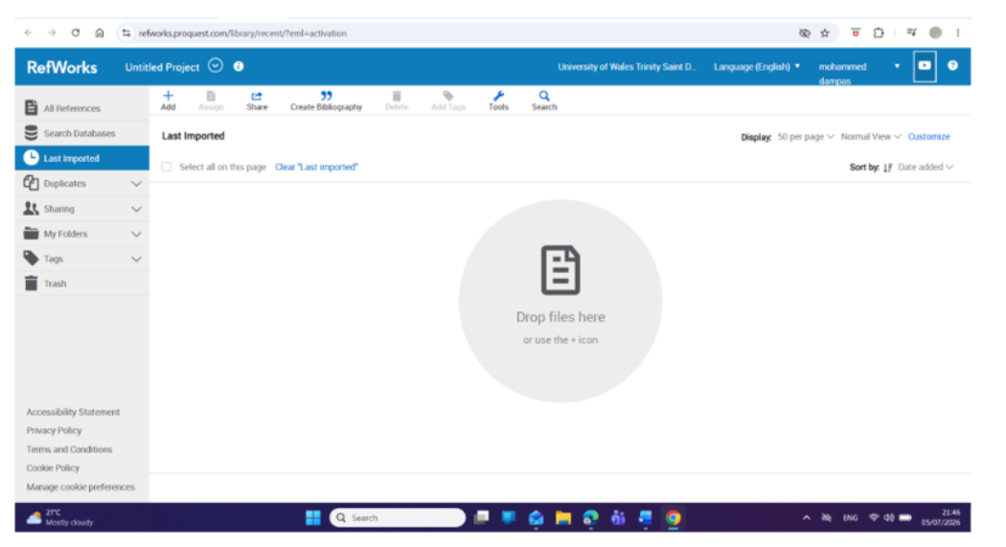
Figure 11 RefWorks login page
This screenshot shows references being imported from the IEEE Xplore Digital Library into RefWorks using the export feature. This saves time and reduces manual referencing errors.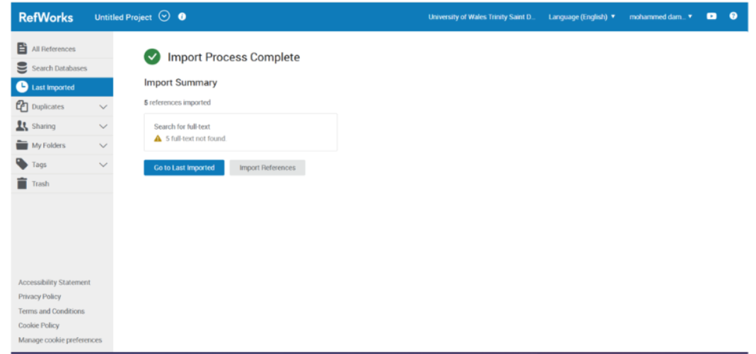
Figure 12 shows Importing references

This screenshot displays the imported references stored in the RefWorks library. The references are organised and ready to be inserted into the assignment.

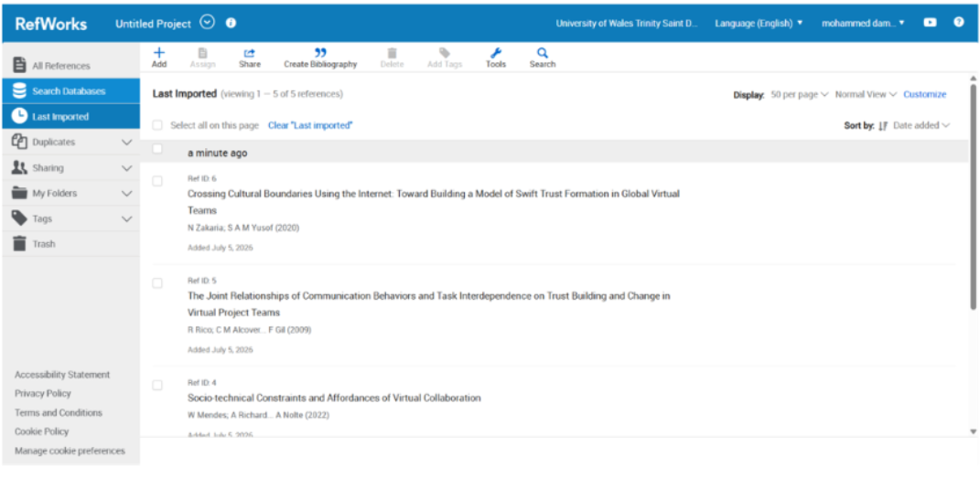
Figure 13 Reference library

This screenshot shows RefWorks generating IEEE in-text citations and the reference list automatically, ensuring consistent formatting according to the required referencing style.

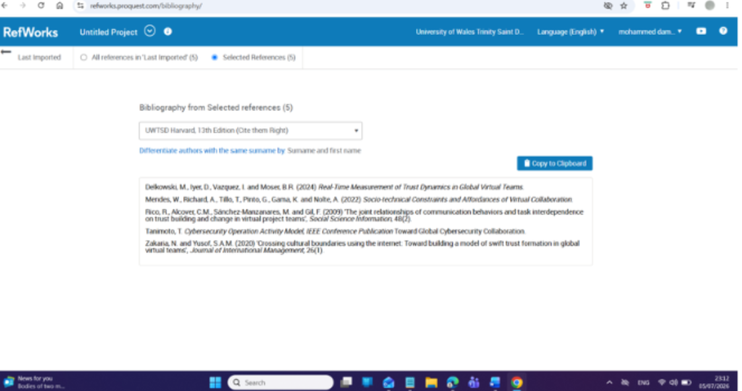
Figure 14 Citations and bibliography

Screen shot of task3 in the e-portfolio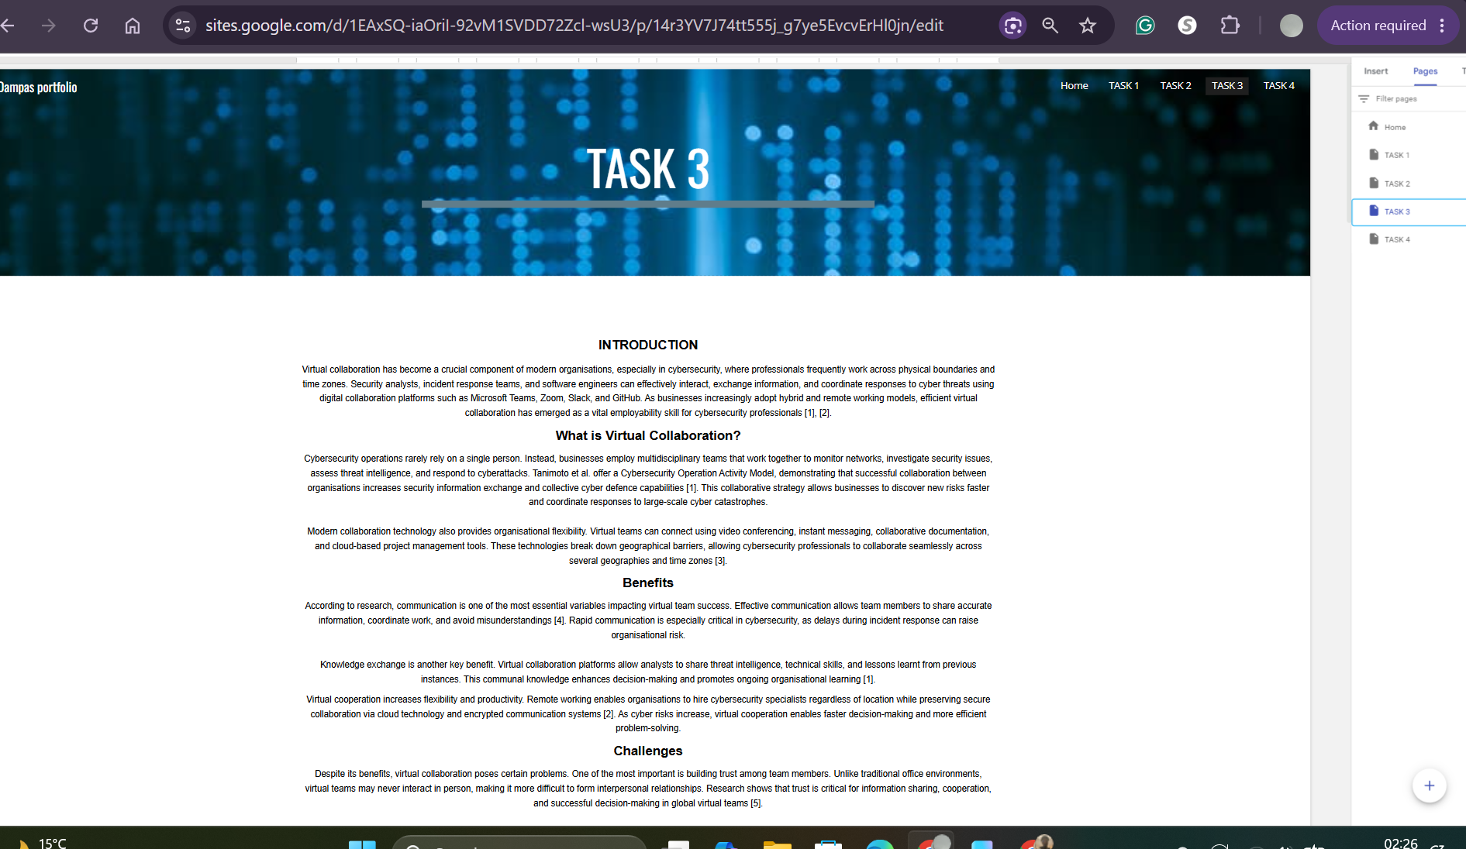
Figure 15 shows task3 answer in the e-portfolio

References
[1] T. Tanimoto, Toward Global Cybersecurity Collaboration: Cybersecurity Operation Activity Model, IEEE Conference Publication.
[2] M. Delkowski, D. Iyer, I. Vazquez and B. R. Moser, "Real-Time Measurement of Trust Dynamics in Global Virtual Teams," 2024.
[3] W. Mendes, A. Richard, T. Tillo, G. Pinto, K. Gama and A. Nolte, "Socio-technical Constraints and Affordances of Virtual Collaboration," 2022.
[4] R. Rico, C. M. Alcover, M. Sánchez-Manzanares and F. Gil, "The Joint Relationships of Communication Behaviours and Task Interdependence on Trust Building and Change in Virtual Project Teams," Social Science Information, vol. 48, no. 2, 2009.
[5] N. Zakaria and S. A. M. Yusof, "Crossing Cultural Boundaries Using the Internet: Toward Building a Model of Swift Trust Formation in Global Virtual Teams," Journal of International Management, vol. 26, no. 1, 2020.

Task 4
E-Portfolio Creation and Review
E-Portfolio Review
This e-portfolio was developed using Google Sites, a free cloud-based website builder that provides an intuitive interface for organising academic work into clearly structured
web pages. Google Sites was selected because it integrates seamlessly with Google Drive, supports the inclusion of images, documents, hyperlinks, and multimedia content, and allows online sharing through a single web link. These features make it an effective platform for presenting coursework in a professional and accessible format.
Creating the e-portfolio improved my digital literacy and organisational skills by requiring me to structure information logically and present academic work in a clear and visually engaging manner. It also enhanced my understanding of online collaboration, cloud technologies, and digital communication, which are valuable transferable skills for a career in cybersecurity. Overall, the e-portfolio provides an effective method for showcasing both academic achievements and practical skills developed throughout this module.

A screenshot of the home page in my e-portfolio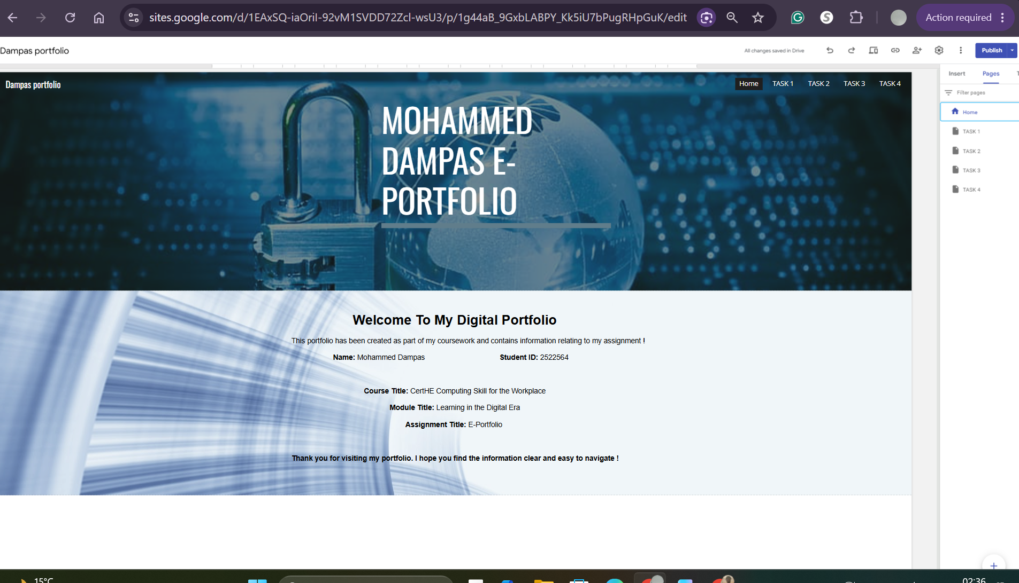
Figure 16 shows the home page

A screenshot of tak1 in my e-portfolio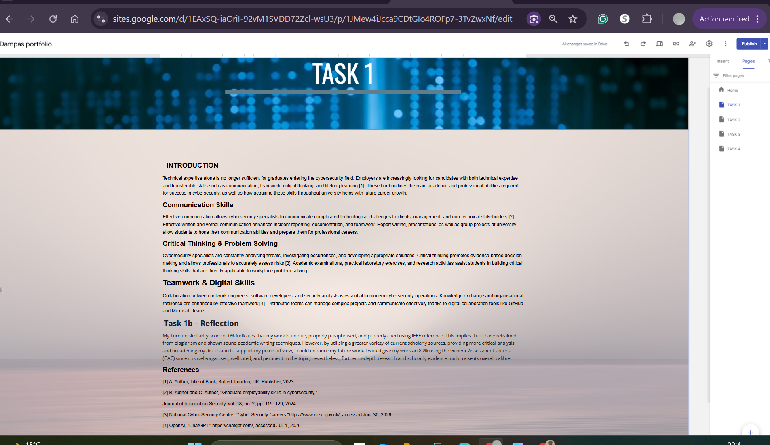
Figure 17 shows task 1

A screenshot of task 2 In my e-portfolio
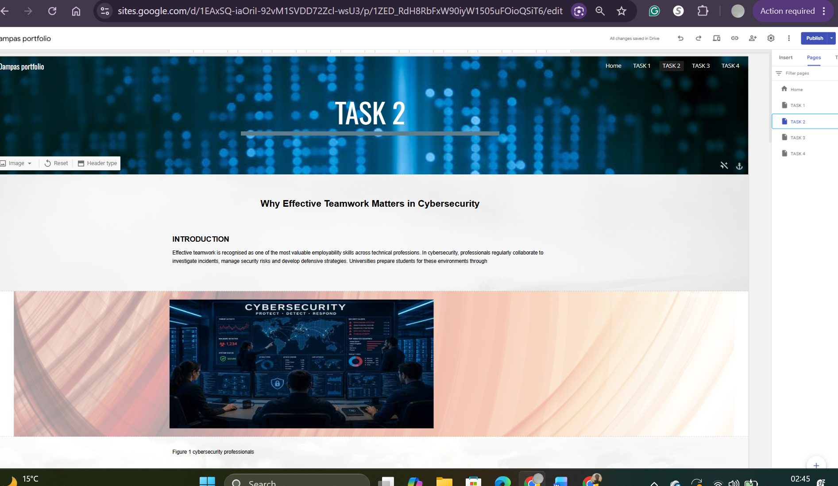
Figure 17 shows task 2
A screenshot of task 3 In my e-portfolio
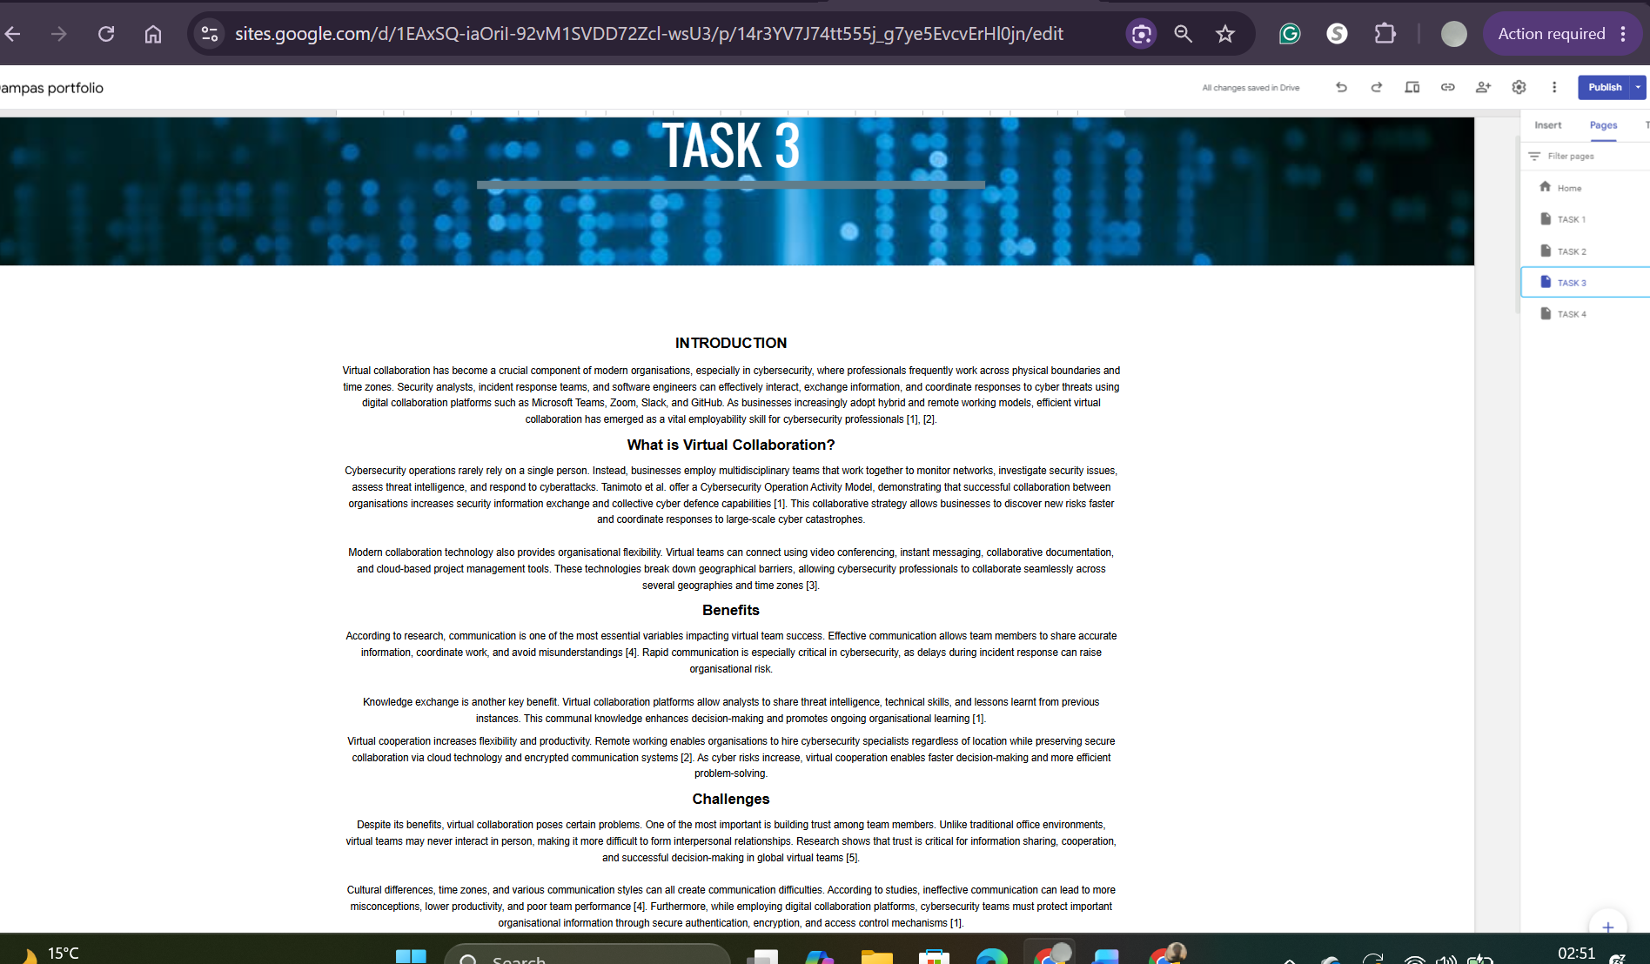
Figure 18 shows task 3

A screenshot of task4 in my e-portfolio
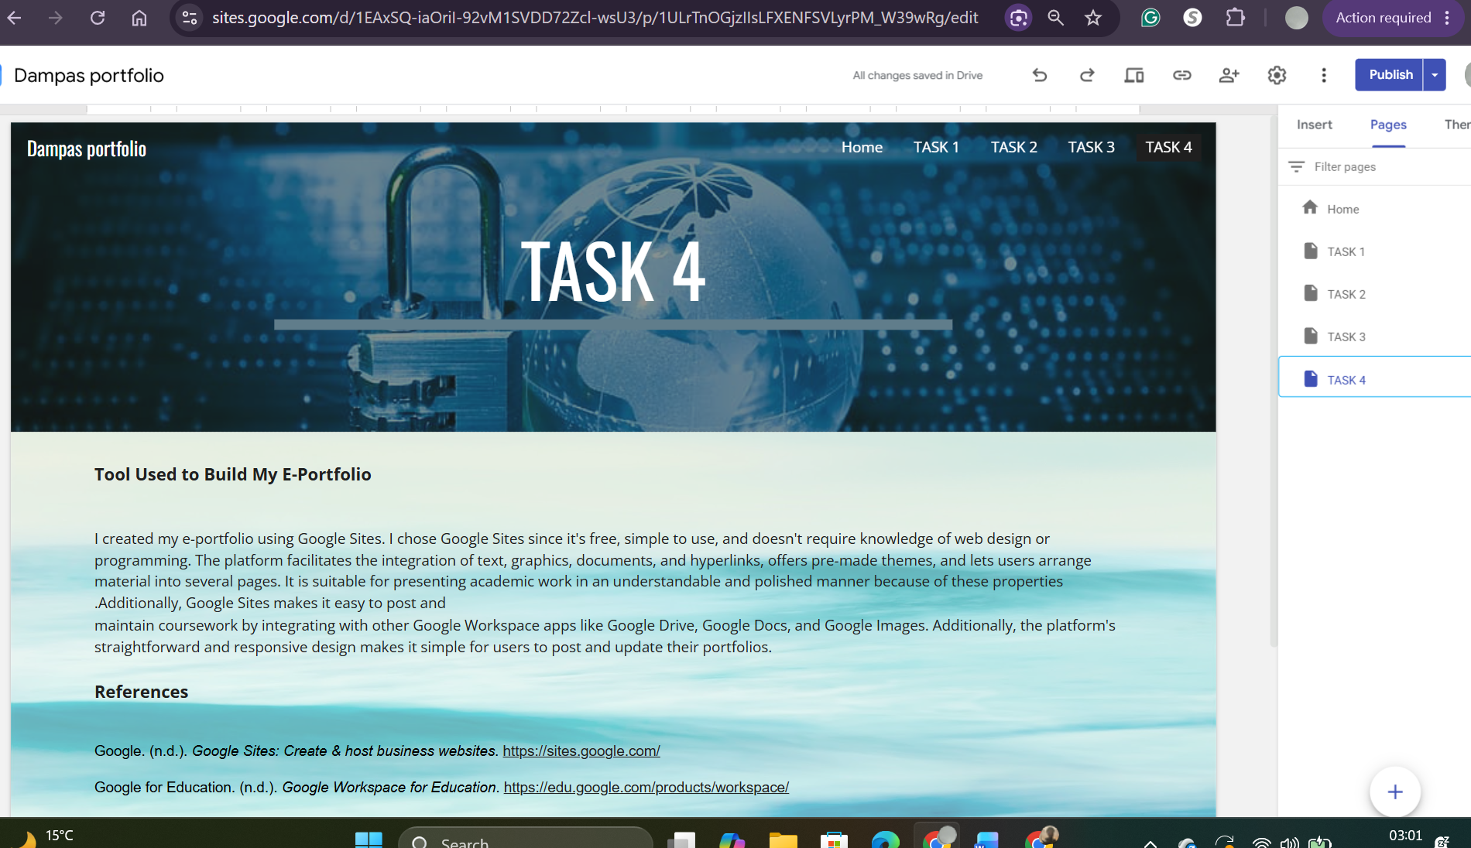
Figure 19 shows task 4

References
[1] Google, "Google Sites," Available: https://sites.google.com/. Accessed: Jul. 2, 2026.
[2] OpenAI, "ChatGPT," Available: https://chatgpt.com/. Accessed: Jul. 2, 2026.

