Leoni Lewis
Pembrokeshire College
Enterprise & innovation group project
ACDA5003

Table of Contents
Business Description 2
Trading Name 2
Legal Classification & Business Description 2
Mission Statement, Objectives & Values 2
The Marketing Plan 3
Target Market 3
Marketing Mix 5
Sales and Marketing 7
Brand Advertising 8
References 9

Business Description

Trading Name
Our trading name is going to be Grab-A-Table. We decided on this name because it is short and sweet, hasn’t been used before by competition companies and is a basic description of what our company is.

Legal Classification & Business Description
The legal classifications we decided to look into were Privacy Policy (GDPR), Cookies Policy and Terms and Conditions.
GDPR was introduced in May 2018.
- It allows individuals to the right to be informed on how their personal data will be used.
- The right to have access to what information is being held and how it is being processed.
- The entitlement to have personal data changed if it isn’t accurate.
- The right to be forgotten, this means individuals have the right to have their data removed without the need for a reason.
- The right to restrict processing, individuals can prevent organisations from processing certain details of their data.
- The right to data portability, this allows for users to access and use their data for their own purpose.
- The right to object, individuals are entitled to object to their personal data being used.
- Rights of automated decision making and profiling, this is where GDPR has put in place safeguards to protect individuals against the risk that a decision is made without human intervention. For example, individuals can choose not to be subject of a decision where the consequence has legal bearing on them or is based on automated processing.
Cookie policy is implemented to ensure that you inform your end users that you are using cookies on your website, this can be through a banner-style notice. On this you must obtain the users explicit consent. Within this you must include a link that redirects to your cookies policy so users can read it, this link should also be present in your websites footer.
Terms and conditions was looked into as it helps to protect a website and its users with clear and fair website terms and conditions. It is used to set out the legal rights and obligations for both the website owner and the users. Contained within terms and conditions are key issues such as acceptable use, privacy, cookies, registration, passwords, links to other sites, termination and disclaimers.

Mission Statement, Objectives & Values
When creating our mission statement we considered what our main purpose is, what our reason is and how to keep it short and simple. We ended up choosing the mission statement “Grab-A-Table’s mission is to help promote local businesses, inspire choice and help discover the hidden gems around West Wales.”.
Our main mission objective is “Our Aim is to provide a fast and easy to use app that will help you uncover places you never knew of, allow you to share your experiences and help you secure a table immediately”. Our other objectives are as follows:
- Locate the restaurant of desire within the application.
- Choose your favourite table. Look through a floor plan for the restaurant of your choice, state a time, choose a size of party and table placement you require.
- Choose your meals and pay, before you leave the house. Have a menu for your chosen restaurant, look through and choose your meal. You can then pay for it directly to the restaurant through the app.
- Arrive, Eat, Enjoy.
Our core company values are:
- Do the right thing: Be ethical, tell the truth, do what’s fair and don’t take shortcuts.
- Have a good attitude: Be polite, treat everybody with respect, be positive and be willing to go the extra mile.
- Team player: Work together, communicate, focus on group success and meet your commitments.
- Hardworking: Self motivated, don’t cut corners, stay focused and see things through.
- Professionalism: Skilful, Experience and present a good image.

The Marketing Plan

Target Market
The age range that we are catering our application too is from the age of 16-55. We have chosen this age range due to the popularity of smartphones within this group. In 2018 it was reported by The Statistics Portal that 95% of 16-34 year olds and 91% of 35-54 year olds owned a smartphone. [1]

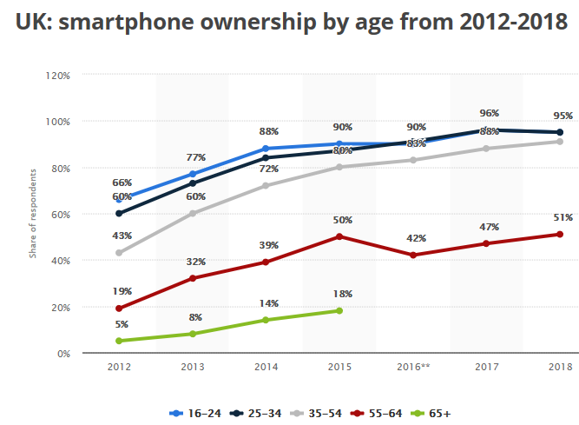
The Statistics Portal also reported that of those that owned a smartphone 93% of 16-24 year olds, 91% of 25-34 year olds, 89% of 35-44 year olds and 85% of 45-54 year olds use their smartphones daily. This dropped to just 64% of 55-64 year olds. [2]

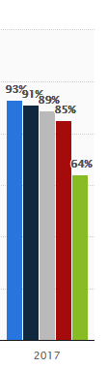
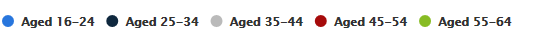
Regarding gender we will be targeting all genders as the app isn’t gender dependent or focused towards one or the other. The location of our target market is going to start with those who live in Pembrokeshire or are travelling to Pembrokeshire as tourists. Once the app is up and running successfully within Pembrokeshire we would then look to expanding the app across South Wales, this would therefore change our target market to people living in/travelling too South Wales.
The language we will be using on the app is English so the target market will have to have an understanding of English. We chose English as the language used throughout the application due to only 11% of the Welsh population aged 3+ being able to speak welsh fluently according to the 2013/14 Welsh Language Survey. In Pembrokeshire only 15% of the population can speak welsh. Those who speak Welsh fluently are able to speak English as their second language, therefore we decided that English was the best option. [3]
The target market that we are expecting to use our application are those who wish to find new/close restaurants in their area of Pembrokeshire that they have never seen before, view the menus of the restaurants before they decide where to book, would rather book a table online as they don’t like communicating over the phone and those who find it convenient to use their phones for everything else so would enjoy having an app to book their meals in too.

Marketing Mix
We used The Ansoff Matrix to get an understanding of the risks of the different marketing options we had in mind. The Ansoff Matrix was developed by H.Igor Ansoff in 1957. It has been used for years by marketers and business leaders in order to think about the risks involved with growing your business. The matrix shows the four strategies you can use to grow, analyse these risks and the idea that the further you move across the matrix the more risk involved. 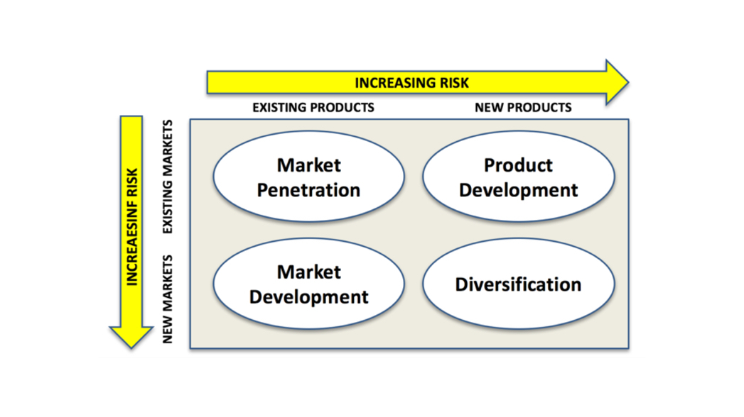
Market penetration is the safest out of all four options available. This is where you focus on expanding sales of the existing product in the existing market. As a marketer you know the product works and that it is comfortable within the market.
Product development is where you introduce a new product to the market you are already in.
Market development is placing your already existing product into a new market by finding a new use for the product or adding new functionality to it.
Diversification is the riskiest option as it is introducing a new product into a completely new market which you have never adventured into before.
In order to use the matrix you first have to look at your options.
Market Penetration
- Develop a new marketing strategy.
- Introduce a loyalty scheme.
- Have a launch price for the product or special promotions.
- Buy a competitor company.
Product Development
- Extend your product by producing different variants or repackage existing products.
- Develop relating products.
- Improve customer service or quality.
Market Development
- Target different geographical markets.
- Use different ways to sell the product.
- Target different groups of people age or gender, different to the normal customer base.
Diversification
- Sell different products or services to different customers.
From using the matrix we decided that the best option for us was to use the Market Penetration in order to develop our new marketing strategy. We have decided that on launch we are going to provide a few restaurants with a free 6 month trial, we are doing this so that they can try the application out for the first few months so we can see how it runs. It also means that we will have a select few restaurants on the application to start out with so users can see how it works, once we have gained statistics on how the application has helped these restaurants, we can approach other restaurants in the area and charge them a subscription fee to be on the available on the app.
We had also discussed offering a premium feature for users to sign up and pay a monthly fee of £2.50 where they are provided with a 10% discount off all restaurants available on the application. [4]
Our main promotion strategy is social media, by using websites such as Facebook, Twitter and Instagram we can promote our application directly. Social media would connect us with more potential customers across the county allowing them to view what our application is and what we are trying to offer them. We have chosen Facebook, Twitter and Instagram as our main social media accounts due to their huge popularity across the World.

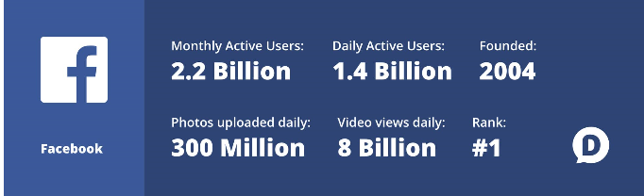 [5]
22% of the world’s population uses Facebook.
Over 50 million businesses use Facebook Business Pages. [6]

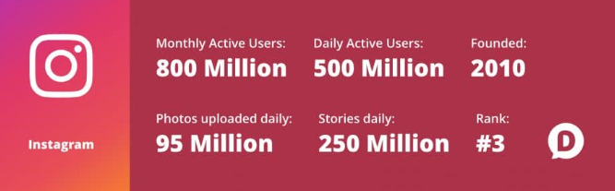 [5]
Top brands on Instagram see an engagement rate of 4.21% per-follower, this is 58 times higher than Facebook and 120 times higher than Twitter.
32% of teenagers consider Instagram to be the most important social network. [6]

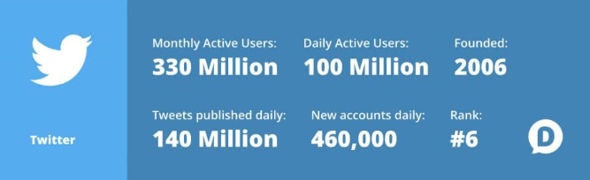 [5]
Link clicks account for 92% of all user interaction with tweets. So if we were to advertise our application by adding a download link within our tweets we could gain more interaction. [6]
PRODUCT PRICE
Through reviewing our cash-flow and considering costs of the business we decided that as a company we would take 5% of every booking taken through our app for example, if a table of 4 booked to eat at a restaurant through our app and spent £56 on food and drink while they were there we would take £2.80.
We also confirmed with each other that we wouldn’t be charging businesses to join our app, this is because we want our app to be populated with as many restaurants as possible and give a wide variety of options to customers.
PLACE OF DEVELOPMENT
We have chosen to develop our website application within Pembrokeshire, we have decided on Pembrokeshire as it is a small county which doesn’t have an application available like the one we are planning on creating. Once we have developed the application within Pembrokeshire we would like to expand to South Wales and eventually the whole of Wales.
DISTRIBUTION METHOD
To distribute our website application we are going to use the Apple App Store and Androids Google Play Store. For users to access our website through the use of laptop or PC we are going to share a link to our website throughout our social media sites in order to gain popularity.

Sales and Marketing
The basic sales funnel has been applied to businesses across the world for numerous years. The stages of the funnel include:
- Awareness: The moment a customer first discovers the brand, product, etc.
- Consideration: They are interested in the brand/product/service but aren’t ready to purchase anything. In this stage customers may compare what you are offering against competitor companies.
- Conversion: When a user makes the choice to buy.
- Loyalty: Users who buy products from your business regularly find it hard to look elsewhere.
- Advocacy: Users who recommend you to others.
The main thing to notice about the funnel is that it doesn’t end when a purchase is made. [7]
From looking at the basic sales funnel and how it would fit into our business sales and marketing plan it would look something like this:
- Awareness: Customer finds us through a recommendation by a friend, social media marketing or from word of mouth.
- Consideration: The customer is interested in booking a table through us but considers any alternatives.
- Conversion: User ventures into downloading our application or viewing our website and likes what they see so decides to book a table at one of our restaurants.
- Loyalty: Customers who regularly eat out decide to keep booking through our quick and easy booking system.
- Advocacy: Users who have used our application to book a table recommend it to others.

Brand Advertising
In order to advertise our brand we decided to create a brand logo, banner and business card. The logo is a basic visual representation of our brand name. it is easily associated with our brand, is unique and will be easily recognizable. We also decided to set up three social media accounts sticking with Facebook, Twitter and Instagram. We decided that social media would be our main source of advertising as it is free, easily accessible and is being used by the majority of the population on a daily basis. Social media is also relatively easy to maintain as information can be broadcasted, edited and removed by a click of a button.


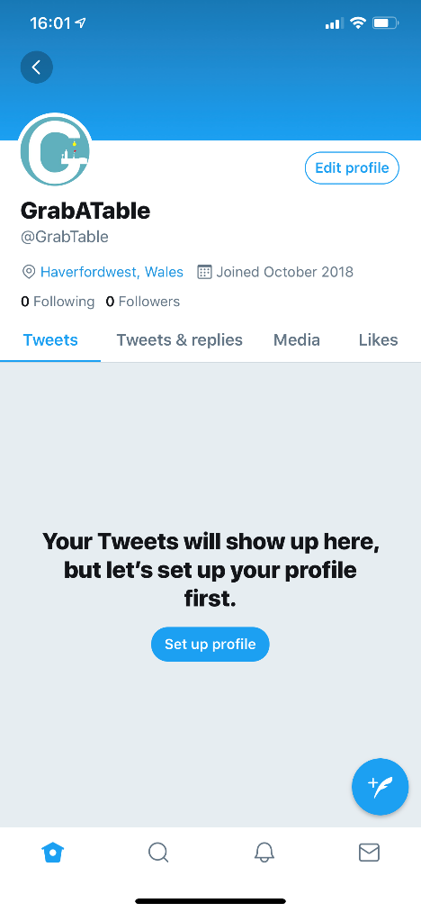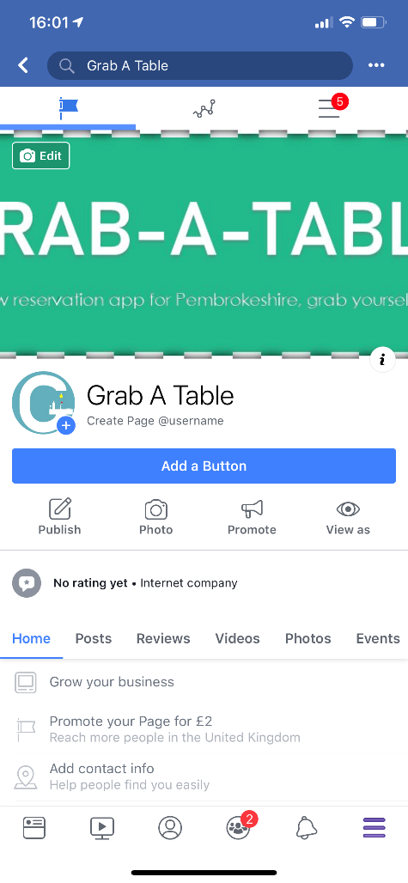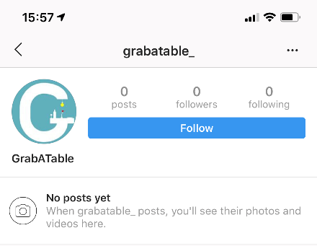

References

[1] | Statista, “The Statistics Portal,” 2018. [Online]. Available: https://www.statista.com/statistics/271851/smartphone-owners-in-the-united-kingdom-uk-by-age/.
[2] | Statista, “The Statistics Portal,” 2017. [Online]. Available: https://www.statista.com/statistics/300402/smartphone-usage-in-the-uk-by-age/.
[3] | Wikipedia, January 2019. [Online]. Available: https://en.wikipedia.org/wiki/Wales#Languages.
[4] | M. T. C. Team, “Mind Tools,” 2018. [Online]. Available: https://www.mindtools.com/pages/article/newTMC_90.htm.
[5] | D. W.Stout, “Dustn.tv,” 2019. [Online]. Available: https://dustn.tv/social-media-statistics/.
[6] | M. Lister, “Word Stream,” 2018. [Online]. Available: https://www.wordstream.com/blog/ws/2017/01/05/social-media-marketing-statistics.

