Multi-Platform Publishing

Running With Fire
I decided to do a multi-platform on a story I’m doing for my Creative project, which is Running With Fire, it’s a 2-D short animation.
For inspiration, I looked at social networks, such as ‘Isle Of Dogs’, I liked how with their posts gave information about the characters within the story before the film being released.
I also looked at Nintendo for inspiration, as I enjoyed their idea of the amibbo, which gives additional items within the game, and each amibbo gives different items.
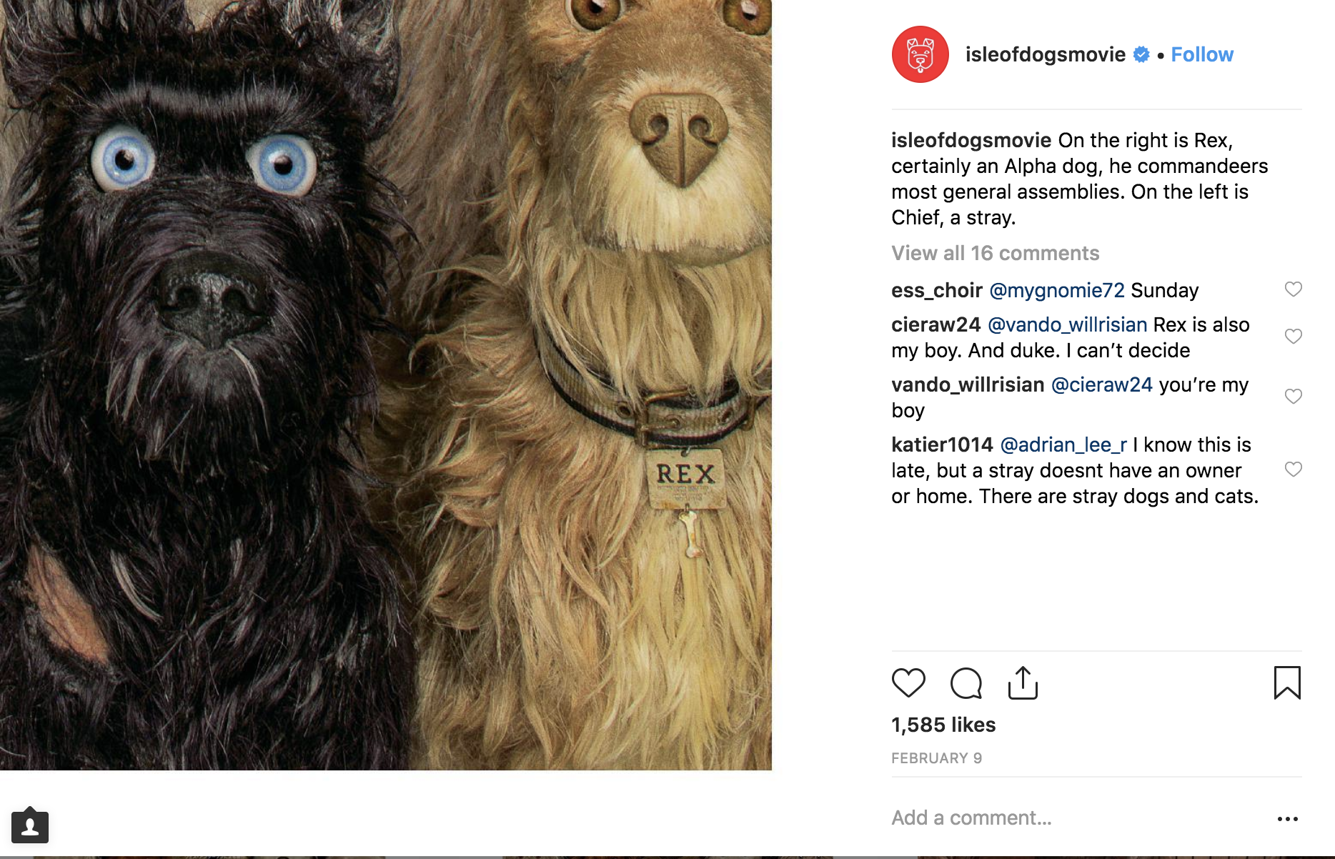
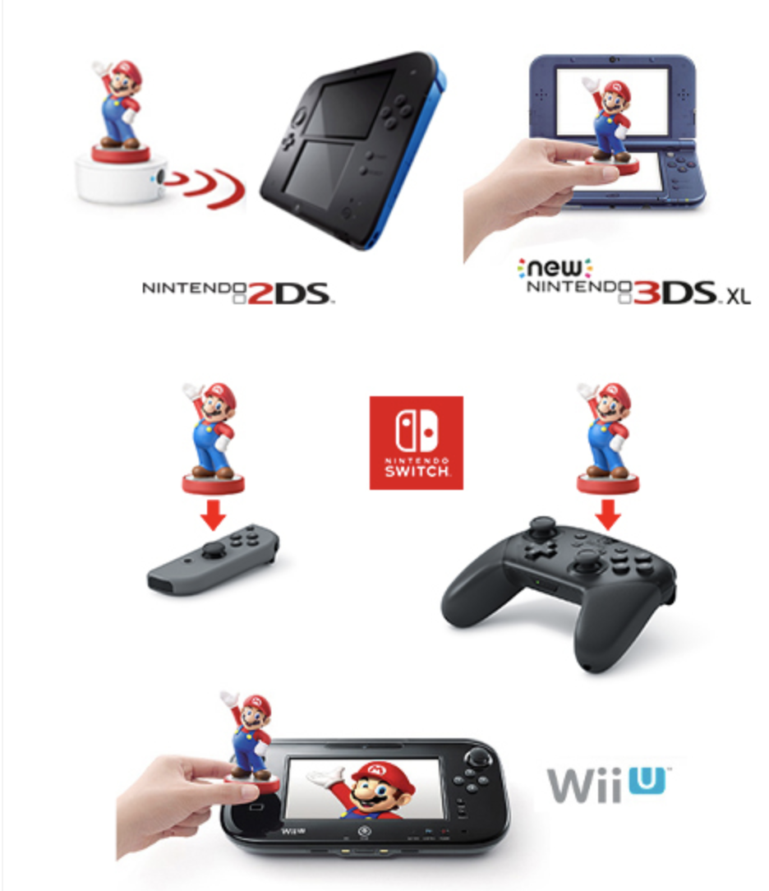

Instagram
I started uploading my stories to Instagram first, I thought this would be best place to start as it would be easier to gain an audience this way. I uploaded the Fire Goblin first, as I thought he was the most interesting character. Then I used the Spirit, then the Elder Enyo, then the Little Enyo. I gave a little detail to each character. I didn’t want to give too much detail, but just enough to keep them interested.
After talking about the characters, I decided to promote my other social networks, such as Anchor and YouTube.

Anchor
I thought Anchor was a good way of telling the story, as it allowed me to express how I designed the characters and talking a bit more about the story (without spoiling it). Unfortunately, I didn’t really use this as much as I should of, as it was quite a simple thing to use. It also allows you to add ‘Interludes’ and ‘Sounds’ which I thought was good, as it made the podcast seem a bit more professional.

Poster
The aim of the poster, was to get more people to know about the film. I also added a Instagram name tag, so if people did find the poster on the streets or online, they could search it and find the Instagram page right away.

Application
The point of the application was to give more information about the story than anywhere else.
I had a ‘Lore’ section, where you could find out about the characters, locations and objects, and in each category, there would be a Name, image and a little biography.
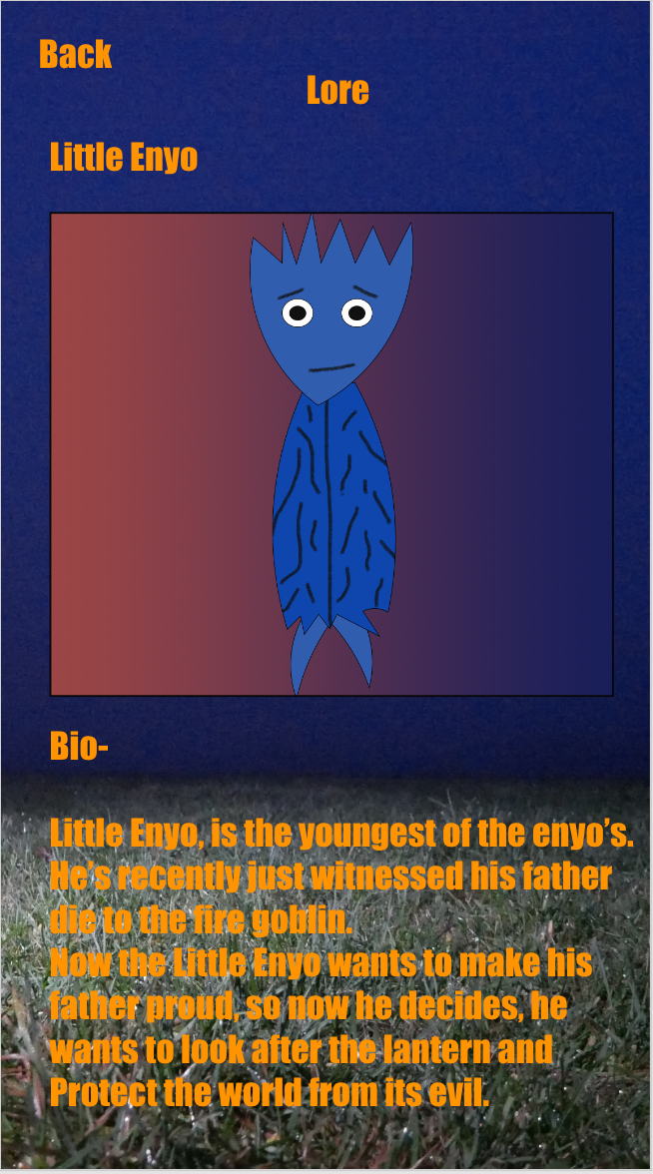
I decided to make ‘Impact’ my font, because I thought it looked professional by standing out, and I decided to make it orange, as it’s the same colour as a flame, but unfortunately, I don’t think it works well with the background as it was too bright.
I also had to change the background in the end, as it was too blurry and out of focus, this was annoying for me, as the background was meant to be the same background as the film, but I had to change it. So I decided to change the background, so it looks more like a fire with the red, orange and black.
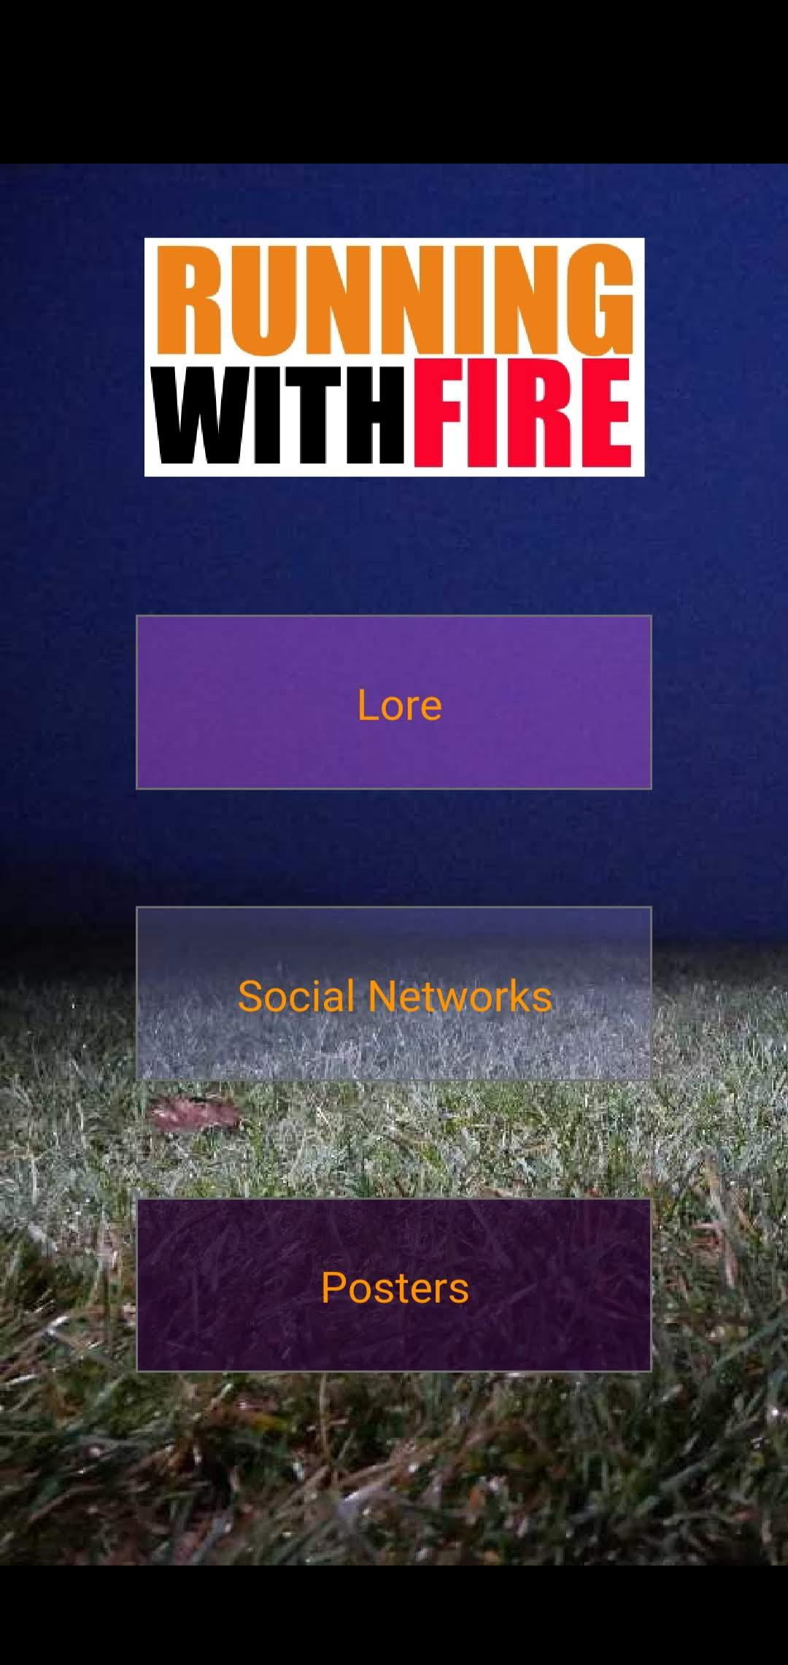
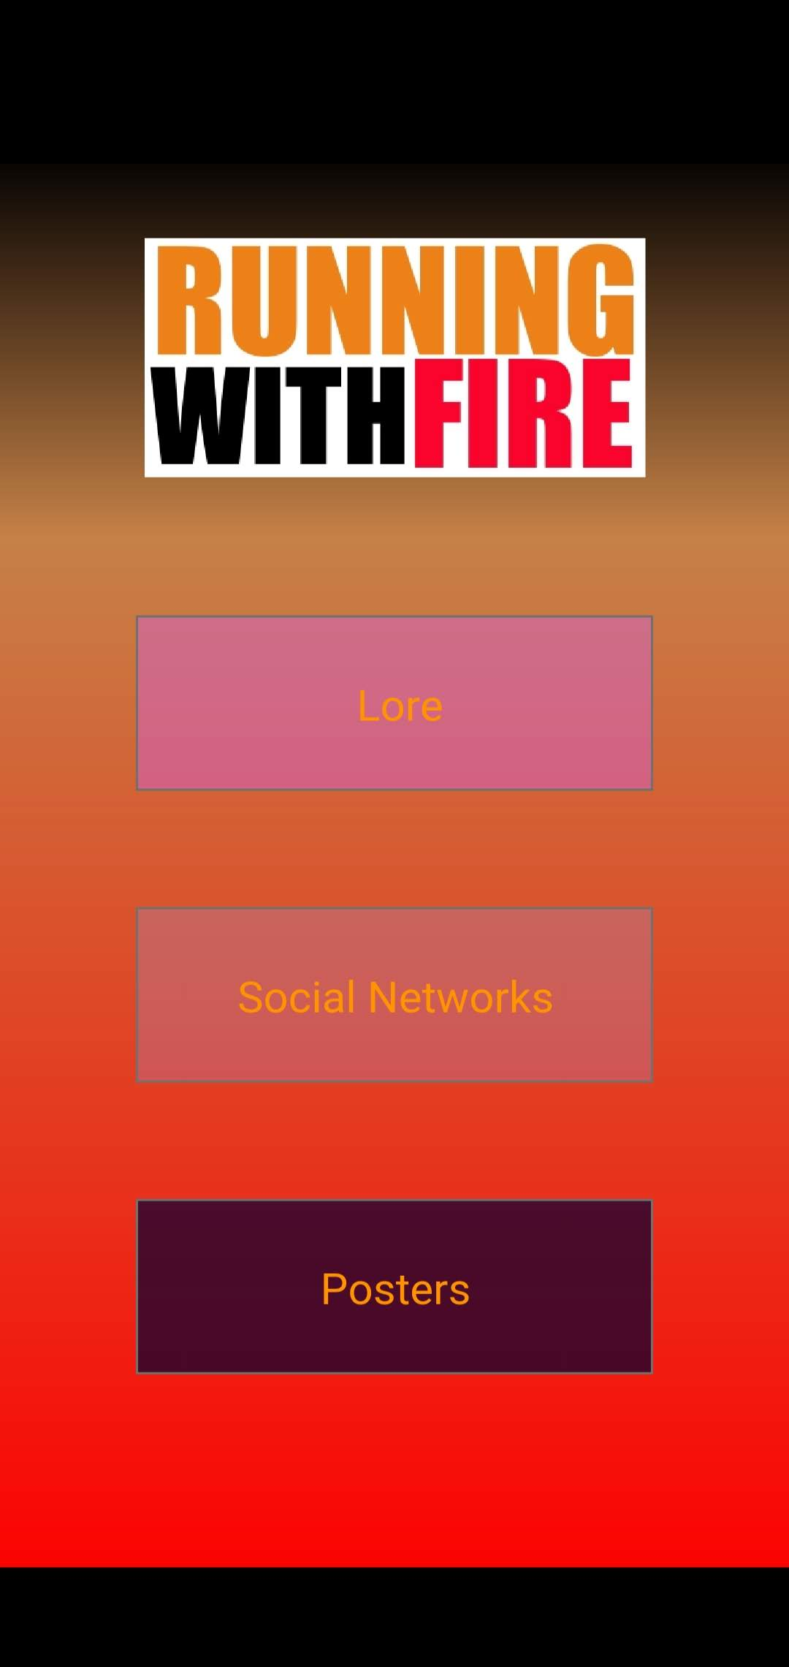

In ‘Social Network’, I decided to create that category because, if people found the app interesting, they could follow the story on that, as it gives three options, Instagram, Anchor and YouTube. Unfortunately, I couldn’t figure out how to make those options into links to the actual site, so people would just have to type it into their search bar.

With the posters, I was hoping to add more images, so that fans could download images and print them, but I didn’t get enough time for that, but there is a poster that they can see.

YouTube
I decided to make a YouTube channel because, I knew I would eventually release the film there, so I thought it would make sense to add content to the channel.
In the first video, I talk about links to my social networks, so in the YouTube description, you can go straight to the Running With Fire page on Instagram and Anchor.
In the second video, I talk about the behind the scenes, so if people are interested in what I do and want to know how I created the designs, they can see examples on there. I also talk about why I use different platforms, and it was because, there are different information in each one, so it makes the audience that are interested, look at these different sites.

Screensaver
This allows people to have their favourite character’s part of their phone background, which would show how much they love the film, which I would feel honoured with, as this is something someone uses every day and every time they open their phone they would see my design.

Conclusion
I would say I did a good job of making each platform a bit unique but I don’t think I added enough detail/information to the stories, so it doesn’t seem that interesting, but to the people that do enjoy it, they can use multiple platforms to find out more about Running With Fire.
I think the app does a good job of letting you know a bit about the characters/objects/locations and I plan on adding more to this, when I have more ideas about the story.
YouTube allowed me to use multiple links, to advertise my work, which was good, as the others only allowed one. The Behind the scenes video also gives a good idea of how the characters were made and why I used multiple platforms.
I think I’ll use Anchor a lot more, as it was easy to use, and I thought it was cool how you could use voice messages and send them to people, hopefully I can reply to some on my podcast someday.
If people would have these characters as their phone background, it would show how much they love the characters, and other people might notice it and ask about it.
I didn’t manage to create the 3-D models I wanted unfortunately, I didn’t have time to learn about 3-D modelling, even though it would have been a good idea to add a QR code to the bottom of the design, and give the audience a unique poster from it.
I didn’t create a picture book because I’m new to the designing, so drawing these characters took longer than it should have, but in the future, I could potentially add this if people enjoy it enough and when I get better at designing on Photoshop.
I decided not to create the Facebook page, as I thought the content would be like the Instagram page, so I decided not to create it.
I also wanted to add cosplay to Instagram, but I didn’t get a big enough attraction to create that. I was going to make a post saying, “Make sure to use the #runningwithfire so that we can post your photos/art on our timeline”, as this would advertise the brand, and the audience would like our attention and being put on our profile.
Overall I think this was a great experience, I was quite confused at the concept at the begin, but now I like the idea of having information on different platforms and I hope to use this in the future when I talk about my work.

