Title Page

The Steminist Team

The Soapbox project

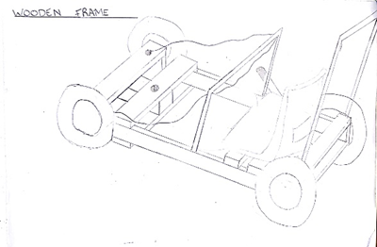

By Ben Wells, Joseph Richardson, Duke Asamoah, Jacob Lewis, Hussain Khan and Merhawi Mickael

Table of Contents
Title Page i
The Soapbox project i
Introduction 1
Aims 1
final design descision making 2
designs 3
scientific calculations 4
Cart analysis 5

Introduction
This group is made up of 6 different individuals with a variety of experiences, knowledge and skills in what we needed for this project. We split the project into different sections, hoping to cater to everyone’s strengths and weaknesses. The following list explains who was in what role and was responsible for different parts of the project:
Hussain and Mike: Responsible for compiling the presentation for the soapbox.
Duke and Joe: Responsible for producing the CAD drawings for the soapbox.
Jacob and Ben: Responsible for producing the technical report.
Everyone: Responsible for calculating the forces put upon the soapbox.

Aims
The aim of this report is to illustrate the final design chosen for the soapbox racer. Also, to display the work and research that went into the final decision. Including detailed CAD drawings of our final design and calculations of the force put upon the soapbox.

final design descision making
After a long discussion with the group, we decided on a final design. After conferring as a team about the advantages and disadvantages of the materials, designs and components that were suggested in the past. We have decided to continue the project using a Mild steel tube frame, a plastic armchair, a lap belt, 2 bicycle disc brakes, a mixture of 2 BMX wheels and 2 mountain bike wheels, a Go-kart axle and steering wheel; 4 motorcycle shock absorbers, 2 basic brake disk systems on the rear and fiberglass for the shell. These were chosen, as they were deemed the most efficient in their function in relation to their weight and cost; without losing too much performance for the soapbox.
We favoured this design over the other two we made because; our first design was a wooden frame with wheelbarrow wheels and a billy kart axle. The price we could have made this soapbox car would be incredibly cheap but using materials such as beech wood could cause a big threat to the car for as its tensile strength is only 3.50MP. When comparing this to materials like mild steel, which has a tensile strength of around 531MPa. This indicates clearly that a wooden frame, despite being the cheapest and easiest to make; would be inadequate for the soapbox cart and track.
Our third design was on the other end of the spectrum, as our first design was cheap and easy to produce. The third design was compiled of very expensive and high specification parts such as: Yamaha suspension springs, hydraulic disk brakes and the cost of the carbon fibre frame.
As a collective we decide to meet in the middle and aim financially economic, without sacrificing the soapbox’s performance. This led to everyone agreeing that our second design fit the needed specifications without being overly complicate to produce. As a group, we also nominated Hussain to be the Driver as he is the smallest, we took his measurements and have deigned the soapbox to cater for his stature.

designs
Below are some basic CAD designs of what the soapbox chassis will look like. These have no chassis components designed into them. The Soapbox is tailored around the driver. The base of the chassis is 1.2m long and 0.5m wide. With the wheels included, the soapbox cart is a total of 0.65m wide. With the soapbox weighing a total of 50kg and the driver weighing 65kg the total weight of the cart is 115kg. this should allow for a good amount of speed to be carried through the course, without impacting the handling or the braking too much.
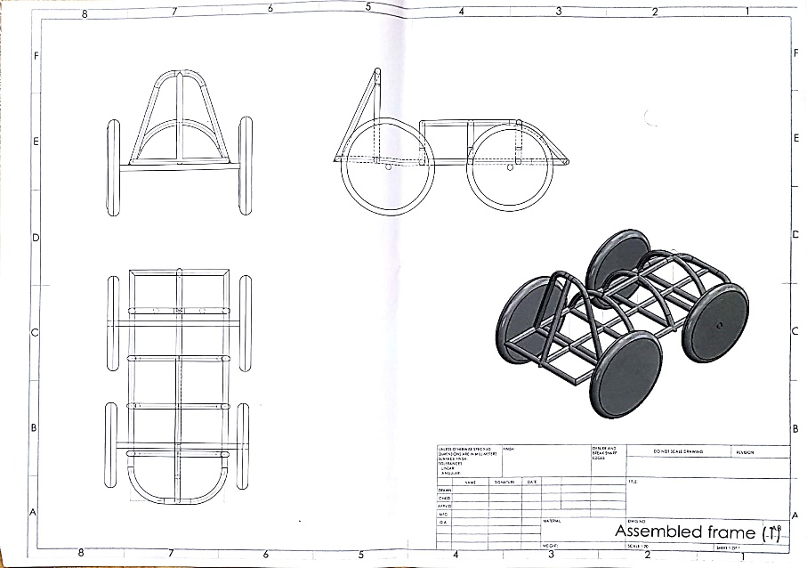
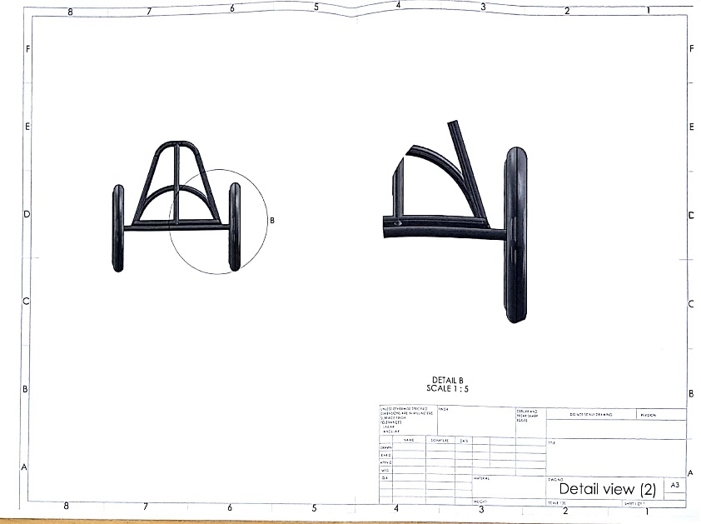
Despite not being included in the design, the suspension units will attach from frame to the wheel axle on all four wheels. This should allow for adequate shock absorption, as the shock will be transferred into the frame dispersing throughout. Reducing the vibrations felt by the driver.

scientific calculations
To get an idea of what forces the soapbox cart would be subject to, the group decided to calculate the force put upon the cart when it was stationary. For these calculations the group used the drivers weight of 65kg and the distance from where his centre of mass will be based to certain points along the frame. The points upon the frame that were calculated was the: point where the driver sits, to each of the rear suspension, to the front centre of the cart (opposite end to where the driver is sat), each of the front suspension and the middle of the frame. The group chose these points on the frame, as they were agreed to be the most vulnerable to breaking or distortion from stress during the race.
The calculations below were just with the driver’s weight. It was agreed upon that the weight of the soapbox cart wasn’t necessary for these calculations as the aim was to see how much force the driver was putting onto the cart.

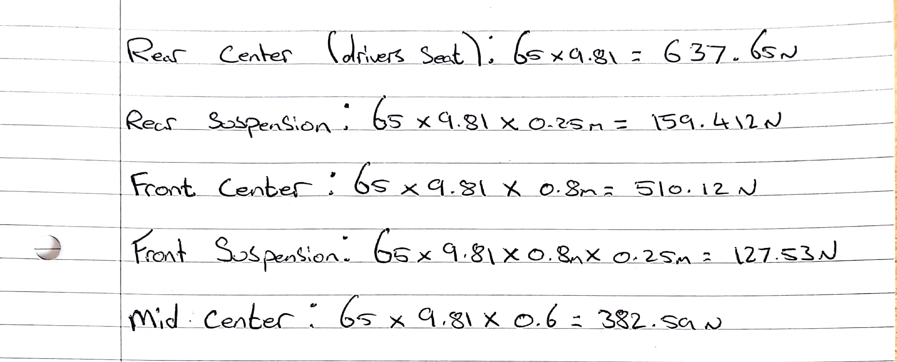

This set of calculations were to find out the force put onto the frame with the fibre glass shell included.
From these, you can see that there was not much of a change in the forces. Again, these calculations were for when the cart is in equilibrium.
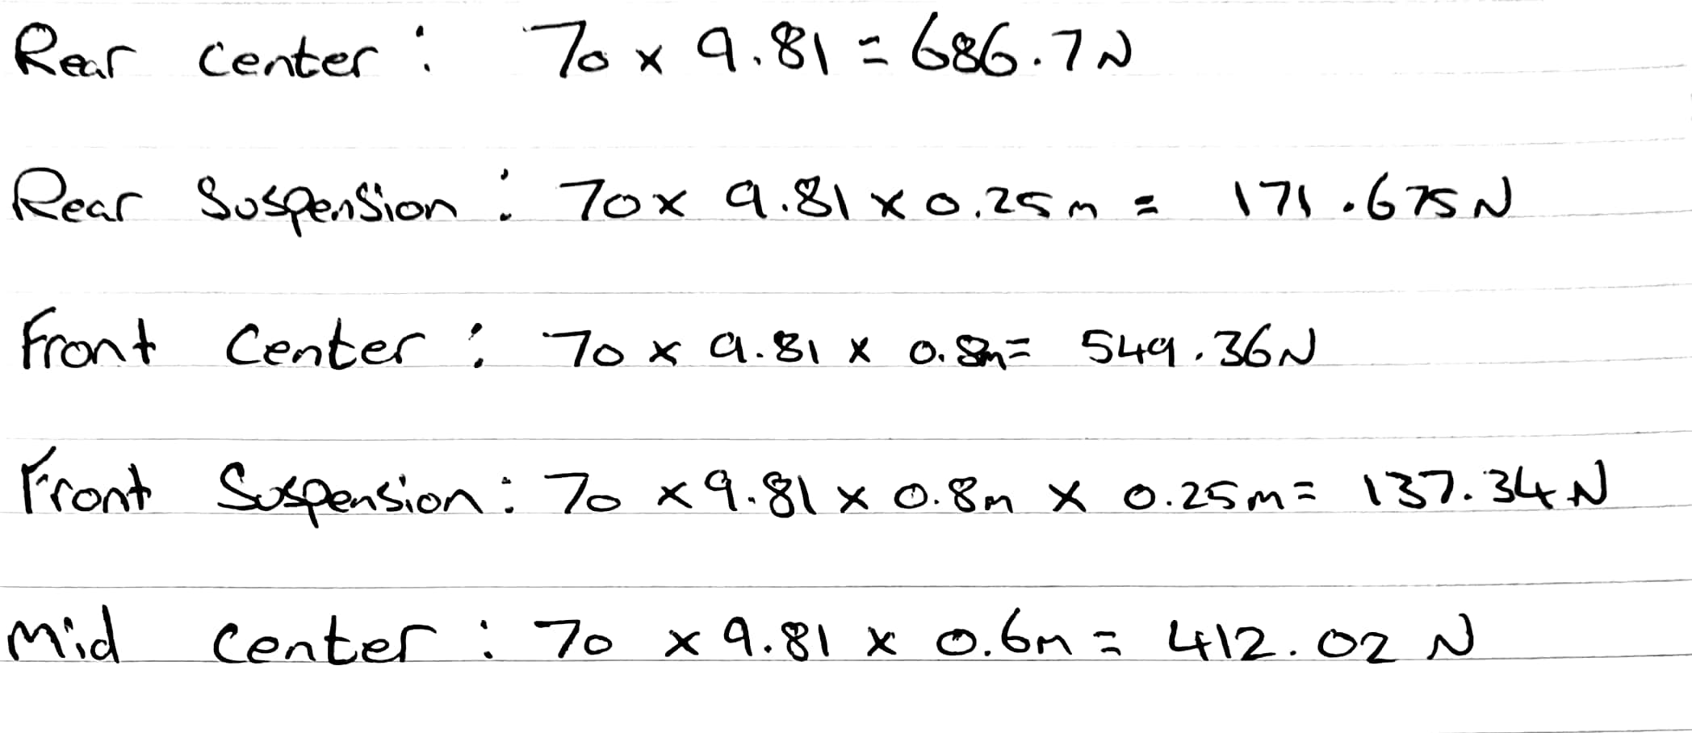

Cart analysis
The soapbox cart designed by the group is very basic, using mostly “budget” components. In the future, if this cart were to be improved; the group would choose a better design of frame, to make it more aero dynamic. The components such as the wheels could be replaced with shorter and possibly wider wheels, the help with handling and to give more stability with speed. This would also give a lower centre of gravity again helping with handling in the corners. The components such as the shock absorbers, go-kart axle and steering column would be acceptable to use on a higher specification soapbox cart.
The dimensions of this soapbox cart were as stated before, tailored around the driver. As well as this, it has also been designed to be slightly longer and not overly wide. This is to allow stability in straight lines and should allow for better handling in the corners, despite having a higher centre of gravity.

