

An Investigation of the Relationship between Chassis Settings and Optimal Trajectory for Improving the Lap-Time of a Racing Motorcycle

Iriney Svilen Georgiev
1900719
Research Methods and Professional Developments
ACEA7013
Course
MSc Motorcycle Engineering
Supervisor
Dr Owen Williams
Swansea
March 2023
Contents
1 Introduction 1
2 Historical Overview 2
3 Literature Review 3
4 Methods 9
4.1 Platform 9
4.2 Development 10
5 Results 11
6 Evaluation 12
References 13

Figure 1: Logic chart of a non-linear MB Motorcycle/Rider System, (Sequenzia, et al., 2016). 3
Figure 2: Effects of Three-Dimensionality, (Massaro & Lovato, 2021). 4
Figure 3: Analysis of Different Weight Configurations ($q\text{v}$) in Relation to Steering Angle ($δ$), Rider Position ($γ\text{r}$) and Throttle ($γ\text{t}$) / Braking ($γ\text{b}$) Inputs, (Tezuka & Ambrogi, 2022). 5
Figure 4: Steering Angle ($δ$) and Longitudinal Commands ($γ\text{t}-γ\text{b}$) Comparison between Simulated Motorcycle Rider (MR) and VI-Grade model, (Tezuka & Ambrogi, 2022). 6
Figure 5: Optimal Trajectory depending on Braking Strategy, (Biniewicz & Pyrz, 2023). 7
Figure 6: Validation of the MB QSS 2D Motorcycle Excel Dynamic Model, (Georgiev, 2022). 10
Figure 6: Validation of the MB QSS 2D Motorcycle Excel Dynamic Model, (Georgiev, 2022). 10

Table 1:Decision Matrix for Comparing Different OCP Solutions based on (Xiong, 2010). 8
Table 1:Decision Matrix for Comparing Different OCP Solutions based on (Xiong, 2010). 8
Table 2: Gantt Chart of the Research Proposal and Major Project 13

Introduction
Before a vehicle is released on the market, it undergoes a series of tests to ensure its safety, performance and durability. If the test results are unsatisfactory, the vehicle design is modified and the testing process is repeated. However, these iterations can increase costs for manufacturers since they must develop expensive prototypes and conduct tests on tracks with skilled drivers. To reduce costs, save time and require fewer physical prototypes for verification, the automotive industry has turned to virtual prototyping tools like multi-body (MB) system software (Danquah, et al., 2020). Unfortunately, this practice is not common in the motorcycle industry according to Bianchin (2022). The unique challenges of controlling a two-wheeled vehicle make it more difficult than controlling a four-wheeled vehicle. This difficulty stems from the conflicting objectives of vehicle balance and path following. If the steering and speed controls are not appropriately combined, a two-wheeled vehicle can easily fall while negotiating a corner.
The author of this study developed a quasi-steady-state (QSS) riderless model, specifically designed for the Junior Talent Cup utilizing the Honda NSF250R motorcycle (Georgiev, 2022). The software incorporated a design of experiment (DOE) model to predict the optimal chassis setup for a given circuit. However, the model did not consider trajectory changes. Comparing virtual to real-life rider performance data, it was revealed that around 80% of the suggested setups were ineffective because they required changes to the rider's racing line. Additionally, the motorcycle simulator did not account for elevation, tyre lateral forces and rider body influence, leading to a significant lap time mismatch on circuits with numerous change-of-direction sections.
During the course of this research, possible solutions to the reason why the motorcycle industry lags behind the automotive industry with respect to multi-body modeling are explored. To identify the key challenges in accurately simulating motorcycle dynamics, studies published over the past decade have been evaluated and assessed. The possibility of implementing machine learning techniques is also examined in light of their recent popularity among technology and the limitless possibilities that they offer (Rueden, et al., 2020). The purpose of this research is to identify key methods and techniques for developing a realistic motorcycle simulation system that can match any high-performance rider, regardless of their competing class. Additionally, the software should provide suggestions for improving the chassis setup so that the real rider's performance can be improved without sacrificing trajectory strategies.

Historical Overview
Limebeer and Sharp (2001) conducted an early theoretical study on a nonholonomic riderless bicycle following a desired ground path. This work inspired Frezza and Beghi (2003) to develop a control strategy for a multi-body model that followed a specified ground path, utilizing a model-based predictive control (MPC). The motorcycle’s roll angle served as a virtual control input instead of the steering angle. The authors further developed their research by controlling various multi-body models of scooters and motorcycles to showcase the flexibility of their dynamic model (Frezza & Beghi, 2006).
Alternatively, Bertolazzi et al. (2006) developed a look-ahead strategy to control speed and lateral deviation errors. This study employed two separate control loops and the proposed rider model was composed of two parts. A path planning procedure, known as the optimal maneuver method, computed the reference ground path and speed to be followed. The reference optimal trajectory was stabilized using independent proportional-integral-derivative loops (PID). The virtual model achieved a lap time six seconds slower than an actual motorcycle lap around Adria circuit. Based on the results of the study, it was determined that the model failed to properly utilize its longitudinal force during a change of direction maneuvers due to the rigid suspension and tyres, as well as the absence of a mobile rider model.
Innovatively, Saccon et al. (2010) developed a non-linear control system that was capable of steering a two-wheeled vehicle along a general route specified by the user while retaining a desired velocity profile. To generate an optimal speed profile, the virtual model employed a look-ahead strategy while considering the limitations imposed by the engine, tyres and the possibility of performing wheelies or stoppies. Due to this, the virtual model was able to make decisions on its own based on the characteristics of its performance. Taking into account the lack of consideration given to rider movement in this study, Sequenzia et al. (2015) created an anthropomorphic rider model with 28 degrees of freedom (DOF). An analysis of motorcycle dynamic performance without and with a mobile rider model revealed a difference of 3 seconds on the Monza circuit.
In the following year, an official multi-body, closed-loop, mobile rider model was introduced on the market under the name VI-BikeRealTime. The dynamic two-wheel software was developed by VI-Grade, a leading automotive simulation software trusted by many major automobile manufacturers (VI-Grade , 2023). Despite its powerful characteristics, VI-BikeRealTime has not yet been adopted as an industry standard by the motorcycle industry.

Literature Review
During the last decade, researchers have strived to obtain ever more accurate and detailed multi-body models of two-wheeled vehicles to simulate dynamic motorcycle behavior. This process, known as MBD, involves modeling rigid and flexible bodies as a set of coordinates and calculating their movement using equations of motion.
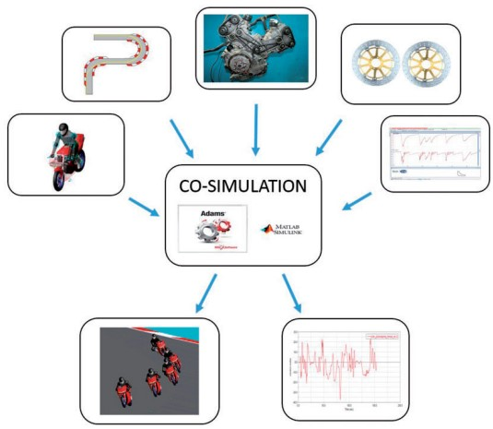
On the basis of their previous work, Sequenzia (2016) developed one of the earliest MB motorcycle models to incorporate suspension movement, tyre performance, rider's mobility and gyroscopic effects. Through the use of co-simulation tools such as Adams, View-Matlab and Simulink, an advanced system has been created to simulate the behavior of a motorcycle and its rider as they traverse a specific trajectory and associated velocity profile.
Figure 1: Logic chart of a non-linear MB Motorcycle/Rider System, (Sequenzia, et al., 2016).

Figure 1 depicts a logic chart for a non-linear MB motorcycle model where the virtual rider was programmed to anticipate specific aspects of a trajectory and make steering, acceleration, braking and body positioning decisions based on the acquired information. Throughout the Adams/Simulink co-simulation, data was exchanged between the two software tools every 0.03 seconds, enabling the Adams software to resolve the model's dynamic equations and the Simulink software to process all data necessary for the control system. The study determined that the non-linear MB model provided a comprehensive view of motorbike-rider dynamic behavior during the design phase. Hence, allowing accurate configuration of all parameters and immediate assessment of their effects.
The main limitation of this research was the use of pre-set data to determine vehicle’s trajectory, which restricted the usefulness of the virtual model since each rider and maneuver would require a unique approach. In 2021, an effort was made to address this issue through the development of a quasi-steady-state motorcycle model with a free trajectory on a two-dimensional (2D) track (Massaro & Lovato, 2021). The key difference was that the model assumed the system's behavior was in equilibrium. This meant that each meter traveled by the motorcycle was calculated and analyzed independently from subsequent iterations.
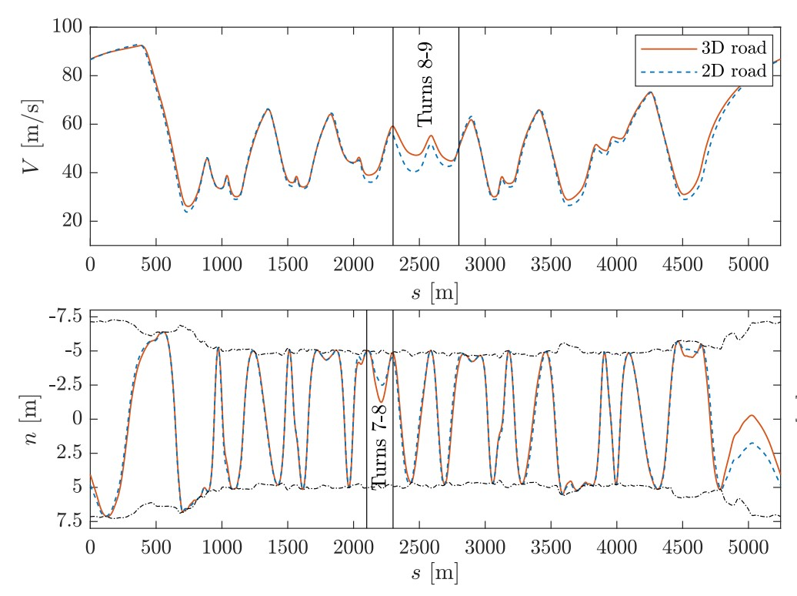
Figure 2: Effects of Three-Dimensionality, (Massaro & Lovato, 2021).

The QSS model was expanded to three-dimensional (3D) space by using curvilinear coordinates to model the track. To solve 3D problems, a giant global graph (g-g-g) of the selected motorcycle was created and used as a reference to identify performance limitations in response to dynamic conditions. Figure 2 provides a visual representation of the vehicle's velocity and lateral position. The performance of the virtual model on 3D track surface differed from the 2D surface by approximately 4 seconds. One limitation of the steady-state method was its inability to account for gyroscopic effects, which resulted in reduced accuracy at low speeds. However, the model proved effective for generating minimal lap times and producing the closest match between real and virtual motorcycle data.
An alternative between the two worlds was proposed by Tezuka and Ambrogi (2022). MB non-linear motorcycle control system affected by caster and roll on steering angle as well as gyroscopic effects. Throughout the simulation, the virtual rider had to control the throttle and brake inputs to accommodate both lateral and longitudinal forces of the tyres and the position of his body to minimize aerodynamic drag.
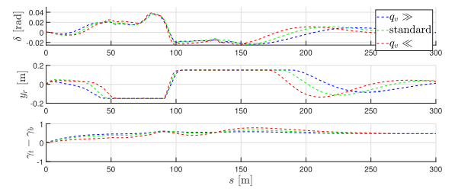
Figure 3: Analysis of Different Weight Configurations ($q\text{v}$) in Relation to Steering Angle ($δ$), Rider Position ($γ\text{r}$) and Throttle ($γ\text{t}$) / Braking ($γ\text{b}$) Inputs, (Tezuka & Ambrogi, 2022).

In the virtual test, three identical bikes of different weights were controlled by the same rider in a chicane maneuver with a radius of forty meters. Figure 5 illustrates how the rider model was able to maintain high velocity by adjusting its movements and inputs when the bike weight was higher and vice versa. Rather than relying solely on real-world data validation, the authors of this study replicated the experiment using the commercial software VI-BikeRealTime to further support their theory.

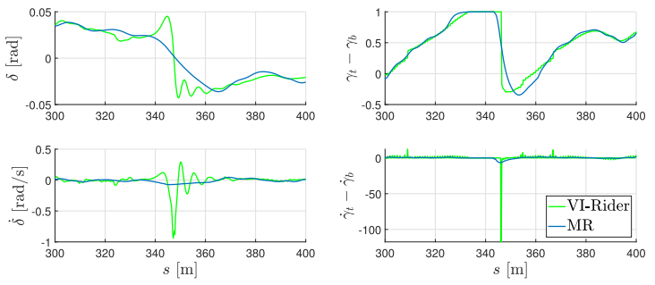
Figure 4: Steering Angle ($δ$) and Longitudinal Commands ($γ\text{t}-γ\text{b}$) Comparison between Simulated Motorcycle Rider (MR) and VI-Grade model, (Tezuka & Ambrogi, 2022).
Despite similar velocity tracking performance, there were significant differences in steering angle and longitudinal command dynamics as shown in figure 4. The VI-BikeRealTime model was found to perform unnaturally compared to a normal human response. However, given the similar trends observed, the research was still deemed successful. Similar unreasonable behavior was previously noted in the comparison of real motorcycle telemetry data from Ducati Panigale 1199S with the commercial software in a previous research (Skoczylas, 2021).
The most recent study on optimizing motorcycle trajectory and improving lap times utilized experimental data to develop QSS equations of motion with input constraints (Biniewicz & Pyrz, 2023). To mitigate the impact of gyroscopic effect, the study incorporated acceleration derivatives (jerks) which accelerated the convergence of the optimal control problem (OCP). The proposed approach resulted in a state and control history that more closely resembled the behavior of a skilled race rider than a standard OCP formulation. The effect of the g-g-g diagram boundary on the optimal trajectory was examined in the context of a chicane and variable radius "U" trajectory test scenarios. The study compared the QSS g-g-g diagram to empirical data and proposed a semi-empirical, hybrid g-g-g boundary. For this study, a Supersport 300 cc motorcycle and a 140 cc minibike were selected for analysis. Given that the braking phase is where riders typically gain an advantage, the QSS simulator was designed to improve braking performance by adjusting the trajectory strategies and rider inputs.

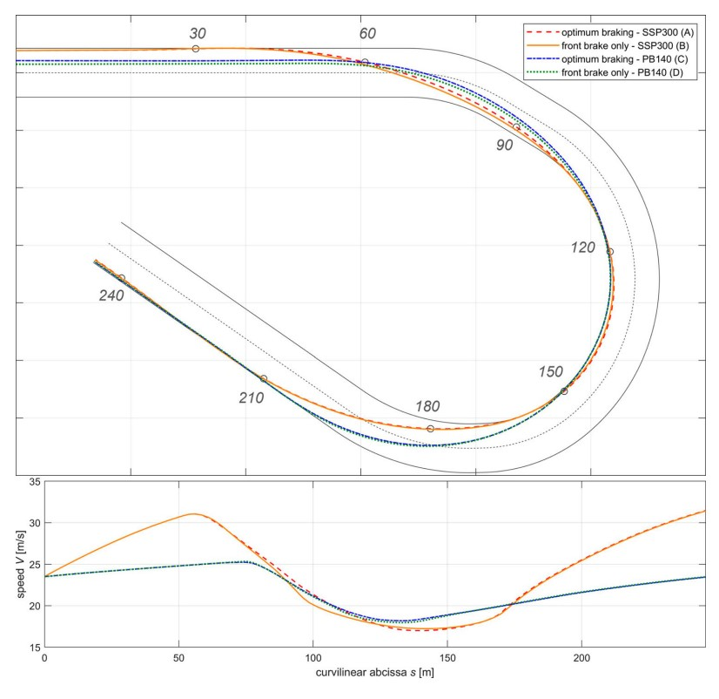
Figure 5: Optimal Trajectory depending on Braking Strategy, (Biniewicz & Pyrz, 2023).
Figure 5 displays two braking variations for each motorcycle model executing the specified corner. The study determined that braking strategy A, which only utilized the front brake, was the most efficient maneuver for the SSP300. Due to the PB140's lower engine power, it was necessary to spend more time near the maximum lateral acceleration to maintain the highest possible cornering speed, a result confirmed by the simulator. Although the braking capabilities of the minibike were not extensively examined, options C and D provided identical results. The proposed method, which relied on experimental data, could be customized for a specific multibody system. Thus, improving its usefulness for riders of varying skill levels. With its ability to better predict corner speeds and braking points, the model had the potential to serve as a tool for racetrack design or redesign.
Artificial intelligence (AI) is becoming increasingly prevalent in a variety of industries, including the automotive industry. Xiong (2010) developed a MB automotive F1 model and used it to assess various solutions to OCP, including an AI method that utilized machine learning algorithms.
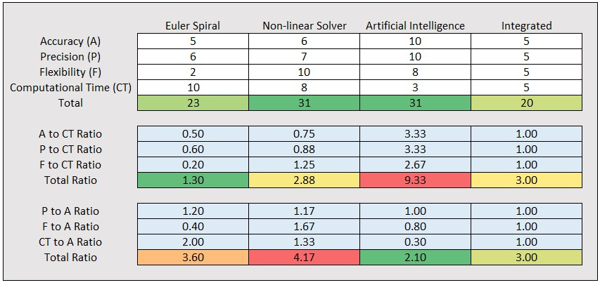
Table 1:Decision Matrix for Comparing Different OCP Solutions based on (Xiong, 2010).

Table 1:Decision Matrix for Comparing Different OCP Solutions based on (Xiong, 2010).

Table 1 displays a decision matrix based on the outcomes of this study. The non-linear solver and the AI method garnered an equivalent total score, with a higher score reflecting superior model performance. Furthermore, a ratio of computational time to accuracy was computed and displayed in blue to reflect the importance of balancing these two objectives in simulation modelling. A lower ratio indicated more favorable circumstances. Remarkably, the AI method had the highest total CT ratio of 9.33, which implied that it was the most computationally intensive method. Also, the AI method had the lowest A ratio, indicating its ability to generate minimal lap times that align with real driver performance.
Garlick and Bradley (2021) developed an innovative AI solution that used machine learning techniques to shorten hardware processing time while still producing an accurate prediction of a racing line. An Artificial Neural Network (ANN) model was incorporated into the automobile QSS software, which processed previously acquired trajectory data and adapted it to any vehicle or circuit type. The network's predictions of racing lines had a mean absolute error of ± 0.27 metres, which reduced to just ± 0.11 metres at corner apex, showcasing its similarity to human drivers. Additionally, the ANN approach provided predictions within 33 milliseconds, making it more than 9,000 times faster than traditional AI methods used for determining the optimal trajectory.

Methods
This section outlines a comprehensive and robust approach to the development of an advanced dynamic motorcycle simulator that takes into account the relationship between chassis setup and optimal trajectory to achieve minimum lap times in close circuit conditions. The previously developed MB QSS riderless motorcycle Excel model will serve as the baseline for this project (Georgiev, 2022). The goal is to create a motorcycle simulation tool that can be utilized by racing teams to test a range of modifications, from chassis to riding style adjustments, performance strategies and even new circuit configurations. Ultimately, this simulator will enable teams to make informed decisions on how to optimize their motorcycle and rider performance, resulting in faster lap times and better chances of success.

Platform
In the case of motorcycle modelling, Excel showed a high computational intensity. Consequently, the motorcycle simulator must be rewritten in a more powerful programming language in order to reduce the amount of processing energy required. The following options were considered:
- C++
- Pascal
- Java
- Python
- Adams, View-Matlab / Simulink

All programming languages listed above have similar features, except Matlab. Matlab is a closed-source program, meaning that its source code is not accessible to the public. Most of the studies in the literature review utilized a combination of Adams, View-Matlab and Simulink. However, the author of this research prefers Python due to its vast community of libraries that make it easier to create models from scratch. According to Periera et al. (2021), Python ranked behind C++, Pascal and Java in terms of computational intensity efficiency. Regardless, Python was selected as the native language for developing the dynamic motorcycle simulator.

Development
There was a fundamental limitation to the Excel motorcycle model, which was the absence of elevation. As in some examples in the literature review, the virtual rider improved or lost time in sections where elevations or descents were present, resulting in a difference of around 3 seconds (Georgiev, 2022).
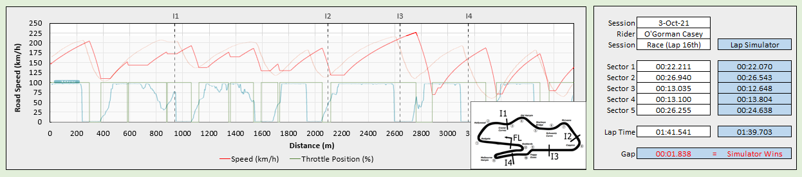
Figure 6: Validation of the MB QSS 2D Motorcycle Excel Dynamic Model, (Georgiev, 2022).

Figure 6: Validation of the MB QSS 2D Motorcycle Excel Dynamic Model, (Georgiev, 2022).

This model was validated against three different tracks using the fastest lap time telemetry from the championship-winning bike of the 2021 British Talent Cup season, as shown in figure 6. However, it was evident that the virtual model was unable to maintain the same speeds in fast corners as a real motorcycle. Additionally, it was observed that after the first section, there was a clear mismatch, as the next two corners were uphill and then descended. The model then tried to compensate with late braking performance but was unsuccessful. For the Python version of the dynamic software, a curvilinear coordinate system is intended to be used. Modelling 3D tracks by using this method has been found to be an effective approach when dealing with OCP problems caused by road vehicles (Massaro & Lovato, 2021).
During the literature review, the rider's body positioning was identified as another crucial factor affecting motorcycle performance. The virtual rider ideally should have 28 DOF, six of which should be directly controlled during maneuvers, while the remaining 22 should be indirectly activated based on the Hybrid 3 model (Sequenzia, et al., 2016). The selection of articulation constraints should take into account the rider's actual movements during the maneuver to replicate realistic scenarios as closely as possible. Alternatively, a passive rider model consisting of two rigid bodies, upper and lower body, similar to the approach taken by Cossalter (2008), can be developed. This approach would provide a simplified representation of the virtual rider.
To simulate tyre dynamics in the automotive industry, the Magic formula model is widely used due to its accuracy in relating the lateral and longitudinal forces to the slip angle and slip ratio. However, when it comes to motorcycle tyres, they experience different conditions with large camber angles of up to 50-55 degrees and low sideslip angles of up to 1-2 degrees, which are the opposite of car tyres. As a result, a method called instantaneous slip is decided to be employed for developing the MB QSS motorcycle simulation simulator. This method enables the proper description of both steady-state and transient tyre behavior using the same relations by coupling elastic tyre properties with sliding properties (Lot, 2014).
First and foremost, it is imperative that the above mentioned goals be achieved. For the time being, fixed trajectory will be the only option available. The effectiveness of MB QSS 3D motorcycle model will be determined by comparing the results obtained with real rider and bike telemetry. According to Bradley (2018), a 5% difference in performance is considered a significant difference in motorcycle performance. If the performance of the virtual and real motorcycle models is within 5% difference, it will be deemed successful, and an AI model will be incorporated. The AI model will employ machine learning techniques to learn from previous telemetry data, which would significantly reduce computational time. The process involves using an artificial neural network to process trajectory data and adapt it to any vehicle or circuit type (Garlick & Bradley, 2021).

Results
Python software will be utilized to conduct the proposed study, which involves testing at least two motorcycle types, rider structures and circuit configurations to determine the potential of the final product. To gather the necessary information, the author of this report will obtain motorcycle dimensions and telemetry data from two riders competing in different classes within the Bennetts British Superbike (BSB) racing series (BSB, 2023). This will be done after the riders chosen for this study sign agreements that comply with ethical and data protection regulations (UWTSD, 2023).
The simulation program has to provide sector times for the selected circuit, which will give an overall view of the motorcycle's performance. It is important to note that while lap times may be similar, the actual telemetry data may differ significantly (Georgiev, 2022). Therefore, both virtual and real rider telemetry data must be thoroughly analyzed, including the following channels:
- Throttle Input
- Front Brake Input
- Gear Position Input
- Front Wheel Velocity
- Rear Wheel Velocity
- Vehicle Lean Angle
- Lateral Acceleration
- Longitudinal Acceleration
Through the use of human-in-the-loop (HIL) method, the simulation process can be fine-tuned. This involves the interaction between a human operator and a machine learning system to provide real-time feedback and guidance (Mosqueira-Rey, et al., 2022). For instance, if the virtual rider performs maneuvers that are beyond human capabilities, the real rider can correct them. Similarly, if the suggested chassis settings are not practically feasible, the rider's mechanic can provide feedback to the software. This approach allows the system to adjust to evolving circumstances, enhancing its decision-making abilities, and ultimately improving performance and safety.

Evaluation
Based on the literature review, achieving a complete representation of motorcycle simulation has proven challenging due to the importance of rider influence and gyroscopic forces in the dynamic models. Researchers typically exclude one of these factors to simplify the simulation model, utilizing one of two popular methods. Non-linear motorcycle modelling approach has the potential to replicate dynamic forces in detail. However, this technique results in slower lap times and a less flexible model since a predetermined trajectory is required. In contrast, the QSS method can simulate minimum lap times and trajectory solutions, but its accuracy at low speeds is poor and its computational complexity is high.
To achieve peak performance, a QSS model was selected in a previous study (Georgiev, 2022). In order to overcome the limitations of the Excel model, a replacement of the development platform with Python and 3D environment, and implementation of dynamic models for the driver and tyres was necessary. Furthermore, to improve the simulation model, an artificial intelligence approach was explored. According to Lenovo (2022), AI technology is being utilized by the MotoGP Ducati Corsa team. The manufacturer can develop comprehensive simulations using computer modeling systems controlled by AI technology, which predict a bike's behavior before it leaves the garage.
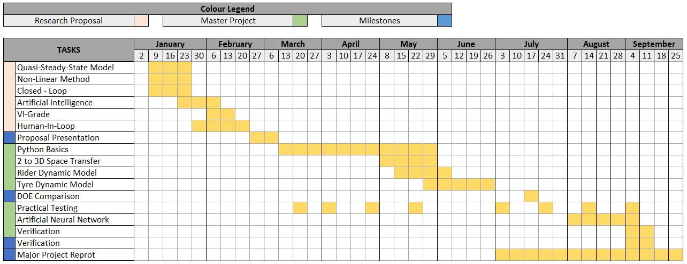
Table 2: Gantt Chart of the Research Proposal and Major Project
Efficient project development requires effective organization and risk anticipation, which distinguish it from repetitive processes (IRJET, 2019). To ensure success, a detailed schedule is essential, as illustrated in table 2. Adopting a more pessimistic approach to the schedule allowed the author to allocate sufficient time for each section of the project.

References
Bertolazzi , E., Biral, F. & Da Lio, M., 2006. Symbolic-numeric efficient solution of optimal control problems for multibody systems, s.l.: Università di Trento.
Bianchin, F., 2022. Learning-Based Nonlinear Model Predictive Control for a Motorcycle Virtual Rider, Padova : University of Padova.
Biniewicz, J. & Pyrz, M., 2023. A quasi-steady-state minimum lap time simulation of race motorcycles using experimental data, s.l.: Vehicle System Dynamics.
Bradley, J., 2018. The Racing Motorcycle. 3 ed. s.l.:Broadland Leisure Publications.
BSB, 2023. Support Series. [Online]
Available at: https://www.britishsuperbike.com/
Cossalter, V., 2006. Motorcycle Dynamics. 2 ed. Padova: Vittore Cossalter.
Danquah, B., Riedmaier, S. & Lienkamp, M., 2020. Potential of statistical model verification, validation and uncertainty quantification in Automotive Vehicle Dyanmics.. Vehicle System Dynamics, 60(4), pp. 1292-1321.
Frezza, R. & Beghi, A., 2003. Simulating a Motorcycle Driver, s.l.: Springer.
Frezza, R. & Beghi, A., 2006. A virtual motorcycle driver for closed-loop. IEEE Control Syst. Mag, Volume 26, pp. 62-77.
Garlick, A. & Bradley, A., 2021. Real-Time Optimal Trajectory Planning for Autonomous Vehicles and Lap Time Simulation Using Machine Learning, Manchester : University of Manchester .
Georgiev, I., 2022. Motorcycle Chassis Modelling, Performance Predictios and Race Weekend Efficiency, Sawansea: UWTSD.
IRJET, 2019. The Impact of Effective Planning on Project Success, https://www.irjet.net/archives/V6/i2/IRJET-V6I2490.pdf: IRJET.
Lenovo, 2022. Big Data and AI are Pushing MotoGP to Achieve Unthinkable Speeds. [Online]
Available at: https://news.lenovo.com/big-data-and-ai-are-pushing-motogp-to-achieve-unthinkable-speeds/
Limebeer, D. & Sharp, R., 2001. A motorcycle model for stability and control analysis. Multibody System Dynamics, Volume 6, pp. 123-142.
Lot, R., 2014. A Motorcycle Tire Model for Dynamic Simulations: Theoretical and Experimental Aspect, Padova: University of Padova.
Massaro, M. & Lovato, S., 2021. A three-dimensional free-trajectory quasi-steady-state optimal-control method for minimum-lap-time of race vehicles, Padova: University of Padova.
Mosqueira-Rey, E. et al., 2022. Human-in-the-loop machine learning: a state of the art. Artificial Intelligence Review, Volume 56, p. 3005–3054.
Pereira, R. et al., 2021. Ranking Programming Languages by Energy Efficiency, s.l.: Universidade da Beira Interior.
Rueden, L., Mayer, S., Bauckhage, C. & Garcke, J., 2020. Combining Machine Learning and Simulation to a Hybrid Modelling Approach: Current and Future Directions, s.l.: Springer.
Saccon, A., Hauser, J. & Beghi, A., 2010. A Virtual Rider for Motorcycles: Maneuver Regulation of a Multi-Body Vehicle Model. IEEE TRANSACTIONS ON CONTROL SYSTEMS TECHNOLOGY, 21(2), pp. 332-346.
Sequenzia, G., Oliveri, S., Cammarata, A. & Barbagallo, R., 2016. Dynamics of a high-performancemotorcycle by an advanced multibody control co-simulation, s.l.: Institution of Mechanical Engineers .
Sequenzia, G., Oliveri, S., Fatuzzo, G. & Cali, M., 2015. An advanced multibody model for evaluating rider’s influence on motorcycle dynamics, s.l.: Institution of Mechanical Engineers.
Skoczylas, M., 2021. Comparison of real telemetry data against GP Bikes game and VI-Grade simulator , Swansea: UWTSD.
Tezuka, Y. & Ambrogi, F., 2022. Real-Time Nonlinear Model Predictive Control of a Virtual Motorcycle. IEEE TRANSACTIONS ON CONTROL SYSTEMS TECHNOLOGY, 29(5), pp. 2214-2222.
UWTSD, 2023. Research Ethics & Integrity Code of Practice, Swansea: UWTSD.
VI-Grade , 2023. Motorcycle Dynamics. [Online]
Available at: https://www.vi-grade.com/en/applications/motorcycle_dynamics/
Xiong, Y., 2010. Racing Line Optimization, s.l.: Massachusetts Institute of Technology 2010.

