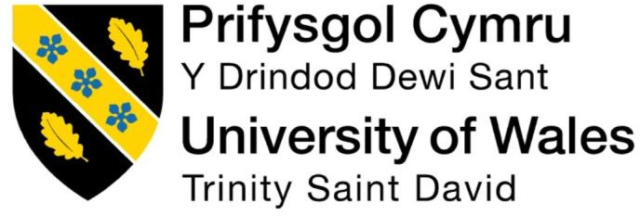

Programme: MBA International Business
Module: Human Capital Management
Module code: LCMB7023 Title:Assessment Component
Word count: 2500
Lecturer : Ejike Udeogu
Student Name : Asmat ullah
Student ID:2439636
Words count: 2680
Submission
Date:17 oct 2025

Introduction 4
Task 1: question. 5
Technological advancement and new job market. 5
How technological advancement Reshape labour market. 6
What implications does this have for HRM and IHRM strategies? 7
Question 2 7

Expanding working-age populations in lower-income countries 7
Geographic/Regional and Urban-Rural Disparities 7
Migration (Internal and International) 8
Key Geopolitical / Geoeconomic Factors 8
Supply chain realignment (reshoring /friend-shoring) 8
Labour Policy, Migration Regulation & Mobility Constraints. 8
Question 3 9

Question 4 11

Reflective Report: My Capabilities in an International Context 11
Technical understanding 12
12
Communication 12
Teamwork 13
Leadership 14
Self-Directed Learning 15
References 16

Introduction

Human Resource Management is the process of recruiting, selecting ,training , developing, evaluating, compensating, and maintaining employees to achieve both individual and organizational goals. The Objective of HRM is to maximize employee performance, to develop and maintain talent and to align workforce capabilities with strategic goals. This report shows how HRM and IHRM involve the processes and strategies that organizations, both national and international, use to manage their workforce effectively and achieve organizational goals through the use of technology and strategic planning. It also discusses how technological advancements like AI, automation digital platform changing the labour market in the world. Moreover, how HR professionals manage the demographically and geopolitical factor in their professional life.
This report shows that how small and big organizations determined skills space and talent shortage in these sectors such as hospitality, computer, and medical departments through strategies HRM. Moreover it discuss the cultural and geopolitical component effect employment markets now a days, and how do they generate the challenges for HRM and IHRM professionals and shows How can firm solve purposeful skills space and talent shortages in these professional sectors (e.g., tech, hospitality, healthcare) through strategies of HRM IHRM.

Task 1 question

In today’s dynamic and technologically advanced world, several important theoretical implications can be identified. Technological progress offers great benefits, allowing humans to work more quickly and efficiently. However, it also has certain drawbacks. For example, many companies now rely heavily on machines instead of human labour, which leads to unemployment among skilled workers.

Technological advancement and new job market.
Almost every company now prefers to use machines instead of humans to perform various tasks. There are several reasons behind this trend. Machines work more efficiently and accurately compared to human labour, and they can operate continuously throughout the day without taking breaks. Moreover, modern machines are capable of performing tasks much faster than human beings.Technological developments in HRM, including the introduction of AI,machine learning and deep learning applications for the analysis and collection of digital records in predicting work-related issues, have raised a number of concerns pertaining to human privacy (Bhave et al., 2020).
Due to these technological advancements, many new tech-related jobs have been created in the market, and various digital roles have emerged in this era. Therefore, people need to become more advanced and develop new skills to meet modern job requirements. In addition, numerous digital labour platforms have been introduced around the world. These platforms not only expand workers’ knowledge but also provide opportunities for them to earn more based on their abilities and use of technology. This transformation has significant implications for HRM and IHRM which represent through below image that these type of new jobs and labour work are emerge in this technological era.

How technological advancement Reshape labour market.
In this era technology reshape the labour market and this will open the new job opportunities for labour which will be more technical and practical skill base. Big organizations and companies has vacancies for those who are technical and skilled person so they hire HR to find out the people who are capable to do their work and serve them as they want so HR through their strategies fine the right person form them and make sure the person he/she select is capable to perform and should be loyal to them. where technology reshape the global labour market and the old job are dispose-off the new emerging jobs will take place which are technical and remote work to do below the picture represent that how commercial digital plate-form introduce new technical and skilled base job.
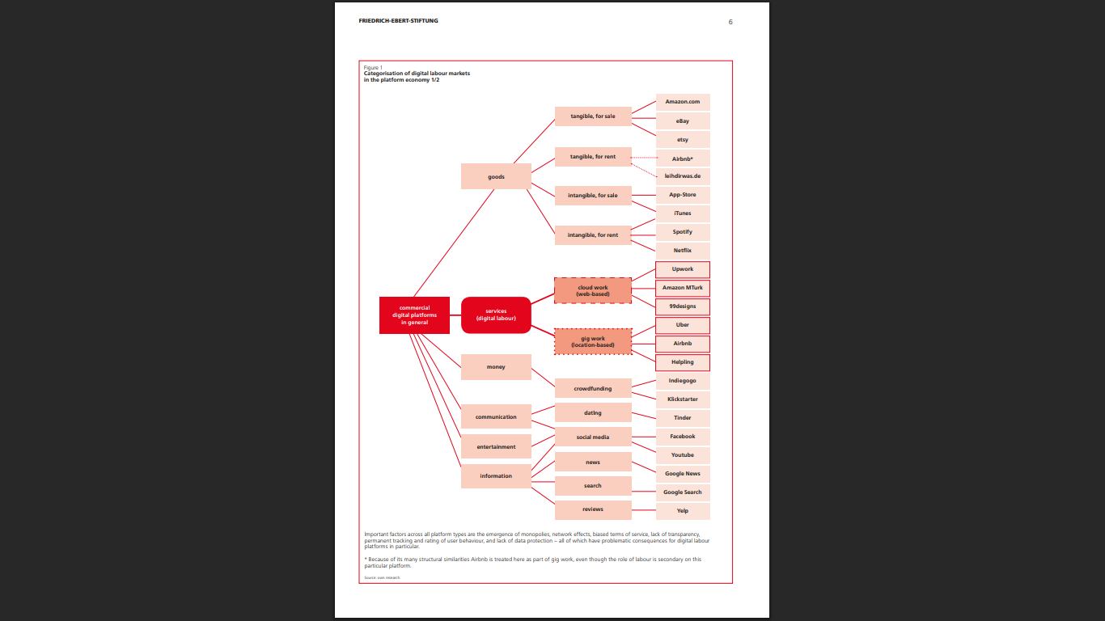Figure frame work development
Source-(8 page -DIGITAL LABOUR MARKETS IN THE PLATFORM ECONOMY)

What implications does this have for HRM and IHRM strategies?
Now the world is changing, and companies are searching for talented and skilled individuals who are experts in technology and globalization. These professionals are not limited to physical workplaces — they are capable of working virtually across borders. In this evolving international environment, HRM faces a major challenge: how to find the best people worldwide, how to integrate them effectively into their organizations, and how to ensure their loyalty and long-term commitment. As a result, companies are now adopting global talent management strategies, using advanced management techniques to attract and retain the most capable individuals from around the world.

Task 2 question 2

There are many demographical and geopolitical factore influence in employment market today which are as fallows.
in many OECD countries, the working-age population (20-64) is shrinking because of declining fertility and rising life expectancy. The OECD old-age dependency ratio has increased from 19% in 1980 to 31% in 2023 and is projected to rise to approximately 52% by 2060. The declining and ageing population affects the labour force and economic growth. Without policy reforms, labour productivity growth in the OECD is projected to be sluggish. (OECD, 2025, p. 45)

Expanding working-age populations in lower-income countries
In low-income countries, working-age populations are rising, which supports growth in education and other labour-intensive industries is the great strategies to overcome this situation. The main purpose is to get higher profit and minimize the cost so we have to expand working age population in lower income countries. Moreover its HR duty to measure the problem and guide them professionally.

Geographic/Regional and Urban-Rural Disparities
High-skilled jobs tend to cluster in urban and high-wage areas whereas rural regions lag behind in opportunities, wages and access to skills. “Regions with shrinking populations and lower productivity levels are likely to be hit particularly hard” (World Bank, n.d.).

Migration (Internal and International)
Migration significantly affects labour supply, skill distribution and the overall flexibility of the labour market. What are the effects of internal migration on the workforce in a country. The external migration also affects the labour markets of both host and home countries.

Key Geopolitical / Geoeconomic Factors
Geoeconomic Fragmentation and Restrictions on Trade and Investment
Rising geopolitical tensions, trade barriers and industrial policy/subsidies are increasingly cited by employers as drivers of business transformation. The World Economic Forum. Hypothesis Threat: 34% of respondents expect the need to respond to geopolitical conflicts. (Multiple choice question); 23% are highly or very highly concerned by trade and investment restrictions; 21% are highly or very highly concerned by industrial policies(World Economic Forum, 2025).

Supply chain realignment (reshoring /friend-shoring)

Technological Access and Digital Infrastructure (due to the lack thereof) Countries with poor digital infrastructure might struggle to compete in remote work markets, AI implementation and other related domains. Additionally, a nation’s geopolitical standing (alliances, trade partnerships) influences the availability of technological resources (World Economic Forum, 2025).

Labour Policy, Migration Regulation & Mobility Constraints.

The “visa rules, immigration policy and cross-border regulation” pillar is determined by the ability of a country to attract and retain talent. Geopolitical tensions or conflicts in certain regions (World Economic Forum, 2025).
The gig economy.
Among the unique demographic forces that define employment markets in today's era is the expansion of the gig economy. This movement toward part-time, freelance, and contract work models is brought about by a change in attitudes toward work-life balance, technology innovations that allow remote work benefits, and a desire for greater autonomy. For human resource professionals, this trend creates challenges in the management of a more dispersed workforce, conformance with multiple labor laws, and talent procurement and retention planning to accommodate non-traditional employment arrangements(Kuhn, Meijerink and Keegan, 2021)

Task 3 Question 3
Workforce planning and skills gap analysis are at the core of strategic Human Resource Management. According to Deloitte (2023), using workforce analytics enables companies to visualise skill distributions, predict retirements and determination of the emerging skills essential for productivity. Work force analytics are particularly relevant for healthcare , technology , and hospitality sectors, where rapid innovation creates challenges. Reskilling and upskilling are central strategies to cope with the talent crisis.

McKinsey & Company (2024) observed that organisations with strong reskilling frameworks experience a 30% higher retention rate and improved productivity. Healthcare organisations for instance are retraining nurses to use telemedicine technologies while hospitality businesses provide digital training for staff for the betterment of customer experience and operational efficiency.

Another Main approach is internal mobility and succession planning. Instead of relying exclusively on external hires organisations can identify and promote existing employees with high potential. This not only boosts morale but preserves institutional knowledge. HRM strategies such as leadership pipelines career development frameworks and mentoring programmes ensure that key positions are filled by competent internal talent. In hospitality for example promoting experienced supervisors into managerial roles helps mitigate shortages caused by high staff turnover (SHRM, 2024).

Expanding and diversifying the talent pool is also essential. Strategic HRM advocates inclusive recruitment practices that attract candidates from non-traditional backgrounds underrepresented groups or different geographic regions. Collaborations with universities technical colleges and vocational institutions help align educational curricula with industry needs ensuring that graduates are work-ready. The World Economic Forum (2023) reported that partnerships between healthcare institutions and training academies have improved job readiness and reduced onboarding costs by up to 20%. Similarly tech firms that collaborate with coding bootcamps are better positioned to hire entry-level talent capable of immediate contribution. Employer branding and flexibility have become decisive factors in attracting and retaining scarce talent.

According to PwC (2023), nearlythree-quarters of job seekers consider flexibility and organisational culture as primary reasons to join or remain in a company.
Strategic HRM integrates employer branding efforts by promoting employee well-being diversity recognition programmes and work-life balance.
For instance offering hybrid or remote work models expands the accessible talent pool beyond local boundaries and increases satisfaction levels among employees. This approach has become particularly effective in tech and professional services sectors. Lastly technology and data analytics play an indispensable role in bridging skills gaps. Modern HR systems and analytics tools support recruitment forecasting performance management and training impact evaluation. Artificial intelligence (AI) and predictive analytics enable HR professionals to anticipate talent shortages before
they occur allowing for pre-emptive interventions. HR Information Systems (HRIS) integrate data from recruitment training and performance evaluations offering leaders actionable insights.

In healthcare for example AI-driven workforce planning tools predict patient demand trends enabling overall the combined application of workforce planning reskilling internal mobility inclusivity employer branding and HR technology forms the cornerstone of strategic HRM. Organisations that implement these strategies not only overcome immediate skill shortages but also cultivate sustainable agile and
future-ready workforces capable of thriving in evolving industries. It gives them boost to findout skilled worker so they can easily solve this problem.

Task 4

Question 4

Reflective Report: My Capabilities in an International Context
In today’s world, which is considered a global world, human beings are able to connect with each other, and they can perform tasks even if they are set anywhere in the world. So, due to the globalization of the world, every employee needs to know the equipment through which they can connect with the world and perform several tasks related to their job satisfaction. In other words, employees must work effectively across cultures, utilize modern technologies, and continuously adapt to change.
This report reflects on my current capabilities in working within an international environment, focusing on technical skills, communication, how I work in team teamwork, leadership qualities, and self-directed learning capability. It also highlights my strengths and weaknesses so I can understand my weaknesses to correct them and also get familiar with my own strengths, and how I intend to leverage and improve them based on my recent learning experiences.

Technical understanding
According to my own understanding, I am capable of understanding digital tools and machines, and able to search for any knowledge to understand and get benefits from the technology. This gives me the potential to manage my own projects. I am familiar with different software which is essential to understand the study level and perform better in the class, so I can easily participate in the class and get knowledge from the most professional teachers. Even during this time, I completed my assignments requiring my online collaboration and digital data interpretation, which strengthened my ability to implement technology effectively in an international context. However, I noticed some of my weaknesses during this term, which are as follows.
Weaknesses
Sometimes I struggle to understand unfamiliar software quickly, which can slow down my efficiency to perform well.
Action Plan to fulfil this weakness
I mostly watch videos to understand the new technology, how they work, and how I can get benefits from the new emerging technology. Through this, I can easily solve my understanding efficiency to perform well in the class. Moreover, I search about the tech with which I am less familiar or try to understand the technology.

2. Communication
Strengths:
I am able to communicate ideas clearly in writing, presentations, and during class discussions, which we mostly do in class group activities, and I always become the leader of my group activity to present any of the research or discussion topics about HRM and IHRM-related topics. Moreover, I successfully explain my analyses to peers from diverse backgrounds, ensuring everyone understands the key points.
Weaknesses:
I occasionally hesitate when my group does not participate with the same energy that I put into the conversation, so I feel disappointed not to receive feedback.
Action Plan to fulfil this weakness
I will engage more in class discussions and participate in cross-cultural simulations to enhance my confidence in communication and to polish my communication skills.

Teamwork
Strenghs
I work well in a collaborative environment to perform any task. It’s my ability to perform well in a team, and I feel confident working in large group activities. During this term, I actively contributed to group projects, coordinated task assignments, and supported teammates during quizzes and research studies.
Weaknesses:
At times, I take on too much responsibility by myself, which can lead to stress and reduced delegation, and most of my teammates depend on me to do all the work.

Action Plan:
I have a plan to divide individual tasks to do so. Through this technique, everyone can perform well in the team and engage with the task according to their own capability, and it will increase their learning and my learning to manage the team and perform as a good leader.

Leadership

The ability to influence and guide a group of people toward a common goal and divide the separate tasks to each individual, guiding them to do their work more efficiently, is a leadership ability. So I became someone, the time leader of my group, especially in class activities. Moreover, I became the class rep to perform as a leader and guide them on how to do the work and guide my international fellows. This is a great opportunity for me to polish my leadership qualities.
Weakness
II have a lack of trust in team members, so I mostly prefer to do most of the work on my own. This lack of confidence is because of not engaging with the team and being unfamiliar with their weaknesses and strengths.
Action Plan:
I have a plan to engage with the class so I can understand their respective strengths and weaknesses, and I will try to do my best to solve their issues and train them on how to perform in the group activity as an international student. Through this action I am able to fully control my leadership qualities.moreover giving them feedback might be a good option so I gave them feedback and they will get an idea that in which specific sector they have to improve their skill and polish it.

Self-Directed Learning
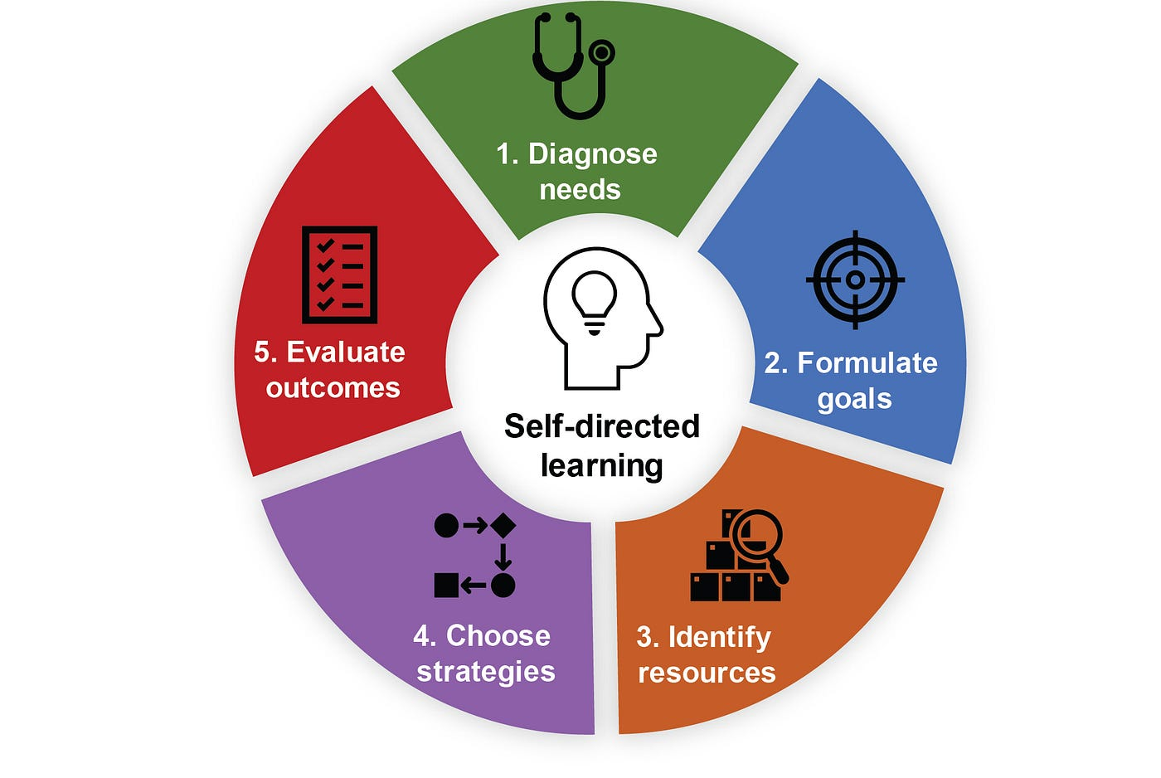
I am going to use this method which represent in the pic. Moreover,I’m really dedicated to learning and often look for resources outside of my classes. For instance, I took some online courses to boost my data analysis skills, which really helped with my studies. This formula contain capability to solve the self direct learnig and improvig my self so im going to find out what strategies might me helpful to tackle the self direct learning strategies

Weaknesses:

I do have a hard time sometimes when it comes to prioritizing what I should learn, which can make my progress a bit uneven.

Action Plan:

To tackle this, I’m planning to put together a weekly learning schedule. I’ll set clear goals for developing my skills and keep track of how I’m doing to make sure I improve consistently.because consistency is the key through I will solve it.However, have to focus on the goal not in the hurdles. And must identifiy the original resources to get knowledge and practical work experience. In Self direct learning I have to choose the best strategies to follow the consistency and in the last I have to evaluate the outcomes.

References
Schmidt, F.A. (2017) Digital labour markets in the platform economy: Mapping the political challenges of crowd work and gig work. Friedrich-Ebert-Stiftung. Available at: https://library.fes.de/pdf-files/wiso/13164.pdf

Schuler, R.S., Jackson, S.E. and Tarique, I. (2011) ‘Global talent management and global talent challenges: Strategic opportunities for IHRM’, Journal of World Business, 46(4), pp. 506–516. Available at: https://doi.org/10.1016/j.jwb.2010.10.011

Ehlinger, E.G. and Stephany, F. (2023) Skills or a degree? The rise of skills-based hiring for AI and green jobs. Bruegel. Available at: https://www.bruegel.org/working-paper/skills-or-degree-rise-skills-based-hiring-ai-and-green-jobs

OECD (2025) OECD Employment Outlook 2025: Can We Get Through the Demographic Crunch? Paris: OECD Publishing. Available at: https://doi.org/10.1787/194a947b-en (Accessed: 17 October 2025).

World Bank (n.d.) Demographic Trends Are Shaping Economic Growth. Available at: https://www.worldbank.org/en/publication/global-monitoring-report/development-trends-and-economic-development (Accessed: 17 October 2025).

CIPD (2023) Addressing skills shortages through strategic workforce planning. Available at: https://www.cipd.org/uk/knowledge/reports/skills-shortages/

Deloitte (2023) Closing the talent gap: Workforce strategies for the future. Available at: https://www.deloitte.com/insights/talent-gap (Accessed: 17 October 2025).

McKinsey & Company (2020) Beyond hiring: How companies are reskilling to address talent gaps. Available at: https://www.mckinsey.com/capabilities/people-and-organizational-performance/our-insights/beyond-hiring-how-companies-are-reskilling-to-address-talent-gaps

Schuler, R.S., Jackson, S.E. and Tarique, I. (2011) ‘Global talent management and global talent challenges: Strategic opportunities for IHRM’, Journal of World Business, 46(4), pp. 506–516. Available at: https://doi.org/10.1016/j.jwb.2010.10.011

